Name: Aryan Narang
Roll No: 2440032
Dept: MCA

SQL> CREATE TABLE classroom
2 (building varchar(15),
3 room_number varchar(7),
4 capacity numeric(4,0),
5 primary key (building,room_number)
6 );

SQL> insert into classroom
2 values (1,'1A',60);

1 row created.

SQL> insert into classroom
2 values (1,'2A',65);

1 row created.

SQL> insert into classroom
2 values (1,'1B',65);

1 row created.

SQL> insert into classroom
2 values (2,'4A',200);

1 row created.

SQL> insert into classroom
2 values (3,'2C',10);

1 row created.

SQL> insert into classroom
2 values (4,'6B',10);

1 row created.

Table created.
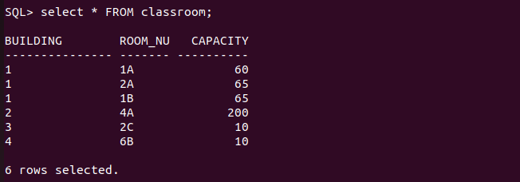
SQL> SELECT * FROM classroom;

BUILDING ROOM_NU CAPACITY
--------------- ------- ----------
1 1A 60
1 2A 65
1 1B 65
2 4A 200
3 2C 10
4 6B 10

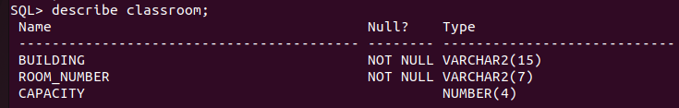

SQL> CREATE TABLE department
2 (dept_name varchar(20),
3 building varchar(15),
4 budget numeric(12,2) check(budget>0),
5 primary key(dept_name)
6 );

Table created.

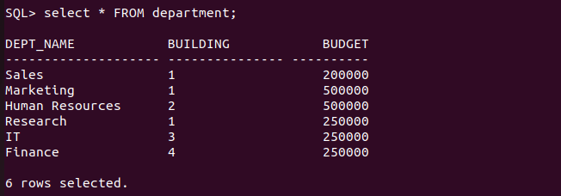

SQL> SELECT * FROM Department;

DEPT_NAME BUILDING BUDGET
-------------------- --------------- ----------
Sales 1 200000
Marketing 1 500000
Human Resources 2 500000
Research 1 250000
IT 3 250000
Finance 4 250000

6 rows selected.

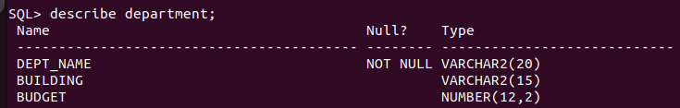
QL> insert into department
2 values ('Sales',1,200000);

1 row created.

SQL> insert into department
2 values ('Marketing',1,500000);

1 row created.

SQL> insert into department
2 values ('Human Resources',2,500000);

1 row created.

SQL> insert into department
2 values ('Research',1,250000);

1 row created.

SQL> insert into department
2 values ('IT',3,250000);

1 row created.

SQL> insert into department
2 values ('Finance',4,250000);

1 row created.

SQL> CREATE TABLE course
2 (course_id varchar(8),
3 title varchar(50),
4 dept_name varchar(20),
5 credits numeric(2,0) check(credits>0),
6 primary key(course_id),
7 foreign key (dept_name) references department
8 on delete set null
9 );

SQL> insert into course
2 values('C101','ECONOMICS','Finance',18);

1 row created.

SQL> insert into course
2 values('C102','Accounts','Finance',18);

1 row created.

SQL> insert into course
2 values('C103','Marketing 101','Marketing',15);

1 row created.

SQL> insert into course
2 values('C104','Computers 101','IT',15);

1 row created.

SQL> insert into course
2 values('C105','Workplace Env','Human Resources',19);

1 row created.

SQL> insert into course
2 values('C106','Researching 101','Research',19);

1 row created.
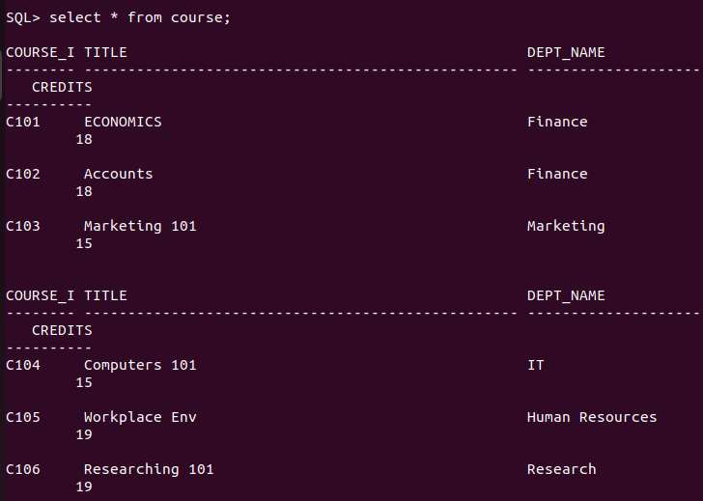
SQL> select * from course;

COURSE_ID TITLE DEPT_NAME
-------- -------------------------------------------------- --------------------
CREDITS
----------
C101 ECONOMICS Finance
18

C102 Accounts Finance
18

C103 Marketing 101 Marketing
15

COURSE_I TITLE DEPT_NAME
-------- -------------------------------------------------- --------------------
CREDITS
----------
C104 Computers 101 IT
15

C105 Workplace Env Human Resources
19

C106 Researching 101 Research
19

6 rows selected.
Table created.
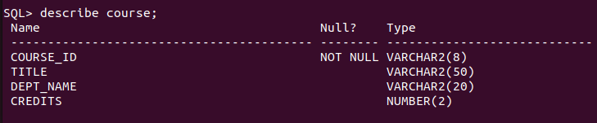

SQL> CREATE TABLE instructor
2 (ID varchar(5),
3 name varchar(20) not null,
4 dept_name varchar(20),
5 salary numeric(8,2) check(salary>29000),
6 primary key(ID),
7 foreign key (dept_name) references department
8 on delete set null
9 );

SQL> SELECT * FROM instructor;

ID NAME DEPT_NAME SALARY
----- -------------------- -------------------- ----------
I11 Ramesh Finance 100000.23
I1 Suresh IT 250000
I2 Aryan Marketing 250000
I3 Rahul Human Resources 450000
I4 Ram Research 450000

SQL> insert into instructor
2 values('I11','Ramesh','Finance',100000.23);

1 row created.

SQL> insert into instructor
2 values('I1','Suresh','IT',250000.00);

1 row created.

SQL> insert into instructor
2 values('I2','Aryan','Marketing',250000.00);

1 row created.

SQL> insert into instructor
2 values('I3','Rahul','Human Resources',450000.00);

1 row created.

SQL> insert into instructor
2 values('I4','Ram','Research',450000.00);

1 row created.
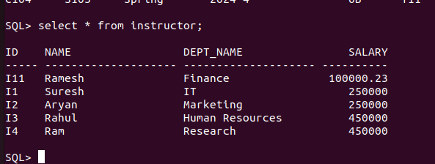
Table created.
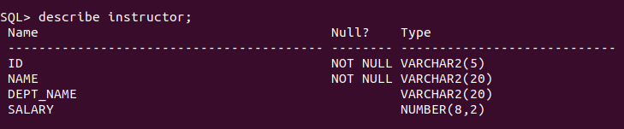
SQL> CREATE TABLE section
2 (course_id varchar(8),
3 sec_id varchar(8),
4 semester varchar(6) check(semester in ('Fall','Winter','Spring','Summer')),
5 year numeric(4,0) check(year>1701 and year<2100),
6 building varchar(15),
7 room_number varchar(7),
8 time_slot_id varchar(4),
9 primary key(course_id,sec_id,semester,year),
10 foreign key (course_id) references course
11 on delete cascade,
12 foreign key (building,room_number) references classroom
13 on delete set null
14 );

Table created.
SQL> insert into section
2 values('C103','S105','Spring',2024,2,'4A','T14');

1 row created.

SQL> insert into section
2 values('C104','S103','Spring',2024,4,'6B','T11');

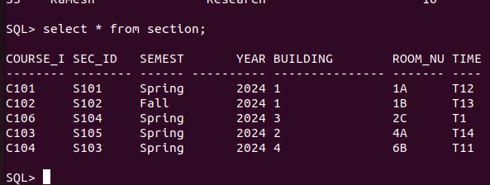
SQL> SELECT * FROM SECTION;

COURSE_I SEC_ID SEMEST YEAR BUILDING ROOM_NU TIME
-------- -------- ------ ---------- --------------- ------- ----
C101 S101 Spring 2024 1 1A T12
C102 S102 Fall 2024 1 1B T13
C106 S104 Spring 2024 3 2C T1
C103 S105 Spring 2024 2 4A T14
C104 S103 Spring 2024 4 6B T11
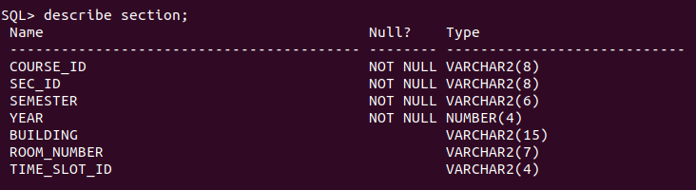

SQL> CREATE TABLE teaches
2 (ID varchar(5),
3 course_id varchar(8),
4 sec_id varchar(8),
5 semester varchar(6),
6 year numeric(4,0),
7 primary key(ID,course_id,sec_id,semester,year),
8 foreign key(course_id,sec_id,semester,year) references section
9 on delete cascade
10 )
11 ;
QL> insert into teaches
2 values('I2','C102','S102','Fall',2024);

1 row created.

SQL> insert into teaches
2 values('I3','C103','S105','Spring',2024);

1 row created.

SQL> insert into teaches
2 values('I4','C104','S103','Spring',2024);

1 row created.

Table created.
SQL> select * from teaches
2 ;

ID COURSE_I SEC_ID SEMEST YEAR
----- -------- -------- ------ ----------
I1 C101 S101 Spring 2024
I2 C102 S102 Fall 2024
I3 C103 S105 Spring 2024
I4 C104 S103 Spring 2024

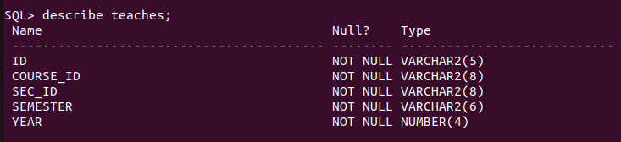

SQL> CREATE TABLE student
2 (ID varchar(5),
3 name varchar(20) not null,
4 dept_name varchar(20),
5 tot_cred numeric(3,0) check(tot_cred>=0),
6 primary key(ID),
7 foreign key (dept_name) references department
8 on delete set null
9 );

SQL> insert into student
2 values('S4','Jackson','IT',16);

1 row created.

SQL> insert into student
2 values('S5','Ramesh','Research',16);

1 row created.

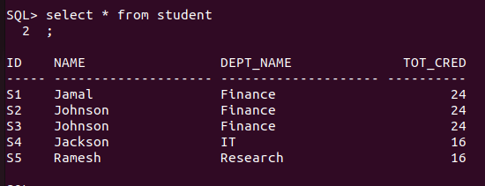

SQL> select * from student;

ID NAME DEPT_NAME TOT_CRED
----- -------------------- -------------------- ----------
S1 Jamal Finance 24
S2 Johnson Finance 24
S3 Johnson Finance 24
S4 Jackson IT 16
S5 Ramesh Research 16

Table created.
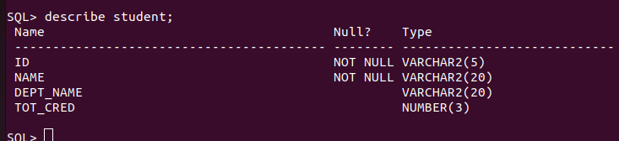

SQL> CREATE TABLE takes
2 (ID varchar(5),
3 course_id varchar(8),
4 sec_id varchar(8),
5 semester varchar(6),
6 year numeric(4,0),
7 grade varchar(2),
8 primary key (ID,course_id,sec_id,semester,year),
9 foreign key(course_id,sec_id,semester,year) references section
10 on delete cascade,
11 foreign key (ID) references student
12 on delete cascade
13 );
SQL> insert into takes
2 values('S1','C101','S101','Spring',2024,'A');

1 row created.

SQL> insert into takes
2 values('S2','C101','S101','Spring',2024,'A');

1 row created.

SQL> insert into takes
2 values('S3','C101','S101','Spring',2024,'A');

1 row created.

SQL> insert into takes
2 values('S4','C102','S102','Fall',2024,'A');

1 row created.

SQL> insert into takes
2 values('S5','C102','S102','Fall',2024,'A');

1 row created.

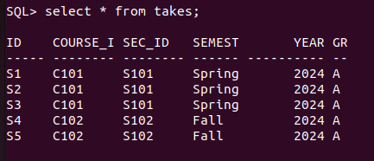

Table created.
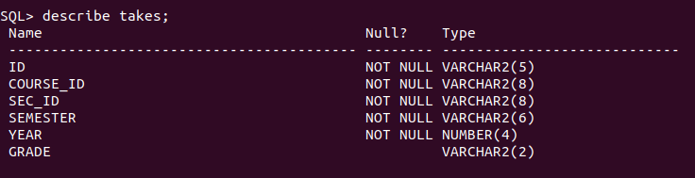

SQL> CREATE TABLE advisor
2 (s_ID varchar(5),
3 i_ID varchar(5),
4 primary key (s_ID),
5 foreign key (i_ID) references instructor(ID)
6 on delete set null,
7 foreign key(s_ID) references student(ID)
8 on delete cascade
9 );

SQL> insert into advisor
2 values('S3','I1');

1 row created.

SQL> insert into advisor
2 values('S4','I2');

1 row created.

SQL> insert into advisor
2 values('S5','I2');

1 row created.

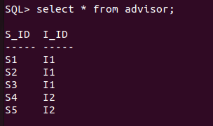

SQL> select * from advisor;

S_ID I_ID
----- -----
S1 I1
S2 I1
S3 I1
S4 I2
S5 I2

Table created.
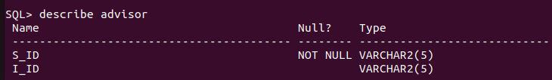

SQL> CREATE TABLE time_slot
2 (time_slot_id varchar(4),
3 day varchar(1),
4 start_hr numeric(2) check (start_hr>=0 and start_hr < 24),
5 start_min numeric(2) check (start_min>=0 and start_min<60),
6 end_hr numeric(2) check(end_hr>=0 and end_hr<24),
7 end_min numeric(2) check (end_min>=0 and end_min<60),
8 primary key (time_slot_id,day,start_hr,start_min)
9 );
SQL> insert into time_slot
2 values('T11','M',13,30,14,30);

1 row created.

SQL> insert into time_slot
2 values('T12','T',11,30,14,30);

1 row created.

SQL> insert into time_slot
2 values('T13','W',12,30,14,30);

1 row created.

SQL> insert into time_slot
2 values('T13','F',15,30,17,30);

1 row created.

SQL> insert into time_slot
2 values('T14','F',15,00,17,00);

1 row created.

SQL> select * from time_slot;

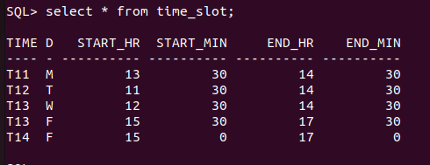
---- - ---------- ---------- ---------- ----------

.
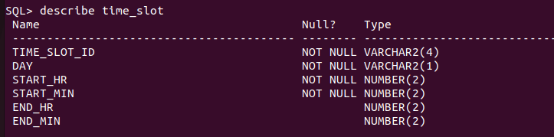

SQL> CREATE TABLE prereq
2 (course_id varchar(8),
3 prereq_id varchar(8),
4 primary key(course_id,prereq_id),
5 foreign key(course_id) references course
6 on delete cascade,
7 foreign key (prereq_id) references course
8 );

Table created.
SQL> insert into prereq
2 values('C101','C102');

1 row created.

SQL> insert into prereq
2 values('C102','C103');

1 row created.

SQL> insert into prereq
2 values('C103','C104');

1 row created.

SQL> insert into prereq
2 values('C104','C101');

1 row created.

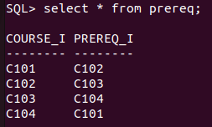
SQL> select * from prereq;

COURSE_I PREREQ_I
-------- --------
C101 C102
C102 C103
C103 C104
C104 C101

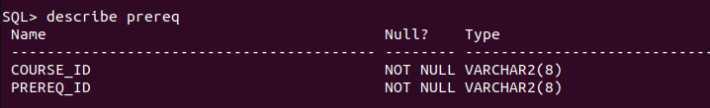

SQL>
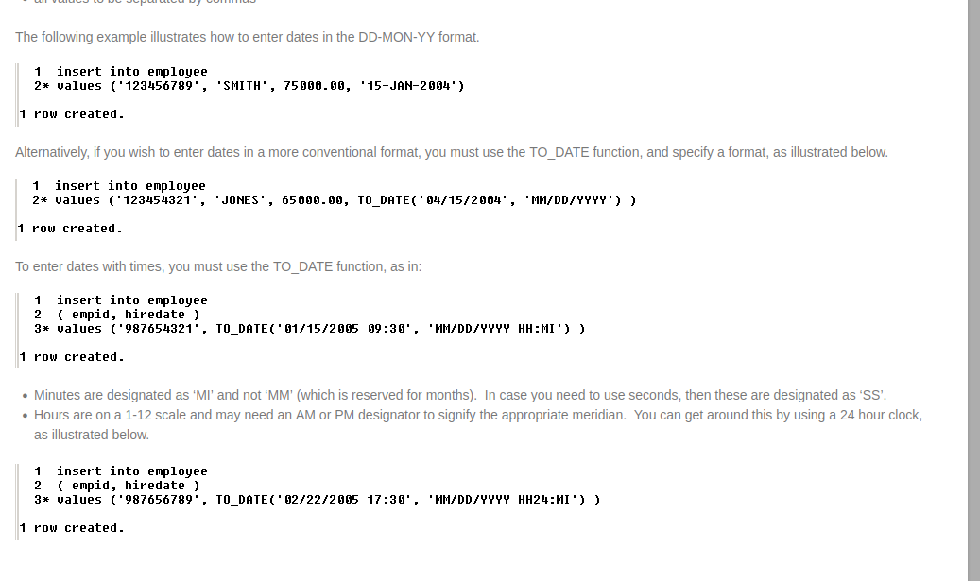
Q

TABLE_NAME
------------------------------
PREREQ
CLASSROOM
DEPARTMENT
COURSE
INSTRUCTOR
SECTION
TEACHES
STUDENT
TAKES
ADVISOR
WWV_FLOW_TEMP_TABLE

