Name : Aryan Narang Roll no:244ca009

1. List all classrooms with a capacity greater than 50.
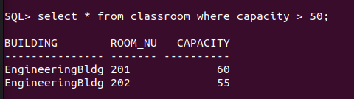

2. Find the names of all instructors in the "Computer Science" department

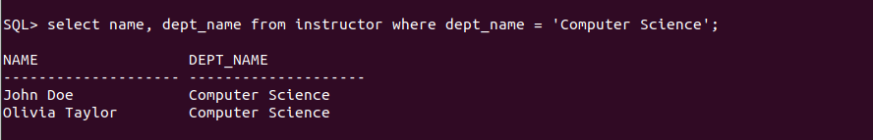

3.Retrieve the titles of all courses offered in the "Spring" semester of 2024
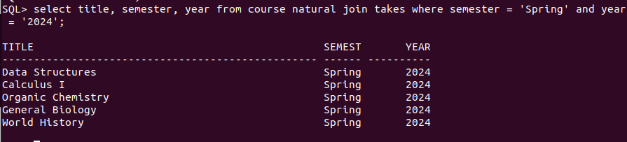

4.List all students who have taken more than 30 total credits.

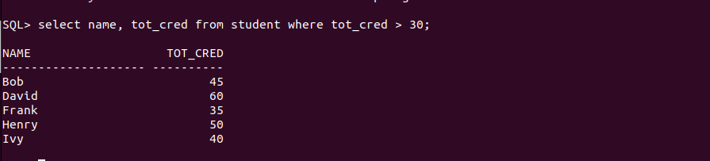

5. Find the names of all departments with a budget greater than ₹1,00,000.

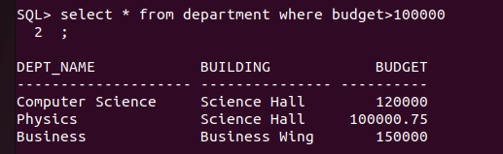
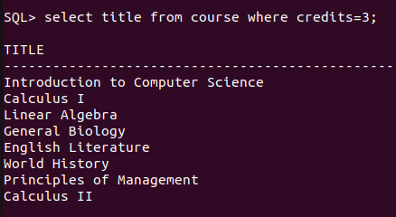
6.List all departments and their respective buildings.
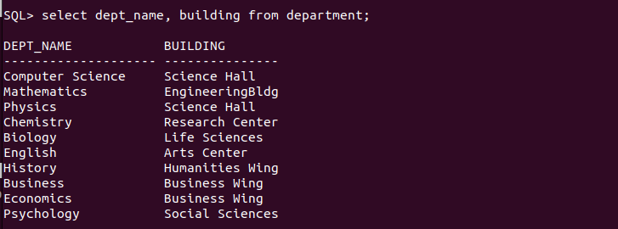

7. Find the names of all students enrolled in the "Physics" department.
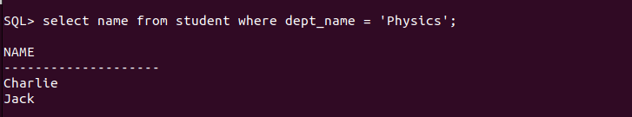

8. Retrieve the titles of all courses with 3 credits.

9. List all instructors who do not belong to any department.
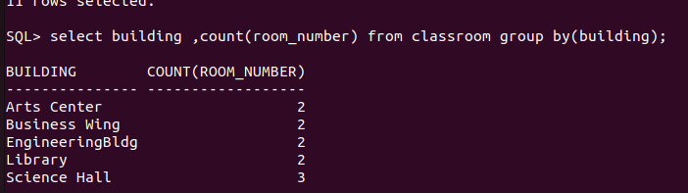
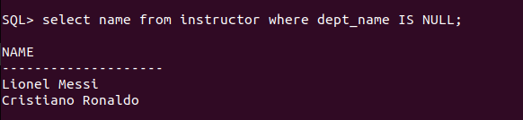

10. Find the total number of classrooms in each building.

11. List all courses taught by the instructor with ID "I001"


12. Find the total number of students enrolled in each department.

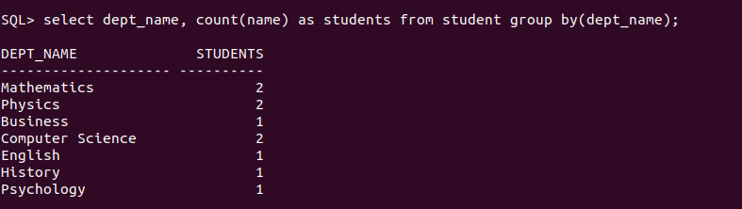

13. Retrieve the names of students who have taken the course "CS-101" and received an
"A" grade.

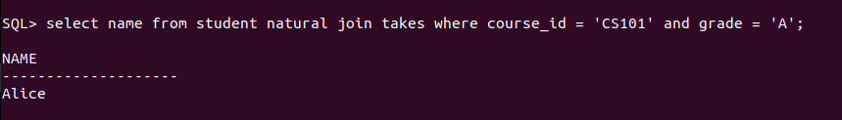

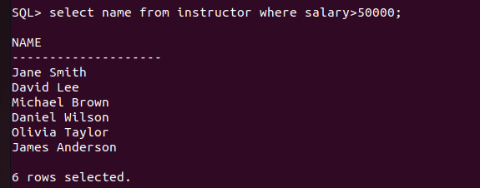
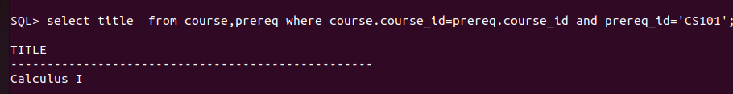
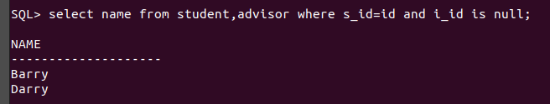
14. List all instructors who earn a salary greater than ₹50,000.

15. Find the average salary of instructors in each department.
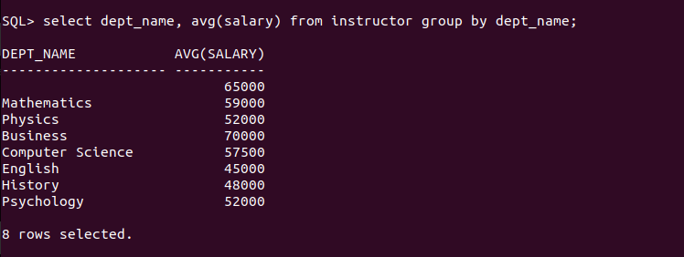

16.Retrieve the names of students who have not been assigned an advisor.

17. List all courses that have "CS-101" as a prerequisite.

18. Find the total number of sections taught in each building.

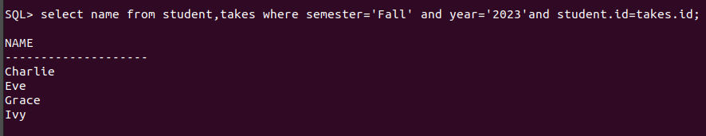
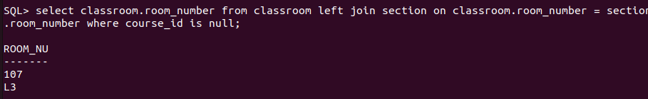
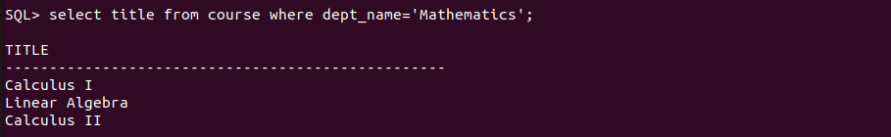
19. Retrieve the names of students who have taken at least one course in the "Fall"
semester of 2023.

20. List all classrooms that have not been assigned to any section.
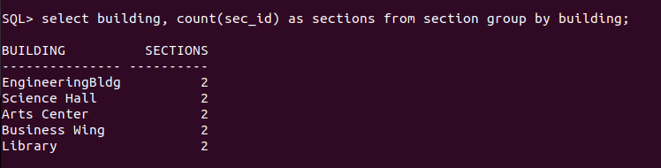

21. List all courses offered by the "Mathematics" department.

22. Find the names of students who have taken courses in both "Fall" and "Spring"
semesters.

23. Retrieve the names of instructors who have taught more than 5 sections.

24. List all courses that have no prerequisites.

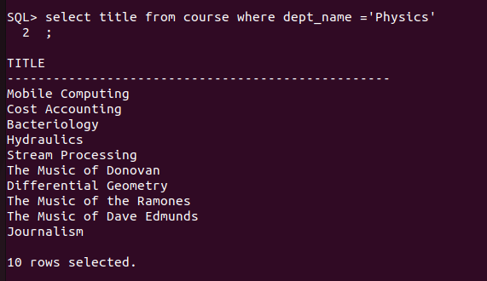
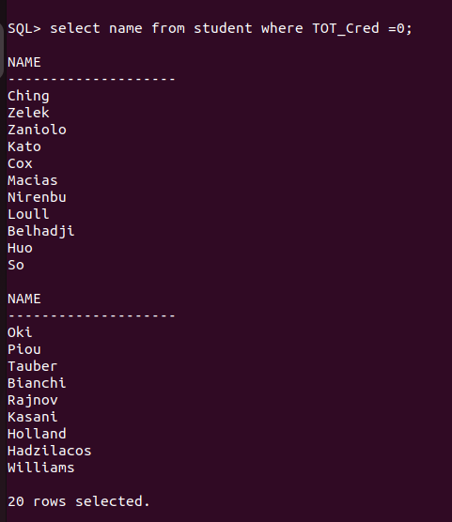

25. Find the average number of credits taken by students in each department.

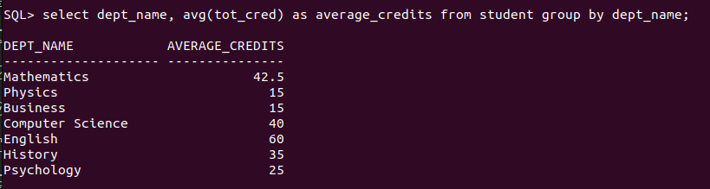

Exercise 2:

1. List all students with a total credit count of 0.

2. Find the names of all courses offered by the "Physics" department.

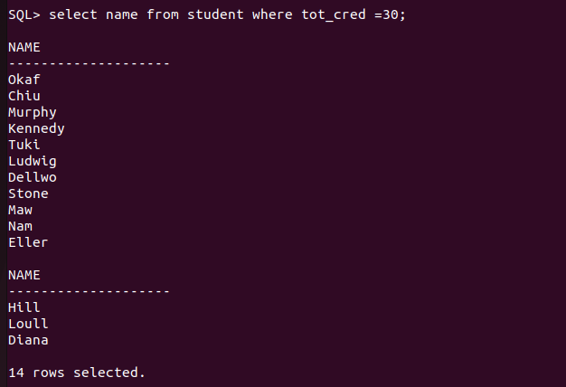
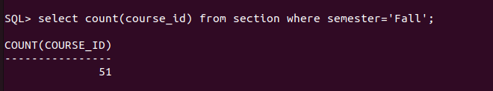
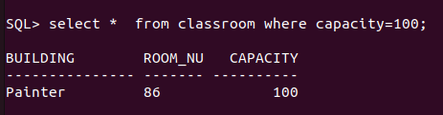
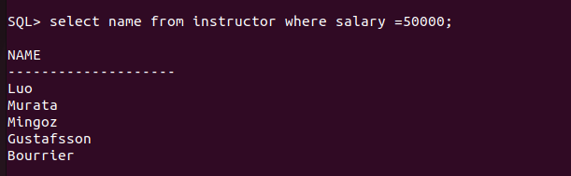
3. Retrieve the names of all instructors who earn exactly ₹50,000.

4. List all classrooms with a capacity of exactly 100.

5. Find the total number of courses offered in the "Fall" semester.

6. List all students who have taken exactly 30 total credits.

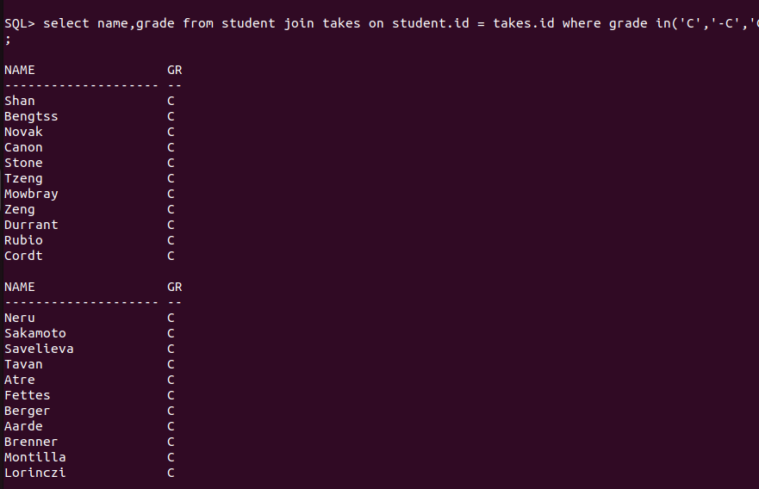
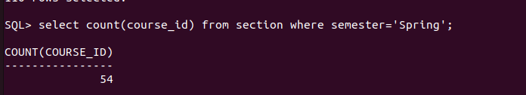
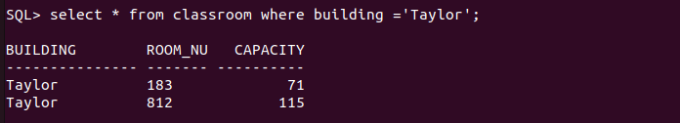
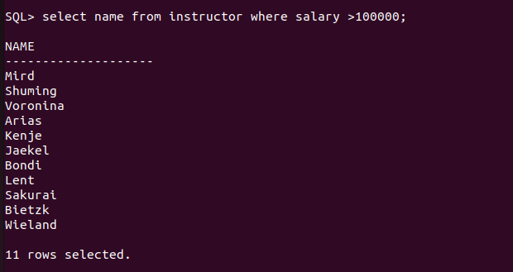
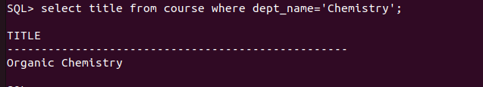
7. Find the names of all courses offered by the "Chemistry" department.

8. Retrieve the names of all instructors who earn more than ₹100,000.

9. List all classrooms located in the "Taylor" building.

10. Find the total number of courses offered in the “Spring” semester.

11. List all students who have taken courses with a grade of "C" or lower.

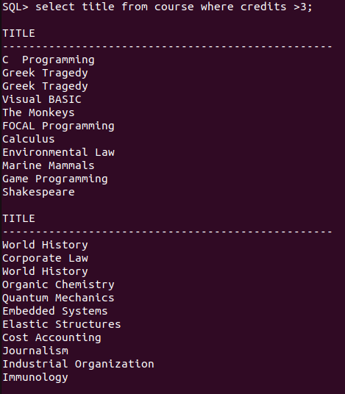
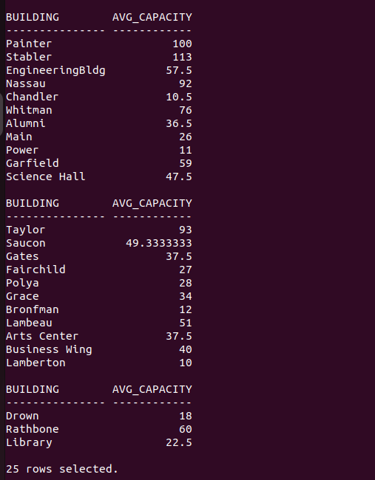
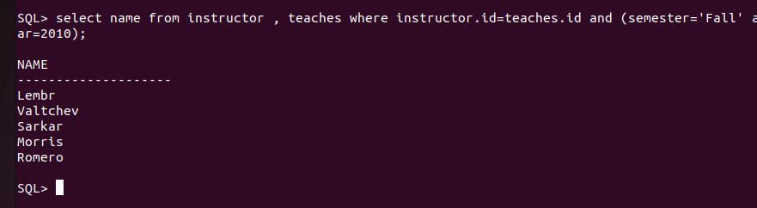

12. Retrieve the names of instructors who have taught in the "Fall" semester of 2010.

13. Find the average capacity of classrooms in each building.

14. List all courses that have more than 3 credits.

15. Retrieve the names of students who have taken courses in the "Watson" building.

16. Find the total number of students advised by each instructor.

17. List all sections that do not have a classroom assigned.

18. Retrieve the names of students who have taken courses with the highest number of
credits.

19. Find the departments with the highest average instructor salary.

20. List all courses that have been taught by more than one instructor.

21. List all students who have taken courses with a grade of "A" in the "Fall" semester of
2022.

22. Retrieve the names of instructors who have taught in the "Spring" semester of 2023.

23. Find the average number of students enrolled in each course.

24. List all courses that have exactly 4 credits.

25. Retrieve the names of students who have taken courses in the "Packard" building.

