Resilient Infrastructure Planning for GLOF-Prone Regions
A Research-Style Technical Documentation of ArcGIS Pro Workflow for Flood Risk, Road Vulnerability, Emergency Routing, and Optimal Emergency Service Location
Study Area: Beas River Basin, Kullu Valley, Himachal Pradesh, India
Prepared on: April 01, 2026
Prepared for project documentation, reporting, and presentation support

Abstract
This document presents a research-style technical description of an ArcGIS Pro workflow developed for resilient infrastructure planning in Glacial Lake Outburst Flood (GLOF)-prone regions, with application to the Beas River Basin in Kullu Valley, Himachal Pradesh. The workflow integrates terrain-based flood depth estimation, OpenStreetMap road and hospital data preparation, road vulnerability assessment, vehicle-safe speed estimation, emergency routing, service area analysis, and optimal emergency center allocation. A Height Above Nearest Drainage (HAND) approach is used to derive flood depth surfaces from a DEM, and the resulting inundation is translated into operational mobility metrics through depth-based road sampling and a depth-disruption function. The framework produces flood risk zones, flood-adjusted travel speeds, passability classes for different vehicle categories, closest-facility evacuation routes, service-area coverage polygons, and candidate versus optimal emergency service locations. In addition, a dedicated graph-generation module converts ArcGIS outputs into presentation-ready analytical figures. The complete workflow is designed for execution within ArcGIS Pro Notebook using Spatial Analyst and Network Analyst, and is intended to support both technical reporting and emergency planning decision-making.
Keywords: GLOF, HAND, ArcGIS Pro, road vulnerability, emergency routing, service area analysis, location-allocation, Kullu Valley, flood risk, safe speed.

1. Introduction
Flood disasters in the Western Himalayas are increasingly influenced by extreme rainfall, slope instability, glacial lake growth, and river corridor disruption. In mountain valleys such as Kullu, even a short-duration high-intensity event can sever road links, isolate settlements, delay ambulances, and prevent rescue teams from reaching vulnerable populations within the critical response window. Conventional flood maps often emphasize inundation extent alone and do not explicitly quantify how flood depth affects road usability, safe vehicle speed, or travel time to emergency services. The present workflow addresses that operational gap by transforming flood information into mobility and accessibility information. In other words, it answers not only where flood water may occur, but also which roads remain usable, how quickly responders can move, which flood-affected areas remain reachable within target time thresholds, and where additional emergency-response facilities should ideally be placed.
The scripts in this project were implemented for ArcGIS Pro Notebook and organized as an end-to-end analytical sequence. The pipeline begins with DEM-based hydrologic derivation and HAND flood mapping, continues through OpenStreetMap data acquisition and flood-aware road assessment, and concludes with cartographic export and graph-based reporting. The resulting framework is particularly suited to mountainous regions where terrain control, road access, and response-time sensitivity are closely coupled.

2. Objectives
The analytical framework was structured around three primary objectives. First, flood-depth results were transformed into local flood risk zones ranging from highly flood-prone regions to comparatively safe regions. Second, roads were evaluated for vulnerability, flood-adjusted safe speed, and passability for different emergency vehicle types in order to support quickest and safest route selection. Third, an emergency facility planning component was developed to identify the optimal and ideal locations of emergency services and shelters under a target response threshold of 20 minutes.
Table 1. Project objectives and principal outputs.
Objective | Analytical Goal | Principal Output
Objective 1 | Flood risk classification | Flood depth raster and flood risk zones
Objective 2 | Road vulnerability and mobility assessment | Safe speed, road status, emergency routes
Objective 3 | Optimal emergency service location | Service areas and optimal emergency centers

3. Software Environment and Input Data
The workflow is built specifically for ArcGIS Pro Notebook and depends on the `arcpy` Python ecosystem. Spatial Analyst is required for raster hydrology, raster algebra, and extraction operations, whereas Network Analyst is required for closest-facility, service-area, and location-allocation analyses. The scripts also use `arcpy.mp.ArcGISProject("CURRENT")`, which means that a live ArcGIS Pro project with an open map is required for automated layer loading and cartographic export.
The main terrain input is the DEM `Bease_River_Basin_DEM-002.tif`. This DEM supports sink filling, flow-direction derivation, flow accumulation, stream extraction, HAND generation, and elevation sampling on roads. Road and healthcare infrastructure are obtained from OpenStreetMap through Overpass API calls, then converted into ArcGIS feature classes. The roads layer becomes the core transport network for vulnerability assessment and routing, while hospitals serve as existing facilities for emergency access and facility-allocation analysis.
Table 2. Major inputs used in the ArcGIS workflow.
Input | Source | Purpose in Workflow
DEM | Local raster | Hydrology, HAND, flood depth, road elevation sampling
Road network | OpenStreetMap via Overpass API | Mobility, routing, service areas
Hospitals and clinics | OpenStreetMap + fallback known facilities | Emergency facilities
Active ArcGIS map | ArcGIS Pro project | Layer display, export, symbology

4. Script Architecture and Execution Sequence
Five scripts constitute the full workflow. The analytical dependency is strict for the first three scripts because each stage depends on outputs from the preceding stage. Visualization and graph generation are downstream modules that rely on completed analysis results.
Table 3. Script inventory and required execution order.
Script | Role | Required Order
01_HAND_Flood_Mapping.py | Terrain preprocessing and flood depth generation | 1
02_Download_Data.py | Road and hospital download and preparation | 2
03_Emergency_Routing.py | Risk, roads, routing, service areas, optimal centers | 3
04_Visualize_Results.py | ArcGIS symbology and map export | 4
05_Generate_Graphs.py | Statistical graphs and reporting figures | 5

5. Methodology

5.1 HAND-Based Flood Inundation Mapping
The flood-mapping stage uses a dual-stage HAND strategy. The DEM is first hydrologically conditioned using sink filling. A flow-direction raster is then derived, followed by a flow-accumulation raster that identifies drainage convergence. Two accumulation thresholds are used to separate tributaries from the main river channel: 160000 for tributary extraction and 1500000 for main-river extraction. This separation is important because a single drainage threshold would overgeneralize river behavior in a mountainous basin where tributaries and the main channel have distinct hydraulic influence.
After stream extraction, HAND surfaces are produced for tributaries and the main river using vertical flow distance. Flood depth is then estimated by comparing HAND values to assumed water levels of 5.0 m for tributaries and 12.0 m for the main river. The raster equation can be conceptually expressed as Flood Depth = Water Level - HAND, subject to the condition that HAND is less than or equal to the specified water level. The tributary flood surface and main-river flood surface are subsequently merged using a cell-wise maximum operator to create the final flood-depth raster. The resulting output captures the strongest modeled flood influence at each cell.
Figure 1. Editable methodology figure
The following figure is intentionally created as editable Word tables so that stage names, inputs, processes, and outputs can be modified directly inside the .docx file without redrawing the figure.
Stage 1 | Stage 2 | Stage 3 | Stage 4 | Stage 5
HAND Flood Mapping | OSM Data Download | Routing and Vulnerability | Map Visualization | Graphs and Reporting
| | | |
Primary Input:  DEM | Primary Input:  DEM extent + OSM | Primary Input:  Flood raster + roads + hospitals | Primary Input:  Analysis outputs | Primary Input:  Geodatabase outputs + map image
Primary Output:  Flood depth raster | Primary Output:  roads.shp and hospitals.shp | Primary Output:  Routes, service areas, optimal centers | Primary Output:  Styled map exports | Primary Output:  Graphs and research report
Figure note: This editable figure summarizes the end-to-end workflow from terrain-based flood mapping to graph-based reporting.

5.2 Download and Preparation of Roads and Healthcare Facilities
The second stage derives the road and facility datasets from OpenStreetMap. The study-area bounding box is obtained directly from the DEM extent. If the DEM is projected, its corner coordinates are transformed to WGS84 before submission to the Overpass API. To reduce timeout risk, the total bounding box is subdivided into four quadrants, each of which is queried independently. Road features are collected for major highway categories including motorway, trunk, primary, secondary, tertiary, residential, unclassified, service, and track. The returned OSM nodes and ways are reconstructed into ArcGIS polyline features.
Each road segment is assigned descriptive and operational attributes, including OSM identifier, highway class, name, maximum speed, one-way status, and surface. Where OSM speed values are missing, default speeds by road class are used. Length and travel time are computed using the relationship Travel Time = Length / Speed. Hospitals, clinics, and relevant healthcare points are also queried from OSM; however, because volunteered geographic datasets can be incomplete, the workflow appends a fallback list of known major hospitals in Kullu District whenever those facilities are absent from OSM results. Finally, both the roads and hospital feature classes are projected into UTM Zone 43N for downstream geometric and network operations.

5.3 Flood Risk Classification
The flood-depth raster is transformed into four operational risk classes. Depths greater than 1.5 m are classified as Red or Major flood risk, depths between 0.5 m and 1.5 m are classified as Orange or Moderate risk, depths between 0 m and 0.5 m are classified as Yellow or Minor risk, and cells with no flood depth are classified as Green or No Flood. The raster is subsequently converted to polygons, and fields are added to store human-readable labels for risk level and depth range. This stage produces the core hazard map for Objective 1.

5.4 Safe Speed Estimation Using Flood Depth
The road-mobility component uses the depth-disruption function reported by Pregnolato et al. (2017), written in the implementation as v(w) = 0.0009w^2 - 0.5529w + 86.9448, where w is flood depth in millimeters and v is the safe speed in km/h. In meter form, the equation is v = 900d^2 - 552.9d + 86.9448. The script constrains this function operationally: if flood depth is zero or less, speed is set to a dry-road baseline of 86.94 km/h; if depth exceeds 0.30 m, speed is forced to 0 km/h; and all values are clipped to the interval 0 to 86.94 km/h. The resulting raster is then reclassified into six speed bands ranging from 60-87 km/h to 0 km/h. This approach converts flood depth into a transport-operational variable that can be used directly in routing.

5.5 Road Vulnerability Assessment
The road vulnerability stage operates at segment level but derives its flood information from dense point sampling. Roads are first projected to the DEM coordinate system to avoid sampling and overlay errors. Additional fields are appended to each road segment to store flood depth, average depth, local elevation range, safe speed, vehicle passability, and overall road status. To improve sampling fidelity, road geometry is densified at 1 m intervals. The densified road vertices are converted into points, and both DEM elevation and flood depth are sampled at those points. The point values are then aggregated back to the parent road segment using maximum depth, average depth, minimum elevation, and maximum elevation statistics.
Vehicle-specific passability is based on conservative Himalayan thresholds: 0.25 m for small cars, 0.35 m for ambulances and SUVs, and 0.45 m for heavy or fire vehicles. In addition, the workflow uses 0.20 m as the minimum instability depth. Segment-level road status is assigned as Safe when depth equals 0, Caution when depth is less than 0.20 m, Restricted when depth falls between 0.20 m and 0.45 m, and Impassable when depth is at least 0.45 m. Separate road subsets are then generated for traversable roads, blocked roads, restricted roads, and the emergency vehicle road network.
Table 4. Core analytical thresholds used in the workflow.
Parameter | Value Used | Role in Analysis
Tributary threshold | 160000 | Stream extraction
Main river threshold | 1500000 | Stream extraction
Tributary water level | 5.0 m | Flood depth estimation
Main river water level | 12.0 m | Flood depth estimation
Small car threshold | 0.25 m | Vehicle passability
Ambulance / SUV threshold | 0.35 m | Vehicle passability
Heavy / fire vehicle threshold | 0.45 m | Vehicle passability
Minimum instability depth | 0.20 m | Road status classification
Response-time target | 20 minutes | Routing and facility analysis

5.6 Flood-Adjusted Network Construction and Emergency Routing
After impassable segments are removed, the remaining emergency road network is assigned a flood-adjusted travel-time field using the relation Flood Time = Length / Safe Speed. The filtered roads are copied into a feature dataset and used to build an ArcGIS network dataset. This network dataset supports closest-facility analysis, which identifies the quickest routes from hospital facilities to flood-affected incidents under a 20-minute cutoff.
Incidents are derived from the flood raster itself. Flood extent is converted to polygons, small polygons below 10,000 square meters are removed, and centroids of the retained polygons are generated to serve as incident points. Hospitals are loaded as facilities, and ArcGIS solves for routes under the flood-adjusted network conditions. This is the tactical emergency routing component of the project.

5.7 Service Area and Location-Allocation Analysis
To evaluate accessibility more systematically, the workflow constructs service areas around hospitals at 5, 10, 15, and 20 minute intervals. These polygons show which portions of the study region remain reachable within operational response thresholds. To address structural coverage gaps, the workflow then creates candidate emergency center locations at 2 km spacing along traversable roads and uses a location-allocation model with the MINIMIZE_IMPEDANCE objective. Existing hospitals are treated as required facilities, candidate points are treated as optional facilities, and flood-centroid demand points are used to represent locations requiring service. The selected facilities constitute the optimal emergency center configuration under the assumed network and response-time constraints.

6. Visualization and Graph Framework
The project contains dedicated modules for visual and statistical communication. The `04_Visualize_Results.py` script loads the outputs into ArcGIS Pro, applies map symbology, adds labeled major places, and exports map figures in PNG and PDF formats. In parallel, the `05_Generate_Graphs.py` module converts geodatabase outputs into standalone charts saved to `D:\Internship\hand\graph`. These graphs are designed for reporting, presentations, and managerial review.
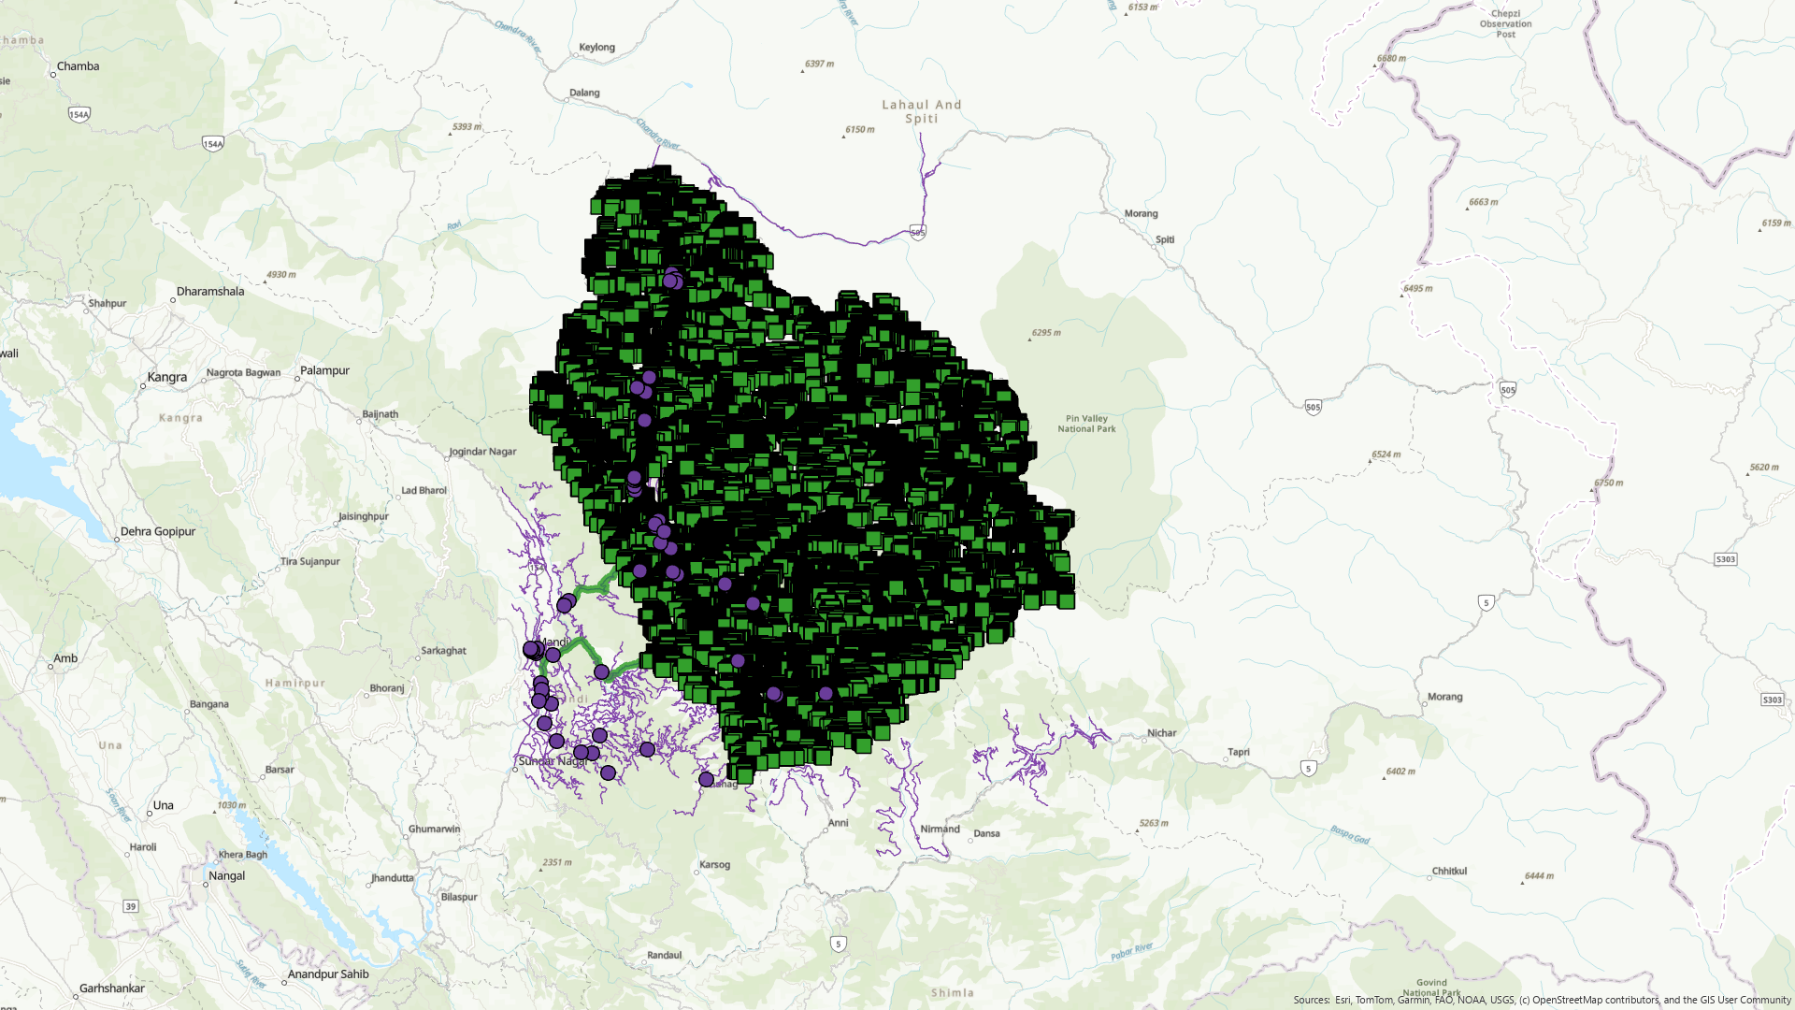
Figure 2. ArcGIS map output showing the emergency routing result generated from the workflow.
Table 5. Graph outputs generated for reporting and presentation.
Graph Output | Purpose
01_flood_risk_distribution.png | Flood risk by polygon count and flood-risk area
02_road_status_distribution.png | Road status by count and total road length
03_vehicle_passability.png | Passable vs impassable roads by vehicle type
04_flood_depth_distribution.png | Road segment distribution by flood-depth band
05_safe_speed_distribution.png | Road safe-speed distribution by count and length
06_service_area_coverage.png | Area reachable within each service-time band
07_emergency_route_distribution.png | Distribution of route time and route length
08_optimal_center_summary.png | Existing vs new centers and candidate selection
09_depth_vs_safe_speed.png | Scatter relation between flood depth and safe speed
10_summary_dashboard.png | Compact dashboard of key project outcomes

7. Current Example Result: Safe Speed Distribution
Based on the current reported run, the safe-speed classification of road segments shows a strong bimodal pattern: most of the network is either effectively dry or highly usable, or entirely impassable under the modeled flood conditions. Intermediate speed classes account for very few segments and very little total road length. This pattern is consistent with a terrain-controlled flood setting in which many road segments remain unaffected while others become rapidly non-traversable once inundation exceeds critical thresholds.
Table 6. Current reported road safe-speed distribution from the analysis run.
Safe Speed Class | Segment Count | Road Length (km) | Interpretation
60-87 km/h | 963 | 695.51 | Near-normal operational mobility
40-60 km/h | 0 | 0.00 | No roads in this moderate reduction band
20-40 km/h | 3 | 0.47 | Very limited moderate-speed operation
10-20 km/h | 1 | 1.17 | Severely reduced but still technically passable
0-10 km/h | 0 | 0.00 | No roads in critical low-speed band
0 km/h | 948 | 1301.03 | Impassable roads under modeled depth
TOTAL | 1915 | 1998.18 | Total assessed network in current summary
The dominant analytical implication of this result is that emergency planning should focus on two simultaneous priorities: preserving access along the still-functional high-speed corridor segments, and developing contingency routing or facility relocation strategies for the large share of road length that falls into the 0 km/h class. Because the intermediate classes are sparse, the system behaves less like a gradual slowdown network and more like a mixed network of passable corridors and blocked segments.

8. Figures and Analytical Graphs
This section compiles the generated map image and all graph outputs as embedded figures. These figures are intended to support technical interpretation, management reporting, and presentation delivery. Because the figures are embedded directly into the Word file, they can be rearranged, resized, replaced, or caption-edited as needed.
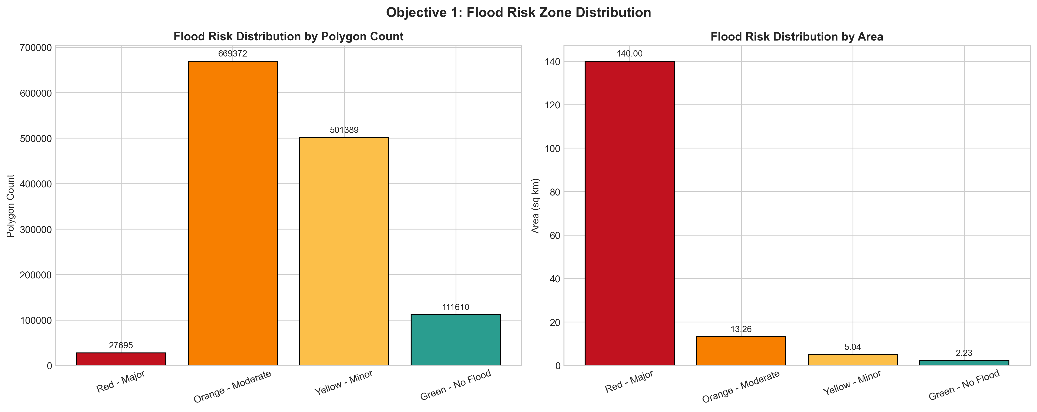
Figure 3. Flood risk distribution by polygon count and areal extent.
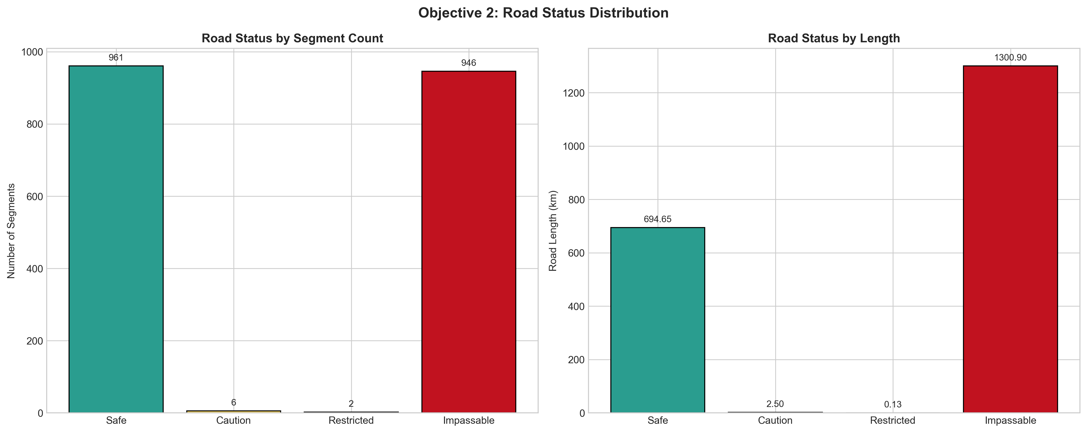
Figure 4. Road status distribution by segment count and road length.
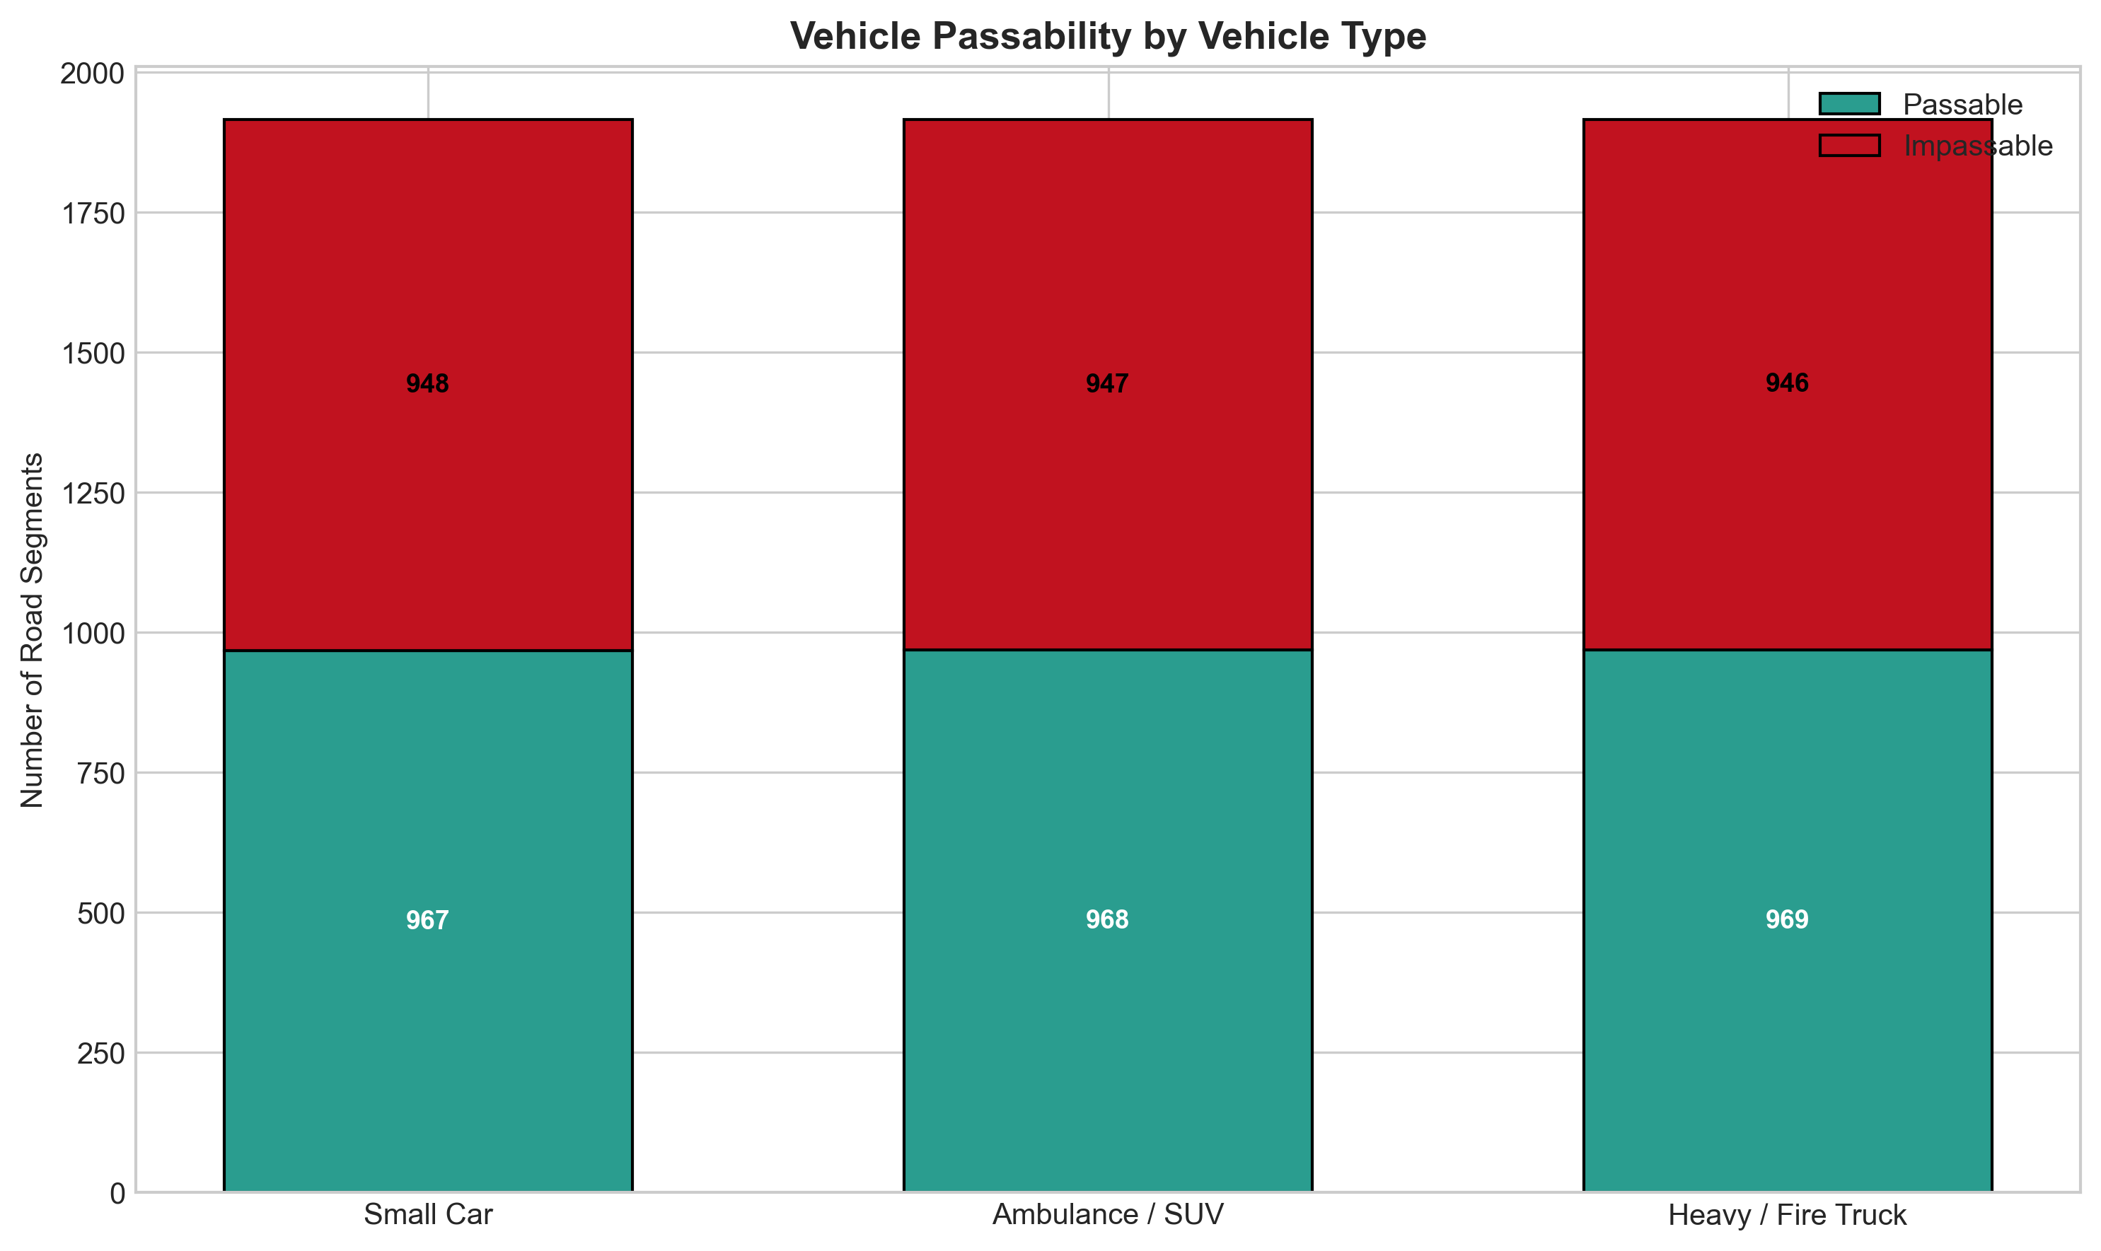
Figure 5. Vehicle passability comparison for small cars, ambulances, and heavy vehicles.
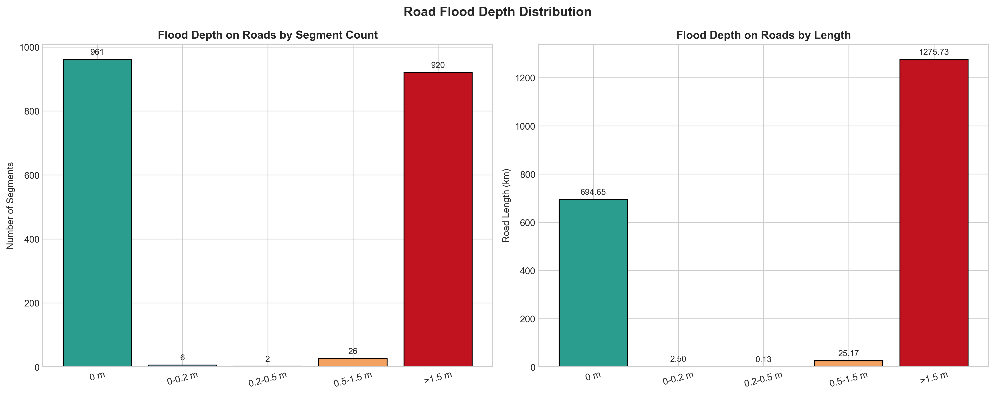
Figure 6. Road-flood-depth distribution by segment count and road length.
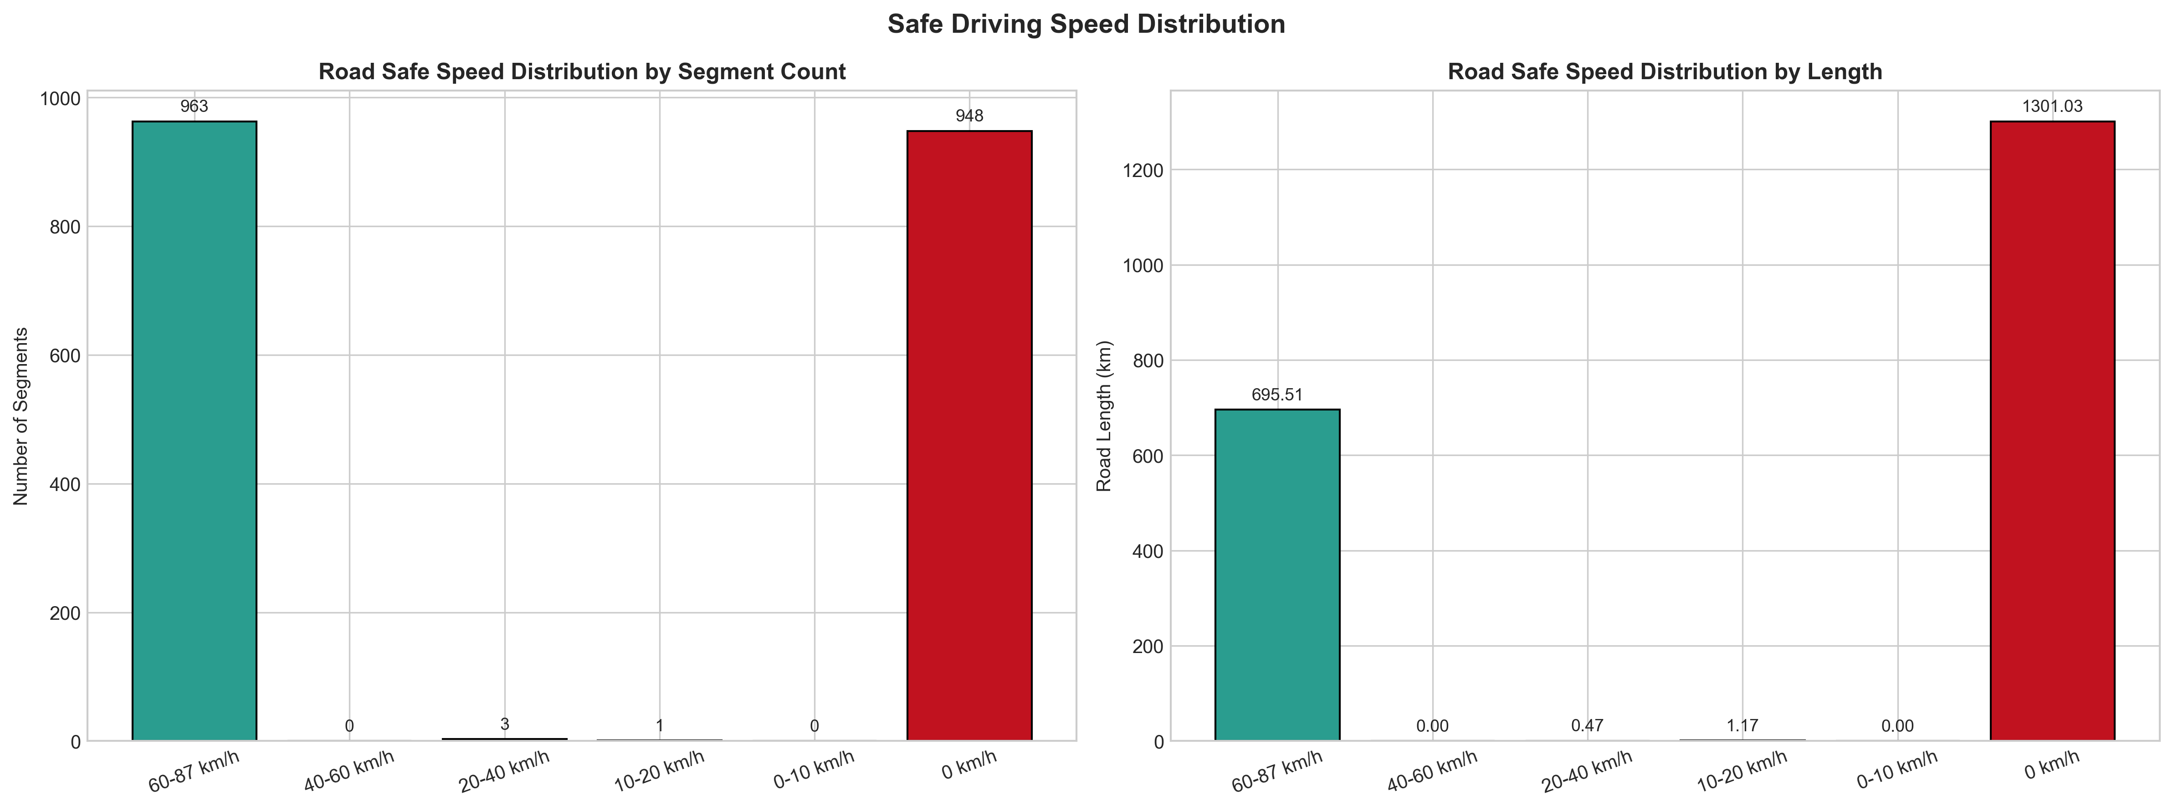
Figure 7. Safe-speed distribution by segment count and road length.
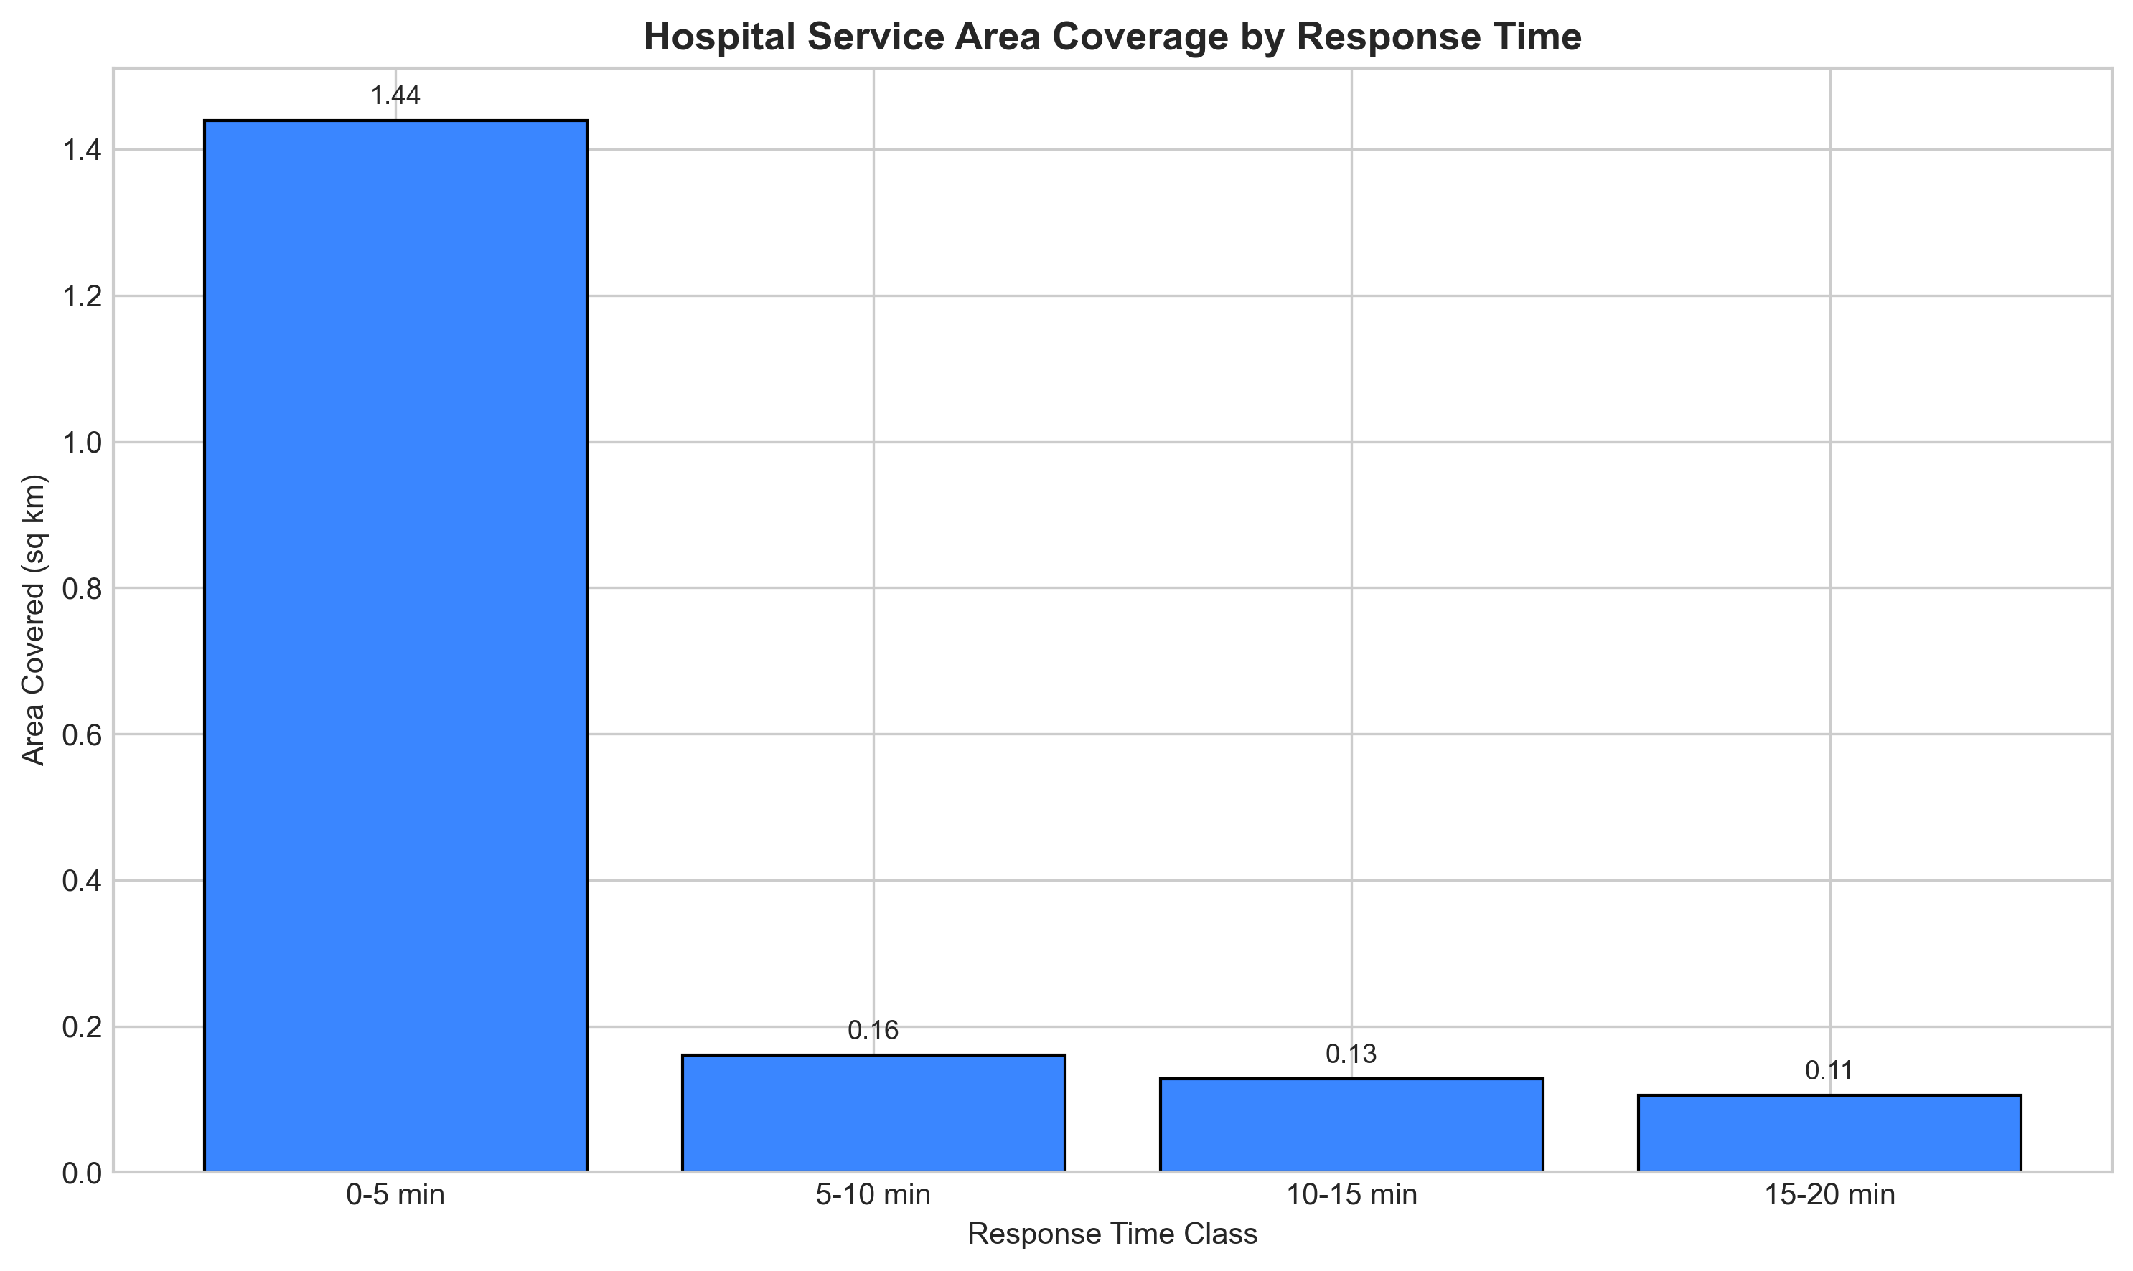
Figure 8. Hospital service-area coverage across response-time bands.
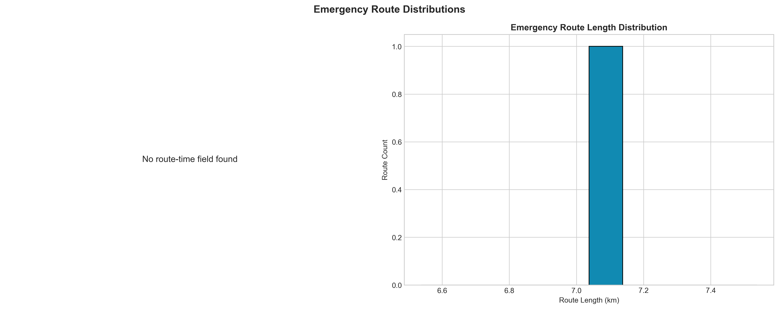
Figure 9. Distribution of emergency-route travel time and route length.
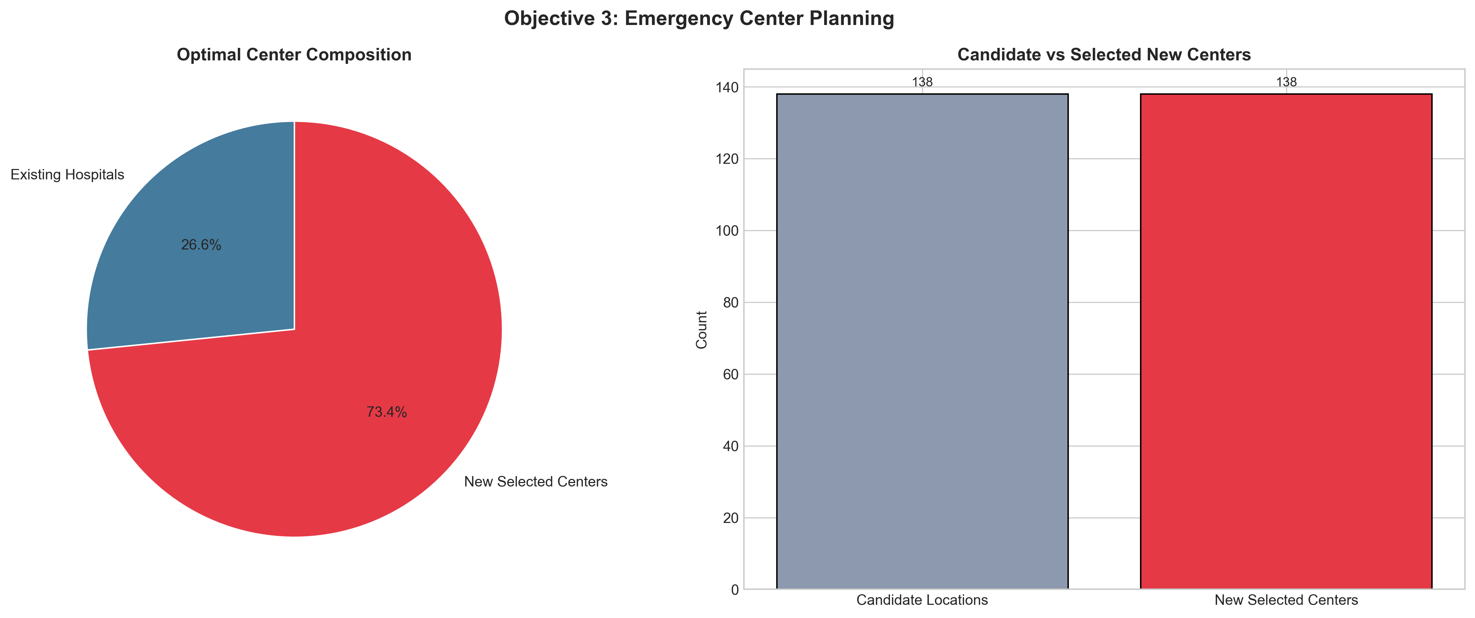
Figure 10. Summary of candidate locations, existing hospitals, and selected optimal centers.
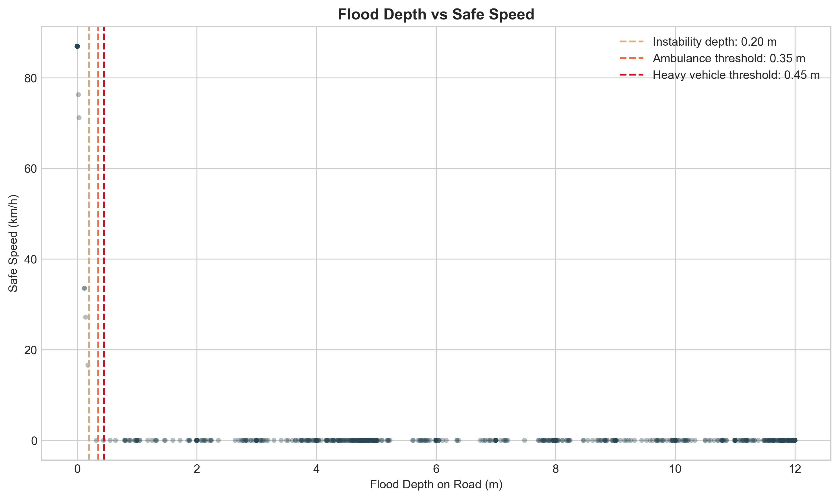
Figure 11. Scatter relation between flood depth and safe speed.
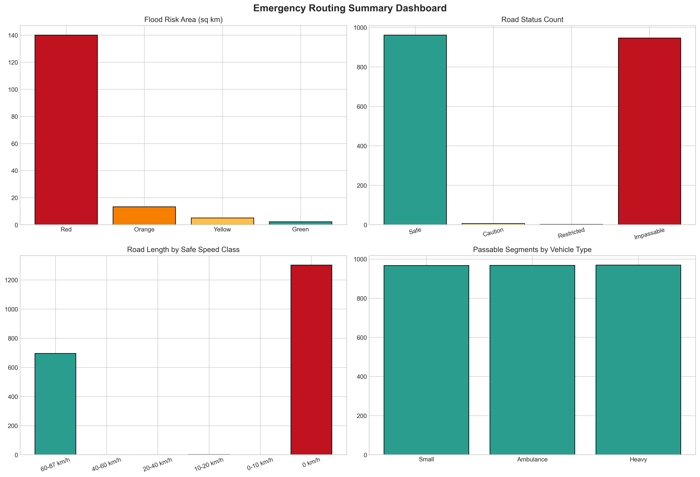
Figure 12. Summary dashboard of the principal analytical outputs.

9. Reproducible Procedure in ArcGIS Pro
The workflow is intended to be run in ArcGIS Pro Notebook with an active map open. The recommended operational sequence is straightforward but should be followed carefully. First, the user should verify that all hard-coded paths point to valid folders and that the DEM is available at the expected location. Second, Spatial Analyst and Network Analyst licenses should be confirmed. Third, the scripts should be run in sequence starting with `01_HAND_Flood_Mapping.py`, followed by `02_Download_Data.py`, then `03_Emergency_Routing.py`. After the analytical outputs are created, the user may run `04_Visualize_Results.py` for map export and `05_Generate_Graphs.py` for graph export.
- Open ArcGIS Pro, open the project, and ensure that a map view is active.
- Check that Spatial Analyst and Network Analyst are available.
- Verify the key paths for the workspace, DEM, and graph output directory.
- Run 01_HAND_Flood_Mapping.py to generate the flood-depth and HAND outputs.
- Run 02_Download_Data.py to prepare the roads and hospitals.
- Run 03_Emergency_Routing.py to generate risk zones, road vulnerability, routes, service areas, and optimal centers.
- Run 04_Visualize_Results.py if map symbology, PDF export, and labeled map output are needed.
- Run 05_Generate_Graphs.py to save all statistical figures to D:\Internship\hand\graph.

10. Principal Outputs
The workflow produces raster outputs, feature-class outputs, cartographic exports, and graph exports. Rasters include flood-depth and safe-speed surfaces. Feature classes include flood risk polygons, road-vulnerability results, route lines, service-area polygons, candidate locations, selected emergency centers, and allocation lines. These outputs together form both an analytical archive and a communication package.
- Raster outputs: HAND rasters, flood-depth rasters, flood-risk raster, safe-speed raster, and speed-class raster.
- Feature outputs: Flood_Risk_Zones, Road_Vulnerability, Traversable_Roads, Restricted_Roads, Blocked_Roads, Emergency_Routes, Hospital_Service_Areas, Candidate_Locations, Optimal_Emergency_Centers, and Allocation_Lines.
- Presentation outputs: exported ArcGIS map PNG/PDF and the graph PNG files.

11. Technical Strengths
The developed framework is strong in several ways. It integrates raster hydrology with network analysis, translates flood hazard into mobility impact, distinguishes passability for different vehicle types, and supports both tactical response planning and strategic facility planning. The workflow is also modular, which means that any improved DEM, flood raster, or infrastructure dataset can be substituted without redesigning the whole framework.

12. Limitations
Despite its practical value, the implementation also has clear limitations. The current flood surface is produced using a HAND-based surrogate approach rather than a fully dynamic hydraulic model. The methodology notes the importance of flood velocity, but the implemented scripts do not yet use a velocity raster directly in the road classification. The safe-speed relation is borrowed from published empirical work rather than calibrated using local responder vehicle tests. OpenStreetMap completeness can also vary across rural mountain settings. These factors should be acknowledged when presenting results as operational guidance.

13. Future Scope
Future improvements could incorporate MIKE+ outputs for flood depth, extent, and velocity; combine road flood risk with bridge vulnerability and landslide susceptibility; introduce population-weighted demand points; validate depth thresholds with local emergency responders; and export summary statistics automatically to spreadsheet-ready formats. Additional layout automation for publication-grade maps and automated generation of annex tables would further strengthen the reporting side of the workflow.

14. Conclusion
This ArcGIS Pro workflow forms a complete analytical chain from terrain-derived flood mapping to emergency response support. Its main value lies in connecting flood depth to operational mobility: which roads are still usable, which vehicles can traverse them, how fast emergency teams can move, which affected areas remain reachable in time, and where new emergency-service facilities should ideally be located. For a hazard-prone Himalayan basin such as Kullu Valley, this makes the framework not only a technical GIS exercise but a decision-support tool for flood preparedness, emergency management, and resilient infrastructure planning.

15. References and Source Basis
The workflow implementation and documentation draw on the internal project brief, the ArcGIS Pro scripts in this repository, and methodological references embedded in those scripts, including the Pregnolato et al. depth-disruption function for safe-speed estimation and published flood-depth stability thresholds for vehicles. Formal academic reference formatting can be added later if a thesis, report, or journal-style bibliography is required.

