Term Project Report on

Spatiotemporal Assessment and Simulation of Land Use
and Land Cover Dynamics Using CA-ANN Modelling

by

Ankit Kumar
(Roll No: 25AG62R05)

Under the Supervision of

Dr. Rajib Maity

Department of Civil Engineering
Indian Institute of Technology Kharagpur
Kharagpur 721302

April 2026

1 Introduction
Land use and land cover (LULC) change is one of the most significant indicators of human interaction with the natural environment. Rapid urbanization, agricultural expansion, deforestation, and industrialization have led to substantial transformations in land surface characteristics across the globe. Understanding these changes is critical for sustainable development, environmental conservation, urban planning, and resource management. Remote sensing and Geographic Information System (GIS) technologies have made it possible to monitor LULC changes over large spatial and temporal scales with high accuracy.
While traditional LULC change detection methods effectively reveal historical patterns, they are limited in their ability to project future scenarios. Simulation models that integrate spatial dynamics with machine learning techniques have emerged as powerful tools for predicting future land-use configurations. Among these, the Cellular Automata-Artificial Neural Network (CA-ANN) framework has gained prominence due to its ability to combine the spatial neighborhood effects captured by Cellular Automata with the nonlinear pattern recognition capabilities of Artificial Neural Networks (Li & Yeh, 2002).
This project is based on the methodology described by Chen et al. (2018), who applied a CA-ANN model to simulate and predict LULC dynamics in Guiyang, China, using nine driving factors and LULC maps from 2007 to 2022, achieving a hindcast accuracy of 84.42% and a Kappa coefficient of 0.73 (Cohen, 1960). The present project adapts this methodology to the Kharagpur region, West Bengal, India, using freely available satellite data from Google Earth Engine (Gorelick et al., 2017) and an entirely Python-based processing pipeline.
The CA-ANN framework used in this study operates in two complementary stages. The ANN component learns the complex, nonlinear relationships between LULC transitions and multiple spatial driving factors such as spectral characteristics, topography, nighttime lights, and proximity to key land features. The CA component then incorporates local neighborhood effects to simulate spatially realistic land-use transitions. Together, they produce future LULC maps that reflect both data-driven suitability and spatial contiguity.
2 Motivation and Objectives
The Kharagpur region in West Bengal has experienced noticeable urban growth and land transformation in recent years. The presence of the Indian Institute of Technology Kharagpur, expanding residential areas, and evolving agricultural practices have contributed to significant changes in the local landscape. Understanding the patterns and drivers of these changes is essential for informed decision-making regarding urban planning, agricultural sustainability, and ecological preservation.
Conventional LULC mapping provides a snapshot of the current state, but does not offer insight into future trajectories. Predictive modelling using CA-ANN (Li & Yeh, 2002; Chen et al., 2018) addresses this gap by leveraging historical transition patterns and spatial drivers to generate plausible future scenarios. This approach is particularly relevant for rapidly developing regions where proactive planning can mitigate adverse environmental impacts.
Taking into account the overall perspective, the following objectives are set for this study:
- To acquire and process multi-temporal LULC maps and spatial predictor layers for the Kharagpur region using Google Earth Engine.
- To analyze historical LULC changes between 2017 and 2023, identifying major transition trends and area statistics.
- To train a Multi-Layer Perceptron (MLP) neural network on observed LULC transitions and 16 spatial driving factors.
- To validate the CA-ANN model through hindcast simulation of the 2023 LULC map and comparison with the observed 2023 map.
- To simulate future LULC for 2026 and assess the projected land transformation patterns, with emphasis on built-up expansion and cropland dynamics.
3 Study Area
The study area is centered on the Kharagpur region in the Paschim Medinipur district of West Bengal, India. The bounding box spans from 87.20°E to 87.45°E longitude and 22.20°N to 22.45°N latitude, covering an approximate area of 25 × 25 km (~625 km²). This region encompasses the urban core of Kharagpur city, the campus of the Indian Institute of Technology Kharagpur, surrounding agricultural lands, forested patches, water bodies, and rural settlements.
Kharagpur is situated in the sub-tropical climatic zone with distinct wet and dry seasons. The landscape is characterized by a mix of cropland (predominantly rice paddies), scattered tree cover, built-up areas, and seasonal water bodies. The region has witnessed steady urban expansion driven by institutional growth, transportation infrastructure, and commercial activities, making it a suitable candidate for studying LULC dynamics and urban-rural transition patterns.
The study area was deliberately selected to match the institutional context of this project and to provide a manageable yet representative case study for applying the CA-ANN modelling framework.
4 Data and Materials
All data used in this study were obtained from Google Earth Engine (GEE), a cloud-based geospatial analysis platform (Gorelick et al., 2017). No manual data downloads or GIS desktop software were required. The data sources and predictor variables are described below.
4.1 LULC Data
Land use and land cover maps were derived from Google Dynamic World V1 (Brown et al., 2022), a near real-time global LULC dataset based on Sentinel-2 imagery (Drusch et al., 2012) with 10 m resolution. Annual mode composites were generated for three time periods: 2017 (t₀), 2020 (t₁), and 2023 (t₂). The dataset provides nine LULC classes: Water, Trees, Grass, Flooded Vegetation, Crops, Shrub and Scrub, Built-up, Bare Ground, and Snow/Ice.
4.2 Predictor Variables
A total of 16 predictor bands were compiled for each time period to serve as driving factors for the ANN model. These include:
Category | Variables | Source
Spectral Bands (6) | Blue (B2), Green (B3), Red (B4), NIR (B8), SWIR1 (B11), SWIR2 (B12) | Sentinel-2 SR Harmonized
Spectral Indices (3) | NDVI, NDBI, MNDWI | Computed from Sentinel-2
Topographic (3) | Elevation, Slope, Aspect | SRTM DEM (Farr et al., 2007)
Socioeconomic (1) | Nighttime Light Intensity | VIIRS (Elvidge et al., 2017)
Distance (3) | Distance to Built-up, Forest, Water | Computed from LULC
Table 1: Summary of predictor variables used in the CA-ANN model
4.3 Software and Tools
The entire pipeline was implemented in Python 3 as a single unified script (gee_ca_ann_python_pipeline.py). Key libraries include: Google Earth Engine Python API (Gorelick et al., 2017) for cloud-based data extraction, scikit-learn (Pedregosa et al., 2011) for the MLP neural network, NumPy and SciPy for raster processing and CA neighborhood computations, Rasterio for GeoTIFF I/O, and Matplotlib for visualization. No GIS desktop software (QGIS, ArcGIS) was used.
5 Methodology
The methodology follows a CA-ANN framework adapted from Chen et al. (2018), implemented entirely in Python. The workflow consists of data acquisition, ANN training, CA-based simulation, validation, and future prediction.
5.1 Data Acquisition and Preprocessing
LULC maps and predictor layers were fetched from Google Earth Engine (Gorelick et al., 2017) using the Earth Engine Python API. For each year, Sentinel-2 Surface Reflectance imagery (Drusch et al., 2012) was composited using the median reducer with cloud masking applied. Spectral indices (NDVI, NDBI, MNDWI) were computed from the composite bands. Static drivers (elevation, slope, aspect from SRTM (Farr et al., 2007); nighttime lights from VIIRS (Elvidge et al., 2017)) were extracted once and applied to all time periods. Distance rasters were computed from the LULC maps using the cumulativeCost function in GEE. All rasters were downloaded as GeoTIFF files at 30 m resolution using chunked HTTP downloads.
5.2 ANN Training
The Artificial Neural Network was trained on the observed LULC transition from t₀ (2017) to t₁ (2020). For each pixel, the feature vector comprised 16 predictor bands from the source year plus the "from" LULC class, yielding 17 input features. The target variable was the LULC class at t₁. Up to 200,000 valid pixels were randomly sampled and split into 70% training and 30% validation sets using stratified sampling.
The MLP classifier (Pedregosa et al., 2011) was configured with three hidden layers of 128, 128, and 64 neurons, ReLU activation function, Adam optimizer, and a maximum of 500 iterations. Early stopping was enabled with a validation fraction of 0.15 and a patience of 20 epochs. Feature standardization was performed using StandardScaler. The model outputs class probability estimates that serve as suitability scores in the CA step.
5.3 Cellular Automata Simulation
The CA component simulates spatial LULC transitions by combining three factors in a weighted scheme, following the approach of Li and Yeh (2002):
- Suitability Score (weight = 0.65): The ANN-predicted probability for each class at each pixel, reflecting the data-driven likelihood of transition.
- Neighborhood Influence (weight = 0.30): The fraction of each LULC class within a 5×5 pixel neighborhood, capturing spatial contiguity and clustering effects.
- Stochastic Perturbation (weight = 0.05): Gumbel-distributed random noise added to introduce realistic spatial variation and prevent overly deterministic outcomes.
The combined score for each class is computed as: S = 0.65 × P_ann + 0.30 × F_neighbor + 0.05 × Noise. A pixel transitions to the class with the highest combined score, subject to an inertia threshold of 0.45 that prevents transitions when the improvement over the current class is insufficient. This ensures spatial stability and avoids unrealistic conversions.
5.4 Hindcast Validation
The trained CA-ANN model was validated by simulating the t₂ (2023) LULC map from the t₁ (2020) state using t₂ predictors. The simulated 2023 map was compared pixel-by-pixel against the observed 2023 LULC map. Evaluation metrics include overall accuracy, Cohen’s Kappa coefficient (Cohen, 1960), per-class precision, recall, and F1-score, confusion matrix, ROC curves, and Precision-Recall curves.
5.5 Future Simulation
Future LULC for 2026 was simulated by applying iterative CA steps from the observed 2023 state. Each annual step recomputes the neighborhood fractions from the current simulated state and applies the CA rule with ANN suitability scores derived from 2023 predictors. Three iterations (2023→2024→2025→2026) were performed, and the final map represents the predicted 2026 LULC configuration.
6 Results and Discussion
6.1 Historical LULC Maps
The classified LULC maps for 2017, 2020, and 2023 reveal the spatial distribution of nine land cover classes across the Kharagpur study area. Cropland dominates the landscape across all three years, followed by tree cover and built-up areas. The maps clearly show the progressive expansion of built-up areas, particularly around the urban core of Kharagpur.
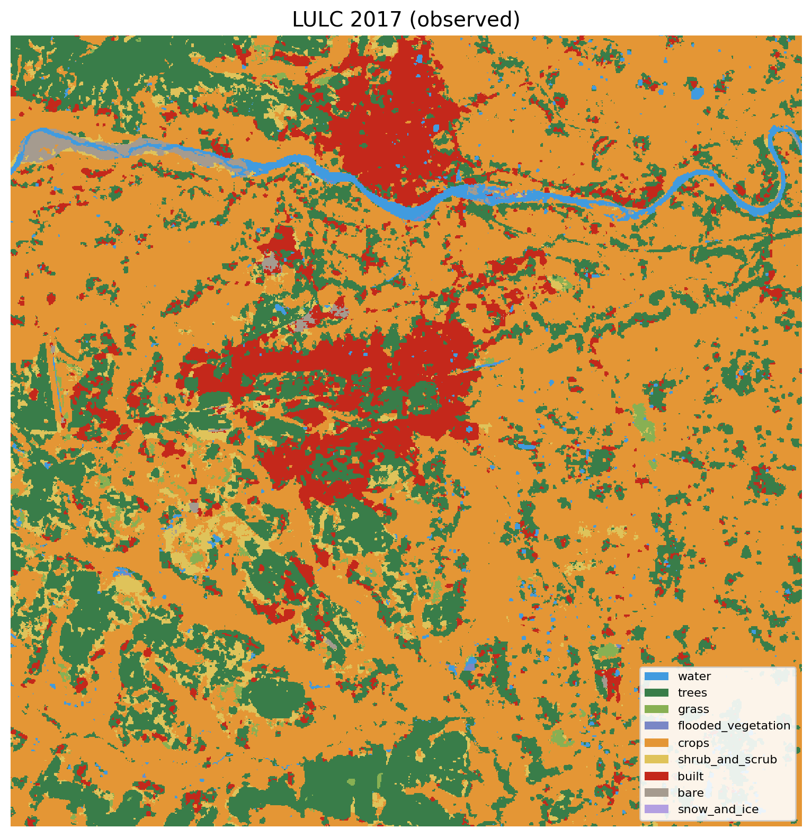
Figure 1: LULC classification map for 2017
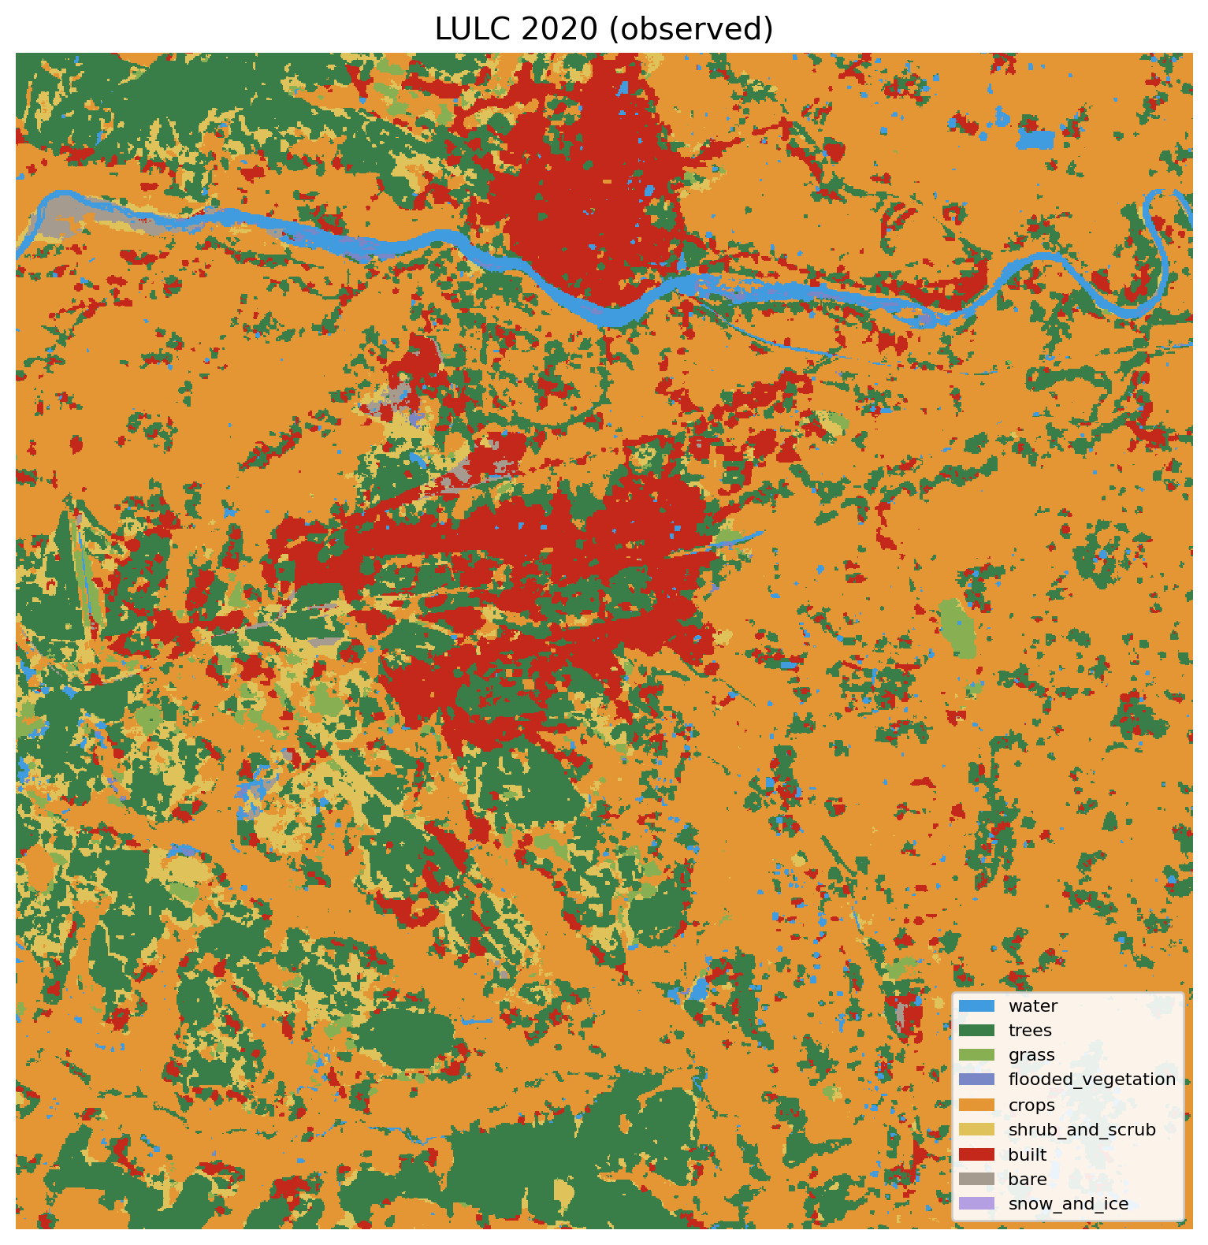
Figure 2: LULC classification map for 2020
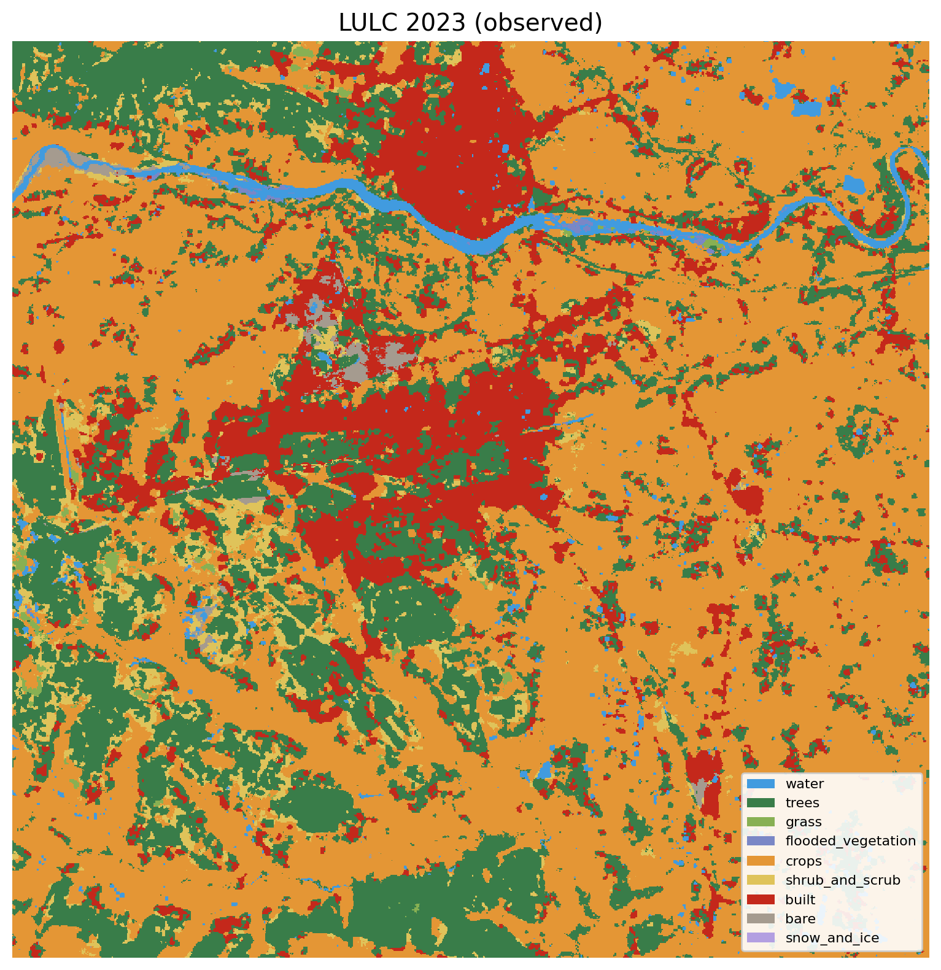
Figure 3: LULC classification map for 2023
6.2 LULC Area Statistics
Table 2 presents the area (in km²) occupied by each LULC class across the study period and the simulated 2026 prediction.
LULC Class | 2017 (km²) | 2020 (km²) | 2023 (km²) | 2026 Sim. (km²)
Water | 12.69 | 15.45 | 15.11 | 15.22
Trees | 170.66 | 167.56 | 165.95 | 164.60
Grass | 4.99 | 8.25 | 2.39 | 1.44
Flooded Vegetation | 0.34 | 1.17 | 0.87 | 0.12
Crops | 429.28 | 406.84 | 403.75 | 410.48
Shrub and Scrub | 24.70 | 33.26 | 24.91 | 21.05
Built-up | 71.33 | 82.85 | 101.19 | 101.27
Bare Ground | 4.53 | 3.14 | 4.35 | 4.34
Snow/Ice | 0.00 | 0.00 | 0.00 | 0.01
Table 2: LULC area statistics for all time periods (km²)
The most striking change is the expansion of built-up land from 71.33 km² in 2017 to 101.19 km² in 2023, representing a 41.9% increase over six years. This urban expansion occurred primarily at the expense of tree cover (declined from 170.66 to 165.95 km²), cropland (declined from 429.28 to 403.75 km²), and grassland (declined from 4.99 to 2.39 km²). Water bodies showed a slight increase, likely reflecting improved detection or seasonal variations.
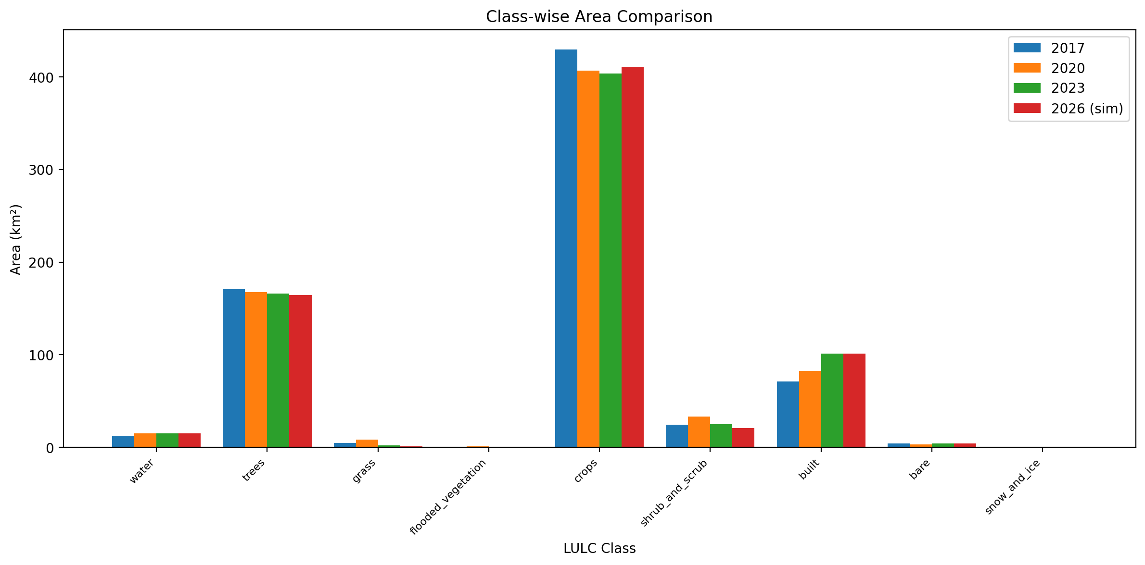
Figure 4: Comparison of LULC class areas across all time periods
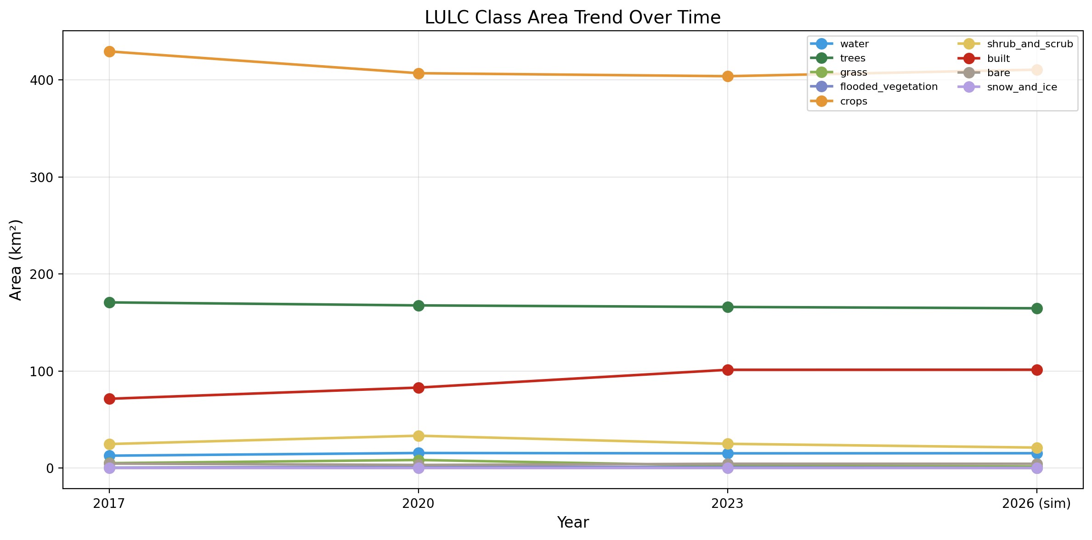
Figure 5: Temporal trends in LULC class areas (2017–2026)
6.3 Change Detection and Transition Analysis
Change detection maps and transition matrices provide detailed insight into the nature and magnitude of LULC conversions. The change detection map for the 2017–2023 period shows widespread spatial changes, concentrated along the fringes of the existing built-up area.
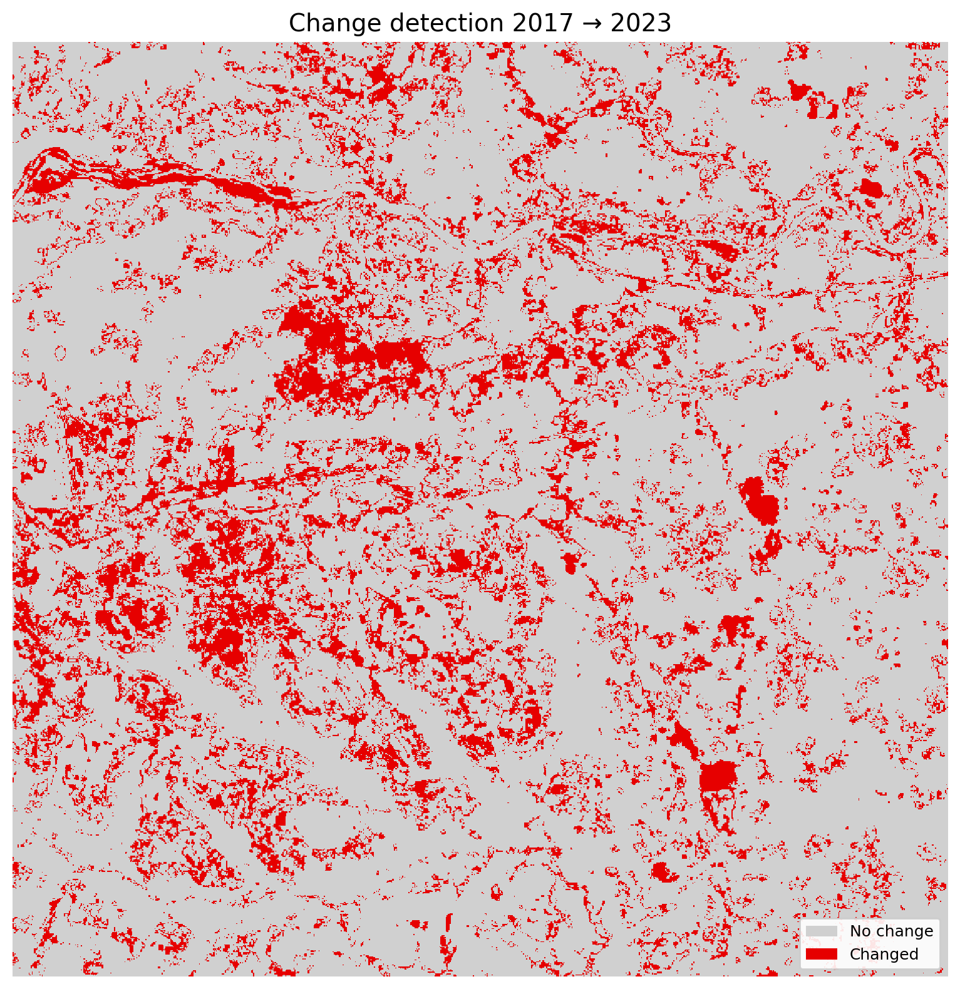
Figure 6: Change detection map for 2017–2023 (changed vs. unchanged pixels)
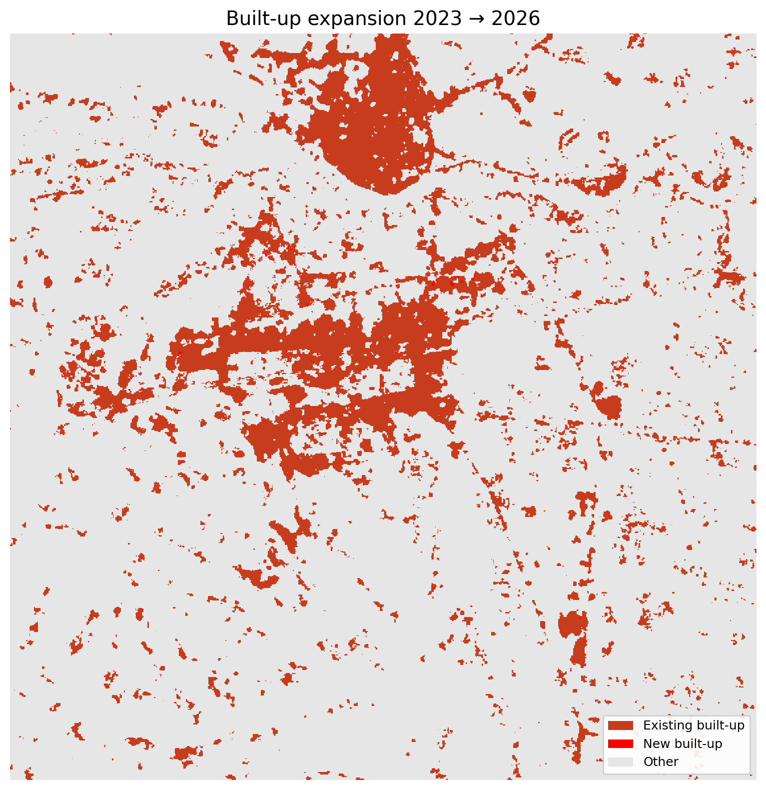
Figure 7: Built-up expansion map showing existing (2017) and new (2023) built-up areas
The transition matrices reveal that the dominant conversion pathways include: cropland to built-up, tree cover to built-up, and shrub/scrub to cropland. The built-up expansion map highlights that new built-up pixels are concentrated around existing urban areas, consistent with typical urban sprawl patterns.
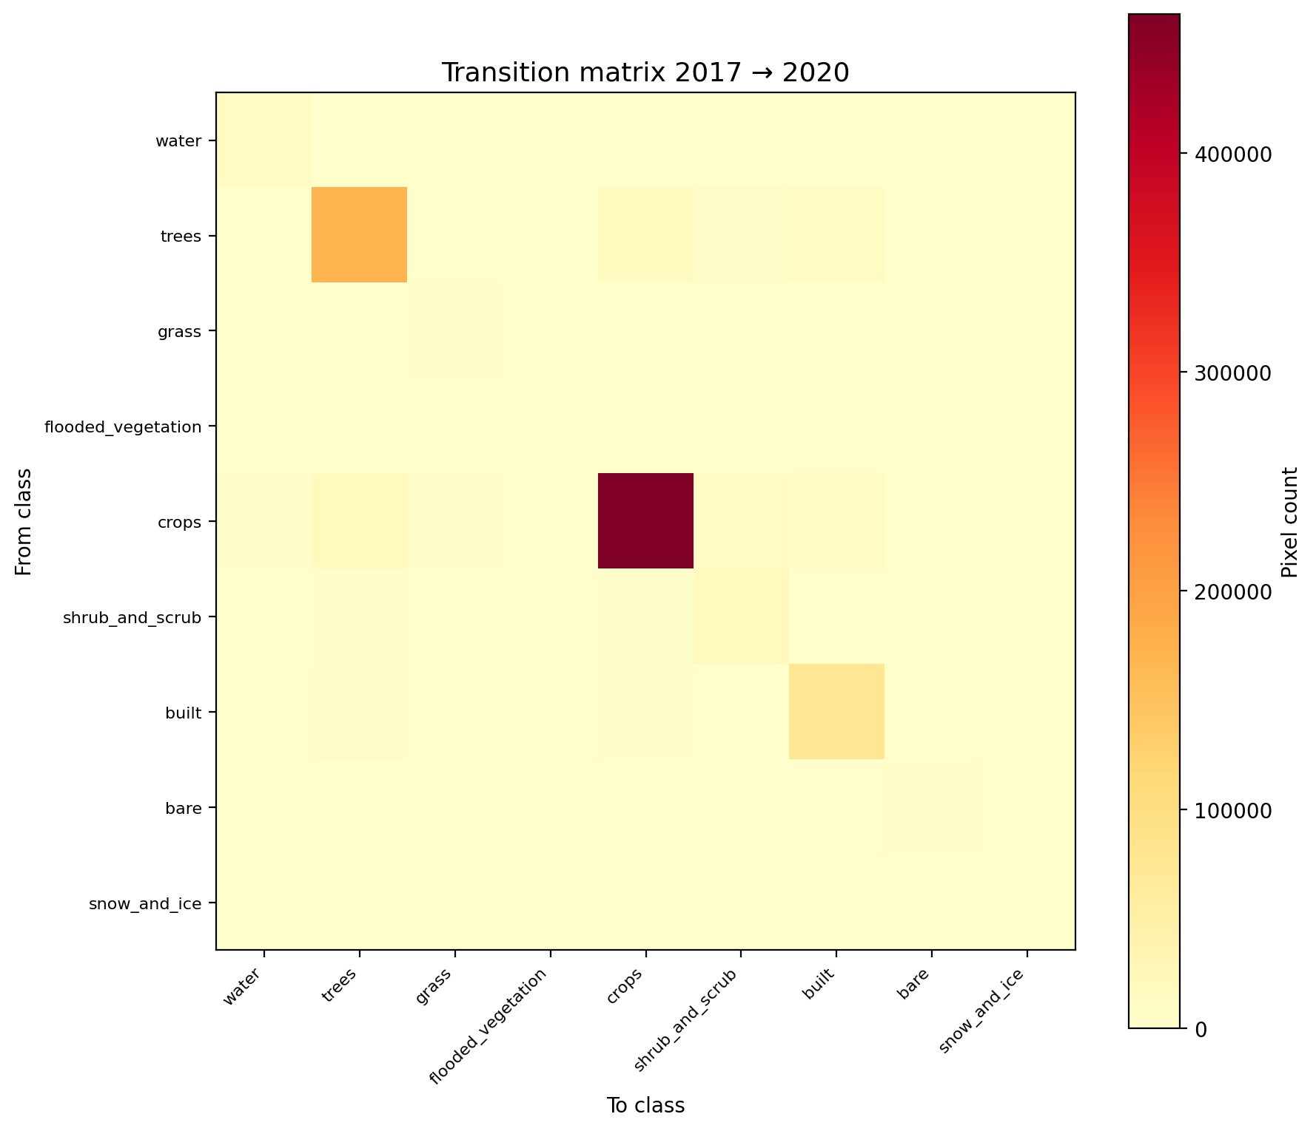
Figure 8: Transition matrix heatmap for 2017–2020
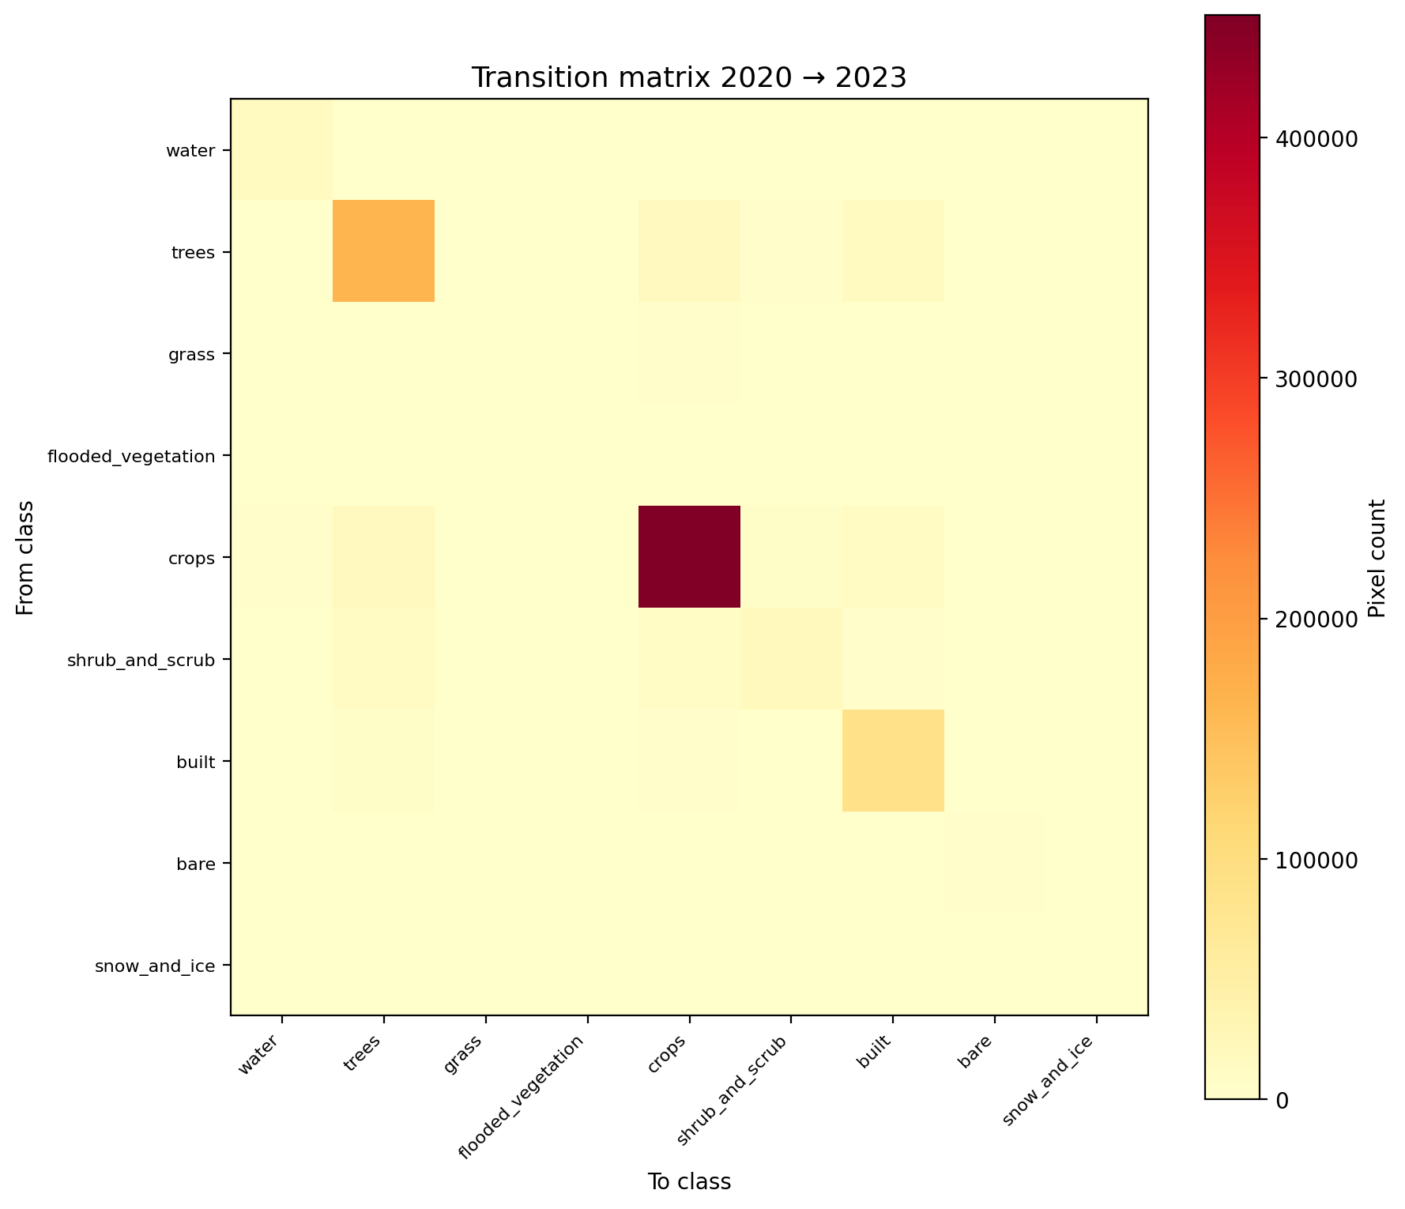
Figure 9: Transition matrix heatmap for 2020–2023
7 Validation and Model Performance
7.1 ANN Hold-out Validation
The ANN model achieved an overall accuracy of 86.84% and a Cohen’s Kappa coefficient of 0.7785 on the 30% hold-out validation set from the t₀→t₁ transition training. These metrics indicate substantial agreement between predicted and observed transitions. Per-class performance was highest for Crops (F1 = 0.928), Trees (F1 = 0.823), and Built-up (F1 = 0.810), while minority classes such as Flooded Vegetation (F1 = 0.202) and Grass (F1 = 0.271) showed lower performance due to limited training samples.
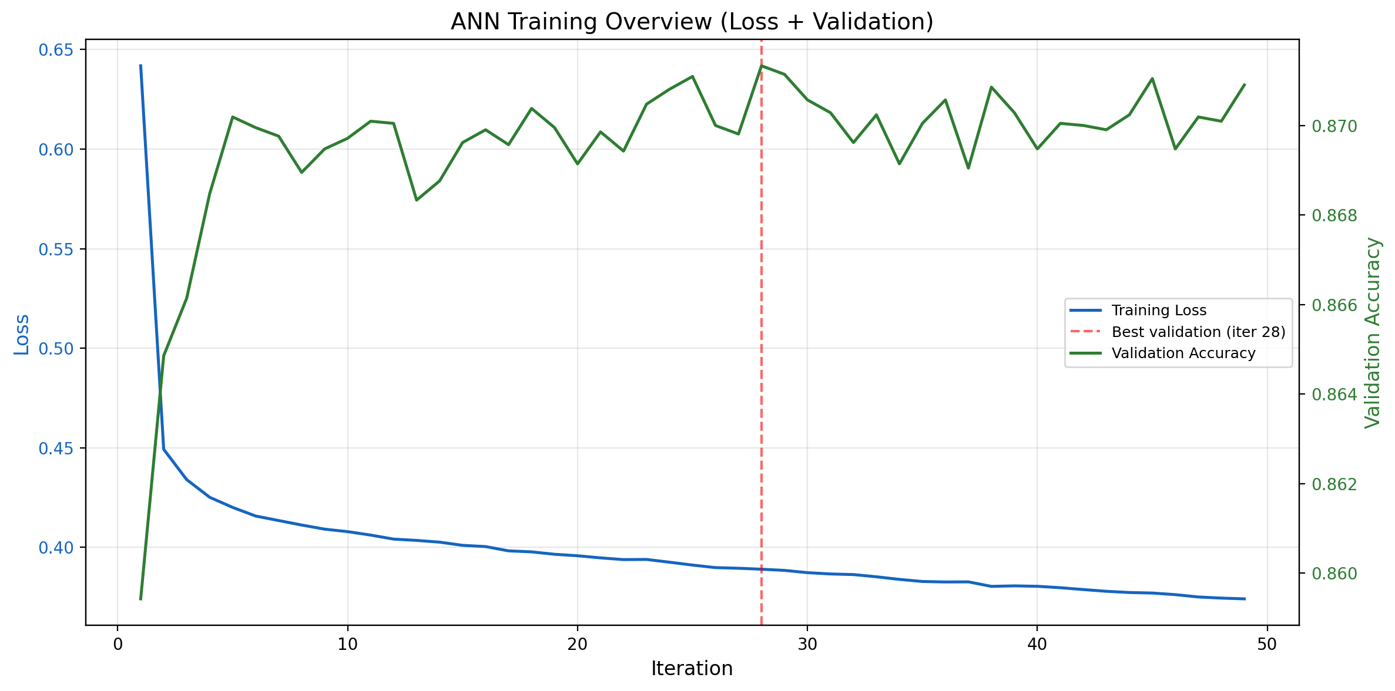
Figure 10: ANN training overview – loss curve and validation accuracy
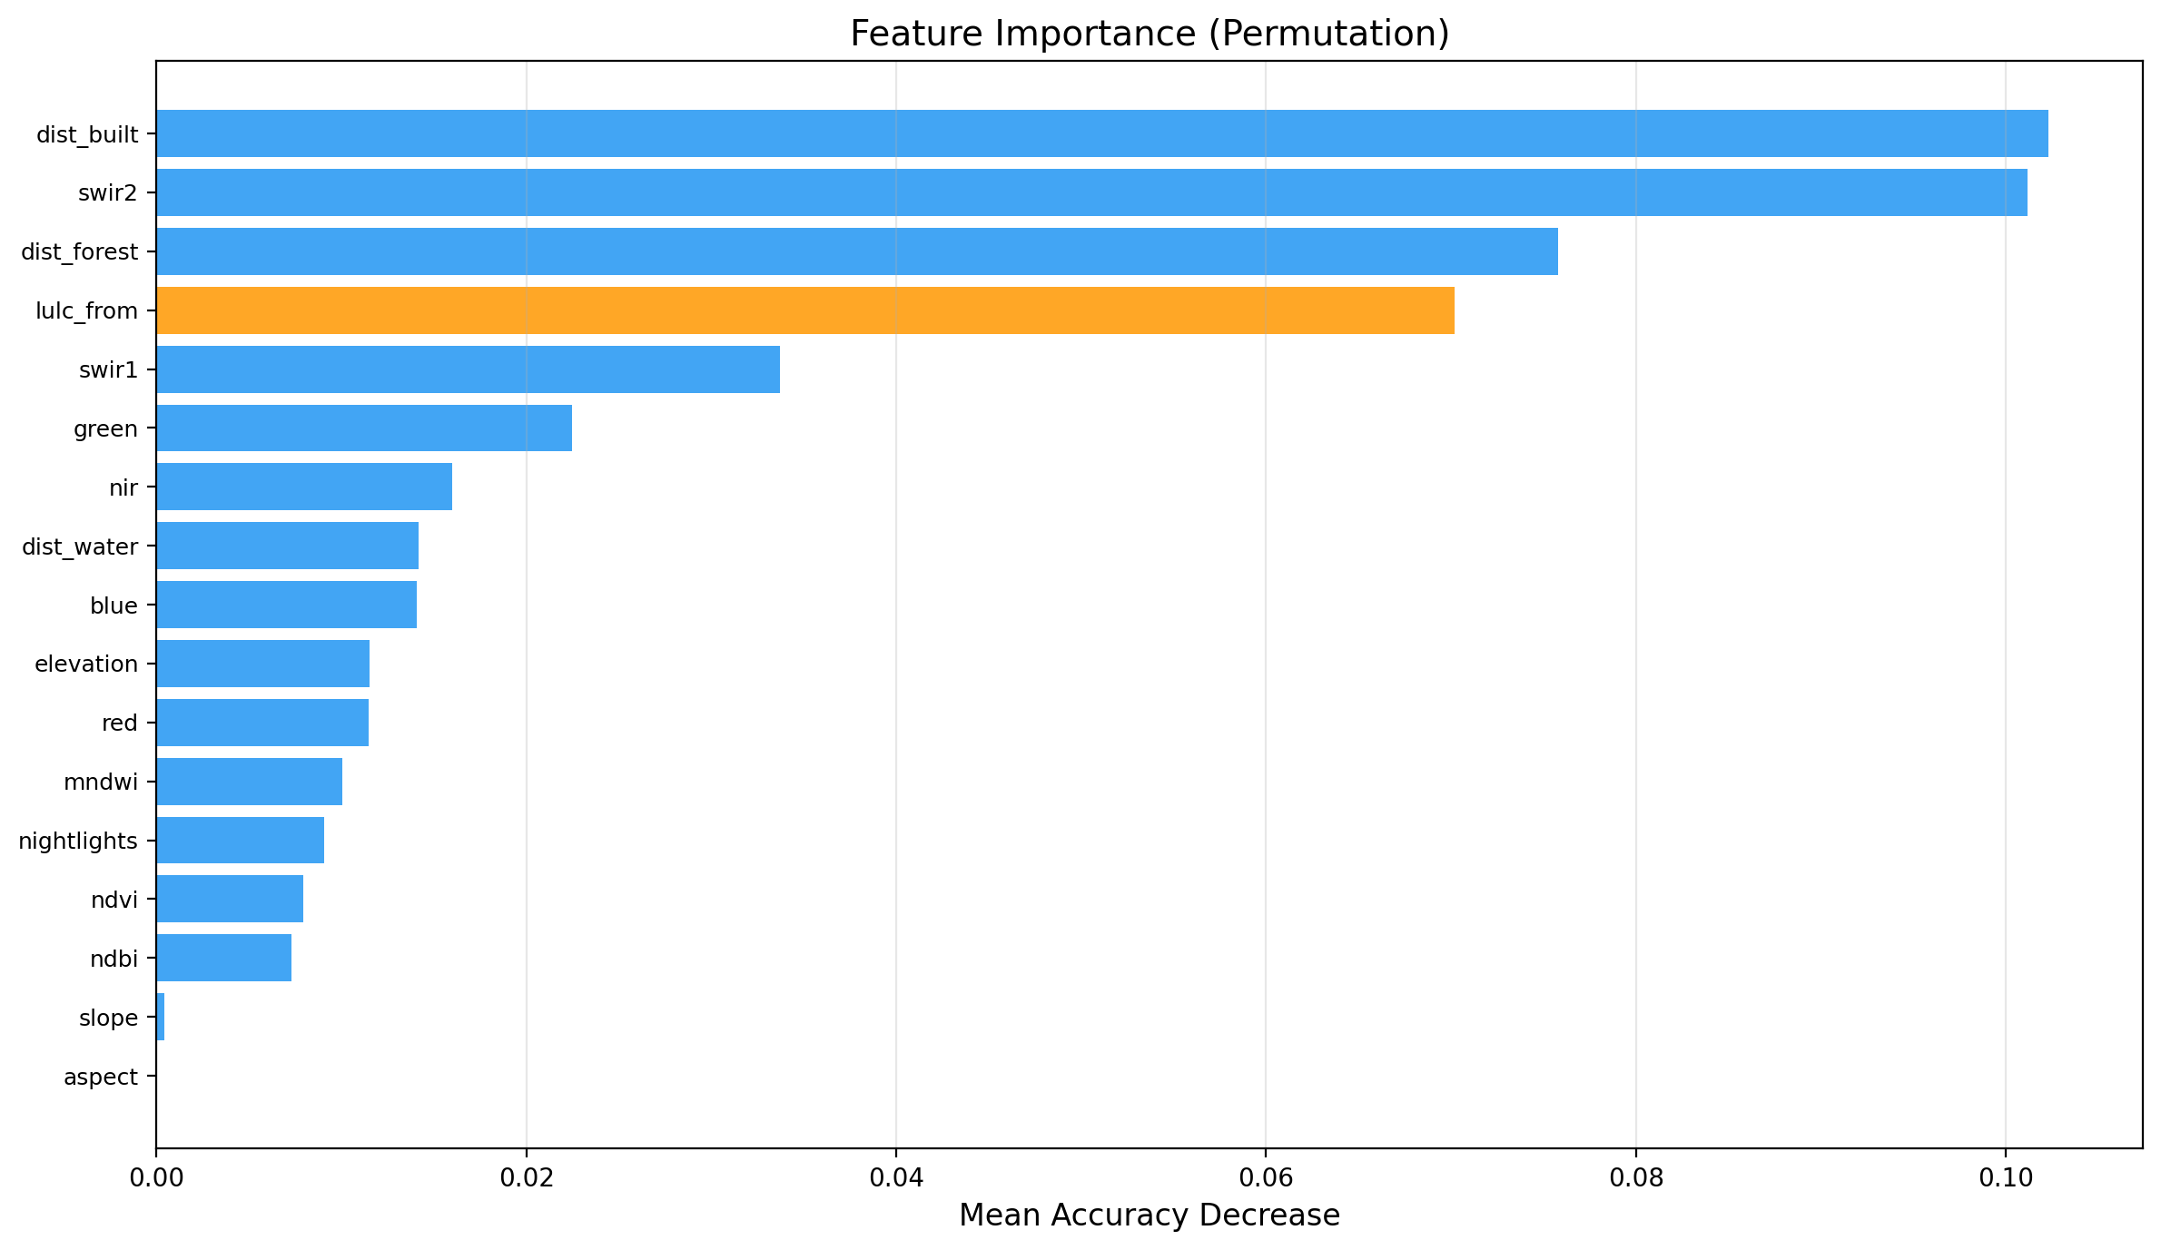
Figure 11: Permutation-based feature importance for the ANN model
Feature importance analysis reveals that the "from" LULC class is the most important predictor, followed by NDVI, elevation, and distance to built-up area. This confirms that land transition is strongly conditioned by the current land class and its environmental context.
7.2 Hindcast Validation (2023)
The CA-ANN model was used to simulate the 2023 LULC map from the 2020 state. Comparing the simulated map with the observed 2023 map yielded an overall accuracy of 86.26% and a Kappa coefficient (Cohen, 1960) of 0.7737. These results are comparable to the hindcast accuracy of 84.42% and Kappa of 0.73 reported by Chen et al. (2018), indicating that the adapted model performs well for the Kharagpur study area.
Metric | ANN Hold-out | Hindcast (2023) | Chen et al. (2018)
Overall Accuracy | 86.84% | 86.26% | 84.42%
Cohen’s Kappa | 0.7785 | 0.7737 | 0.73
Table 3: Comparison of validation metrics
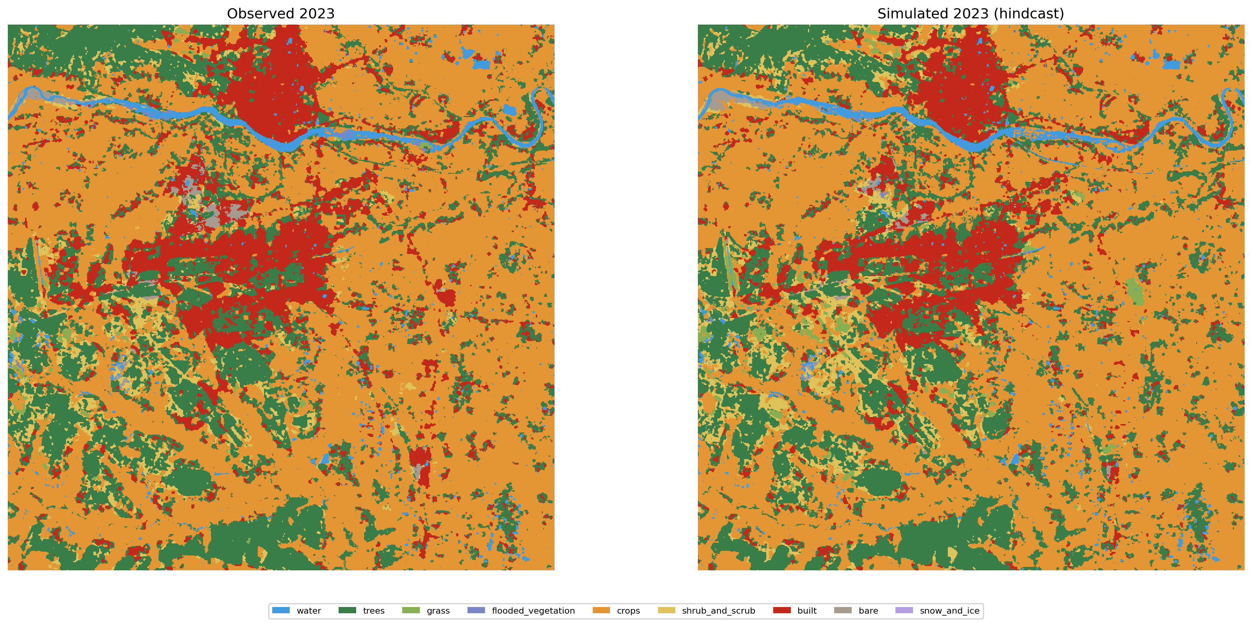
Figure 12: Comparison of observed vs. simulated LULC for 2023
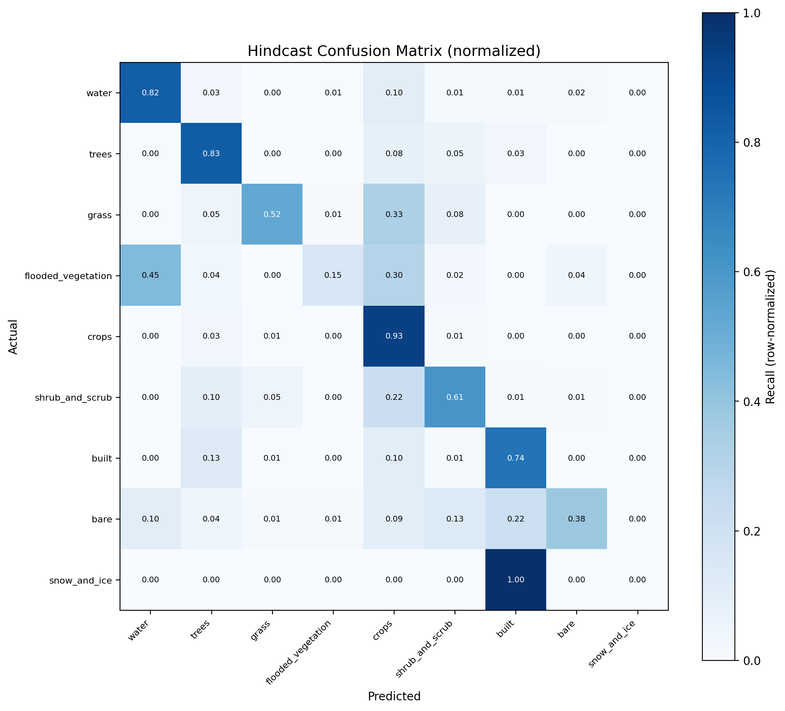
Figure 13: Normalized confusion matrix for hindcast validation
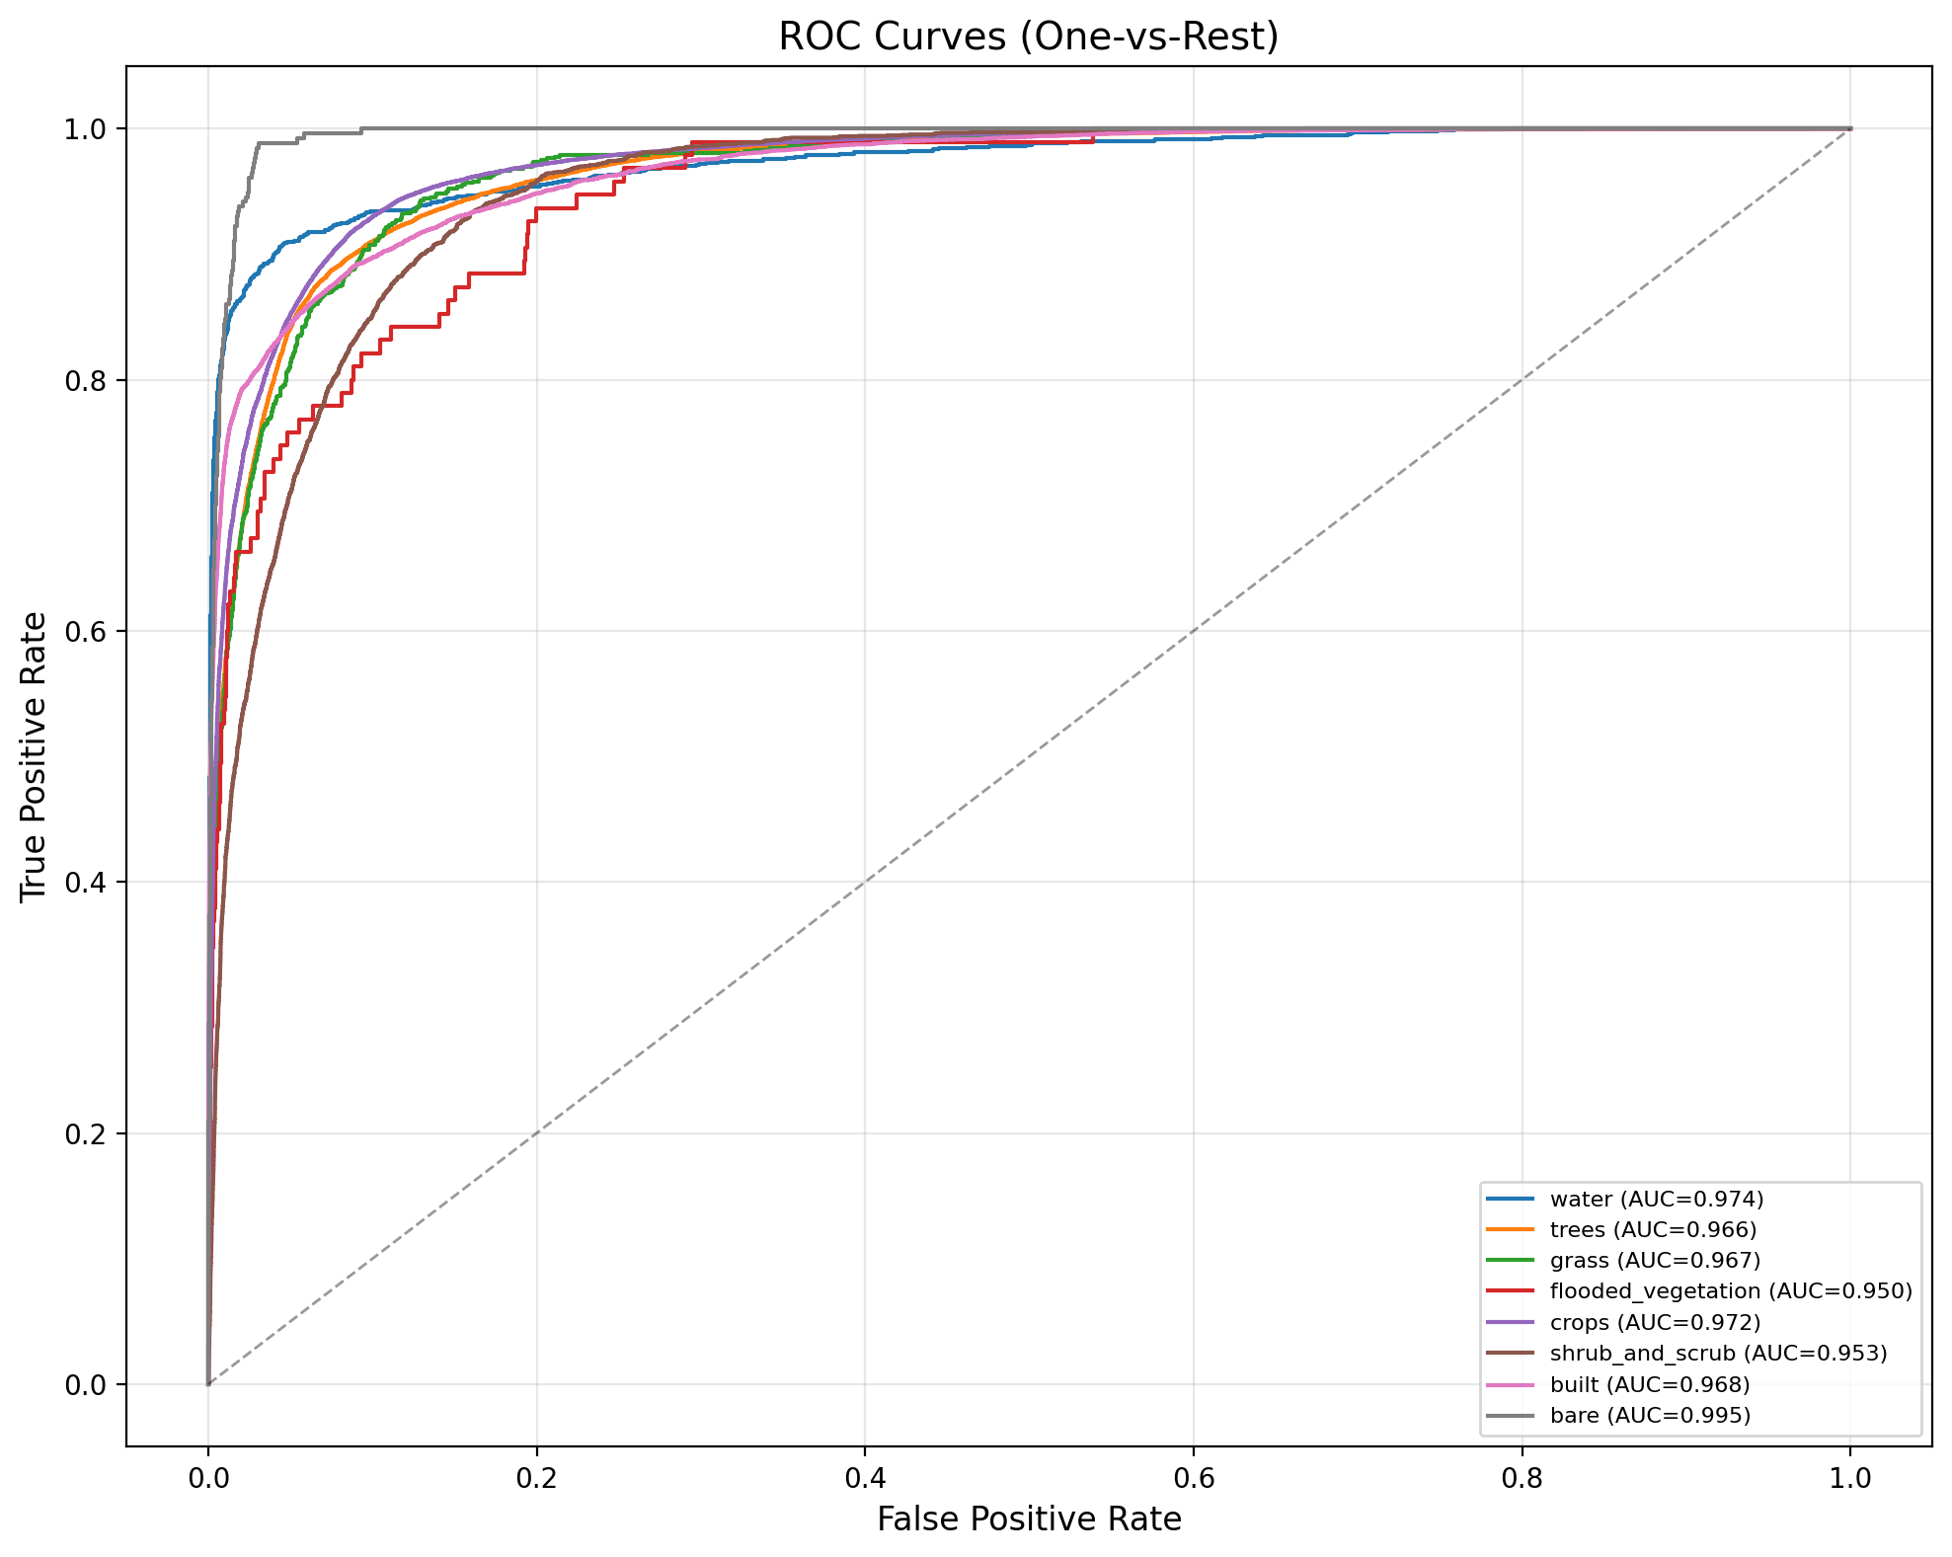
Figure 14: ROC curves (one-vs-rest) for hindcast validation
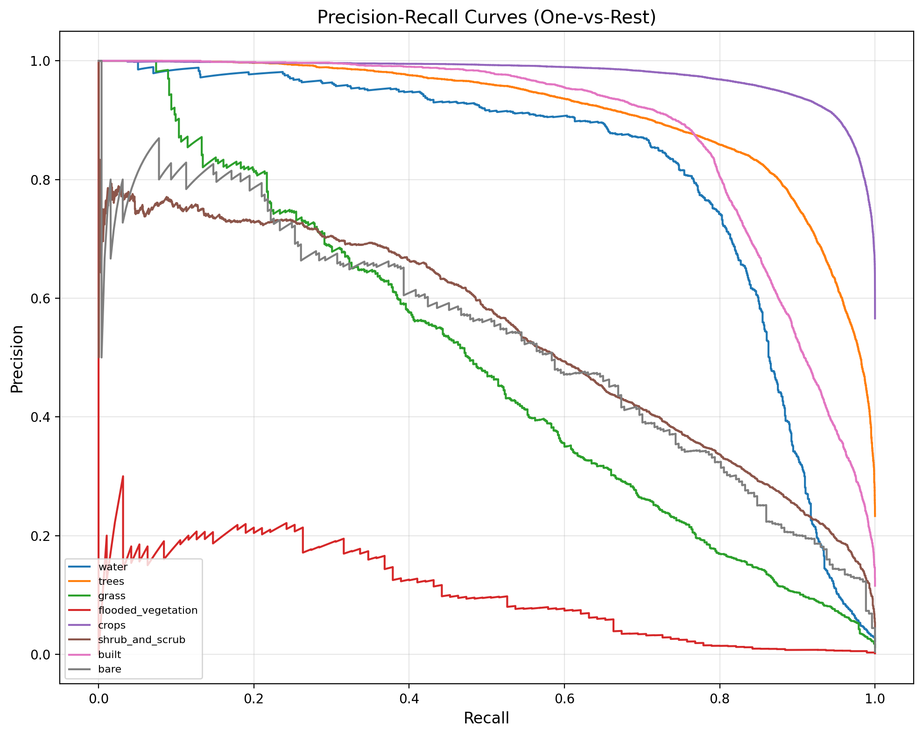
Figure 15: Precision-Recall curves for hindcast validation
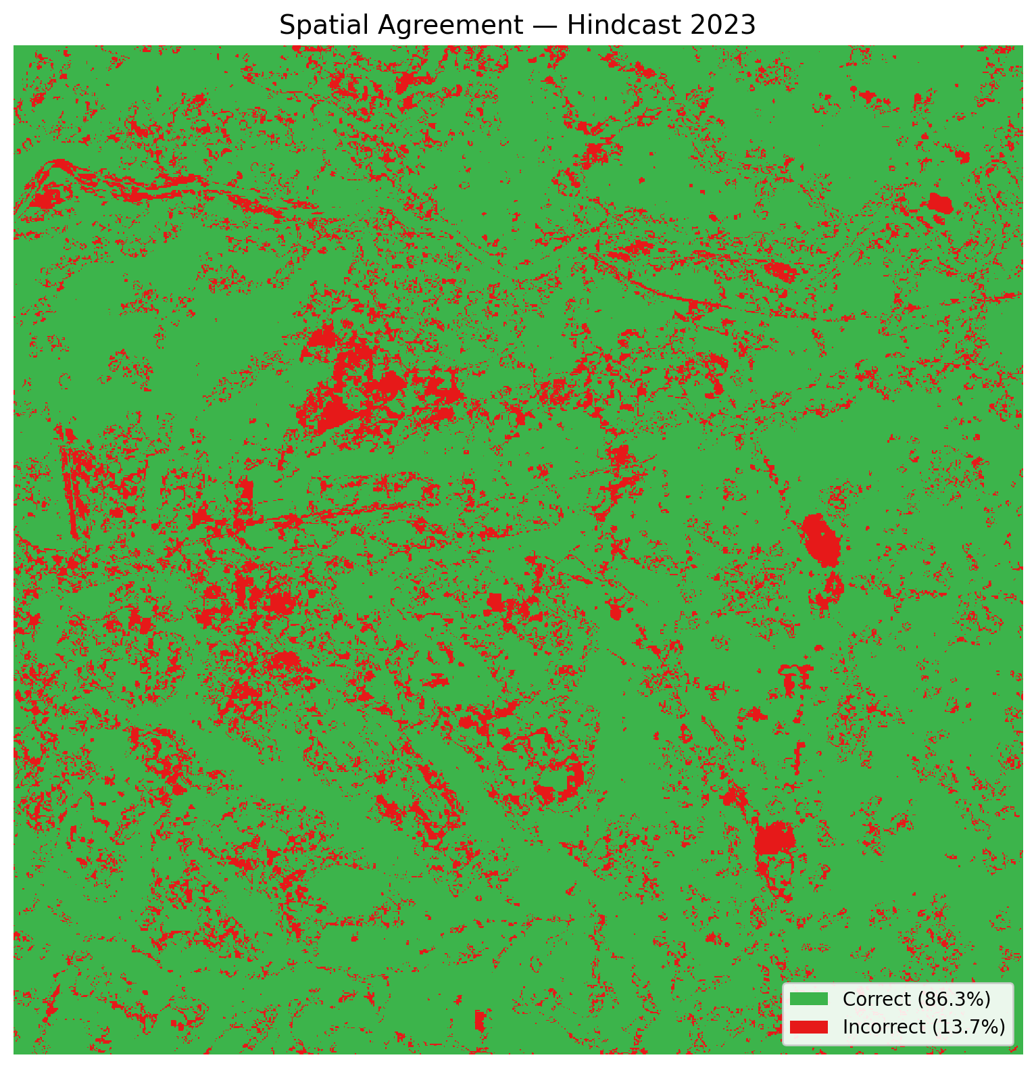
Figure 16: Spatial agreement map – correctly vs. incorrectly predicted pixels
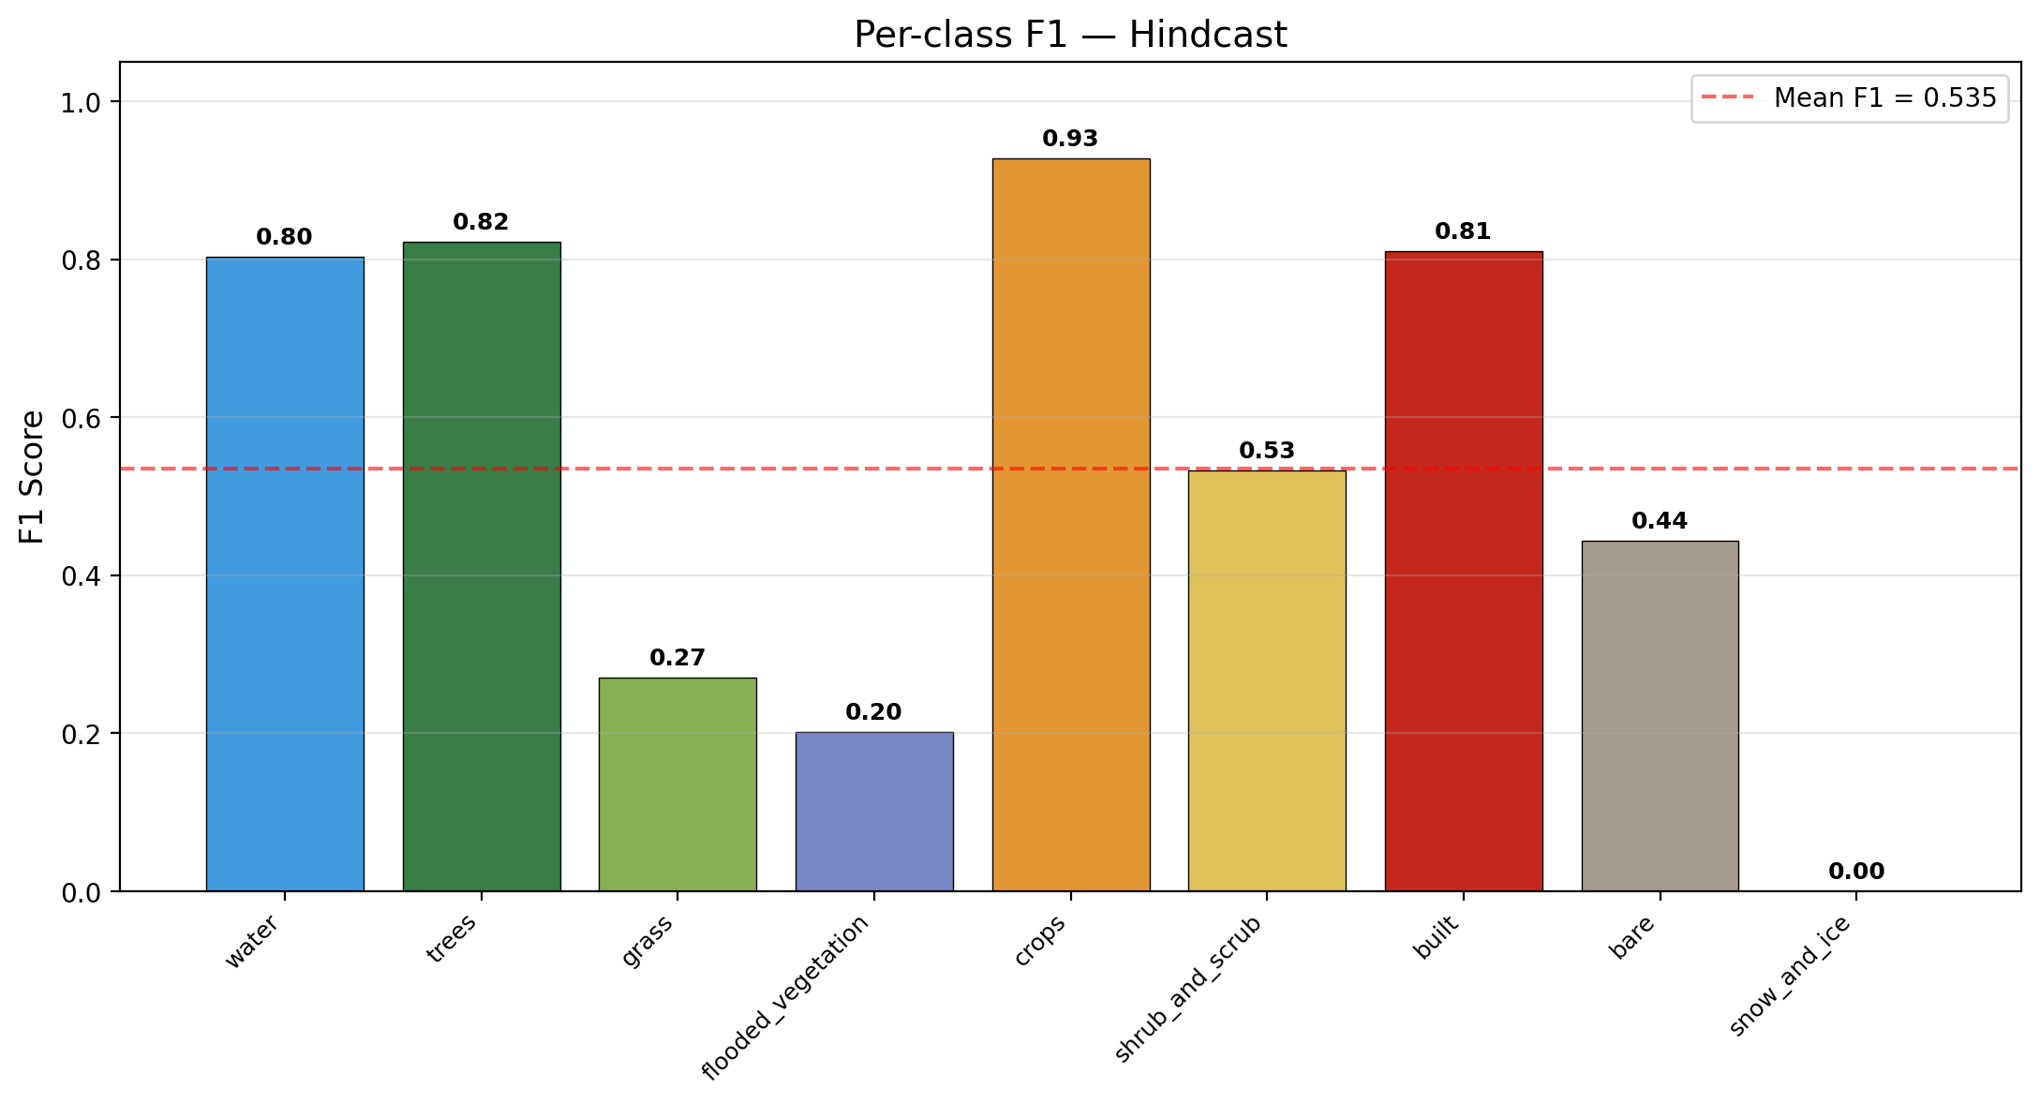
Figure 17: Per-class F1-scores for hindcast validation
LULC Class | Precision | Recall | F1-Score
Water | 0.788 | 0.820 | 0.804
Trees | 0.820 | 0.826 | 0.823
Grass | 0.183 | 0.525 | 0.271
Flooded Vegetation | 0.292 | 0.154 | 0.202
Crops | 0.920 | 0.935 | 0.928
Shrub and Scrub | 0.474 | 0.608 | 0.533
Built-up | 0.898 | 0.739 | 0.811
Bare Ground | 0.534 | 0.380 | 0.444
Table 4: Per-class hindcast validation metrics
8 Future Simulation (2026)
Using the validated CA-ANN model, future LULC for the year 2026 was simulated through three iterative CA steps starting from the observed 2023 map. The simulated 2026 map and associated change analysis are presented below.
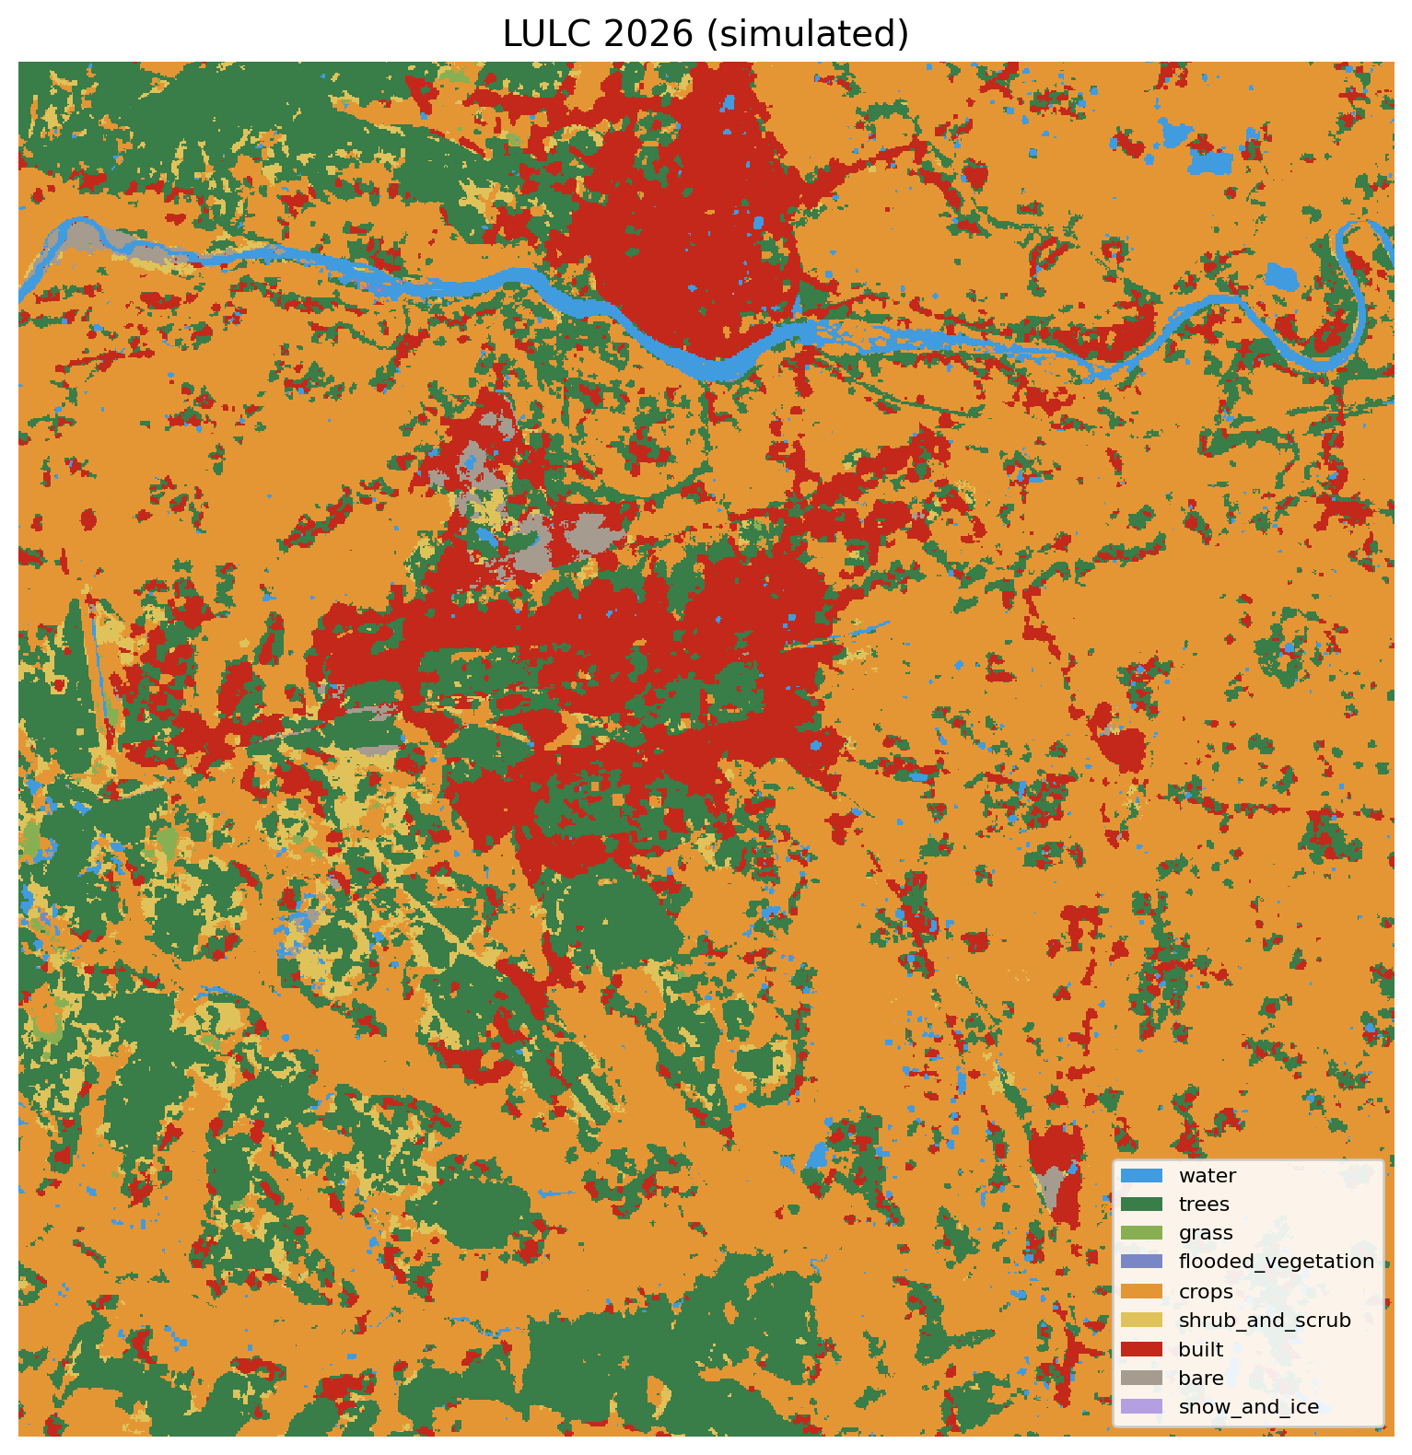
Figure 18: Simulated LULC classification map for 2026
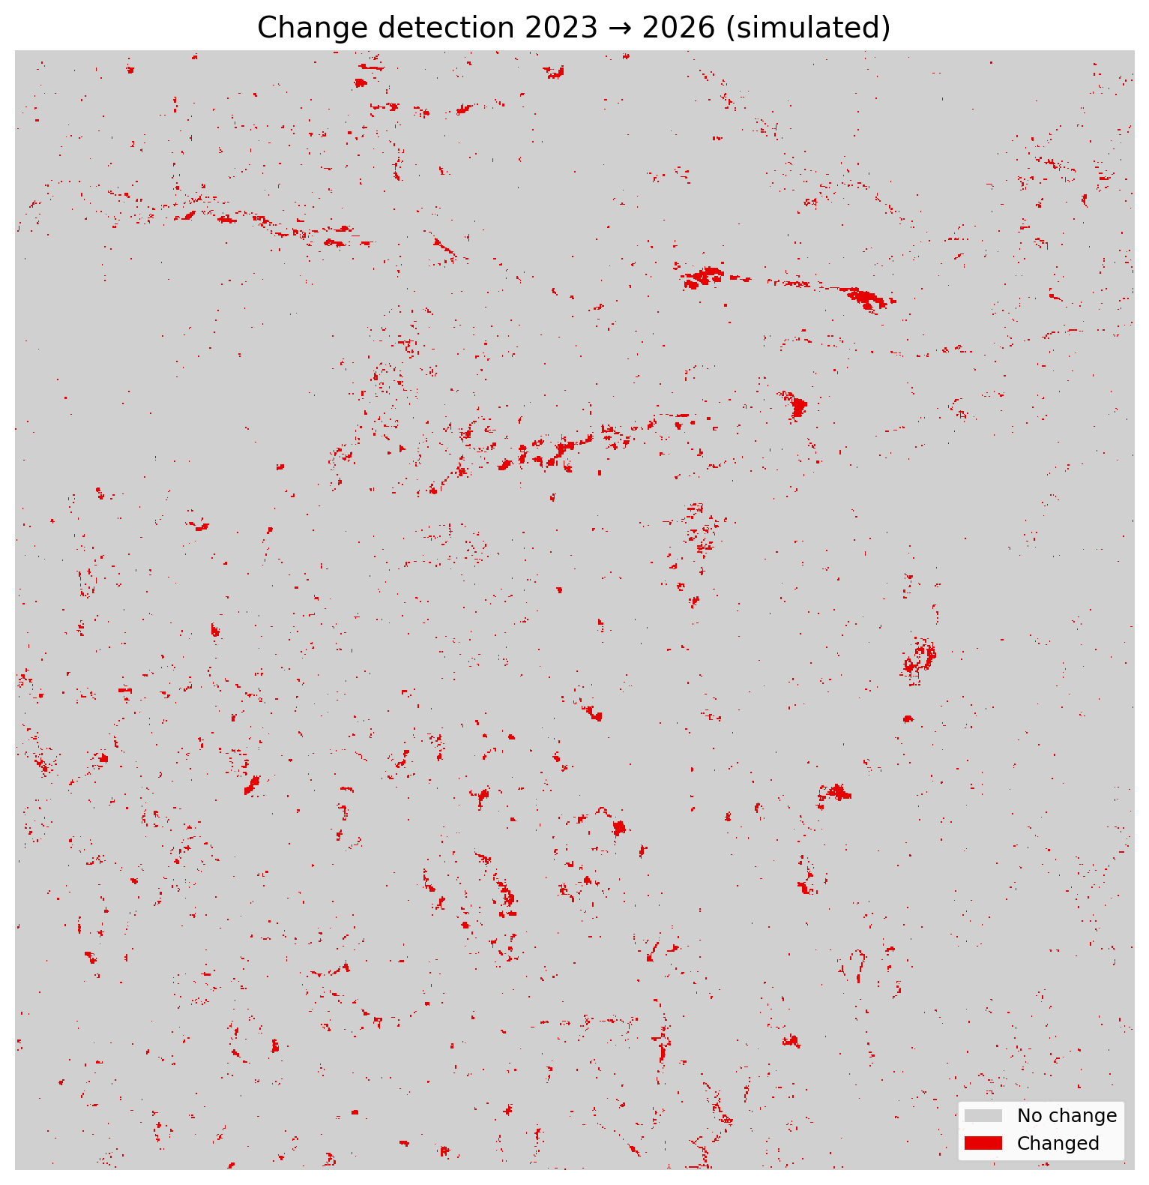
Figure 19: Change detection map for 2023–2026 (simulated)
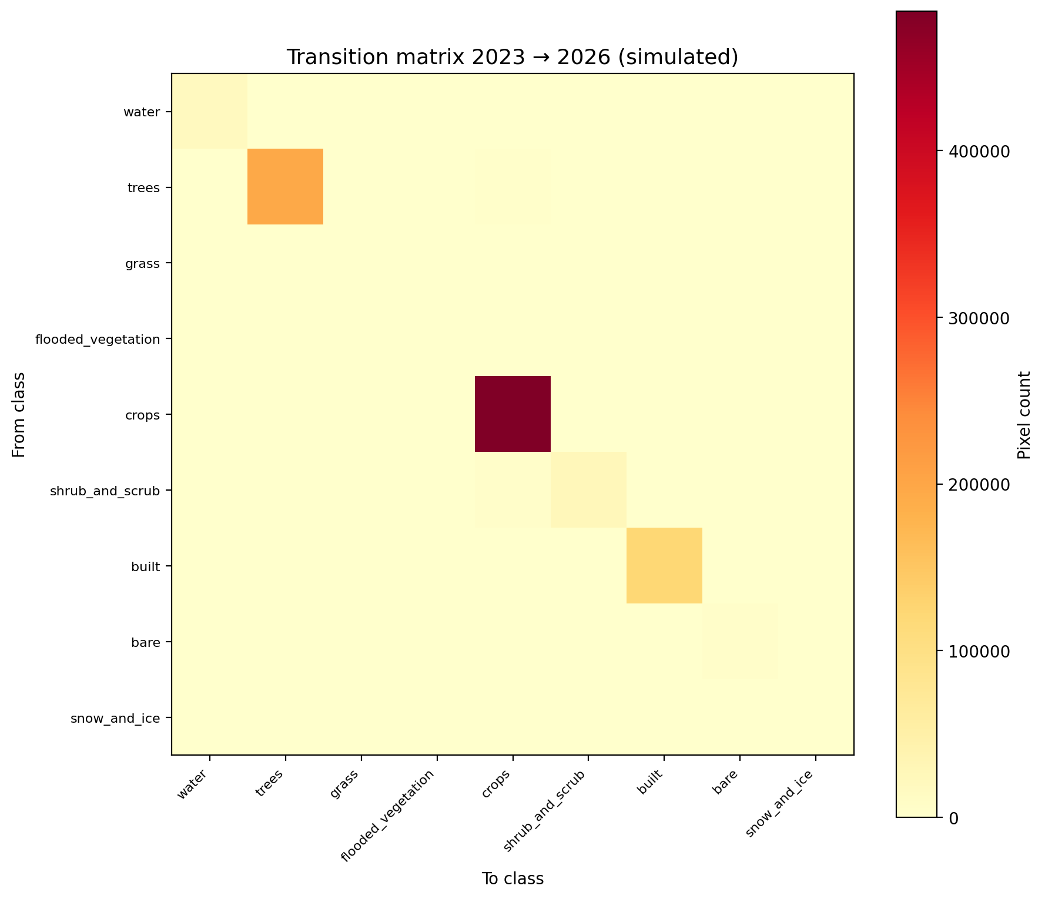
Figure 20: Transition matrix heatmap for 2023–2026 (simulated)
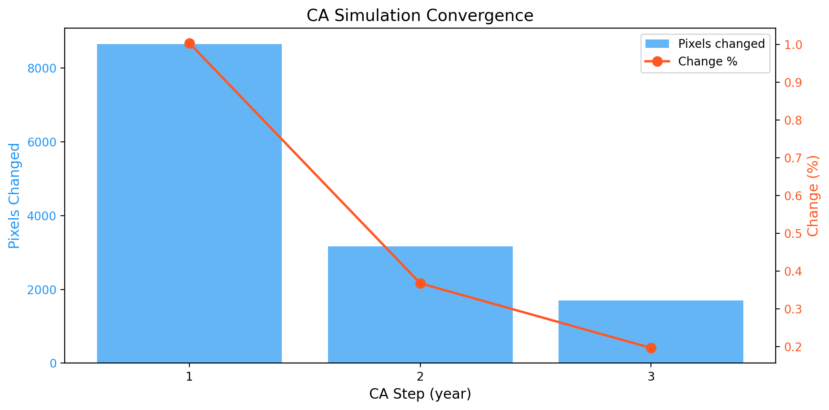
Figure 21: CA simulation convergence – pixels changed per iteration
The 2026 simulation indicates that built-up area is projected to remain largely stable at approximately 101.27 km², suggesting that the rapid urbanization phase observed from 2017 to 2023 may be reaching a plateau. Cropland shows a slight recovery to 410.48 km², while tree cover continues a marginal decline to 164.60 km². Grassland and flooded vegetation continue to diminish, while shrub/scrub also shows a decrease to 21.05 km².
The convergence plot shows that the CA simulation stabilizes rapidly, with the majority of transitions occurring in the first iteration. This indicates that the model reaches a spatially stable configuration quickly, which is characteristic of well-calibrated CA-ANN models.
9 Conclusion
This project successfully implemented a Cellular Automata-Artificial Neural Network (CA-ANN) framework for spatiotemporal assessment and simulation of land use and land cover dynamics in the Kharagpur region, West Bengal, India. The following key conclusions emerge from this study:
- The Kharagpur region experienced significant built-up expansion of approximately 41.9% (from 71.33 km² to 101.19 km²) between 2017 and 2023, primarily at the expense of cropland and tree cover.
- The CA-ANN model achieved a hindcast accuracy of 86.26% and Kappa of 0.7737, outperforming the values of 84.42% accuracy and 0.73 Kappa reported by Chen et al. (2018), thereby validating the model’s applicability to the study area.
- The ANN component identified the current LULC class, NDVI, elevation, and distance to built-up area as the most influential predictors of land-use transition.
- The 2026 simulation suggests stabilization of urban growth, with built-up area projected at 101.27 km², while cropland shows potential for partial recovery.
- The entirely Python-based pipeline, leveraging Google Earth Engine for cloud-based data access, demonstrates a reproducible and scalable approach to LULC modelling that eliminates the need for proprietary GIS software.
Limitations of this study include the lower predictive accuracy for minority LULC classes (grass, flooded vegetation), the absence of road network and GDP data as driving factors, and the assumption of stationary transition rules for future prediction. Future work could incorporate additional socioeconomic drivers, explore ensemble or deep learning approaches, and extend the prediction horizon to assess longer-term land transformation scenarios.
10 References
Brown, C. F., Brumby, S. P., Guzder-Williams, B., Birber, T., Hyde, S. B., Mez, J., Ogden, R. E., Ouaknine, R., Patel, S., Raber, D., Reckling, W., Reymondin, L., Riez, D., Saez, D., Siber, R., & Tait, A. M. (2022). Dynamic World, Near real-time global 10 m land use land cover mapping. Scientific Data, 9, 251. https://doi.org/10.1038/s41597-022-01307-4
Chen, L., Sun, Y., & Sajjad, S. (2018). Application and assessment of a CA-ANN model for land use change simulation and multi-temporal prediction in Guiyang City, China. Remote Sensing, 10(10), 1560. https://doi.org/10.3390/rs10101560
Cohen, J. (1960). A coefficient of agreement for nominal scales. Educational and Psychological Measurement, 20(1), 37–46. https://doi.org/10.1177/001316446002000104
Drusch, M., Del Bello, U., Carlier, S., Colin, O., Fernandez, V., Gascon, F., Hoersch, B., Isola, C., Laberinti, P., Martimort, P., Meygret, A., Spoto, F., Sy, O., Marchese, F., & Bargellini, P. (2012). Sentinel-2: ESA’s optical high-resolution mission for GMES operational services. Remote Sensing of Environment, 120, 25–36. https://doi.org/10.1016/j.rse.2011.11.026
Elvidge, C. D., Baugh, K., Zhizhin, M., Hsu, F. C., & Ghosh, T. (2017). VIIRS night-time lights. International Journal of Remote Sensing, 38(21), 5860–5879. https://doi.org/10.1080/01431161.2017.1342050
Farr, T. G., Rosen, P. A., Caro, E., Crippen, R., Duren, R., Hensley, S., Kobrick, M., Paller, M., Rodriguez, E., Roth, L., Seal, D., Shaffer, S., Shimada, J., Umland, J., Werner, M., Oskin, M., Burbank, D., & Alsdorf, D. (2007). The Shuttle Radar Topography Mission. Reviews of Geophysics, 45(2), RG2004. https://doi.org/10.1029/2005RG000183
Gorelick, N., Hancher, M., Dixon, M., Ilyushchenko, S., Thau, D., & Moore, R. (2017). Google Earth Engine: Planetary-scale geospatial analysis for everyone. Remote Sensing of Environment, 202, 18–27. https://doi.org/10.1016/j.rse.2017.06.031
Li, X., & Yeh, A. G. O. (2002). Neural-network-based cellular automata for simulating multiple land use changes using GIS. International Journal of Geographical Information Science, 16(4), 323–343. https://doi.org/10.1080/13658810210137004
Pedregosa, F., Varoquaux, G., Gramfort, A., Michel, V., Thirion, B., Grisel, O., Blondel, M., Prettenhofer, P., Weiss, R., Dubourg, V., Vanderplas, J., Passos, A., Cournapeau, D., Brucher, M., Perrot, M., & Duchesnay, É. (2011). Scikit-learn: Machine learning in Python. Journal of Machine Learning Research, 12, 2825–2830.

