## Problem Statement

**Dataset:** UCI-credit card defaults  
**Datasource:** <https://archive.ics.uci.edu/ml/datasets/default+of+credit+card+clients>  
**UseCase**: Banks loses quite billion of money by default payments in credit cards.

## Solution

A decision tree classifier is trained using 30,000 credit card holder data from Taiwan. Using the predictive model, possibly defaulting clients are identified at an accuracy of 82.1%. Moreover, repayment status and amount of previous payments are identified as dominating decision factors for default classification.

Utilizing machine learning on client data records like this, banks and other financing institutions can have a better grasp of people’s capacity to pay up their debts and loans; thus, allowing them to make better data-driven decisions.

We have also created a interactive voice to message Chatbot, ‘CreditCardExpert’, gives probability of default score to banks for determining credit default in interactive UI.

url: <https://bot.api.ai/a5a29ae3-77b6-42b5-85f8-ad39650116cd>

## AI Technology and Libraries

* **General AI Platforms** - Google.
* **Virtual Agents** - Google, api.ai
* **Open Source** –numpy,panda,scikit, spyder ide, anaconda package-python.

**Algorithms:**

* KNN(K-Nearest Neighbor)
* ANN(Artificial Neural Network)
* LinearRegressor algorithm
* DD3(DecisionTree Algorithm)

**Consoles:**

* Ipython-console

## Screenshots:

DataAnalysis(Future Analysis)

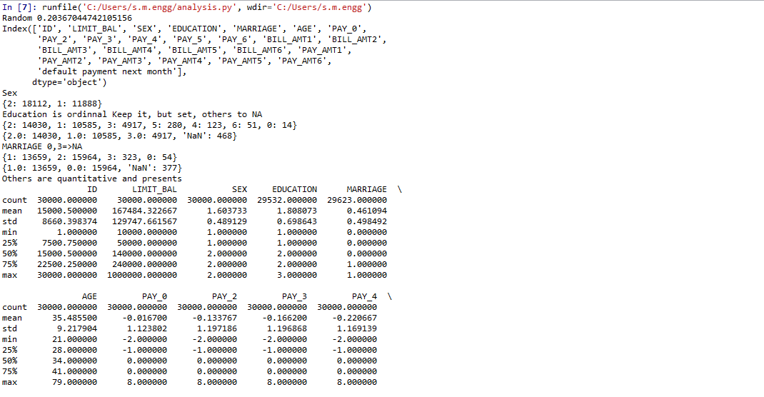

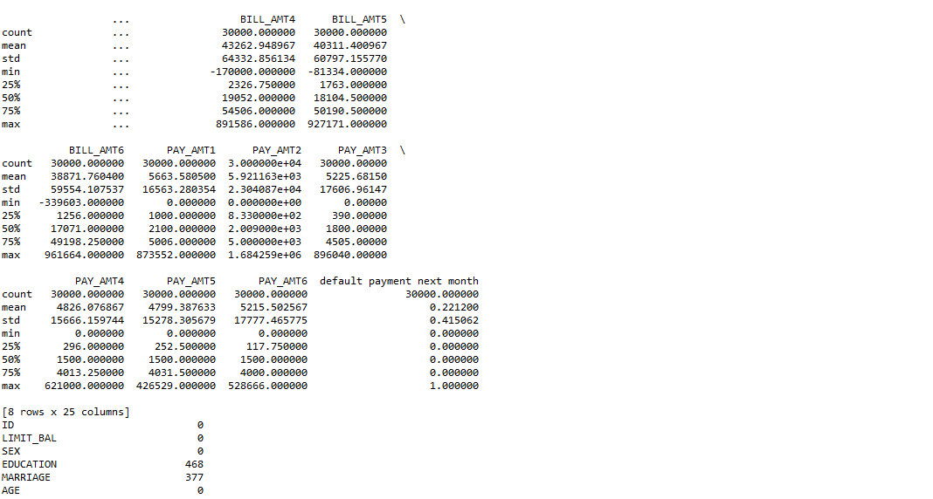

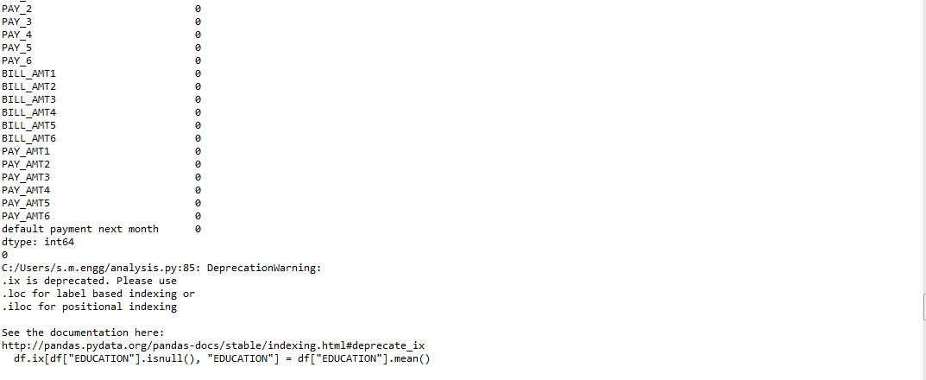

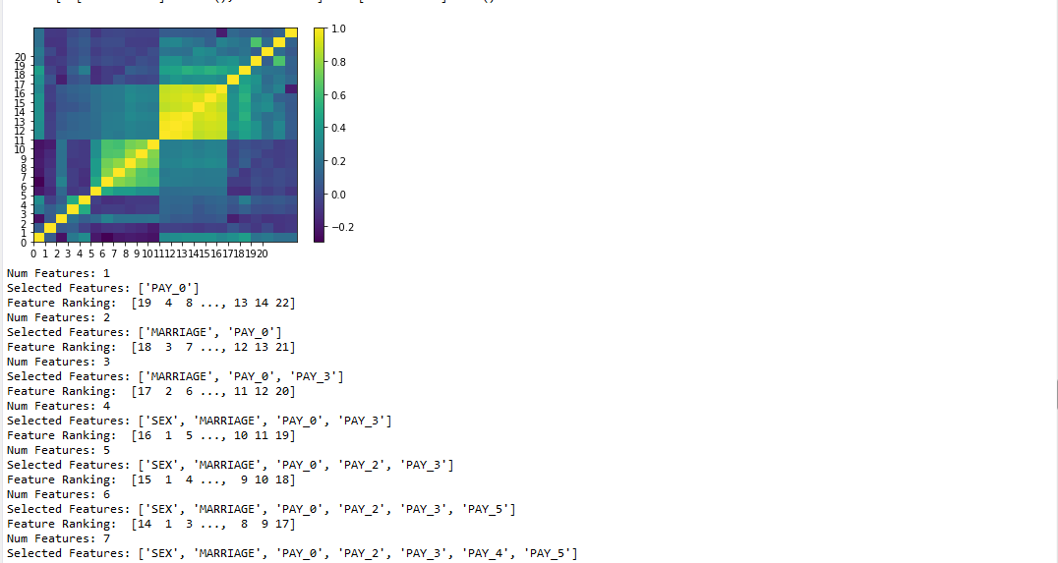

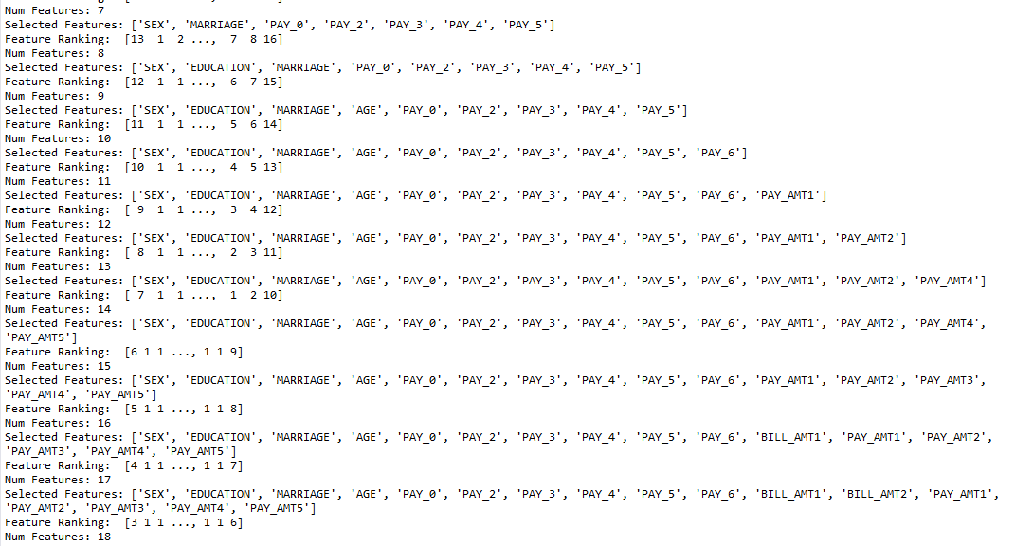

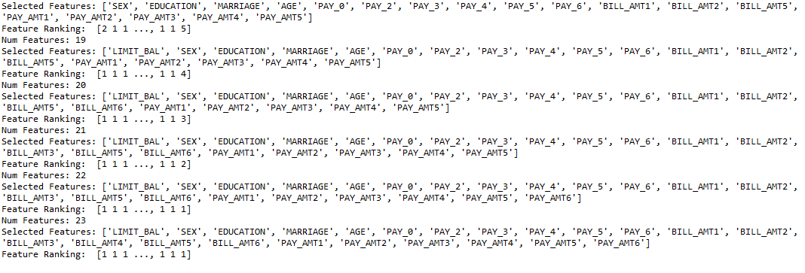

Artificial Neural Network Model(Learning Model):

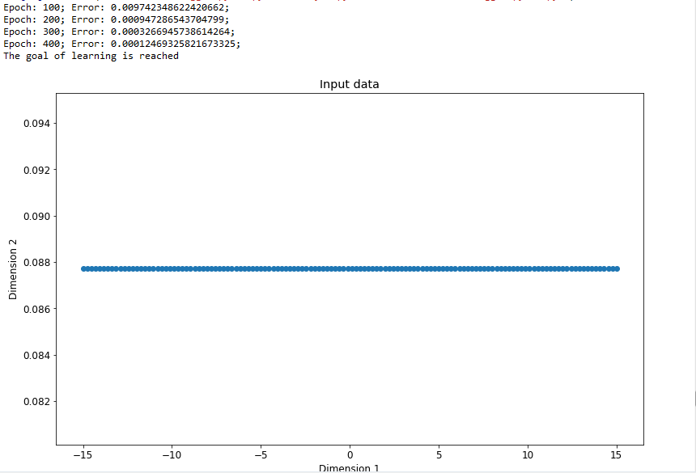

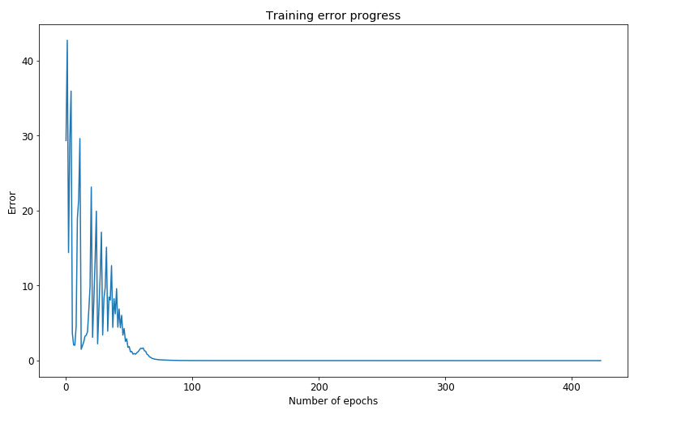

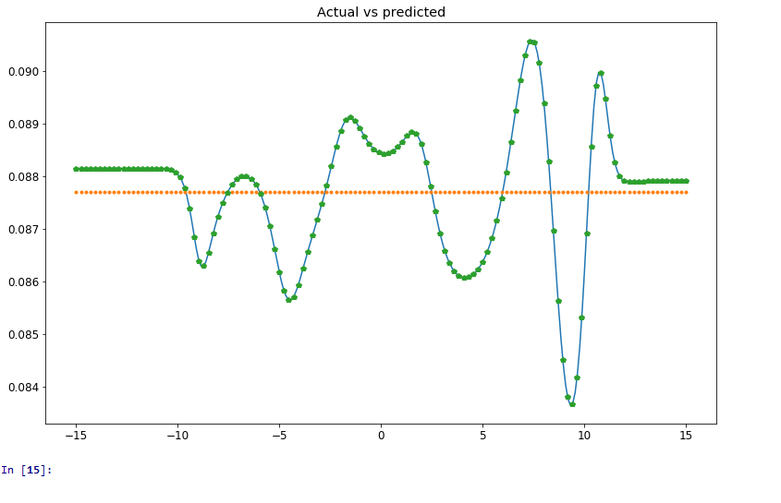

Decision tree

# levelName n Avg Limit % Good Credit % Default

## 1 All NA NA NA

## 2 ¦--20-29 NA NA NA

## 3 ¦ ¦--Female NA NA NA

## 4 ¦ ¦ ¦--Married NA NA NA

## 5 ¦ ¦ ¦ ¦--High School 192 $ 99,688 0.21 0.29

## 6 ¦ ¦ ¦ ¦--University 814 $118,206 0.25 0.28

## 7 ¦ ¦ ¦ °--Graduate School 148 $176,689 0.45 0.16

## 8 ¦ ¦ °--Single NA NA NA

## 9 ¦ ¦ ¦--High School 365 $110,219 0.31 0.24

## 10 ¦ ¦ ¦--University 2337 $119,718 0.28 0.24

## 11 ¦ ¦ °--Graduate School 2363 $150,165 0.45 0.19

## 12 ¦ °--Male NA NA NA

## 13 ¦ ¦--Married NA NA NA

## 14 ¦ ¦ ¦--High School 53 $103,962 0.23 0.32

## 15 ¦ ¦ ¦--University 197 $110,457 0.25 0.26

## 16 ¦ ¦ °--Graduate School 45 $161,556 0.36 0.27

## 17 ¦ °--Single NA NA NA

## 18 ¦ ¦--High School 325 $ 70,062 0.22 0.30

## 19 ¦ ¦--University 1462 $ 91,826 0.20 0.27

## 20 ¦ °--Graduate School 1134 $144,180 0.41 0.19

## 21 ¦--30-39 NA NA NA

## 22 ¦ ¦--Female NA NA NA

## 23 ¦ ¦ ¦--Married NA NA NA

## 24 ¦ ¦ ¦ ¦--High School 500 $141,260 0.34 0.22

## 25 ¦ ¦ ¦ ¦--University 1948 $173,850 0.40 0.21

## 26 ¦ ¦ ¦ °--Graduate School 1062 $246,365 0.67 0.19

## 27 ¦ ¦ °--Single NA NA NA

## 28 ¦ ¦ ¦--High School 266 $185,677 0.49 0.16

## 29 ¦ ¦ ¦--University 1220 $192,311 0.39 0.18

## 30 ¦ ¦ °--Graduate School 1505 $242,930 0.65 0.16

## 31 ¦ °--Male NA NA NA

## 32 ¦ ¦--Married NA NA NA

## 33 ¦ ¦ ¦--High School 271 $150,701 0.30 0.31

## 34 ¦ ¦ ¦--University 1010 $170,178 0.34 0.26

## 35 ¦ ¦ °--Graduate School 635 $257,008 0.59 0.22

## 36 ¦ °--Single NA NA NA

## 37 ¦ ¦--High School 279 $136,022 0.26 0.24

## 38 ¦ ¦--University 1045 $142,737 0.27 0.23

## 39 ¦ °--Graduate School 1240 $229,266 0.49 0.19

## 40 ¦--40-49 NA NA NA

## 41 ¦ ¦--Female NA NA NA

## 42 ¦ ¦ ¦--Married NA NA NA

## 43 ¦ ¦ ¦ ¦--High School 688 $133,808 0.38 0.26

## 44 ¦ ¦ ¦ ¦--University 1331 $176,255 0.45 0.22

## 45 ¦ ¦ ¦ °--Graduate School 626 $255,719 0.67 0.18

## 46 ¦ ¦ °--Single NA NA NA

## 47 ¦ ¦ ¦--High School 235 $139,617 0.34 0.25

## 48 ¦ ¦ ¦--University 407 $167,052 0.35 0.20

## 49 ¦ ¦ °--Graduate School 247 $254,211 0.60 0.20

## 50 ¦ °--Male NA NA NA

## 51 ¦ ¦--Married NA NA NA

## 52 ¦ ¦ ¦--High School 414 $137,222 0.29 0.27

## 53 ¦ ¦ ¦--University 824 $165,534 0.32 0.27

## 54 ¦ ¦ °--Graduate School 693 $266,869 0.59 0.23

## 55 ¦ °--Single NA NA NA

## 56 ¦ ¦--High School 197 $100,902 0.21 0.24

## 57 ¦ ¦--University 334 $110,329 0.18 0.27

## 58 ¦ °--Graduate School 201 $235,323 0.41 0.20

## 59 ¦--50-59 NA NA NA

## 60 ¦ ¦--Female NA NA NA

## 61 ¦ ¦ ¦--Married NA NA NA

## 62 ¦ ¦ ¦ ¦--High School 369 $119,837 0.32 0.25

## 63 ¦ ¦ ¦ ¦--University 339 $168,112 0.36 0.27

## 64 ¦ ¦ ¦ °--Graduate School 172 $257,035 0.73 0.19

## 65 ¦ ¦ °--Single NA NA NA

## 66 ¦ ¦ ¦--High School 133 $103,684 0.27 0.21

## 67 ¦ ¦ ¦--University 112 $145,714 0.34 0.17

## 68 ¦ ¦ °--Graduate School 56 $232,857 0.59 0.18

## 69 ¦ °--Male NA NA NA

## 70 ¦ ¦--Married NA NA NA

## 71 ¦ ¦ ¦--High School 267 $136,180 0.32 0.31

## 72 ¦ ¦ ¦--University 294 $157,619 0.27 0.29

## 73 ¦ ¦ °--Graduate School 260 $276,192 0.52 0.25

## 74 ¦ °--Single NA NA NA

## 75 ¦ ¦--High School 81 $ 95,926 0.20 0.20

## 76 ¦ ¦--University 86 $ 90,930 0.16 0.24

## 77 ¦ °--Graduate School 53 $180,755 0.32 0.19

## 78 °--60-69 NA NA NA

## 79 ¦--Female NA NA NA

## 80 ¦ ¦--Married NA NA NA

## 81 ¦ ¦ ¦--High School 56 $124,464 0.30 0.25

## 82 ¦ ¦ ¦--University 38 $184,211 0.50 0.29

## 83 ¦ ¦ °--Graduate School 24 $267,083 0.71 0.33

## 84 ¦ °--Single NA NA NA

## 85 ¦ °--High School 15 $ 86,000 0.20 0.40

## 86 °--Male NA NA NA

## 87 ¦--Married NA NA NA

## 88 ¦ ¦--High School 40 $173,000 0.22 0.22

## 89 ¦ ¦--University 42 $173,095 0.50 0.45

## 90 ¦ °--Graduate School 50 $288,600 0.56 0.24

## 91 °--Single NA NA NA

## 92 ¦--High School 12 $149,167 0.33 0.17

## 93 °--University 13 $192,308 0.15 0.08

Result:

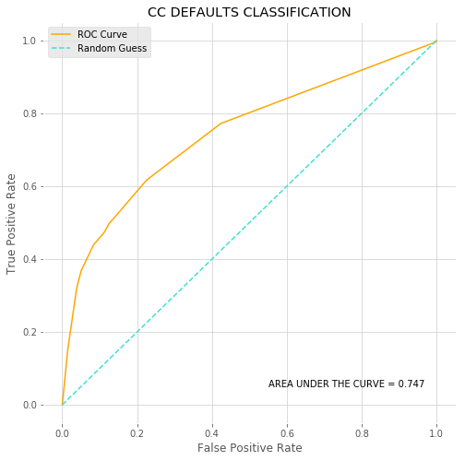

**ChatBot: CreditCard Defaulters**

