# How to Make Your Rental Property Popular on AirB&B



Image source: mashvisor.com

If you like to travel and, like myself, prefer to stay at a private residence instead of a cramped hotel room, you are most likely utilizing sites like AirB&B to find properties for rent. On another hand, what if you are considering making income off renting your property? You also can use this platform to put the property out for rent, communicate with the potential customers, and arrange bookings. While AirB&B provide the guidance on how to list and price the property, the main question is how to maximize the amount of time the property will be rented out?

I used this as a hypothetical question to guide my analysis using publicly available AirB&B rental information of properties in Seattle in 2016.

First question is what is the main factor contributing to the property popularity? The first answer that comes to mind is location, location, and location! I checked the number of properties that rented out more than 90% of the year by neighborhood and zip code. Both graphs below show that properties at some locations are more popular than at others. For instance, around 70% of properties at Arbor Heights are booked > 90% of the time while only 23% of properties in Cedar Park are booked > 90% of the time.

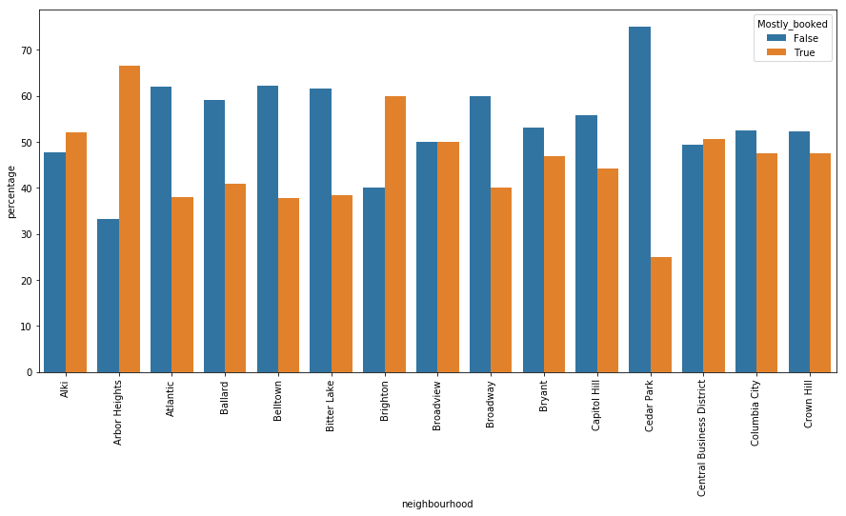

How about other obvious factors such as price and customers reviews?

Since price may fluctuate by the neighborhood, I selected the neighborhoods with similar number of popular properties. Specifically, I considered seven zipcodes with 40 to 45 percent of properties that were booked more than 90 percent of the time. The boxplot below shows that even though there is quite a variation in price, the average price for more popular properties is $126 vs. $130 for less popular properties. While there is an indication that popular properties cost less, the difference is not significant.

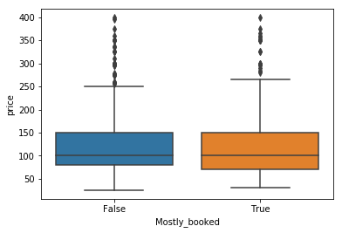

Property ratings in those two groups differ even less. The average ratings for popular vs. less popular groups are 94.1 vs. 94.5 on a scale from 1 to 100. Although there are some properties in both groups with very low rating.

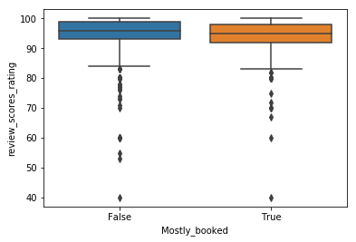

The last question is, what are other factors that may help to increase property occupancy time?

The diagram below shows that one and two bedroom properties are more popular.

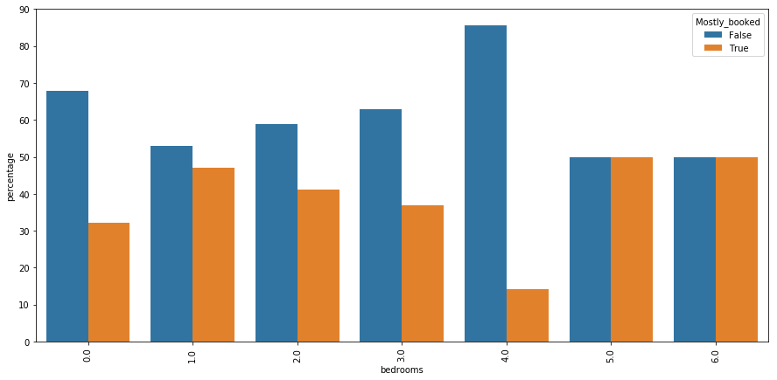

Additionally, cancellation policy may play some role. Properties with strict cancellation policy are booked more throughout the year.

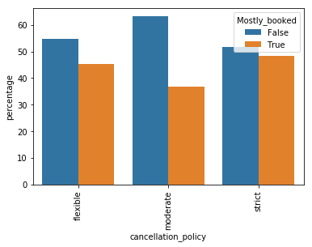

Finally, host status as superhost does not help to increase the property occupancy. Based on the chart below, 42% of properties listed by superhost are popular vs. 46% that are listed by non-superhosts.

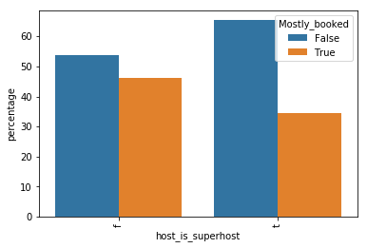

To conclude, if you want to invest into a property and use it as a rental income, choose the location carefully. If you have an existing property or can’t afford a popular location, then take number of bedrooms into consideration and carefully plan the cancellation policy not to take a hit of potential renters cancelling at the last minute. Additionally, while setting the right price and keeping the property ratings high is important, you can’t rely on those factors along to have your property consistently booked. Similarly, do not worry if you don’t have a super-host badge. 