**Name:** Sudharshan R

**Registration Number:** 185001173

**Class:** CSE – C **Semester :** 6

**Compiler Design Lab – Assignment 1**

**Lexical Analyser**

**AIM:**

Construct a program to simulate the functionalities of a Lexical Analyser of a compiler using C programming.

**CODE:**

#include<stdio.h>

#include<string.h>

#include<stdlib.h>

char*kw[]={"int","float","double","char","void","if","else","for","while","do","switch","case","continue","break","void"};

char SP[20]={'{','(',')','}',',',';'};

//char* fc[]={"main","printf","scanf","sizeof"};

int sing_flag=0,multi_flag=0,FC_flag=0,str_flag=0,id_flag=0;

int isletter(char str)

{

if(!((str=='_') || (str>='A' && str <='Z') || (str>='a' && str <='z')))

return 0;

return 1;

}

void substring(char s[], char sub[], int p, int l)

{

int i=0;

while (p < l)

{

sub[i++] = s[p++];

}

sub[p] = '\0';

}

int is_digit(char num)

{

if(num>='0' && num<='9')

{

return 1;

}

return 0;

}

int isID(char str[])

{

int i=0;

if(!isletter(str[0]))

return 0;

for(i=1;i<strlen(str);i++)

{

if(isletter(str[i])||is_digit(str[i]))

continue;

else

return 0;

}

return 1;

}

int is_digits(char num[])

{

int i;

if(strlen(num)==0)

return 0;

for(i=0;i<strlen(num);i++)

{

if(is_digit(num[i]))

{

continue;

}

else

return 0;

}

return 1;

}

int isoptfrac(char num[])

{

int c=0,found=0;

for(c=0;c<strlen(num);c++)

{

if(num[c]=='.')

{

break;

found=1;

}

}

if(!found)

{

return 0;

}

if(c>0 && c<strlen(num))

{

char word[20];

substring(num,word,c+1,strlen(num));

if(is_digits(word))

{

substring(num,word,0,c);

if(is_digits(word))

return 1;

}

}

return 0;

}

int isoptexp(char num[])

{

int c=0,found=0;

for(c=0;c<strlen(num);c++)

{

if(num[c]=='E')

{

break;

found=1;

}

}

if(!found)

{

return 0;

}

if(c>0 && c<strlen(num))

{

char word[20];

if(num[c+1]=='+'||num[c+1]=='-')

substring(num,word,c+2,strlen(num));

else if(is_digit(num[c+1]))

substring(num,word,c+1,strlen(num));

else

return 0;

if(is_digits(word)||isoptfrac(word))

{

substring(num,word,0,c);

if(is_digits(word)||isoptfrac(word))

return 1;

}

}

return 0;

}

int isSP(char s)

{

int i=0;

for(i=0;i<strlen(SP);i++)

{

if(s==SP[i])

return 1;

}

return 0;

}

int iskeyword(char str[])

{

int i;

int n=sizeof(kw)/sizeof(kw[0]);

for(i=0;i<n;i++)

{

if(!strcmp(str,kw[i]))

return 1;

}

return 0;

}

char* test_token(char str[])

{

int i=0;

if(str[strlen(str)-1]=='\n')

str[strlen(str)-1]='\0';

if(multi_flag==1)

{

if(!strcmp(str,"*/"))

multi_flag=0;

return "";

}

if(sing_flag==1)

return "";

if(FC_flag==1 || FC_flag==2)

{

if(FC_flag==1)

{

if(str[strlen(str)-1]==')')

{

FC_flag=2;

}

}

else

{

if(str[0]=='(')

{

FC_flag=1;

}

else if(str[0]==';')

{

FC_flag=0;

}

}

return "";

}

if(str_flag==1)

{

if(str[0]=='"')

{

str_flag=0;

}

return "";

}

if(str[0]=='/')

{

if(str[1]=='*')

{

multi_flag=1;

return "MULTI";

}

else if(str[1]=='/')

{

sing_flag=1;

return "SINGLE";

}

else

return "ARITHOP";

}

else if((str[0]=='+' || str[0]=='*'|| str[0]=='-'||str[0]=='%') && (str[1]=='\0'))

return "ARITHOP";

else if(isSP(str[0]))

return "SP";

else if(str[0]=='<' || str[0]=='>')

return "RELOP";

else if(str[0]=='=')

{

if(str[1]=='=')

return "RELOP";

else if(str[1]=='\0')

return "ASSIGN";

}

else if(str[0]=='!')

{

if(str[1]=='=')

return "RELOP";

else if(str[1]=='\0')

return "LOGICOP";

}

else if((!strcmp(str,"&&"))||(!strcmp(str,"||")))

return "LOGICOP";

else if(iskeyword(str))

return "KW";

else if(str[0]=='\'')

{

if(str[strlen(str)-1]=='\'')

return "CHARCONST";

}

else if(str[0]=='"')

{

str_flag=1;

if(str[strlen(str)-1]=='"')

return "STRCONST";

}

else if(is_digits(str)||isoptfrac(str)||isoptexp(str))

{

return "NUMCONST";

}

else if(isID(str))

{

id_flag=1;

return "ID";

}

return str;

}

int reset_flag()

{

FC_flag=0;

str_flag=0;

sing_flag=0;

id_flag=0;

}

int is_delimiter(char str)

{

char word[20]={'(',',',')',';','"'};

int i;

for(i=0;i<strlen(word);i++)

{

if(str==word[i])

return 1;

}

return 0;

}

int is_opr1(char str)

{

char word[20]={'=','+','<','>','!','&','|','-','*','/','%'};

int i;

for(i=0;i<strlen(word);i++)

{

if(str==word[i])

return 1;

}

return 0;

}

int is_opr2(char str)

{

char word[20]={'=','&','|','/','*'};

int i;

for(i=0;i<strlen(word);i++)

{

if(str==word[i])

return 1;

}

return 0;

}

void LA(char stmt[200])

{

int i=0,c=0,j,k=0,ld=0,hold=0;

reset_flag();

char * token = strtok(stmt, " ");

char tokens[20][20],word[200]="",word1[20]="";

while( token != NULL )

{

strcpy(tokens[c++],token);

token = strtok(NULL, " ");

}

char sub_tk[10][20];

while(i<c)

{

//test_token(tokens[i++]2

for(j=0;j<strlen(tokens[i]);j++)

{

if(is_delimiter(tokens[i][j]))

{

if(ld!=j)

{

substring(tokens[i],sub_tk[k],ld,j);

sub_tk[k++][j-ld]='\0';

}

sub_tk[k][0]=tokens[i][j];

sub_tk[k++][1]='\0';

ld=j+1;

}

else if(is_opr1(tokens[i][j]))

{

if(is_opr2(tokens[i][j+1]))

{

substring(tokens[i],sub_tk[k],ld,j);

sub_tk[k++][j-ld]='\0';

substring(tokens[i],sub_tk[k],j,j+2);

sub_tk[k++][2]='\0';

j++;

ld=j+1;

}

else

{

substring(tokens[i],sub_tk[k],ld,j);

sub_tk[k++][j-ld]='\0';

sub_tk[k][0]=tokens[i][j];

sub_tk[k++][1]='\0';

ld=j+1;

}

}

}

substring(tokens[i],sub_tk[k],ld,strlen(tokens[i]));

sub_tk[k++][strlen(tokens[i])-ld]='\0';

for(j=0;j<k;j++)

{

strcpy(word1,test_token(sub_tk[j]));

if(hold==1)

{

if(!strcmp(sub_tk[j],"("))

{

strcpy(word1,"FC");

FC_flag=1;

hold=0;

}

else

{

strcat(word,"ID ");

hold=0;

}

}

else if(!strcmp(word1,"ID"))

{

hold=1;

}

if(!hold)

{

strcat(word,word1);

if(strcmp(word1,""))

strcat(word," ");

}

if(strcmp(word1,"ID"))

{

id_flag=0;

}

//printf("%s ",sub_tk[j]);

}

ld=0;

k=0;

i++;

}

//printf("\n");

if(multi_flag!=1)

printf("%s\n",word);

else

printf("%s",word);

}

void main()

{

char stmt[128];

FILE *fp = fopen("test_file.c", "r");

if(fp == NULL)

{

perror("Unable to open file!");

exit(1);

}

while(fgets(stmt, sizeof(stmt), fp) != NULL)

{

LA(stmt);

strcpy(stmt,"\0");

}

fclose(fp);

}

/*

MULTI

FC

SP

KW ID ASSIGN NUMCONST SP ID ASSIGN NUMCONST SP

SINGLE

KW SP ID RELOP ID SP

FC

KW

FC

SP

FC

SP

SP

*/

**INPUT:**

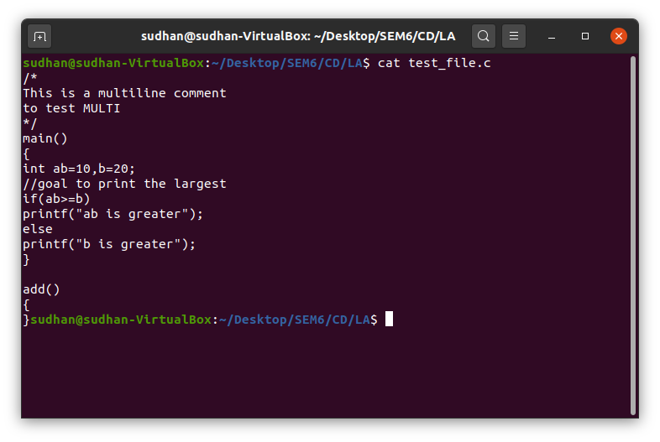

**OUTPUT:**

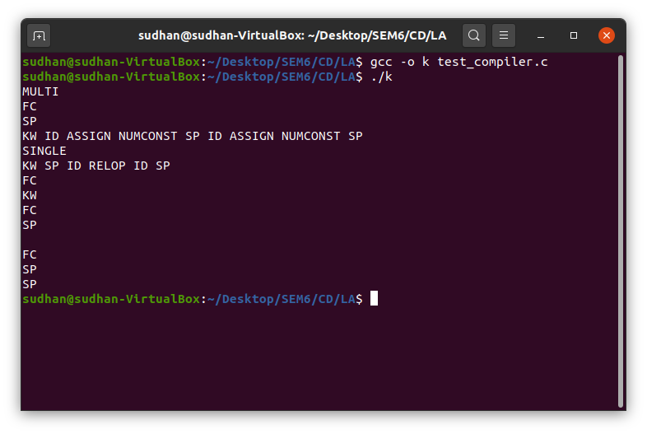

**Learning Outcome:**

* I learnt about the role of Lexical analyser in a compiler.
* I understood how the lexical analyser splits the tokens of input statements and organises it.
* I learnt how to tokenize element of a string using inbuilt C functions.
* I also came to know how to differentiate between identifiers and functions.
* Inferred handling of comments , both single line comments and multi-line comments.
* Understood how to differentiate between operators that come in pairs.

**Result:**

Hence the Role of lexical analyser in a compiler is simulated.

**Name:** Sudharshan R

**Registration Number:** 185001173

**Class:** CSE – C **Semester :** 6

**Compiler Design Lab – Assignment 2**

**Lexical Analyser Using LexTool**

**AIM:**

Construct a program to simulate the functionalities of a Lexical Analyser of a compiler using lex Tool.

**CODE:**

%{

#include<stdio.h>

#include<string.h>

int multi_flag=0,count=0,addr=2000,assign=0,id_flag=0,dec=0;

char cur_type[20];

struct symTable{

char sym[20];

int address;

char type[20];

char value[20];

int size;

}tab[10];

void constab(char*);

void reset_flag();

void update(char*);

%}

numberC ([0-9]+)|([0-9]*(\.)[0-9]+)

charC '(.)'

stringC \"((.)*)\"

relop ("<"|"<="|"=="|"!="|">"|">=")

arithop ("+"|"-"|"*"|"/"|"%")

logop ("&&"|"||"|"!")

assign "="

multi_s \/\*

multi_e \*\/

single "//".*

SP \(|\)|\{|\}|","|";"

KW if|else|while|do|for|break|continue|switch

data_type int|float|char|double

function ([ _ a-z A-Z ])([ _ a-z A-Z 0-9 ])*\((.)*\)

id ([_a-zA-Z])([_a-zA-Z0-9])*

newline "\n"

%%

{numberC} {if(!multi_flag) printf("NUMCONST ");if(assign==1){update(yytext);reset_flag();}}

{charC} {if(!multi_flag) printf("CHARCONST ");if(assign==1){update(yytext);reset_flag();}}

{stringC} {if(!multi_flag) printf("STRCONST ");if(assign==1){update(yytext);reset_flag();}}

{relop} {if(!multi_flag) printf("RELOP ");reset_flag();}

{arithop} {if(!multi_flag) printf("ARITHOP ");reset_flag();}

{logop} {if(!multi_flag) printf("LOGOP ");reset_flag();}

{assign} {if(!multi_flag) printf("ASSIGN "); if(id_flag==1) assign=1; }

{multi_s} {if(!multi_flag) printf("MULTI_S ");multi_flag=1;reset_flag();}

{multi_e} {multi_flag=0;if(!multi_flag) printf("MULTI_E "); reset_flag();}

{single} {if(!multi_flag) printf("SINGLE ");reset_flag();}

{SP} {if(!multi_flag) printf("SP ");reset_flag();}

{KW} {if(!multi_flag) printf("KW "); reset_flag();}

{data_type} {if(!multi_flag) printf("KW"); strcpy(cur_type,yytext); dec=1; }

{function} {if(!multi_flag) printf("FN ");reset_flag();}

{newline} {if(!multi_flag) printf("\n"); dec=0;}

{id} {if(!multi_flag) printf("ID "); if(dec==1){constab(yytext); id_flag=1;}}

%%

void main()

{

int i;

FILE *fp = fopen("test_file1.c", "r");

if(fp == NULL)

{

perror("Unable to open file!");

exit(1);

}

yyin=fp;

yylex();

printf("\nNAME TYPE SIZE ADDR VALUE\n");

for(i=0;i<count;i++)

{

printf("%4s %6s %4d %4d %s\n",tab[i].sym,tab[i].type,tab[i].size,tab[i].address,tab[i].value);

}

}

void update(char* val)

{

strcpy(tab[count-1].value,val);

}

void reset_flag()

{

assign=0;

id_flag=0;

}

void constab(char* id)

{

strcpy(tab[count].sym,id);

strcpy(tab[count].type,cur_type);

tab[count].address=addr;

if(!strcmp(cur_type,"int"))

{

addr+=2;

tab[count].size = 2;

}

else if(!strcmp(cur_type,"float"))

{

addr+=4;

tab[count].size =4;

}

else if(!strcmp(cur_type,"char"))

{

addr+=1;

tab[count].size =1;

}

else if(!strcmp(cur_type,"double"))

{

addr+=8;

tab[count].size =8;

}

count++;

update("-");

}

int yywrap(void){}

/*

MULTI_S

MULTI_E

FN

SP

KW ID ASSIGN NUMCONST SP ID ASSIGN NUMCONST SP

SINGLE

KW 'SP ID RELOP ID SP

FN SP

KW

FN SP

SP

FN

SP

SP

NAME TYPE SIZE ADDR VALUE

ab int 2 2000 10

b int 2 2002 20

c char 1 2004 'a'

d float 4 2005 9.134

e float 4 2009 -

*/

**INPUT:**

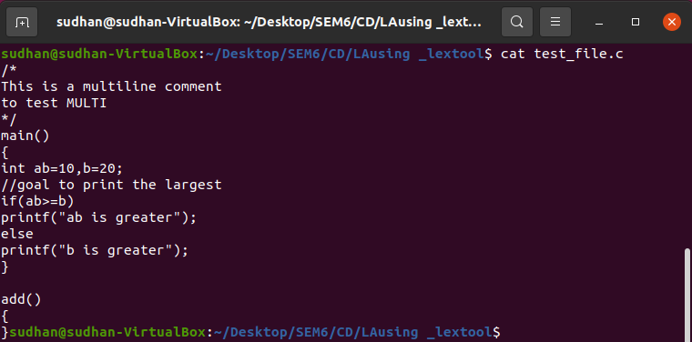

**OUTPUT:**

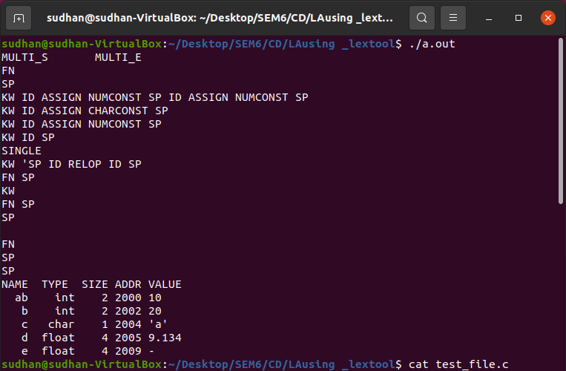

**Learning Outcome:**

* I learnt about the role of Lexical analyser in a compiler.
* I understood how the lexical analyser splits the tokens of input statements and organises it.
* I learnt how to tokenize element of a string using lex Tool.
* I also came to know how to how to handle patterns and actions in a lex program.
* Inferred handling of -comments, both single line comments and multi-line comments.
* Understood the use of yywrap() and yylex().

**Result:**

Hence the Role of lexical analyser in a compiler is simulated using a lex tool.

**Name:** Sudharshan R

**Registration Number:** 185001173

**Class:** CSE – C **Semester:** 6

**Compiler Design Lab – Assignment 3**

**Left Recursion Eliminator**

**AIM:**

Construct a program to eliminate the left recursion for a given grammar.

**CODE:**

#include<stdio.h>

#include<string.h>

#include<stdlib.h>

void LReliminator(char prod[]);

void main()

{

char stmt[50];

FILE *fp = fopen("test_file.c", "r");

if(fp == NULL)

{

perror("Unable to open file!");

exit(1);

}

while(fgets(stmt, sizeof(stmt), fp) != NULL)

{

LReliminator(stmt);

strcpy(stmt,"\0");

}

fclose(fp);

}

void LReliminator(char prod[])

{

int i,j=0,c=0;

char * token = strtok(prod,"->"),lhs[20]="",rhs[20]="";

char tokens[20][20],alpha[20];

while( token != NULL )

{

strcpy(tokens[c++],token);

token = strtok(NULL, "->");

}

//printf("%s\n%s\n",tokens[0],tokens[1]);

strcpy(lhs,tokens[0]);

strcpy(rhs,tokens[1]);

for(i=0;i<strlen(lhs);i++)

{

if(lhs[i]==rhs[i])

{

continue;

}

else

{

j=1;

break;

}

}

if(j==1)

{

printf("%s->%s\n",lhs,rhs);

return;

}

for(j=0;rhs[i]!='|';i++,j++)

{

alpha[j]=rhs[i];

}

alpha[i]='\0';

j=-1;

for(i=0;i<strlen(rhs);i++)

{

if(rhs[i]=='|')

{

j=i;

break;

}

}

if(j==-1)

{

printf("LR cant be eliminated\n");

return;

}

c=0;

char *tok=strtok(rhs,"|");

while( tok != NULL )

{

strcpy(tokens[c++],tok);

tok = strtok(NULL,"|");

}

if(tokens[c-1][strlen(tokens[c-1])-1]=='\n')

{

tokens[c-1][strlen(tokens[c-1])-1]='\0';

}

printf("%s->",lhs);

i=1;

while(i<c)

{

if(i!=c-1)

printf("%s%s'|",tokens[i],lhs);

else

printf("%s%s'",tokens[i],lhs);

i++;

}

printf("\n%s'->(epsilon)|%s%s'\n",lhs,alpha,lhs);

}

/*

Input File:

E->E+T|T

T->T*F|F

F->i

Output:

E->TE'

E'->(epsilon)|+TE'

T->FT'

T'->(epsilon)|*FT'

F->i

*/

**INPUT:**

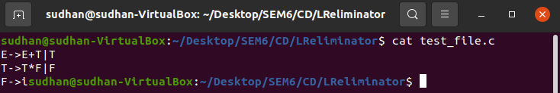

**OUTPUT:**

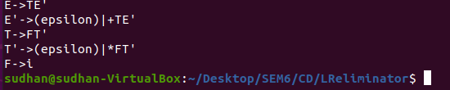

**Learning Outcome:**

* I learnt about the problems of the grammar with left recursion.
* I understood how to eliminate Left recursion in a production.
* I learnt how to tokenize element of a string using inbuilt C functions.
* I also came to know how to differentiate the production into alpha and beta .
* Inferred handling of non – left recursion productions.

**Result:**

Hence the Left recursion has been handled and eliminated.

**Name:** Sudharshan R

**Registration Number:** 185001173

**Class:** CSE – C **Semester:** 6

**Compiler Design Lab – Assignment 4**

**Recursive Descent Parser**

**AIM:**

**Write a program in C to construct Recursive Descent Parser for the following grammar which is for arithmetic expression involving + and *. Check the Grammar for left recursion and convert into suitable for this parser. Write recursive functions for every non-terminal. Call the function for start symbol of the Grammar in main().**

**G: E🡪E+T|T**

**T🡪T*F | F**

**F🡪i**

**Extend this parser to include division, subtraction and parenthesis operators**

**G: E🡪E+T|E-T|T**

**T🡪T*F | T/F|F**

**F🡪(E)|i**

**CODE:**

#include<stdio.h>

#include<string.h>

#include<stdlib.h>

char input[100];

int length=0,flag=0,indt=0;

void E();

void T();

void Edash();

void Tdash();

void F();

void indent();

void main()

{

int l;

printf("Enter the Input String:");

scanf("%s",input);

l=strlen(input);

input[l]='$';

input[l+1]='\0';

E();

if(input[length]=='$')

printf("\nThe given string is accepted\n");

else

{

printf("Mismatch at position %d:%c\n",length,input[length]);

printf("String is not accepted\n");

}

}

void E()

{ indent();

indt+=1;

printf(" called E()\n");

T();

Edash();

indt-=1;

}

void Edash()

{

indent();

indt+=1;

printf(" called E'() ");

if(input[length]=='+'||input[length]=='-')

{

if(input[length]=='+')

printf("Matched +\n");

else

printf("Matched -\n");

length++;

T();

Edash();

}

else

printf("\n");

indt-=1;

}

void T()

{

indent();

indt+=1;

printf(" called T()\n");

F();

Tdash();

indt-=1;

}

void Tdash()

{

indent();

indt+=1;

printf(" called T'() ");

if(input[length]=='*'||input[length]=='/')

{

if(input[length]=='*')

printf("Matched *\n");

else

printf("Matched /\n");

length++;

F();

Tdash();

}

else

printf("\n");

indt-=1;

}

void F()

{

indent();

indt+=1;

printf(" called F() ");

indt-=1;

if(input[length]=='i' && input[length+1]=='d')

{

printf("Matched id\n");

length+=2;

}

else if(input[length]=='(')

{

printf("Matched (\n");

length++;

E();

if(input[length]==')')

{

indt+=1;

indent();

indt-=1;

printf("Matched )\n");

length++;

}

else

{

printf("Mismatch at position %d:%c\n",length,input[length]);

printf("String is not accepted\n");

exit(1);

}

}

else

{

printf("Mismatch at position %d:%c\n",length,input[length]);

printf("String is not accepted\n");

exit(1);

}

}

void indent()

{

int i;

for(i=0;i<indt;i++)

{

printf("\t");

}

}

**Input / Output:**

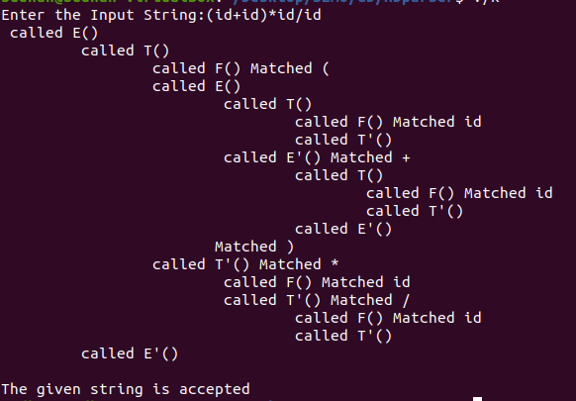

**Learning Outcome:**

* I learnt about the Recursive Descent Parser.
* I understood how to trace the flow of the recursive Descent parser.
* I learnt how to indent different flows of code.
* I also came to know how and when to throw an error.
* Inferred handling errors in input.

**Result:**

Hence the Recursive Descent Parser has been implemented for the input.

**Name:** Sudharshan R

**Registration Number:** 185001173

**Class:** CSE – C **Semester:** 6

**Compiler Design Lab – Assignment 5**

**Calculator using lex and yacc**

**AIM:**

To implement a calculator using lex and yacc tools.

**Code:**

**LEX:**

%{

#include<stdio.h>

#include<stdlib.h>

#include"y.tab.h"

void yyerror(char*);

extern int yylval;

%}

%%

[0-9]+ {

yylval=atoi(yytext);

return NUMBER;

}

[-+*/^()=&|%] {return *yytext;}

"<"|">" {return *yytext;}

">=" {return GTE;}

"<=" {return LTE;}

"!=" {return NE;}

"==" {return EQ;}

"&&" {return AND;}

"||" {return OR;}

"!" {return NOT;}

"<<" {return LS;}

">>" {return RS;}

[\t] ;

[\n] return 0;

. {yyerror("invalid case");}

%%

int yywrap(void)

{

return 1;

}

**YACC:**

%{

#include<stdio.h>

#include<stdlib.h>

#include<math.h>

#include"y.tab.h"

int yylex(void);

void yyerror(char *str);

%}

%token NUMBER OR AND NOT GTE LTE NE EQ LS RS

%right '='

%left OR

%left AND

%left NOT

%left '|'

%left '&'

%left EQ NE

%left '<' '>' GTE LTE

%left LS RS

%left '+' '-' '%'

%left '*' '/'

%left '^'

%left '(' ')'

%%

Expression: E {

printf("\nResult=%d\n", $$);

return 0;

};

E:E'+'E {$$=$1+$3;}

|E'-'E {$$=$1-$3;}

|E'*'E {$$=$1*$3;}

|E'/'E {$$=$1/$3;}

|E'%'E {$$=$1%$3;}

|E'^'E {$$=pow($1,$3);}

|'('E')' {$$=$2;}

|NOT E {$$=(!$2);}

|E'<'E {$$=$1<$3;}

|E'>'E {$$=$1>$3;}

|E'&'E {$$=$1&$3;}

|E'|'E {$$=$1|$3;}

|E GTE E {$$=$1>=$3;}

|E LTE E {$$=$1<=$3;}

|E EQ E {$$=$1==$3;}

|E NE E {$$=$1!=$3;}

|E AND E {$$=$1&&$3;}

|E OR E {$$=$1||$3;}

|E LS E {$$=$1<<$3;}

|E RS E {$$=$1>>$3;}

| '-' E { $$ = (-($2));}

|NUMBER {$$=$1;}

;

%%

void yyerror(char *str)

{

fprintf(stderr,"%s\n",str);

}

void main()

{

yyparse();

}

**INPUT/OUTPUT:**

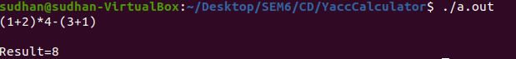

**Learning Outcome:**

* I learnt about the Yacc tool and how to combine it with lex to parse a grammar.
* I understood how to write a grammar in yacc.
* I learnt how to mention precedence and associativity.
* I also came to know how to handle error in case of error.
* Inferred handling of multi character tokens by tokens.

**Result:**

Hence the Calculator has been implemented using lex and yacc.

**Name:** Sudharshan R

**Registration Number:** 185001173

**Class:** CSE – C **Semester:** 6

**Compiler Design Lab – Assignment 6**

**Syntax Checker**

**AIM:**

To implement a syntax checking algorithm using lex and yacc.

**CODE:**

**LEX:**

%{

#include<stdio.h>

#include<stdlib.h>

#include"y.tab.h"

void yyerror(char*);

extern int yylval;

%}

%%

[0-9]+ {

yylval=atoi(yytext);

return NUMBER;

}

for {return FOR;}

while {return WHILE;}

if {return IF;}

else {return ELSE;}

[a-zA-Z_]([a-zA-z_]|[0-9])* {return ID;}

[{};()] {return *yytext;}

[-+*/^()=&|%] {return *yytext;}

"<"|">" {return *yytext;}

">=" {return GTE;}

"<=" {return LTE;}

"!=" {return NE;}

"==" {return EQ;}

"&&" {return AND;}

"||" {return OR;}

"!" {return NOT;}

"<<" {return LS;}

">>" {return RS;}

[\t] ;

[\n] ;

[ ] ;

. {yyerror("invalid case");}

%%

int yywrap(void)

{

return 1;

}

**YACC:**

%{

#include<stdio.h>

#include<stdlib.h>

#include<math.h>

#include"y.tab.h"

int yylex(void);

void yyerror(char *str);

%}

%token NUMBER OR AND NOT GTE LTE NE EQ LS RS FOR IF ELSE ID WHILE

%right '='

%left OR

%left AND

%left NOT

%left '|'

%left '&'

%left EQ NE

%left '<' '>' GTE LTE

%left LS RS

%left '+' '-' '%'

%left '*' '/'

%left '^'

%left '(' ')'

%%

S: ST{printf("\nNo Syntax Error\n");return 0;};

ST: FOR'('SA';'C';'E')'BLOCK

|WHILE'('C')'BLOCK

;

BLOCK:'{'BODY'}'

|BODY

;

BODY:BODY BODY

|SA';'

|IF'('C')'BLOCK ELSE BLOCK

|IF'('C')'BLOCK

|ST

|

;

SA:ID'='E

|E'+''+'

|E'-''-'

;

E:E'+'E

|E'-'E

|E'*'E

|E'/'E

|E'%'E

|E'^'E

|'('E')'

|E'&'E

|E'|'E

|E LS E

|E RS E

| '-' E

|E'+''+'

|E'-''-'

|NUMBER

|ID

;

C:NOT E

|E'<'E

|E'>'E

|E GTE E

|E LTE E

|E EQ E

|E NE E

|E AND E

|E OR E

%%

void yyerror(char *str)

{

fprintf(stderr,"%s\n",str);

}

void main()

{

yyparse();

}

**INPUT:**

for(i=1;i<10;i++)

{

if(a< b)

x=a;

else

x=b;

}

**OUTPUT:**



**Learning Outcome:**

* I learnt about the syntax checking algorithm.
* I understood how to pass a file as input to a lex and yacc program.
* I learnt how to tokenize elements in order to use them in grammar.
* I also came to know how to throw error in case of wrong syntax.
* Inferred handling of if, for and while syntax.

**Result:**

Hence the Syntax Checker has been implemented and tested.

**Name:** Sudharshan R

**Registration Number:** 185001173

**Class:** CSE – C **Semester:** 6

**Compiler Design Lab – Assignment 7**

**INTERMEDIATE CODE GENERATION**

**AIM:**

To generate intermediate code using lex and yacc.

**CODE:**

**LEX:**

%{

#include<stdio.h>

#include<stdlib.h>

struct data{

int val;

char *code;

char *var;

};

#include"y.tab.h"

extern YYSTYPE yylval;

void yyerror(char*);

%}

%%

[-+]?[0-9]+ {

yylval.val=atoi(yytext);

return NUMBER;

}

[-+]?[0-9]*[.][0-9]+ {

yylval.val=atoi(yytext);

return NUMBER;

}

for {return FOR;}

while {return WHILE;}

if {return IF;}

then {return THEN;}

else {return ELSE;}

end_if {return ENDIF;}

integer {return INT;}

real {return REAL;}

char {return CHAR;}

begin {return BEG;}

end {return END;}

var {return VAR;}

['].['] {yylval.val=(int)yytext[1];return NUMBER;}

[a-zA-Z_]([a-zA-z_]|[0-9])* {yylval.info.var=(char*)malloc(10);strcpy(yylval.info.var,yytext);return ID;}

[{};()] {return *yytext;}

[-+*/^()=&|%:] {return *yytext;}

"<"|">" {return *yytext;}

">=" {return GTE;}

"<=" {return LTE;}

"!=" {return NE;}

"==" {return EQ;}

"&&" {return AND;}

"||" {return OR;}

"!" {return NOT;}

"<<" {return LS;}

">>" {return RS;}

[\t] ;

[\n] ;

[ ] ;

. {yyerror("invalid case");}

%%

int yywrap(void)

{

return 1;

}

**YACC:**

%{

#include<stdio.h>

#include<stdlib.h>

#include<string.h>

#include<math.h>

struct SymTable

{

char *var;

int val;

char *type;

}s_table[20];

int yylex(void);

void yyerror(char *str);

void find(char *var);

int label=1,t=1,count=0;

void disp();

void find(char *var)

{

int j=0;

for(j=0;j<count;j++)

{

if(!strcmp(var,s_table[j].var))

return;

}

char err[100];

sprintf(err,"%s not found\n",var);

yyerror(err);

exit(0);

return;

}

void disp()

{

int j=0;

printf("\tSYMBOL TABLE\n");

printf("Name Type Value\n");

for(j=0;j<count;j++)

{

if(!strcmp(s_table[j].type,"CHAR"))

{

if(s_table[j].val==-1)

printf("%-10s %-10s \n",s_table[j].var,s_table[j].type);

else

printf("%-10s %-10s %-10c\n",s_table[j].var,s_table[j].type,s_table[j].val);

}

else

printf("%-10s %-10s %-10d\n",s_table[j].var,s_table[j].type,s_table[j].val);

}

}

struct data{

int val;

char *code;

char *var;

};

%}

%token NUMBER OR AND NOT GTE LTE NE EQ LS RS FOR IF ELSE ID WHILE INT REAL CHAR BEG END THEN ENDIF VAR

%union{

struct data info;

int val;

char *code;

}

%type<code> S BLOCK BODY SA;

%type<info> E C ID

%type<val> NUMBER

%right '='

%left OR

%left AND

%left NOT

%left '|'

%left '&'

%left EQ NE

%left '<' '>' GTE LTE

%left LS RS

%left '*' '/'

%right '+' '-'

%left '%'

%left '^'

%left '(' ')'

%%

S:DECL BEG BLOCK END {printf("BEGIN\n%sEND\n",$3);disp();return 0;};

DECL:DECL DECL

|VAR ID':' INT'='NUMBER';' {s_table[count].var=(char*)malloc(10);s_table[count].type=(char*)malloc(10);strcpy(s_table[count].var,$2.var);strcpy(s_table[count].type,"INT");s_table[count++].val=$6;}

|VAR ID':' REAL'='NUMBER';'{s_table[count].var=(char*)malloc(10);s_table[count].type=(char*)malloc(10);strcpy(s_table[count].var,$2.var);strcpy(s_table[count].type,"REAL");s_table[count++].val=$6;}

|VAR ID':' REAL';' {s_table[count].var=(char*)malloc(10);s_table[count].type=(char*)malloc(10);strcpy(s_table[count].var,$2.var);strcpy(s_table[count].type,"REAL");s_table[count++].val=0;}

|VAR ID':' INT';' {s_table[count].var=(char*)malloc(10);s_table[count].type=(char*)malloc(10);strcpy(s_table[count].var,$2.var);strcpy(s_table[count].type,"INT");s_table[count++].val=0;}

|VAR ID':' CHAR'='NUMBER';' {s_table[count].var=(char*)malloc(10);s_table[count].type=(char*)malloc(10);strcpy(s_table[count].var,$2.var);strcpy(s_table[count].type,"CHAR"); s_table[count++].val=$6;}

|VAR ID':' CHAR';' {s_table[count].var=(char*)malloc(10);s_table[count].type=(char*)malloc(10);strcpy(s_table[count].var,$2.var);strcpy(s_table[count].type,"CHAR");s_table[count++].val=-1;}

|

;

BLOCK:'{'BODY'}' {$$=(char*)malloc(2000);sprintf($$,"%s",$2);}

|BODY {$$=(char*)malloc(2000);sprintf($$,"%s",$1);}

;

BODY:BODY BODY {$$=(char*)malloc(2000);sprintf($$,"%s%s",$1,$2);}

|SA';' {$$=(char*)malloc(2000);sprintf($$,"%s\n",$1);}

|IF'('C')' THEN BLOCK ELSE BLOCK ENDIF {$$=(char*)malloc(2000);sprintf($$," if %s goto L%d\n goto L%d\nL%d:\n%s goto L%d\nL%d:\n%sL%d:\n",$3.code,label,label+1,label,$6,label+2,label+1,$8,label+2);label+=3;}

|IF'('C')' THEN BLOCK ENDIF {$$=(char*)malloc(2000);sprintf($$," if %s goto L%d\n goto L%d\nL%d:\n%sL%d:\n",$3.code,label,label+1,label,$6,label+1);label+=2;}

|BLOCK {$$=(char*)malloc(2000);sprintf($$,"%s",$1);}

| {$$=(char*)malloc(2000);strcpy($$,"");}

;

SA:ID'='E {find($1.var);$$=(char*)malloc(2000); sprintf($$,"%s %s=%s",$3.code,$1.var,$3.var);}

|ID'+''+' {find($1.var);$$=(char*)malloc(2000);sprintf($$," %s++",$1.var);}

|ID'-''-' {find($1.var);$$=(char*)malloc(2000);sprintf($$," %s--",$1.var);}

;

E:E'+'E {$$.var=(char*)malloc(3);sprintf($$.var,"t%d",t);t+=1;$$.code=(char*)malloc(300);sprintf($$.code,"%s%s %s = %s + %s\n",$1.code,$3.code,$$.var,$1.var,$3.var);}

|E'-'E {$$.var=(char*)malloc(3);sprintf($$.var,"t%d",t);t+=1;$$.code=(char*)malloc(300);sprintf($$.code,"%s%s %s = %s - %s\n",$1.code,$3.code,$$.var,$1.var,$3.var);}

|E'*'E {$$.var=(char*)malloc(3);sprintf($$.var,"t%d",t);t+=1;$$.code=(char*)malloc(300);sprintf($$.code,"%s%s %s = %s * %s\n",$1.code,$3.code,$$.var,$1.var,$3.var);}

|E'/'E {$$.var=(char*)malloc(3);sprintf($$.var,"t%d",t);t+=1;$$.code=(char*)malloc(300);sprintf($$.code,"%s%s %s = %s / %s\n",$1.code,$3.code,$$.var,$1.var,$3.var);}

|E'%'E {$$.var=(char*)malloc(3);sprintf($$.var,"t%d",t);t+=1;$$.code=(char*)malloc(300);sprintf($$.code,"%s%s %s = %s mod %s\n",$1.code,$3.code,$$.var,$1.var,$3.var);}

|E'^'E {$$.var=(char*)malloc(3);sprintf($$.var,"t%d",t);t+=1;$$.code=(char*)malloc(300);sprintf($$.code,"%s%s %s = %s ^ %s\n",$1.code,$3.code,$$.var,$1.var,$3.var);}

|'('E')' {$$.var=(char*)malloc(3);sprintf($$.var,"%s",$2.var);$$.code=(char*)malloc(300);sprintf($$.code,"%s\n",$2.code);}

|E'&'E {$$.var=(char*)malloc(3);sprintf($$.var,"t%d",t);t+=1;$$.code=(char*)malloc(300);sprintf($$.code,"%s%s %s = %s & %s\n",$1.code,$3.code,$$.var,$1.var,$3.var);}

|E'|'E {$$.var=(char*)malloc(3);sprintf($$.var,"t%d",t);t+=1;$$.code=(char*)malloc(300);sprintf($$.code,"%s%s %s = %s | %s\n",$1.code,$3.code,$$.var,$1.var,$3.var);}

|E LS E {$$.var=(char*)malloc(3);sprintf($$.var,"t%d",t);t+=1;$$.code=(char*)malloc(300);sprintf($$.code,"%s%s %s = %s << %s\n",$1.code,$3.code,$$.var,$1.var,$3.var);}

|E RS E {$$.var=(char*)malloc(3);sprintf($$.var,"t%d",t);t+=1;$$.code=(char*)malloc(300);sprintf($$.code,"%s%s %s = %s >> %s\n",$1.code,$3.code,$$.var,$1.var,$3.var);}

| '-' E {$$.var=(char*)malloc(3);sprintf($$.var,"t%d",t);t+=1;$$.code=(char*)malloc(300);sprintf($$.code,"%s %s=-%s\n",$2.code,$$.var,$2.var);}

|E'+''+'{$$.var=(char*)malloc(3);sprintf($$.var,"%s",$1.var);t+=1;$$.code=(char*)malloc(300);sprintf($$.code,"%s %s++\n",$1.code,$1.var);}

|E'-''-'{$$.var=(char*)malloc(3);sprintf($$.var,"%s",$1.var);t+=1;$$.code=(char*)malloc(300);sprintf($$.code,"%s %s--\n",$1.code,$1.var);}

|NUMBER {$$.var=(char*)malloc(10);sprintf($$.var,"%d",$1);$$.code=(char*)malloc(1);strcpy($$.code,"");}

|ID {find($1.var);$$.var=(char*)malloc(10);sprintf($$.var,"%s",$1.var);$$.code=(char*)malloc(1);strcpy($$.code,"");}

;

C:NOT E {$$.code=(char*)malloc(300);sprintf($$.code,"!%s",$2.var);}

|E'<'E {$$.code=(char*)malloc(300);sprintf($$.code,"%s < %s",$1.var,$3.var);}

|E'>'E {$$.code=(char*)malloc(300);sprintf($$.code,"%s > %s",$1.var,$3.var);}

|E GTE E {$$.code=(char*)malloc(300);sprintf($$.code,"%s >= %s",$1.var,$3.var);}

|E LTE E {$$.code=(char*)malloc(300);sprintf($$.code,"%s <= %s",$1.var,$3.var);}

|E EQ E {$$.code=(char*)malloc(300);sprintf($$.code,"%s == %s",$1.var,$3.var);}

|E NE E {$$.code=(char*)malloc(300);sprintf($$.code,"%s != %s",$1.var,$3.var);}

|E AND E {$$.code=(char*)malloc(300);sprintf($$.code,"%s && %s",$1.var,$3.var);}

|E OR E {$$.code=(char*)malloc(300);sprintf($$.code,"%s || %s",$1.var,$3.var);}

%%

void yyerror(char *str)

{

fprintf(stderr,"%s\n",str);

}

void main()

{

yyparse();

}

**INPUT:**

var i:integer=1;

var a:integer=4;

var b:integer=3;

var c:real=6.5;

var d:integer=2;

var x:integer;

var e:char='a';

begin

if (i>0) then

x=a+b*c/d;

else

x=a*b*c-d;

end_if

end

**OUTPUT:**

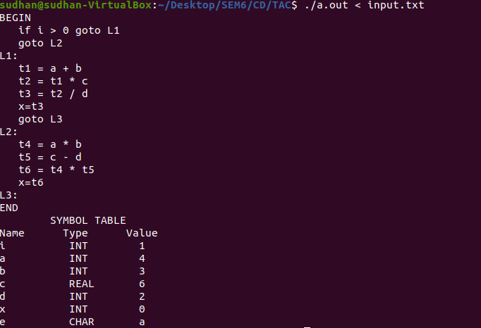

**Learning Outcome:**

* I learnt about the Three address code generation and its working.
* I understood how to generate intermediate code for any give grammar.
* I learnt how to pass structure as datatype to lex.
* I also came to know how to set up union of datatypes and use a type for different stacks.
* Inferred handling of errors in productions and also learnt how to throw errors.

**Result:**

Hence the intermediate code generation has been generated using lex and yacc.

**Name:** Sudharshan R

**Registration Number:** 185001173

**Class:** CSE – C **Semester:** 6

**Compiler Design Lab – Assignment 8**

**Code Optimization**

**AIM:**

To perform code Optimization techniques on intermediate code.

**Code:**

#include<stdio.h>

#include<stdlib.h>

#include<string.h>

void print(char *input)

{

if(input[0]=='\n'||input[0]=='\0')

{

printf("%c",input[0]);

return;

}

int flag=0;

if(input[3]=='+')

{

if(input[2]=='0')

flag=1;

if(input[4]=='0')

flag=4;

}

if(input[3]=='*')

{

if(input[2]=='1')

flag=1;

if(input[4]=='1')

flag=4;

if(input[4]=='2')

flag=5;

}

if(input[3]=='/')

{

if(input[4]=='1')

flag=4;

}

if(input[2]=='p'&&input[3]=='o'&&input[4]=='w')

{

if(input[8]=='2')

flag=2;

}

if(input[3]=='-')

{

if(input[2]=='0')

flag=3;

}

if(input[3]=='-')

{

if(input[4]=='0')

flag=4;

}

if(flag==0)

{

printf("%s",input);

}

else if(flag==1)

{

printf("%c=%c\n",input[0],input[4]);

}

else if(flag==2)

{

printf("%c=%c*%c\n",input[0],input[6],input[6]);

}

else if(flag==3)

{

printf("%c=-%c\n",input[0],input[4]);

}

else if(flag==4)

{

printf("%c=%c\n",input[0],input[2]);

}

else if(flag==5)

{

printf("%c=%c+%c\n",input[0],input[2],input[2]);

}

}

void main(int argc,char *argv[])

{

char input[1000];

FILE *fp = fopen("input.txt", "r");

if(fp == NULL)

{

perror("Unable to open file!");

exit(1);

}

int i=0;

while(fgets(input, sizeof(input), fp) != NULL)

{

print(input);

strcpy(input,"\0");

}

printf("\n");

fclose(fp);

}

**INPUT:**

VERSION 1:

a=x+1

b=x+2

c=x+0

a=y*2

b=y*4

c=y*1

VERSION 2:

a=x-1

b=0-x

c=x-0

a=y/1

b=y/2

c=y/3

REDUCING POW:

a=pow(x,2)

b=pow(y,3)

**OUTPUT:**

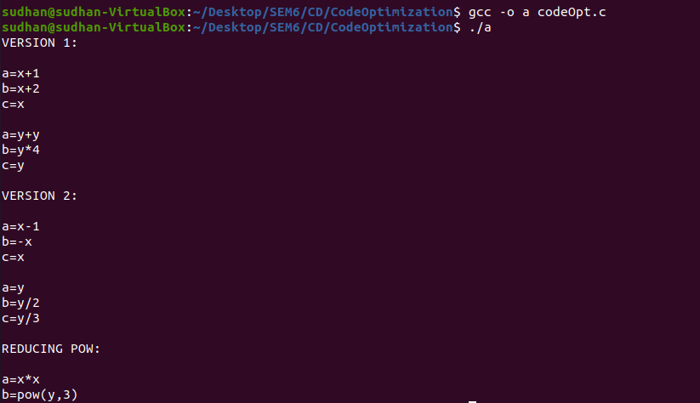

**Learning Outcome:**

* I learnt about the problems of the unoptimized code.
* I understood how to optimize a code provided intermediate code.
* I learnt about Strength reduction techniques in code Optimization.
* I also came to know about pow function reduction.
* Inferred handling + , * compared to /,-.

**Result:**

Hence code optimization has been done for a sample of intermediate codes.