**UCS1712 – GRAPHICS AND MULTIMEDIA LAB**

**Lab Exercise 1**: Study of Basic Output Primitives in C++ using OpenGL

a). To create an output window using OPENGL and to draw the following basic output primitives – POINTS, LINES, LINE_STRIP, LINE_LOOP, TRIANGLES, QUADS, QUAD_STRIP, POLYGON.

b) To create an output window and draw a checkerboard using OpenGL.

c) To create an output window and draw a house using POINTS,LINES,TRAINGLES and QUADS/POLYGON.

**CODE:**

#include<GL/glut.h>

void myInit()

{

glClearColor(1.0, 1.0, 1.0, 1.0);

glColor3f(0.0f, 0.0f, 0.0f);

glPointSize(5);

glMatrixMode(GL_PROJECTION);

glLoadIdentity();

gluOrtho2D(0.0, 1440.0, 0.0, 480.0);

}

void myDispA() {

glClear(GL_COLOR_BUFFER_BIT);

glBegin(GL_POLYGON);

glVertex2d(100, 100);

glVertex2d(150, 230);

glVertex2d(170, 130);

glVertex2d(300, 350);

glEnd();

glFlush();

}

void myDispB()

{

glClear(GL_COLOR_BUFFER_BIT);

glBegin(GL_LINES);

for (int i = 0; i <= 8; i++)

{

glVertex2d(120 + i * 50, 40);

glVertex2d(120 + i * 50, 440);

}

for (int i = 0; i <= 8; i++)

{

glVertex2d(120 , 40 + i * 50);

glVertex2d(520 , 40 + i*50);

}

glEnd();

glBegin(GL_QUADS);

for (int i = 0; i < 4; i++)

{

for (int j = 0; j < 4; j++)

{

glVertex2d(120 + j * 100, 40 + i * 100);

glVertex2d(170 + j * 100, 40 + i * 100);

glVertex2d(170 + j * 100, 90 + i * 100);

glVertex2d(120 + j * 100, 90 + i * 100);

}

for (int j = 0; j < 4; j++)

{

glVertex2d(170 + j * 100, 90 + i * 100);

glVertex2d(220 + j * 100, 90 + i * 100);

glVertex2d(220 + j * 100, 140 + i * 100);

glVertex2d(170 + j * 100, 140 + i * 100);

}

}

glEnd();

glFlush();

}

void myDispC() {

glClear(GL_COLOR_BUFFER_BIT);

glBegin(GL_TRIANGLES);

glVertex2d(320, 440);

glVertex2d(120, 280);

glVertex2d(520, 280);

glEnd();

glBegin(GL_LINE_STRIP);

glVertex2d(170, 280);

glVertex2d(170, 40);

glVertex2d(470, 40);

glVertex2d(470, 280);

glEnd();

glBegin(GL_QUADS);

glVertex2d(220, 200);

glVertex2d(300, 200);

glVertex2d(300, 40);

glVertex2d(220, 40);

glEnd();

glBegin(GL_LINE_LOOP);

glVertex2d(360, 230);

glVertex2d(420, 230);

glVertex2d(420, 170);

glVertex2d(360, 170);

glEnd();

glBegin(GL_QUADS);

glVertex2d(360, 230);

glVertex2d(375, 220);

glVertex2d(375, 180);

glVertex2d(360, 170);

glVertex2d(420, 230);

glVertex2d(405, 220);

glVertex2d(405, 180);

glVertex2d(420, 170);

glEnd();

glFlush();

}

void myDispD()

{

glClear(GL_COLOR_BUFFER_BIT);

glColor3f(0.45f, 0.45f, 0.45f);

glBegin(GL_TRIANGLES);

glVertex2d(120, 390);

glVertex2d(430, 390);

glVertex2d(275, 460);

glVertex2d(1320, 210);

glVertex2d(1170, 210);

glVertex2d(1170, 290);

glEnd();

glBegin(GL_QUADS);

glVertex2d(275, 390);

glVertex2d(275, 440);

glVertex2d(480, 440);

glVertex2d(480, 390);

glVertex2d(470, 210);

glVertex2d(470, 300);

glVertex2d(720, 300);

glVertex2d(720, 210);

glVertex2d(720, 210);

glVertex2d(720, 290);

glVertex2d(1170, 290);

glVertex2d(1170, 210);

glVertex2d(720, 200);

glVertex2d(720, 210);

glVertex2d(1320, 210);

glVertex2d(1320, 200);

glEnd();

glColor3f(1.0f, 0.9f, 0.6f);

glBegin(GL_QUADS);

glVertex2d(120, 40);

glVertex2d(120, 90);

glVertex2d(480, 90);

glVertex2d(480, 40);

glVertex2d(180, 90);

glVertex2d(180, 190);

glVertex2d(480, 190);

glVertex2d(480, 90);

glVertex2d(120, 190);

glVertex2d(120, 240);

glVertex2d(480, 240);

glVertex2d(480, 190);

glVertex2d(480, 210);

glVertex2d(720, 210);

glVertex2d(720, 40);

glVertex2d(480, 40);

glVertex2d(720, 45);

glVertex2d(1020, 45);

glVertex2d(1020, 210);

glVertex2d(720, 210);

glVertex2d(1020, 50);

glVertex2d(1020, 60);

glVertex2d(1320, 60);

glVertex2d(1320, 50);

glVertex2d(1020, 60);

glVertex2d(1020, 190);

glVertex2d(1280, 190);

glVertex2d(1280, 60);

glVertex2d(1020, 190);

glVertex2d(1020, 200);

glVertex2d(1320, 200);

glVertex2d(1320, 190);

glVertex2d(150, 240);

glVertex2d(150, 350);

glVertex2d(470, 350);

glVertex2d(470, 240);

glVertex2d(120, 350);

glVertex2d(120, 390);

glVertex2d(470, 390);

glVertex2d(470, 350);

glEnd();

glBegin(GL_TRIANGLES);

glVertex2d(720, 210);

glVertex2d(720, 300);

glVertex2d(1020, 210);

glEnd();

glColor3f(1.0f, 1.0f, 1.0f);

glBegin(GL_QUADS);

glVertex2d(210, 90);

glVertex2d(210, 180);

glVertex2d(240, 180);

glVertex2d(240, 90);

glVertex2d(250, 90);

glVertex2d(250, 180);

glVertex2d(280, 180);

glVertex2d(280, 90);

glVertex2d(290, 90);

glVertex2d(290, 180);

glVertex2d(320, 180);

glVertex2d(320, 90);

glVertex2d(330, 90);

glVertex2d(330, 180);

glVertex2d(360, 180);

glVertex2d(360, 90);

glVertex2d(490, 70);

glVertex2d(490, 180);

glVertex2d(650, 180);

glVertex2d(650, 70);

glVertex2d(655, 70);

glVertex2d(655, 180);

glVertex2d(680, 180);

glVertex2d(680, 70);

glVertex2d(690, 60);

glVertex2d(690, 190);

glVertex2d(700, 190);

glVertex2d(700, 60);

glVertex2d(750, 70);

glVertex2d(750, 180);

glVertex2d(990, 180);

glVertex2d(990, 70);

glVertex2d(1030, 80);

glVertex2d(1030, 170);

glVertex2d(1200, 170);

glVertex2d(1200, 80);

glVertex2d(170, 240);

glVertex2d(170, 340);

glVertex2d(410, 340);

glVertex2d(410, 240);

glEnd();

glColor3f(0.9f, 0.6f, 0.5f);

glBegin(GL_QUADS);

glVertex2d(1210, 80);

glVertex2d(1210, 170);

glVertex2d(1270, 170);

glVertex2d(1270, 80);

glEnd();

glColor3f(0.0f, 0.0f, 0.0f);

glBegin(GL_LINE_LOOP);

glVertex2d(120,40);

glVertex2d(120,90);

glVertex2d(180,90);

glVertex2d(180,190);

glVertex2d(120,190);

glVertex2d(120,240);

glVertex2d(480,240);

glVertex2d(480,210);

glVertex2d(720,210);

glVertex2d(720,190);

glVertex2d(480,190);

glVertex2d(480,60);

glVertex2d(720,60);

glVertex2d(720,40);

glEnd();

glBegin(GL_LINES);

glVertex2d(1020, 60);

glVertex2d(1320, 60);

glVertex2d(470, 300);

glVertex2d(720, 300);

glVertex2d(470, 390);

glVertex2d(480, 390);

glVertex2d(480, 390);

glVertex2d(480, 440);

glVertex2d(480, 440);

glVertex2d(318, 440);

glVertex2d(1170, 290);

glVertex2d(750, 290);

glEnd();

glBegin(GL_LINE_LOOP);

glVertex2d(210, 90);

glVertex2d(210, 180);

glVertex2d(240, 180);

glVertex2d(240, 90);

glEnd();

glBegin(GL_LINE_LOOP);

glVertex2d(250, 90);

glVertex2d(250, 180);

glVertex2d(280, 180);

glVertex2d(280, 90);

glEnd();

glBegin(GL_LINE_LOOP);

glVertex2d(290, 90);

glVertex2d(290, 180);

glVertex2d(320, 180);

glVertex2d(320, 90);

glEnd();

glBegin(GL_LINE_LOOP);

glVertex2d(330, 90);

glVertex2d(330, 180);

glVertex2d(360, 180);

glVertex2d(360, 90);

glEnd();

glBegin(GL_LINE_LOOP);

glVertex2d(490, 70);

glVertex2d(490, 180);

glVertex2d(650, 180);

glVertex2d(650, 70);

glEnd();

glBegin(GL_LINE_LOOP);

glVertex2d(655, 70);

glVertex2d(655, 180);

glVertex2d(680, 180);

glVertex2d(680, 70);

glEnd();

glBegin(GL_LINE_LOOP);

glVertex2d(690, 60);

glVertex2d(690, 190);

glVertex2d(700, 190);

glVertex2d(700, 60);

glEnd();

glBegin(GL_LINE_LOOP);

glVertex2d(750, 70);

glVertex2d(750, 180);

glVertex2d(990, 180);

glVertex2d(990, 70);

glEnd();

glBegin(GL_LINE_LOOP);

glVertex2d(1030, 80);

glVertex2d(1030, 170);

glVertex2d(1200, 170);

glVertex2d(1200, 80);

glEnd();

glBegin(GL_LINE_LOOP);

glVertex2d(170, 240);

glVertex2d(170, 340);

glVertex2d(410, 340);

glVertex2d(410, 240);

glEnd();

glBegin(GL_LINE_LOOP);

glVertex2d(1210, 80);

glVertex2d(1210, 170);

glVertex2d(1270, 170);

glVertex2d(1270, 80);

glEnd();

glBegin(GL_LINE_LOOP);

glVertex2d(150,240);

glVertex2d(150,350);

glVertex2d(430,350);

glVertex2d(430,240);

glVertex2d(410,240);

glVertex2d(410,340);

glVertex2d(170,340);

glVertex2d(170,240);

glEnd();

glBegin(GL_LINE_LOOP);

glVertex2d(120,350);

glVertex2d(120,390);

glVertex2d(470,390);

glVertex2d(470,240);

glVertex2d(430,240);

glVertex2d(430,350);

glEnd();

glBegin(GL_LINE_LOOP);

glVertex2d(720, 45);

glVertex2d(720, 300);

glVertex2d(1020, 210);

glVertex2d(1020, 45);

glEnd();

glBegin(GL_LINE_LOOP);

glVertex2d(1020, 200);

glVertex2d(1320, 200);

glVertex2d(1320, 190);

glVertex2d(1280, 190);

glVertex2d(1280, 60);

glVertex2d(1320, 60);

glVertex2d(1320, 50);

glVertex2d(1020, 50);

glEnd();

glBegin(GL_LINE_LOOP);

glVertex2d(120, 390);

glVertex2d(430, 390);

glVertex2d(275, 460);

glEnd();

glBegin(GL_LINE_LOOP);

glVertex2d(1320, 210);

glVertex2d(1020, 210);

glVertex2d(1170, 290);

glEnd();

glBegin(GL_QUADS);

glVertex2d(120, 390);

glVertex2d(130, 390);

glVertex2d(275, 455);

glVertex2d(275, 460);

glVertex2d(430, 390);

glVertex2d(420, 390);

glVertex2d(275, 455);

glVertex2d(275, 460);

glVertex2d(1020, 210);

glVertex2d(1030, 210);

glVertex2d(1170, 285);

glVertex2d(1170, 290);

glVertex2d(1320, 210);

glVertex2d(1310, 210);

glVertex2d(1170, 285);

glVertex2d(1170, 290);

glVertex2d(130, 240);

glVertex2d(135, 240);

glVertex2d(135, 350);

glVertex2d(130, 350);

glVertex2d(430, 240);

glVertex2d(425, 240);

glVertex2d(425, 350);

glVertex2d(430, 350);

glVertex2d(130, 270);

glVertex2d(130, 267);

glVertex2d(430, 267);

glVertex2d(430, 270);

for (int i = 1; i < 10; i++)

{

glVertex2d(130 + i * 30, 240);

glVertex2d(132 + i * 30, 240);

glVertex2d(132 + i * 30, 270);

glVertex2d(130 + i * 30, 270);

}

glVertex2d(1290, 60);

glVertex2d(1290, 190);

glVertex2d(1292, 190);

glVertex2d(1292, 60);

glVertex2d(1310, 60);

glVertex2d(1310, 190);

glVertex2d(1312, 190);

glVertex2d(1312, 60);

glVertex2d(140, 90);

glVertex2d(140, 190);

glVertex2d(142, 190);

glVertex2d(142, 90);

glVertex2d(160, 90);

glVertex2d(160, 190);

glVertex2d(162, 190);

glVertex2d(162, 90);

glEnd();

glBegin(GL_POINTS);

glVertex2d(1220, 120);

glEnd();

glFlush();

}

int main(int argc, char* argv[])

{

glutInit(&argc, argv);

glutInitDisplayMode(GLUT_SINGLE | GLUT_RGB);

glutInitWindowSize(1440, 480);

glutCreateWindow("Exercise1");

glutDisplayFunc(myDispD); //To be changed for each function

myInit();

glutMainLoop();

return 1;

}

**Output:**

Polygon:

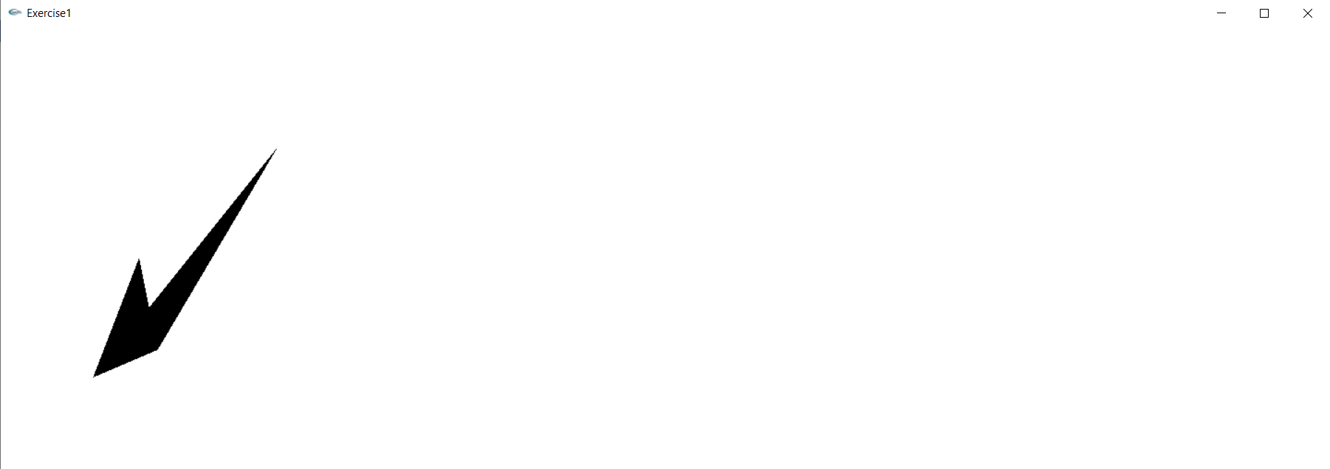

Checker Board:

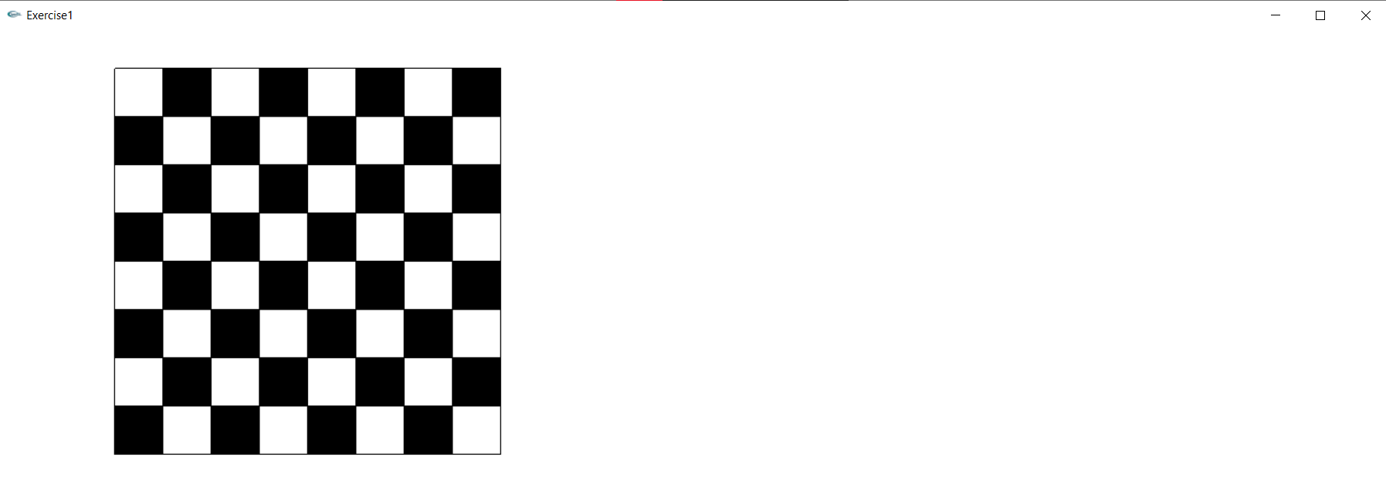

House:

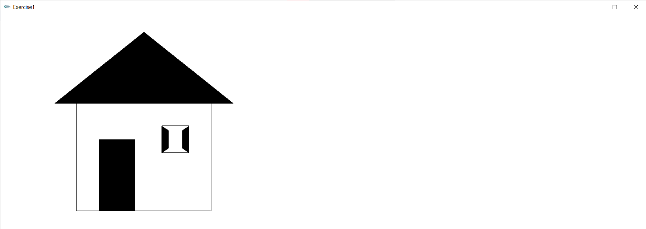

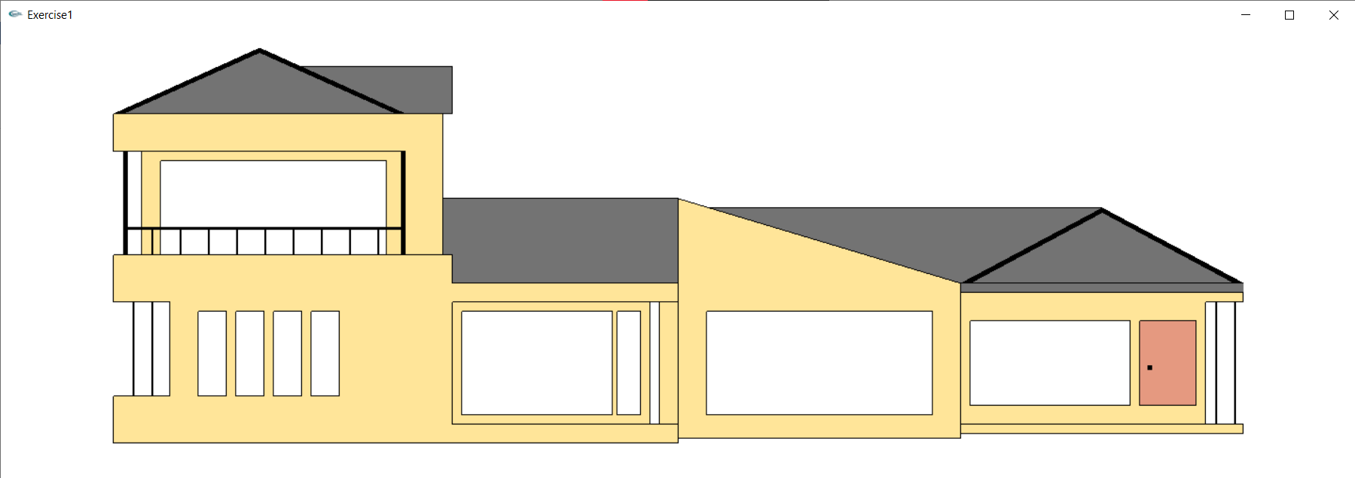

**Result:**

Thus Basic Output primitives have been studied and executed.