**Lab Exercise 11: Image Editing and Manipulation**

**Aim:**

To perform the below operations using GIMP, include an image and apply filters, noise and masks. To create a GIF animated image.

**Data:**

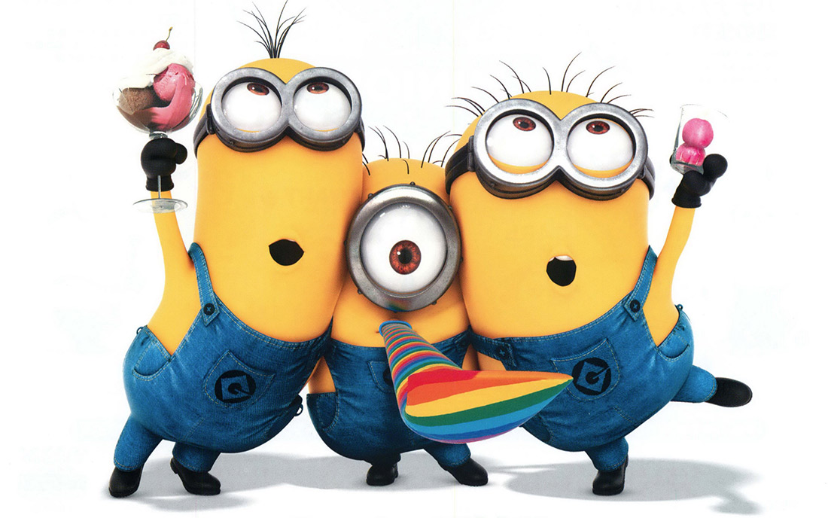

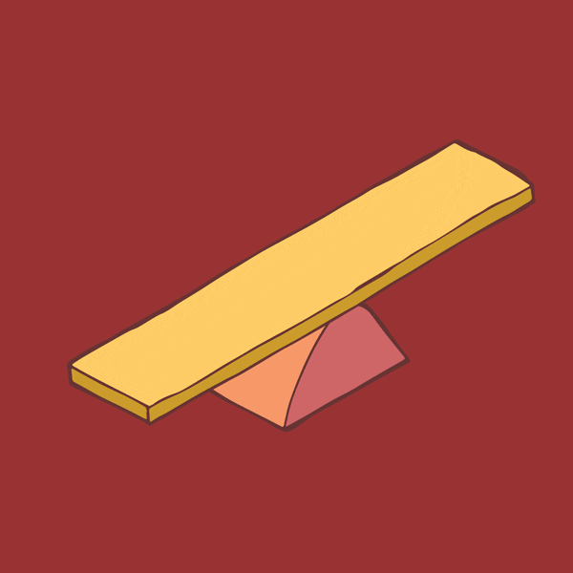 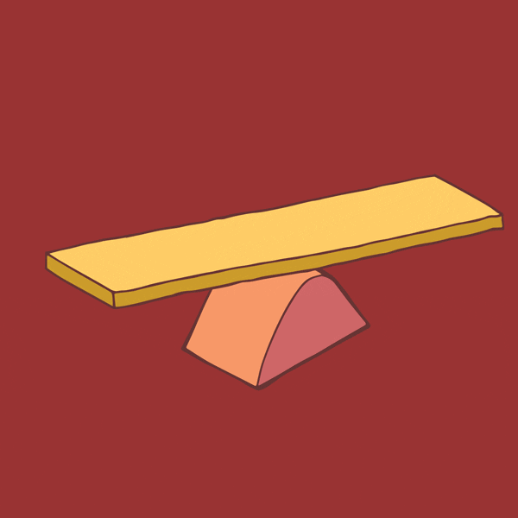

**Output:**

Noise and Masks

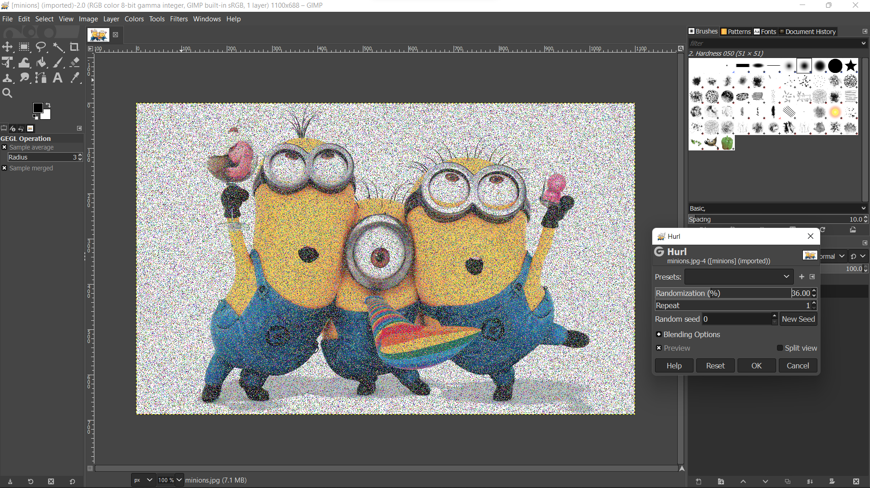

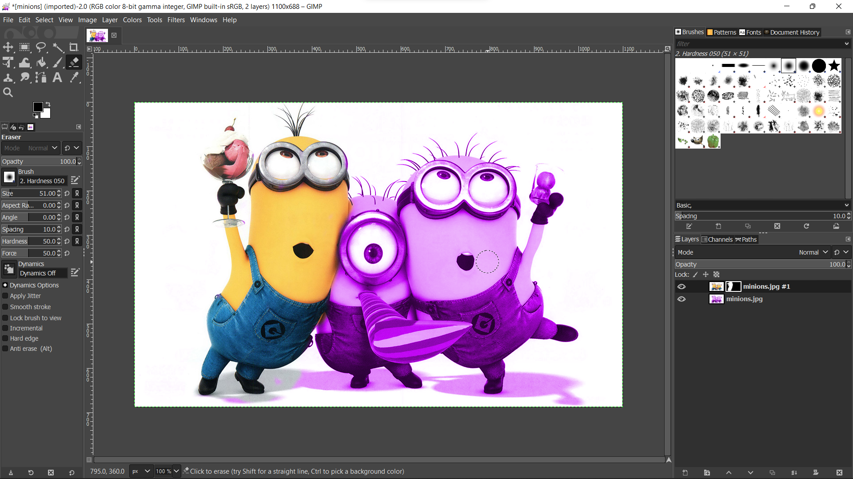

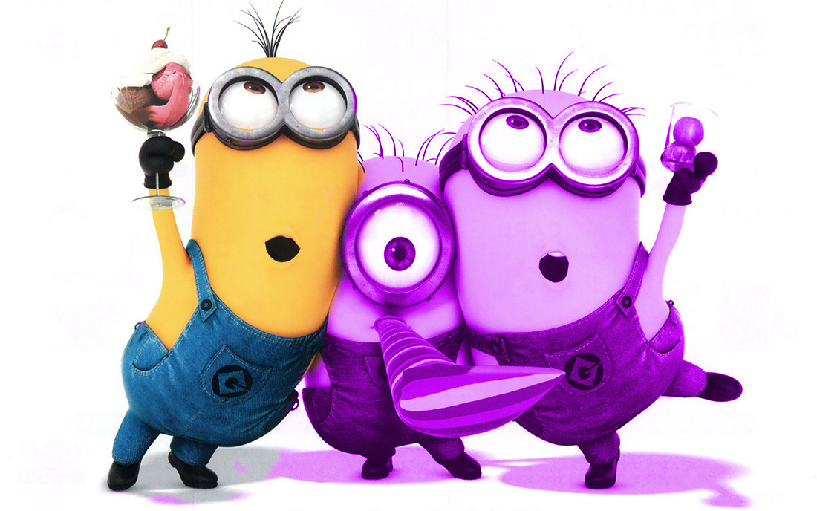

GIF Animated Image

Frame 0



Frame 1

