**Lab Exercise 5: 2D Transformations in C++ using OpenGL**

To apply the following 2D transformations on objects and to render the final output along with the original object.

1) Translation

2) Rotation

a) About origin

b) With respect to a fixed point (xr,yr)

3) Scaling with respect to

a) Origin - Uniform Vs Differential Scaling

b) Fixed point (xf,yf)

4) Reflection with respect to

a) X-axis

b) Y-axis

c) Origin

d) The line x=y

5) Shearing

a) x-direction shear

b) y-direction shear

Note: Use Homogeneous coordinate representations and matrix multiplication to perform transformations. Divide the output window into four quadrants. (Use LINES primitive to draw x and y axis

**CODE:**

#include<bits/stdc++.h>

#include <GL/glut.h>

constexpr auto PI = 3.14;

using namespace std;

vector<pair<int, int>> coords;

int n;

int tx, ty;

int xr, yr;

int xf, yf;

double sx, sy;

double ang, angRad;

double shx, shy;

void myInit(void)

{

glClearColor(1.0, 1.0, 1.0, 1.0);

glColor3f(0.0f, 0.0f, 0.0f);

glPointSize(4.0);

glMatrixMode(GL_PROJECTION);

glLoadIdentity();

gluOrtho2D(-500, 500, -500, 500);

}

void DrawCartesianPlane() {

glBegin(GL_LINES);

glColor3f(0.0, 0.0, 0.0);

glVertex2d(-500, 0);

glVertex2d(500, 0);

glVertex2d(0, -500);

glVertex2d(0, 500);

glEnd();

}

void drawPolygon()

{

glBegin(GL_LINE_LOOP);

glColor3f(0.0, 0.0, 0.0);

for (int i = 0; i < n; i++)

{

glVertex2d(coords[i].first, coords[i].second);

}

glEnd();

}

void drawPolygonTrans()

{

glBegin(GL_LINE_LOOP);

glColor3f(1.0, 0.0, 0.0);

for (int i = 0; i < n; i++)

{

glVertex2d(coords[i].first+tx, coords[i].second+ty);

}

glEnd();

}

void rotatePolygonOrigin() {

glBegin(GL_LINE_LOOP);

glColor3f(0.0, 0.0, 1.0);

for (int i = 0; i < n; i++)

{

glVertex2d(round(coords[i].first * cos(angRad)-coords[i].second*sin(angRad)), round(coords[i].first * sin(angRad)+ coords[i].second * cos(angRad)));

}

glEnd();

}

void rotatePolygonFixed() {

glBegin(GL_LINE_LOOP);

glColor3f(1.0, 0.0, 1.0);

vector<pair<int, int>> newCoords;

vector<vector<double>> rotatingMatrix(3, vector<double>(3, 0));

vector<double> curpoint(3, 0), matProduct(3, 0);

rotatingMatrix[0][0] = cos(angRad);

rotatingMatrix[1][1] = cos(angRad);

rotatingMatrix[2][2] = 1;

rotatingMatrix[1][0] = sin(angRad);

rotatingMatrix[0][1] = -1*sin(angRad);

rotatingMatrix[0][2] = xr * (1 - cos(angRad)) + yr * sin(angRad);

rotatingMatrix[1][2] = yr * (1 - cos(angRad)) - xr * sin(angRad);

for (int i = 0; i < n; i++) {

curpoint[0] = coords[i].first;

curpoint[1] = coords[i].second;

curpoint[2] = 1;

matProduct[0] = 0;

matProduct[1] = 0;

matProduct[2] = 0;

for (int j = 0; j < 3; j++) {

for (int k = 0; k < 3; k++) {

matProduct[j] += rotatingMatrix[j][k] * curpoint[k];

}

}

newCoords.push_back(make_pair(round(matProduct[0]), round(matProduct[1])));

}

for (int i = 0; i < n; i++)

{

glVertex2d(newCoords[i].first, newCoords[i].second);

}

glEnd();

}

void scalePolygonOrigin() {

glBegin(GL_LINE_LOOP);

glColor3f(0.0, 1.0, 0.0);

for (int i = 0; i < n; i++)

{

glVertex2d(round(coords[i].first*sx), round(coords[i].second*sy));

}

glEnd();

}

void scalePolygonFixed() {

glBegin(GL_LINE_LOOP);

glColor3f(1.0, 1.0, 0.0);

vector<pair<int,int>> newCoords;

vector<vector<double>> scalingMatrix(3, vector<double>(3, 0));

vector<double> curpoint(3,0), matProduct(3, 0);

scalingMatrix[0][0] = sx;

scalingMatrix[1][1] = sy;

scalingMatrix[2][2] = 1;

scalingMatrix[0][2] = xf * (1 - sx);

scalingMatrix[1][2] = yf * (1 - sy);

for (int i = 0; i < n; i++) {

curpoint[0] = coords[i].first;

curpoint[1] = coords[i].second;

curpoint[2] = 1;

matProduct[0] = 0;

matProduct[1] = 0;

matProduct[2] = 0;

for (int j = 0; j < 3; j++) {

for (int k = 0; k < 3; k++) {

matProduct[j] += scalingMatrix[j][k] * curpoint[k];

}

}

newCoords.push_back(make_pair(round(matProduct[0]), round(matProduct[1])));

}

for (int i = 0; i < n; i++)

{

glVertex2d(newCoords[i].first, newCoords[i].second);

}

glEnd();

}

void reflection_Xaxis() {

glBegin(GL_LINE_LOOP);

glColor3f(1.0, 0.5, 0.0);

vector<pair<int, int>> newCoords;

vector<vector<double>> reflectMatrix(3, vector<double>(3, 0));

vector<double> curpoint(3, 0), matProduct(3, 0);

reflectMatrix[0][0] = 1;

reflectMatrix[1][1] = -1;

reflectMatrix[2][2] = 1;

for (int i = 0; i < n; i++) {

curpoint[0] = coords[i].first;

curpoint[1] = coords[i].second;

curpoint[2] = 1;

matProduct[0] = 0;

matProduct[1] = 0;

matProduct[2] = 0;

for (int j = 0; j < 3; j++) {

for (int k = 0; k < 3; k++) {

matProduct[j] += reflectMatrix[j][k] * curpoint[k];

}

}

newCoords.push_back(make_pair(round(matProduct[0]), round(matProduct[1])));

}

for (int i = 0; i < n; i++)

{

glVertex2d(newCoords[i].first, newCoords[i].second);

}

glEnd();

}

void reflection_Yaxis() {

glBegin(GL_LINE_LOOP);

glColor3f(1.0, 0.5, 0.0);

vector<pair<int, int>> newCoords;

vector<vector<double>> reflectMatrix(3, vector<double>(3, 0));

vector<double> curpoint(3, 0), matProduct(3, 0);

reflectMatrix[0][0] = -1;

reflectMatrix[1][1] = 1;

reflectMatrix[2][2] = 1;

for (int i = 0; i < n; i++) {

curpoint[0] = coords[i].first;

curpoint[1] = coords[i].second;

curpoint[2] = 1;

matProduct[0] = 0;

matProduct[1] = 0;

matProduct[2] = 0;

for (int j = 0; j < 3; j++) {

for (int k = 0; k < 3; k++) {

matProduct[j] += reflectMatrix[j][k] * curpoint[k];

}

}

newCoords.push_back(make_pair(round(matProduct[0]), round(matProduct[1])));

}

for (int i = 0; i < n; i++)

{

glVertex2d(newCoords[i].first, newCoords[i].second);

}

glEnd();

}

void reflection_origin() {

glBegin(GL_LINE_LOOP);

glColor3f(1.0, 0.5, 0.0);

vector<pair<int, int>> newCoords;

vector<vector<double>> reflectMatrix(3, vector<double>(3, 0));

vector<double> curpoint(3, 0), matProduct(3, 0);

reflectMatrix[0][0] = -1;

reflectMatrix[1][1] = -1;

reflectMatrix[2][2] = 1;

for (int i = 0; i < n; i++) {

curpoint[0] = coords[i].first;

curpoint[1] = coords[i].second;

curpoint[2] = 1;

matProduct[0] = 0;

matProduct[1] = 0;

matProduct[2] = 0;

for (int j = 0; j < 3; j++) {

for (int k = 0; k < 3; k++) {

matProduct[j] += reflectMatrix[j][k] * curpoint[k];

}

}

newCoords.push_back(make_pair(round(matProduct[0]), round(matProduct[1])));

}

for (int i = 0; i < n; i++)

{

glVertex2d(newCoords[i].first, newCoords[i].second);

}

glEnd();

}

void reflection_XeqYline() {

glBegin(GL_LINE_LOOP);

glColor3f(1.0, 0.5, 0.0);

vector<pair<int, int>> newCoords;

vector<vector<double>> reflectMatrix(3, vector<double>(3, 0));

vector<double> curpoint(3, 0), matProduct(3, 0);

reflectMatrix[0][1] = 1;

reflectMatrix[1][0] = 1;

reflectMatrix[2][2] = 1;

for (int i = 0; i < n; i++) {

curpoint[0] = coords[i].first;

curpoint[1] = coords[i].second;

curpoint[2] = 1;

matProduct[0] = 0;

matProduct[1] = 0;

matProduct[2] = 0;

for (int j = 0; j < 3; j++) {

for (int k = 0; k < 3; k++) {

matProduct[j] += reflectMatrix[j][k] * curpoint[k];

}

}

newCoords.push_back(make_pair(round(matProduct[0]), round(matProduct[1])));

}

for (int i = 0; i < n; i++)

{

glVertex2d(newCoords[i].first, newCoords[i].second);

}

glEnd();

}

void x_directionShear() {

glBegin(GL_LINE_LOOP);

glColor3f(0.0, 1.0, 1.0);

vector<pair<int, int>> newCoords;

vector<vector<double>> shearMatrix(3, vector<double>(3, 0));

vector<double> curpoint(3, 0), matProduct(3, 0);

shearMatrix[0][0] = 1;

shearMatrix[1][1] = 1;

shearMatrix[2][2] = 1;

shearMatrix[0][1] = shx;

for (int i = 0; i < n; i++) {

curpoint[0] = coords[i].first;

curpoint[1] = coords[i].second;

curpoint[2] = 1;

matProduct[0] = 0;

matProduct[1] = 0;

matProduct[2] = 0;

for (int j = 0; j < 3; j++) {

for (int k = 0; k < 3; k++) {

matProduct[j] += shearMatrix[j][k] * curpoint[k];

}

}

newCoords.push_back(make_pair(round(matProduct[0]), round(matProduct[1])));

}

for (int i = 0; i < n; i++)

{

glVertex2d(newCoords[i].first, newCoords[i].second);

}

glEnd();

}

void y_directionShear() {

glBegin(GL_LINE_LOOP);

glColor3f(1.0, 0.0, 0.5);

vector<pair<int, int>> newCoords;

vector<vector<double>> shearMatrix(3, vector<double>(3, 0));

vector<double> curpoint(3, 0), matProduct(3, 0);

shearMatrix[0][0] = 1;

shearMatrix[1][1] = 1;

shearMatrix[2][2] = 1;

shearMatrix[1][0] = shy;

for (int i = 0; i < n; i++) {

curpoint[0] = coords[i].first;

curpoint[1] = coords[i].second;

curpoint[2] = 1;

matProduct[0] = 0;

matProduct[1] = 0;

matProduct[2] = 0;

for (int j = 0; j < 3; j++) {

for (int k = 0; k < 3; k++) {

matProduct[j] += shearMatrix[j][k] * curpoint[k];

}

}

newCoords.push_back(make_pair(round(matProduct[0]), round(matProduct[1])));

}

for (int i = 0; i < n; i++)

{

glVertex2d(newCoords[i].first, newCoords[i].second);

}

glEnd();

}

void myDisplay()

{

glClear(GL_COLOR_BUFFER_BIT);

glColor3f(0.0, 0.0, 0.0);

DrawCartesianPlane();

drawPolygon();

drawPolygonTrans();

scalePolygonOrigin();

scalePolygonFixed();

rotatePolygonOrigin();

rotatePolygonFixed();

reflection_Xaxis();

reflection_Yaxis();

reflection_origin();

reflection_XeqYline();

x_directionShear();

y_directionShear();

glFlush();

}

int main(int argc, char** argv)

{

cout << "Specify polygon Dimensions" << endl;

cout << "Enter the number of vertices : ";

cin >> n;

int x, y;

for (int i = 0; i < n; i++)

{

cout << "Enter vertex " << i + 1 << "(x,y) : ";

cin >> x >> y;

coords.push_back(make_pair(x,y));

}

cout << "Enter the translation factor for X and Y: ";

cin >> tx >> ty;

cout << "Enter the angle of rotation: ";

cin >> ang;

angRad = ang * PI / 180;

cout << "Enter the point to rotate about: ";

cin >> xr >> yr;

cout << "Enter the Scaling factor for X and Y : ";

cin >> sx >> sy;

cout << "Enter the point to scale (x,y): ";

cin >> xf >> yf;

cout << "Enter shear parameter for x-direction shear: ";

cin >> shx;

cout << "Enter shear parameter for y-direction shear: ";

cin >> shy;

cout << "Original polygon -> Black Color" << endl;

cout << "Translated polygon -> Red Color" << endl;

cout << "Rotated Polygon : " << endl;

cout << " about origin -> Dark Blue Color" << endl;

cout << " about fixed point -> Purple Color" << endl;

cout << "Scaled Polygon : " << endl;

cout << " about origin -> Green Color" << endl;

cout << " about fixed point -> Yellow Color" << endl;

cout << "Reflection Polygons -> Orange Color" << endl;

cout << "X-Direction Shear -> Light Blue Color" << endl;

cout << "Y-Direction Shear -> Pink Color" << endl;

glutInit(&argc, argv);

glutInitDisplayMode(GLUT_SINGLE | GLUT_RGB);

glutInitWindowSize(1000, 1000);

glutCreateWindow("Transformation");

glutDisplayFunc(myDisplay);

myInit();

glutMainLoop();

return 0;

}

**OUTPUT:**

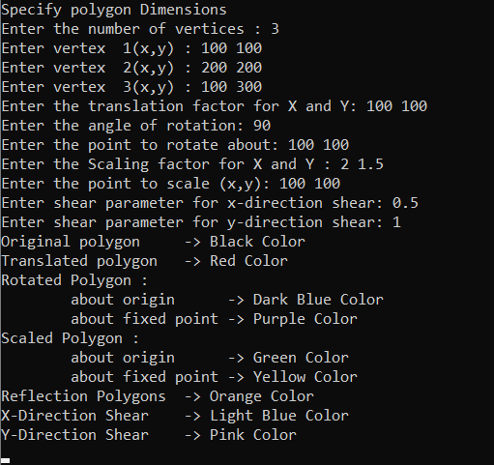

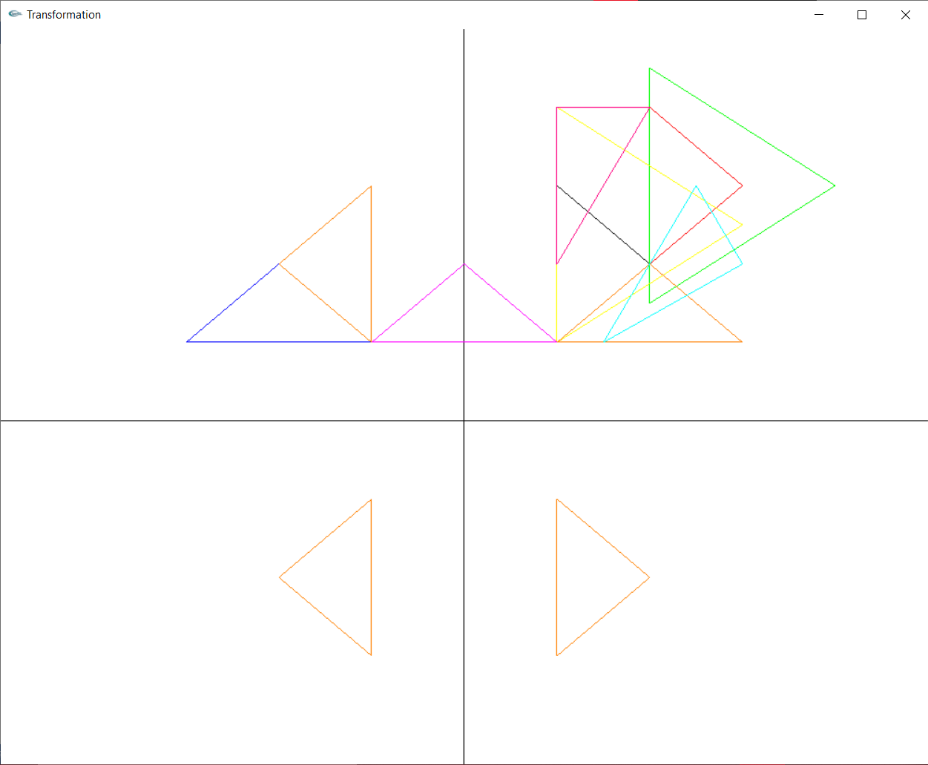

Translation:

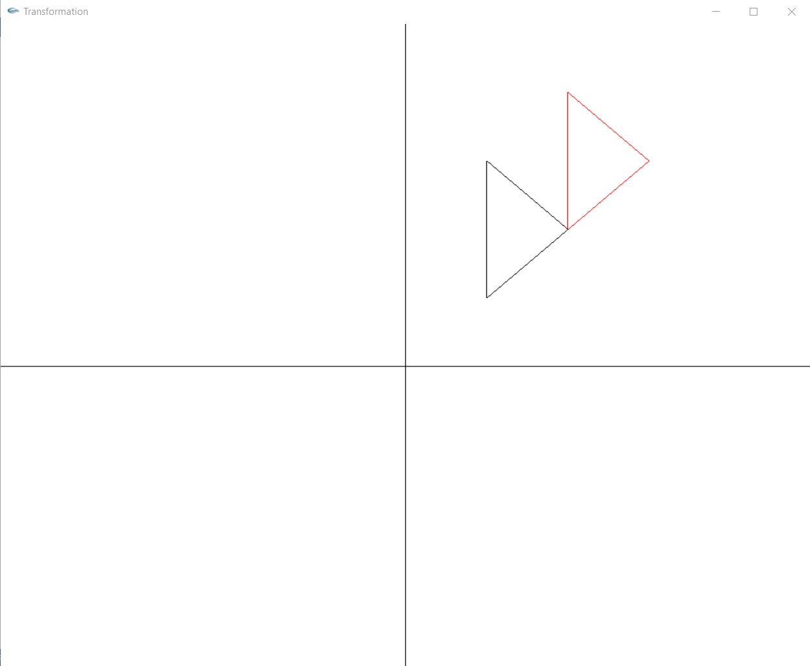

Rotation:

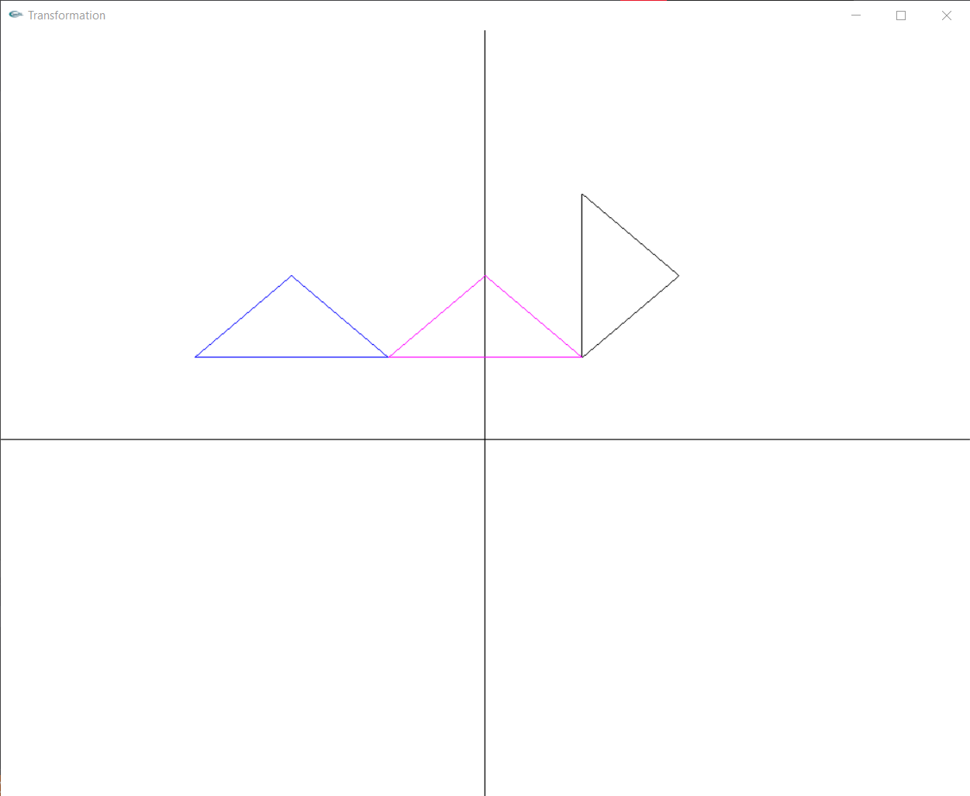

Scaling:

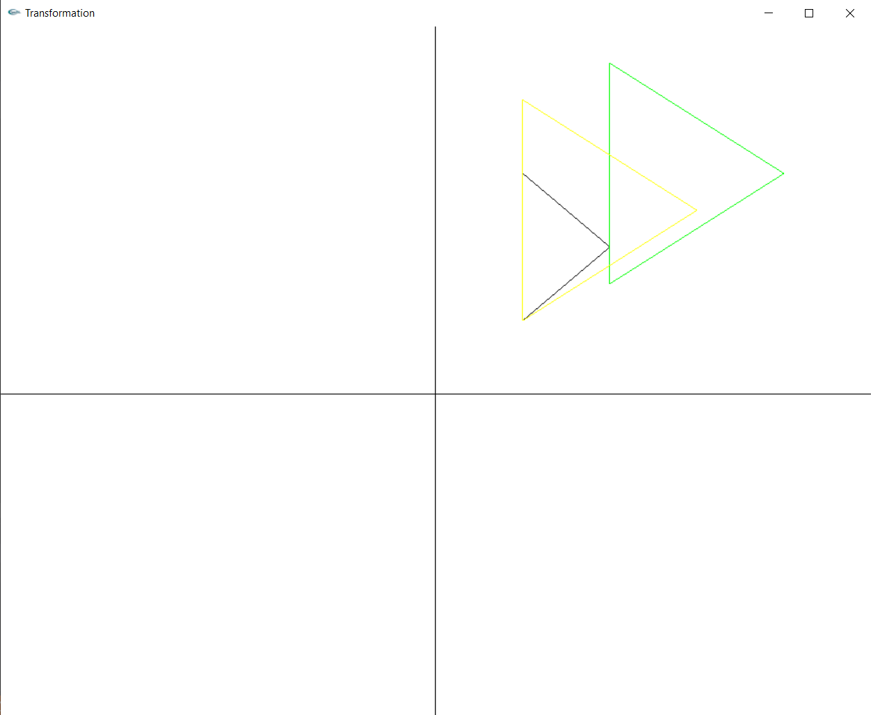

Reflection:

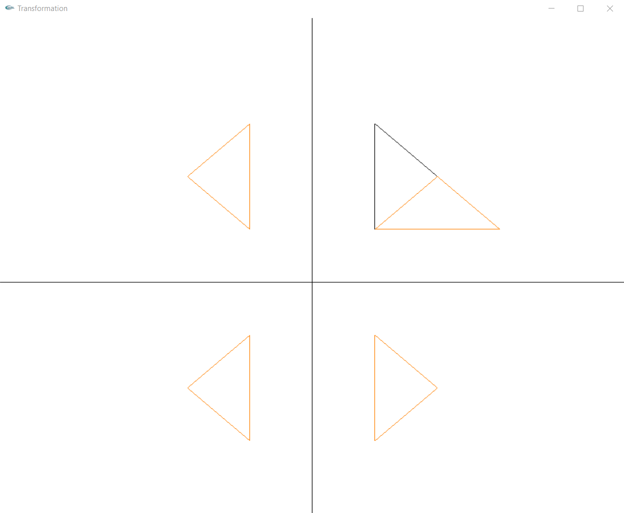

Shearing:

