Name: Sudharshan R

Reg:185001173

Class: CSE-C

Exercise 5: Profile Servlet using Session and MySQL

AIM:

Implement Profile Servlet using Http Sessions. The specifications are given below.

Code:

Index.html

<!DOCTYPE html>

<html>

<head>

    <title>Login</title>

    <link rel="stylesheet" href="formstyle.css">

</head>

<body>

    <div class="formblock centre" style="height:50%;">

    <form class="centre" name="login" action="./loginServlet">

        <input type='text' id="name" name="name" placeholder="Username"><br><br>

        <input type='password' id="pass" name="pass" placeholder="Password"><br><br>

        <input type="submit" value="Login">

    </form>

    </div>

</body>

</html>

loginServlet.java

import java.sql.\*;

import java.io.\*;

import javax.servlet.\*;

import javax.servlet.http.\*;

public class loginServlet extends HttpServlet {

    public void doGet(HttpServletRequest request,HttpServletResponse response) throws ServletException, IOException {

        response.setContentType("text/html");

        PrintWriter pw=response.getWriter();

        int flag=0;

        Connection con;

        PreparedStatement ps;

        Statement st;

        CallableStatement cs;

        ResultSet rs;

        try

        {

            Class.forName("com.mysql.cj.jdbc.Driver");

            try

            {

                flag=1;

                con =DriverManager.getConnection("jdbc:mysql://localhost:3306/profile","root","Sun@0097");

                try

                {

                    String srch = "SELECT name,pass FROM data WHERE name=\""+(String)request.getParameter("name")+"\" and pass=\""+(String)request.getParameter("pass")+"\";";

                    st=con.createStatement();

                    rs=st.executeQuery(srch);

                    if(rs.next()){

                        HttpSession ses=request.getSession(true);

                        ses.setAttribute("uname",(String)request.getParameter("name"));

                        pw.println("<html>");

                        pw.println("<head>");

                        pw.println("<link rel=\"stylesheet\" href=\"viewstyle.css\">");

                        pw.println("</head>");

                        pw.println("<body>");

                        pw.println("<div class=\"formblock centre\">");

                        pw.println("<h1>  Welcome "+(String)request.getParameter("name")+"</h1><br><br>");

                        pw.println("<script>");

                        pw.println("alert(\"login Successfully \");");

                        pw.println("</script>");

                        pw.println("<button style=\"height:10%;width:auto;\" onclick='location.replace(\"./viewProfile\");'>view profile</button>");

                        pw.println("</div>");

                        pw.println("</body>");

                        pw.println("</html>");

                    }

                    else{

                        pw.println("<script>");

                        pw.println("alert(\"username/password invalid\");");

                        pw.println("location='http://localhost:8080/LabEX5/index.html';");

                        pw.println("</script>");

                    }

                }

                catch(SQLException e)

                {

                    pw.println("<script>");

                    pw.println("alert("+e+");");

                    pw.println("location='http://localhost:8080/LabEX5/index.html';");

                    pw.println("</script>");

                }

            }

            catch (SQLException e)

            {

                flag=2;

            }

        }

        catch(ClassNotFoundException e)

        {

            flag=3;

        }

        if(flag==2)

        {

            pw.println("<script>");

            pw.println("alert(\"Failed to establish connection.Try again Later. Error Code :1 \");");

            pw.println("location='http://localhost:8080/LabEX5/index.html';");

            pw.println("</script>");

        }

        else if(flag==3)

        {

            pw.println("<script>");

            pw.println("alert(\"Driver class not found.Error Code :0 \");");

            pw.println("location='http://localhost:8080/LabEX5/index.html';");

            pw.println("</script>");

        }

        pw.close();

    }

}

viewProfile.java

import java.sql.\*;

import java.io.\*;

import javax.servlet.\*;

import javax.servlet.http.\*;

public class viewProfile extends HttpServlet {

    public void doGet(HttpServletRequest request,HttpServletResponse response) throws ServletException, IOException {

        response.setContentType("text/html");

        PrintWriter pw=response.getWriter();

        int flag=0;

        Connection con;

        PreparedStatement ps;

        Statement st;

        CallableStatement cs;

        ResultSet rs;

        try

        {

            Class.forName("com.mysql.cj.jdbc.Driver");

            try

            {

                flag=1;

                con =DriverManager.getConnection("jdbc:mysql://localhost:3306/profile","root","Sun@0097");

                try

                {

                    HttpSession ses=request.getSession(false);

                    String srch = " SELECT \* FROM data WHERE name=\""+(String)ses.getAttribute("uname")+"\";";

                    st=con.createStatement();

                    rs=st.executeQuery(srch);

                    if(rs.next()){

                        pw.println("<link rel=\"stylesheet\" href=\"viewstyle.css\">");

                        pw.println("<div class=\"formblock centre\">");

                        pw.println("<table border=\'1px\'>");

                        pw.println("<thead>");

                        pw.println("<tr><th>Attribute</th><th>Value</th></tr>");

                        pw.println("</thead>");

                        pw.println("<tbody>");

                        pw.println("<tr><td>Name</td><td>"+rs.getString(1)+"</td></tr>");

                        pw.println("<tr><td>Age</td><td>"+rs.getString(3)+"</td></tr>");

                        pw.println("<tr><td>Date Of Birth</td><td>"+rs.getString(4)+"</td></tr>");

                        pw.println("<tr><td>Address</td><td>"+rs.getString(5)+"</td></tr>");

                        pw.println("<tr><td>Mobile</td><td>"+rs.getString(6)+"</td></tr>");

                        pw.println("<tr><td>Occupation</td><td>"+rs.getString(7)+"</td></tr>");

                        pw.println("</tbody>");

                        pw.println("</table>");

                        pw.println("<button style=\"height:10%;\" onclick='location.replace(\"./logout\");'>logout</button>");

                        pw.println("</div>");

                    }

                    else{

                        pw.println("<script>");

                        pw.println("alert(\"Could not load data\");");

                        pw.println("location='http://localhost:8080/LabEX5/index.html';");

                        pw.println("</script>");

                    }

                }

                catch(SQLException e)

                {

                    pw.println("<script>");

                    pw.println("alert("+e+");");

                    pw.println("location='http://localhost:8080/LabEX5/index.html';");

                    pw.println("</script>");

                }

            }

            catch (SQLException e)

            {

                flag=2;

            }

        }

        catch(ClassNotFoundException e)

        {

            flag=3;

        }

        if(flag==2)

        {

            pw.println("<script>");

            pw.println("alert(\"Failed to establish connection.Try again Later. Error Code :1 \");");

            pw.println("location='http://localhost:8080/LabEX5/index.html';");

            pw.println("</script>");

        }

        else if(flag==3)

        {

            pw.println("<script>");

            pw.println("alert(\"Driver class not found.Error Code :0 \");");

            pw.println("location='http://localhost:8080/LabEX5/index.html';");

            pw.println("</script>");

        }

        pw.close();

    }

}

Logout.java

import java.io.\*;

import javax.servlet.\*;

import javax.servlet.http.\*;

public class logout extends HttpServlet {

    public void doGet(HttpServletRequest request,HttpServletResponse response) throws ServletException, IOException{

        HttpSession ses = request.getSession();

        PrintWriter pw=response.getWriter();

        ses.invalidate();

        pw.println("<script>");

        pw.println("alert(\"Logged out Successfully\");");

        pw.println("location='http://localhost:8080/LabEX5/index.html';");

        pw.println("</script>");

    }

}

Viewstyle.css

.formblock{

    display:flex;

    border-radius:50px;

    background:#191919;

    width:60%;

    height:90%;

}

.centre{

    margin: 0;

    position: absolute;

    top: 50%;

    left: 50%;

    -ms-transform: translate(-50%, -50%);

    transform: translate(-50%, -50%);

    color:white;

    text-align:center;

}

.centre button{

    background:none;

    display:block;

    margin:5px auto;

    text-align:center;

    border:2px solid green;

    width:20%;

    padding-top:10px;

    padding-bottom: 10px;

    outline:none;

    color:white;

    border-radius:20px;

}

.centre button:hover{

    border:2px solid green;

    cursor:pointer;

    background: #2ecc71;

}

body{

    background: #34495e;

}

table{

    border:2px solid blue;

    border-collapse:collapse;

    margin-left :auto;

    margin-right :auto;

    transform: translateY(100%);

    table-layout:auto;

    width:60%;

    color:white;

}

thead

{

    background:none;

}

td{

    margin-left :auto;

    margin-right: auto;

    padding-left: 15px;

    border:2px solid blue;

    border-collapse:collapse;

    background:none;

}

td:hover

{

    background:#2ecc71 ;

}

Formstyle.css

.formblock{

    display:flex;

    border-radius:50px;

    background:#191919;

    width:30%;

    height:90%;

    text-align:center;

}

.centre{

    margin: 0;

    position: absolute;

    top: 50%;

    left: 50%;

    -ms-transform: translate(-50%, -50%);

    transform: translate(-50%, -50%);

    color:white;

}

.centre input[type='text'],.centre input[type='number'],.centre input[type='password'],.centre input[type='date'],.centre textarea,.centre input[type='submit']{

    background:none;

    display:block;

    margin:5px auto;

    text-align:center;

    border:2px solid blue;

    width:110%;

    transform:translateX(-6%);

    padding-top:10px;

    padding-bottom: 10px;

    outline:none;

    color:white;

    border-radius:20px;

}

body{

    background: #34495e;

}

.centre input[type='text']:focus,.centre input[type='number']:focus,.centre input[type='date']:focus,.centre textarea:focus,.centre input[type='password']:focus{

    width:130%;

    transform:translateX(-12%);

}

.slct{

    background:none;

    display:block;

    margin:5px auto;

    text-align-last:center;

    border:2px solid blue;

    width:110%;

    transform:translateX(-6%);

    padding-top:10px;

    padding-bottom: 10px;

    outline:none;

    color:white;

    border-radius:20px;

}

.slct option{

    background: none;

    color:black;

}

.centre input[type='submit']{

    border:2px solid green;

    width:50%;

}

.centre input[type='submit']:hover{

    border:2px solid green;

    cursor:pointer;

    background: #2ecc71;

}

.centre input[type='button']{

    background:none;

    display:block;

    margin:5px auto;

    text-align:center;

    border:2px solid green;

    width:50%;

    padding-top:10px;

    padding-bottom: 10px;

    outline:none;

    color:white;

    border-radius:20px;

}

.centre input[type='button']:hover{

    border:2px solid green;

    cursor:pointer;

    background: #2ecc71;

}

Web.xml

<web-app>

<servlet>

    <servlet-name>loginServlet</servlet-name>

    <servlet-class>loginServlet</servlet-class>

</servlet>

<servlet-mapping>

    <servlet-name>loginServlet</servlet-name>

    <url-pattern>/loginServlet</url-pattern>

</servlet-mapping>

<servlet>

    <servlet-name>viewProfile</servlet-name>

    <servlet-class>viewProfile</servlet-class>

</servlet>

<servlet-mapping>

    <servlet-name>viewProfile</servlet-name>

    <url-pattern>/viewProfile</url-pattern>

</servlet-mapping>

<servlet>

    <servlet-name>logout</servlet-name>

    <servlet-class>logout</servlet-class>

</servlet>

<servlet-mapping>

    <servlet-name>logout</servlet-name>

    <url-pattern>/logout</url-pattern>

</servlet-mapping>

</web-app>

Output Screenshots:

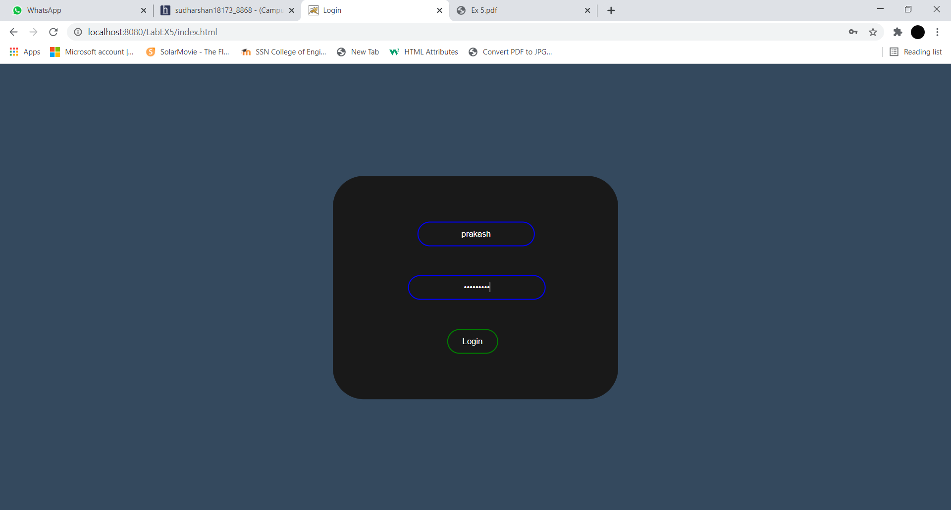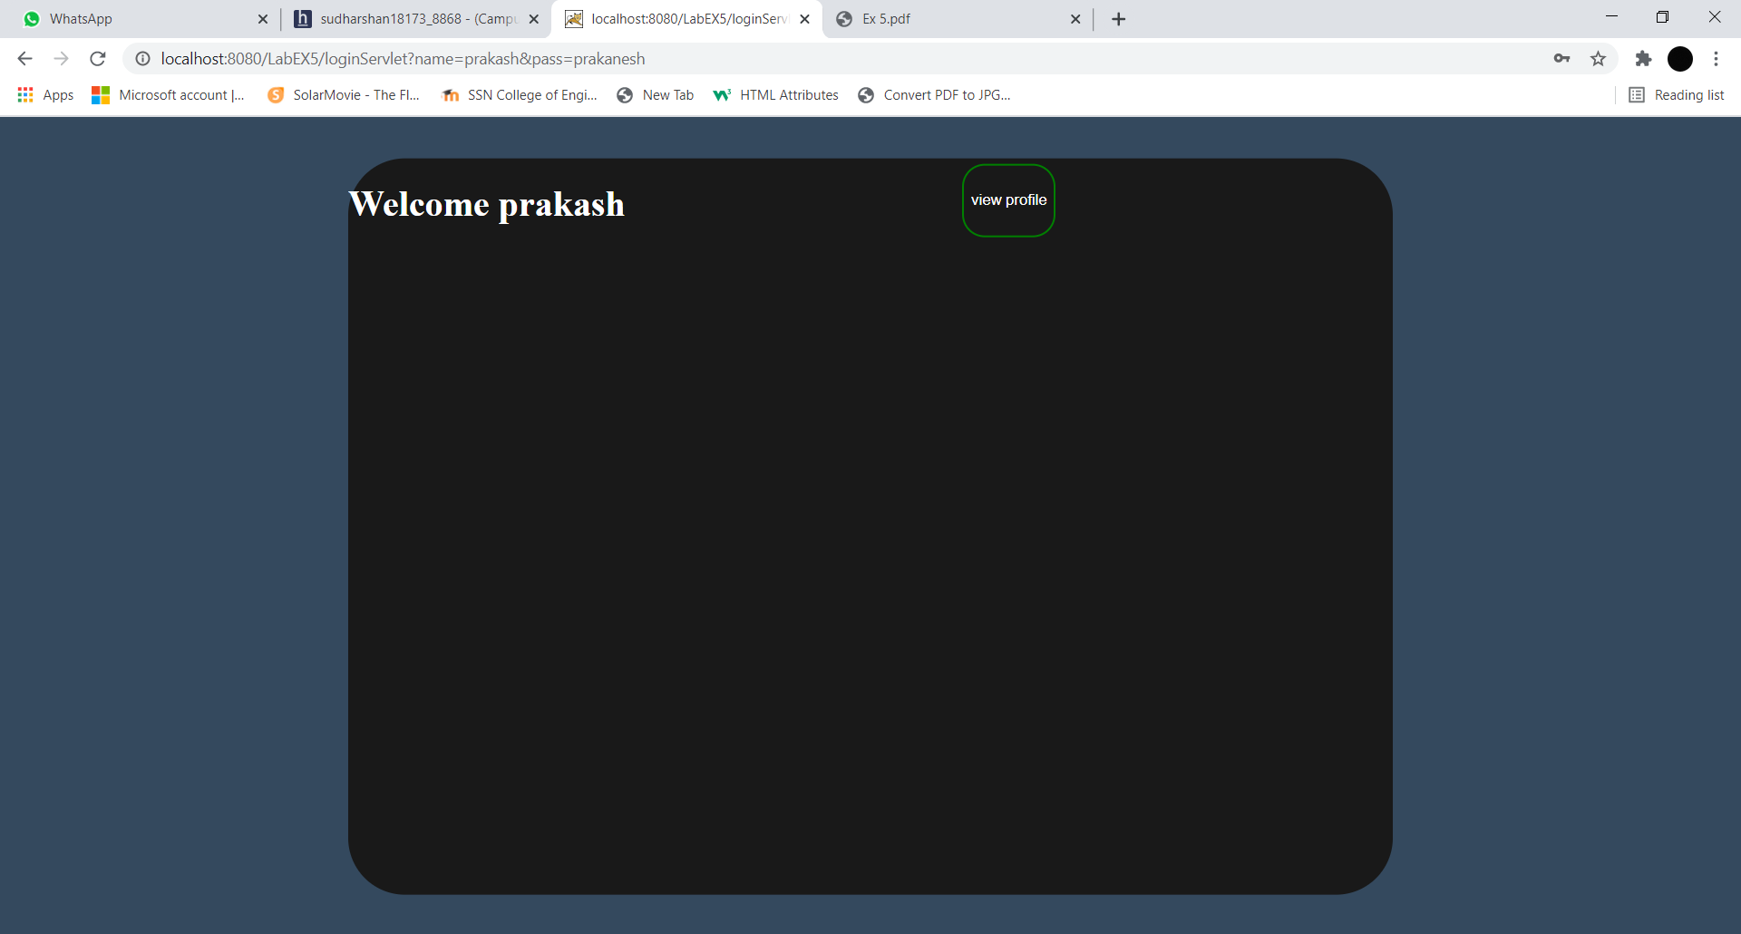

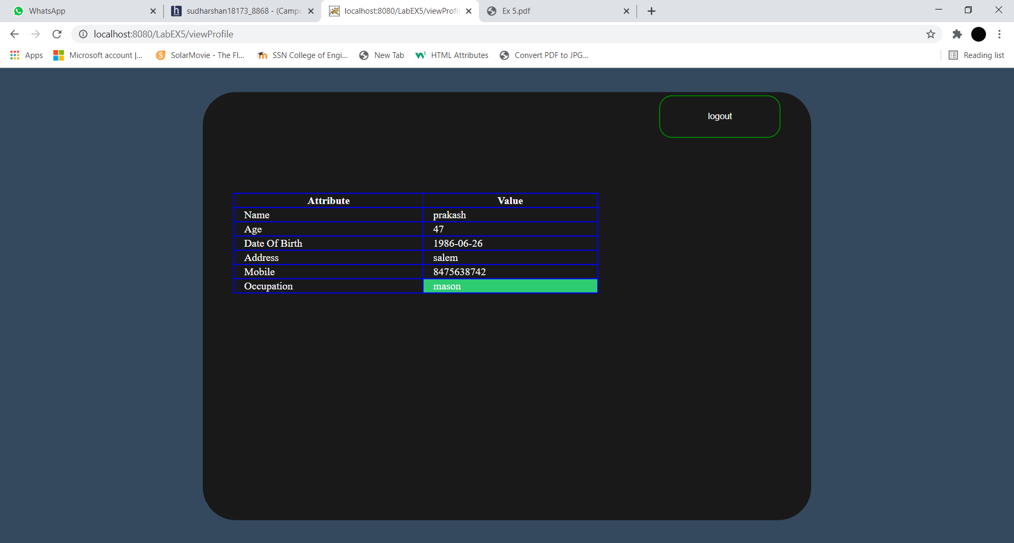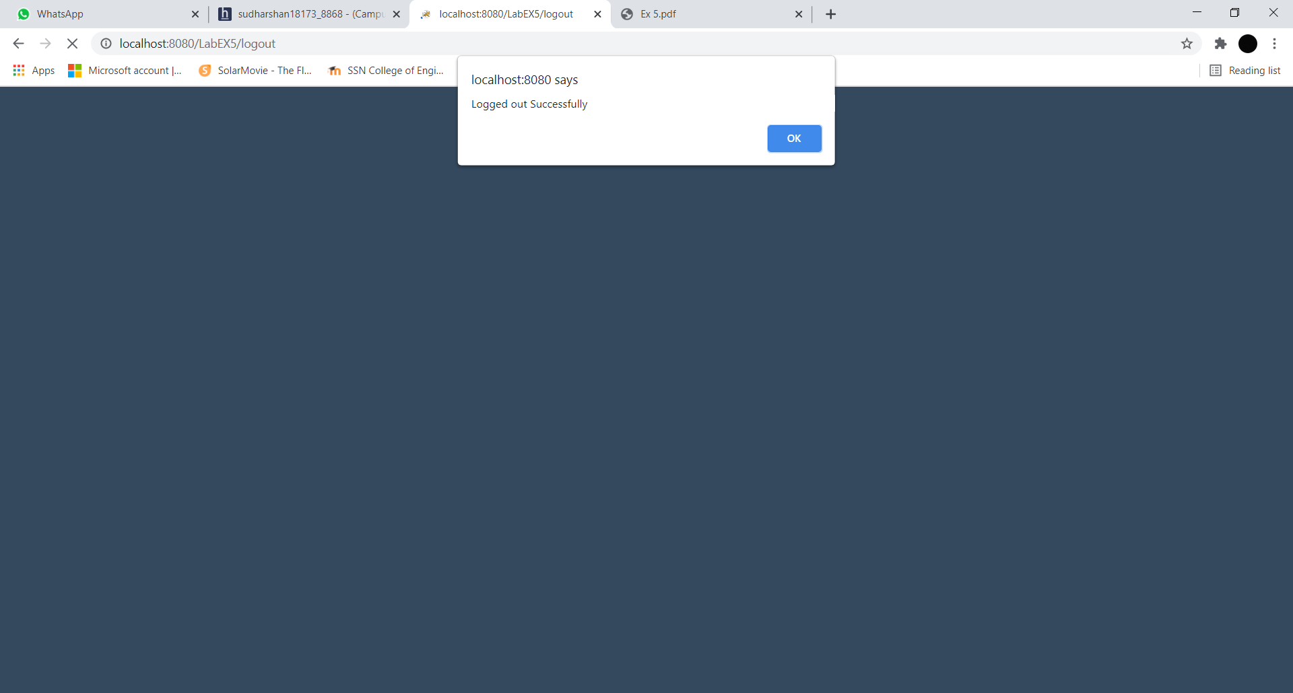

Learning Outcome:

* Learnt how to create a new session
* Learnt how to handle JDBC with java
* Learnt on creating attributes in http session and on how to access them on a different servlet.
* Learnt how to invalidate a session.