**Name: Sudharshan R**

**Reg : 185001173**

**Class : CSE-C**

**Exercise8: Programs using Node.js**

AIM:

a. Write a Node.js program that reads all the greetings from the file greetings.txt, asks the user "What is your name?", then prints a random greeting followed by the given name. Make sure to check for the case where the file doesn’t exist! For example, if the greeting is "Hey", then the program will print "Hey, Joe" to the console, then pick some other greeting and do the same until finished. Use Non-blocking I/O.

Code:

var fs=require('fs');

const readline = require("readline");

const rl = readline.createInterface({

    input: process.stdin,

    output: process.stdout

});

rl.question("What is your name ? ", function(name) {

    fs.readFile('../input.txt', function (err, data) {

        if (err) return console.log("File Not Found");

        data+='';

        var x=data.split(/\r?\n/)

        var greet = x[Math.floor(Math.random()*x.length)]

        console.log(greet,name);

    });

    rl.close();

});

Output:

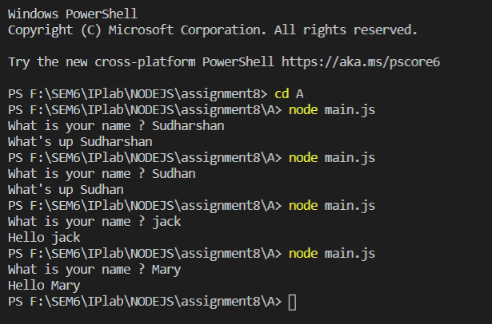

AIM:

b) Write a Node.js program that reads all the greetings as before. When all the greetings are loaded, it creates a server listening on port number 8080. On request, it checks for whether there is a name value in the query string. If there isn’t, the value of query.name will be undefined. In other words, if you access http://localhost:8080/?name=Mike, then your browser should just display something like "Hello, Mike" when the page loads

Code:

var fs=require('fs');

var http = require("http");

var url = require('url');

http.createServer(function (request, response) {

    const queryObject = url.parse(request.url,true).query;

    response.writeHead(200, {'Content-Type': 'text/plain'});

    fs.readFile('../input.txt', function (err, data) {

        if (err) return console.log("File Not Found");

        data+='';

        var x=data.split(/\r?\n/)

        var greet = x[Math.floor(Math.random()*x.length)]

        response.write(greet);

        response.write(" ");

        response.end(queryObject['name']);

    });

}).listen(8080);

Output:

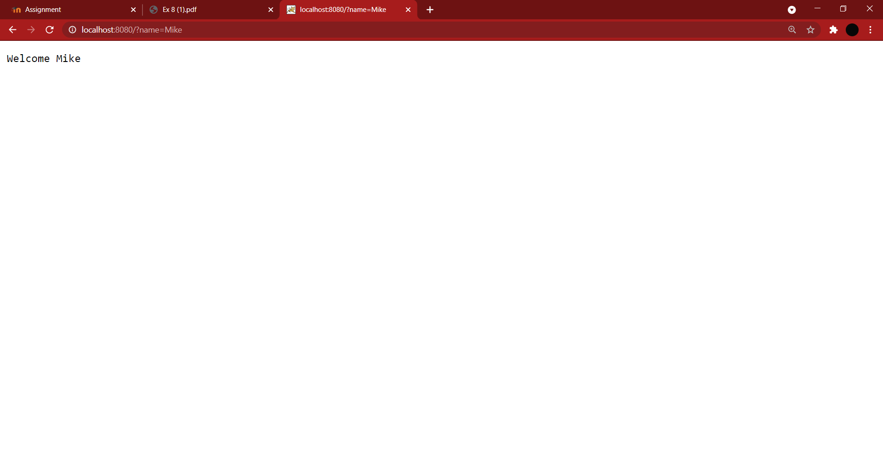

AIM:

c. Create a web server using node.js which listens for clients request. Once the client request the server, the server returns a web page which contains a list of books and its details in table format.

CODE:

Server/main.js:

var http = require('http');

var fs = require('fs');

var url = require('url');

http.createServer( function (request, response) {

    var pathname = url.parse(request.url).pathname;

    console.log("Request for " + pathname + " received.");

    fs.readFile('.'+pathname, function (err, data) {

        if (err) {

            console.log(err);

            response.writeHead(404, {'Content-Type': 'text/html'});

        }

        else {

            response.writeHead(200, {'Content-Type': 'text/html'});

            response.write(data.toString());

        }

        response.end();

    });

}).listen(8080);

console.log('Server running at http://127.0.0.1:8080/');

Client/main.js

var http = require('http');

var options = { host: 'localhost', port: '8080', path: '/index.html' };

var callback = function(response) {

    var body = '';

    response.on('data', function(data) {

        body += data;

    });

    response.on('end', function() {

        console.log(body);

    });

}

var req = http.request(options, callback);

req.end();

Index.html

<!DOCTYPE html>

<html>

    <head>

        <title>Simple Node Server</title>

    </head>

    <style>

        table{

            border-collapse: collapse;

        }

    </style>

    <body>

        <table border="1px solid black" >

            <thead>

                <tr>

                    <td><strong>Attribute</strong></td>

                    <td><strong>Value</strong></td>

                </tr>

            </thead>

            <tbody>

                <tr>

                    <td>Name</td>

                    <td>abc</td>

                </tr>

                <tr>

                    <td>Author</td>

                    <td>def</td>

                </tr>

                <tr>

                    <td>description</td>

                    <td>ghi</td>

                </tr>

                <tr>

                    <td>Genre</td>

                    <td>jkl</td>

                </tr>

            </tbody>

        </table>

    </body>

</html>

OUTPUT:

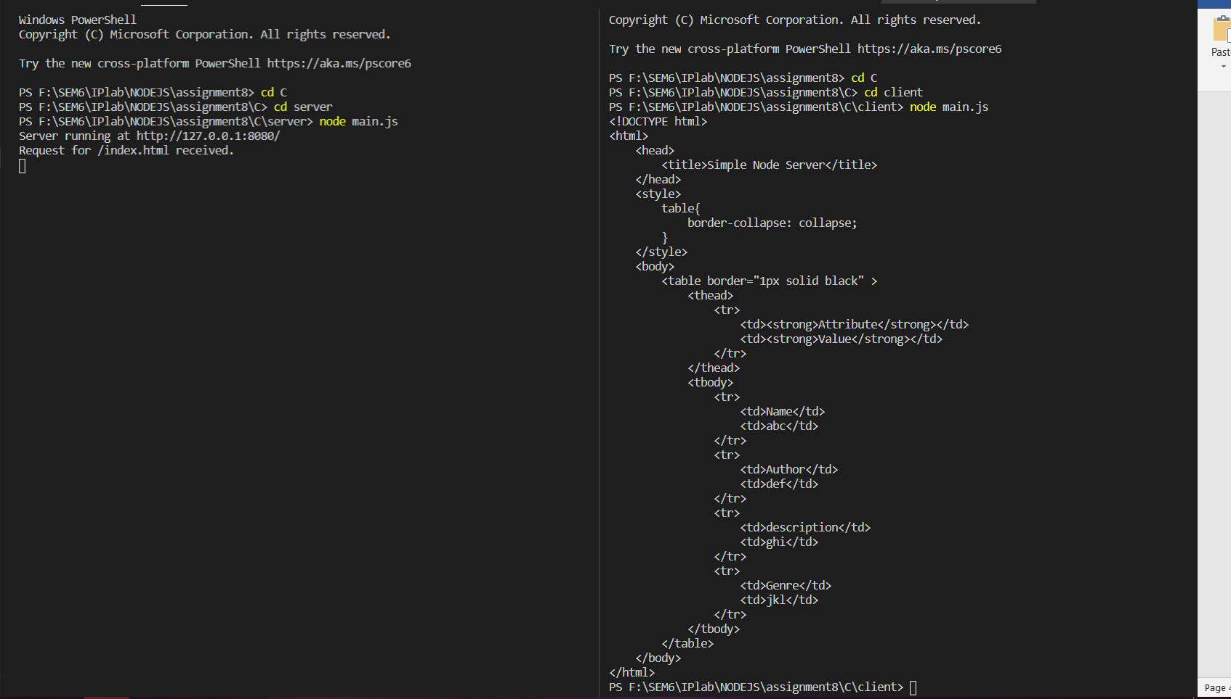

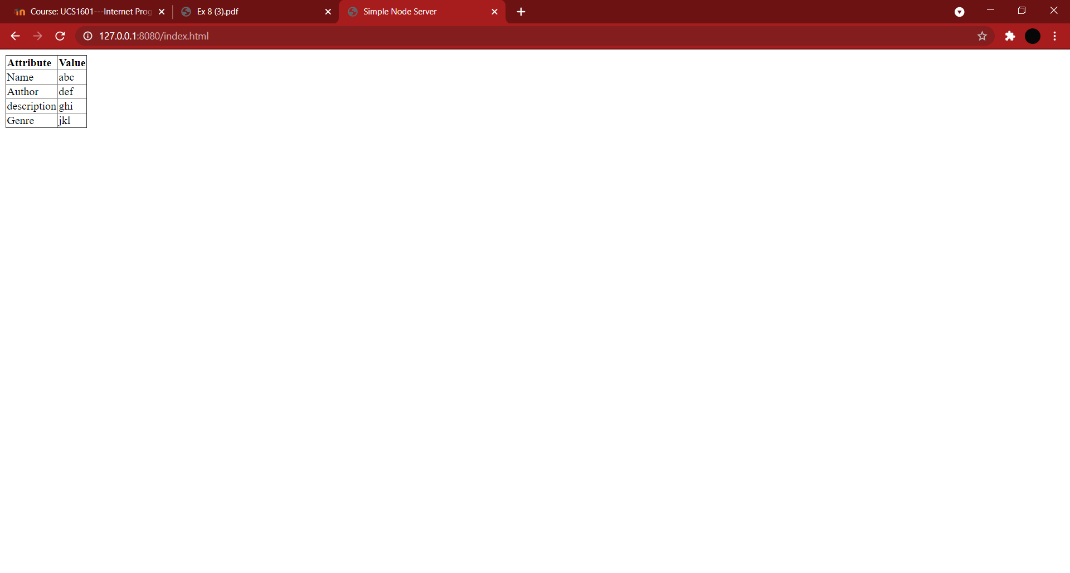

AIM:

d. Create a DB with the following details using Mongodb:

Database Name: Patient_Details

Table Schema: Name, age, ID, gender, address, marital status, Date of Visit

Write a node.js program to do the following operations:

Add, Delete, Update, Search.

CODE:

Main.js

var MongoClient = require('mongodb').MongoClient;

var url = "mongodb://localhost:27017/Patient_Details";

MongoClient.connect(url, {useUnifiedTopology: true }, function(err, db) {

  if (err) throw err;

  console.log("Database Connected");

  var dbObject = db.db("Patient_Details");

  var myobj = {

                Name:'murali',

                age:15,

                ID:126,

                gender:'Male',

                address:'Erode',

                marital_status:'single',

                DateOfVisit:Date()

            };

    dbObject.collection("patients").insertOne(myobj, function(err, res) {

        if (err) throw err;

        console.log("inserted");

        dbObject.collection('patients').find().toArray(function(err,res){

            if(err) throw err;

            console.log(res);

            dbObject.collection('patients').deleteOne({Name:'murali'},function(err,res){

                if(err) throw err

                console.log('Deleted murali');

                dbObject.collection('patients').find().toArray(function(err,res){

                    if(err) throw err;

                    console.log(res);

                    var upd_url = { Name:"Raj" };

                    var upd_values = { $set: {Name: "Raj Kumar", address: "Chennai" } };

                    dbObject.collection("patients").updateOne(upd_url, upd_values, function(err, res) {

                        if (err) throw err;

                        console.log("updated Raj");

                        dbObject.collection('patients').find().toArray(function(err,res){

                            if(err) throw err;

                            console.log(res);

                            db.close();

                        });

                    });

                });

            });

        });

    });

});

MongoDB queries

use Patient_Details

db.createCollection('patients')

db.patients.insertOne(

{

Name:'Raj',

age:25,

ID:123,

gender:'Male',

address:'Coimbatore',

marital_status:'single',

DateOfVisit:Date()

}

)

OUTPUT:

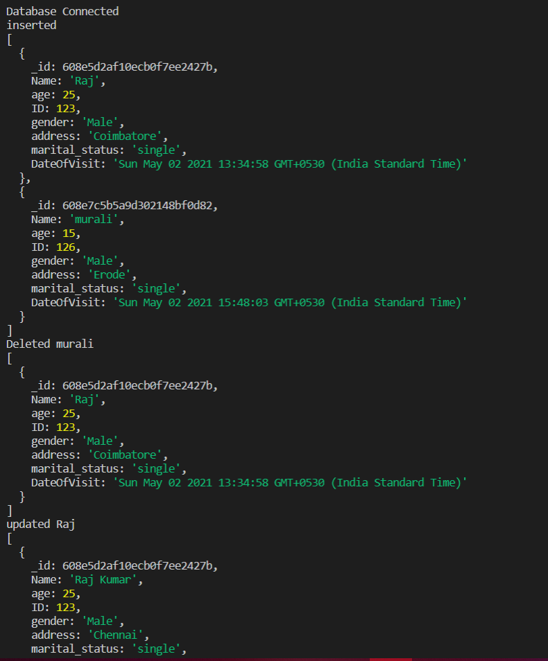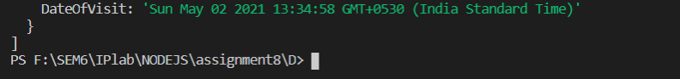

Learning Experience:

* Learnt how to run a node program.
* Learnt the use of readline library.
* Learnt how to read from file and from console.
* Learnt the use of url library
* Learnt how to get data from url.
* Learnt about mongodb and its CRUD.
* Learnt to create a web server.