Manual Data Collection

Clone this repo

<https://github.com/harishbalajib/StreetAwareV2/blob/main/ssh_multiple_run_script.py>

Power on the Camera and sensors and set the inputs from the power source to AC.

Enable the Global time sync module.

Connect to the network router which the Sensors are connected to.

Run the ssh_multi_run_script.py

Wait for around 10 mins (or as how long of data collection if instructed)

Terminate the script executed manually from terminal with ctrl+c

SSH into the sensor's IP. (Or RealVNCViewer can be used for interactive mode)

IP can be found by connecting to the router.

* Go to 192.168.0.0
* Login to the router with the set password.
* Identify the connected devices IP from there.

Go to the /Data directory.

Copy the sensor output as needed for that particular date and transfer it to the local system, either via scp or using the interactive mode drag and drop.

Connect to the Research Space for StreetAware and upload the collected Data.

App Setup - Manual

Street Aware App Setup:

Clone into <https://github.com/exploring-curiosity/StreetAwareApp>

**Frontend:**

Cd street-aware-app

Npm i

**Backend:**

Cd street-aware-service

Python -m venv myenv

Source myenv/bin/activate

Pip install -r requirements.txt

**Scripts:**

Cd street-aware-scripts

Source myenv/bin/activate

Pip install -r requirements.txt

App Run - Manual

**Frontend:**

Cd street-aware-app

Npm run start

**Backend:**

Cd street-aware-service

Source myenv/bin/activate

Python app.py

**Scripts:**

Cd street-aware-scripts

Source myenv/bin/activate

<Run Scripts as required>

App Setup - Bash

Street Aware App Setup:

Clone into <https://github.com/exploring-curiosity/StreetAwareApp>

chmod +x [setup.](http://setup.py)sh run.sh stop.sh

setup.sh

App Run - Bash

**Start app:**

[run.sh](http://run.sh)

**Stop App:**

stop.sh

How to use the App

Health Check:

Below Image Indicates the health check sample that can be viewed from the App UI.   
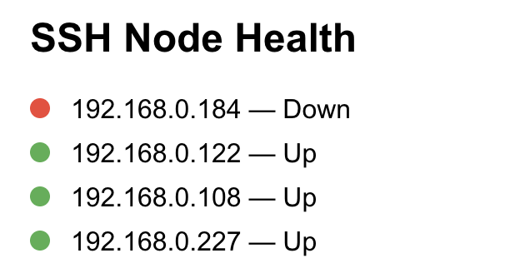

Collect Data:

As per the below image setup a time in seconds for the total duration of the sensors to collect the data.



Set value for Session timeout in seconds and click on Start SSH & Collect Button.

NOTE: In case you want to stop the data collection interim, use the Stop Job button.

Download Data to local Device:

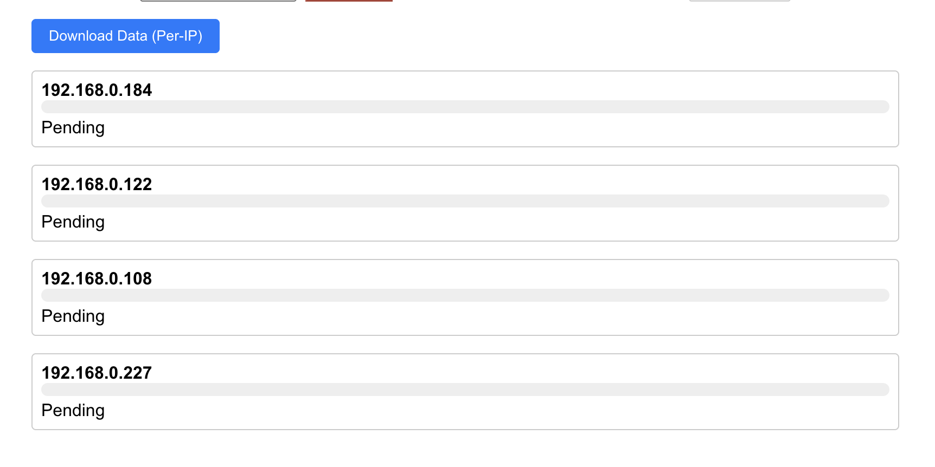

Click on Download Data (per-ip) to start downloading the collected data from sensors to local device. This data can be found in street-aware-scripts/data/<current-date>. You can upload them to Research Space for future reference.