## horizontal line

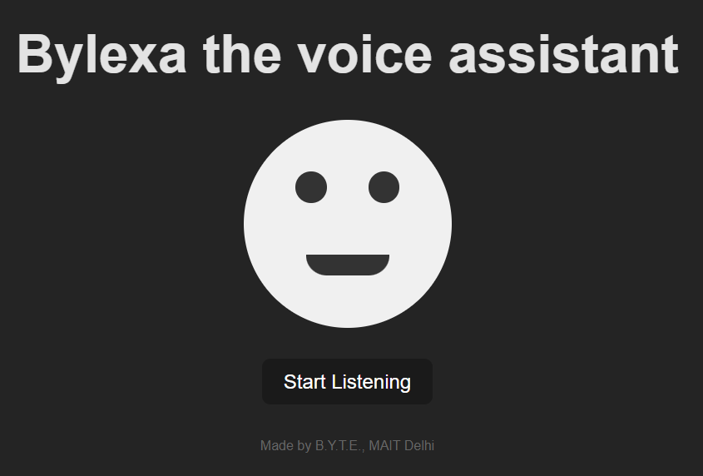

Bylexa(G.O.A.T. Greatest Of Automated Tasks)

The Large Multi-Action Model

Starting Date Ending Date

**─ 19 Aug,2024 Ongoing**

Project Lead

Members : Aman

# Problem Statement

# The model solves the problem of managing complex, multi-action tasks across IoT devices, web browsing, messaging and data retrieval, all through voice input. It simplifies task automation by seamlessly integrating device control, internet searches, web scraping and communication, making it easier for users to execute various commands without manual intervention. In short a jarvis/ Friday or as I call it GOAT.

# About The Project

# The Bylexa : GOAT (Greatest Of Automated Tasks) project began with a simple aim: to develop a basic voice assistant capable of responding based on voice inputs. The first milestone was creating a functional voice-based assistant, laying the foundation for more advanced capabilities.

# As the project evolved, the next step was integrating the assistant with IoT devices using a server and Wi-Fi modules. This allowed the system to control devices via voice commands, enabling automation of IoT tasks. Once deployed, the assistant could seamlessly interact with IoT ecosystems, enhancing convenience and user experience.

# In the following phase, the goal was to make the assistant a general-purpose voice-powered system for DIY projects, allowing any microcontroller with a Wi-Fi module to become voice-controllable. This was achieved by linking the hardware to the assistant through an API, generated for individual projects, which could be controlled via the Bylexa web app. This provided flexibility to developers and users, empowering them to integrate voice control into custom hardware projects.

# The next ambitious step involved developing an in-house Large Language Model (LLM) to replace paid APIs and external dependencies, significantly reducing costs and making the system more self-reliant. By focusing on GenAI engineering, the project aimed to create an internal LLM to handle all voice interactions and task automation, building an AI ecosystem entirely in-house with minimal external reliance.

# To further expand its potential, the assistant was integrated with operating systems, allowing voice commands to control OS-level tasks, thereby making it a full-fledged voice-interactive environment for a wide range of use cases.

# Ultimately, GOAT's use cases are limited only by imagination, evolving from a basic voice assistant into a comprehensive platform capable of controlling IoT, handling voice-based microcontroller interactions, developing in-house AI models, and managing operating systems—all through voice. This makes it a cutting-edge tool for automation, transforming how users interact with both hardware and software.

# Goals to be Achieved by the Projects

1. The part of voice assistant was done on web and deployed on web server for anyone to test using **Gemini.** (26 Aug 2024)
2. The next step of interacting with iot using voice was also done with testing against an Esp32 , servo motors and a few sensors. (2-sept 2024)
3. The general purpose voice automation for DIY projects is in progress but implemented 90% just fine tuning the bugs and making it more accessible by deploying it. (ongoing)

# Specifications

All the work till now is done by @exploring-solver(Aman) as of 21 Sept. 2024.

# Technology Used/TechStack

VueJs, ReactJs, ExpressJs, MongoDb, Gemini, GenAI, Transcript Modelling, ESP32 Libs, Arduino IDE

# Materials Used

Esp32, servo motors, sensors and for testing more iot bots may be used but only for testing not to build anything from scratch or bought externally

# Industrial UseCase

# Smart Manufacturing Automation, Healthcare Facility Management, Smart Building Operations, Hospitality Guest Services, Retail Inventory Management, Logistics and Warehouse Automation, Agricultural Monitoring and Control, Educational Interactive Learning, Automotive Fleet Management, Security and Surveillance Systems, Energy Management Systems, Remote Site Operations

And the rest is limited by imagination only.

# Industries/Company Contacted

NA but building it for some major genai competitions and hackathons.

# Google drive link NA