- HOME---------------------

PrintOne Graphics
DESIGN • DIGITAL PRINTING • CORPORATE GIFTING

Your Trusted Partner for Design, Digital Printing & Corporate Gifting
From concept and creative design to premium printing and finishing, we deliver quality, precision and reliable service for every project.

Our Vision, Mission & Values

OUR VISION
To become a trusted and preferred partner for printing, publishing, corporate communications and gifting solutions by consistently delivering value, innovation and quality.

OUR MISSION

To provide end-to-end print solutions that combine creative design, modern technology, competitive pricing and dependable delivery, helping our clients communicate more effectively.

OUR CORE VALUES
- Quality and professionalism
- Customer satisfaction
- Integrity and transparency
- Innovation and continuous improvement
- Timely execution
- Long-term partnerships

OUR CORE EXPERTISE
Annual Reports | Corporate Printing | Digital Printing | Commercial Printing | Books & Publications | Educational Printing | Calendars | Diaries | Corporate Gifting | Packaging | Creative Design | Binding & Finishing

- ABOUT US

Your Trusted Partner for Design, Digital Printing & Corporate Gifting
At PrintOne Graphics, we transform ideas into impactful print solutions through creative design, advanced digital printing, quality production and dependable service. Established in 2021, we have grown rapidly by focusing on quality, competitive pricing, timely delivery and long-term client relationships.

Based in Byculla East, Mumbai, we provide comprehensive printing and corporate communication solutions to businesses, listed companies, educational institutions, publishers and organisations across India.

Our goal is simple: to deliver printing solutions that communicate your brand's identity, strengthen your corporate image and create a lasting impression.

OUR STORY
PrintOne Graphics was established with a vision to provide businesses with a reliable, professional and competitive partner for their printing and design requirements.

Since our inception, we have continuously expanded our capabilities to serve a wide range of industries and clients. By combining creative expertise, modern printing technology and practical production experience, we manage projects from initial design and content preparation to printing, finishing and final delivery.

Our growing portfolio includes annual reports, corporate publications, educational books, commercial printing, calendars, diaries and customised corporate gifts.

We believe every project deserves attention to detail, consistent quality and a commitment to delivering the best possible results.
Why Choose PrintOne Graphics?
Creative Design Expertise – use icon
Thoughtfully designed layouts and visual concepts that communicate your brand message clearly and professionally.
In-House Production Capabilities – use icon
Integrated design, digital printing, binding and finishing capabilities help us coordinate projects efficiently.
Commitment to Timely Delivery - – use icon
We plan our production schedules carefully to meet project deadlines and business requirements.
Competitive Pricing – use icon
Cost-conscious solutions designed to balance quality, production requirements and your budget.
Quality & Attention to Detail – use icon
A focus on colour consistency, accurate layouts, finishing quality and careful coordination at every stage.
Long-Term Client Partnerships – use icon
We value transparent communication, dependable support and relationships built on trust.

Our Commitment to Every Client
At PrintOne Graphics, we understand that printed materials represent more than paper and ink. They represent your organisation's identity, credibility and values.
Whether it is a detailed annual report, a publication, an educational book or a customised corporate gift, we approach every assignment with dedication and a focus on delivering value.
From concept to creation, we bring your ideas to print.

- OUR SERVICES
Your Trusted Partner for Design, Digital Printing & Corporate Gifting
At PrintOne Graphics, we offer end-to-end solutions for design, content development, digital printing, commercial printing, annual reports, publications, educational printing and corporate gifting.

With an in-house design and production facility, modern digital printing technology and experienced professionals, we combine quality, creativity and quick turnaround to deliver projects that meet professional standards and deadlines.
WHAT WE DO

1. Annual Report Design & Printing – USE IMAGES
We provide comprehensive annual report solutions, including content writing, thematic cover design, typesetting, financial and non-financial report layouts, statutory and non-statutory sections, printing, binding and digital versions such as PDF flipbooks.

2. Commercial & Digital Printing – USE IMAGES
From brochures, catalogues, company profiles and magazines to flyers, corporate stationery and marketing collaterals, we deliver professional printing solutions tailored to your business requirements.

3. Educational & Publication Printing – USE IMAGES
We support educational institutions, publishers and organisations with textbooks, journals, educational materials, institutional magazines, answer sheets and other printed learning resources.

4. Corporate Gifting & Promotional Products – USE IMAGES
We offer customised calendars, diaries, notebooks, pens, mugs, gift sets, card holders and promotional merchandise, with branding options to help businesses create memorable connections with clients, employees and business partners.

4.TESTIMONIALS
Trusted by Businesses. Proven by Results.
“We value every relationship we build and every project we deliver. Our clients' trust inspires us to continually raise the standard of design, printing and service.”
WHAT OUR CLIENTS SAY

“A Trusted Printing Partner for Our Annual Reports”
PrintOne Graphics has been a dependable partner for our annual report projects. Their team understands the importance of accuracy, presentation and timelines. From design and typesetting to printing and finishing, the entire process was handled professionally.
— Corporate Client | Annual Report
“Excellent Quality & Timely Delivery”
We appreciate the quality of printing and the quick response from the PrintOne Graphics team. They consistently delivered our requirements within the committed timeline while maintaining excellent print quality.
— Corporate Client | Commercial Printing
“Professional Team with Great Attention to Detail”
The team at PrintOne Graphics is extremely responsive and detail-oriented. Their understanding of corporate publications, design requirements and finishing options made the entire project smooth and hassle-free.
— Corporate Client | Corporate Publications
“One-Stop Solution for Printing & Corporate Gifting”
PrintOne Graphics offers a complete solution under one roof—from creative design and digital printing to calendars, diaries and corporate gifting. Their team is professional, flexible and easy to work with.
— Corporate Client | Corporate Gifting
“Quality Printing with Quick Turnaround”
For projects where deadlines are critical, PrintOne Graphics has always been a reliable choice. Their in-house capabilities and experienced team help achieve quick turnaround without compromising on quality.
— Corporate Client | Digital Printing
“A Reliable Partner for Educational & Publication Printing”
PrintOne Graphics understands the specific requirements of books, journals, magazines and educational publications. Their attention to paper quality, colour reproduction, binding and finishing has made them a valued printing partner.
— Educational & Publishing Client

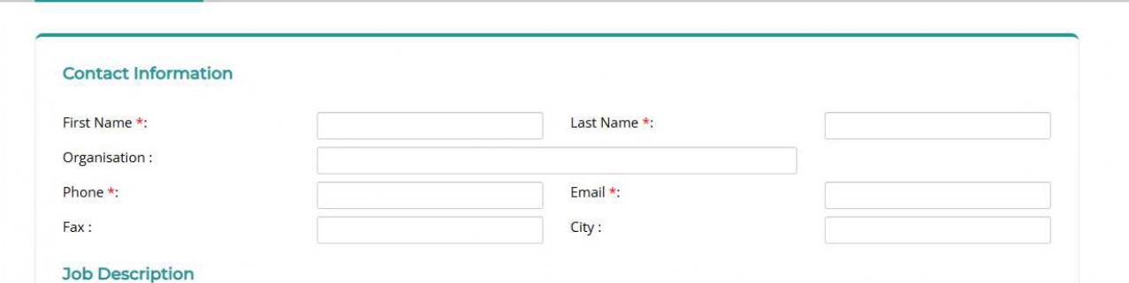
- GET A QUOTE

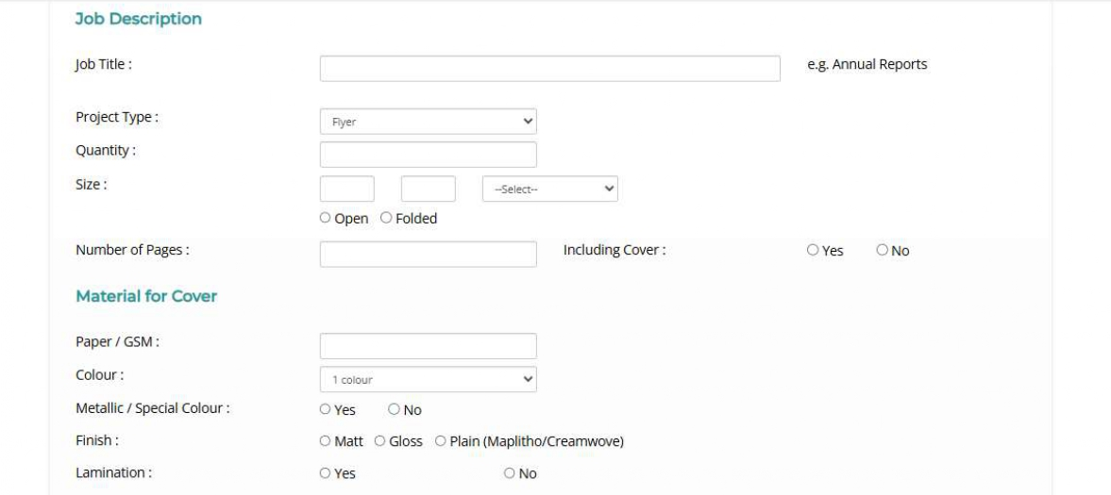
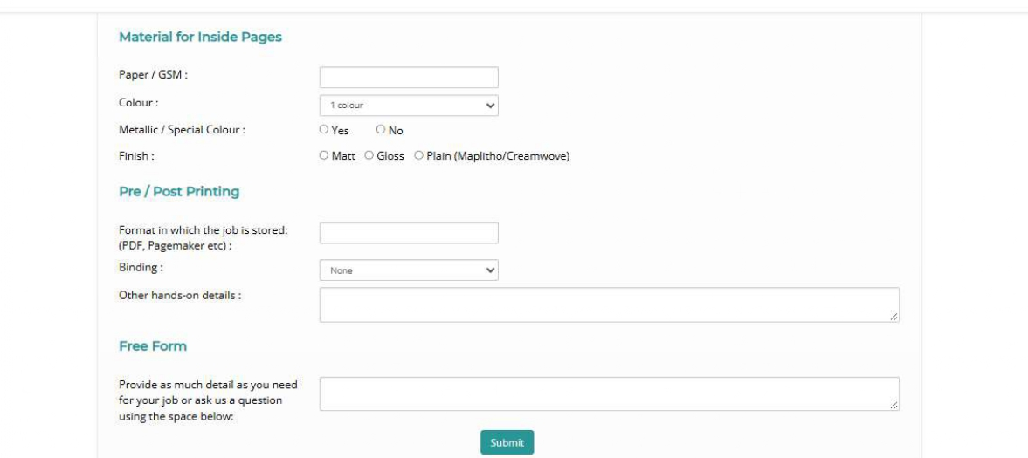

CONTACT US

Let’s Create Something Great Together
Have a printing project, annual report, publication, corporate gifting requirement or a custom design in mind? PrintOne Graphics is here to help.
From concept and design to printing, finishing and delivery, our team provides complete solutions tailored to your requirements.

Get in Touch
PrintOne Graphics
Your Trusted Partner for Design, Digital Printing & Corporate Gifting
📍 Office Address
PrintOne Graphics
Byculla Service Industrial Premises,
A-Wing, Unit No. 309,
Byculla East, Mumbai – 400027, Maharashtra, India
📞 Contact Us
Jogendra Vichare: +91 95940 05894
Shashank Khandare: +91 98191 24907
✉️ Email
printone.graphics21@gmail.com

