TIC-TAC-TOE game
INTRODUCTION
Tic-tac-toe, noughts and crosses, or Xs and Os is a paper-and-pencil game for two players who take turns marking the spaces in a three-by-three grid with X or O. The player who succeeds in placing three of their marks in a horizontal, vertical, or diagonal row is the winner
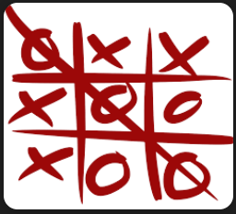
Figure1: 3X3 grid of tic-tac-toe game

Working operation
In this game, a player plays the Tic Tac Toe game with a computer. When the player/ computer plays the game, a 2-bit value is stored into one of the nine positions in the 3x3 grid like Xs/ Os in the real paper-and-pencil version. 2'b00 is stored into a position when neither the player or computer played in that position. Similarly, 2'b01 (X) is the value to be stored when the player played in the position and 2'b10 (O) is the value to be saved when the computer played in the position. The grid can be represented as
|1|2|3|
|4|5|6|
|7|8|9|
The player/ computer wins the game when successfully placing three similar (01-Xs) or (10-Os) values in the following row pairs: (1,2,3); (4,5,6);(7,8,9); (1,4,7); (2,5,8);(3,6,9); (1,5,9);(3,5,7). The below figure shows the block diagram of tic-tac-toe

clk

rst
TIC_TAC_TOE
who1
comp_pos[3:0]

player_pos[3:0]

Figure2: Block diagram of tic-tac-toe

