CLOCK WITH ALARM
DESIGN INTRODUCTION
The design includes generation of a clock with 7 output signals including Alarm signal, Hour, Minute, and seconds. The clock generated is in a 24 - hour format. An initial time value to the system when reset signal=1 or by turning the signal LD_time=1. We can further set the alarm time by turning LD_alarm=1. The alarm is enabled or disabled using the input AL_ON. The alarm rings only if AL_ON is 1. STOP_al signal is used to stop the alarm. The input clock given as input is 10Hz. Clock is generated with time period 1 second from this input clock and used it to increment seconds and further minutes and hours.

I/O Specifications
Input Signals:
- reset : Active high reset pulse, to set the time to the input hour and minute (as defined by the H_in1, H_in0, M_in1, and M_in0 inputs) and the second to 00. It should also set the alarm value to 0.00.00, and to set the Alarm (output) low.For normal operation, this input pin should be 0
- clk : A 10Hz input clock. This should be used to generate each real-time second
- H_in1 : A 2-bit input used to set the most significant hour digit of the clock (if LD_time=1),or the most significant hour digit of the alarm (if LD_alarm=1). Valid values are 0 to 2.
- H_in0 : A 4-bit input used to set the least significant hour digit of the clock (if LD_time=1) or the least significant hour digit of the alarm (if LD_alarm=1). Valid values are 0 to 9.
- M_in1 : A 4-bit input used to set the most significant minute digit of the clock (if LD_time=1),or the most significant minute digit of the alarm (if LD_alarm=1). Valid values are 0 to 5.
- M_in0 : A 4-bit input used to set the least significant minute digit of the clock (if LD_time=1),or the least significant minute digit of the alarm (if LD_alarm=1). Valid values are 0 to 9.
- LD_time : If LD_time=1, the time should be set to the values on the inputs H_in1, H_in0, M_in1, and M_in0. The second time should be set to 0.If LD_time=0, the clock should act normally (i.e. second should be incremented every 10 clock cycles).
- LD_alarm : If LD_alarm=1, the alarm time should be set to the values on the inputs H_in1, H_in0, M_in1, and M_in0.If LD_alarm=0, the clock should act normally.
- STOP_al : If the Alarm (output) is high, then STOP_al=1 will bring the output back low.
- AL_ON : If high, the alarm is ON (and Alarm will go high if the alarm time equals the real time). If low the the alarm function is OFF.
Output Signals:
- Alarm : This will go high if the alarm time equals the current time, and AL_ON is high. This will remain high, until STOP_al goes high, which will bring Alarm back low.
- H_out1 : The most significant digit of the hour. Valid values are 0 to 2.
- H_out0 : The least significant digit of the hour. Valid values are 0 to 9.
- M_out1 : The most significant digit of the minute. Valid values are 0 to 5.
- M_out0 : The least significant digit of the minute. Valid values are 0 to 9.
- S_out1 : The most significant digit of the minute. Valid values are 0 to 5.
- S_out0 : The least significant digit of the minute. Valid values are 0 to 9.
Internal Signals:
- clk_1s : 1-s clock
- tmp_1s : count for creating 1-s clock
- tmp_hour, tmp_minute, tmp_second : counter for clock hour, minute and second
- c_hour1,a_hour1 : The most significant hour digit of the temp clock and alarm.
- c_hour0,a_hour0 : The least significant hour digit of the temp clock and alarm.
- c_min1,a_min1 : The most significant minute digit of the temp clock and alarm.
- c_min0,a_min0 : The least significant minute digit of the temp clock and alarm.
- c_sec1,a_sec1 : The most significant second digit of the temp clock and alarm.
- c_sec0,a_sec0 : The least significant minute digit of the temp clock and alarm.

The block diagram of alarm clock is shown in Figure 1.
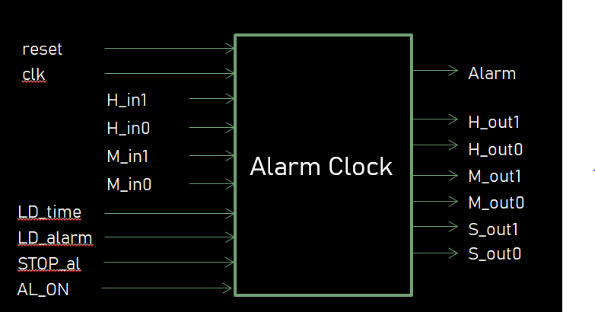
Figure 1: Alarm Clock
FLOW CHART
Figure 2 shows the working of alarm clock through flow chart

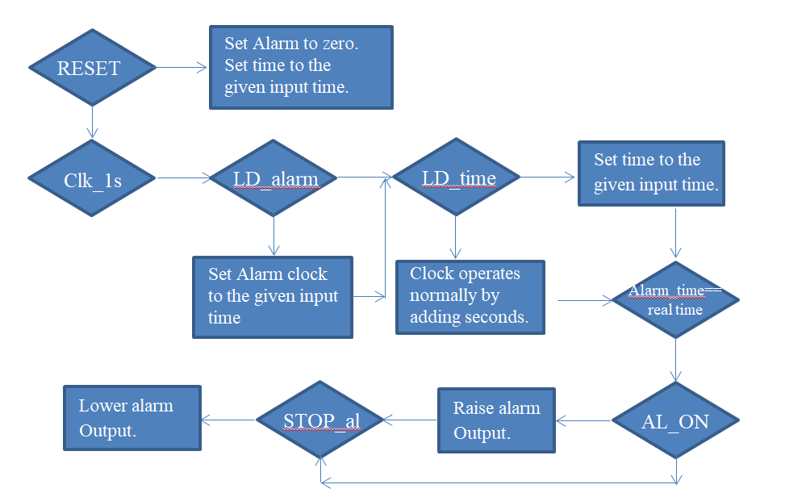
Figure 2: Flow chart

