DICE GAME
INTRODUCTION
Dice game is a game in which players roll a pair of dice and bet on the outcome of the roll or a series of rolls. It is a good example of a finite state machine
Dice game rules:
- After 1st roll of a dice, player wins if roll is 7 or 11. Player loses if roll is 2,3 or 12. Anything else is saved as the players point
- On the subsequent rolls, player loses if roll is a seven. Player wins if the dice roll is equal to their point
Using this sum and a set of rules for the game, a winner can be determined. The game is then continued in this fashion until the player wins or lose. Below figure shows the flow chart of dice game
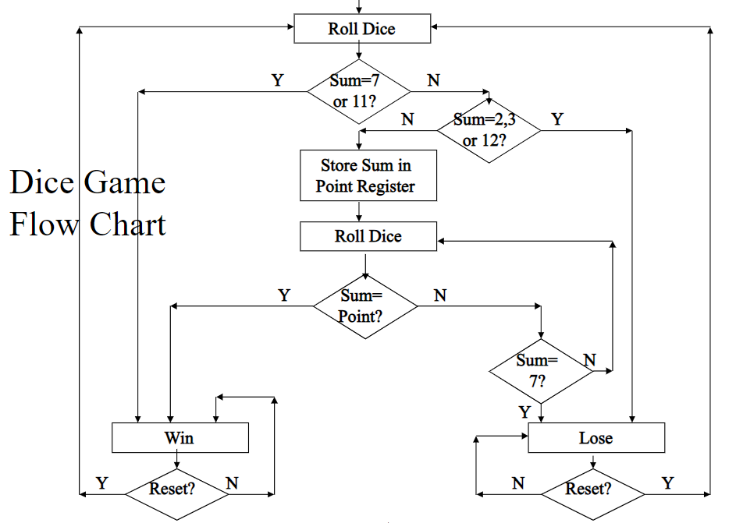

BLOCK DIAGRAM

clock

roll
Dice game
reset
rb
win
lose
Sum[3:0]

Figure : Dice game

