VOTING MACHINE
DESIGN INTRODUCTION
The voting machine is designed for 3 candidates with output size of 32 bits. It is made by adding an asynchronous reset up counter as its components. The number of counters added depend upon the number of candidates to vote for. The design uses the state machine approach comprising of 4 states idle, vote, stop and finish. Runs on clock frequncy 100MHz.The figure shows the working of voting machine through state machine

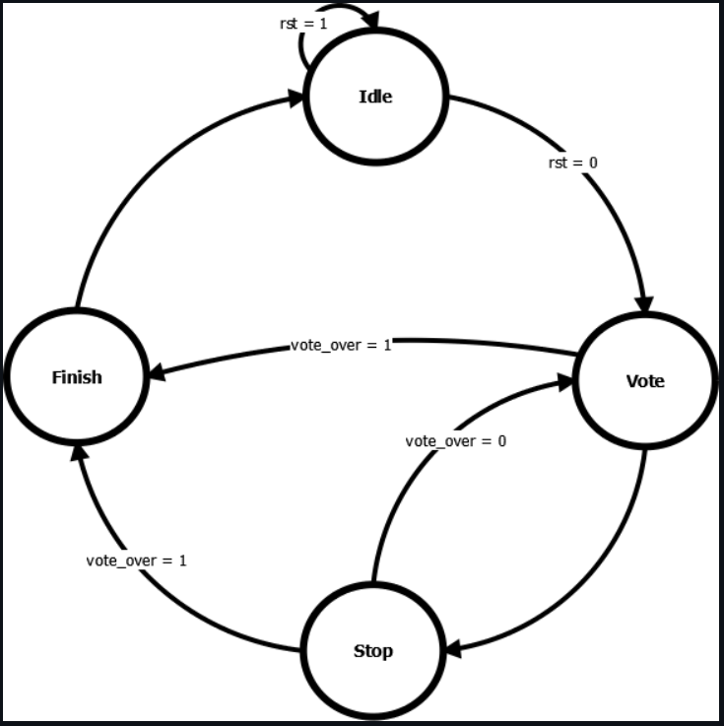
Figure1: State Machine of Voting Machine
BLOCK DIAGRAM
The block diagram of Voting Machine is shown in Figure 2. reset signal indicates input High to reset counting (active high), i_candidate_1 indicates the input to vote for candidate 1, i_candidate_2 indicates the input to vote for candidate 2, i_candidate_i indicates the input to vote for candidate 3, i_voting input indicates high to get total votes after voting is over. o_count1 indicates the output for total number of votes of candidate 1, o_count2 indicates the output for total number of votes of candidate 2, o_count3 indicates output for total number of votes of candidate 3

clk

rst
o_count1[31:0]
Voting_Machine
i_candidate_1
i_candidate_2
i_candidate_3
i_voting_over
o_count2[31:0]

o_count3[31:0]

Figure 1: 8-bit ALU

Figure2: Block diagram of Voting Machine

