WASHING MACHINE CONTROLLER
INTRODUCTION
The Washing Machine controller is composed of two blocks: a finite ‐ state machine (FSM) block and a timer block. The FSM block receives some signals from the user, from the timer, and from other hardware parts such as the door sensor. FSM block output control the timer block and other hardware components of the washing machine. Table1 identifies the FSM input and output signals and their functionality. The timer block generates the correct time periods required for each cycle after it has been reset. The timer block is composed of an up‐ counter and combinational logic to give the correct time signals once certain count values have been achieved. The timer values will be determined by the clock frequency being used in the system
The washing machine controller has the following functionalities:
1. The wash machine has the following states: idle, soak, wash, rinse, spin.
2. There are three modes of operation i.e mode1, mode2 and mode3.
3. Different time durations are allocated to each mode of operation.

I/O Description
The table1 shows the list of i/o in the washing machine controller
Variables | Input/output | Operation
i_clk | input | Main Clock for the System
i_lid | input | Machine door (lid) is open.
i_coin | input | Start wash machine
i_cancel | input | Cancels the washing process
i_mode1/mode2/mode3 | input | Select Washing modes
o_ideal | output | Do not perform any process
o_ready | output | Machine is ready to start the process
o_soak | output | Soaking operation
o_wash | output | Washing operation
o_rinse | output | Rinsing operation
o_spin | output | Spinning operation
o_coinreturn | output | Returns the coin
o_waterinlet | output | Intakes the water
o_done | output | Indicates operation is done

OPERATION
Figure 1 shows the working flow of the washing machine . The FSM has 6 states State transitions take place according to the timing control signals generated by the timer block and inputs given to a particular state. The processing in the next state depends on outputs produced in the previous state. Different wash times are selected by using the 3 different mode switches.
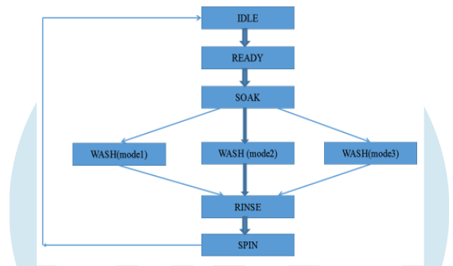
Figure 1: System flow chart of Washing Machine Controller

Figure 2 shows the State diagram of Washing Machine Control System which is based on Mealy Machine. It has following states: IDLE, READY, SOAK, WASH, RINSE, SPIN. Initially the FSM is in the idle state. Once the coin is inserted, the FSM will go to the READY state. Once in ready state, any of the 3 modes for washing can be selected. The selected mode decides the timing allocated to each state. If no mode is selected, it will remain in the READY state itself. In case the process is cancelled now, the coin is returned as the washing process has not yet started and the FSM returns to the IDLE state. But once the washing process starts, cancellation results in loss of the coin
Once the washing process starts, the state transitions take place according to the control signals generated by the Timer unit. The Timer unit generates the control signals once the timers corresponding to the states elapse. The control signal to activate the water intake is generated during both the SOAK and RINSE states, as both the operations require fresh intake of water. The FSM transits from state READY to SPIN through the states - SOAK, WASH, RINSE, in an order. Once the last state i.e., SPIN is completed, the FSM transits back to IDLE state to take orders for the new wash cycle. If in between the washing process, the LID is opened to add or remove cloths or detergent, the washing process is paused for safety reasons

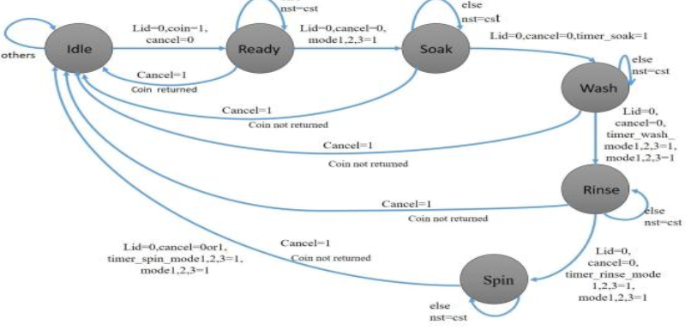
Figure 2: State diagram of Washing Machine Control System

