ELEVATOR CONTROLLER
INTRODUCTION
A lift (or elevator) is a form of vertical transportation between building floors, levels or decks, commonly used in offices, public buildings and other types of multi-storey building. The Verilog design module represents an elevator control system that manages floor requests, handles emergencies and controls the elevator's movement and door operation. The code uses a state machine to control the elevator's behavior under different conditions and states
WORKING OPERATION
Table 1 provides a detailed overview of the finite state machine transitions within elevator control system. It outlines the current states, input conditions, next states, and associated output actions, including reset conditions, door operations, and movement directions.
Current State | Input | Next State | Output
Reset | reset = 1 | Reset | Idle =1,door=0, Up=1, Down=0,requests=0, estop=0, current_floor=0
 | reset = 0 | Door Closed & Idle (1) | Idle =1,door=0, Up=1, door_timer=0
 | Checker : requests[current_floor] = 1 | Door Open & Idle (1) | door = 1; idle = 1; requests[current_floor] = 0; door_timer = 1
Door Closed & Idle (1) | max_request > current_floor && Up = 0 | Moving Up | idle = 0; current floor +=1
Door Closed & Idle (1) | min_request > current_floor && Down = 0 | Moving Down | idle = 0; current floor -=1
 | max_request = current_floor | Down Direction Setter | Up=0; Down=1
 | min_request = current_floor | Up Direction Setter | Up=1; Down=0
Door Open & Idle (1) | door_timer = 1 | Door Closed & Idle (1) | Idle =1,door=0, Up=1, door_timer=0
 | Checker = 1 | Door Open & Idle (1) | door = 1; idle = 1; requests[current_floor] = 0; door_timer = 1
Moving Up | Checker = 0 | Moving Up | idle = 0; current floor +=1
 | estop = 1 | Door Closed & Idle (1) | Idle =1,door=0, Up=1, door_timer=0
 | Checker = 1 | Door Open & Idle (1) | door = 1; idle = 1; requests[current_floor] = 0; door_timer = 1
Moving Down | Checker = 0 | Moving Down | idle = 0; current floor -=1
 | estop = 1 | Door Closed & Idle (1) | Idle =1,door=0, Up=1, door_timer=0
Up Direction Setter | x | Door Open & Idle (1) | door = 1; idle = 1; requests[current_floor] = 0; door_timer = 1
Down Direction Setter | x | Door Open & Idle (1) | door = 1; idle = 1; requests[current_floor] = 0; door_timer = 1

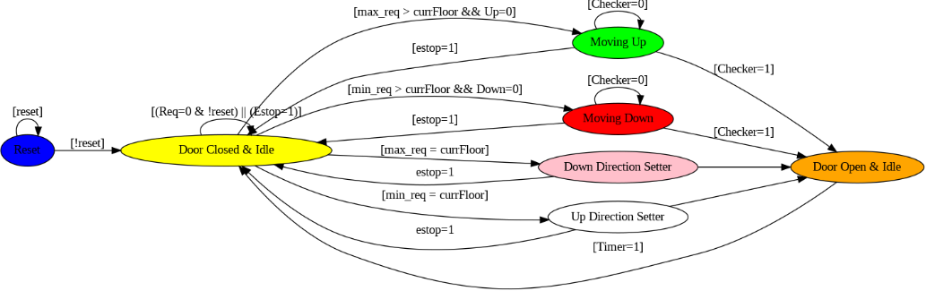
Table 2 presents a concise representation of state transitions related to the update of elevator requests, max_request, and min_request. It defines how the elevator system handles new floor requests and maintains these key variables, which play a crucial role in elevator movement.

Current State | Input | Next State | Output
Update request | NewFloorRequested | NewFloorRequested | x
Update request | No NewFloorRequested | UpdateRequests
 | max_req < req_floor | UpdateMaxReq | max_req = req_floor
 | min_req > req_floor | UpdateMinReq | min_req = req_floor
NewFloorRequested | req[max_req] == 0 & req_floor>currFloor | UpdateMaxReq | max_req = req_floor
 | req[min_req] == 0 & req_floor | UpdateMinReq | min_req = req_floor
UpdateMaxReq UpdateMinReq | x | UpdateRequests UpdateRequests | x

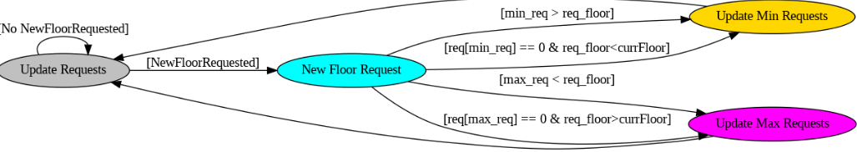

I/O Specification
Inputs
- clk: A clock signal for synchronous operation.
- reset: A reset signal used to initialize the elevator system.
- req_floor : A 3-bit input representing the requested floors (0 to 7).
- emergency_stop : An input signal that serves as an emergency stop button.
- Outputs
- door: A 2-bit output representing the state of the elevator door.
- max_request: A 3-bit output representing the highest requested floor.
- min_request: A 3-bit output representing the lowest requested floor.
- Up: A 2-bit output indicating whether the elevator is moving up.
- Down: A 2-bit output indicating whether the elevator is moving down.
- idle: A 2-bit output indicating whether the elevator is idle.
- current_floor: A 3-bit output representing the current floor of the elevator.
- requests : An 8-bit output representing the floor requests.
2. Internal Variables
- door_timer: A signal used to control the timing of elevator door opening and closing.
- emergency_stopped: A signal to indicate whether the elevator is in an emergency stop state.
- flag: A flag to manage emergency stop state transitions.
- updownflag : A flag used during emergency reset to keep track of the previous values of "Up" and "Down" directions.
3. Request Handling
- An always block updates the elevator's request list (requests) based on the requested floors (req_floor).
- It also updates max_request (Highest Floor no. in requests queue) and min_request (Lowest Floor no. in requests queue) based on the requested floors and the current floor.
4. Current Floor Handling
- Another always block handles the elevator's behavior when it reaches a requested floor.
- If the elevator arrives at a requested floor, it sets the elevator to idle, opens the door, clears the request, and starts a door timer.
5. State Machine for Lift Control
- The core logic of the elevator control system is implemented within an always @(posedge clk) block, representing a synchronous state machine.
- It handles various states and transitions:
  - Reset: Initializes elevator state.
  - Emergency Stop: Activated when the emergency stop button is pressed.
  - Emergency Stop (During Stopped State): Remains stopped until the emergency stop button is released.
  - Emergency Reset: Clears the emergency stop state when the button is released.
  - Normal Operation: Handles normal elevator movement based on requests and current floor.
  - Opening Door: Opens the door when the elevator arrives at a requested floor.
  - Other Cases: Handles cases for moving up, moving down, and staying idle based on the requested floors.
6. Usage of min_request and max_request
- min_request keeps track of the lowest floor number that has pending requests, while max_request tracks the highest floor number with pending requests.
- These variables are used to optimize the elevator's movement strategy:
  - If the elevator is moving upward and reaches max_request, it changes direction to move downward to serve lower floors efficiently.
  - Similarly, if the elevator is moving downward and reaches min_request, it changes direction to move upward to serve higher floors efficiently.
- min_request and max_request ensure that the elevator prioritizes requests based on their relative positions, minimizing unnecessary travel and wait times

