Bloomreach Engagement SFRA Integration

*21.10.0*



Table of Contents

1. Component Overview 3

Functional Overview 3

Compatibility 3

2. Implementation Guide 4

Setup of Business Manager 4

Configuration 4

3. Known Issues 10

4. Release History 11

# **Component Overview**

## Functional Overview

Bloomreach software enables highly personalized digital experiences for retailers, brands, distributors, manufacturers, and a diverse set of businesses and organizations around the world.

## Compatibility

*Available since Commerce Cloud Platform Release 16.8, SFRA 6.0.0*

*The cartridge is available for installations on storefronts that support both Controller and SFRA implemenations.*

# Implementation Guide

## Setup of Business Manager

*The Bloomreach Engagement LINK Cartridge contains several cartridges that are required for full functionality. Additionally, Controller and SFRA support is broken out into two separate cartridges, thereby facilitating the installation and use of one or the other models.*

*Import all three cartridges into UX studio and associate them with a Server Connection.*

*Site Cartridge Assignment*

1. *Navigate to Administration > Sites > Manage Sites*
2. *Click on the Site Name for the Storefront Site that will add Bloomreach Engagement Functionality*
3. *Select the “Settings” tab*
4. *For SFRA "int_bloomreach_engagement_sfra:int_bloomreach_engagement" need to be added to the cartridge path,  
     
   i.e. SFRA-based Site Path:* ***int_bloomreach_engagement_sfra:int_bloomreach_engagement****:app_storefront_base*
5. *Repeat steps 2 – 4 for each Storefront Site where Bloomreach Engagement will be implemented*

*Metadata import*

1. *Navigate to BM > Administration > Site Development > Import & Export, upload and import  
     
   link_bloomreach_engagement/metadata/site-templates/meta/system-objecttype-extensions.xml*
2. *Navigate to BM > Administration > Operations > Import & Export , upload and import  
     
   link_bloomreach_engagement/metadata/site-templates/jobs.xml  
     
   Note: If there are data errors after import i.e. Finished (11 data errors), it could be caused by not applied jobsteps.json changes. In such case, please activate another code version, then re-activate the current code version and re-import the jobs file.*
3. *Navigate to BM > Administration > Operations > Import & Export , upload and import*

## Configuration

*1. Navigate to Administration > Operations > Jobs, assign proper site(s) to each of the Bloomreach jobs (by default they are assigned to RefArch site):*

* *Bloomreach - CustomerFeed (Delta Export)*
* *Bloomreach - CustomerFeed (Full Export)*
* *Bloomreach - MasterProductFeed (Full Export)*
* *Bloomreach - MasterProductInventoryFeed*
* *Bloomreach - VariationProductFeed (Full Export)*
* *Bloomreach - VariationProductInventoryFeed*
* *Bloomreach- Generate (Pre-Init) CSV Files*
* *Bloomreach-Purchase Feed (FullExport)*
* *Bloomreach-Purchase Feed (NewOrders)*
* *Bloomreach-Purchase Product Feed (FullExport)*
* *Bloomreach-Purchase Product Feed (NewOrders)*

*2. Navigate to Administration > Operations > Jobs and execute ‘Bloomreach- Generate (Pre-Init) CSV Files’ Job*

*It will generate csv files used to define Imports on Bloomreach account.*

*Then navigate to BM > Administration > Site Development > Development Setup > Open WebDAV Access folder: Sites > Impex > src > bloomreach > preinit*

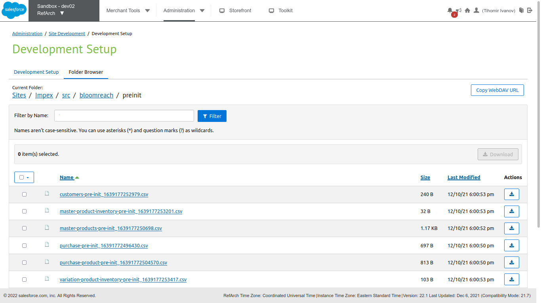

*The csv full URL file paths will be used on further steps.*

*3. Open Bloomreach API settings page:*

<https://cloud.exponea.com/p/sandbox-12/project-settings/api>

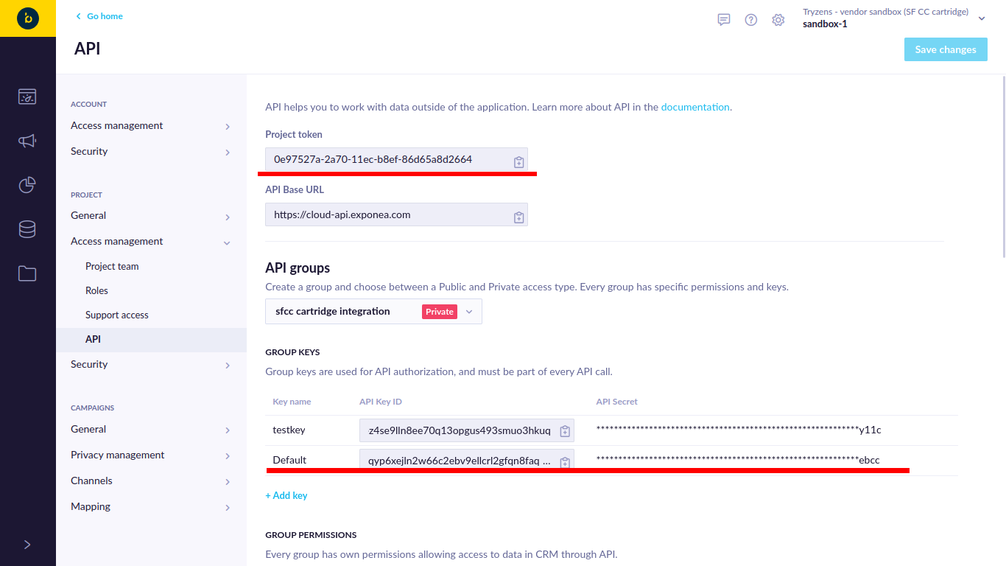

- Copy-Paste the ‘Project Token’, ‘API Key ID’ and ‘API Secret’ to BM > Merchant Tools > Custom Preferences > ‘Bloomreach Engagement API’ > ‘Bloomreach Project Token’, ‘Bloomreach API Key ID’ and ‘Bloomreach API Key Secret’:

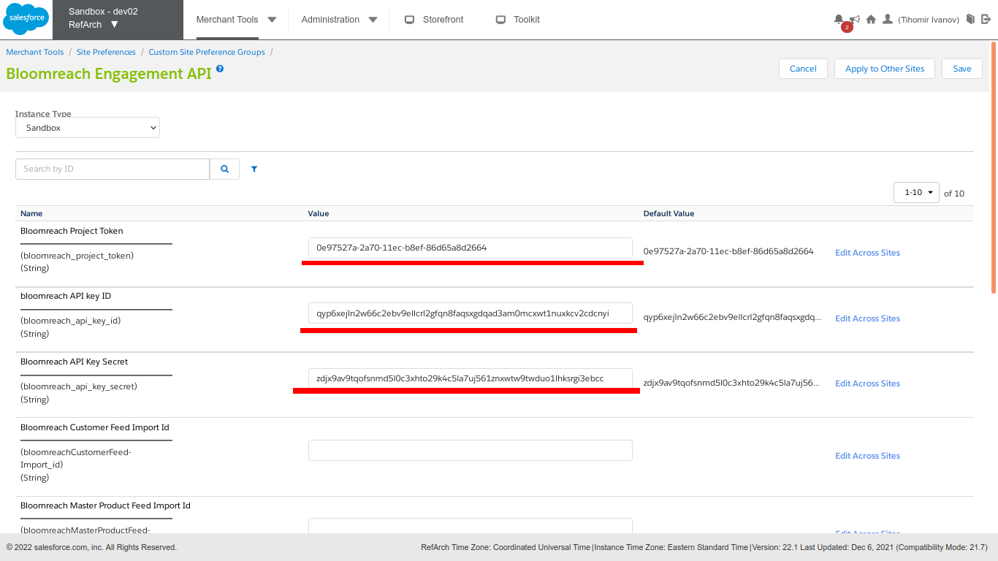

and Save changes.

4. Navigate to Bloomreach Account > Left Menu > Data & Assets > Imports (<https://cloud.exponea.com/p/sandbox-12/data/imports>)

and click on '+ New Import' button

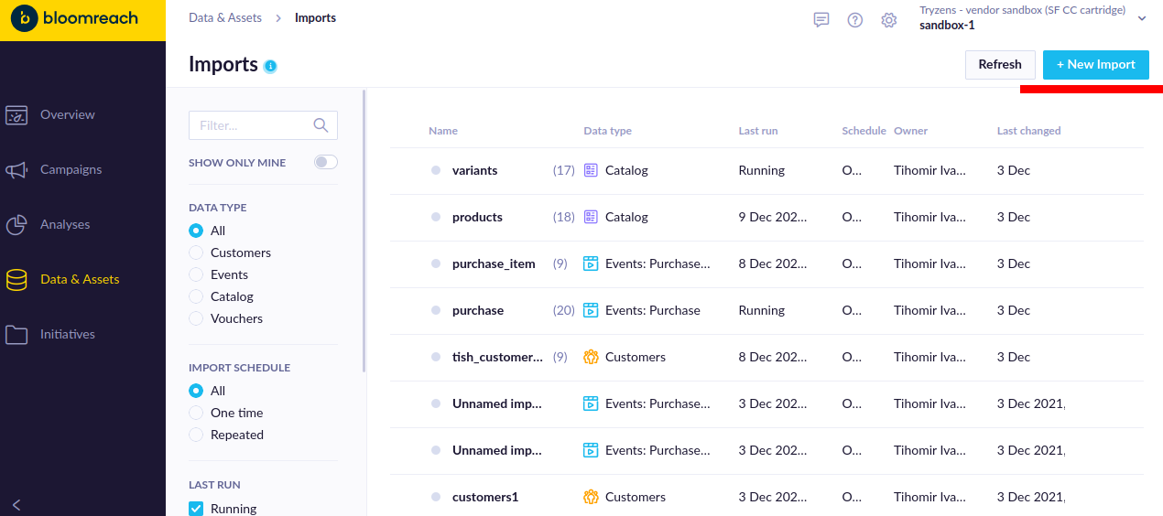

5. Select Type you want to create an Import

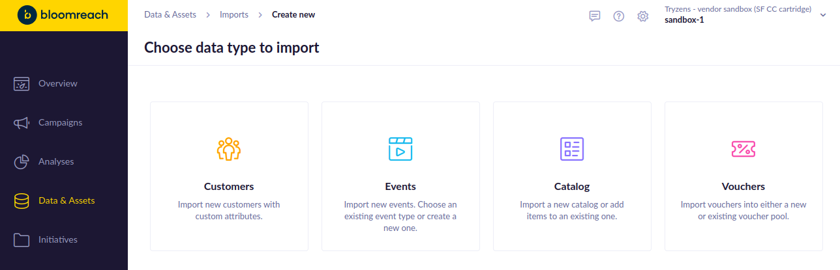

Select ‘URL’ and fill CSV URL path from step 2 with WebDAV access for your sandbox:

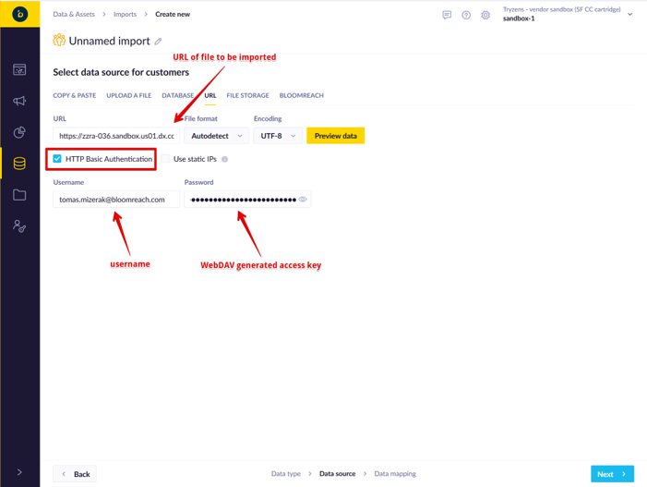

Finish the import (1 row will be imported)

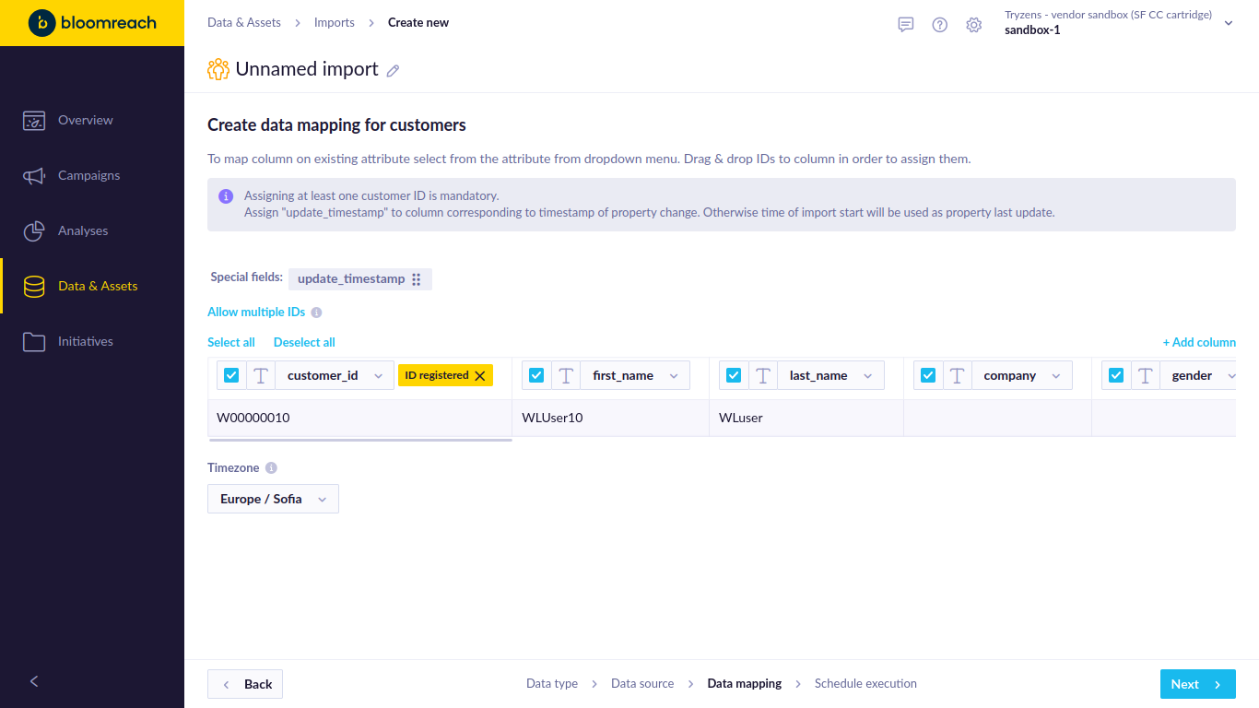

Copy the import_id from the import definition URL from the Exponea app

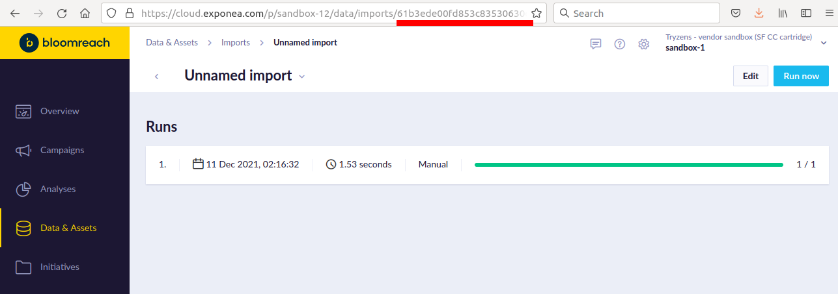

and set that value to corresponding Import ID in BM > Merchant Tools > Custom Preferences > ‘Bloomreach Engagement API’:

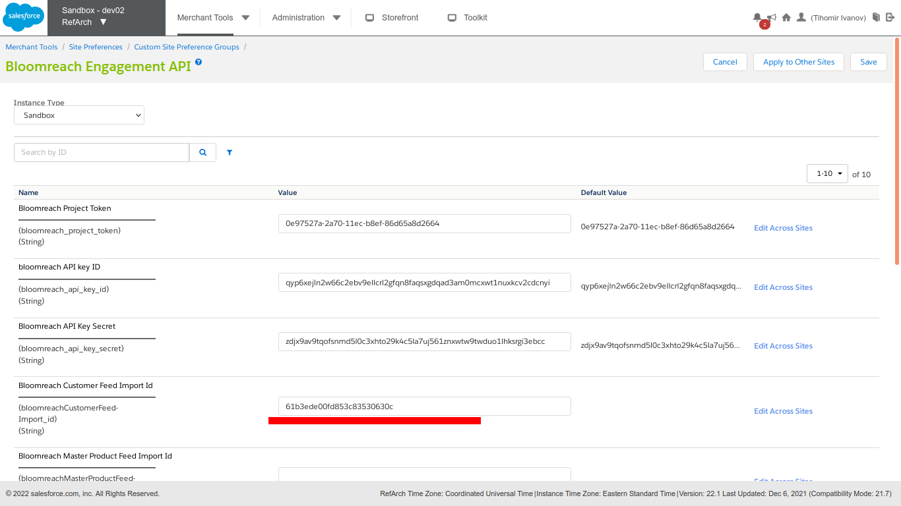

Repeat the above steps for repeat all data feeds

Customer feed => "Customer" type import

Purchase feeds => "Event" type import, event name "purchase" and "purchase_item" (for line items)

Catalog feeds => "Catalog" type import, catalog name "products" (for master, bundles and single products) and "variants" (for single products)

5. *Navigate to Administration > Operations > Jobs and execute Bloomreach jobs:*

* *Bloomreach - CustomerFeed (Delta Export)*
* *Bloomreach - CustomerFeed (Full Export)*
* *Bloomreach - MasterProductFeed (Full Export)*
* *Bloomreach - MasterProductInventoryFeed*
* *Bloomreach - VariationProductFeed (Full Export)*
* *Bloomreach - VariationProductInventoryFeed*
* *Bloomreach-Purchase Feed (FullExport)*
* *Bloomreach-Purchase Feed (NewOrders)*
* *Bloomreach-Purchase Product Feed (FullExport)*
* *Bloomreach-Purchase Product Feed (NewOrders)*

You can execute (Full Export) jobs manually and schedule recurring execution of Delta exports.

# Known Issues

The LINK Cartridge has no known issues.

# Release History

|  |  |  |
| --- | --- | --- |
| **Version** | **Date** | **Changes** |
|  |  |  |
|  |  |  |
| 21.10.0 | 2021-10-25 | Initial release |