Input Mask

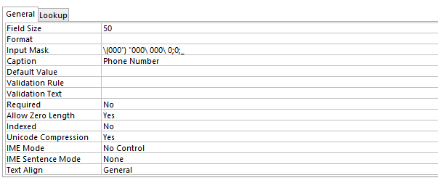

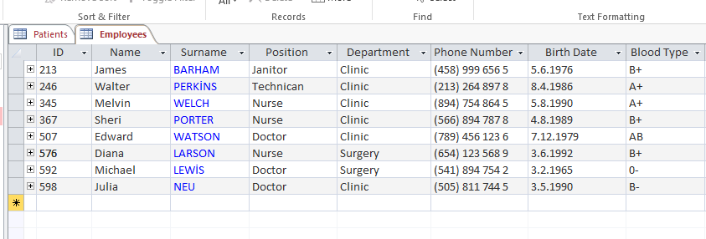

Validation Rule & Validation Text

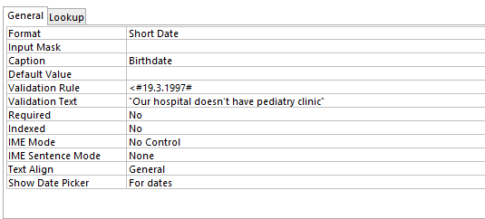

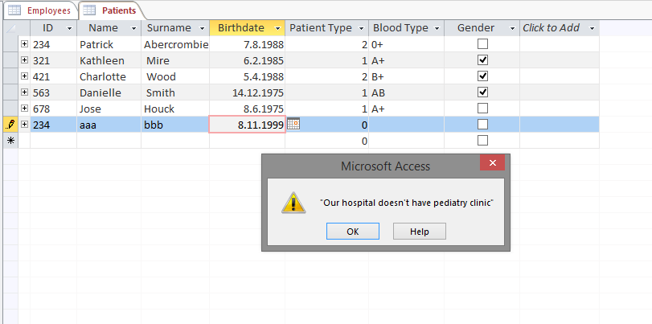

Relationships and Design

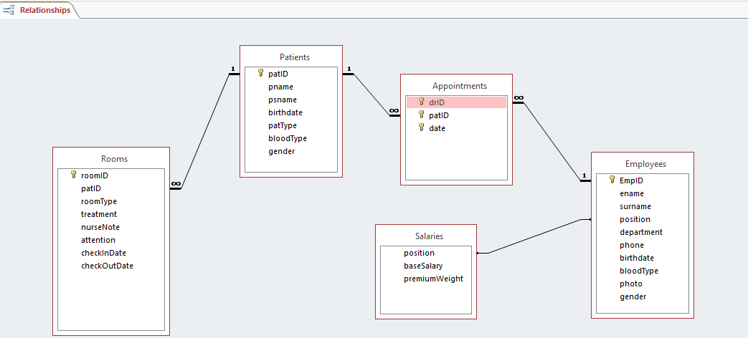

-Data Types

Text

roomID, patID, treatment, nurseNote, attention, pname, psname, bloodType, ename, surname, position, department, phone

Integer

patType,premiumWeight

Yes/No

gender

Currency

baseSalary

Date

checkInDate,checkOutDate,date,birthdate

Primary Keys Foreign Keys

patID,EmpID patID(Rooms),drID