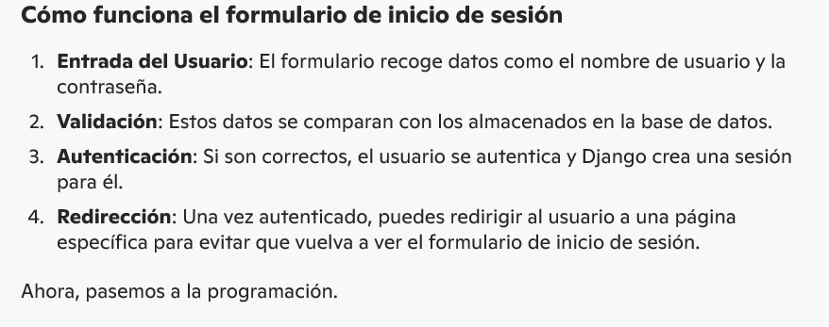
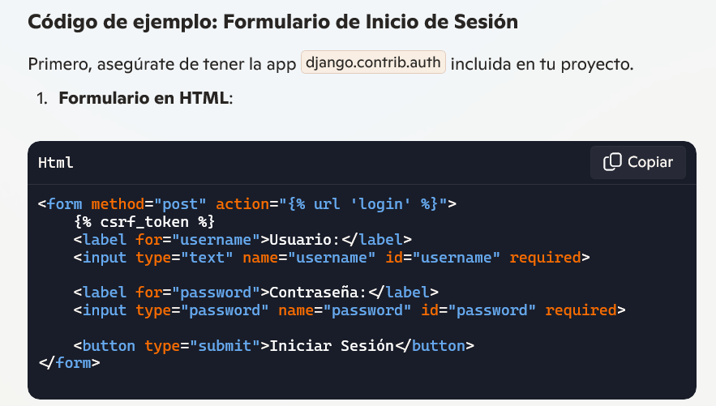
<form method="post" action="{% url 'login' %}">
{% csrf_token %}
<label for="username">Usuario:</label>
<input type="text" name="username" id="username" required>

<label for="password">Contraseña:</label>
<input type="password" name="password" id="password" required>

<button type="submit">Iniciar Sesión</button>
</form>
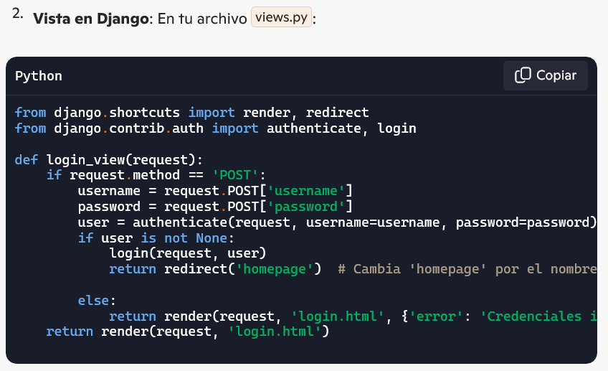
from django.shortcuts import render, redirect
from django.contrib.auth import authenticate, login

def login_view(request):
if request.method == 'POST':
username = request.POST['username']
password = request.POST['password']
user = authenticate(request, username=username, password=password)
if user is not None:
login(request, user)
return redirect('homepage') # Cambia 'homepage' por el nombre de tu vista principal
else:
return render(request, 'login.html', {'error': 'Credenciales inválidas'})
return render(request, 'login.html')

