Presshub: A Cloud-Based Publication Management System for the Browser - Tarlac State University, College of Computer Studies

M.T. Gregorio, BSIT

J.M. Manalo, BSIT

K.C. Morales, BSIT

R. Pioquinto, BSIT

I. Introduction

Modernization and digitization have conquered today’s generation as these have emerged, evolved and helped everyone greatly in a daily basis. It makes life easier as if it is in the palm of your hands, by saving up time, resources and workforce. As a product of innovation, Information Technology is being used to store, manipulate or create and distribute information with reduced human intervention for productivity. This leads to producing an extra hand to do the works for everyone

Publication, or the school paper, exists to inform people through tabloids, newspapers and other forms of media but behind every output produced requires a lot of efforts. Publication is strenuous as its members need to do things under pressure along with their studies, like any other organizations, as there are articles which need to be submitted on time. Aside from articles are the other important papers which every organization prepares like resolutions, letters, reports, and others. Due to conflict of schedules and lack of resources, everything is getting delayed and the deadline has always been pushed. This also initiates to miscommunication and conflict in the organization.

The technology nowadays is a vital point. As it has spread like a wildfire, nothing is almost out of reach. Through innovation of technology, it makes everyone reach each other in a few clicks. “Time is equivalent to money so as we waste time, we are basically wasting money.” As a solution, the proponents have found a way to save up some and make it a lot easier to communicate and to manage everything over your hands, anytime, anywhere.

II. Project Context

Github is a development platform inspired through collaboration. Github is used for developers to host and review codes, manage projects, and build their desired software. Now, instead of codes, it can be articles. The Browser, the College of Computer Studies’ Official Publication, goes through a lot of works and deadlines to meet. As an organization, it runs a lot of paper works to be signed by the higher ups. As a publication, it focuses mainly on releasing articles on time, which it needs to produce quality articles. As the articles need to be scanned through countless of times until they are ready to be released, it consumes time, labor and money. Instead of going on weekends and spending hours of time to travel and hundreds of peso on fare, with an established internet connection, we can save huge amount of resources. A publication has to set boundaries from other external organizations where a publication needs to uphold privacy. Now, one more factor is that the local does not have a physical office where the members can stay or meet for certain agendas. Through the proposal, the staff members or the end users can just upload their articles and other important stuffs letting the editor check for the progress and edit them right away applying the relevant changes. Presshub will have an embedded editor which lets the users create and edit everything at the moment. Thus, the editors or the admins will be able to proofread each item interchangeably, finding a room in a cloud, right away. They will be able to make announcements as well, like the upcoming activities for the current semester which notifies the members as they log in. Presshub will serve as a virtual room, a better way to work together as it brings team as one to work under different circumstances, move ideas forward and get updated along the way.

III. Purpose and Description

The proponents intend to develop a system that will provide greater accessibility and convenience to the management of the locale. This proposal aims to help its stakeholders to make their tasks, duties and responsibilities well-handed in terms of project keeping, editing, monitoring and securing data.

For the adviser, editor in chief, and associate editor, as admins, this will be beneficial particularly on their day to day transactions as they are able to generate timely and more accurate reports that will greatly save time and effort. It will be convenient to check for the progress of the on-going articles as well as it will be convenient to do proofreading or editing. It will eventually bring convenience to monitor all transactions like the other ongoing projects or documents relevant to the organization.

For the staff members, as users, it will be convenient to submit their works or articles on time. It enables them to be updated about the current progress of other articles as well as they are able to view announcements.

For the proponents, it will be helpful to extend and widen their knowledge with regards to the subject od the research.

IV. Objectives

The main objective of the study is to design and develop Presshub: A Cloud-Based Publication Management System for The Browser - College of Computer Studies that will be utilized by its editorial board and staffs.

This study aims to accomplish the following specific objectives:

1. To design and develop Presshub: A Cloud-Based Publication Management System for The Browser - College of Computer Studies
2. To create a system that will have the following modules:

2.1. Admin/EIC/Associate Editor/Adviser

2.1.1. Login Page

2.1.2. Collection of Output Paper (Tabloid, Broadsheet, Folio)andDocuments

2.1.3. Collectionof Raw Articles

2.1.4. Viewing of Announcements and Progress of Articles

2.1.5. Creating of Articles/Documents

2.1.6. Editing of Articles/Documents

2.1.7. Setting of Deadline of Submission

2.2. User/Section Editors/Correspondents

2.2.1. Login Page

2.2.2. Creating of Articles/Documents

2.2.3. Editing of Articles/Documents

2.2.4. Viewing ofAnnouncements and Progress of Articles

1. To evaluate the system in terms of:

3.1. User’s Perspective

3.1.1. Ease of use/Functionality

3.1.2. Interface Design

3.2. IT Expert’s Perspective

3.2.1. Database Design

3.2.2. Security

V. Scopes and Limitations

The proposed system focuses on the creation of articles that are to be distributed through different media such as broadsheets, tabloids, newspapers, etc.. It consists of each member given an item to write about. These items are created into articles where it has to be forwarded to each of the corresponding Section Editors for reviewing. If there are revisions, the articles will be given back to the corresponding writer. After going through the Section Editors, it will be submitted to the Associate Editor before passing it to the Editor in Chief. All the final touches will be done by the Editor in Chief before publishing the paper. With the proposed system, it will be converting the business process digitally which will be more accessible and advanced.

The system is intended to be utilized by the members of the organization itself. The stakeholders include the whole editorial board and staffs of the organization, as well as its adviser. Functionality of the system enables members to upload the articles or paper works they are currently working on with. The Editor-in-Chief, Associate Editor and Adviser, as the admins, are entitled to edit the articles and external papers uploaded by the staffs interchangeably as it won’t be hassle to send it to different people. The section editors will be able to edit the corresponding article as per their category. It also enables a progress section where it shows the current progress of all the articles being made. It is equipped with an editor for all the users to create their articles on it. Since the proponents would like to utilize, the advancement of technology, using comments instead of symbols will be used.

Limitations include the restrictions for the staffs, as users, when it comes to editing and accessing the articles to be uploaded. Since only the editors, admins, are able to edit the articles, the members will just be able to view the articles and all the progress of the whole project. Since the system is a web-based application, it won’t run as a mobile application.

Definition of Terms

**Administrator**– it is a person who manages and supports a computer system or network, as in a

**Articles-** a piece of writing included with others in a newspaper, magazine, or other publication.

**Associate Editor**- is responsible for supporting the editor-in-chief or editor-at-large of a newspaper, magazine, radio program or website.

**Cloud-based-** is a term that refers to applications, services or resources made available to users on demand via the Internet from a cloud computing provider's servers.

**Editor in Chief**- is a publication's editorial leader who has final responsibility for its operations and policies.

**Proponent**– it is a person who carries out academic or scientific research

**Publication-** is something made to communicate with the public. Publications are usually printed on paper (like magazines and books), but online publications are delivered via the Internet.

**Staff**- the members of the organization

**Stakeholders-** a person with an interest or concern in something, especially a business.

**Section Editors**- usually manage the Review of submissions and the editing of those that are accepted.

VI. Review of Related Literature and Studies

This chapter presents related literature and studies from journal, websites, books, thesis and studies that have been previously conducted by other proponents. These literature and studies indeed are useful for the analysis of the study as these serve as the proponents’ basis of comparison, definition of similarities and differences, as well as the foundation of overview in facilitating the ideas for the project.

Foreign Literature

In an article cited as The Benefits of Content Management System by [John Bonini](https://www.impactbnd.com/blog/author/john-bonini) (2012), a content management system helps streamline the content approval process. For example, let’s say someone writes an article and submits it. The CMS will then send that page to the manager for approval. The manager can approve it and the page will then be whisked away to an editing team. Once the editing team has worked its magic, a CMS can then send it to the legal team for final approval, and then it will be posted to the website. [1]

The system will be a bridge for the members to communicate easily with each of the staff members which make it easier to implement the transactions or processes the system will be evaluating. With that said, it is just the same light as the proponents’ study.

According to Prashant Gupta, et. al (2013) in their article, The Usage and Adoption of Cloud Computing by Small and Medium Businesses, which the focus is on the perceived inclination of micro and small businesses (SMEs or SMBs) toward cloud computing and the benefits reaped by them. This presents different factors influencing the cloud usage by this business community, such as ease of use and convenience, followed by security and privacy and then comes the cost reduction. [2]

The use of cloud computing in the small and medium businesses has grown hugely. Although it is barely used, the utilization of the said technology has given benefits that have helped the specified businesses. These benefits include, ease of use and convenience, as well as security and privacy plus cost reduction, which are the major focus of the proponents’ study.

Based on Lyn Hogan (2014), “Instructions for Preparing Articles for Publication,” each file submitted should contain (or, if it is not a text file, be accompanied by) a brief abstract describing its contents. This serves the same purpose as the abstract of any paper. It can (and typically should) refer to the main paper and other files that are submitted. . [3]

Each file which is a composition of articles is to be sent with a brief description of its contents. I relation to the proponents’ study, just as other papers which include abstract, it will be describing the content of the file giving an overview what it is all about.

Local Literature

In the article published by MEC Networks Corporation (2014) entitled “Cloud Computing,” it states that anyone in the field of Information Technology would probably be able to tell you - the loudest buzz today is Cloud Computing. There was a growing collection of applications dedicated to cloud computing for on demand IT delivery with the key objective of cost savings. Cloud-enabled infrastructure starts from within the physical walls of a data center. Today’s data center network architecture design and implementation are changing in response to demands on cloud computing. [4]

From this article, it can be realized that most of the mobile application in our technology industry are using cloud technology for interaction between the person and the technology through the network connectivity for communication, creating information, supporting the target user for the academic and events to quickly access the storage. In relation to the study, the cloud storage feature of the application will be the tool to record and save important files/articles, this will serve as the backup of data which reduces costs associated with disaster recovery and stored files can be accessed from anywhere via network connection.

According to Ponce (2013), “With the use of internet, we can access our online job to update, maintain and print out the records of university employees, in this year. Using computer, I can do my work even if I’m at home or at the cafe, with the power of Internet, I can access anytime anywhere the online system for the PDS of employees.” [5]

The importance of internet is that it allows us to access resources wherever everyone is through different platforms. In the relevance of the study, almost everything is accessible which even some of the parts of this research came out from that. Back in the research, the users will be updated and will be able to do things anytime, anywhere. This is to let them to spread the reality through their words and will access articles in the system as daily updates or just updates.

As stated by Bhunia (2017), Government Cloud service is launched in the Philippines for accelerating online deployment of agencies’ services and data. He added, “GovCloud will use a hybrid cloud strategy, ensuring data security while enabling on-demand availability of storage and computing resources. The cloud infrastructure serves as a centralized data repository and will allow sharing and integration of resources among the government agencies. It offers flexible technical specifications depending on the requirements of each client.” [6]

Cloud enables data to be accessed regardless of place. In line with the proponents’ study, information will be more accessible and convenient. Through a network connection as the Internet, this will lead to organized data and security as it only gives access to the users. This is a great help as it creates a bond within a certain group. Since data sharing will be a lot easier, having a centralized data repository will make accessibility a lot much easier.

Foreign Studies

According to [Jacquelijn Ringersma](mailto:jacquelijn.ringersma@wur.nl) (2018), in her research “Open Data Journal for Agricultural Research,” Agricultural research uses and produces many relevant data sets in studying agricultural systems across the globe, through its efforts in investigating conditions of global food (in)security at different spatial scales (from regional to national to continental). ODjAR acts as a central hub for storing, curating and publishing the data sets as a resource for the future where publications and their authors get appropriate credit through citations and digital object identifiers for future reference. [7]

A repository of data in the agricultural field has also been created with the aid of ODJAR. Its functions are similar to the proponents system, enabling the members to store, curate and for data to be accessible for future uses.

According to David W Chadwick, et. al (2013) in their research “My Private Cloud – Granting Federated Access to Cloud Resources,” they stated that Cloud file storage service allows users to log in to it, by using their existing credentials from a configured trusted identity provider. Once authenticated, users are shown a set of accounts that they are the owners of, based on their identity attributes. Once users open one of their accounts, they can upload and download files to it. Not only that, but they can then grant access to their file resources to anyone else in the federated system, regardless of whether their chosen delegate has used the cloud service before or not. [8]

This system lets a trusted provider to give account for logging in the system, so does the proposed system. A generated account will be provided to be utilized by each of the members of the publication.

According to Xing Chen et. al (2014) in their research “Architecture-based Integrated Management of Diverse Cloud Resources,” Cloud management faces great challenges, due to the diversity of cloud resources and ever-changing management requirements. Thus, all the management tasks could be carried out through executing programs on the customized model. The experiment on a real-world cloud demonstrates the feasibility, effectiveness and benefits of the new approach to integrated management of Cloud resources [9]

First, manageability of Cloud resources is abstracted as runtime models, which could automatically and immediately propagate any observable runtime changes of target resources to corresponding architecture models, and vice versa. Second, a customized model is constructed according to the personalized management requirement and the synchronization between the customized model and Cloud resource runtime models is ensured through model transformation.

Local Studies

According to Dungca et. al (2016) in their study “Students’ Interactive “Cloud Storage” Management for Ecumenical Christian School using Mobile Android Application,” the system helps them to manage their time through the integration of the Android Application Technology with the help of Cloud. This allows students to have better interaction with the college or the educational institute that they belong via mobile notifications. [10]

In relation with our study, it is really powerful that you are able to access the information you need within a few clicks. Saving up time is power as you can save a lot of it to be used in other things. In relation with our study, it gives the users a better interaction with their needed resources as it manages their time through the integration of the said system.

According to the study, “Tarlac State University “The Work” Online Publication” by De Jesus (2014), the system is intended to benefit those people who want to share their articles. It is for the articles to be accessible online and will add an improvement to the organization and will broaden its wide capability since the delivery of newspapers, magazines, book, news and other digitzed information is accessible anytime through internet through the developed system. [11]

A digitize information is accessible anytime through a system which allows users to be non-stagnant. Since everything can be accessed in the cloud, the members of the publication will be able to access their works online making it easier to deliver the needed products as newspapers, magazines, books and such.

According to Winston et al (2014), on their research Document Management System, “The development of a records management policy is the first stepping preserving our past by deciding what needs to be kept today. The purpose of the study is to lessen the burden in receiving documents of the employees and to automate the stamping and recording of received documents to minimize the workload of TSU Central Records Management Office employees.” [12]

Paper-based business eats huge spaces on desk which crowds free spaces that could have been used in other things. The Document Management System has helped in lessening the time consumed in manual process of manipulating corresponding documents from different offices of Tarlac State University. With correlation to the proponents’ study, it will be aiding in manipulating the articles and files needed by the locale plus it will be organized as it doesn’t have to bombard the spaces of your desk’s space

Conceptual Framework

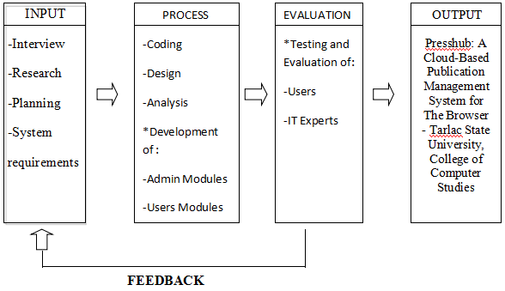

Figure 1 Conceptual Framework

Figure 1 illustrates the Conceptual Framework of the study by identifying the input such as system requirements, interview and planning. The proposed system requires hardware such as personal computers and a printer. Planning for the proposed system required brainstorming and the selection of the locale. Testing and evaluation of end users and IT experts for feedback is also required to come up with a user-friendly and reliable system for the members of The Browser.

VII. Research Design and Methodology

This chapter discusses the different methods, research design and procedures of research that the proponents will be using in the development and designing the system to determine how and where to locate data, as well as the techniques to be used in collecting, proper consultation to the researchers adviser and integrating data upon which a solution the research problem can be made.

The researchers used different methods of research to obtain meaningful information to help in building the proposed system to The Browser. The proponents’ methods of study will be using Agile Scrum Methodology.

1. Locale

The researcher’s locale is Presshub: A Cloud-Based Publication Management System for The Browser - Tarlac State Universtiy, College of Computer Studies. The said Editor-in-Chief was only using manual system that caused duplication of documents and work redundancy. The proposed system will mainly be aiding on their manual passing of their articles and inputs of data which are the cause manual labor.

The said locale started on 1996 under the governance of the Dr. Gigi Maricar Florin, the presiding Editor-in-Chief that time. It was called ICS Gazette. The first issue was a 1-page leaflet paper. On 1997, the name changed to ICS Browser, until it became The Browser up to the present.

Organizational Chart

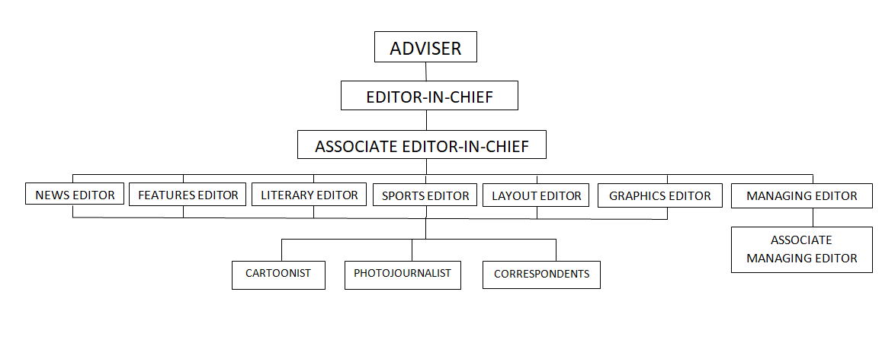

Figure 2

Figure 2 shows the organizational chart of the locale

Operational Feasibility

Presshub: A Cloud-Based Publication Management System for The Browser - Tarlac State Universtiy, College of Computer Studies will be utilized by the members of The Browser-CCS. The system to be implemented is new, so the users will undergo brief training mainly for them to understand the modules and functionality of the system; it will not take too long as they basically understand the basic of computer hardware and software. As soon as the members fully acquire the knowledge in how to system works, it will be easier for them to manage the whole process of the publication. The system is designed to have a systematize management of the publication and a user-friendly interface; it will benefit the users for its features that ensures efficiency. This feasibility study shows the functionality and usability of the proposed system. This system will eliminate the problems of the current process of the publication such as requirement to have a hard copy of articles for checking, unorganized handling of articles, and many more down the line using the manual process.

Technical Feasibility

The technical feasibility deals with the technology used in the system. A computer is essential in implementing this system entitled Presshub: A Cloud-Based Publication Management System for The Browser - Tarlac State Universtiy, College of Computer Studies. Indicated in the title is a cloud-basedsystem is needed in order to satisfy the proposed feature of the system. Windows OS running 7 to 10 is the minimum system software requirements for this. The system will be implemented in the College of Computer Studies, Tarlac State Universiry – San Isidro Campus to be used by the member of The Browser-CCS. The maintenance of this system will be depending on the brand of cloud storage purchased; it will be easily managed and maintaine as all of the members have enough knowledge when it comes to system management.

1. System Development Methodology

Methods of Gathering Data

**Internet**- The proponents used the Internet Research Method. This method is widely used because of vast source of in almost fields.

**Library Research-** The proponents also used this library research method as a means of collecting data. It is a process of searching pertinent information through books, newspaper and unpublished thesis related to this study. In this method the researchers visited the Tarlac State University - San Isidro Campus Library. It is a source of information’s that they can relate in developing the system and this really helped the researchers because it gave relevant data’s related to the study.

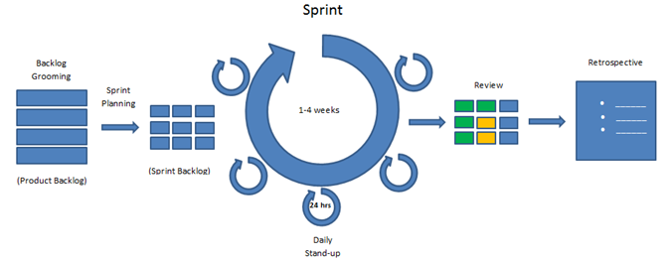**Observation-** The researchers will use observation as a technique in observing the process flow of the organization and to determine the problem being encountere, and to prove that there is a need to develop a system. This will give the researchers a chance to analyze the actual working environment.

Figure 3. Agile Scrum Software Development

Figure 3 shows the diagram of Agile Scrum which the researchers chose for the proposed system. Agile software development refers to a group of software development methodologies based on iterative development, where requirements and solutions evolve through collaboration between self-organizing cross-functional teams. Sprint is very important because it contains all ceremonies and it always ends on time. Next is the backlog grooming, where development team revisits a product backlog that has been pre-defined by the team's facilitator. Third, the Sprint Planning meeting is for team members to plan and agree on the stories or backlog items where the team are confident they are able complete during the sprint and identify the detailed tasks and tests for acceptance. The daily scrum is the team’s participation. Fourth, sprint review, this means that at the end of each sprint, the team has produced a coded, tested and usable piece of software. Sprint review is where feedbacks are received. And the last is retrospective, it is the concrete improved proposals that include steps to achieve the objectives.

Product backlog

Product backlog consists of all the things that are needed to be done with the project. The proponents collaborated about all the requirements, what is to be prioritized and what should be included in every sprint. By defining all the requirements, the proponents will be able to work and finish the system. They will get feedback/s from the locale if there are suggestions and changes that need to be done.

Planning

In this phase, the proponents will be gathering the different requirements they need to start the project with. The researchers have listed down all the problems that the locale has encountered and discussed it together with the locale.

Analysis

In this phase, the proponents will be giving the instruction on how to use the application in order to maintain the effectiveness of the application. The purpose of this application is to inform the end-users that there is application reliable and stable. The application will work with the use of computer with an internet connection.

Design

In this phase, the end users will adapt the system. The proponents will gain feedback on the end users or who’s using it.

Implementation

The system will be implemented and will be up to its domain and fully working capability. All of the errors will be removed and fixed. The system now will be operated by the locale’s administrator and users. The proponents obtained ratings upon implementing the system will help the process of analysis of the effectiveness of the system to the users.

C. Project Schedule

Gantt Chart Table 1

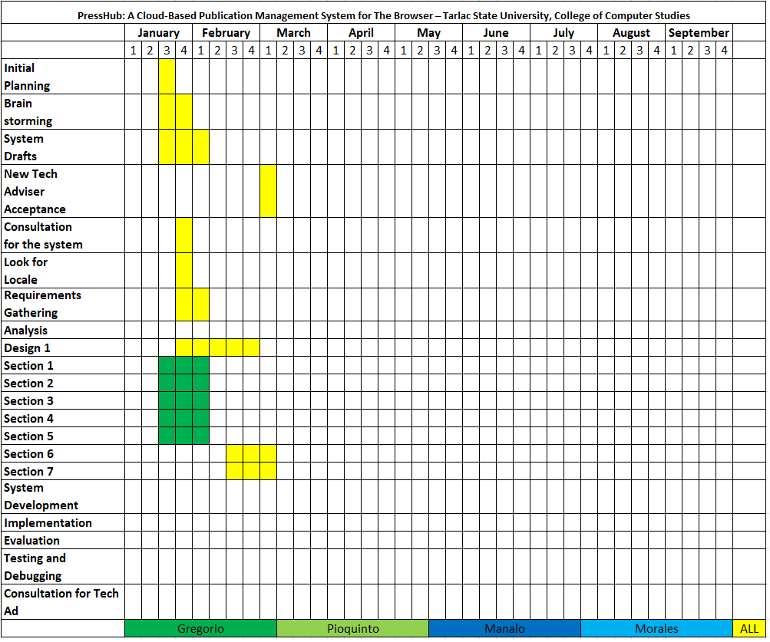

Table I shows the time frame of activities that were done every week. The table also shows the development of the project from searching of locale and scheduling for the title defense.

D. Sampling Technique and Population

The researchers will be using the total population sampling technique as it produces the results which will be beneficial in determining if the proposed system is helpful to the organization. In total population sampling, the proponents chose to study the entire population because the size of the population that has the particular set of characteristics that they are interested in is very small. Since total population sampling involved all members within the population of interest, it was possible to get deep insights into the phenomenon involved. With such wide coverage of the population of interest, there is also a reduced risk of missing potential insights from members that were not included

Population of the Study

The study will be conducted at Tarlac State University, College of Computer Studies. The organization has a total of 16 members and their adviser.

E. Statistical Treatment

The researchers will create an evaluation form that provided the assessment and suggestion regarding the proposed system.

The data that obtained by the researchers from the respondents with the use of evaluation form is processed manually to verify if the result was accurate. The table used by the proponentshelp to easily organize and to summarize the data to conclude the differences of each evaluation. Therefore, the researchers determined the most relevant statistical treatment to be used by the evaluation of the IT experts.

A weighted mean is a kind of average. Instead of each data point contributing equally to the final mean, some data points contribute more ‘weight’ than others. The proponents will be using the percentage method to analyze the calculated information data from the questionnaire to determine and to locate the weakness of the proposed system. The proponents will be using the Likert’s scale to easily comprehend and measure the computation of some mathematical analysis.

Likert’s Scale

|  |  |  |
| --- | --- | --- |
| **Rating** | **Scale** | **Verbal Description** |
| 5 | 4.51 - 5.0 | Strongly Agree |
| 4 | 3.51 - 4.50 | Agree |
| 3 | 2.51 – 3.50 | Undecided |
| 2 | 1.51 – 2.50 | Disagree |
| 1 | 1.0 – 1.50 | Strongly Disagree |

Table II shows the statistical formula using the Likert’s Scale.

The formula in calculating the mean for the tabulated data is: X=

=(5*f)+(4*f)+(3*f)+(2*f)+(1*f)

n

Where:

X = Weighted mean

f = frequency of occurrence for particular field

x = number of unit

n = total number of respondent

Context Diagram

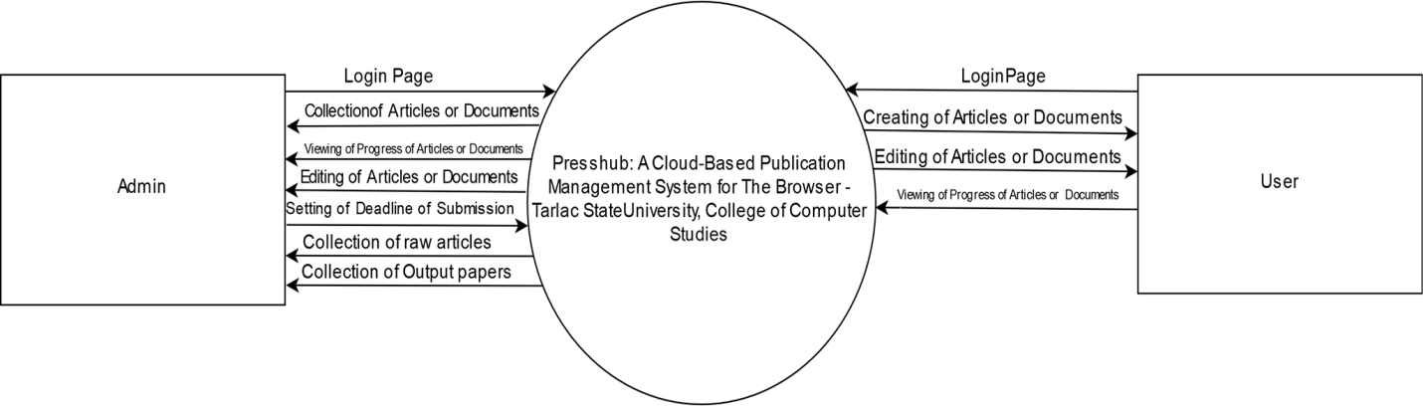

Figure 4

Figure 4 shows the correlation of data and the processes to be made using the Context Diagram.

Data Flow Diagram

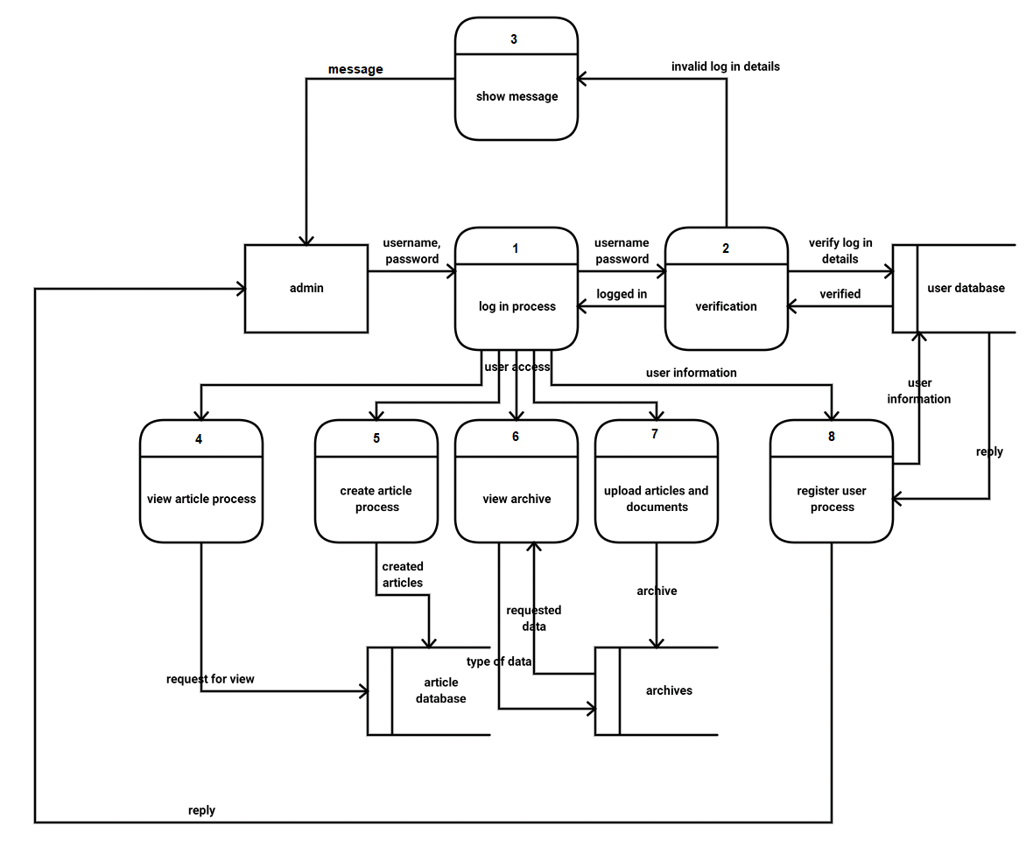

Figure 5.1 Admin

Figure 5 represents the Admin flow of data using the Data Flow Diagram.

Data Flow Diagram

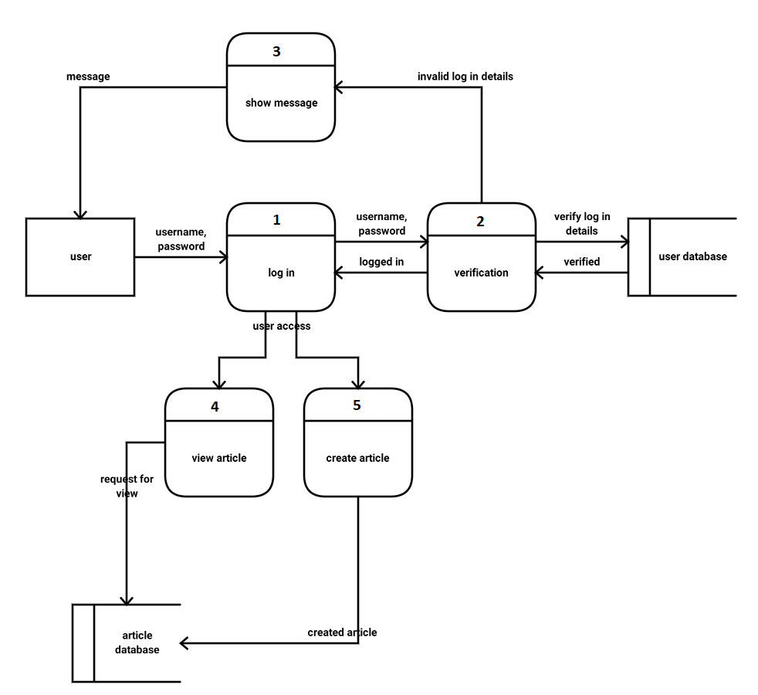

Figure 5.2 User

Figure 5.2 represents the Users flow of data using the Data Flow Diagram.

Flow Chart

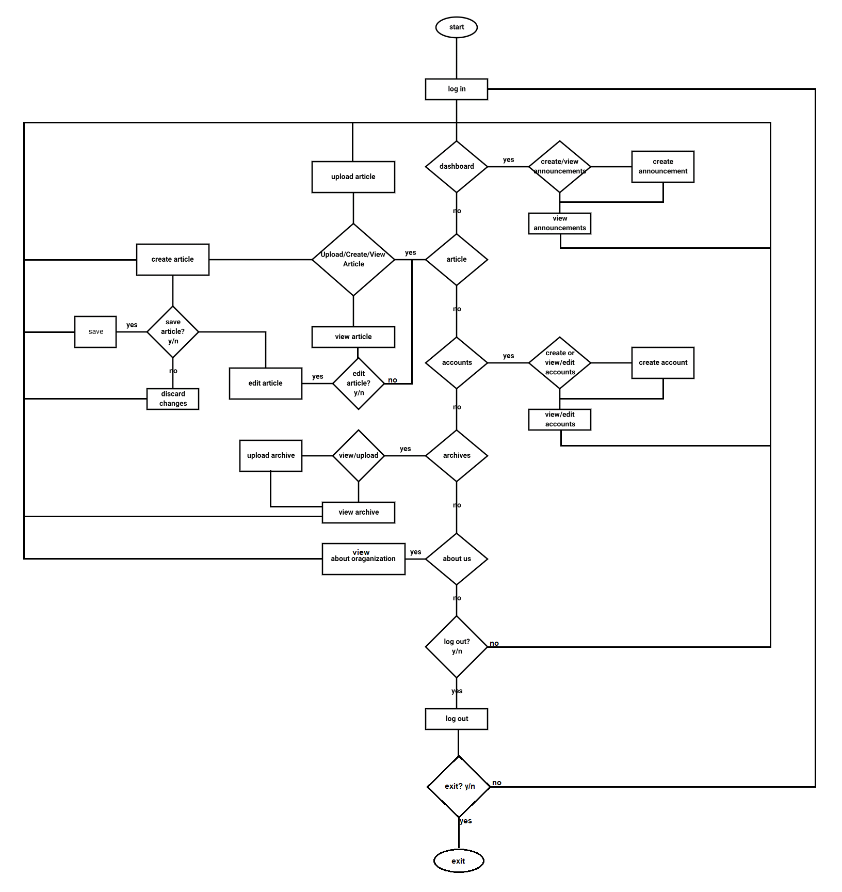

Figure 6.1 Admin

Figure 6.1 shows the Admin side using the Flow Chart Diagram

Flow Chart

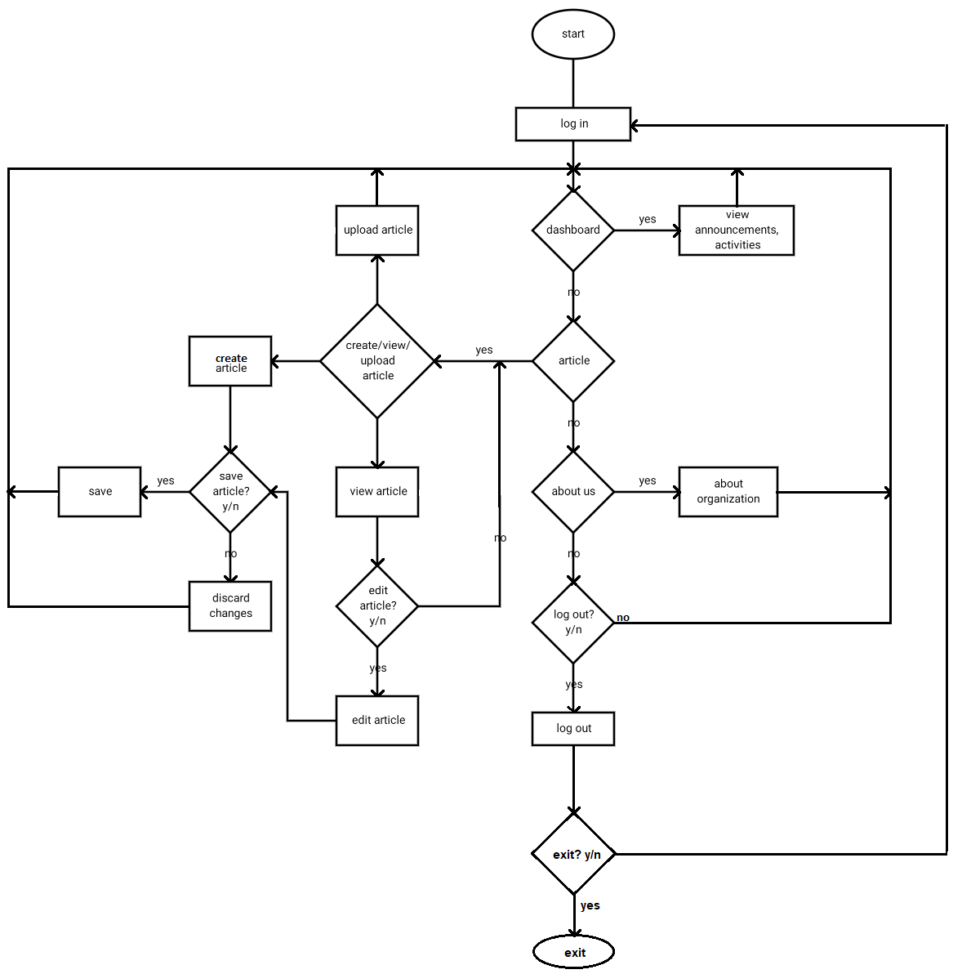

Figure 6.2 User

Figure 6.2 shows the flow of data in the User module using the Flow Chart Diagram.