Name: Erikson Sodergren

Program: Computer Science

Year: 4th

Class: Computational problem solving 1

Section: CPET-121-04

Project 1

Example of an F: 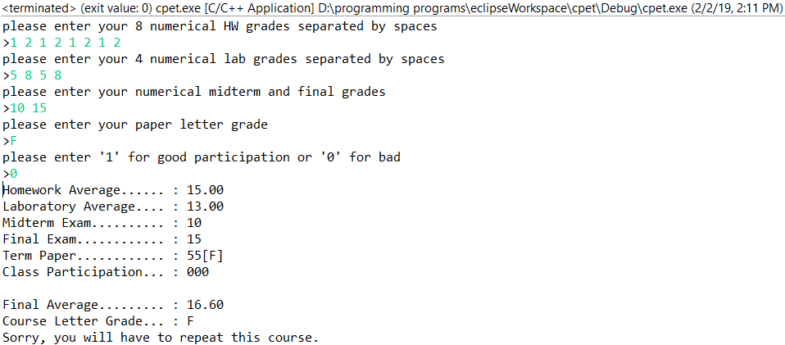

Example of a D: 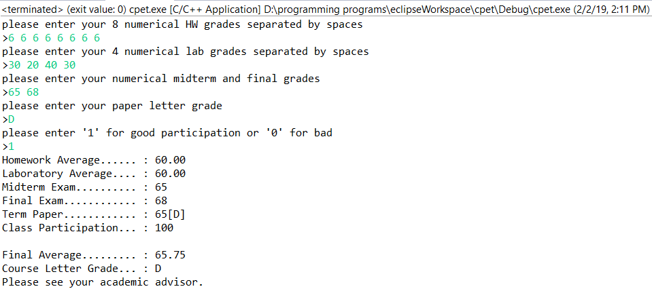

Example of a C-: 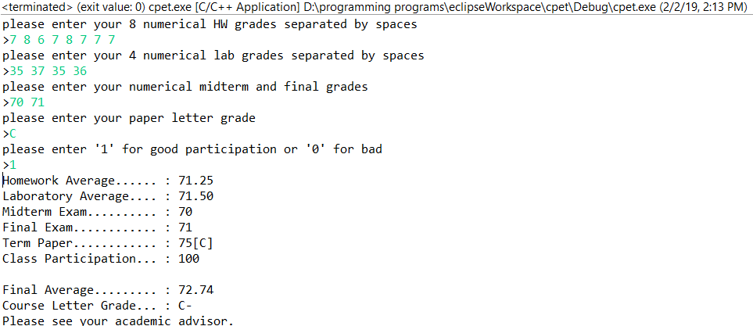

Example of a B: 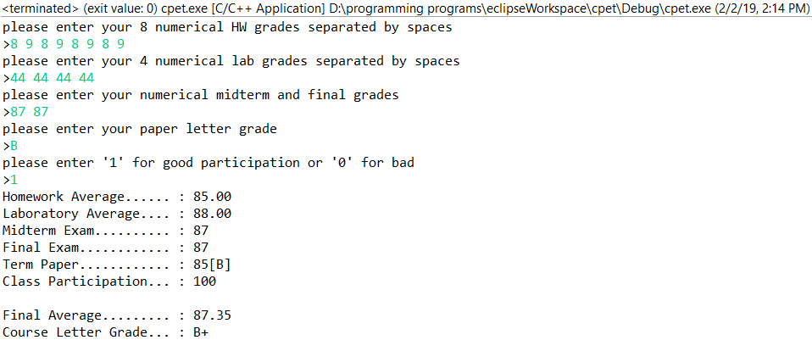

Example of an A: 