MSVC 2012 Express (not officially supported by Teamcenter)

Changes in bmide.bat

The bmide_generatecode.bat is using TC_BIN, if not defined following error
Error: Could not find or load main class com.teamcenter.bmide.codegen.utility.GenerateCodeMain
is shown. Add TC_BIN definition into bmide.bat

if not defined TC_ROOT set TC_ROOT=C:\plm\tc112
if not defined TC_BIN set TC_BIN=%TC_ROOT%\bin

Add following line for 64bit compilation:

call "C:\Program Files (x86)\Microsoft Visual Studio 11.0\VC\vcvarsall.bat" x86_amd64
set PATH=%JRE_HOME%\bin;%JDK_HOME%\bin;%TC_ROOT%\lib;%FMS_HOME%\bin;%FMS_HOME%\lib;%FMS_HOME%;%PATH%

Configuration in BMIDE Project properties

Path and symbols
For symbol evaluation define correct include directories:
${TC_ROOT}\include
${VCINSTALLDIR}\include

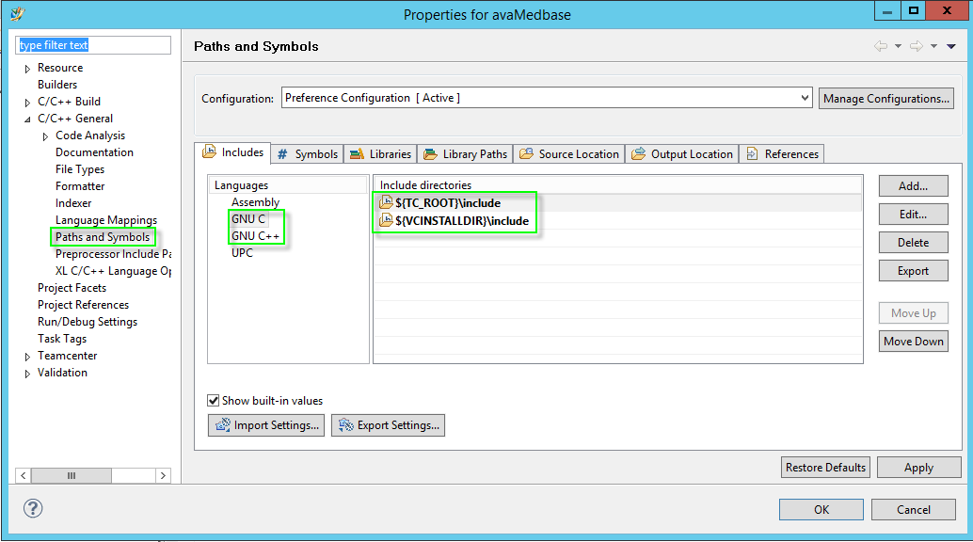
for GNU C and GNU C++ compiler.

