Rabbit Simulator 2014 USER DOC

By: Shane Exterkamp

In the source code: There should be in the src 13 java files and one folder images. In images there should be 22 png files and 1 folder. In that folder there exist backups of the images in PSD form. All files in the src are important and everything except the fies in src/images/PSDs can be considered critically important to compilation.

To Compile: The code has already been compiled and built. Simply go into the RabbitSimulator2014 and run the “RabbitSimualtor.jar” file. If that does not work then to recompile follow thusly:

This code was made in and for Eclipse Luna. Compilation through another means is not recommended and its success cannot be guaranteed. To import the project to Eclipse Luna, go to file->import in the drop down, select General->Existing Projects into Workspace. Once imported, run DisplayImage.java as a Java Application.

\*IF THE SOURCE CODE DOES NOT WORK\* - a copy of it exists in my github, found at https://github.com/exterkamps/TermProjectDAS

To Play:

To begin, select “file->make new simulation field,” and then select the optimal resolution for your device (note: small works better than large since I did not have time to make large assets, so pick large at your own risk.) This process is the same when making a completely new game from the splash or from the game screen.

Before a simulation can be started you must take some steps to prepare:

1. Select a difficulty from the “Difficulty” drop down menu. They will be rendered as you select them so you can see which seems appropriate. (At this point you can click “Start” and play the game, but that is not advisable because you will LOSE, although it can be funny to watch clueless rabbits walk around)
2. Customize your stats. There are four stats to choose from, Fight, Flight, Hunger, and Courage. You have 20 total points to invest into these stats, invest them wisely.
   1. Fight is the chance that upon seeing a fox, the rabbit will stop and attempt to fight the fox, if successful the fox will be stunned for zero to number of points you invested + 5
   2. Flight is the chance that upon seeing the fox your rabbit will run away from the fox at double speed.
   3. Hunger is the distance from which you be able to see food. The distance is x2 the number of points you invest.
   4. Courage will lessen the chance that your rabbit will become nervous and stop when pathing to food. Additionally, when seeing a fox the rabbit will have three options, FIGHT, FLIGHT, RUNAWAY, higher courage lessens the chance of running away (which is the worst) and increases the chance that is they run away they will not drop the food and run home from fear.
3. Some advice on builds: A hunger of 1-3 is low, 3-6 is good, and 7-10 the rabbits will almost always path immediately. Fight is good to make distractions for other rabbits to use to slip in and get food. Flight is good for survivability. Courage is a good skill to invest spare points in, but is often forgot because it doesn’t do anything “fancy” but is a critical component of a success build. ALSO NOTE: you may change any of these stats during the game at any time, but any rabbits currently out will not be changes, only new ones will be changed to the new stats.

Once the stats have been selected you may now begin to play. Press the “Start” button to begin the simulation.

Rabbit hole

The Gamescreen: Here is a screenshot of the game.

Rabbit

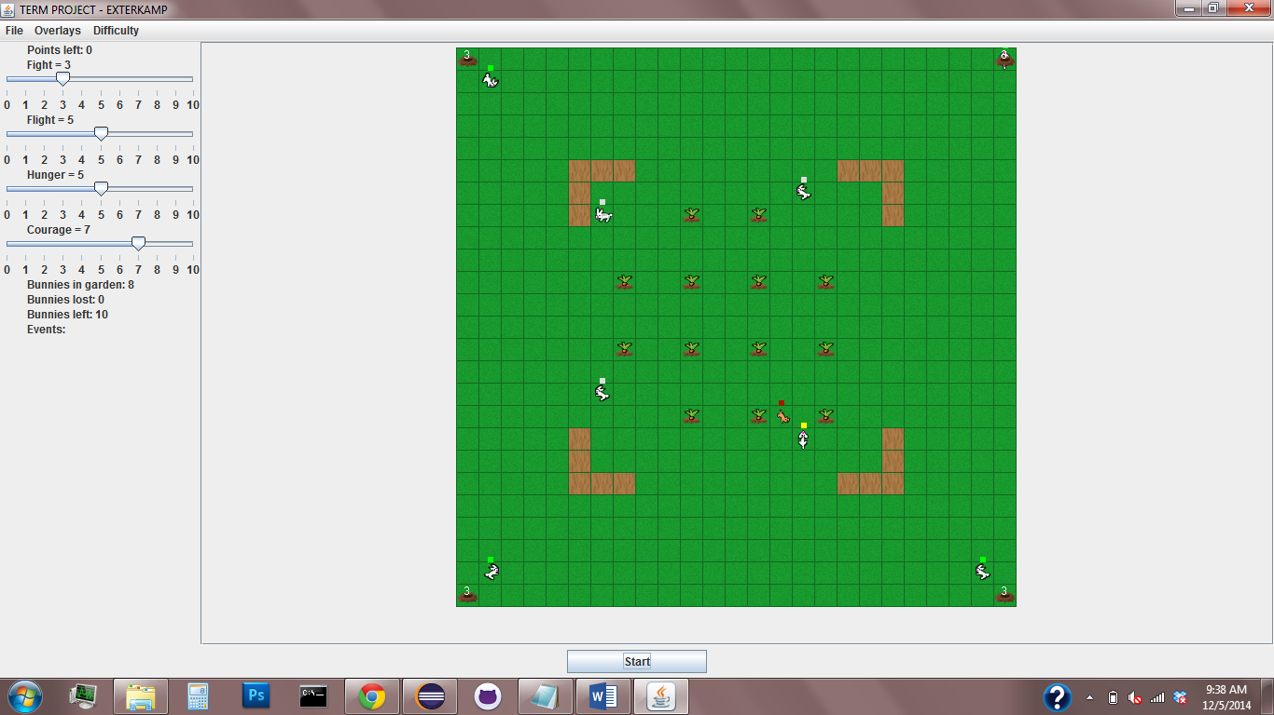

Fence

FOX!

Food

These are the stat sliders.

Once you begin the game the 4 rabbit holes will begin to spawn rabbits at 3 second intervals, noted by the numbers above them. These rabbits will begin to try to raid the garden and avoid the fox. Past this point the game requires no control except for additional behavior adjustments if desired. On the left there are some numbers, “Bunnies in garden,” “Bunnies lost” and “Bunnies left.” These indicate the number of bunnies currently deployed, number of bunnies lost to the fox, and the number of bunnies you can lose before all remaining bunnies lose morale and retreat and end the game in failure.

Above the rabbits and fox are some colored squares, these are called “plumbobs,” they indicate the status of the rabbit (or fox.) Here is a list of their meaning:

Rabbits:

Red: scared

Pink: nervous

Green: confused

Grey: going home

Black: fighting

Yellow: flighting

Magenta: running away

Fox:

Yellow: patrolling around

Dark Red: hunting a rabbit

Light Blue: fighting a rabbit

Additional options are in the “Overlays” menu, selecting the “Path Overlay” option will display the bunny’s desired paths.

If you are feeling fun, or custom-y. You may also, if you think the game is too easy, or somehow too hard, add more fences by clicking on an empty cell. Be aware this is permanent!

Winning:

To win you must not lose more than the initial “number left” of bunnies and retrieve all the FOOD back into the rabbit holes! Once all food is back in the rabbit holes, the rabbits will all be called home and once home the simulation will stop and you will get a popup! To begin again, select “file->Make new simulation field.”

PROTIP: To see both win and loss states go to easy, and use 0/20 of your stats, watch the rabbits try but fail (usually), to win, I usually go 0/5/7/8 Fight/Flight/Hunger/Courage! But easy is no fun, try medium!

Don’t forget to have fun! And try not to feed the fox!