REUSE MANUAL
LAMBERT_2
10xxxxxx.1
Implementation

Table of Contents
Table of Contents i
SECTION 1. Introduction 1
1.1 Purpose of the reuse Manual 1
1.2 PURPOSE OF THE REUSABLE SOFTWARE COMPONENT 1
1.3 GENERAL INFORMATION 2
1.3.1 POINT OF CONTACT 2
1.3.2 CERTIFICATION LEVEL 2
1.3.3 LEGAL RESTRICTIONS 2
Section 2. INSTALLATION 3
2.1 PARTIAL REUSE 3
2.2 MODIFICATIONS 3
Section 3. ENVIRONMENT 4
3.1 HARDWARE 4
3.1.1 DEVELOPMENT 4
3.1.2 TARGET 4
3.2 SOFTWARE 4
3.2.1 OPERATING SYSTEM 4
3.2.2 COMPILERS 4
3.3 ASSUMPTIONS AND PERFORMANCE LIMITATIONS 5
Section 4. Global RSC Environment 6
4.1 TYPES 6
4.2 CONSTANTS 6
4.3 VARIABLES 6
4.4 INCLUDE FILES 7
SECTION 5. FUNCTIONS 8
5.1 SET_LAMBERT_PARAMETERS 8
5.2 GET_LAMBERT_PARAMETERS 10
5.3 Convert_Geodetic_To_LAMBERT 12
5.4 Convert_LAMBERT_TO_GEODETIC 13
APPENDIX A STRUCTURE/DEPENDENCY DIAGRAMS 16
APPENDIX B DEFINITIONS/GLOSSARY 17
APPENDIX C REFERENCES 19

SECTION 1. Introduction

1.1 Purpose of the reuse Manual
This document describes the characteristics of the LAMBERT_2 reusable software component and provides instructions on its installation and operation. The manual is a self-contained reference for the software engineer intending to incorporate the component in another software system. This manual was written with the assumption that the user has a basic working knowledge of C and is familiar with fundamental C concepts and terminology.

1.2 PURPOSE OF THE REUSABLE SOFTWARE COMPONENT
The purpose of LAMBERT_2 is to provide a reusable component that supports the following coordinate conversions:
- Geodetic coordinates (latitude and longitude in radians) to Lambert Conformal Conic projection coordinates (easting and northing in meters) with two standard parallels,
- Lambert Conformal Conic projection coordinates (easting and northing in meters) with two standard parallels to Geodetic coordinates (latitude and longitude in radians).
A particular ellipsoid is specified in terms of the following parameters:
- Semi-Major Axis (a): Radius (in meters) at the equator, and
- Flattening (f): Ratio of the difference between the semi-major axis and polar radius of the Earth to its semi-major axis.
A particular variation of the Lambert Conformal Conic projection with two standard parallels is specified in terms of the following parameters:
- Central Meridian – Longitude (in radians) at the origin of the projection coordinate system,
- Origin Latitude – Latitude (in radians) at the origin of the projection coordinate system,
- 1st Standard Parallel – Latitude (in radians) of the first of the two standard parallels, where the point scale factor is 1.0,
- 2nd Standard Parallel – Latitude (in radians) of the second of the two standard parallels,
- False Easting – A coordinate value (in meters) assigned to the origin longitude of the projection to avoid the inconvenience of using negative coordinates, and
- False Northing – A coordinate value (in meters) assigned to the origin latitude of the projection to avoid the inconvenience of using negative coordinates.
Note that when the two standard parallel parameters are both set to the same latitude value, the result is a Lambert Conformal Conic projection with one standard parallel at the specified latitude, and a scale factor of 1.0 at that latitude.

1.3 GENERAL INFORMATION

1.3.1 POINT OF CONTACT
U.S. Army Topographic Engineering Center (USATEC)
Geospatial Information Division (GID)
ATTN: CETEC-GD-A (Dan Specht)
7701 Telegraph Road
Alexandria, VA 22315-3864
Dan Specht (703) 428 - 6761 Project Manager

1.3.2 CERTIFICATION LEVEL
This RSC has been certified at level 4. A level 4 component satisfies the criteria for reliability, testing, and documentation for the Army Reuse Center (ARC). The component comes with test materials and a Reuse Manual that aids in integrating the component into a software system.

1.3.3 LEGAL RESTRICTIONS
This Reusable Software Component (RSC) contains data with Unlimited Government Rights.

Section 2. INSTALLATION
The following is a list of the compilation files for the LAMBERT_2 component:
Source Code Files:
Lambert_2.c
Header Files :
Lambert_2.h
Data Files :
none
The compilation instructions for the LAMBERT_2 component are as follows:
DOS Makefile (Uses Microsoft C):

cl /nologo /W3 /FR /G2 /DNDEBUG /Gs /Ox /AM /D_DOS /c lambert_2.c
UNIX Makefile (Uses gcc compiler):

cc -g -O -ansi -Wall -c lambert_2.c
The compilation order of the LAMBERT_2 component relative to other components is unconstrained.

2.1 PARTIAL REUSE
The LAMBERT_2 component does not allow for partial reuse.

2.2 MODIFICATIONS
The LAMBERT_2 component does not permit modifications.

Section 3. ENVIRONMENT
This section provides details on the environment under which LAMBERT_2 was developed, tested, and executed.

3.1 HARDWARE

3.1.1 DEVELOPMENT
The following is a list of hardware configurations under which LAMBERT_2 was developed and tested.
- SUN SparcStation 20
- IBM compatible Pentium PC

3.1.2 TARGET
The following is a list of hardware configurations under which LAMBERT_2 was executed.
- SUN SparcStation 20
- IBM compatible Pentium PC

3.2 SOFTWARE

3.2.1 OPERATING SYSTEM
The following is a list of operating systems under which LAMBERT_2 was executed and tested.
- Solaris 2.7
- Windows 2000/NT

3.2.2 COMPILERS
The following is a list of compilers on which LAMBERT_2 was compiled successfully.
- GCC version 2.95.2
- Microsoft Visual C++ version 6

3.3 ASSUMPTIONS AND PERFORMANCE LIMITATIONS
There are no hardware or environment constraints. There are no limitations.
This RSC is written in ANSI C.

Section 4. Global RSC Environment

4.1 TYPES
Not applicable.

4.2 CONSTANTS
The following is a list of significant visible constants declared globally in LAMBERT_2 with their descriptions.

LAMBERT_2_NO_ERROR : No errors occurred in function
LAMBERT_2_LAT_ERROR : Latitude outside of valid range
(-90 to 90 degrees)
LAMBERT_2_LON_ERROR : Longitude outside of valid range
(-180 to 360 degrees)
LAMBERT_2_EASTING_ERROR : Easting outside of valid range
(depends on ellipsoid and projection
parameters)
LAMBERT_2_NORTHING_ERROR : Northing outside of valid range
(depends on ellipsoid and projection
parameters)
LAMBERT_2_FIRST_STDP_ERROR : First standard parallel outside of valid
range (-89 59 59.0 to 89 59 59.0 degrees)
LAMBERT_2_SECOND_STDP_ERROR : Second standard parallel outside of valid
range (-89 59 59.0 to 89 59 59.0degrees)
LAMBERT_2_ORIGIN_LAT_ERROR : Origin latitude outside of valid range
(-89 59 59.0 to 89 59 59.0 degrees)
LAMBERT_2_CENT_MER_ERROR : Central meridian outside of valid range
(-180 to 360 degrees)
LAMBERT_2_A_ERROR : Semi-major axis less than or equal to zero
LAMBERT_2_INV_F_ERROR : Inverse flattening outside of valid range
(250 to 350)
LAMBERT_2_HEMISPHERE_ERROR : Standard parallels cannot be opposite
latitudes
LAMBERT_2_FIRST_SECOND_ERROR : The 1st & 2nd standard parallels cannot
both be 0

4.3 VARIABLES
The following is a list of significant global variables declared in LAMBERT_2 with their descriptions.

Ellipsoid Parameters:
static double Lambert_2_a : Semi-major axis of ellipsoid in meters
static double Lambert_2_f : Flattening of ellipsoid

Projection Parameters:
static double Lambert_2_Std_Parallel_1 : Lower standard parallel latitude in radians
static double Lambert_2_Std_Parallel_2 : Upper standard parallel latitude in radians
static double Lambert_2_Origin_Lat : Latitude of origin in radians
static double Lambert_2_Origin_Long : Longitude of origin in radians
static double Lambert_2_False_Easting : False easting in meters
static double Lambert_2_False_Northing : False northing in meters

Maximum variance for easting and northing values:
static double Lambert_2_Delta_Easting
static double Lambert_2_Delta_Northing

4.4 INCLUDE FILES

math.h : Standard C math library
lambert_1.h : Lambert Conformal Conic with 1 std parallel
Lambert_2.h : Error codes and prototype error checking

4.5 DEPENDENCIES
The following is a list of the software external to the RSC and its descriptions.
LAMBERT_1, since the parameters of the Lambert Conformal Conic projection with one standard parallel can be computed from the parameters of the Lambert Conformal Conic projection with two standard parallels.
Note: The lambert_2 directory also contains files: lambert.c and lambert.h. These files provide the same functionality as lambert_2.c and lambert_2.h, respectively. They are not used by the GEOTRANS application, but are provided for backward compatibility with earlier versions of GEOTRANS.

SECTION 5. FUNCTIONS

5.1 SET_LAMBERT_2_PARAMETERS

5.1.1 DESCRIPTION
This function sets the ellipsoid and Lambert Conformal Conic projection parameters to the specified values.

5.1.2 INTERFACES AND EXAMPLES
The following is a list of the formal arguments required to use this function.
long Set_Lambert_2_Parameters (double a,
double f,
double Origin_Latitude,
double Central_Meridian,
double Std_Parallel_1,
double Std_Parallel_2,
double False_Easting,
double False_Northing);
a Semi-major axis of ellipsoid in meters (input),
f Flattening of ellipsoid (input),
Origin_Latitude Latitude in radians at the origin of the projection (input),
Central_Meridian Longitude in radians at the origin of the projection (input),
Std_Parallel_1 Latitude in radians of the lower standard parallel (input),
Std_Parallel_2 Latitude in radians of the upper standard parallel (input),
False_Easting Coordinate value in meters assigned to the origin longitude (input),
False_Northing Coordinate value in meters assigned to the origin latitude (input).
Note that when the two standard parallel parameters are both set to the same latitude value, the result is a Lambert Conformal Conic projection with one standard parallel at the specified latitude, and a scale factor of 1.0 at that latitude.
Example:
status = Set_Lambert_2_Parameters (a, f, Origin_Latitude, Central_Meridian, Std_Parallel_1, Std_Parallel_2, False_Easting, False_Northing)
Inputs:
a 6378137.0
f 1 / 298.257223563
Origin_Latitude 45.0
Central_Meridian 0.0
Std_Parallel_1 40.0
Std_Parallel_2 50.0
False_Easting 0.0
False_Northing 0.0
Outputs:
None.

5.1.3 DECLARATIONS

5.1.3.1 TYPES
Not applicable.

5.1.3.2 CONSTANTS
Not applicable.

5.1.3.3 VARIABLES
Not applicable.

5.1.4 DEPENDENCIES
None.

5.1.5 ERROR HANDLING
This function returns the following status codes:

LAMBERT_2_NO_ERROR : No errors occurred in function
LAMBERT_2_FIRST_STDP_ERROR : First standard parallel outside of valid
range (-89 59 59.0 to 89 59 59.0 degrees)
LAMBERT_2_SECOND_STDP_ERROR : Second standard parallel outside of valid
range (-89 59 59.0 to 89 59 59.0 degrees)
LAMBERT_2_ORIGIN_LAT_ERROR : Origin latitude outside of valid range
(-89 59 59.0 to 89 59 59.0 degrees)
LAMBERT_2_CENT_MER_ERROR : Origin longitude outside of valid range
(-180 to 360 degrees)
LAMBERT_2_A_ERROR : Semi-major axis less than or equal to zero
LAMBERT_2_INV_F_ERROR : Inverse flattening outside of valid range
(250 to 350)
LAMBERT_2_HEMISPHERE_ERROR : Standard parallels cannot be opposite
Latitudes
LAMBERT_2_FIRST_SECOND_ERROR : The 1st & 2nd standard parallels cannot
both be 0

5.2 GET_LAMBERT_2_PARAMETERS

5.2.1 DESCRIPTION
This function returns the current values of the ellipsoid parameters and Lambert Conformal Conic projection parameters.

5.2.2 INTERFACES AND EXAMPLES
The following is a list of the formal arguments required to use this function.
void Get_Lambert_2_Parameters (double *a,
double *f,
double *Origin_Latitude,
double *Central_Meridian,
double *Std_Parallel_1,
double *Std_Parallel_2,
double *False_Easting,
double *False_Northing);
a Semi-major axis of ellipsoid in meters (output),
f Flattening of ellipsoid (output),
Origin_Latitude Latitude in radians at the origin of the projection (output),
Central_Meridian Longitude in radians at the origin of the projection (output),
Std_Parallel_1 Latitude in radians of the lower standard parallel (output),
Std_Parallel_2 Latitude in radians of the upper standard parallel (output),
False_Easting Coordinate value in meters assigned to the origin longitude (output),
False_Northing Coordinate value in meters assigned to the origin latitude (output).

5.2.3 DECLARATIONS

5.2.3.1 TYPES
Not applicable.

5.2.3.2 CONSTANTS
Not applicable.

5.2.3.3 VARIABLES
Not applicable.

5.2.4 DEPENDENCIES
None.

5.2.5 ERROR HANDLING
No errors are reported by this function.

5.3 Convert_Geodetic_To_LAMBERT_2

5.3.1 DESCRIPTION
This function converts Geodetic coordinates (latitude and longitude in radians) to Lambert Conformal Conic projection coordinates (easting and northing in meters), using the current ellipsoid and Lambert Conformal Conic projection parameters.

5.3.2 INTERFACES AND EXAMPLES
The following is a list of the formal arguments required to use this function.
long Convert_Geodetic_To_Lambert_2 (double Latitude,
double Longitude,
double *Easting,
double *Northing);
Latitude Latitude in radians (input),
Longitude Longitude in radians (input),
Easting Easting (X) in meters (output),
Northing Northing (Y) in meters (output).
Example:
status = Convert_Geodetic_To_Lambert_2 (Latitude, Longitude, Easting, Northing)
Inputs:
Latitude: 35.0
Longitude: 75.0
Outputs:
Easting: 5972201
Northing: 1872576

5.3.3 DECLARATIONS

5.3.3.1 TYPES
Not applicable.

5.3.3.2 CONSTANTS
Not applicable.

5.3.3.3 VARIABLES
Not applicable.

DEPENDENCIES
None.

5.3.5 ERROR HANDLING
This function returns the following status codes:

LAMBERT_2_NO_ERROR : No errors occurred in function
LAMBERT_2_LAT_ERROR : Latitude outside of valid range
(-90 to 90 degrees)
LAMBERT_2_LON_ERROR : Longitude outside of valid range
(-180 to 360 degrees)

5.4 Convert_LAMBERT_2_TO_GEODETIC

5.4.1 DESCRIPTION
This function converts Lambert Conformal Conic projection coordinates (easting and northing in meters) to Geodetic coordinates (latitude and longitude in radians), using the current ellipsoid and Lambert Conformal Conic projection parameters.

5.4.2 INTERFACES AND EXAMPLES
The following is a list of the formal arguments required to use this function.
long Convert_Lambert_2_To_Geodetic (double Easting,
double Northing,
double *Latitude,
double *Longitude);
Easting Easting (X) in meters (input),
Northing Northing (Y) in meters (input),
Latitude Latitude in radians (output),
Longitude Longitude in radians (output).
Example:
status = Convert_Lambert_2_To_Geodetic (Easting, Northing, Latitude, Longitude)
Inputs:
Easting: 5972201
Northing: 1872576
Outputs:
Latitude: 35.0
Longitude: 75.0

5.4.3 DECLARATIONS

5.4.3.1 TYPES
Not applicable.

5.4.3.2 CONSTANTS
Not applicable.

5.4.3.3 VARIABLES
Not applicable.

DEPENDENCIES
None.

5.4.5 ERROR HANDLING
This function returns the following status codes:

LAMBERT_2_NO_ERROR : No errors occurred in function
LAMBERT_2_EASTING_ERROR : Easting outside of valid range
(depends on ellipsoid and projection
parameters)
LAMBERT_2_NORTHING_ERROR : Northing outside of valid range
(depends on ellipsoid and projection
parameters)

APPENDIX A STRUCTURE/DEPENDENCY DIAGRAMS
This component consists of a single compilation unit and depends on the LAMBERT_1 component, as well as on the ANSI C standard math library.
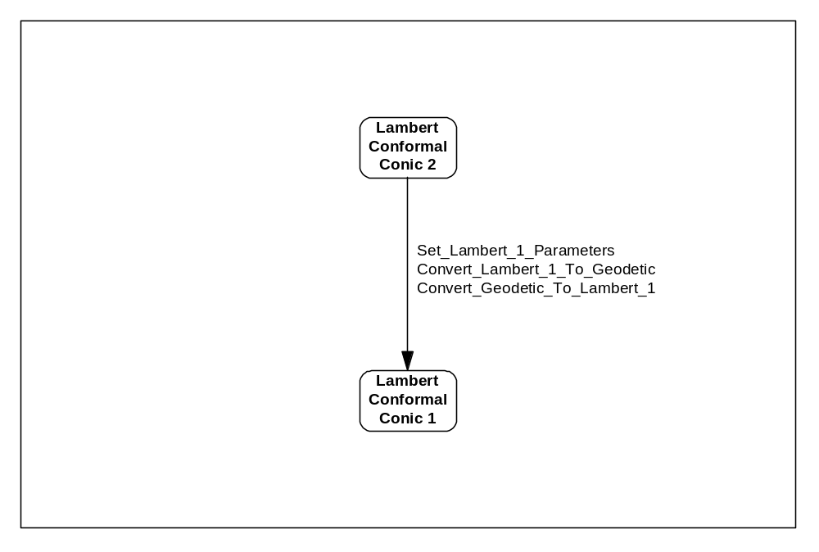

APPENDIX B DEFINITIONS/GLOSSARY
Central Meridian – Longitude at the horizontal center of a projection.
Coordinate – Linear or angular quantities that designate the position that a point occupies in a given reference frame or system. Also used as a general term to designate the particular kind of reference frame or system, such as Cartesian or spherical coordinates.
Ellipsoid – The surface generated by an ellipse rotating about one of its axes.
False Easting – A coordinate value (in meters) assigned to the origin longitude of the projection to avoid the inconvenience of using negative coordinates.
False Northing – A coordinate value (in meters) assigned to the origin latitude of the projection to avoid the inconvenience of using negative coordinates.
Geodetic Coordinates – The quantities of latitude and longitude that define the position of a point on the surface of the earth with respect to the reference ellipsoid. Also, imprecisely called geographic coordinates.
Geodetic Latitude – The angle between the plane of the equator and the normal to the ellipsoid through the computation point. Geodetic latitude is positive north of the equator and negative south of the equator.
Geodetic Longitude – The angle between the plane of a meridian and the plane of the prime meridian. A longitude can be measured from the angle formed between the local and prime meridians at the pole of rotation of the reference ellipsoid, or by the arc along the equator intercepted by these meridians.
Lambert Conformal Conic Projection – A conformal projection in which the projected parallels are arcs of concentric circles centered at the pole. The projected meridians are radii of concentric circles that meet at the pole. There are one or two parallels, called standard parallels, along which the point scale factor is one.
Map Projection – A function relating coordinates of points on a curved surface (usually an ellipsoid or sphere) to coordinates of points on a plane. A map projection may be established by analytical computation or, less commonly, may be constructed geometrically.
Map Scale – The ratio between a distance on a map and the corresponding actual distance on the earth’s surface.
Meridian – A north-south reference line, particularly a great circle through the geo–graphical poles of the earth, from which longitudes and azimuths are determined; or the intersection of a plane forming a great circle that contains both geographic poles of the earth, and the ellipsoid.
Origin Latitude – Latitude of the origin of the projected coordinate system.
Parallel – A line on the earth, or a representation thereof, that represents the same latitude at every point.
Scale Factor (Projection) – A multplier for reducing a distance in a map projection to the actual distance on the chosen reference ellipsoid.

APPENDIX C REFERENCES
(1) Topographic Engineering Center, TEC-SR-7, Handbook for transformation of DATUMS, PROJECTIONS, GRIDS, AND COMMON COORDINATE SYSTEMS, January 1996.
(2) Snyder, J. P., Geological Survey Professional Paper 1395 Map Projections - A Working Manual, 1987.

