Document No: 1100508
CAGE Code: 12436
Date: 3 December 2009
Mensuration Services Program (MSP)
Programmer’s Guide for
MSP Geographic Translator (GEOTRANS) Version 3.0

Program Title: Mensuration Services Program
Contract No: HM1572-06-C-0021
CDRL: A026
DID: Contractor Format
Prepared For: National Geospatial-Intelligence Agency
12310 Sunrise Valley Drive
Reston, VA 20191-3449

Change Log
Version | Date | Description of Change
01 | 3 December 2009 | Original issue.

Table of Contents
1. Scope 1
1.1 Identification 1
1.2 System Overview 1
1.3 Document Overview 2
2. Referenced Documents 3
3. Programming Environment 4
3.1 Software 4
3.1.1 Operating System(s) 4
3.1.2 Compilation and Linking 4
3.1.3 Directory Structure 4
3.2 Hardware Requirements 6
3.3 Packaging Requirements 6
4. Software Support Information 7
4.1 GEOTRANS Coordinate Conversion Service Software 7
4.2 GEOTRANS Application Software 12
4.2.1 GEOTRANS Application GUI Software 12
4.2.2 On-Line Help Source Files 13
4.3 Data Files 17
4.4 Compilation/Build Procedures 18
4.4.1 UNIX Compilation/Build Procedures 18
4.4.2 Windows Compilation/Build Procedures 19
4.4.3 Java Compilation/Build Procedures 19
5. Notes 20
5.1 Coordinate Conversion Logic 20
5.2 Datum Shift Logic 21

List of Figures
Figure 4-1. CoordinateConversionService, DatumLibrary, and EllipsoidLibrary 8
Figure 4-2. CoordinateConversionParameters and its Subclasses 9
Figure 4-3. CoordinateTuple and its Subclasses 12

1. Scope

1.1 Identification
This document is the Programmer’s Guide for Version 3.0 of the Geographic Translator (GEOTRANS).

1.2 System Overview
GEOTRANS (Geographic Translator) is an application that allows you to convert geographic coordinates among a wide variety of coordinate systems, map projections, grids, and datums. GEOTRANS runs in Microsoft Windows, LINUX and UNIX environments.
The user interface of GEOTRANS consists primarily of a single window. To convert coordinates, select the coordinate reference frame and datum in which your coordinates are defined, enter any associated parameters, and enter the coordinates in the upper half of the window. Then select the coordinate reference frame and datum to which you want the coordinates to be converted, and enter any associated parameters, in the lower half of the window. Click on the Convert Upper-to-Lower button, and the resulting coordinates will be displayed in the lower half of the window. You can convert additional coordinate sets from the same source by just entering the new coordinates and clicking on the Convert Upper-to-Lower button. You can change any of the coordinate reference frame, datum, or parameter selections at any time. Also, you can reverse the roles of input and output by using the Convert Lower-to-Upper button. Currently, thirty-five different types of coordinate systems, map projections, grids, and coding schemes are supported, as well as more than two hundred different horizontal datums.
GEOTRANS can also be used to efficiently convert large numbers of coordinates contained in text files. The file format is very simple. A multi-line file header defines the coordinate reference frame and datum of the coordinates contained in the file, including any associated parameter values. Following the header, each line contains a single set of coordinates, separated by commas followed by at least one space. Using the GEOTRANS file processing interface, you can select an existing file of coordinates to be converted. You can then define the coordinate reference frame and datum to which you want to convert the coordinates, along with any associated parameter values. Finally, you can specify the name and location of the output file that is to be created. GEOTRANS then converts all of the coordinates in the input file and creates the output file as a single operation.

1.3 Document Overview
The remainder of this document is organized as follows:
- Section 2 identifies the other documents that are referenced in this Programmer’s Guide.
- Section 3 describes the programming environment in which the GEOTRANS application was developed, and summarizes the structure of the GEOTRANS application software.
- Section 4 presents the as built design of the GEOTRANS application software, briefly describing each of the components, the build procedures, and modification procedures.
- Section 5 contains additional notes.

2. Referenced Documents
The following documents describe coordinate systems, map projections, coordinate conversion, and datum transformation:
- NGA TM 8358.1, Datums, Ellipsoids, Grids, and Grid Reference Systems, 1990.
- NGA TM 8358.2, The Universal Grids: Universal Transverse Mercator (UTM) and Universal Polar Stereographic (UPS), 1989.
- MIL-STD-2401, Department of Defense World Geodetic System (WGS), 1994.
- STANAG 2211, Geodetic Datums, ellipsoids, grids and grid references, Fifth Edition, 1991.
- TEC-SR-7, Handbook for Transformation of Datums, Projections, Grids and Common Coordinate Systems, 1996.
- NGA, Department of Defense Glossary of Mapping, Charting, and Geodetic Terms, Fourth Edition, 1981.
- Rapp, Richard H., Geometric Geodesy - Part I; Department of Geodetic Science and Surveying, The Ohio State University, Columbus, Ohio. 1984.
- Rapp, Richard H., Geometric Geodesy - Part II; Department of Geodetic Science and Surveying, The Ohio State University, Columbus, Ohio. 1987.
- Snyder, J. P., Geological Survey Professional Paper 1395 Map Projections - A Working Manual, 1987.
- Federal Geographic Data Committee (FGDC), FGDC-STD-011-2001, United States National Grid, December 2001
- http://earth-info.nga.mil/GandG/coordsys/grids/gars.html, Global Area Reference System (GARS)

3. Programming Environment
This section describes the programming environment in which the GEOTRANS application was developed, and summarizes the structure of the GEOTRANS application software. It also summarizes the hardware requirements of the GEOTRANS application software.

3.1 Software

3.1.1 Operating System(s)
The GEOTRANS software was developed and tested using the Microsoft Windows XP operating system, as well as Sun Solaris 8 UNIX, and Red Hat LINUX. It should work on all later versions of these operating systems. The software was designed to reduce as much as possible any operating system dependencies.

3.1.2 Compilation and Linking
The GEOTRANS Coordinate Conversion Service was developed in C++. The Windows versions were developed using Microsoft Visual C++ .Net 2003. The UNIX versions were developed using the Sun Forte Workshop 6 Update 2 compiler and LINUX versions were developed using the GNU C++ compiler (gcc, version 3.4.6).
The GEOTRANS application GUI was developed in Java. The Java GUI was developed using the NetBeans IDE, available at www.netbeans.org.

3.1.3 Directory Structure
The GEOTRANS software distribution includes all of the directories and files needed to build and execute all versions (UNIX, LINUX and Windows) of the GEOTRANS software. The GEOTRANS software distribution consists of three top-level components:
- The GEOTRANS Application software component is contained in a directory named GEOTRANS3.
- The GEOTRANS Coordinate Conversion Service software component is contained in a directory named CCS.
- The GEOTRANS data files needed for initializing the GEOTRANS application are contained in a directory named data.

3.1.3.1 GEOTRANS Application Component
Within the GETOTRANS3 directory, the GEOTRANS Application software component is organized into subdirectories as follows:
- docs – contains documentation for the GEOTRANS application software in Microsoft Word 2003 format,
- help – contains the on-line help source files for the GEOTRANS application, including files in HyperText Markup Language (HTML) and graphics files in GIF format,
- java_gui – contains the source code for the GEOTRANS Application graphical user interface GUI,
- solaris – contains the SOLARIS GEOTRANS jar file, the Coordinate Conversion Service (CCS) shared object library, JNI CCS shared object library, makefile, and all other files needed to build and run the GEOTRANS Application on SOLARIS systems.
- linux – contains the LINUX GEOTRANS jar file, the Coordinate Conversion Service (CCS) shared object library, JNI CCS shared object library, makefile, and all other files needed to build and run the GEOTRANS Application on LINUX systems.
- win – contains the Windows GEOTRANS jar file, the CCS DLL, JNI CCS DLL, Visual C++ solution and project files, and all other files needed to build and run the GEOTRANS application on Windows systems.

3.1.3.2 GEOTRANS Coordinate Conversion Service Component
The GEOTRANS Coordinate Conversion Service resides within the CCS directory. It supports the following types of coordinate conversions:
- Conversions between geodetic, geocentric, and local Cartesian coordinate systems,
- Conversions between geodetic coordinates (latitude and longitude in radians) and various types of map projection coordinates (easting and northing in linear units),
- Conversions between geodetic coordinates and Military Grid Reference System (MGRS), United States National Grid (USNG), Global Area Reference System (GARS), or World Geographic Reference System (GEOREF) grid coordinates,
- Transformations of geodetic or geocentric coordinates between different global or local horizontal datums,
- Transformations between ellipsoid heights and geoid (or local MSL) heights, and
- Conversions that combine two or more of the above operations.
There are two subdirectories within the CCS directory containing the engine component:
- doxygen – which contains the CCS API documentation in the form of a set of hyperlinked HTML files created using the doxygen documentation generation tool.
- src – which contains the source files for the CCS component,
- solaris – which contains the SOLARIS makefiles and all other files needed to build the CCS shared object library for SOLARIS,
- linux – which contains the LINUX makefiles and all other files needed to build the CCS shared object library for LINUX,
- win – which contains the Visual C++ solution and project files, and all other files needed to build the CCS Windows DLL.

3.1.3.3 GEOTRANS Data Component
Within the data directory are the datum and ellipsoid parameter files, and the geoid separation grid files, required to properly initialize the GEOTRANS software.

3.2 Hardware Requirements
The hardware requirements of the GEOTRANS software are minimal. It is designed to run on any 32- or 64-bit processor with 256MB or more of memory, and 128MB or more of available disk space.

3.3 Packaging Requirements
The GEOTRANS software is normally distributed via download from unclassified NGA’s GEOTRANS web page:
Located at: http://earth-info.nga.mil/GandG/geotrans/.
Additionally, the software can be downloaded from the SIPRNet or JWICS web sites, or ordered on CD via the MSP Help line.
SIPRNet link: http://www.geoint.nga.smil.mil/products/gandg/geotrans
JWICS link: http://www.geoint.nga.ic.gov/products/gandg/geotrans/
MSP Help line: 858-592-5677 (5MSP)

4. Software Support Information
This section describes the as built design of the GEOTRANS Application software component.
This section describes each of the components that make up the GEOTRANS software. The GEOTRANS software consists of three components, as follows:
- The GEOTRANS Coordinate Conversion Service software is located in the CCS directory,
- the GEOTRANS3 Application software is located in the GEOTRANS3 directory, and
- the GEOTRANS data files are located in the data directory.
Each of these components is described below.

4.1 GEOTRANS Coordinate Conversion Service Software
This section describes the structure and organization of the GEOTRANS Coordinate Conversion Service software, which is located in the CCS/src directory. The CCS/src directory is organized into subdirectories, as follows:
- CoordinateConversion – contains the source code for the CoordinateConversionService class.
- dtcc – contains the DatumLibrary, EllipsoidLibrary, and GeoidLibrary classes. These classes and CoordinateConversionService class form the primary external interface of the GEOTRANS Coordinate Conversion Service. They are shown in UML form in Figure 4-1.
- dtcc/CoordinateSystemParameters – contains the source code for the abstract CoordinateSystemParameters class and all of its concrete subclasses. These classes are shown in UML form in Figure 4-2.
- dtcc/CoordinateSystems – contains the source code for the abstract CoordinateSystem class and all of its concrete subclasses. It also contains classes for datums and ellipsoids. It is organized into subdirectories, as follows:
- albers – contains the AlbersEqualAreaConic class, which performs conversions between geodetic coordinates and Albers Equal Area Conic projection coordinates.
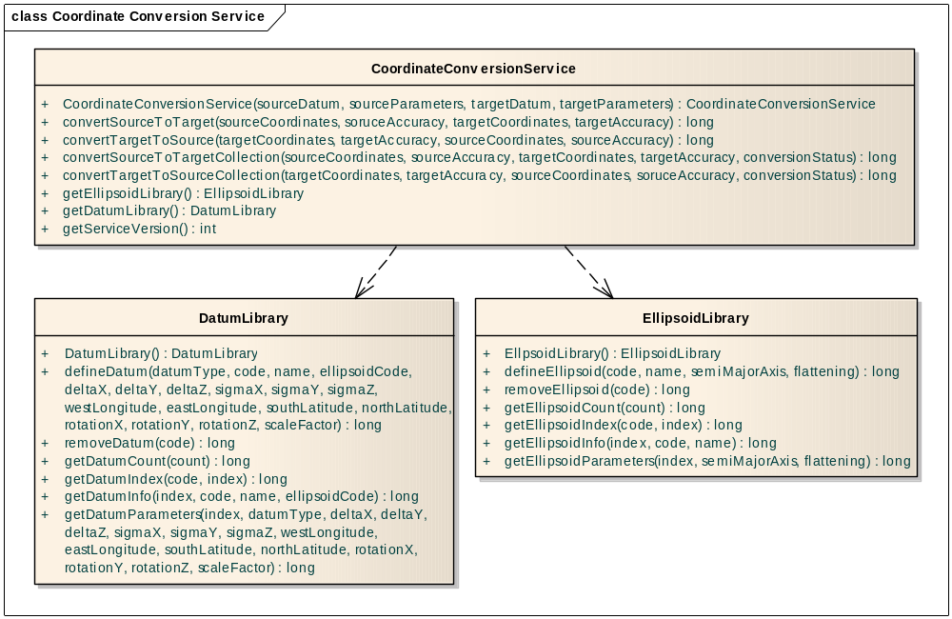
Figure 4-1. CoordinateConversionService, DatumLibrary, and EllipsoidLibrary
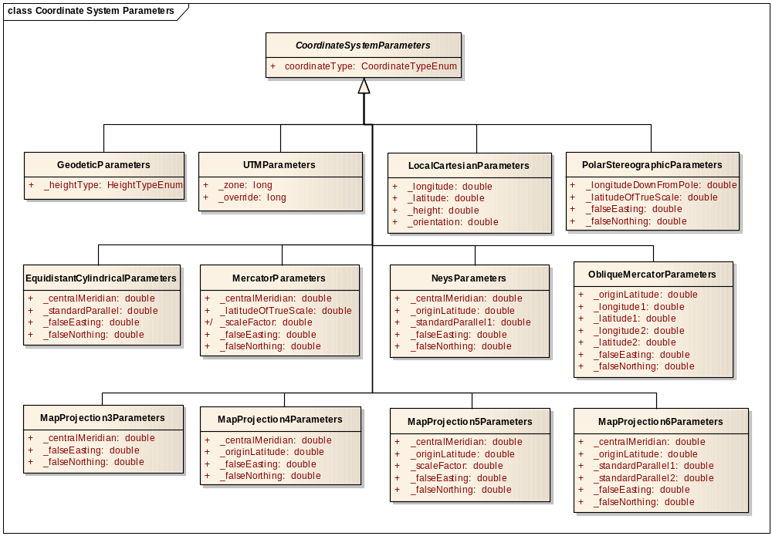
Figure 4-2. CoordinateConversionParameters and its Subclasses
- azeq – contains the AzimuthalEquidistant class, which performs conversions between geodetic coordinates and Azimuthal Equidistant projection coordinates.
- bng – contains the BritishNationalGrid class which, performs conversions between Geodetic and Transverse Mercator projection coordinates and British National Grid coordinates. It depends on the TransverseMercator class.
- bonne – contains the Bonne class, which performs conversions between geodetic coordinates and Bonne projection coordinates.
- cassini– contains the Cassini class, which performs conversions between geodetic coordinates and Cassini projection coordinates.
- cyleqa – contains the CylindricalEqualArea class, which performs conversions between Geodetic coordinates and Cylindrical Equal Area projection coordinates.
- datum – contains the DatumLibraryImplementation class, as well as the abstact Datum class and its concrete subclasses. These classes provide access to datum parameters for over 200 local datums, and perform datum transformations in either geodetic or geocentric coordinates.
- eckert4– contains the Eckert4 class, which performs conversions between geodetic coordinates and Eckert IV projection coordinates.
- eckert6– contains the Eckert6 class, which performs conversions between geodetic coordinates and Eckert VI projection coordinates.
- ellipse – contains the EllipsoidLibraryImplementation class, as well as the Ellipsoid class. These classes provide access to ellipsoid parameters for approximately two dozen standard ellipsoids.
- eqdcyl– contains the Equidistant Cylindrical class, which performs conversions between geodetic coordinates and Equidistant Cylindrical projection coordinates.
- gars – contains the GARS class, which performs conversions between geodetic coordinates and Global Area Reference System (GARS) coordinates.
- geocent – contains the Geocentric class, which performs conversions between geodetic coordinates and Geocentric coordinates.
- georef – contains the GEOREF class, which performs conversions between geodetic coordinates and World Geographic Reference System (GEOREF) coordinates.
- gnomonic – contains the Gnomonic class, which performs conversions between geodetic coordinates and Gnomonic projection coordinates.
- grinten– contains the VanDerGrinten class, performs conversions between geodetic coordinates and Van der Grinten projection coordinates.
- lambert – contains the LambertConformalConic class, which performs conversions between geodetic coordinates and Lambert Conformal Conic projection coordinates.
- loccart – contains the LocalCartesian class, which performs conversions between geodetic and geocentric coordinates and Local Cartesian coordinates. It depends on the Geocentric class.
- mercator – contains the Mercator class, which performs conversions between geodetic coordinates and Mercator projection coordinates.
- mgrs – contains the MGRS class, whcih performs conversions between Geodetic, UPS, and UPS coordinates and Military Grid Reference System (MGRS) coordinates. It depends on the UPS and UTM classes.
- miller– contains the MillerCylindrical class, which performs conversions between geodetic coordinates and Miller Cylindrical projection coordinates.
- misc– contains the abstract CoordinateSystem class.
- mollweid– contains the Mollweide class, which performs conversions between geodetic coordinates and Mollweide projection coordinates.
- neys – contains the Neys class, which performs conversions between geodetic coordinates and Ney's (modified Lambert Conformal Conic) projection coordinates.
- nzmg – contains the NZMG class, which performs conversions between geodetic coordinates and New Zealand Map Grid coordinates.
- Omerc – contains the ObliqueMercator class, which performs conversions between geodetic coordinates and Oblique Mercator projection coordinates.
- orthog– contains the Orthographic class, which performs conversions between geodetic coordinates and Orthographic projection coordinates.
- polarst – contains the PolarStereographic class, which performs conversions between geodetic coordinates and Polar Stereographic projection coordinates.
- polycon– contains the Polyconic class, which performs conversions between geodetic coordinates and Polyconic projection coordinates.
- sinusoid– contains the Sinusoidal class, which performs conversions between geodetic coordinates and Sinusoidal projection coordinates.
- stereogr – contains the Stereographic class, which performs conversions between geodetic coordinates and Stereographic projection coordinates.
- threads – contains the Threads class.
- trcyleqa – contains the TransverseCylindricalEqualArea class, which performs conversions between geodetic coordinates and Transverse Cylindrical Equal Area projection coordinates.
- tranmerc – contains the TransverseMercator class, which performs conversions between geodetic coordinates and Transverse Mercator projection coordinates.
- ups – contains the UPS class, which performs conversions between geodetic coordinates and Universal Polar Stereographic projection coordinates. It depends on the POLAR STEREOGRAPHIC module.
- usng – contains the USNG class, which performs conversions between Geodetic, UPS, and UPS coordinates and United States National Grid (USNG) coordinates. It depends on the UPS and UTM class.
- utm – contains the UTM class, which performs conversions between geodetic coordinates and Universal Transverse Mercator projection coordinates. It depends on the TransverseMercator class.
- dtcc/CoordinateTuples – contains the source code for the abstract CoordinateTuple class and all of its concrete subclasses, as well as the Accuracy class. These classes are shown in Figure 4-3.
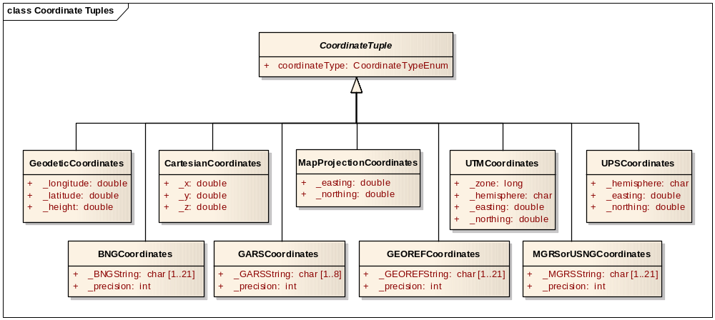
Figure 4-3. CoordinateTuple and its Subclasses
- dtcc/Enumerations - contains the various enumerations used by the CCS component.
- dtcc/Exceptions – contains the source code for the CoordinateConversionException class, as well as for the associated error and warning messages.

4.2 GEOTRANS Application Software
This section describes the structure and organization of the GEOTRANS application software, which is located in the GEOTRANS3 directory. It includes the GEOTRANS Application GUI source code, which is located in the GEOTRANS3/java_gui/geotrans3 subdirectory, and the online help files, which are located in the GEOTRANS3/help subdirectory.

4.2.1 GEOTRANS Application GUI Software
The GEOTRANS Application GUI software was generated using the NetBeans IDE, available at www.netbeans.org. The GEOTRANS Application GUI software is organized into subdirectories as follows:
- coordinates – contains the source code for the Java abstract CoordinateTuple class and all of its concrete subclasses, as well as the Accuracy and ConvertResults classes..
- enumerations – contains the source code for the Java classes that implement the various enumerations used by the GEOTRANS application.
- exceptions – contains the source code for the Java classes that allow the application to handle exceptions thrown by the Coordinate Conversion Service.
- gui – contains the source code for the Java classes that implement the actual GUI components and controls, including the various control panels and dialog boxes.
- jni – contains the source code for the Java and C++ classes that implement a Java Native Interface (JNI) for the GEOTRANS Coordinate Conversion Service component.
- misc – contains a collection of miscellaneous Java support classes dealing with geodetic coordinate formatting options, conversion between character strings and coordinate values, loading and saving option settings, etc.
- parameters – contains the source code for the Java abstract CoordinateSystemParameters class and all of its concrete subclasses.
- utility – contains a collection of utility Java classes dealing with platforms, environment variables, directories and files, constants, and the online help browser interface.

4.2.2 On-Line Help Source Files
This section describes the structure and organization of the On-Line Help source files, which are contained in the GEOTRANS3/help subdirectory. The source files are of two types. Files with the extension “.htm” are source files in Hyper Text Markup Language (HTML), which contain formatted text for one or more on-line help topics. Files with the extension “.gif” are graphics files, which contain the graphic images used in the on-line help topics. The On-Line Help source files consist of the following modules:
- Basic Operations (file basicops.htm) – describes the basic interactive operation of the GEOTRANS application,
- Contents (file contents.htm) – contains the top-level table of contents for the on-line help,
- Coordinate System Descriptions (file coordDescriptions.htm) – contains detailed descriptions of the various types of coordinate systems supported by the GEOTRANS application, including references to the following graphics:
- Geodetic & Geocentric Coordinates (file geodetic.gif) – graphic showing the relationship between geodetic and geocentric coordinate systems (Figure 4.2 from TEC-SR-7),
- GEOREF 15° Grid (file georef1.gif) – graphic showing the high-level 15° GEOREF grid,
- GEOREF 1° Grid (file georef2.gif) – graphic showing the low-level 1° GEOREF grid,
- MGRS Zones (file mgrs_zones.gif) – graphic showing the MGRS zones,
- MGRS 100,000m Square Designations (AL Pattern) (file mgrs_al.gif) – graphic showing the patterns of MGRS 100,000m Square Designations used with the Clarke 1866, Clarke 1880, and Bessel 1841 ellipsoids,
- MGRS 100,000m Square Designations (AA Pattern) (file mgrs_aa.gif) – graphic showing the patterns of MGRS 100,000m Square Designations used with all other ellipsoids,
- MGRS 100,000m Square Designations for North Polar Zone (file mgrs_n.gif) – graphic showing the patterns of MGRS 100,000m Square Designations in the north polar zone,
- MGRS 100,000m Square Designations for South Polar Zone (file mgrs_s.gif) – graphic showing the patterns of MGRS 100,000m Square Designations in the south polar zone,
- Coordinate System Descriptions (file coordDescriptions.htm) – contains detailed descriptions of the various types of coordinate systems supported by the GEOTRANS application,
- Coordinate Systems (file coordsys.htm) – contains brief descriptions of the various types of coordinate systems and map projections supported by the GEOTRANS application,
- Create Datum Dialog (file createDatumDlg.htm) – contains a description of the Create Datum dialog box,
- Create Ellipsoid Dialog (file createEllipsoidDlg.htm) – contains a description of the Create Ellipsoid dialog box,
- Datum Table (file datum1.htm) – contains a table of countries and geographic areas, identifying which local datums are applicable to each,
- Delete Datum Dialog (file deleteDatumDlg.htm) – contains a description of the Delete Datum dialog box,
- Delete Ellipsoid Dialog (file deleteEllipsoidDlg.htm) – contains a description of the Delete Ellipsoid dialog box,
- Ellipsoid Table (file elliptab.htm) – contains a table of standard ellipsoids and their parameters,
- Error Messages (file errors.htm) – contains descriptions of the error messages that may be output by the GEOTRANS application,
- Fields (file fields.htm) – contains descriptions of all of the fields and controls included in the graphical user interface of the GEOTRANS application,
- File Format (file fileform.htm) – contains a description of the format of the ASCII coordinate files read and created by the GEOTRANS application,
- File Format (file fileHeader.htm) – contains a description of the GEOTRANS Create File Header command,
- File Format (file fileHeaderWindow.htm) – contains a description of the Create File Header window,
- File Open Dialog (file fileOpenDlg.htm) – contains a description of the File Open dialog box,
- File Processing (file fileproc.htm) – describes how to use the file processing capabilities of the GEOTRANS application,
- File Processing Dialog (file fileProcessingDlg.htm) – contains a description of the File Processing dialog box,
- File Processing Window (file fileProcessingWindow.htm) – contains a description of the File Processing window,
- Glossary (file glossary.htm) – contains the definitions of general MC&G terms that are used in describing the GEOTRANS application,
- Main Window (file mainWindow.htm) – contains a description of the GEOTRANS application main window,
- Menu Commands (file menubar.htm) – contains descriptions of all of the menu commands provided by the menu bar in the GEOTRANS main window,
- Overview (file overview.htm) – contains an overview of the GEOTRANS application, and
- Projection Descriptions (file projectionDescriptions.htm) – contains detailed descriptions of the various types of map projections supported by the GEOTRANS application, including references to the following graphics:
- Mercator Projection (file mercator.gif) – graphic showing the Mercator projection,
- Transverse Mercator Projection (file transmerc.gif) – graphic showing the Transverse Mercator projection,
- UTM Projection (file utm.gif) – graphic showing meridians and parallels and a Universal Transverse Mercator grid (Figure 7.3 from TEC-SR-7),
- Polar Stereographic Projection (file polarst.gif) – graphic showing meridians and parallels in a Polar Stereographic projection (Figure 7.4 from TEC-SR-7),
- UPS Projection (file ups.gif) – graphic showing meridians and parallels on the Universal Polar Stereographic grid (Figure 7.6 from TEC-SR-7),
- Albers Equal Area Conic projection (file albers.gif) – graphic showing an Albers Equal Area Conic projection,
- Azimuthal Equidistant projection (file azeq.gif) – graphic showing an Azimuthal Equidistant projection,
- Bonne projection (file bonne.gif) – graphic showing a Bonne projection,
- British National Grid (file bng.gif) – graphic showing the British National Grid,
- Cassini projection (file cassini.gif) – graphic showing a Cassini projection,
- Cylindrical Equal Area projection (file cyleqa.gif) – graphic showing a Cylindrical Equal Area projection,
- Eckert IV projection (file eckert4.gif) – graphic showing an Eckert IV projection,
- Eckert VI projection (file eckert6.gif) – graphic showing an Eckert VI projection,
- Equidistant Cylindrical projection (file eqdcyl.gif) – graphic showing an Equidistant Cylindrical projection,
- Gnomonic projection (file gnomonic.gif) – graphic showing a Gnomonic projection,
- Lambert Conformal Conic (1 parallel) Projection (file lambert_1.gif) – graphic showing a Lambert Conformal Conic (1 parallel) projection,
- Lambert Conformal Conic (2 parallel) Projection (file lambert_2.gif) – graphic showing a Lambert Conformal Conic (2 parallel) projection,
- Miller Cylindrical projection (file miller.gif) – graphic showing a Miller Cylindrical projection,
- Mollweide projection (file mollweid.gif) – graphic showing a Mollweide projection,
- Ney’s Projection (file neys71.gif) – graphic showing Ney’s projection,
- New Zealand Map Grid (file nzmg.gif) – graphic showing the New Zealand Map Grid,
- Oblique Mercator projection (file omerc.gif) – graphic showing an Oblique Mercator projection,
- Orthographic projection (file ortho.gif) – graphic showing a Orthographic projection,
- Polyconic projection (file polyconic.gif) – graphic showing a Polyconic projection,
- Sinusoidal projection (file sinusoidal.gif) – graphic showing a Sinusoidal projection,
- Stereographic projection (file stereogr.gif) – graphic showing a Stereographic projection,
- Transverse Cylindrical Equal Area projection (file trcyleqa.gif) – graphic showing a Transverse Cylindrical Equal Area projection,
- Van der Grinten projection (file grinten.gif) – graphic showing a Van der Grinten projection,
- Save As Dialog (file saveAsDlg.htm) – contains a description of the Save As dialog box.

4.3 Data Files
GEOTRANS requires several data files that contain datum, ellipsoid, and geoid separation information. The following data files are normally located in the data directory, and GEOTRANS looks for them there by default:
- 3_param.dat – the data file containing the datum shift parameters for 3-parameter local datums,
- 7_param.dat – the data file containing the datum shift parameters for 7-parameter local datums,
- egm96.grd – the data file containing the Earth Gravity Model 1996 (EGM96) geoid separation values,
- egm84.grd – the data file containing the Earth Gravity Model 1984 (EGM84) geoid separation values,
- ellips.dat – the data file containing the standard ellipsoid parameters.
As an alternative, you can define the environment variable MSPCCS_DATA, and place the files in the directory identified by this variable.

4.4 Compilation/Build Procedures
The GEOTRANS executable directories: GEOTRANS3/linux, GEOTRANS3/solaris, and GEOTRANS3/win, each contain required library files, executables for the GEOTRANS application, makefiles, and other supporting files.

4.4.1 UNIX Compilation/Build Procedures
The CCS UNIX library directory, CCS/solaris or CCS/linux, contains the CCS shared objects and makefile:
To make the UNIX dtcc library, type:
%make libMSPdtcc.so

To make the UNIX Coordinate Conversion Service library, type:
%make libMSPCoordinateConversionService.so

The GEOTRANS UNIX executable directory, GEOTRANS3/solaris or GEOTRANS3/linux, contains the executable, makefile and supporting files:
To make the UNIX GEOTRANS Java Native Interface (JNI) shared object library, type:
%make libjnimsp_ccs.so
To delete unneeded files created during the build process, type:
%make clean
Note: The dtcc and Coordinate Conversion Service libraries should be built before trying to build the GEOTRANS JNI shared object library.

4.4.2 Windows Compilation/Build Procedures
The CCS Windows library directory, CCS/win, contains the CCS libraries and Microsoft Visual Studio .Net 2003 solution and projects.
The GEOTRANS Windows executable directory, GEOTRANS3/win, contains the GEOTRANS executable, Microsoft Visual Studio .Net 2003 solution, projects and supporting files.
To build the GEOTRANS Windows DLLs, start up the Microsoft Visual Studio .Net 2003 and open the CCS/win/MSP_CCS.sln solution file. In the Solution Explorer window, select the project to be built. The 2 projects are MSP_DTCC, which builds the dtcc DLL, and MSP_CCS, which builds the Coordinate Conversion Service DLL. Then, from the Build pop-up menu, select the Build command.
The GEOTRANS Java Native Interface DLL that supports the GEOTRANS Java GUI is built using the jnigeotrans solution.

4.4.3 Java Compilation/Build Procedures
To compile and build the GEOTRANS Java files, start up NetBeans IDE, available at www.netbeans.org, and mount the /GEOTRANS3/java_gui directory in the filesystems explorer window by going to the File pull-down menu and selecting Open Project. Navigate to the /GEOTRANS3/java_gui directory and click Open Project Folder. Within the filesystems explorer window, highlight the mounted java_gui directory and right click on it. Select the Build Project command from the menu shown.
Next, edit the GEOTRANS Java archive (jar) file properties. First, click on the Files tab. Double click on Manifest.mf and insert the following line, Main-Class: geotrans3/MSP_GEOTRANS3. Next, click on nbproject under the GEOTRANS directory tree. Double click on project.properties. On the dist.jar line, type the directory and name of the jar file. The jar file is automatically created when the project is built.

5. Notes
This section contains notes on aspects of the GEOTRANS software. Section 5.1 discusses the coordinate conversion logic that is implemented by the GEOTRANS Coordinate Conversion Service. Section 5.2 summarizes the datum transformation logic.

5.1 Coordinate Conversion Logic
The function Convert in the GEOTRANS Coordinate Conversion Service component is the heart of the GEOTRANS software. It is this function that actually performs all coordinate conversions and datum shifts. Given the input and output datums, the input and output coordinate reference frames, including the values of any projection parameters, and the input coordinates, it produces the output coordinates.
Although the source code for this function is quite long, its structure is relatively simple, consisting of nested if and switch statements. The code blocks that perform individual coordinate conversion and datum shift steps are quite short. Several special cases are handled initially to avoid unnecessary conversions.
The general case is handled in three stages:
- Convert the input coordinates from the input coordinate reference frame to geodetic,
- Shift the intermediate geodetic coordinates from the input datum to the output datum, converting between ellipsoid and geoid/MSL heights if necessary,
- Convert the shifted intermediate geodetic coordinates to the output coordinate reference frame.
The first stage is accomplished by a switch statement on the input coordinate reference frame, with a case for each of the coordinate reference frames supported. If the input coordinates are already in geodetic, they are simply copied to the intermediate coordinates.
The second stage is accomplished in three steps. First, the intermediate Geodetic coordinates are shifted to WGS 84, if necessary. Second, if the input geodetic coordinates included an ellipsoid height and the output Geodetic coordinates require a geoid/MSL height, or vice versa, the geoid separation is either added to or subtracted from the height, as appropriate. Note that if either the input or the output was projected, the geodetic height is considered meaningless, and the output height is forced to zero. Third, the shifted intermediate geodetic coordinates are shifted to the output datum.
The third stage is similar to the first stage. A switch statement on the output coordinate reference frame, with a case for each of the coordinate reference frames supported, is used to convert the shifted intermediate Geodetic coordinates to the output coordinate reference frame. If the output coordinate reference frame is Geodetic, the shifted intermediate coordinates are simply copied to the output coordinates.

5.2 Datum Shift Logic
Normally, a datum shift is performed in two stages: from the input datum to WGS 84, and then from WGS 84 to the output datum. If either the input datum or the output datum is WGS 84, then one or both of these stages will be skipped.
The methods used depend on the types of the input and output datums, and, in some cases, on the location of the coordinates being shifted. The datums are organized into the following categories:
- WGS 84,
- WGS 72,
- 3-parameter datums – local datums which are defined in the file 3-param.dat, and which have three datum shift parameters (delta X, delta Y, delta Z), and
- 7-parameter datums – local datums which are defined in the file 7-param.dat, and which have seven datum shift parameters (delta X, delta Y, delta Z, X rotation, Y rotation, Z rotation, and scale factor).
Each of the 7-parameter datums (EUR-7 and OGB-7) also have 3-parameter versions (EUR-M and OGB-M). Distinct codes have been defined for these so that it is always clear which set of datum shift parameters should be used.
Four datum shift methods are used, as follows:
- 72-to-84 (and its inverse 84-to-72) – Used to shift between WGS 72 and WGS 84 in geodetic coordinates,
- Molodensky method – Used to shift between 3-parameter datums and WGS 84 in geodetic coordinates, except in the polar regions, where it is not valid,
- 3-parameter method – Used to shift between 3-parameter datums and WGS 84 in geocentric coordinates,
- 7-parameter method – Used to shift between 7-parameter datums and WGS 84 in geocentric coordinates.

