Programmer’s Guide
for
Geographic Translator (GEOTRANS) Version 2.4.2

19 March 2008

Prepared for:

National Geospatial-Intelligence Agency
12310 Sunrise Valley Drive
Reston, VA 20191-3449

Prepared by:

Northrop Grumman Mission Systems
Beeches Technical Campus, Rt 26N
Rome, NY 13440

Contents
Contents i
List of Figures iii
1. Scope 1
1.1 Identification 1
1.2 System Overview 1
1.3 Document Overview 2
2. Referenced Documents 3
3. Programming Environment 7
3.1 Software 7
3.1.1 Operating System(s) 7
3.1.2 Compilation and Linking 7
3.1.3 Directory Structure 8
3.1.4 Language 13
3.2 Hardware Requirements 14
3.3 Packaging Requirements 14
4. Software Architecture 16
5. Software Support Information 22
5.1 Software Design 22
5.1.1 GEOTRANS Common Support Software 22
5.1.2 Windows GUI Software 24
5.1.3 Java GUI Software 26
5.1.4 On-Line Help Source Files 31
5.2 Installation Procedures 35
5.2.1 UNIX Installation Procedure 35
5.2.2 Windows Installation Procedure 35
5.3 Startup Procedures 36
5.3.1 Windows Startup Procedure 36
5.3.2 Java Startup Procedure 36
5.3.3 Required Data Files 37
5.4 Compilation/Build Procedures 38
5.4.1 UNIX Compilation/Build Procedures 38
5.4.2 Windows Compilation/Build Procedures 39
5.4.3 Java Compilation/Build Procedures 40
5.5 Modification Procedures 41
6. Notes 44
6.1 Distribution Packages 44
6.2 Coordinate Conversion Logic 46
6.3 Datum Shift Logic 46

List of Figures
Figure 4-1. GEOTRANS Software Architecture 17
Figure 4-2. DT&CC Module Dependencies 21
Figure 5-1. GEOTRANS Core Software Dependencies 23
Figure 5-2. Windows GUI Software Dependencies 26

1. Scope

1.1 Identification
This document is the Programmer’s Guide for Version 2.4.2 of the Geographic Translator (GEOTRANS).

1.2 System Overview
GEOTRANS (Geographic Translator) is an application that allows you to convert geographic coordinates among a wide variety of coordinate systems, map projections, grids, and datums. GEOTRANS runs in Microsoft Windows (95, 98, NT, 2000 and XP), LINUX and UNIX environments.
The user interface of GEOTRANS consists primarily of a single window. To convert coordinates, select the coordinate reference frame and datum in which your coordinates are defined, enter any associated parameters, and enter the coordinates in the upper half of the window. Then select the coordinate reference frame and datum to which you want the coordinates to be converted, and enter any associated parameters, in the lower half of the window. Click on the Convert Upper-to-Lower button, and the resulting coordinates will be displayed in the lower half of the window. You can convert additional coordinate sets from the same source by just entering the new coordinates and clicking on the Convert Upper-to-Lower button. You can change any of the coordinate reference frame, datum, or parameter selections at any time. Also, you can reverse the roles of input and output by using the Convert Lower-to-Upper button. Currently, thirty-five different types of coordinate systems, map projections, grids, and coding schemes are supported, as well as more than two hundred different horizontal datums.
GEOTRANS can also be used to efficiently convert large numbers of coordinates contained in text files. The file format is very simple. A multi-line file header defines the coordinate reference frame and datum of the coordinates contained in the file, including any associated parameter values. Following the header, each line contains a single set of coordinates, separated by commas followed by at least one space. Using the GEOTRANS file processing interface, you can select an existing file of coordinates to be converted. You can then define the coordinate reference frame and datum to which you want to convert the coordinates, along with any associated parameter values. Finally, you can specify the name and location of the output file that is to be created. GEOTRANS then converts all of the coordinates in the input file and creates the output file as a single operation.

1.3 Document Overview
The remainder of this document is organized as follows:
- Section 2 identifies the other documents that are referenced in this Programmer’s Guide.
- Section 3 describes the programming environment in which the GEOTRANS application was developed, and summarizes the structure of the GEOTRANS application software.
- Section 4 presents the architectural design of the software, identifying the components and their relationships, as well as the concept of execution.
- Section 5 presents the as built design of the GEOTRANS application software, briefly describing each of the components, the build procedures, and modification procedures.
- Section 6 contains additional notes.

2. Referenced Documents
The following documents describe coordinate systems, map projections, coordinate conversion, and datum transformation:
- NGA TM 8358.1, Datums, Ellipsoids, Grids, and Grid Reference Systems, 1990.
- NGA TM 8358.2, The Universal Grids: Universal Transverse Mercator (UTM) and Universal Polar Stereographic (UPS), 1989.
- MIL-STD-2401, Department of Defense World Geodetic System (WGS), 1994.
- STANAG 2211, Geodetic Datums, ellipsoids, grids and grid references, Fifth Edition, 1991.
- TEC-SR-7, Handbook for Transformation of Datums, Projections, Grids and Common Coordinate Systems, 1996.
- NGA, Department of Defense Glossary of Mapping, Charting, and Geodetic Terms, Fourth Edition, 1981.
- Rapp, Richard H., Geometric Geodesy - Part I; Department of Geodetic Science and Surveying, The Ohio State University, Columbus, Ohio. 1984.
- Rapp, Richard H., Geometric Geodesy - Part II; Department of Geodetic Science and Surveying, The Ohio State University, Columbus, Ohio. 1987.
- Snyder, J. P., Geological Survey Professional Paper 1395 Map Projections - A Working Manual, 1987.
- Federal Geographic Data Committee (FGDC), FGDC-STD-011-2001, United States National Grid, December 2001
- http://earth-info.nga.mil/GandG/coordsys/grids/gars.html, Global Area Reference System (GARS)
The following documents describe other aspects of the GEOTRANS application:
- U.S. Army Corps of Engineers, Topographic Engineering Center, User’s Guide for Geographic Translator (GEOTRANS) Version 2.4, August, 2006.
- U.S. Army Corps of Engineers, Topographic Engineering Center, Test Plan/Report for Geographic Translator (GEOTRANS) Version 2.4, August 2006.
The following documents describe the Reusable Software Components (RSCs) that are used by the GEOTRANS application:
- U.S. Army Corps of Engineers, Topographic Engineering Center, Reuse Manual for GEOTRANS Engine Implementation, June 2000.
- U.S. Army Corps of Engineers, Topographic Engineering Center, Reuse Manual for ALBERS EQUAL AREA CONIC Implementation, September 1999.
- U.S. Army Corps of Engineers, Topographic Engineering Center, Reuse Manual for AZIMUTHAL EQUIDISTANT Implementation, June 2000.
- U.S. Army Corps of Engineers, Topographic Engineering Center, Reuse Manual for BRITISH NATIONAL GRID Implementation, September 2000.
- U.S. Army Corps of Engineers, Topographic Engineering Center, Reuse Manual for BONNE Implementation, September 1999.
- U.S. Army Corps of Engineers, Topographic Engineering Center, Reuse Manual for CASSINI Implementation, September 1999.
- U.S. Army Corps of Engineers, Topographic Engineering Center, Reuse Manual for CYLINDRICAL EQUAL AREA Implementation, September 1999.
- U.S. Army Corps of Engineers, Topographic Engineering Center, Reuse Manual for DATUM Implementation, September 1999.
- U.S. Army Corps of Engineers, Topographic Engineering Center, Reuse Manual for ECKERT IV Implementation, September 1999.
- U.S. Army Corps of Engineers, Topographic Engineering Center, Reuse Manual for ECKERT VI Implementation, September 1999.
- U.S. Army Corps of Engineers, Topographic Engineering Center, Reuse Manual for ELLIPSOID Implementation, September 1999.
- U.S. Army Corps of Engineers, Topographic Engineering Center, Reuse Manual for EQUIDISTANT CYLINDRICAL Implementation, September 1999.
- U.S. Army Corps of Engineers, Topographic Engineering Center, Reuse Manual for GARS Implementation, August 2006.
- U.S. Army Corps of Engineers, Topographic Engineering Center, Reuse Manual for GEOCENTRIC Implementation, April 1997.
- U.S. Army Corps of Engineers, Topographic Engineering Center, Reuse Manual for GEOID Implementation, September 1999.
- U.S. Army Corps of Engineers, Topographic Engineering Center, Reuse Manual for GEOREF Implementation, April 1997.
- U.S. Army Corps of Engineers, Topographic Engineering Center, Reuse Manual for GNOMONIC Implementation, June 2000.
- U.S. Army Corps of Engineers, Topographic Engineering Center, Reuse Manual for LAMBERT CONFORMAL CONIC Implementation, September 1999.
- U.S. Army Corps of Engineers, Topographic Engineering Center, Reuse Manual for LOCAL CARTESIAN Implementation, September 1999.
- U.S. Army Corps of Engineers, Topographic Engineering Center, Reuse Manual for MERCATOR Implementation, September 1999.
- U.S. Army Corps of Engineers, Topographic Engineering Center, Reuse Manual for MGRS Implementation, September 1999.
- U.S. Army Corps of Engineers, Topographic Engineering Center, Reuse Manual for MILLER CYLINDRICAL Implementation, September 1999.
- U.S. Army Corps of Engineers, Topographic Engineering Center, Reuse Manual for MOLLWEIDE Implementation, September 1999.
- U.S. Army Corps of Engineers, Topographic Engineering Center, Reuse Manual for NEY’s Implementation , September 2000.
- U.S. Army Corps of Engineers, Topographic Engineering Center, Reuse Manual for NEW ZEALAND MAP GRID Implementation, September 2000.
- U.S. Army Corps of Engineers, Topographic Engineering Center, Reuse Manual for OBLIQUE MERCATOR Implementation, June 2000.
- U.S. Army Corps of Engineers, Topographic Engineering Center, Reuse Manual for ORTHOGRAPHIC Implementation, September 1999.
- U.S. Army Corps of Engineers, Topographic Engineering Center, Reuse Manual for POLAR STEREOGRAPHIC Implementation, September 1999.
- U.S. Army Corps of Engineers, Topographic Engineering Center, Reuse Manual for POLYCONIC Implementation, September 1999.
- U.S. Army Corps of Engineers, Topographic Engineering Center, Reuse Manual for SINUSOIDAL Implementation, September 1999.
- U.S. Army Corps of Engineers, Topographic Engineering Center, Reuse Manual for STEREOGRAPHIC Implementation, September 2000.
- U.S. Army Corps of Engineers, Topographic Engineering Center, Reuse Manual for TRANSVERSE CYLINDRICAL EQUAL AREA Implementation, September 1999.
- U.S. Army Corps of Engineers, Topographic Engineering Center, Reuse Manual for TRANSVERSE MERCATOR Implementation, September 1999.
- U.S. Army Corps of Engineers, Topographic Engineering Center, Reuse Manual for UPS Implementation, April 1997.
- U.S. Army Corps of Engineers, Topographic Engineering Center, Reuse Manual for USNG Implementation, August 2006.
- U.S. Army Corps of Engineers, Topographic Engineering Center, Reuse Manual for UTM Implementation, April 1997.
- U.S. Army Corps of Engineers, Topographic Engineering Center, Reuse Manual for VAN DER GRINTEN Implementation, September 1999.

3. Programming Environment
This section describes the programming environment in which the GEOTRANS application was developed, and summarizes the structure of the GEOTRANS application software. It also summarizes the hardware requirements of the GEOTRANS application software.

3.1 Software

3.1.1 Operating System(s)
There are two versions of the GEOTRANS software:
- A Windows version, which was developed and tested on a Pentium-based personal computer running the Microsoft Windows XP operating system.
- A Java GUI version, which is platform independent and will run under Windows, UNIX and LINUX. The linux versions were tested under SUSE LINUX 9.3 and RedHat 9.

3.1.2 Compilation and Linking
The UNIX and LINUX versions of the GEOTRANS shared object (.so) library requires the ANSI C compiler. The GNU C compiler (gcc, version 2.95.2) and Sun’s ANSI C compiler (version 4.2) were used during the development of the GEOTRANS software.
The Windows version of the GEOTRANS application software, GEOTRANS DLL and JNI DLL were developed using the Microsoft Visual C++ compiler, Version 6.
Note: When building the JNI DLL, the path to the JNI header files must be set by doing the following:
In Microsoft Visual Studio, go to Tools, Options, Directories tab. Select Win32 Platform, Show directories for: Include files and add these directories:
C:\your Java installation directory\include
C:\your Java installation directory\include\win32
Also make sure these directories are listed:
C:\your MS Visual Studio installation directory\Microsoft Visual Studio\VC98\include
C:\your MS Visual Studio installation directory\Microsoft Visual Studio\VC98\MFC\include
C:\your MS Visual Studio installation directory\Microsoft Visual Studio\VC98\ATL\include
The Java GUI was developed using NetBeans IDE, available at www.netbeans.org.

3.1.3 Directory Structure
The GEOTRANS master software distribution contains all of the directories and files needed to build and execute all versions (UNIX, LINUX and Windows) of the GEOTRANS application software. The GEOTRANS master software distribution consists of three top-level components:
- The GEOTRANS Application software component, which is contained in a directory named geotrans2,
- The GEOTRANS Engine software component, which is contained in a directory named engine,
- The Datum Transformation & Coordinate Conversion (DT&CC) software component, which consists of a collection of thirty-four (34) individual Reusable Software Components (RSCs), and which is contained in a directory named dt_cc.

3.1.3.1 GEOTRANS Application Component
Within the geotrans2 directory, the GEOTRANS Application software component is organized into subdirectories as follows:
- data – which contains data files needed for initializing the GEOTRANS application,
- docs – which contains documentation for the GEOTRANS application software in Microsoft Word 2000 format,
- help – which contains the on-line help source files for the GEOTRANS application, including files in HyperText Markup Language (HTML) and graphics files in GIF format,
- java_gui – which contains the source code for the Java version of the graphical user interface of the GEOTRANS application,
- redhat_linux – which contains the RedHat LINUX GEOTRANS shared object library, makefiles, Java GUI and JNI shared object library.
- src – which contains the source code for the GEOTRANS file processing and common support software,
- suse_linux – which contains the SUSE LINUX GEOTRANS shared object library, makefiles, Java GUI and JNI shared object library.
- unix – which contains the UNIX GEOTRANS shared object library, makefiles, Java GUI, JNI shared object library and all other files needed to build and run the UNIX versions of the GEOTRANS application.
- win_gui – which contains the source code for the Windows version of the graphical user interface of the GEOTRANS application,
- win – which contains the Windows GEOTRANS application executables, the GEOTRANS DLL, JNI DLL, Java GUI, Visual C++ workspace and project files, and all other files needed to build and run the Windows versions of the GEOTRANS application.
The unix, suse_linux and redhat_linux directories are omitted in distributions of the Windows version of the GEOTRANS software. Similarly, the win and win_gui directories are omitted in distributions of the UNIX and LINUX versions.
The structure and organization of this component are described in more detail in Sections 4 and 5.

3.1.3.2 GEOTRANS Engine Component
The GEOTRANS Engine provides a reusable software component (RSC) that supports the following types of coordinate conversions:
- Conversions between geodetic, geocentric, and local Cartesian coordinate systems,
- Conversions between geodetic coordinates (latitude and longitude in radians) and various types of map projection coordinates (easting and northing in linear units),
- Conversions between geodetic coordinates and Military Grid Reference System (MGRS), United States National Grid (USNG), Global Area Reference System (GARS), or World Geographic Reference System (GEOREF) grid coordinates,
- Transformations of geodetic or geocentric coordinates between different global or local horizontal datums,
- Transformations between ellipsoid heights and geoid (or local MSL) heights, and
- Conversions that combine two or more of the above operations.
The GEOTRANS Engine consists of a single header (engine.h) file and a single source (engine.c) file, which are contained in the engine/src directory. Documentation for the GEOTRANS Engine, including an Abstract and a Reuse Manual, is contained in the engine/docs subdirectory.
There are four additional subdirectories within the engine directory:
- unix – which contains the UNIX makefiles and all other files needed to build a UNIX object library containing the engine module,
- redhat_linux – which contains the RedHat LINUX makefiles and all other files needed to build a LINUX object library containing the engine module,
- suse_linux – which contains the SUSE LINUX makefiles and all other files needed to build a LINUX object library containing the engine module,
- win – which contains the Visual C++ workspace and project files, and all other files needed to build a Windows object library containing the engine module.

3.1.3.3 DT&CC Component
The GEOTRANS Engine depends on a collection of Datum Transformation and Coordinate Conversion (DT&CC) modules. Each of these modules is packaged as a Reusable Software Component (RSC). These modules should be contained in a directory, dt_cc, which parallels the geotrans2 directory. Within the dt_cc directory, each module is contained in a separate subdirectory, as follows:
- albers – which contains the ALBERS EQUAL AREA CONIC module. This module performs conversions between geodetic coordinates and Albers Equal Area Conic projection coordinates.
- azeq – which contains the AZIMUTHAL EQUIDISTANT module. This module performs conversions between geodetic coordinates and Azimuthal Equidistant projection coordinates.
- bng – which contains the BRITISH NATIONAL GRID module. This module performs conversions between Geodetic and Transverse Mercator projection coordinates and British National Grid coordinates. It depends on the TRANSVERSE MERCATOR module.
- bonne – which contains the BONNE module. This module performs conversions between geodetic coordinates and Bonne projection coordinates.
- cassini– which contains the CASSINI module. This module performs conversions between geodetic coordinates and Cassini projection coordinates.
- cyleqa – which contains the CYLINDRICAL EQUAL AREA module. This module performs conversions between Geodetic coordinates and Cylindrical Equal Area projection coordinates.
- datum – which contains the DATUM module. This module provides access to datum parameters for over 200 local datums, and performs datum transformations in either geodetic or geocentric coordinates. It depends on the ELLIPSOID and GEOCENTRIC modules.
- eckert4– which contains the ECKERT IV module. This module performs conversions between geodetic coordinates and Eckert IV projection coordinates.
- eckert6– which contains the ECKERT VI module. This module performs conversions between geodetic coordinates and Eckert VI projection coordinates.
- ellipse – which contains the ELLIPSOID module. This module provides access to ellipsoid parameters for approximately two dozen standard ellipsoids.
- eqdcyl– which contains the EQUIDISTANT CYLINDRICAL module. This module performs conversions between geodetic coordinates and Equidistant Cylindrical projection coordinates.
- gars – which contains the GARS module. This module performs conversions between geodetic coordinates and Global Area Reference System (GARS) coordinates.
- geocent – which contains the GEOCENTRIC module. This module performs conversions between geodetic coordinates and Geocentric coordinates.
- geoid – which contains the GEOID module. This module performs conversions between ellipsoid heights and geoid/MSL heights.
- georef – which contains the GEOREF module. This module performs conversions between geodetic coordinates and World Geographic Reference System (GEOREF) coordinates.
- gnomonic – which contains the GNOMONIC module. This module performs conversions between geodetic coordinates and Gnomonic projection coordinates.
- grinten– which contains the VAN DER GRINTEN module. This module performs conversions between geodetic coordinates and Van der Grinten projection coordinates.
- lambert_1 – which contains the LAMBERT CONFORMAL CONIC 1 module. This module performs conversions between geodetic coordinates and Lambert Conformal Conic projection coordinates with one standard parallel.
- Lambert_2 – which contains the LAMBERT CONFORMAL CONIC 2 module. This module performs conversions between geodetic coordinates and Lambert Conformal Conic projection coordinates with two standard parallels.
- loccart – which contains the LOCAL CARTESIAN module. This module performs conversions between geodetic and geocentric coordinates and Local Cartesian coordinates. It depends on the GEOCENTRIC module.
- mercator – which contains the MERCATOR module. This module performs conversions between geodetic coordinates and Mercator projection coordinates.
- mgrs – which contains the MGRS module. This module performs conversions between Geodetic, UPS, and UPS coordinates and Military Grid Reference System (MGRS) coordinates. It depends on the UPS and UTM modules.
- miller– which contains the MILLER CYLINDRICAL module. This module performs conversions between geodetic coordinates and Miller Cylindrical projection coordinates.
- mollweid– which contains the MOLLWEIDE module. This module performs conversions between geodetic coordinates and Mollweide projection coordinates.
- neys – which contains the NEY'S module. This module performs conversions between geodetic coordinates and Ney's (modified Lambert Conformal Conic) projection coordinates.
- nzmg – which contains the NEW ZEALAND MAP GRID module. This module performs conversions between geodetic coordinates and New Zealand Map Grid coordinates.
- omerc– which contains the OBLIQUE MERCATOR module. This module performs conversions between geodetic coordinates and Oblique Mercator projection coordinates.
- orthog– which contains the ORTHOGRAPHIC module. This module performs conversions between geodetic coordinates and Orthographic projection coordinates.
- polarst – which contains the POLAR STEREOGRAPHIC module. This module performs conversions between geodetic coordinates and Polar Stereographic projection coordinates.
- polycon– which contains the POLYCONIC module. This module performs conversions between geodetic coordinates and Polyconic projection coordinates.
- sinusoid– which contains the SINUSOIDAL module. This module performs conversions between geodetic coordinates and Sinusoidal projection coordinates.
- stereogr – which contains the STEREOGRAPHIC module. This module performs conversions between geodetic coordinates and Stereographic projection coordinates.
- tcyleqa – which contains the TRANSVERSE CYLINDRICAL EQUAL AREA module. This module performs conversions between geodetic coordinates and Transverse Cylindrical Equal Area projection coordinates.
- tranmerc – which contains the TRANSVERSE MERCATOR module. This module performs conversions between geodetic coordinates and Transverse Mercator projection coordinates.
- ups – which contains the UPS module. This module performs conversions between geodetic coordinates and Universal Polar Stereographic projection coordinates. It depends on the POLAR STEREOGRAPHIC module.
- usng – which contains the USNG module. This module performs conversions between Geodetic, UPS, and UPS coordinates and United States National Grid (USNG) coordinates. It depends on the UPS and UTM modules.
- utm – which contains the UTM module. This module performs conversions between geodetic coordinates and Universal Transverse Mercator projection coordinates. It depends on the TRANSVERSE MERCATOR module.
Each of these RSCs is described in a separate Reuse Manual, as identified in Section 2. Each RSC consists of a single header (.h) file and a single source (.c) file, which are contained in the root directory for each RSC. Documentation for each RSC, including an Abstract and a Reuse Manual, is contained in a docs subdirectory.
There are four additional subdirectories within the dt_cc directory:
- unix – which contains the UNIX makefiles and all other files needed to build a UNIX object library containing all of the DT&CC modules,
- redhat_linux – which contains the RedHat LINUX makefiles and all other files needed to build a LINUX object library containing all of the DT&CC modules,
- suse_linux – which contains the SUSE LINUX makefiles and all other files needed to build a LINUX object library containing all of the DT&CC modules,
- win – which contains the Visual C++ workspace and project files, and all other files needed to build a Windows object library containing all of the DT&CC modules.

3.1.4 Language
GEOTRANS is written in a combination of ANSI C, C++, and Java. The DT&CC modules, the GEOTRANS Engine, and the GEOTRANS file processing modules are written in ANSI C. The Windows user interface modules are written in C++. The Java user interface modules are written in Java.

3.2 Hardware Requirements
The UNIX version of GEOTRANS requires:
- a Sun SPARCstation (porting to other UNIX workstations should be straightforward),
- a minimum of 32MB of RAM,
- approximately 40MB of disk space for the full installation, including source code,
- a color or grayscale monitor,
- a mouse or equivalent pointing device, and
- a keyboard.
The Windows version of GEOTRANS requires:
- a PC with a Pentium processor,
- a minimum of 32MB of RAM,
- approximately 40MB of disk space for the full installation, including source code,
- a color or grayscale monitor,
- a mouse or equivalent pointing device, and
- a keyboard.

3.3 Packaging Requirements
The UNIX version of the GEOTRANS software is normally distributed via FTP or over the World Wide Web as a compressed tar file. There are two UNIX distributions:
- an end-user distribution, which contains application executable files and other necessary data files (sun_user.tgz), and
- a developer distribution, which contains source code, makefiles, and all other files necessary to recompile the software (sun_dev.tgz).
The Windows version of the GEOTRANS software is normally distributed via FTP or over the World Wide Web as a compressed zip file. There are two Windows distributions:
- an end-user distribution, which contains application executable files and other necessary data files (win_user.zip), and
- a developer distribution, which contains source code, makefiles, and all other files necessary to recompile the software (win_dev.zip).

4. Software Architecture
This section presents the architectural design of the GEOTRANS software, identifying its primary components and their relationships, as well as the overall concept of execution.
The architecture of the GEOTRANS software is shown in Figure 4-1. In the figure, the components of the GEOTRANS software are organized into three columns. UNIX-specific components are in the left-hand column, Windows-specific components are in the right-hand column, and common components are in the center column. An arrow from one component (or subcomponent) to another indicates that the component that is the source of the arrow is dependent on the component that is the target of the arrow. As described in the previous section, and shown in the figure, the GEOTRANS software consists of three top-level components:
- The GEOTRANS Application software component, shown in the figure as a large box containing several subcomponents, and which is contained in the geotrans2 directory,
- The GEOTRANS Engine software component, which is contained in a directory named engine,
- The Datum Transformation & Coordinate Conversion (DT&CC) software component, which is contained in the dt_cc directory, and
The GEOTRANS Application software component consists of five subcomponents, shown as smaller boxes within the larger box, as follows:
- the GEOTRANS Common Support software, which is contained in the geotrans/src directory,
- the Windows GUI software, which is contained in the geotrans/win_gui directory,
- the Java GUI software, which is contained in the geotrans/java_gui directory, and
- the On-Line Help source files, which are contained in the geotrans/help directory.
These subcomponents are each described in more detail in Section 5.
The GEOTRANS Engine provides a reusable software component (RSC) that supports conversions between all of the supported coordinate types, including datum transformations and ellipsoid-geoid/MSL height conversions. It consists of a single C module, which is contained in the engine directory. The GEOTRANS Engine is described in its own Reuse Manual, and so will not be described in detail here.
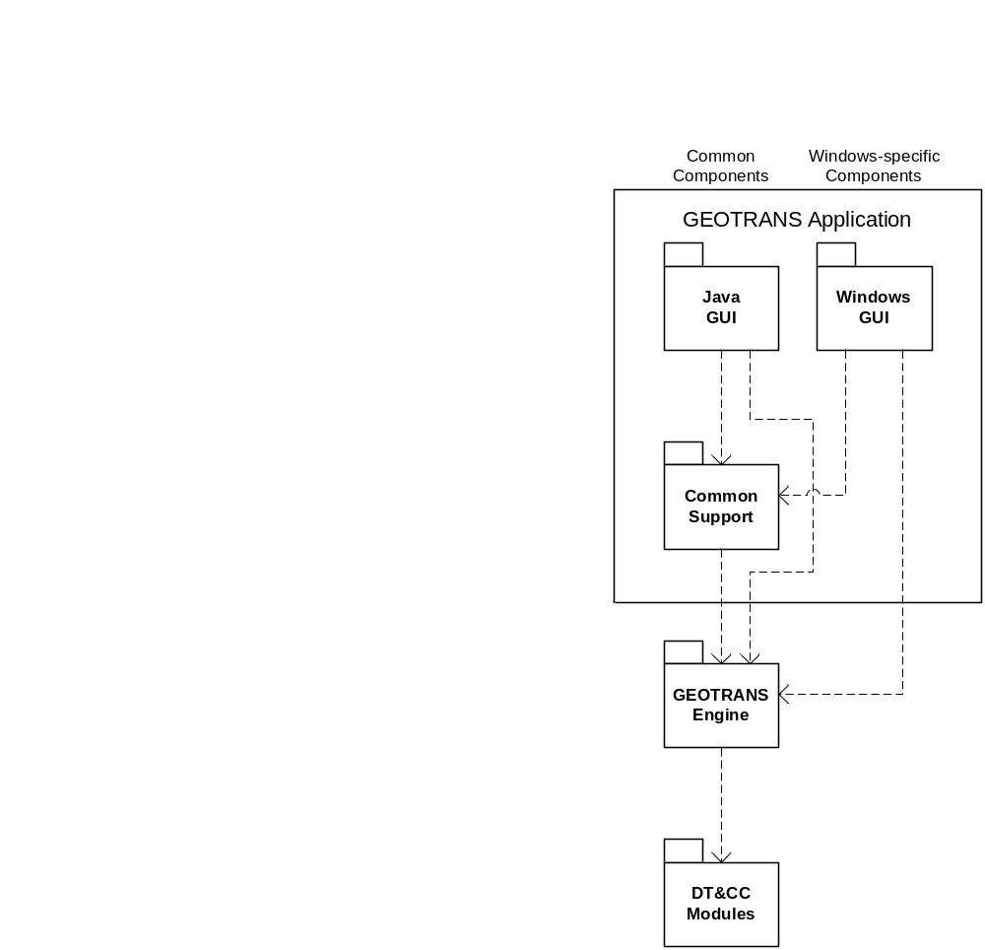Figure 4-1. GEOTRANS Software Architecture
The DT&CC software component consists of a collection of thirty-four Reusable Software Components (RSCs) that perform various coordinate conversions and datum transformations:
- ALBERS EQUAL AREA CONIC – which performs conversions between geodetic coordinates and Albers Equal Area Conic projection coordinates.
- AZIMUTHAL EQUIDISTANT – which performs conversions between geodetic coordinates and Azimuthal Equidistant projection coordinates.
- BRITISH NATIONAL GRID – which performs conversions between geodetic and Transverse Mercator projection coordinates and British National Grid coordinates. It depends on the TRANSVERSE MERCATOR module.
- BONNE – which performs conversions between geodetic coordinates and Bonne projection coordinates. It depends on the SINUSOIDAL module.
- CASSINI – which performs conversions between geodetic coordinates and Cassini projection coordinates.
- DATUM – which provides access to datum parameters for over 200 local datums, and performs datum transformations in either geodetic or geocentric coordinates. It depends on the ELLIPSOID and GEOCENTRIC modules.
- CYLINDRICAL EQUAL AREA – which performs conversions between geodetic coordinates and Cylindrical Equal Area projection coordinates.
- ECKERT IV – which performs conversions between geodetic coordinates and Eckert IV projection coordinates.
- ECKERT VI – which performs conversions between geodetic coordinates and Eckert VI projection coordinates.
- ELLIPSOID – which provides access to ellipsoid parameters for approximately two dozen standard ellipsoids. It depends on the DATUM module.
- EQUIDISTANT CYLINDRICAL – which performs conversions between geodetic coordinates and Equidistant Cylindrical projection coordinates.
- GARS – which performs conversions between geodetic coordinates and Global Area Reference System (GARS) coordinates.
- GEOCENTRIC – which performs conversions between geodetic coordinates and Geocentric coordinates.
- GEOID – which performs conversions between ellipsoid heights and geoid/MSL heights.
- GEOREF – which performs conversions between geodetic coordinates and World Geographic Reference System (GEOREF) coordinates.
- GNOMONIC – which performs conversions between geodetic coordinates and Gnomonic projection coordinates.
- LAMBERT CONFORMAL CONIC 1 – which performs conversions between geodetic coordinates and Lambert Conformal Conic projection coordinates with one standard parallel.
- LAMBERT CONFORMAL CONIC 2 – which performs conversions between geodetic coordinates and Lambert Conformal Conic projection coordinates with two standard parallels.
- LOCAL CARTESIAN – which performs conversions between geodetic and geocentric coordinates and local Cartesian coordinates. It depends on the GEOCENTRIC module.
- MERCATOR – which performs conversions between geodetic coordinates and Mercator projection coordinates.
- MGRS – which performs conversions between geodetic, UTM, and UPS coordinates and Military Grid Reference System (MGRS) coordinates. It depends on the UPS and UTM modules.
- MILLER CYLINDRICAL – which performs conversions between geodetic coordinates and Miller Cylindrical projection coordinates.
- MOLLWEIDE – which performs conversions between geodetic coordinates and Mollweide projection coordinates.
- NEY'S – which performs conversions between geodetic coordinates and Ney's (modified Lambert Conformal Conic) projection coordinates.
- NEW ZEALAND MAP GRID – which performs conversions between geodetic coordinates and New Zealand Map Grid coordinates.
- OBLIQUE MERCATOR – which performs conversions between geodetic coordinates and Oblique Mercator projection coordinates.
- ORTHOGRAPHIC – which performs conversions between geodetic coordinates and Orthographic projection coordinates.
- POLAR STEREOGRAPHIC – which performs conversions between geodetic coordinates and Polar Stereographic projection coordinates.
- POLYCONIC – which performs conversions between geodetic coordinates and Polyconic projection coordinates.
- SINUSOIDAL – which performs conversions between geodetic coordinates and Sinusoidal projection coordinates.
- STEREOGRAPHIC – which performs conversions between geodetic coordinates and Stereographic projection coordinates.
- TRANSVERSE CYLINDRICAL EQUAL AREA – which performs conversions between geodetic coordinates and Transverse Cylindrical Equal Area projection coordinates.
- TRANSVERSE MERCATOR – which performs conversions between geodetic coordinates and Transverse Mercator projection coordinates.
- UPS – which performs conversions between geodetic coordinates and Universal Polar Stereographic projection coordinates. It depends on the POLAR STEREOGRAPHIC module.
- USNG – which performs conversions between geodetic, UTM, and UPS coordinates and United States National Grid (USNG) coordinates. It depends on the UPS and UTM modules.
- UTM – which performs conversions between geodetic coordinates and Universal Transverse Mercator projection coordinates. It depends on the TRANSVERSE MERCATOR module.
- VAN DER GRINTEN – which performs conversions between geodetic coordinates and Van der Grinten projection coordinates.
The dependencies between the GEOTRANS Engine and these modules are summarized in Figure 4-2. The GEOTRANS Engine uses all of these components to access datum and ellipsoid parameters, and to perform datum transformations and coordinate conversions. Each of these RSC’s is described in its own Reuse Manual, and so will not be described in detail here.
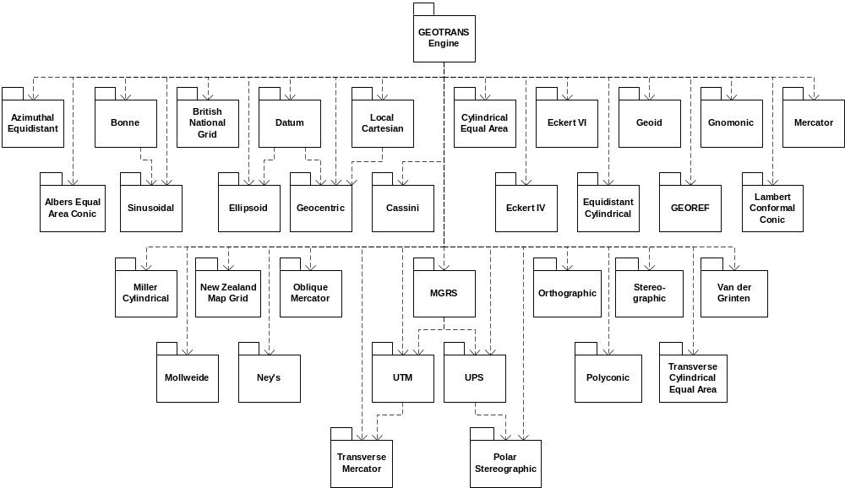Figure 4-2. DT&CC Module Dependencies

5. Software Support Information
This section describes the as built design of the GEOTRANS Application software component, the build procedures for the GEOTRANS application software, and modification procedures for the most likely types of modifications.

5.1 Software Design
This section describes each of the modules that make up the GEOTRANS Application software component. The GEOTRANS Application software component consists of five subcomponents, as follows:
- the GEOTRANS Common Support software, which is contained in the geotrans2/src subdirectory,
- the Windows GUI software, which is contained in the geotrans2/win_gui subdirectory,
- the Java GUI software, which is contained in the geotrans2/java_gui subdirectory, and
- the On-Line Help source files, which are contained in the geotrans2/help subdirectory.
Each of these high-level components is described below.

5.1.1 GEOTRANS Common Support Software
This section describes the structure and organization of the GEOTRANS Common Support software, which is contained in the geotrans2/src subdirectory. The GEOTRANS Common Support software consists of the following modules:
- File Processing (files fiomeths.h and fiomeths.c) – This ANSI C module contains functions which implement the file processing capabilities of the GEOTRANS application. Key functions include Set_Input_Filename, which opens the input coordinate file and reads its header, Set_Output_Filename, which opens the output coordinate file and writes its header, and Convert_File, which reads coordinate tuples from the input file, calls the Engine to convert each one, and writes the resulting coordinate tuples to the output file.
- String-Value Conversions (files strtoval.h and strtoval.c) – This ANSI C module contains functions which convert character strings into internal integer or floating point values (latitudes, longitudes, eastings, northings, zone numbers, etc.), performing lexical and basic range checking, and convert internal values into character strings, rounding according to the current precision option.
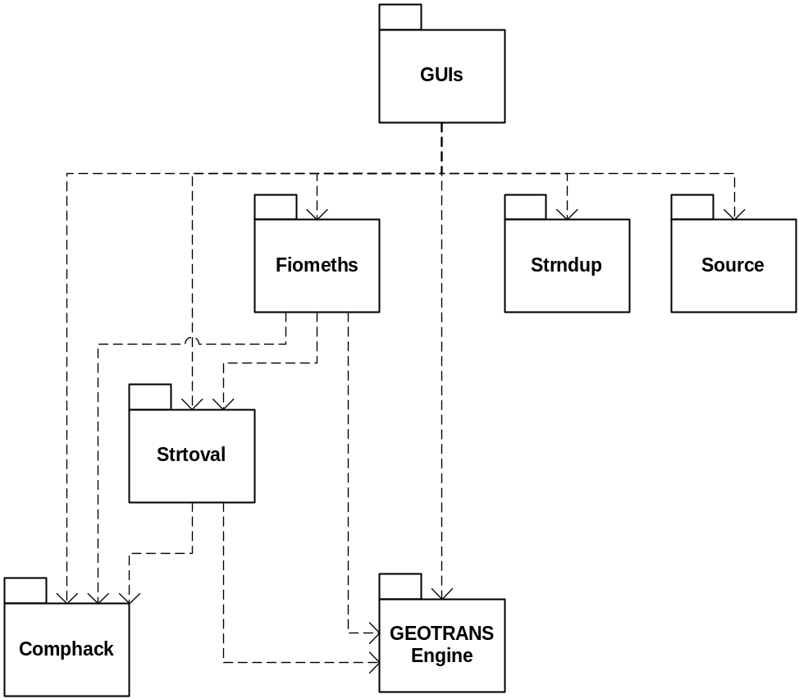Figure 5-1. GEOTRANS Core Software Dependencies
- String Duplication (files strndup.h, strndup.c) – This C module provides character string copying services supporting both C and C++ components.
- Sources (files source.h, source.c) – This C module provides access to a list of standard coordinate sources (GPS systems, hardcopy map types, digital geospatial databases, etc.), and their associated accuracy values.
- Boolean (file comphack.h) – This C/C++ module implements a basic Boolean data type.
The dependencies among these modules are shown in Figure 5-1. The String-Value Conversion, String and String Duplication, and Boolean modules are essentially utility modules that are used by the other GEOTRANS Common Support modules as well as by the Windows GUI.

5.1.2 Windows GUI Software
This section describes the structure and organization of the Windows GUI software, which is contained in the geotrans2/win_gui subdirectory. The Windows GUI software was generated using the Microsoft Foundation Class library and the Microsoft AppWizard. The Windows GUI software consists of the following modules:
- GEOTRANS Application Class (files geotrans.h and geotrans.cpp) – This class defines the main application class, CGeotransApp.
- GEOTRANS Document Class (files geotrdoc.h and geotrdoc.cpp) – This class defines the application’s document class, CGeotransDoc, which implements standard document features. All MFC-based Windows applications are assumed to display and allow the user to edit a particular type of ‘document’.
- GEOTRANS Document View Class (files geotrvw.h and geotrvw.cpp) – This class defines the application’s document view class, CGeotransView, which implements standard document viewing features. All MFC-based Windows applications are assumed to display and allow the user to edit a particular type of ‘document’.
- Main Frame View Class (files mainfrm.h and mainfrm.cpp) – This class defines the MFC frame class CMainFrame that controls all standard frame features.
- Progress Dialog Box Class (files progress.h and progress.cpp) – This class implements the GEOTRANS File Processing Progress dialog box.
- Standard AFX Class (files stdafx.h and stdafx.cpp) – This standard class generated by AppWizard is used to build a precompiled header (PCH) file named stdafx.pch, and a precompiled types (PCT) file named stdafx.obj.
- Convert View Class (files convertvw.h and convertvw.cpp) – This class implements the Convert buttons.
- Datum View Class (files datumvw.h and datumvw.cpp) – This class implements the dialog box used to input the parameters of a user-defined datum.
- Delete Datum View Class (files deldatumvw.h and deldatumvw.cpp) – This class implements the dialog box used to input the parameters of a user-defined datum to be deleted.
- Ellipsoid View Class (files ellipsevw.h and ellipsevw.cpp) – This class implements the dialog box used to input the parameters of a user-defined ellipsoid.
- Delete Ellipsoid View Class (files delellipvw.h and delellipvw.cpp) – This class implements the dialog box used to input the parameters of a user-defined ellipsoid to be deleted.
- File Processing Window Class (files filevw.h and filevw.cpp) – This class implements the GEOTRANS File Processing Dialog Box.
- Master View Class (files mastervw.h and mastervw.cpp) – This class implements the both the upper and lower panels of the GEOTRANS main window.
The dependencies among these modules are shown in Figure 5-3. The main program is shown at the top of the diagram. The view classes are shown as a group at the upper left, one for each supported coordinate system and map projection. These are independent of each another, and all have similar dependencies. The other modules that make up the Windows GUI are shown along both sides of the diagram. All of these modules depend on the declarations contained in the geotrans.h file, as well as those in stdafx.h. The dependencies on the GEOTRANS Common Support software involve the File Processing, File-Value Conversion, String-Value Conversion, and Boolean modules.
There are several other files contained within the geotrans/win_gui subdirectory, including:
- geotrans.rc – This is a listing of all of the Microsoft Windows resources that the program uses. It includes the icons, bitmaps, and cursors that are stored in the res subdirectory.
- res/geotrans.ico – This is an icon file, which is used as the application’s icon. This icon is included by the main resource file geotrans.rc.
- res/geotrans.rc2 – This file contains resources that are not edited by App Studio.
- geotrans.def – This file contains information about the application that must be provided to run with Microsoft Windows. It defines parameters such as the name and description of the application, and the size of the initial local heap.
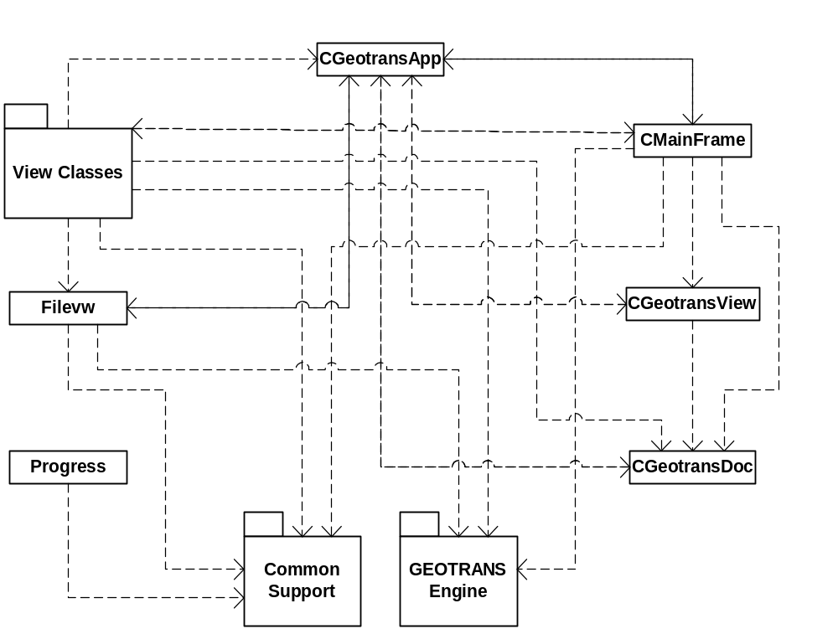Figure 5-2. Windows GUI Software Dependencies
- resource.h – This is the standard header file, which defines new resource Ids. App Studio reads and updates this file.

5.1.3 Java GUI Software
This section describes the structure and organization of the Java GUI software, which is contained in the geotrans2/java_gui/geotrans subdirectory. The Java GUI software was generated using NetBeans IDE, available at www.netbeans.org. The Java GUI software consists of the following modules:
- AboutDlg class (file AboutDlg.java) – This class defines the About dialog box.
- AboutIconPanel class (file AboutIconPanel.java) – This class defines the panels used to display the TEC and NGA icons within the About dialog box.
- Accuracy class (file Accuracy.java) – This class stores a set of coordinate accuracy values.
- AlbersEqualAreaConic class (file AlbersEqualAreaConic.java) – This class stores parameter and coordinate values for an Albers Equal Area Conic projection.
- AzimuthalEquidistant class (file AzimuthalEquidistant.java) – This class stores parameter and coordinate values for an Azimuthal Equidistant projection.
- BNG class (file BNG.java) – This class stores parameter and coordinate values for a British National Grid coordinate system.
- Bonne class (file Bonne.java) – This class stores parameter and coordinate values for a Bonne projection.
- Cassini class (file Cassini.java) – This class stores parameter and coordinate values for a Cassini projection.
- Center class (file Center.java) – This class centers windows when they initially appear.
- ConversionState class (file ConversionState.java) – This class defines an enumerated type for the two conversion states, file (0) and interactive (1).
- CoordinateTypes class (file CoordinateTypes.java) – This class defines an enumerated type for coordinate system and projection types.
- CoordPanel class (file CoordPanel.java) – This class defines the panels used to display coordinate values.
- CreateDatumDlg class (file CreateDatumDlg.java) – This class defines the Create Datum dialog box.
- CreateEllipsoidDlg class (file CreateEllipsoidDlg.java) – This class defines the Create Ellipsoid dialog box.
- CylindricalEqualArea class (file CylindricalEqualArea.java) – This class stores parameter and coordinate values for a Cylindrical Equal Area projection.
- DATFileFilter class (file DATFileFilter.java) – This class defines a file selection filter for data (.dat) files.
- DeleteDlg class (file DeleteDlg.java) – This class defines the Delete Datum and Delete Ellipsoid dialog boxes.
- Eckert4 class (file Eckert4.java) – This class stores parameter and coordinate values for an Eckert IV projection.
- Eckert6 class (file Eckert6.java) – This class stores parameter and coordinate values for an Eckert VI projection.
- EquidistantCylindrical class (file EquidistantCylindrical.java) – This class stores parameter and coordinate values for an Equidistant Cylindrical projection.
- FileDlg class (file FileDlg.java) – This class defines the File Processing dialog box.
- FillList class (file FillList.java) – This class defines the Datum and Ellipsoid pull-down lists.
- FormatOptionsDlg class (file FormatOptionsDlg.java) – This class defines the Formatting Options dialog box.
- GARS class (file GARS.java) – This class stores parameter and coordinate values for a Global Area Reference System (GARS) coordinate system.
- Geocentric class (file Geocentric.java) – This class stores parameter and coordinate values for a Geocentric coordinate system.
- Geodetic class (file Geodetic.java) – This class stores parameter and coordinate values for a Geodetic coordinate system.
- GEOREF class (file GEOREF.java) – This class stores parameter and coordinate values for a World Geodetic Reference System (GEOREF) coordinate system.
- Geotrans class (file Geotrans.java) – This class defines the main class of the GEOTRANS application.
- GeotransError class (file GeotransError.java) – This class defines a GEOTRANS error message.
- GeotransWarning class (file GeotransWarning.java) – This class defines a GEOTRANS warning message.
- Gnomonic class (file Gnomonic.java) – This class stores parameter and coordinate values for a Gnomonic projection.
- HeightType class (file HeightType.java) – This class defines an enumerated type for height types.
- IOValue class (file IOValue.java) – This class defines an enumerated type for conversion direction.
- JNIEngine class (file JNIEngine.java) – This class defines the Java Native Interface (JNI) to the GEOTRANS Engine.
- JNIException class (file JNIException.java) – This class defines a GEOTRANS exception message.
- JNIFiomeths class (file JNIFiomeths.java) – This class defines the Java Native Interface (JNI) to the GEOTRANS File Processing module.
- JNISource class (file JNISource.java) – This class defines the Java Native Interface (JNI) to the GEOTRANS Source module.
- JNIStrtoval class (file JNIStrtoval.java) – This class defines the Java Native Interface (JNI) to the GEOTRANS String-to-Value module.
- jOptions class (file jOptions.java) – This class defines the enumerated types for the coordinate formatting options, and stores current formatting option settings.
- LambertConformalConic1 class (file LambertConformalConic1.java) – This class stores parameter and coordinate values for a Lambert Conformal Conic (1 parallel) projection.
- LambertConformalConic2 class (file LambertConformalConic2.java) – This class stores parameter and coordinate values for a Lambert Conformal Conic (2 parallel) projection.
- ListType class (file ListType.java) – This class defines an enumerated type for list types (Datum or Ellipsoid).
- LocalCartesian class (file LocalCartesian.java) – This class stores parameter and coordinate values for a Local Cartesian coordinate system.
- MasterPanel class (file MasterPanel.java) – This class defines a coordinate system or projection display/entry panel.
- Mercator class (file Mercator.java) – This class stores parameter and coordinate values for a Mercator projection.
- MGRS class (file MGRS.java) – This class stores parameter and coordinate values for a Military Grid Reference System (MGRS) coordinate system.
- MillerCylindrical class (file MillerCylindrical.java) – This class stores parameter and coordinate values for a Miller Cylindrical projection.
- Mollweide class (file Mollweide.java) – This class stores parameter and coordinate values for a Mollweide projection.
- Neys class (file Neys.java) – This class stores parameter and coordinate values for a Ney’s projection.
- NZMG class (file NZMG.java) – This class stores parameter and coordinate values for a New Zealand Map Grid (NZMG) coordinate system.
- ObliqueMercator class (file ObliqueMercator.java) – This class stores parameter and coordinate values for an Oblique Mercator projection.
- Orthographic class (file Orthographic.java) – This class stores parameter and coordinate values for an Orthographic projection.
- PolarStereographic class (file PolarStereographic.java) – This class stores parameter and coordinate values for a Polar Stereographic projection.
- Polyconic class (file Polyconic.java) – This class stores parameter and coordinate values for a Polyconic projection.
- ProgressDlg class (file ProgressDlg.java) – This class defines the Progress dialog box.
- Sinusoidal class (file Sinusoidal.java) – This class stores parameter and coordinate values for a Sinusoidal projection.
- StartBrowser class (file StartBrowser.java) – This class starts an Internet browser (Internet Explorer or Netscape) to allow the GEOTRANS on-line help to be viewed.
- Stereographic class (file Stereographic.java) – This class stores parameter and coordinate values for a Stereographic projection.
- TransverseCylindricalEqualArea class (file TransverseCylindricalEqual- Area.java) – This class stores parameter and coordinate values for a Transverse Cylindrical Equal Area projection.
- TransverseMercator class (file TransverseMercator.java) – This class stores parameter and coordinate values for a Transverse Mercator projection.
- UPS class (file UPS.java) – This class stores parameter and coordinate values for a Universal Polar Stereographic (UPS) projection.
- USNG class (file USNG.java) – This class stores parameter and coordinate values for a United States National Grid (USNG) coordinate system.
- UTM class (file UTM.java) – This class stores parameter and coordinate values for a Universal Transverse Mercator (UTM) projection.
- VanDerGrinten class (file VanDerGrinten.java) – This class stores parameter and coordinate values for a Van der Grinten projection.
There are several other files contained within the geotrans/java_gui/geotrans subdirectory, including:
- icons – This subdirectory contains a collection of .gif files that define the icons for the various toolbar buttons, as well as the TEC and NGA logos.
- *.c and *.h files – These files are generated from the corresponding Java Native Interface (JNI) classes, and provide the translation of function calls and parameters between the Java GUI and the GEOTRANS Engine and other supporting C language components..
- *.form – These files contain GUI layout information that is used by the NetBeans IDE GUI specification tool.

5.1.4 On-Line Help Source Files
This section describes the structure and organization of the On-Line Help source files, which are contained in the geotrans2/help subdirectory. The source files are of two types. Files with the extension “.htm” are source files in Hyper Text Markup Language (HTML), which contain formatted text for one or more on-line help topics. Files with the extension “.gif” are graphics files, which contain the graphic images used in the on-line help topics. The On-Line Help source files consist of the following modules:
- Basic Operations (file basicops.htm) – which describes the basic interactive operation of the GEOTRANS application,
- Contents (file contents.htm) – which contains the top-level table of contents for the on-line help,
- Coordinate System Descriptions (file coordDescriptions.htm) – which contains detailed descriptions of the various types of coordinate systems supported by the GEOTRANS application, including references to the following graphics:
- Geodetic & Geocentric Coordinates (file geodetic.gif) – graphic showing the relationship between geodetic and geocentric coordinate systems (Figure 4.2 from TEC-SR-7),
- GEOREF 15° Grid (file georef1.gif) – graphic showing the high-level 15° GEOREF grid,
- GEOREF 1° Grid (file georef2.gif) – graphic showing the low-level 1° GEOREF grid,
- MGRS Zones (file mgrs_zones.gif) – graphic showing the MGRS zones,
- MGRS 100,000m Square Designations (AL Pattern) (file mgrs_al.gif) – graphic showing the patterns of MGRS 100,000m Square Designations used with the Clarke 1866, Clarke 1880, and Bessel 1841 ellipsoids,
- MGRS 100,000m Square Designations (AA Pattern) (file mgrs_aa.gif) – graphic showing the patterns of MGRS 100,000m Square Designations used with all other ellipsoids,
- MGRS 100,000m Square Designations for North Polar Zone (file mgrs_n.gif) – graphic showing the patterns of MGRS 100,000m Square Designations in the north polar zone,
- MGRS 100,000m Square Designations for South Polar Zone (file mgrs_s.gif) – graphic showing the patterns of MGRS 100,000m Square Designations in the south polar zone,
- Coordinate Systems (file coordsys.htm) – which contains brief descriptions of the various types of coordinate systems and map projections supported by the GEOTRANS application,
- Coordinate System Descriptions (file coordDescriptions.htm) – which contains detailed descriptions of the various types of coordinate systems supported by the GEOTRANS application,
- Create Datum Dialog (file createDatumDlg.htm) – which contains a description of the Create Datum dialog box,
- Create Ellipsoid Dialog (file createEllipsoidDlg.htm) – which contains a description of the Create Ellipsoid dialog box,
- Datum Table (file datum1.htm) – which contains a table of countries and geographic areas, identifying which local datums are applicable to each,
- Delete Datum Dialog (file deleteDatumDlg.htm) – which contains a description of the Delete Datum dialog box,
- Delete Ellipsoid Dialog (file deleteEllipsoidDlg.htm) – which contains a description of the Delete Ellipsoid dialog box,
- Ellipsoid Table (file elliptab.htm) – which contains a table of standard ellipsoids and their parameters,
- Error Messages (file errors.htm) – which contains descriptions of the error messages that may be output by the GEOTRANS application,
- Fields (file fields.htm) – which contains descriptions of all of the fields and controls included in the graphical user interface of the GEOTRANS application,
- File Format (file fileform.htm) – which contains a description of the format of the ASCII coordinate files read and created by the GEOTRANS application,
- File Open Dialog (file fileOpenDlg.htm) – which contains a description of the File Open dialog box,
- File Processing (file fileproc.htm) – which describes how to use the file processing capabilities of the GEOTRANS application,
- File Processing Dialog (file fileProcessingDlg.htm) – which contains a description of the File Processing dialog box,
- File Processing Window (file fileProcessingWindow.htm) – which contains a description of the File Processing window,
- Glossary (file glossary.htm) – which contains the definitions of general MC&G terms that are used in describing the GEOTRANS application,
- Main Window (file mainWindow.htm) – which contains a description of the GEOTRANS application main window,
- Menu Commands (file menubar.htm) – which contains descriptions of all of the menu commands provided by the menu bar in the GEOTRANS main window,
- Overview (file overview.htm) – which contains an overview of the GEOTRANS application, and
- Projection Descriptions (file projectionDescriptions.htm) – which contains detailed descriptions of the various types of map projections supported by the GEOTRANS application, including references to the following graphics:
- Mercator Projection (file mercator.gif) – graphic showing the Mercator projection,
- Transverse Mercator Projection (file transmerc.gif) – graphic showing the Transverse Mercator projection,
- UTM Projection (file utm.gif) – graphic showing meridians and parallels and a Universal Transverse Mercator grid (Figure 7.3 from TEC-SR-7),
- Polar Stereographic Projection (file polarst.gif) – graphic showing meridians and parallels in a Polar Stereographic projection (Figure 7.4 from TEC-SR-7),
- UPS Projection (file ups.gif) – graphic showing meridians and parallels on the Universal Polar Stereographic grid (Figure 7.6 from TEC-SR-7),
- Albers Equal Area Conic projection (file albers.gif) – graphic showing an Albers Equal Area Conic projection,
- Azimuthal Equidistant projection (file azeq.gif) – graphic showing an Azimuthal Equidistant projection,
- Bonne projection (file bonne.gif) – graphic showing a Bonne projection,
- British National Grid (file bng.gif) – graphic showing the British National Grid,
- Cassini projection (file cassini.gif) – graphic showing a Cassini projection,
- Cylindrical Equal Area projection (file cyleqa.gif) – graphic showing a Cylindrical Equal Area projection,
- Eckert IV projection (file eckert4.gif) – graphic showing an Eckert IV projection,
- Eckert VI projection (file eckert6.gif) – graphic showing an Eckert VI projection,
- Equidistant Cylindrical projection (file eqdcyl.gif) – graphic showing an Equidistant Cylindrical projection,
- Gnomonic projection (file gnomonic.gif) – graphic showing a Gnomonic projection,
- Lambert Conformal Conic (1 parallel) Projection (file lambert_1.gif) – graphic showing a Lambert Conformal Conic (1 parallel) projection,
- Lambert Conformal Conic (2 parallel) Projection (file lambert_2.gif) – graphic showing a Lambert Conformal Conic (2 parallel) projection,
- Miller Cylindrical projection (file miller.gif) – graphic showing a Miller Cylindrical projection,
- Mollweide projection (file mollweid.gif) – graphic showing a Mollweide projection,
- Ney’s Projection (file neys71.gif) – graphic showing Ney’s projection,
- New Zealand Map Grid (file nzmg.gif) – graphic showing the New Zealand Map Grid,
- Oblique Mercator projection (file omerc.gif) – graphic showing an Oblique Mercator projection,
- Orthographic projection (file ortho.gif) – graphic showing a Orthographic projection,
- Polyconic projection (file polyconic.gif) – graphic showing a Polyconic projection,
- Sinusoidal projection (file sinusoidal.gif) – graphic showing a Sinusoidal projection,
- Stereographic projection (file stereogr.gif) – graphic showing a Stereographic projection,
- Transverse Cylindrical Equal Area projection (file trcyleqa.gif) – graphic showing a Transverse Cylindrical Equal Area projection,
- Van der Grinten projection (file grinten.gif) – graphic showing a Van der Grinten projection,
- Save As Dialog (file saveAsDlg.htm) – which contains a description of the Save As dialog box.

5.2 Installation Procedures

5.2.1 UNIX Installation Procedure
The distribution of GEOTRANS for UNIX is normally packaged as a compressed tar archive named either sun_user.tgz or sun_dev.tgz. To install it:
- Create a directory to contain the distribution:
% mkdir /home/geotrans
You may replace /home/geotrans with whatever path you choose.
- Change your working directory to the directory you just created:
% cd /home/geotrans
- Copy the archive from wherever it is located to the GEOTRANS home directory:
% cp sun_user.tgz /home/geotrans
- Uncompress the archive using the Gnu unzip utility:
% gunzip sun_user.tgz
% tar xvf sun_user.tar

5.2.2 Windows Installation Procedure
The distribution of GEOTRANS for Windows is normally packaged as a ZIP archive named either win_user.zip or win_dev.zip. To install it (using DOS commands):
- Create a directory to contain the distribution:
C:\>mkdir \geotrans
- Change your working directory to the directory you just created:
C:\>cd \geotrans
- Copy the archive to the GEOTRANS directory. For example:
C:\>cp D:\ win_user.zip C:\geotrans
- Use PKUNZIP to unpack the archive.
C:\GEOTRANS>pkunzip geotrans.zip
Of course, you may also use the Windows desktop to perform these steps, creating a GEOTRANS home directory, copying the ZIP archive into that directory, and then unzipping it.

5.3 Startup Procedures

5.3.1 Windows Startup Procedure
The GEOTRANS Windows executables are located in the directory .../geotrans2/win. There are two executables: the statically linked executable is named geotrans2.exe; the dynamically linked executable, which uses the dynamically linked library geotrans2.dll, is named geotrans2d.exe.
To run the Windows version of GEOTRANS, double-click on its icon in the Windows Program Manager, or double-click on the executable file, geotrans2.exe, in any File Manager window.
It is also possible for you to create a shortcut for the GEOTRANS executable and place it on your desktop. Once you have done this, you can run GEOTRANS by double clicking on the shortcut icon.

5.3.2 Java Startup Procedure
The Java version of GEOTRANS runs in UNIX, LINUX and Windows environments. Note that only the user interface is written in Java – the Java version uses the same libraries as the dynamically linked LINUX, UNIX and Windows versions, respectively.
The Java version of GEOTRANS is contained in a Java archive file named geotrans2.jar. Copies of this file are located in .../geotrans2/redhat_linux, .../geotrans2/suse_linux, .../geotrans2/unix and the .../geotrans2/win directories.
To run the Java version of GEOTRANS on UNIX and LINUX, you must the use the following command to invoke the Jave runtime environment: java –jar geotrans2.jar.
To run the Java version of GEOTRANS on Windows, double-click on the Java archive file, geotrans2.jar, in any File Manager window.
It is also possible for you to create a shortcut for the GEOTRANS Java archive and place it on your desktop. Once you have done this, you can run the Java version of GEOTRANS by double clicking on the shortcut icon.
The Java version of GEOTRANS requires the Java Platform Standard Edition, Version 1.3 or later. It can be downloaded at no cost from http://java.sun.com/j2se for Solaris, Linux and Windows.

5.3.3 Required Data Files
GEOTRANS requires several data files that contain datum, ellipsoid, and geoid separation information. The following data files are normally located in the geotrans2/data directory, and GEOTRANS looks for them there by default:
- 3_param.dat – the data file containing the datum shift parameters for 3-parameter local datums,
- 7_param.dat – the data file containing the datum shift parameters for 7-parameter local datums,
- egm96.grd – the data file containing the Earth Gravity Model 1996 (EGM96) geoid separation values,
- egm84.grd – the data file containing the Earth Gravity Model 1984 (EGM84) geoid separation values,
- ellips.dat – the data file containing the standard ellipsoid parameters.
As an alternative, you can define the environment variable GEOTRANS_DATA, and place the files in the directory identified by this variable.

5.4 Compilation/Build Procedures
The GEOTRANS executable directories: geotrans2/redhat_linux, geotrans2/suse_linux, geotrans2/unix, and geotrans2/win, each contain required data files, executables for the GEOTRANS application, makefiles, and other supporting files.

5.4.1 UNIX Compilation/Build Procedures
The UNIX dtcc library directory, dt_cc/unix, contains the following files:
- libdtcc.a – the GEOTRANS DT&CC Module library used by the GEOTRANS applications and shared object libraries,
- makefile – the UNIX makefile for the DT&CC library
To make the UNIX DT&CC library, type:
%make libdtcc.a

The UNIX engine library directory, engine/unix, contains the following files:
- libengine.a – the GEOTRANS engine library used by the GEOTRANS applications and shared object libraries,
- makefile – the UNIX makefile for the engine library
To make the UNIX engine library, type:
%make libengine.a

The UNIX executable directory, geotrans2/unix, contains the following files:
- geotrans2.jar – the Java archive version of the GEOTRANS application,
- libgeotrans.so.1 – the GEOTRANS shared object library used by the UNIX version of the GEOTRANS executable Geotrans2d,
- libjnigeotrans.so – the GEOTRANS Java Native Interface (JNI) shared object library used by the Java version of the GEOTRANS application when it runs on UNIX platforms,
- makefile – the UNIX makefile for the GEOTRANS application, and for the GEOTRANS shared object library.
To make the UNIX GEOTRANS shared object library, type:
%make libgeotrans.so.1
To make the UNIX GEOTRANS Java Native Interface (JNI) shared object library, type:
%make libjnigeotrans.so
To delete unneeded files created during the build process, type:
%make clean
Note: The DT&CC and engine libraries should be built before trying to build the GEOTRANS applications and shared object libraries. The GEOTRANS shared object library should be built before trying to build the JNI shared object library.

5.4.2 Windows Compilation/Build Procedures
The Windows executable directory, geotrans2/win, contains the following files:
- geotrans_dll.dsp – the Microsoft Developer's Studio project file for the GEOTRANS DLL,
- geotrans2.def – the module definition file defining the functions to be exported by the GEOTRANS DLL,
- geotrans2.dll – the GEOTRANS DLL used by the dynamically linked GEOTRANS application executable,
- geotrans2.dsp – the Microsoft Developer's Studio project file for the GEOTRANS application,
- geotrans2.dsw – the Microsoft Developer's Studio workspace file for the GEOTRANS application,
- geotrans2.exe – the statically linked Windows executable for the GEOTRANS application,
- geotrans2.exp – the symbols exported by the GEOTRANS DLL,
- geotrans2.jar – the Java archive version of the GEOTRANS application,
- geotrans2.lib – the library component of the GEOTRANS DLL,
- geotrans2d.dsp – the Microsoft Developer's Studio project file for the dynamically linked GEOTRANS application executable, which depends on a GEOTRANS DLL, and
- geotrans2d.exe – the dynamically linked Windows executable for the GEOTRANS application, which depends on the GEOTRANS DLL.
- jnigeotrans.dll – the GEOTRANS Java Native Interface (JNI) DLL used by the Java version of the GEOTRANS application,
- jnigeotrans.dsp – the Microsoft Developer's Studio project file for the GEOTRANS JNI DLL,
- jnigeotrans.exp – the symbols exported by the GEOTRANS JNI DLL,
- jnigeotrans.lib – the library component of the GEOTRANS JNI DLL,
To build the GEOTRANS Windows executables and/or the GEOTRANS DLL, start up the Microsoft Developers Studio and open the geotrans2.dsw workspace file. Using the Project pull-down menu, select the project to be built. The three projects are geotrans2_dll, which builds the GEOTRANS DLL, geotrans2, which builds the statically linked executable, and geotrans2d, which builds the dynamically linked executable. Then, from the Build pull-down menu, select the Build command.
Two additional projects, which build the DT&CC modules and the GEOTRANS Engine, are also included. These projects are built in the dt_cc/win and engine/win directories, respectively.
The GEOTRANS Java Native Interface DLL that supports the Java version of GEOTRANS is built using the jnigeotrans project.

5.4.3 Java Compilation/Build Procedures
To compile and build the GEOTRANS Java files, start up NetBeans IDE, available at www.netbeans.org, and mount the /geotrans2/java_gui directory in the filesystems explorer window by going to the File pull-down menu and selecting Open Project. Navigate to the /geotrans2/java_gui directory and click Open Project Folder. Within the filesystems explorer window, highlight the mounted java_gui directory and right click on it. Select the Build Project command from the menu shown.
Next, edit the GEOTRANS Java archive (jar) file properties. First, click on the Files tab. Double click on Manifest.mf and insert the following line, Main-Class: geotrans/Geotrans. Next, click on nbproject under the geotrans2 directory tree. Double click on project.properties. On the dist.jar line, type the directory and name of the jar file. The jar file is automatically created when the project is built.

5.5 Modification Procedures
The most common type of modification is expected to be the addition of a new type of coordinate reference frame. This section briefly summarizes the changes necessary to add support to the GEOTRANS software for a new coordinate reference frame type. It is assumed that there is a DT&CC module for the new coordinate reference frame, supporting the following four functions:
- Set_XXX_Parameters,
- Get_XXX_Parameters,
- Convert_Geodetic_to_XXX, and
- Convert_XXX_to_Geodetic,
where XXX is replaced with the name of the new coordinate reference frame.
Further, it is assumed that any new map projection does not require any new types of projection parameters or coordinate values beyond those already supported (i.e., Central Meridian, Origin Latitude, Standard Parallel, etc.). If this is not the case additional modifications will have to be made to the GEOTRANS software to support the new parameter type.
Additions are required in the GEOTRANS Engine, the GEOTRANS Common Support software, the Motif GUI software, the Windows GUI software, and the on-line help files, as well as in the documentation. In the GEOTRANS Engine, the following additions are required:
- Engine – The new coordinate reference frame must be added to the enum Coordinate_Types in file engine.h. The coordinate tuple definition and coordinate system definition for the new coordinate reference frame must be added in file engine.h. These definitions must be added to the corresponding unions defined in file engine.c. The functions Set_XXX_Coordinates and Get_XXX_Coordinates must be defined in file engine.h and implemented in file engine.c. If necessary, the functions Set_XXX_Params and Get_XXX_Params must also be added. Cases for the new coordinate reference frame must be added to the function Convert. If the new coordinate reference frame requires any new error codes to be defined, these must be defined in engine.h. Cases for the new error codes must be added to the functions Get_Return_Code_String and Get_Conversion_Status_String.
In the GEOTRANS Common Support, the following additions are required:
- String-Value Conversions – Cases for the new coordinate reference frame must be added to the functions String_to_Projection and Projection_to_String, as well as to the function Error_Prefix.
- File Processing – Cases for the new coordinate reference frame must be added to the functions Write_Output_File_Header and Convert_File.
In the Windows GUI software, the following additions are required:
- mastervw.cpp – New cases must be added to the switch statements in the functions GetParams, GetCoords, SetCoords, and Initialize_Form.
- filevw.cpp – New cases must be added to the switch statements in the functions OnInitDialog, OnSelchangeOutputSystemCombobox, and OnOK.
In the Java GUI software, the following additions are required:
- CoordPanel.java – New cases must be added to the switch statements in the functions getCoords, setCoords, and createCoordPanel.
- CoordinateTypes.java – A new enumerated type must be added.
- JNIEngine.java – New JNIGetXXXParams,JNISetXXXParams, JNIGetXXXCoordin-ates, and JNISetXXXCoordinates function declarations must be added.
- MasterPanel.java – New cases must be added to the switch statements in the functions initFileInputPanel, createMasterPanel, setEngine, and fillProjectionList.
- A new java class file defining the coordinates and parameters of the new projection must also be created.
The JNI source files must also be updated to reflect the addition of a new coordinate reference frame. The files that must be updated are:
- JNIEngine.c – New JNIGetXXXParams, JNISetXXXParams, JNIGetXXXCoordin-ates, and JNISetXXXCoordinates functions must be added.
- JNIEngine.h – New JNIGetXXXParams, JNISetXXXParams, JNIGetXXXCoordin-ates, and JNISetXXXCoordinates function declarations must be added. This can either be done by directly adding new declarations to the file or by generating a new header file using the javah -jni command.
The on-line help files must also be updated to reflect the addition of a new coordinate reference frame. The files that must be updated are:
- coordsys.htm – A new section should be added to this file to describe the new coordinate reference frame.
- errors.htm – Descriptions of any new error messages should be added to this file to describe unique error conditions associated with the new coordinate reference frame.
- fileform.htm – The keyword used to identify the new coordinate reference frame in a GEOTRANS coordinate file should be added to the list contained in this file.

6. Notes
This section contains notes on three aspects of the GEOTRANS software. Section 6.1 describes the different possible distribution packages for the GEOTRANS software. Section 6.2 discusses the coordinate conversion logic that is implemented by the function Convert in the Engine module of the GEOTRANS Engine. Section 6.3 summarizes the datum transformation logic that is implemented by the functions Geocentric_Datum_Shift and Geodetic_Datum_Shift in the DATUM module.

6.1 Distribution Packages
The GEOTRANS software can be distributed in several different forms, depending on what platform(s) each potential user has, and on whether or not a potential user is to be provided with source code.
The master GEOTRANS distribution consists of four top-level components:
- The GEOTRANS Application Component, which has the following directory structure:
+---GEOTRANS2
| +---DOCS
| +---HELP
| +---JAVA_GUI
| +---REDHAT_LINUX
| +---SRC
| +---SUSE_LINUX
| +---UNIX
| +---WIN_GUI
| +---WIN
- The GEOTRANS Engine Component, which has the following directory structure:
+---ENGINE
| +---DOCS
| +---REDHAT_LINUX
| +---SRC
| +---SUSE_LINUX
| +---UNIX
| +---WIN
- The Datum Transformation & Coordinate Conversion Component, which has the following directory structure:
+---DT_CC
| +---ALBERS
| +---AZEQ
| +---BONNE
| +---CASSINI
| +---CYLEQA
| +---DATUM
| +---ECKERT4
| +---ECKERT6
| +---ELLIPSE
| +---EQDCYL
| +---GARS
| +---GEOCENT
| +---GEOID
| +---GEOREF
| +---GNOMONIC
| +---GRINTEN
| +---LAMBERT_1
| +---LAMBERT_2
| +---LOCCART
| +---MERCATOR
| +---MGRS
| +---MILLER
| +---MOLLWEID
| +---OMERC
| +---ORTHOGR
| +---POLARST
| +---POLYCON
| +---REDHAT_LINUX
| +---SINUSOID
| +---SUSE_LINUX
| +---TRANMERC
| +---TRCYLEQA
| +---UNIX
| +---UPS
| +---USNG
| +---UTM
| +---WIN
There are at least four other possible distributions of the GEOTRANS software, depending on the target platform(s) and whether or not source code is to be included:
- Windows End-User Distribution – which would support Windows platforms and provide only executable files, data files, and documentation. This distribution would look like:
+---GEOTRANS2
| +---DOCS
| +---HELP
| +---WIN
- UNIX End-User Distribution – which would support UNIX platforms and provide only executable files, data files, and documentation. This distribution would look like:
+---GEOTRANS2
| +---DOCS
| +---HELP
| +---UNIX
- Windows Developer Distribution – which would support Windows platforms and provide source code. This distribution would look like:
+---GEOTRANS2
| +---DOCS
| +---HELP
| +---JAVA_GUI
| +---SRC
| +---WIN_GUI
| +---WIN
+---ENGINE
| +---DOCS
| +---SRC
| +---WIN
+---DT_CC
| +---ALBERS
| +---AZEQ
| +---BONNE
| +---CASSINI
| +---CYLEQA
| +---DATUM
| +---ECKERT4
| +---ECKERT6
| +---ELLIPSE
| +---EQDCYL
| +---GARS
| +---GEOCENT
| +---GEOID
| +---GEOREF
| +---GNOMONIC
| +---GRINTEN
| +---LAMBERT_1
| +---LAMBERT_2
| +---LOCCART
| +---MERCATOR
| +---MGRS
| +---MILLER
| +---MOLLWEID
| +---OMERC
| +---ORTHOGR
| +---POLARST
| +---POLYCON
| +---SINUSOID
| +---TRANMERC
| +---TRCYLEQA
| +---UPS
| +---USNG
| +---UTM
| +---WIN
- UNIX Developer Distribution – which would support UNIX platforms and provide source code. This distribution would look like:
+---GEOTRANS2
| +---DOCS
| +---HELP
| +---JAVA_GUI
| +---SRC
| +---UNIX
+---ENGINE
| +---DOCS
| +---SRC
| +---UNIX
+---DT_CC
| +---ALBERS
| +---AZEQ
| +---BONNE
| +---CASSINI
| +---CYLEQA
| +---DATUM
| +---ECKERT4
| +---ECKERT6
| +---ELLIPSE
| +---EQDCYL
| +---GARS
| +---GEOCENT
| +---GEOID
| +---GEOREF
| +---GNOMONIC
| +---GRINTEN
| +---LAMBERT_1
| +---LAMBERT_2
| +---LOCCART
| +---MERCATOR
| +---MGRS
| +---MILLER
| +---MOLLWEID
| +---OMERC
| +---ORTHOGR
| +---POLARST
| +---POLYCON
| +---SINUSOID
| +---TRANMERC
| +---TRCYLEQA
| +---UNIX
| +---UPS
| +---USNG
| +---UTM
To support multiple platforms, either with or without source code, simply merge the appropriate single platform distributions described above.
The DT&CC modules can each be distributed individually. However, some of the DT&CC modules depend on other DT&CC modules. When a particular module is distributed, all of the other modules that it depends on must also be included in the distribution. These dependencies are shown in Figure 4-2, and can be summarized as follows:
- DATUM – ELLIPSE & GEOCENTRIC must also be included in the distribution,
- ELLIPSE – DATUM must also be included in the distribution,
- LOCAL CARTESIAN – GEOCENTRIC must also be included in the distribution,
- BONNE – SINUSOIDAL must also be included in the distribution,
- LAMBERT_2 – LAMBERT_1 must also be included in the distribution,
- MGRS – UTM, UPS, TRANSVERSE MERCATOR, & POLAR STEREOGRAPHIC must also be included in the distribution, which would look like:
+---DT_CC
| +---MGRS
| +---POLARST
| +---TRANMERC
| +---UPS
| +---UTM
- UPS – POLAR STEREOGRAPHIC must also be included in the distribution,
- USNG – UTM, UPS, TRANSVERSE MERCATOR, & POLAR STEREOGRAPHIC must also be included in the distribution, which would look like:
+---DT_CC
| +---USNG
| +---POLARST
| +---TRANMERC
| +---UPS
| +---UTM
- UTM – TRANSVERSE MERCATOR must also be included in the distribution.

6.2 Coordinate Conversion Logic
The function Convert in the GEOTRANS Engine component is the heart of the GEOTRANS software. It is this function that actually performs all coordinate conversions and datum shifts. Given the input and output datums, the input and output coordinate reference frames, including the values of any projection parameters, and the input coordinates, it produces the output coordinates.
Although the source code for this function is quite long, its structure is relatively simple, consisting of nested if and switch statements. The code blocks that perform individual coordinate conversion and datum shift steps are quite short. Several special cases are handled initially to avoid unnecessary conversions.
The general case is handled in three stages:
- Convert the input coordinates from the input coordinate reference frame to geodetic,
- Shift the intermediate geodetic coordinates from the input datum to the output datum, converting between ellipsoid and geoid/MSL heights if necessary,
- Convert the shifted intermediate geodetic coordinates to the output coordinate reference frame.
The first stage is accomplished by a switch statement on the input coordinate reference frame, with a case for each of the coordinate reference frames supported. If the input coordinates are already in geodetic, they are simply copied to the intermediate coordinates.
The second stage is accomplished in three steps. First, the intermediate Geodetic coordinates are shifted to WGS 84, if necessary. Second, if the input geodetic coordinates included an ellipsoid height and the output Geodetic coordinates require a geoid/MSL height, or vice versa, the geoid separation is either added to or subtracted from the height, as appropriate. Note that if either the input or the output was projected, the geodetic height is considered meaningless, and the output height is forced to zero. Third, the shifted intermediate geodetic coordinates are shifted to the output datum.
The third stage is similar to the first stage. A switch statement on the output coordinate reference frame, with a case for each of the coordinate reference frames supported, is used to convert the shifted intermediate Geodetic coordinates to the output coordinate reference frame. If the output coordinate reference frame is Geodetic, the shifted intermediate coordinates are simply copied to the output coordinates.

6.3 Datum Shift Logic
Normally, a datum shift is performed in two stages: from the input datum to WGS 84, and then from WGS 84 to the output datum. If either the input datum or the output datum is WGS 84, then one or both of these stages will be skipped. Datum shifts are performed using two functions defined in the Datum module, Geodetic_Shift_to_WGS84, and Geodetic_Shift_from_WGS84.
The methods used by these functions depend on the types of the input and output datums, and, in some cases, on the location of the coordinates being shifted. The datums are organized into the following categories:
- WGS 84,
- WGS 72,
- 3-parameter datums – local datums which are defined in the file 3-param.dat, and which have three datum shift parameters (delta X, delta Y, delta Z), and
- 7-parameter datums – local datums which are defined in the file 7-param.dat, and which have seven datum shift parameters (delta X, delta Y, delta Z, X rotation, Y rotation, Z rotation, and scale factor).
Each of the 7-parameter datums (EUR-7 and OGB-7) also have 3-parameter versions (EUR-M and OGB-M). Distinct codes have been defined for these so that it is always clear which set of datum shift parameters should be used.
Four datum shift methods are used, as follows:
- 72-to-84 (and its inverse 84-to-72) – Used to shift between WGS 72 and WGS 84 in geodetic coordinates,
- Molodensky method – Used to shift between 3-parameter datums and WGS 84 in geodetic coordinates, except in the polar regions, where it is not valid,
- 3-parameter method – Used to shift between 3-parameter datums and WGS 84 in geocentric coordinates,
- 7-parameter method – Used to shift between 7-parameter datums and WGS 84 in geocentric coordinates.
The functions Geodetic_Shift_to_WGS84 and Geodetic_Shift_from_WGS84 perform datum shifts in geodetic coordinates. In Geodetic_Shift_to_WGS84, the method used depends on the type of the input datum, as follows:
- WGS 84 – copy coordinates,
- WGS 72 – use 72-to-84 method,
- 3-parameter datums – if near a pole, convert to geocentric coordinates, use 3-parameter method, convert to geodetic coordinates; otherwise use Molodensky method,
- 7-parameter datums – convert to geocentric coordinates, use 7-parameter method, convert to geodetic coordinates
In Geodetic_Shift_from_WGS84, the method used depends on the type of the output datum, as follows:
- WGS 84 – copy coordinates,
- WGS 72 – use 84-to-72 method,
- 3-parameter datums – if near a pole, convert to geocentric coordinates, use 3-parameter method, convert to geodetic coordinates; otherwise use Molodensky method,
- 7-parameter datums – convert to geocentric coordinates, use 7-parameter method, convert to geodetic coordinates.

