Sprint Planning

Know the end from the beginning

* When the sprint ends
  + March 26
* How many hours you have to work on this project this sprint
  + 28 Hours
* Who is going to be here on what days (vacation / other class priorities)
  + Jeffrey every day
  + Marcy poo every day
  + Brandon every day
  + Jazlyn when she feels like it (every day)
* Pick a metric to evaluate each other on during the retrospective
  + Story points (tasks from the backlog/Sprint)

Each story brought into the sprint should have

* Title
* Size estimate by the team
* Description of what is in scope, what’s out of scope
* Acceptance criteria in the description stating what it will look like when it’s done
* Tasks that will be accomplished to complete the story
  + Tasks should have an hour estimate
  + Tasks should be small enough that one person can complete it in 1-2 days
* Stories and tasks should not be assigned to a specific person (unless carrying over from a previous sprint)
  + - GO TO GITHUB FOR INFO

Artifacts

* Stories / tasks are created and on the sprint backlog
* Burndown chart is created and maintained by the Scrum Master
  + - GO TO STAND UP DOCUMENT FOR INFO
  + Identify the scrum master on this document along with all team members and who’s here and who’s not here

Story Points:

* Do cool things
* Like make sprint documents
* Write the codes
* Make website 30% complete

**Daily Scrum or Standup Meeting**

Team name: Project4

Scrum Master: Brandon

Date: 19 March 2019

|  |  |  |  |
| --- | --- | --- | --- |
| **Team Member** | **What did you do since the last scrum?** | **What do you plan to do before the next scrum?** | **What obstacles do you have?** |
| Jeffrey | Make it so user can login and logout | Populate profile page | The database does not exist yet. |
| Marc | Documentation | Meet with Brandon and Create tables | Strep throat |
| Jazlyn | Front end prototyping in html and css | Make sample games show up with EJS | Slightly sick |
| Brandon | Working on DB structure | Meet with Marc and Create tables | People being out sick. Other class exam study |

Burndown:

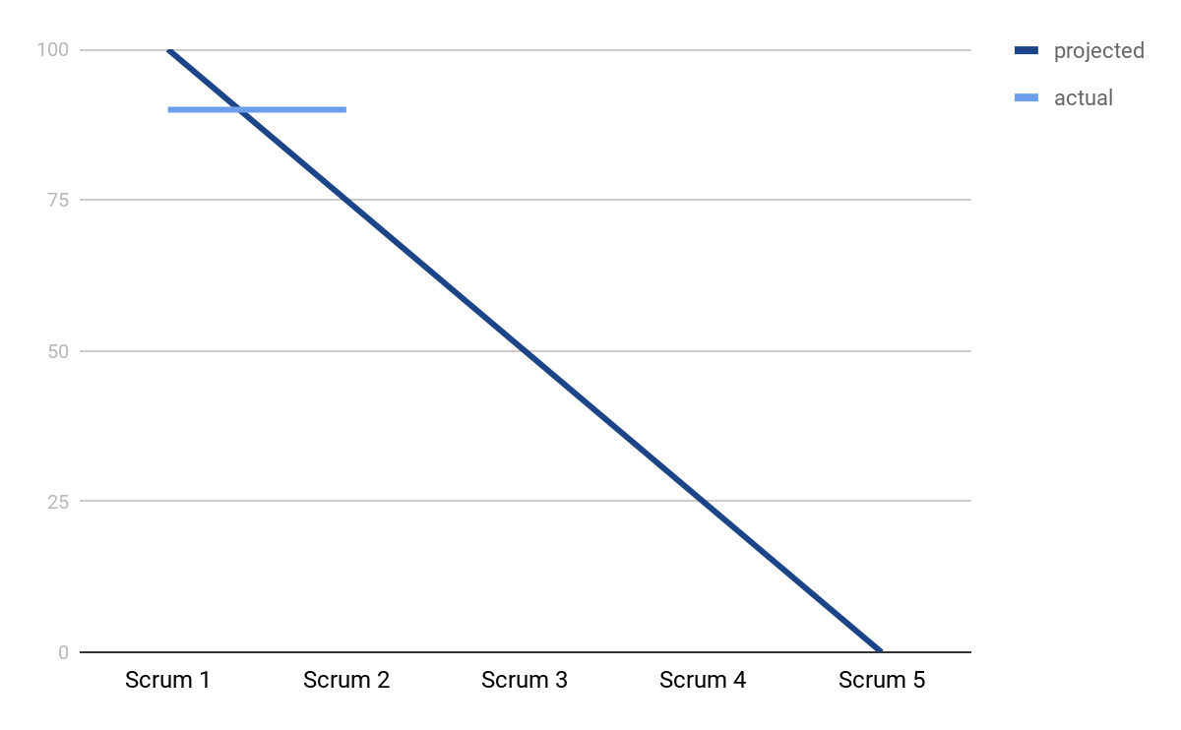

Screenshot of your task board:

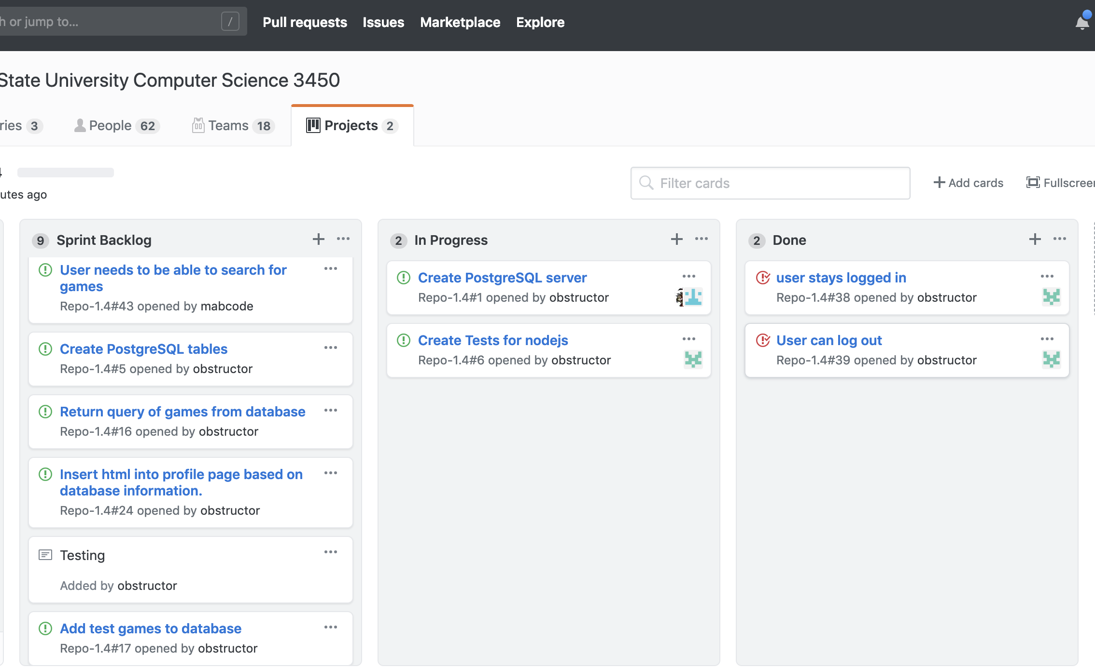

Team name: Project4

Scrum Master: Brandon

Date: 21 March 2019

|  |  |  |  |
| --- | --- | --- | --- |
| **Team Member** | **What did you do since the last scrum?** | **What do you plan to do before the next scrum?** | **What obstacles do you have?** |
| Jeffrey | Make it so user can login and logout | Populate profile page | The database does not exist yet. |
| Marc | Documentation | Meet with Brandon and Create tables | Strep throat |
| Jazlyn | Front end prototyping in html and css | Make sample games show up with EJS | Slightly sick |
| Brandon | Working on DB structure | Meet with Marc and Create tables | People being out sick. Other class exam study |

Burndown:

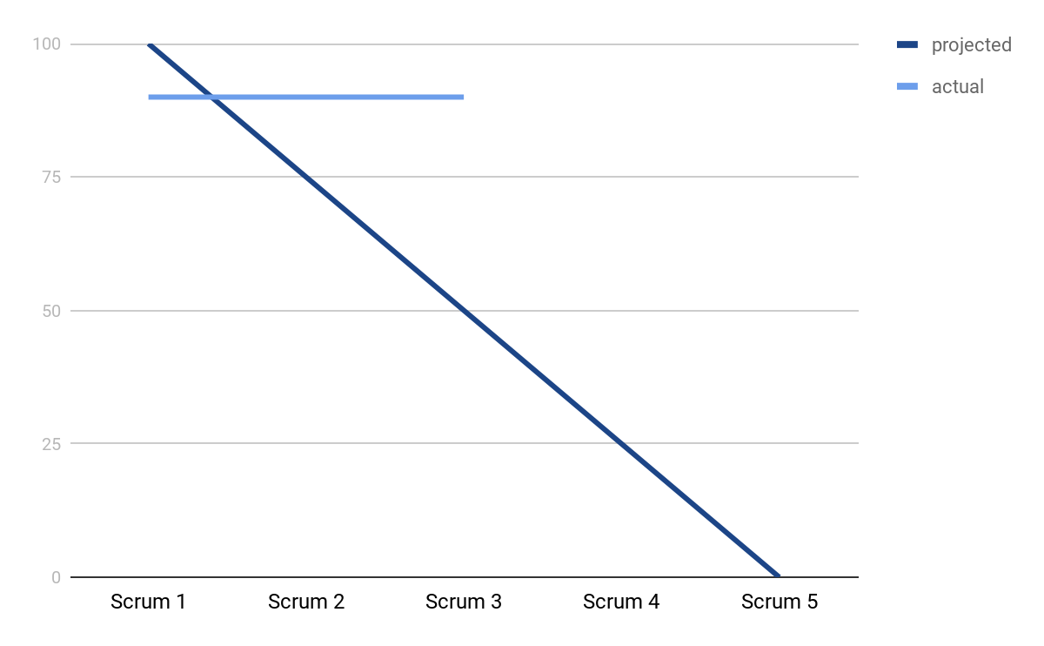

Screenshot of your task board:

