EXTOL AFFILIATES
Growth systems
for B2B companies
PREPARED FOR DAVID SAMUEL · OCTOBER 2026

FOUNDERS
Devasya Dwivedi · Anshul Mikita Prajapati
We make experts the name buyers think of first.
01 · WHAT HAPPENED NEXT
We built it on ourselves first
Then the clients came to us.
01 | Built our own AI agents  Ran them on Extol’s own LinkedIn.
02 | Clients started coming in  When our page reached about 50 followers.
03 | Three clients, three markets  3D Images AI · Bloggerly · a consultancy (NDA).
04 | Now: the right introductions  That’s where David comes in.
02 · THE WORK SO FAR
Three clients, one method
Different markets. Same system underneath.
3D IMAGES AI  Outreach to 2,100+ Amazon brand owners |  | BLOGGERLY  LinkedIn campaign. Leads now asking for calls |  | CONSULTANCY · NDA  Full growth plan, the day after the first call
03 · WHAT WE FOUND
Real stories get 6× more attention
From a real client audit, October 2026.
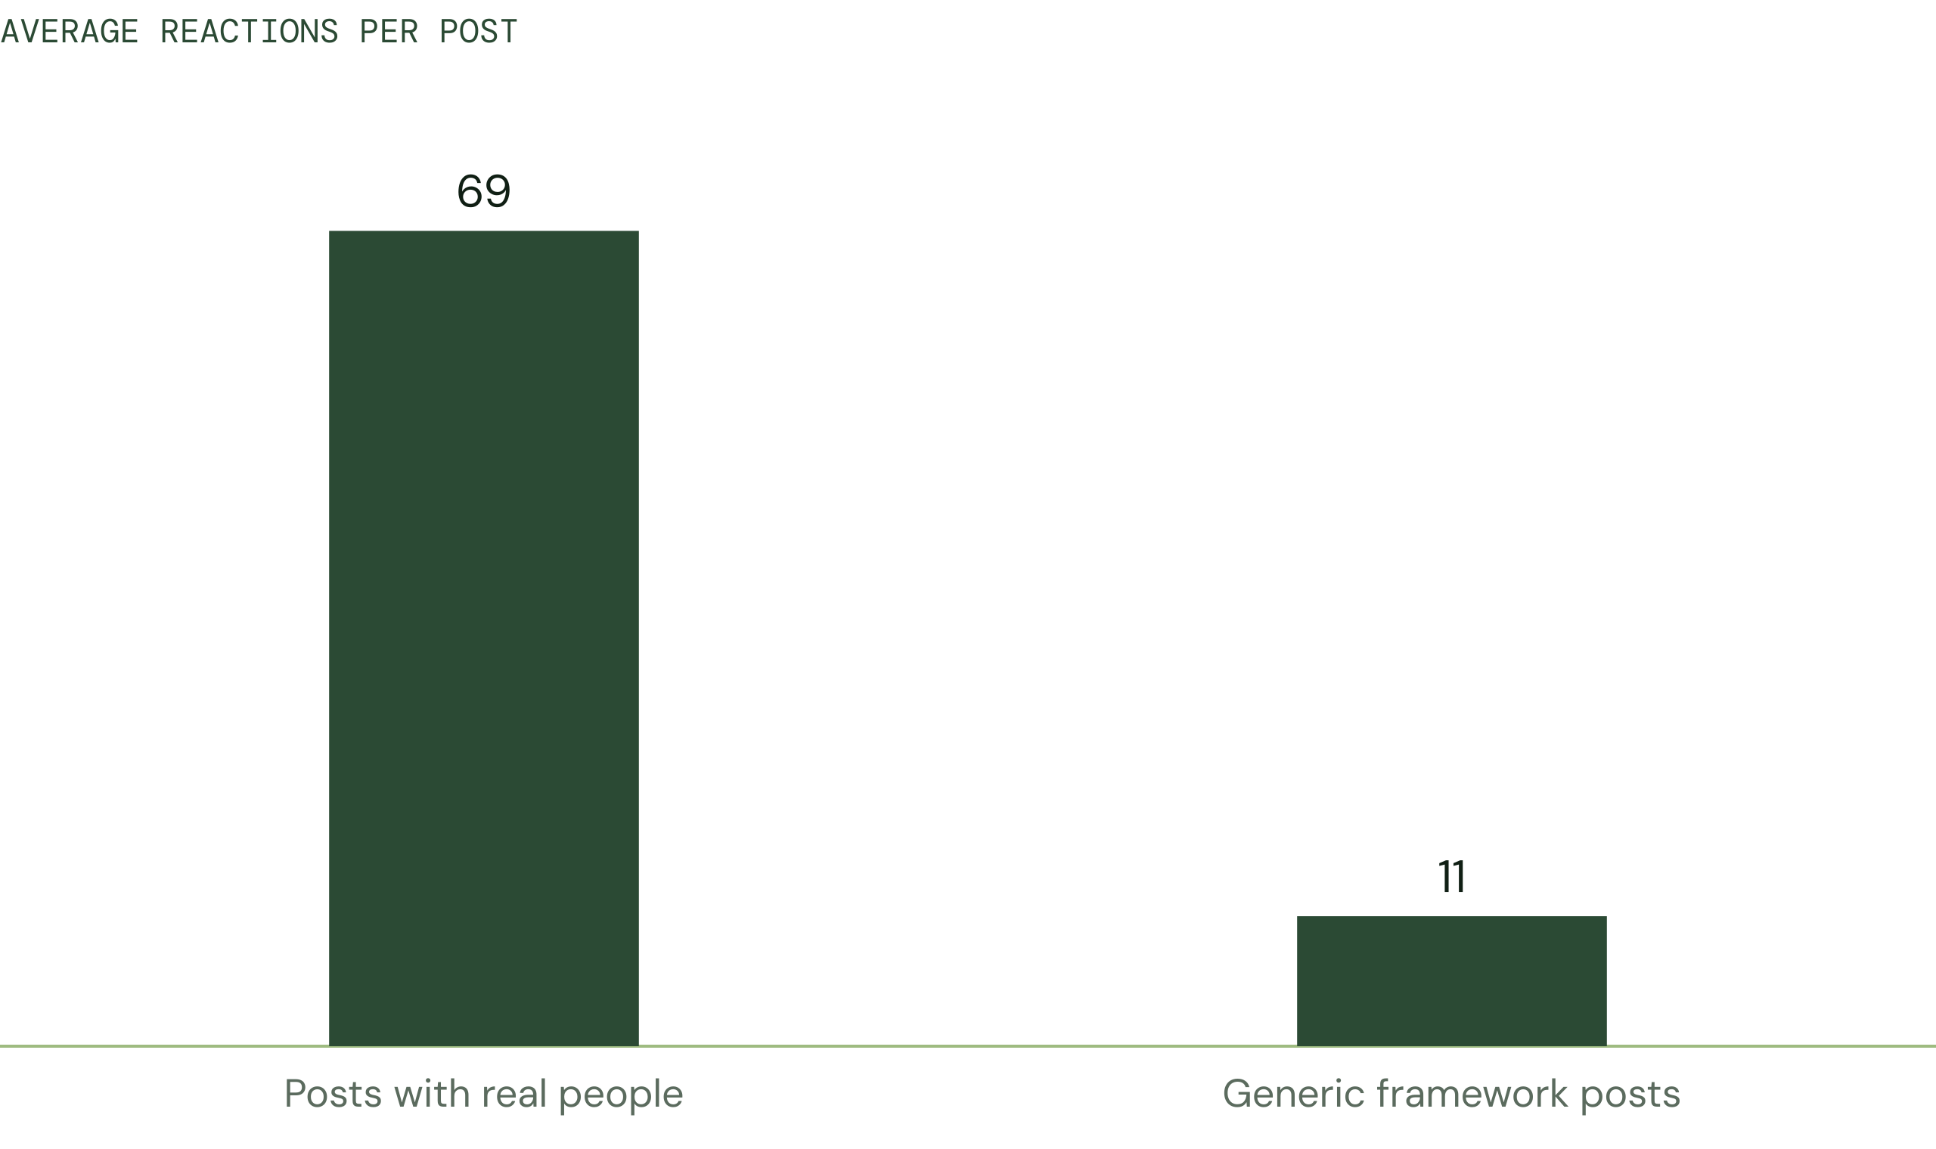

76% of their comments just said “congrats”. The expertise is there. It isn’t reaching buyers.
04 · OUR APPROACH
Make the client a thoughtful leader
Six systems. We run all of them.
01  LinkedIn, run by agents |  | 02  One idea, every platform |  | 03  Taste system

04  Webinars and clips |  | 05  Skool community |  | 06  Website and tracking
05 · SYSTEM ONE
LinkedIn, run by agents
The agents do the work. The client approves.
01 | Profile  Rewritten around one clear idea.
02 | Posts and comments  Every week, in the client’s voice.
03 | Connections  5 a day, rising to 20. Safe pace.
04 | Follow-ups  No warm lead goes cold.
06 · SYSTEMS TWO AND THREE
One note, six platforms
Each platform gets its own version.
LinkedIn | X | Instagram | Threads | Substack | YouTube

Taste: 200+ proven references
MATCH  One reference per piece |  | APPLY  Borrow the craft |  | NEVER COPY  The voice stays theirs
07 · SYSTEMS FOUR TO SIX
Followers become clients
Live sessions and community build trust.
WEBINAR  Monthly. Solve real problems live |  | CLIPS  One hour becomes a month of posts |  | SKOOL  Waitlist, cohorts, membership

Every attendee is followed up within 48 hours.
08 · HOW IT WORKS
2½ hours a week from the client
Note → drafts → approve → publish.
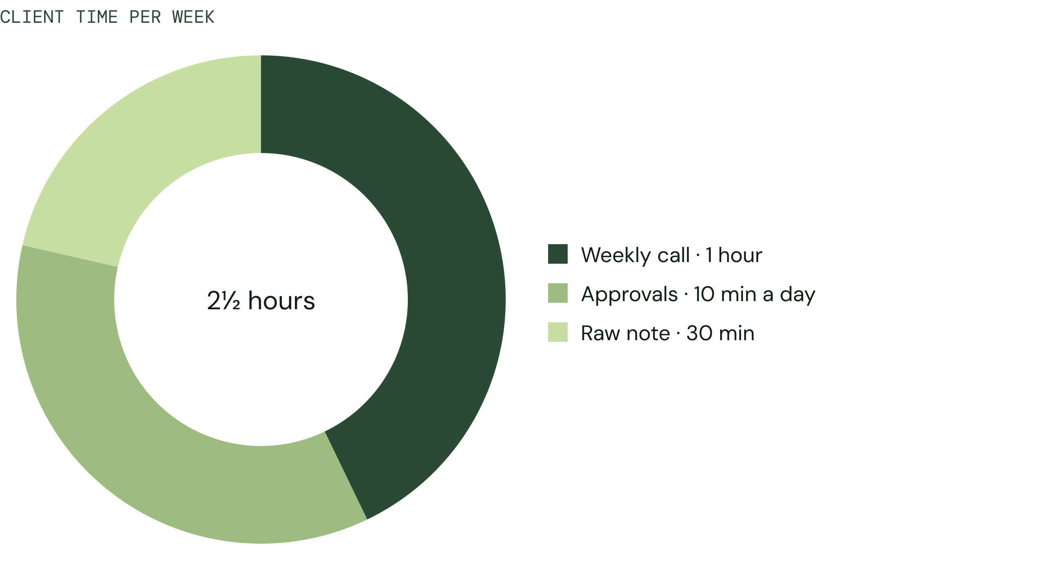

Nothing goes out without the client’s yes.
09 · WHAT COMES NEXT
Where David fits
Three ways to help us grow.
ADVISE  Sharpen our offer and pitch |  | GUIDE  Pick the one market to own |  | CONNECT  Introduce us to the right people

You know the people. We build the system.

