EXTRACTMET PRIVATE LIMITED
Incubated at IIT Madras Research Park · in association with the Centre for Pyrometallurgy, IIT Madras

Ore Beneficiation Digital Twin
Version 5
Plant 3-D model · hybrid mechanistic and data-driven layer · measurable acceptance criteria
Gravity and magnetic iron-ore beneficiation — lump ore, sinter fines and pellet-plant feed
DEPLOYMENT AND TECHNICAL GUIDE
Python backend · CSS / JavaScript / Three.js operator desk · GitHub and Render · on-premise
Document reference: EXM/OBDT-V5/GUIDE · Model version OBDT-2026.10.5 · Issue 1
Commercial in confidence. All reference plants anonymised as Industry-X.

Contents
1 What this package is, and what version 5 adds 3
2 Architecture 5
3 Repository layout 7
4 Installing and running it locally 8
5 Deploying to GitHub and Render 10
6 Running it on the plant’s own infrastructure 12
7 Connecting to the plant historian and DCS 14
8 The plant 3-D model layer 15
9 The hybrid mechanistic and data-driven layer 18
10 Validation, acceptance and the test report 20
11 Configuration reference 23
12 Operating the system 24
13 Security 25
14 Troubleshooting 26
Annexure A API endpoint reference 27
Annexure B Acceptance criteria as shipped 28
Annexure C Test inventory 30

1 What this package is, and what version 5 adds
This package is a complete, deployable digital twin of a gravity and magnetic iron-ore beneficiation plant: run-of-mine crushing and screening, rotary scrubbing, lump and fines jigging, screw classification, hydrocyclones, spiral concentrators, shaking tables and wet high-intensity magnetic separation, producing lump ore, sinter fines and pellet-plant feed from a single ROM stream.
It consists of a Python backend carrying the process models, the control and machine-learning layers and the acceptance framework, and a browser operator desk written in plain CSS, JavaScript and Three.js. The two live in one repository in separate folders and deploy as two independent services.

1.1 What version 5 adds
Version 5 adds three layers to the version 4 twin, in answer to three questions put by a client. Everything from version 4 is unchanged and all of it still works.
Question | What version 5 does about it
“Digital twin in a plant 3-D model — is this possible?” | Yes. A tagged, levelled, clash-checked 3-D model of the plant whose appearance is driven by the live twin rather than by a drawing: 33 tagged assets, 30 material routes, five elevations, seven overlays. The geometry is supplied by the backend as a scene graph, so the site’s own CAD or laser-scan model can replace it without touching the front end. See chapter 8.
“The twin shall be both mechanistic and data driven.” | It is, and the composition is explicit rather than a slogan. Six named compositions are implemented and compared; the one in service is a gated residual, in which the learned correction is bounded in magnitude and tapered to zero as the operating point leaves the data it was trained on. See chapter 9.
“Define measurable acceptance criteria, validation methodology, accuracy requirements, operating conditions, scenarios, comparison against plant data, performance indicators and the acceptance procedure.” | A full verification-and-validation layer: 14 KPI criteria and 12 system criteria, a validated operating envelope, 17 test scenarios, a statistics engine, a six-gate acceptance procedure and a generated acceptance test report. See chapter 10.

1.2 What the package contains
Item | Count
Unit models solved in the circuit | 18
Streams carried, including every recycle | 30
Particle state | 36 size classes (250 mm to 1.35 µm) × 15 liberation classes
Constraints evaluated | 33 across 5 priority tiers
Manipulated variables available to the controller | 24
Tagged assets in the 3-D plant model | 33, with 30 material routes across 5 levels
Acceptance criteria | 14 KPI criteria, 12 system criteria, 17 scenarios
API endpoints | 84
Operator desk pages | 16
Automated tests | 182 backend, 21 operator desk
Tip: This package does not replace anything. The copper concentrator twin, the BHQ iron-ore twin and the version 4 gravity twin remain exactly as delivered and are unaffected by installing this one.

2 Architecture
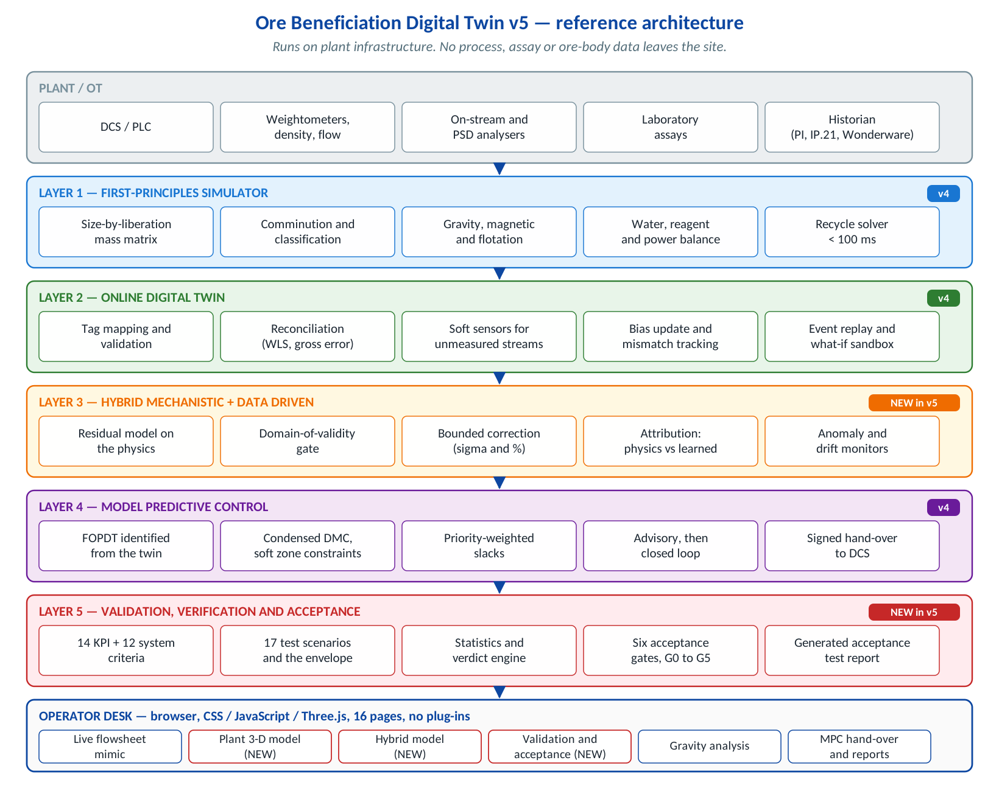
Figure 1 The five layers and the operator desk. Layers 3 and 5 are new in version 5.

2.1 Reading the diagram
Each layer is useful on its own and each depends only on the one below it. A plant may take layers 1 and 2 and stop there; a plant may run all five. Nothing above layer 2 writes to the control system until phase 3, and then only to the specific set-point tags named in a signed interface specification.
Layer | What it does | Package
1 · First-principles simulator | Solves the whole circuit, including recycles, from a size-by-liberation particle state. Because liberation fixes composition it also fixes density and magnetic susceptibility, which is what every gravity and magnetic separator actually acts on. | app/twin/
2 · Online digital twin | Runs the simulator against live historian data, reconciles the measurements, estimates what is not measured and tracks model-plant mismatch. | app/services/, app/adapters/
3 · Hybrid layer | Learns the residual between the physics and the plant, bounds it, and gates it on a measured distance from the training data. | app/hybrid/
4 · Model predictive control | Identifies step-response models from the twin, solves a condensed dynamic matrix problem with soft zone constraints, and hands signed set-points to the DCS. | app/control/
5 · Validation and acceptance | Grades the twin against measurable criteria over declared operating conditions and scenarios, and produces the acceptance test report. | app/validation/
Plant 3-D model | Serves the plant geometry as a scene graph and binds live twin state onto it. | app/plant3d/

3 Repository layout
ore-beneficiation-digital-twin-v5/
├─ render.yaml Render blueprint — deploys BOTH services from this one repo
├─ Makefile local convenience targets
├─ README.md
├─ .github/workflows/ci.yml tests + the acceptance suite on every push
│
├─ backend/ Python 3.11+ / FastAPI → Render web service
│ ├─ app/
│ │ ├─ twin/ unit models, circuit solver, constraints, objectives
│ │ ├─ control/ identification, MPC, advisory
│ │ ├─ ml/ datasets, models, registry, anomaly detection
│ │ ├─ hybrid/ composition, domain of validity, builder [NEW]
│ │ ├─ plant3d/ asset model, geometry, bindings, CAD import [NEW]
│ │ ├─ validation/ criteria, metrics, scenarios, protocol, [NEW]
│ │ │ runner, report
│ │ ├─ services/ one service per API group
│ │ ├─ api/v1/endpoints/ the HTTP surface
│ │ ├─ adapters/ historian integrations (OPC-UA, PI, MQTT, …)
│ │ ├─ models/ pydantic domain and API models
│ │ └─ core/ settings, logging, exception handlers
│ ├─ tests/ 182 tests
│ ├─ requirements.txt Dockerfile render.yaml .env.example start.sh
│
└─ frontend/ CSS + JavaScript + Three.js → Render static site
├─ index.html config.js
├─ css/ theme, layout, components
├─ js/
│ ├─ pages/ one module per desk page (16)
│ │ plant3d.js, hybrid.js, validation.js [NEW]
│ ├─ viz/ flowsheet.js, scene3d.js, plantmodel.js [NEW]
│ ├─ charts/plots.js 50 chart builders
│ ├─ api/ client, endpoint registry, schemas, mock layer
│ └─ ui/ DOM helpers and components
├─ data/mock/ captured payloads for offline demonstration
├─ vendor/ three.js, OrbitControls, plotly (vendored, no CDN)
├─ scripts/ serve, write-config, capture-mock
└─ tests/ 21 tests (jsdom)

Tip: The front end vendors its libraries rather than loading them from a content delivery network. A plant network that blocks outbound traffic is the normal case, not the exception.

4 Installing and running it locally

4.1 Prerequisites
- Python 3.11 or 3.12. Python 3.13 works; 3.10 and earlier do not.
- Node.js 20 or later — needed to serve the desk and to run its tests, not to build it.
- About 600 MB of disk for the virtual environment, and 2 GB of RAM.
- No database, no message broker and no external service. The twin solves in process.

4.2 Backend
cd backend
python -m venv .venv
source .venv/bin/activate # Windows: .venv\Scripts\activate
pip install -r requirements.txt
cp .env.example .env # edit if you are not using the demo historian
uvicorn app.main:app --reload --port 8000

Check it: http://localhost:8000/health returns a JSON banner with the model version, and http://localhost:8000/docs is the interactive API documentation.

4.3 Operator desk
cd frontend
npm install # jsdom, for the tests only
node scripts/serve.mjs # http://localhost:8080

The desk reads config.js, which is committed pointing at http://localhost:8000. Nothing else needs configuring for local use.

4.4 Tests
cd backend && python -m pytest -q # 182 passed
cd frontend && node --test tests/app.test.mjs # 21 passed

# or, from the repository root
make test

Important: Run both suites before every deployment. The backend suite includes the full acceptance suite against all three reference plants, so a change that breaks a validation criterion fails here rather than at a factory acceptance test.

4.5 First five minutes on the desk
- Open Home and confirm the three products and their grades.
- Open Plant 3-D model, switch the overlay to *Equipment duty*, and click the scrubber. The datasheet, live duty and connected streams appear in the side panel.
- Open Hybrid model → Behaviour off-domain and watch the gated hybrid converge onto the mechanistic prediction as the operating point walks out of the training data.
- Open Validation & acceptance → Run & verdict and let the suite run. It takes thirty to ninety seconds and ends with a verdict for every criterion.
- Open Validation & acceptance → Report, generate the acceptance test report and download it.

5 Deploying to GitHub and Render
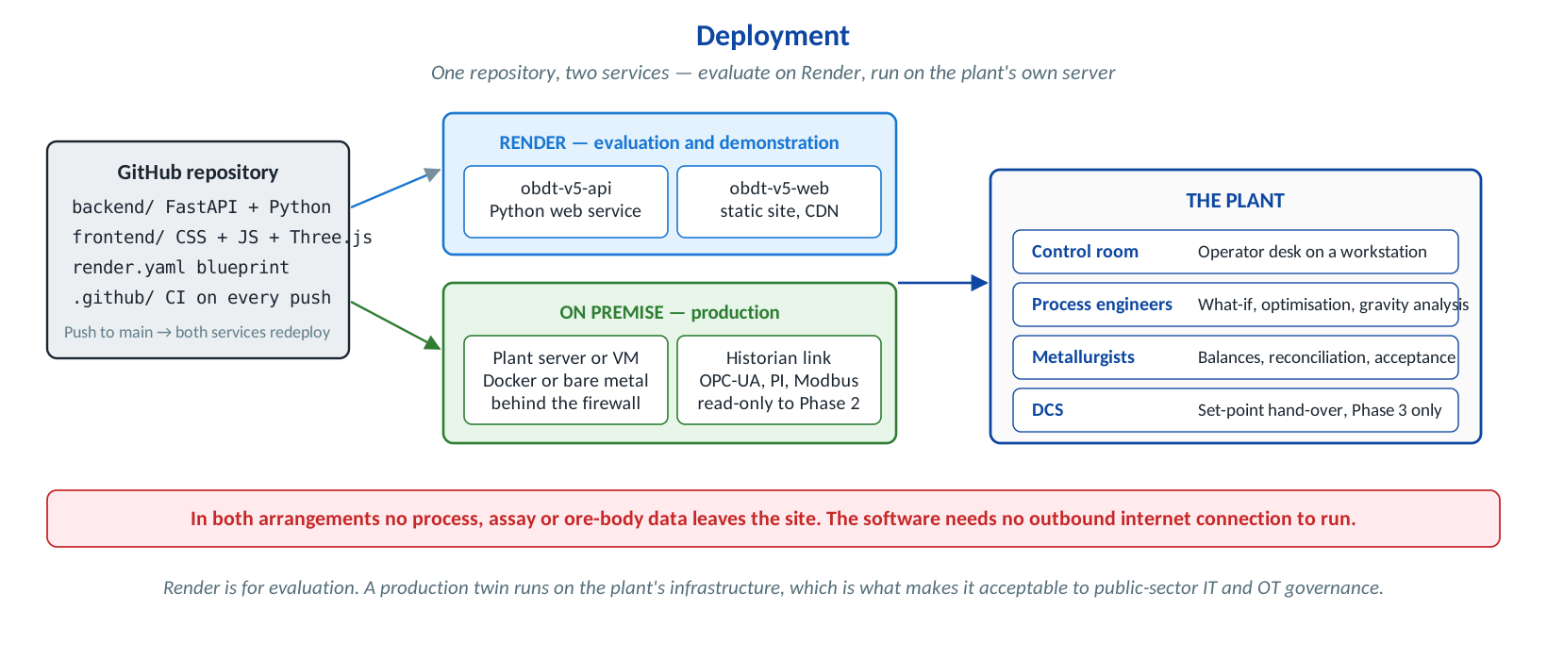
Figure 2 One repository, two services, two destinations.

5.1 Push the repository
cd ore-beneficiation-digital-twin-v5
git init
git add .
git commit -m "Ore beneficiation digital twin v5"
git branch -M main
git remote add origin git@github.com:<org>/<repo>.git
git push -u origin main

.gitignore already excludes virtual environments, node_modules, caches and .env files. Check that no real .env has been committed before the first push: git ls-files | grep -i env should show only the two .env.example files.

5.2 Create both services from the blueprint
In the Render dashboard choose New + → Blueprint, connect the repository and apply. Render reads render.yaml at the repository root and creates two services. The rootDir key is what lets one repository hold both: each build runs inside its own folder.
Service | Type | Root | Start command | Free plan?
obdt-v5-api | Python web service | backend | uvicorn app.main:app --host 0.0.0.0 --port $PORT | Works. A cold start takes about a minute and the optimiser and validation suite are slow on fractional CPU.
obdt-v5-web | Static site | frontend | node scripts/write-config.mjs at build time | Yes. Global CDN, no cold start.

5.3 Close the loop between the two services
Neither URL exists until the first deploy, so two environment variables are deliberately left unset in the blueprint. Set them in the Render dashboard after the first apply, then redeploy both.
Service | Variable | Set it to
obdt-v5-api | ALLOWED_ORIGINS | the desk URL, for example https://obdt-v5-web.onrender.com
obdt-v5-web | BACKEND_BASE_URL | the API URL, for example https://obdt-v5-api.onrender.com
Confirm it worked: open the desk, go to Admin → Backend, and check that it reports the live API, the model version OBDT-2026.10.5 and a round-trip time. If it reports mock mode, BACKEND_BASE_URL is wrong or the API is still waking up.

5.4 Continuous integration
.github/workflows/ci.yml runs on every push and pull request:
- the backend suite, 182 tests, with the JUnit report uploaded as an artefact;
- a syntax check over every front-end module, then the desk suite, 21 tests;
- the acceptance suite against all three reference plants, which fails the build if any gating criterion is blocked;
- on main, generation of the acceptance test reports, uploaded as build artefacts.
Important: Render deploys from main. Protect that branch and require the CI check to pass, otherwise a failing acceptance criterion can reach a demonstration.

5.5 Cold starts on the free plan
Render idles a free service after fifteen minutes. The first request afterwards waits for the process to start, and the hybrid and validation endpoints then train models and run the suite on top of that. Three things make this tolerable for a demonstration:
- MOCK_MODE=auto on the desk, so it falls back to captured payloads rather than showing an error while the API wakes.
- LONG_TIMEOUT_S=300 for the slow endpoints.
- A scheduled ping every ten minutes during a demonstration window, or the starter plan, which does not idle.

6 Running it on the plant’s own infrastructure
Render is for evaluation and demonstration. A production twin runs on the plant’s own server behind the site firewall, which is what makes it acceptable to public-sector IT and OT governance.

6.1 Sizing
Use | CPU | RAM | Disk | Notes
Single plant, offline studies | 2 vCPU | 4 GB | 20 GB | A full circuit solve takes under 100 ms.
Single plant, online twin | 4 vCPU | 8 GB | 40 GB | Add space for the historian cache and model store.
Online twin with MPC and ML | 8 vCPU | 16 GB | 80 GB | Identification and re-training are the peaks.
Several plants on one server | 8–16 vCPU | 32 GB | 200 GB | One process per plant; the services are stateless.

6.2 Containers
# backend
cd backend
docker build -t obdt-api:5.0 .
docker run -d --name obdt-api -p 8000:8000 --env-file .env --restart unless-stopped obdt-api:5.0

# operator desk (nginx, config.js written at build time)
cd ../frontend
docker build -t obdt-web:5.0 --build-arg BACKEND_BASE_URL=http://obdt-api:8000 .
docker run -d --name obdt-web -p 8080:80 --restart unless-stopped obdt-web:5.0

6.3 Without Docker
The backend is an ordinary ASGI application. Run it under systemd with start.sh, behind nginx or IIS for TLS termination. The desk is static files; any web server will serve them.
# /etc/systemd/system/obdt-api.service
[Unit]
Description=Ore Beneficiation Digital Twin API
After=network.target

[Service]
User=obdt
WorkingDirectory=/opt/obdt/backend
EnvironmentFile=/opt/obdt/backend/.env
ExecStart=/opt/obdt/backend/.venv/bin/uvicorn app.main:app --host 0.0.0.0 --port 8000
Restart=always
RestartSec=5

[Install]
WantedBy=multi-user.target

7 Connecting to the plant historian and DCS

7.1 Historian
Set HISTORIAN_TYPE and the credentials for the chosen adapter. The adapters live in app/adapters/industrial.py and all present the same interface to the twin, so changing historian does not change anything above the adapter.
HISTORIAN_TYPE | System | Variables to set
mock | Built-in 168 h replay with seeded events. The default. | none
opcua | Any OPC-UA server | OPCUA_ENDPOINT, OPCUA_USERNAME, OPCUA_PASSWORD, OPCUA_NAMESPACE
pi | AVEVA PI via PI Web API | PI_WEB_API_URL, PI_DATA_SERVER, PI_USERNAME, PI_PASSWORD
mqtt | MQTT broker | MQTT_BROKER_URL, MQTT_TOPIC_PREFIX
kafka | Kafka topic | KAFKA_BOOTSTRAP_SERVERS, KAFKA_TOPIC
sql | Any SQL historian | SQL_DATABASE_URL, SQL_TABLE
rest | A site REST API | REST_HISTORIAN_URL, REST_HISTORIAN_TOKEN
csv | Exported files, for a first calibration | CSV_HISTORIAN_PATH
The optional client libraries are listed but commented out in requirements.txt. Install only the one the site uses — a PI site has no reason to carry a Kafka driver.

7.2 Tag mapping
The twin ships with 45 demonstration tags in app/services/plant_service.py. Replace them with the site’s own tag list at Gate 0; each entry carries the tag, its engineering unit, its type (PV, CV, MV or SP) and the twin variable it maps to. Nothing else needs changing.

7.3 Writing to the DCS
Important: Layers 1 to 3 are strictly read-only. Write access is introduced only in phase 3, only to the set-point tags named in the signed interface specification, and only through an explicit checksummed hand-over that the operator authorises. Rate limits, move limits and a watchdog are enforced on the controller side as well as in the DCS.
The hand-over payload is produced by POST /api/v1/mpc/handover and carries, for each set-point: the tag, the current value, the proposed value, the move limit, the ramp rate, a validity window and a sixteen-character checksum over the whole payload. A payload whose checksum does not verify is rejected by the controller and logged.

8 The plant 3-D model layer
A 3-D model of a plant is a picture. A 3-D digital twin is a picture whose colour, fill, rotation and labelling are driven by the current state of the process. This layer does the second one.

8.1 How it is put together
Module | What it holds
app/plant3d/model.py | The asset register: 33 assets, each with its plant tag, position on the plant grid, principal dimensions, geometry archetype, level, criticality, datasheet, connected streams and the twin bindings that drive its appearance. Also the areas, elevations, camera bookmarks and overlays.
app/plant3d/geometry.py | Derives the scene graph, the material routes between assets, axis-aligned bounding boxes, the clash check and a glTF 2.0-shaped node manifest for CAD round-tripping.
app/plant3d/bindings.py | Resolves each binding against a solved twin result and produces the state frame: per-asset status, duty, throughput, power, grade and overlay value, and per-route flow.
app/plant3d/importers.py | Brings in the site’s own geometry: supported formats, tag matching and coordinate registration.
frontend/js/viz/plantmodel.js | Builds Three.js meshes from the scene graph. Knows nothing about this plant.

8.2 Coordinate convention
Right-handed, metres: +x east along the main process axis with the ROM tip at the west end and the products at the east, +y up from the plant datum with 0.000 m at finished grade, +z north across the process axis. The shipped model spans 285 m east–west by 127 m north–south by 21.5 m high.

8.3 Model and state are separate calls
GET /plant3d/model is large and changes only when the plant is modified. GET /plant3d/state is small and changes every cycle. The viewer fetches the model once and the state on a timer. Do not merge them.

8.4 Overlays
Overlay | What is painted onto the geometry
Constraint status | Halo colour per asset: green normal, amber caution, red alarm.
Equipment duty | Percentage of the limit, from whichever field that unit reports — power utilisation, loading fraction, area utilisation, rake torque.
Motor power | kW from the power balance. Shared entries such as the pump total are excluded rather than divided arbitrarily between machines.
Solids throughput | t/h through the asset.
Stream Fe grade | Grade of the asset’s principal product stream.
Slurry density | Per cent solids.

8.5 Replacing the model with the site’s own geometry
The shipped model is schematic: positions and dimensions good enough to navigate, reason about and bind data to, built from the flowsheet and the equipment list. Most sites that want a 3-D twin already have something better, and the right answer is to use theirs.
Format | Support | In practice
glTF 2.0 / GLB | Native | The preferred delivery format. Renders directly with no conversion.
IFC 2x3 / IFC 4 | Metadata plus converted mesh | Property sets usually hold the plant tag, which makes matching reliable.
AVEVA RVM / ATTRIB (PDMS, E3D) | Converted | Common on Indian EPC projects. Attributes are the best tag source we see.
STEP / IGES | Converted | Accurate, heavy, usually untagged. Expect manual mapping by assembly path.
E57 / LAS point cloud | Reference layer | What the plant actually looks like today. Not clickable equipment unless segmented.
OBJ / FBX | Converted | Object names are often meaningless after an export chain.
DWG / DXF | Reference only | General arrangements, used to place the schematic model when no 3-D model exists.

What the site must supply
- The model or scan, with the plant grid origin stated.
- Units and up-axis declared. CAD is usually metres with +Z up; the twin uses metres with +Y up and converts on import.
- At least three control points whose coordinates are known in both the model and the plant survey grid.
- A tag list for the equipment that is to be live, ideally with the tag written into the node name or an IFC property set.
- Confirmation of which revision is as-built. An EPC design model and the plant as it stands are rarely the same thing.

Matching and registration
POST /plant3d/import/match takes the node names out of the model and returns a three-way split — matched, ambiguous, unmatched — with a coverage percentage. Nothing is bound on a guess: an ambiguous or unmatched node stays as inert geometry for an engineer to resolve. Below about eighty per cent coverage the imported model is treated as a backdrop rather than as the twin surface.
POST /plant3d/import/register solves the similarity transform from the control points by the closed-form Umeyama method and reports the residual. A maximum residual above about one metre usually means a mis-picked control point or a model on a different grid, not a bad solve.
Important: A 3-D model is not by itself a digital twin. A scan is a snapshot and does not update itself when the plant changes; a point cloud is not equipment; and an untagged model with no live bindings is a viewer, which should be bought as one. These limits are stated in the product documentation as well as here.

9 The hybrid mechanistic and data-driven layer
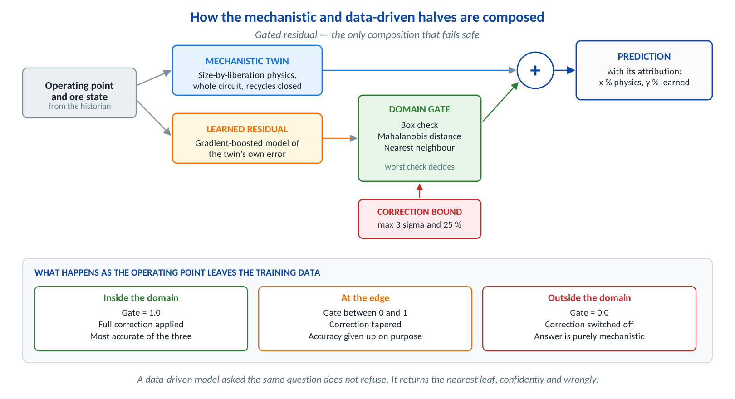
Figure 3 Gated residual composition and its behaviour off-domain.

9.1 Why a composition rather than a blend
“Mechanistic and data driven” is a specific architectural choice with specific trade-offs, and there are several ways to make it. All of them are implemented so the choice can be argued rather than asserted.
Composition | Strength | Weakness
Mechanistic only | Extrapolates. Every answer is a consistent solution of the physics. | Carries the site-specific bias the physics does not model.
Data driven only | Most accurate inside the range it was trained on. | No extrapolation, no mass balance, and no answer at all for an untried set-point.
Parallel residual | Keeps the physics response shape and removes systematic bias. | The correction is unbounded and ungated, so it misbehaves off-domain.
Serial parameter estimation | Every prediction remains a physically consistent solution. | Needs a full twin solve per evaluation, so it is the slowest.
Gated residual — in service | Degrades to the mechanistic model instead of guessing, and that is demonstrable in an acceptance test. | Gives up a little accuracy at the edge of the envelope, on purpose.
Fixed-weight ensemble | Trivial to explain. | The weight is right in one operating region and wrong everywhere else.

9.2 The gate
Three independent checks are combined into one confidence between zero and one, and the worst check decides, because a point is only as trustworthy as its weakest evidence:
- Box check — is each feature inside the range the model was trained on?
- Mahalanobis distance — is the *combination* plausible? A feed rate and a cut density can each be ordinary while the pair has never been run together.
- Local density — how far is the nearest training point? This catches holes inside the convex hull, which the first two checks miss entirely.
Below a confidence of 0.80 the correction begins to taper; at 1.60 it is switched off. The correction is also bounded in magnitude at three residual standard deviations or twenty-five per cent of the mechanistic value, whichever is smaller.

9.3 The guarantee, and how it is proven
Tip: In gated mode the hybrid prediction converges on the mechanistic prediction exactly as the operating point leaves the learned domain, and the correction can never exceed the configured bound. Both properties are demonstrated by the extrapolation walk in the acceptance suite, and both are enforced by unit tests, not by documentation.
GET /hybrid/extrapolation walks the operating point steadily out of the training envelope and reports, at each step, the domain verdict, the gate value, and the prediction from each composition. At the far end the gated hybrid equals the mechanistic prediction to machine precision, while the data-only model has collapsed to a tree leaf and is more than a percentage point of alumina away from anything defensible.

9.4 Attribution
Every hybrid prediction carries its decomposition: how much of the number came from the physics and how much from the learner, the gate value, whether the correction was clamped, and why. An operator who cannot see that will not act on the number, and should not.

9.5 Training data and re-training
During development the residual model is trained against a documented unmodelled effect — clay re-attachment in the downstream launders, which is below the twin’s level of detail and genuinely site-specific — so that the demonstration has something real to find. On a live plant that is replaced by the reconciled historian: the residual model is trained on the difference between what the twin said and what the plant actually did.
Re-training is triggered by evidence rather than by a calendar. Population-stability indices are computed on both the feed characteristics and the model residuals; when either shifts materially the drift monitor raises it and the model is re-fitted. Any re-calibration during a performance trial is recorded, and the trial restarts if the model is changed.

10 Validation, acceptance and the test report
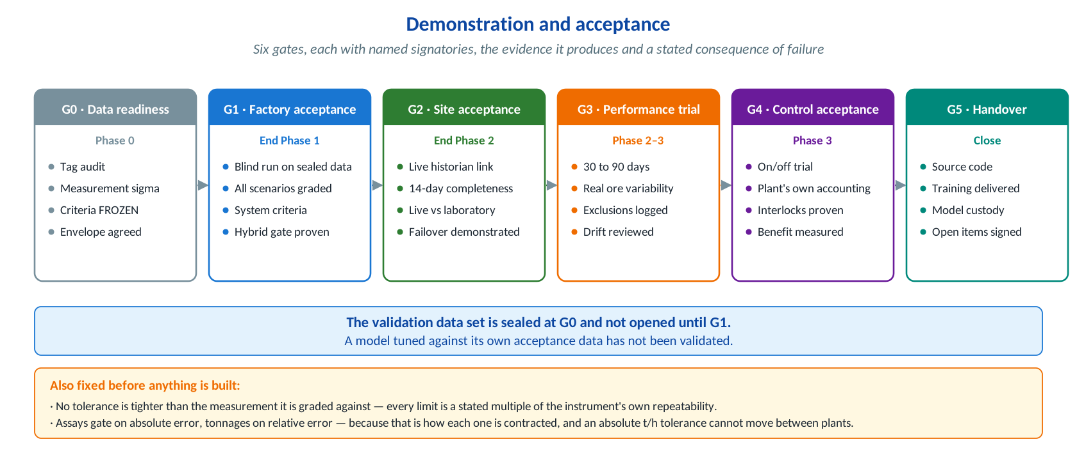
Figure 4 The six gates and the two rules fixed before anything is built.

10.1 The three rules that are enforced in code
- No tolerance is tighter than the measurement it is graded against. Every limit is a stated multiple of the reference instrument’s own repeatability, and there is a unit test that fails the build if anyone writes one that is not.
- Assays gate on absolute error; tonnages gate on relative error. That is how each is contracted. Applying both to both silently makes the tighter one the real criterion, and which one that is changes from plant to plant.
- A measure that cannot discriminate is reported, not used. A correlation statistic computed on a variable whose whole range over the test period sits inside its own measurement noise is grading the noise. It is computed, shown, and explicitly excluded from the verdict with the reason recorded in the report.

10.2 What is graded
Kind of test | What it establishes | How it is graded
Accuracy | The model agrees with the plant over the declared operating conditions. | Against the numerical criteria: bias, MAE, RMSE, MAPE, R², Theil’s U2, interval coverage.
Behaviour | The model moves the right lever the right way. | On the sign and, where stated, the magnitude of the response to a step, against the plant’s own step tests.
Fault | The twin finds a developing fault before the production figures do, and attributes it correctly. | Detection lead time and correct attribution on a known historical event.
Fail-safe | The twin declines to answer rather than answering badly. | Envelope flag raised, offending variables named, hybrid gate at zero.
Excluded | Start-up, shut-down and trips are out of scope. | The exclusion itself is accepted, and those periods are flagged and removed from every statistic.
A model can hit every numerical tolerance and still be wrong in a way a metallurgist would spot in a second — a cut density that moves the wrong way, a recovery that rises when it should fall. That is why behaviour is graded separately, and why those checks are machine-checkable rather than a matter of opinion.

10.3 Running the suite
# everything, with a verdict for every criterion
curl "localhost:8000/api/v1/validation/run?plant_id=IX-OB-01&section=all&tests_pass=true"

# one section at a time: accuracy | behaviour | fail_safe | system
curl "localhost:8000/api/v1/validation/run?plant_id=IX-OB-01&section=behaviour"

# the signable report
curl "localhost:8000/api/v1/validation/report.md?plant_id=IX-OB-01&gate=G1" -o ATR.md

# or from the repository root
make accept

On the desk the same thing is Validation & acceptance → Run & verdict, and the report is generated and downloaded from the Report tab.

10.4 Reading a verdict
Verdict | Meaning
pass | Every gating measure is inside its limit.
marginal | Inside the limit, but with less than ten per cent of the available headroom left. Worth a note, not a failure.
fail | At least one gating measure is outside its limit. Class A failures block acceptance and cannot be conceded.
insufficient_data | Fewer paired samples than the criterion’s stated minimum. No verdict is given rather than a weak one. This is the correct result for, say, a high-clay criterion on a plant that runs low-clay ore.
not_discriminating | The measure was computed but cannot discriminate on this series, with the reason recorded.
not_applicable | The measure is wrong for this criterion’s averaging window — a persistence benchmark at hourly resolution against a criterion judged on a shift composite, for instance.
reported | Computed and shown, but outside this criterion’s gating set.
evidence_required | A system criterion that can only be measured on the live installation — availability, data completeness, latency. Supplied at the site acceptance test rather than assumed.

10.5 The report
GET /validation/report.md renders the whole run as Markdown, which converts cleanly to Word or PDF: a verdict summary, the accuracy table with every statistic, the suppressed measures with their reasons, every step test with its before-and-after values, the fail-safe checks, the system criteria, the full criteria table, the scenario catalogue, the gate procedure and a signature block. It runs to roughly fifteen pages and can be reproduced exactly by re-running the endpoint on the same model version and data window.

11 Configuration reference
All configuration is by environment variable, read through pydantic-settings. Nothing sensitive is hard-coded. backend/.env.example is the full list; the table below is what actually matters.
Variable | Default | What it does
APP_ENV | development | development | staging | production
LOG_LEVEL | INFO | Set DEBUG only while diagnosing; it is verbose.
MODEL_VERSION | OBDT-2026.10.5 | Stamped on every response and on the acceptance report. Change it when the model is re-calibrated.
ALLOWED_ORIGINS | localhost | Comma-separated CORS origins. Use * only for a demonstration.
ALLOWED_ORIGIN_REGEX | https://.*\.onrender\.com | Additional origins by pattern.
API_KEY | empty | If set, X-API-Key is required on /api/v1. Must match on both services.
HISTORIAN_TYPE | mock | See chapter 7.
DEMO_MODE | true | Set false on a real plant; it disables the seeded demonstration events.
OPTIMIZER_MAX_EVALS | 260 | Lower it on constrained hardware; the optimiser is the heaviest endpoint.
MONTE_CARLO_SAMPLES | 14 | Robustness study sample count.
SIM_CACHE_SIZE | 1500 | Solved-result cache. Raise it on a server with spare memory.
REPLAY_ANCHOR_UTC | 2026-01-05 | Epoch at which the 168 h demonstration replay starts.

11.1 Desk configuration
frontend/config.js is written at build time by scripts/write-config.mjs from BACKEND_BASE_URL, APP_ENV, MOCK_MODE, API_KEY, AUTH_MODE, APP_PASSWORD and LONG_TIMEOUT_S. MOCK_MODE=auto is the useful setting: the desk uses the live API when it answers and falls back to the captured payloads when it does not.
Important: Anything in config.js is visible to anyone who opens the browser developer tools. API_KEY there gates casual access, not a determined one. For a real deployment put the desk behind the plant’s single sign-on.

12 Operating the system

12.1 Health and monitoring
Check | Endpoint or page | What good looks like
Service alive | GET /health | status: ok with the model version. Use this as the load-balancer probe.
Twin solving | POST /api/v1/simulation/run | Returns in well under a second with constraint_penalty at zero on the baseline.
Mass balance | GET /api/v1/diagnostics/balance | Solids and iron closure above 99.5 %.
Instrument health | Desk → Data quality | No tag in fault; coverage above 95 %.
Model-plant mismatch | Desk → Diagnostics → Residuals | No tag with a mean residual above 8 %.
Drift | Desk → Machine learning → Drift | Population stability index stable; shifted is a prompt to re-calibrate.
Acceptance | Desk → Validation & acceptance | Nothing blocking; Class A criteria passing.

12.2 Backup
The services are stateless — everything is derived from the configuration and the historian. Back up backend/.env, the plant register and tag list in app/services/plant_service.py, any calibrated parameter overrides, the trained model store if one has been persisted, and the acceptance reports. That is the whole recovery set.

12.3 Upgrading
- Read the release note and check whether the model version changes. If it does, the acceptance evidence is against the old version.
- Deploy to a staging service first and run both test suites there.
- Run the acceptance suite on staging and compare the verdicts against the last accepted report. Any criterion that moves from pass to fail blocks the upgrade.
- Deploy to production. Keep the previous image or commit available for an immediate rollback.
- Re-capture the desk’s offline payloads so a demonstration does not show stale numbers: node scripts/capture-mock.mjs <api-url>.

12.4 Re-calibration
Re-calibrate when the drift monitors say so, when the ore body moves to a new area, or after a significant plant modification. Re-calibration changes the model, so the acceptance evidence has to be refreshed: run the suite, generate a new report, and record it against the new model version. During a performance trial, a re-calibration restarts the trial.

13 Security
Area | Position
Where data lives | On the plant’s infrastructure. No process, assay, production or ore-body data leaves the site, and the software needs no outbound internet connection to run. This is a design decision, not an option.
Control-system access | Read-only through layers 1 to 3. Write access only in phase 3, only to the named set-point tags, only through a checksummed hand-over the operator authorises, under move limits and a watchdog enforced on both sides.
Transport | TLS everywhere. On Render it is automatic; on premise terminate at nginx or IIS with the site’s own certificate.
Authentication | An optional shared API key for the API, and an optional password gate on the desk. Neither is a substitute for the plant’s single sign-on, and the guide says so rather than implying otherwise.
Secrets | Environment variables only. .gitignore excludes .env; nothing sensitive is committed. Check with git ls-files | grep -i env before the first push.
Dependencies | Pinned by lower bound in requirements.txt and vendored on the front end, so the desk loads nothing from a content delivery network.
Audit | Every MPC hand-over is logged with its checksum, the operator who authorised it and the resulting set-points. Every acceptance run is reproducible from its model version and data window.
Anonymisation | Plant identity is never disclosed in any publication, reference or marketing material without written consent. The reference plants in this package are anonymised as Industry-X.

14 Troubleshooting
Symptom | Likely cause | Fix
Desk shows “mock mode” when the API is deployed | BACKEND_BASE_URL wrong, or the API is cold | Check Admin → Backend. Open the API URL directly; if it takes a minute, it was idle. Confirm the variable has no trailing slash.
Browser console shows a CORS error | ALLOWED_ORIGINS does not include the desk URL | Set it to the exact origin, scheme included, and redeploy the API.
401 from every /api/v1 call | API_KEY set on one service but not the other | Set the same value on both, or clear it on both.
3-D model shows “scene unavailable” | No WebGL — headless browser, locked-down desktop, some remote-desktop sessions | The page stays usable: the asset register, levels and import tabs carry the same information. Enable hardware acceleration, or use a local browser.
Validation run times out | Free-plan CPU, or a cold start on top of a full suite | Raise LONG_TIMEOUT_S, run one section at a time, or move to the starter plan.
Hybrid endpoints slow on first call | Models train lazily on first use | Expected. Subsequent calls are cached. Warm them after a deploy with a single GET /hybrid/config.
A criterion reports insufficient_data | Not enough paired samples for that criterion | Correct behaviour, not a fault. Either widen the data window or accept that the criterion does not apply to this plant.
Mass balance closure below 99.5 % | The recycle solver has not converged | Check the recrush loop: a tertiary crusher setting above the screen aperture floods the recycle. Compare tertiary_css_mm against the trommel aperture.
Optimiser very slow | OPTIMIZER_MAX_EVALS too high for the hardware | Lower it to 120–160. The result is barely different and the wait is halved.
Desk payloads look stale after a backend change | Captured mock payloads not refreshed | node scripts/capture-mock.mjs <api-url>. It resumes; add --force to redo everything.

Annexure A API endpoint reference
84 endpoints across twelve groups. Interactive documentation at /docs; the machine-readable schema at /openapi.json.
Group | Prefix | Principal endpoints
Plants | /api/v1/plants | /, /{id}, /{id}/tags, /{id}/config-schema
Simulation | /api/v1/simulation | /run, /sensitivity, /tornado, /compare, /grade-recovery, /washability
Optimisation | /api/v1/optimization | /run, /monte-carlo, /pareto, /objectives
MPC | /api/v1/mpc | /config, /identification, /step-response, /solve, /simulate, /advisory, /handover
Machine learning | /api/v1/ml | /status, /models, /predict, /importance, /partial-dependence, /anomaly, /drift, /retrain
Hybrid | /api/v1/hybrid | /config, /modes, /predict, /attribution, /domain-check, /compare, /extrapolation
Plant 3-D | /api/v1/plant3d | /model, /state, /asset/{id}, /levels, /clash, /gltf-manifest, /import-spec, /import/match, /import/register
Validation | /api/v1/validation | /criteria, /scenarios, /protocol, /envelope, /envelope/check, /run, /report, /report.md, /certificate
Live | /api/v1/live | /snapshot, /soft-sensors, /trend, /tag-trend
Unit operations | /api/v1/units | /, /{unit_id}
Diagnostics | /api/v1/diagnostics | /balance, /reconcile, /residuals, /events
Data quality | /api/v1/data-quality | /report, /missing
Time series | /api/v1/timeseries | /kpis, /tags, /replay-info
Metadata | /api/v1/metadata | /, /constraints, /objectives
Health | /health, / | Service banner and probe

Annexure B Acceptance criteria as shipped
These are the defaults. At Gate 0 they are replaced by the site’s own measurement uncertainties and signed; the numbers below are a starting point and an illustration of the form, not a proposal.
KPI | Class | Unit | Ref σ | Max |bias| | Max RMSE | Gates on
lump_fe_pct | A | % Fe | 0.25 | 0.30 | 0.60 | absolute
lump_al2o3_pct | A | % Al₂O₃ | 0.06 | 0.08 | 0.16 | absolute
fines_fe_pct | A | % Fe | 0.25 | 0.30 | 0.60 | absolute
fe_recovery_pct | A | % | 0.80 | 1.00 | 1.80 | absolute
mass_yield_pct | A | % | 0.60 | 0.80 | 1.50 | absolute
lump_al2o3_pct@high_clay | A | % Al₂O₃ | 0.06 | 0.10 | 0.20 | absolute
pellet_fines_fe_pct | B | % Fe | 0.30 | 0.40 | 0.75 | absolute
tailings_fe_pct | B | % Fe | 0.40 | 0.55 | 1.00 | absolute
throughput_tph | B | t/h | 6.0 | — | — | relative, 2.5 % MAPE
lump_tph | B | t/h | 3.0 | — | — | relative, 3.0 % MAPE
fines_tph | B | t/h | 2.5 | — | — | relative, 3.0 % MAPE
energy_kwh_t | C | kWh/t | 0.18 | — | — | relative, 6 % MAPE
fresh_water_m3_h | C | m³/h | 12.0 | — | — | relative, 10 % MAPE
classifier_d50_um | C | µm | 22.0 | — | — | relative, 18 % MAPE

System criterion | Class | Limit
Solids mass-balance closure | A | ≥ 99.5 %
Iron-unit closure | A | ≥ 99.5 %
Silica and alumina closure | B | within ± 7 % of unity
Full-circuit solve time, 95th percentile | B | ≤ 2000 ms
MPC solve time per interval | B | ≤ 30 s
Service availability over the trial | A | ≥ 99.0 %
Historian data completeness | B | ≥ 95.0 %
Soft-sensor update latency | B | ≤ 60 s
Bitwise reproducibility | A | identical inputs give identical outputs
Hybrid correction gating | A | correction → 0 outside the learned domain
Automated regression suite | A | 100 % pass
Delivered operating point feasible | B | constraint penalty = 0
Important: The silica and alumina closure tolerance is stated at the level the model actually delivers, around five to six per cent, rather than at a number that sounds better and would have to be conceded later. Secondary minerals are re-partitioned at each separator by a first-order bias model rather than carried as their own state axes. A site that needs tighter secondary-mineral closure is quoted a multi-component state, which is a larger model and a larger calibration programme.

Annexure C Test inventory
Suite | File | Tests | Covers
Twin | tests/test_twin.py | 30 | Particle state, comminution, gravity partitions, WHIMS capture, circuit closure, constraints, objectives
Control and ML | tests/test_control_ml.py | 15 | Identification, MPC solve and closed loop, soft sensors, anomaly detection, drift
Services and API | tests/test_services_api.py | 45 | Every service and every v4 endpoint, error paths, schema contracts
v5 layers | tests/test_v5_layers.py | 92 | Plant 3-D model and bindings, CAD import and registration, hybrid composition and gating, validation metrics, criteria rules, scenario catalogue, acceptance runs, v5 endpoints
Operator desk | tests/app.test.mjs | 21 | All 16 pages across 3 plants with every tab opened, mock contracts, flowsheet SVG, chart builders, MPC and ML flows, the v5 payload contracts

A few of these are worth knowing about because they encode a rule rather than check a number:
- test_no_tolerance_is_tighter_than_its_measurement fails the build if anyone writes an acceptance limit below the instrument’s own repeatability.
- test_every_binding_resolves_against_a_real_result fails if a 3-D model binding points at a twin field that does not exist, which would otherwise show as a silently dead visual channel.
- test_gated_mode_falls_back_to_physics_outside_the_domain is the machine-checkable form of the hybrid guarantee.
- test_a_better_than_expected_response_is_not_a_failure keeps the WHIMS grade check one-sided, so a concentrate that improves is not scored as a defect.
- test_scrubber_dilution_response_is_counter_intuitive_and_correct checks that adding dilution water makes the lump product *worse*. A twin that shows the opposite has modelled a washing plant, not a scrubber.

