RK-DRI Twin — Product Brief and Technical Offer
Digital twin, process simulator and safe advisory control for coal-based rotary-kiln DRI plants
Extractmet Private Limited · IIT Madras Research Park, Chennai
Release 1.0.0-simulator · November 2026

1. Summary
RK-DRI Twin is a browser-based digital twin of a coal-based rotary kiln that makes sponge iron (DRI) from iron-ore pellets or lump ore. It has four layers:
- Physics core — a counter-current, one-dimensional finite-volume model of the kiln with 23 atom-balanced reactions, pellet reduction kinetics, char gasification, heat transfer and refractory conduction, plus the cooler, magnetic separation, after-burner (ABC), waste-heat boiler (WHRB), ESP and stack.
- State estimation — an extended Kalman filter and data reconciliation that fuse plant sensors and delayed laboratory results.
- Machine learning — a metallization soft sensor, a bounded correction of physics residuals, and anomaly / accretion-precursor detection, each with uncertainty estimates.
- Advisory model-predictive control (MPC) — a receding-horizon optimiser that recommends setpoint moves within actuator and process limits, behind six safety gates and operator approval.
The release is labelled SIMULATOR. It does not write to any PLC or DCS. Results on synthetic inputs are not plant benefits.

2. Why rotary-kiln DRI
India is the world’s largest producer of sponge iron, most of it from coal-based rotary kilns. Output was estimated at about 55 Mt in FY25 (Mysteel), and production in April–September 2025 grew about 9 % year on year to about 29 Mt (BigMint). In these plants:
- coal is the largest variable cost, and the split between feed-end and injection coal, together with the secondary-air distribution, is set mainly by operator experience;
- metallization is known only from laboratory samples taken hours after the solids pass through the kiln;
- accretion (ring formation) and refractory hot spots cut throughput and cause unplanned stops;
- off-gas sensible heat, unburnt char and shell loss are seldom quantified together.

3. What the operator desk shows
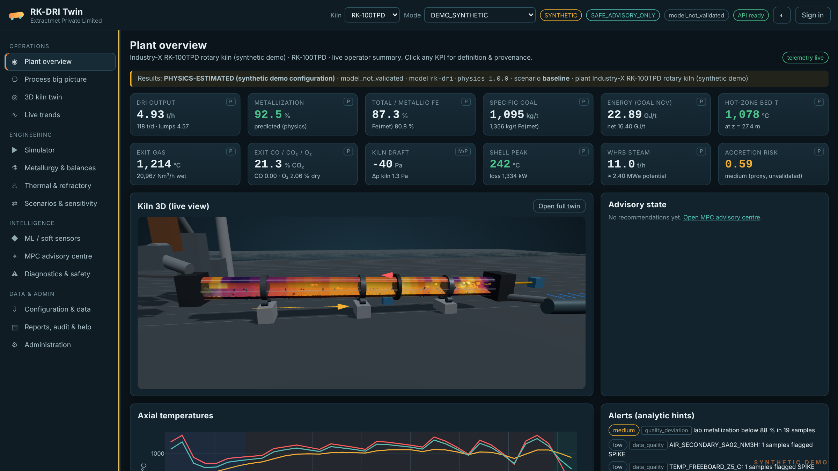
Plant overview: twelve KPIs, a live 3D kiln and analytic alerts
The desk has 14 screens: Plant overview; Process big picture (full flowsheet from bins to stack); 3D kiln twin; Trends; Process simulator; Metallurgy and balances; Thermal and refractory; Scenarios and optimisation; ML models; MPC advisory; Diagnostics; Data ingestion; Reports; Admin and audit. Every value carries a provenance label — measured, physics-estimated, ML-predicted or model-projected — and the run ID it came from.
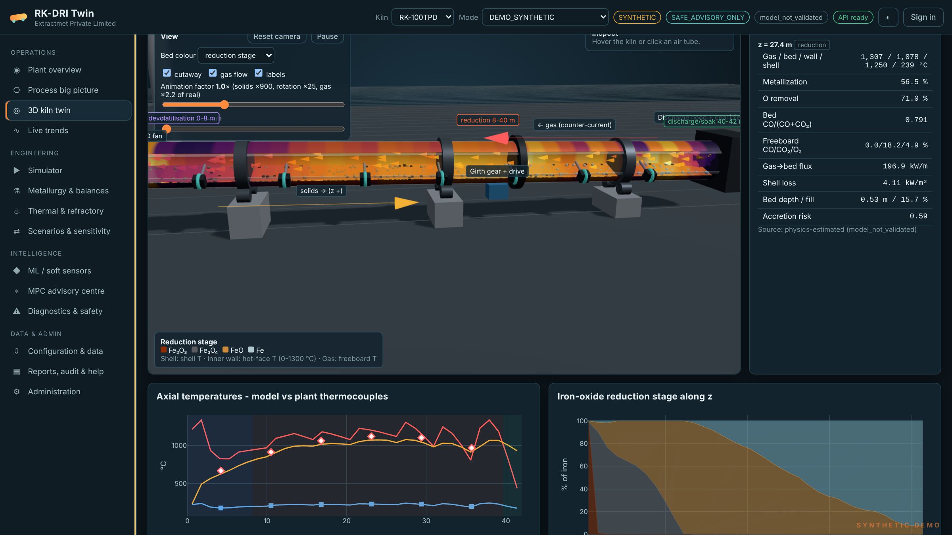
3D kiln twin: cutaway shell, refractory and bed coloured by temperature
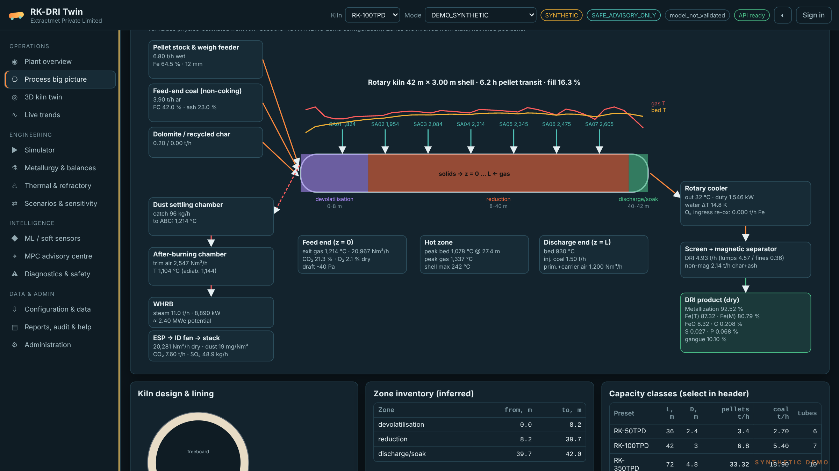
Process big picture: feeders, zones, air tubes, cooler, separation, ABC, WHRB, ESP
Kiln classes for 50, 100, 350 and 500 TPD are configured out of the box. Length, diameter, slope, speed, dam height, lining layers and thicknesses, air-tube positions and flows, and all feed assays can be edited.

4. Scientific scope
Area | What is modelled
Iron-oxide reduction | Fe₂O₃ → Fe₃O₄ → FeO → Fe by CO and H₂; equilibrium-limited; three-interface shrinking-core kinetics with gas-film and pore diffusion
Coal | Proximate/ultimate reconciliation; devolatilisation closed against NCV (Dulong check); Boudouard and steam gasification of char; sulfur release
Flux | Dolomite / limestone calcination; CaO capture of H₂S
Freeboard | Combustion of CO, H₂, CH₄, H₂S; water-gas shift; bed-surface char burn and Fe re-oxidation
Bed transport | Kramers–Saeman bed depth and velocity, fill fraction, residence time, dam effect
Heat transfer | Gas–bed, gas–wall, wall–bed contact (Tscheng–Watkinson, penetration theory), gray-gas radiation
Lining and shell | Multi-layer refractory conduction with wall heat capacity; shell natural/forced convection and radiation
Downstream | Rotary cooler, magnetic separation (product / char / non-magnetic split), ABC, WHRB steam, ESP and stack emissions
Integrity | Element, mass and energy audits every step; LHV energy ledger; accretion-risk index
On the shipped 100 TPD demonstration configuration the solver audit reports a total mass residual near 3 × 10⁻⁷, an energy residual near 1 × 10⁻¹¹, and element residuals near 10⁻¹⁵ (all relative). The external LHV ledger closes to about 0.1 %. Results that do not close are rejected, not normalised.
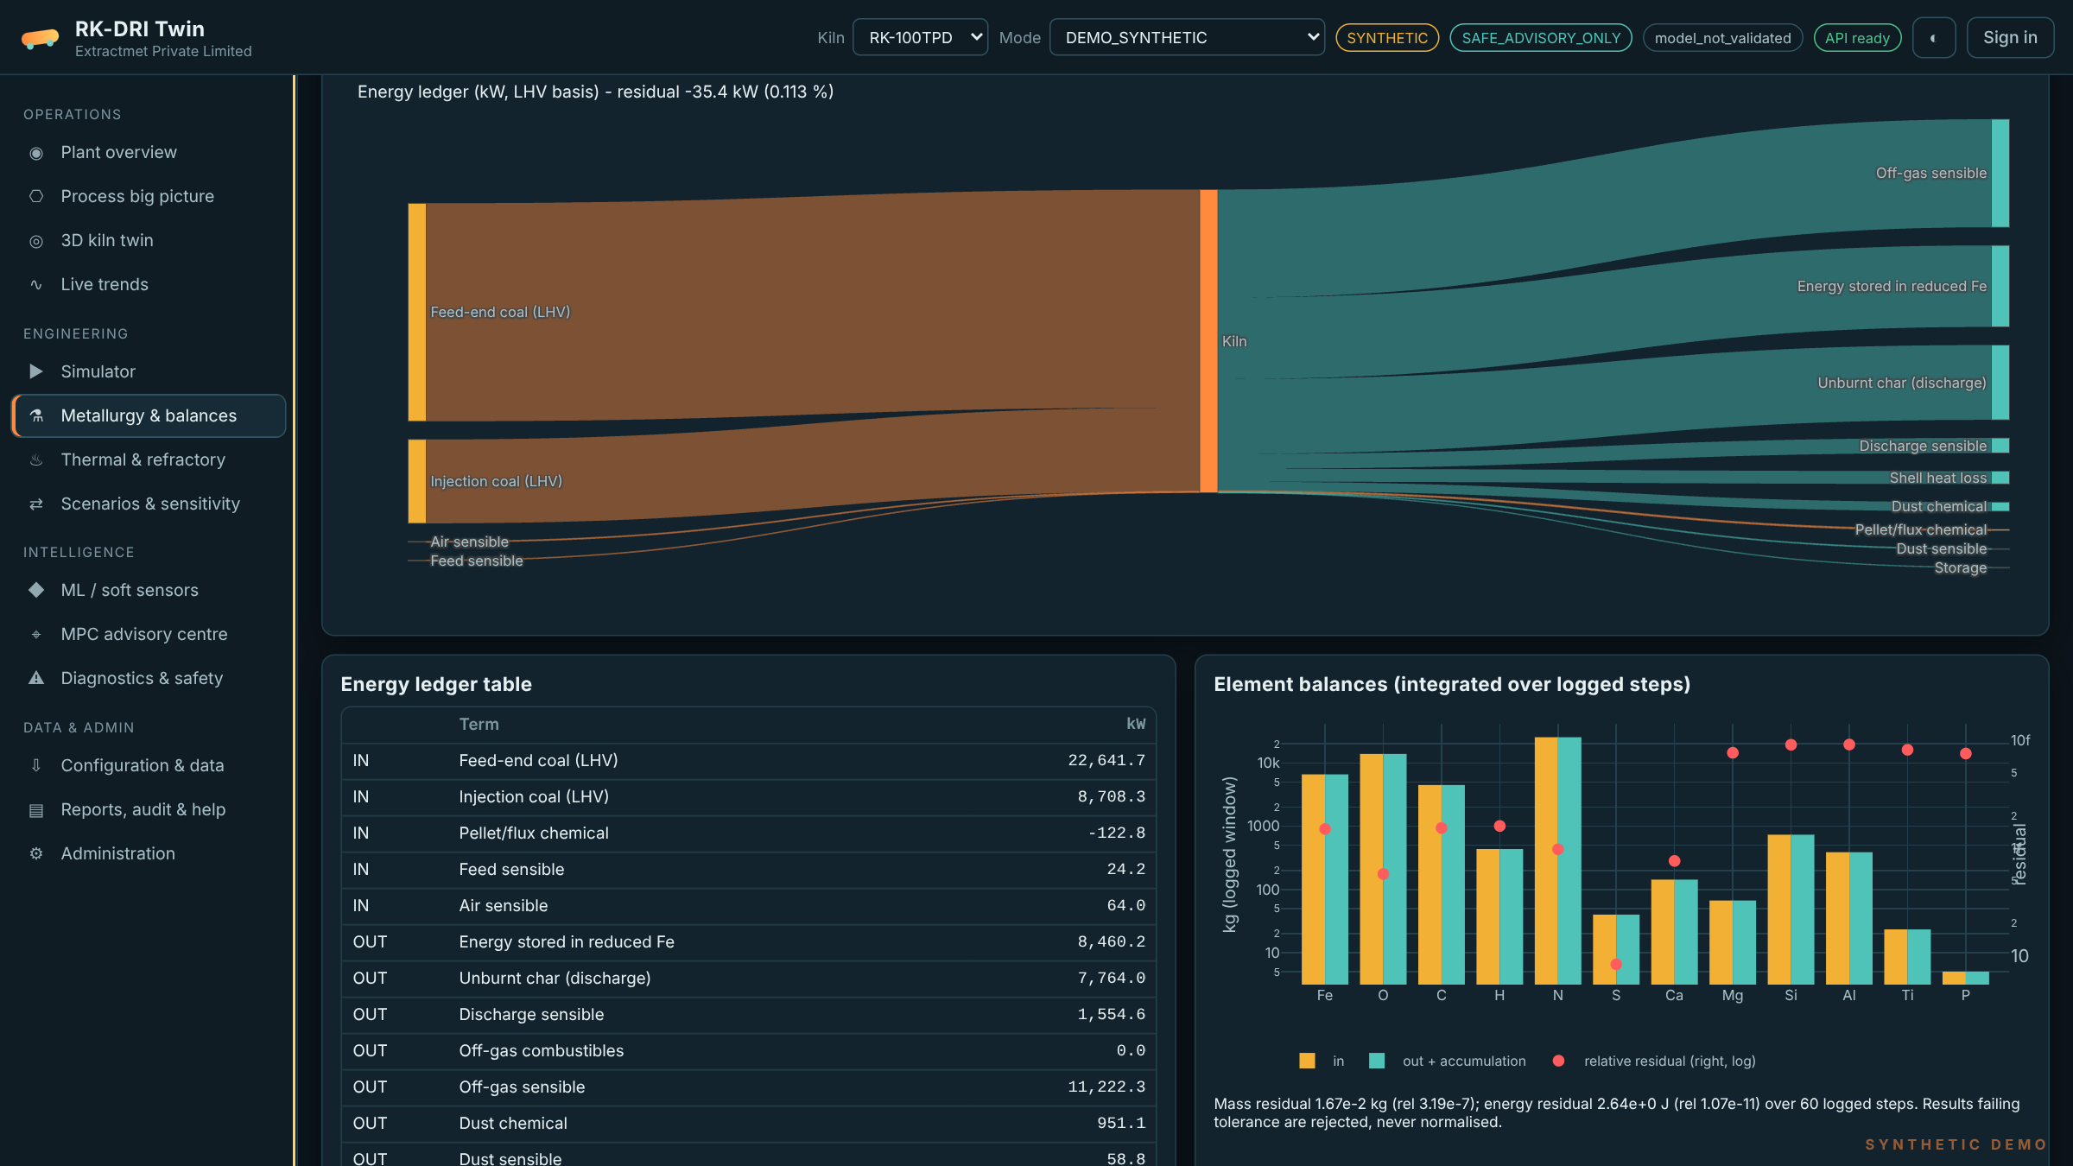
Energy ledger (Sankey) and element balances, 100 TPD demonstration case

5. Demonstration results (synthetic, uncalibrated)
Kiln class | Length (m) | Metallization (%) | DRI (t/d, model) | Coal (kg/t DRI) | Peak bed (°C) | WHRB steam (t/h)
RK-50TPD | 36 | 93.5 | 59 | 1,102 | 1,145 | 3.5
RK-100TPD | 42 | 92.5 | 118 | 1,095 | 1,078 | 11.0
RK-350TPD | 72 | 92.5 | 576 | 788 | 1,153 | 29.9
RK-500TPD | 80 | 93.5 | 808 | 802 | 1,169 | 45.8
These are physics results on synthetic inputs with literature-default kinetic and heat-transfer parameters. For the 350 and 500 TPD geometries the model predicts output above the nameplate class, which shows that the parameters must be calibrated to each plant before any number is used for decisions.

6. Advisory control and safety
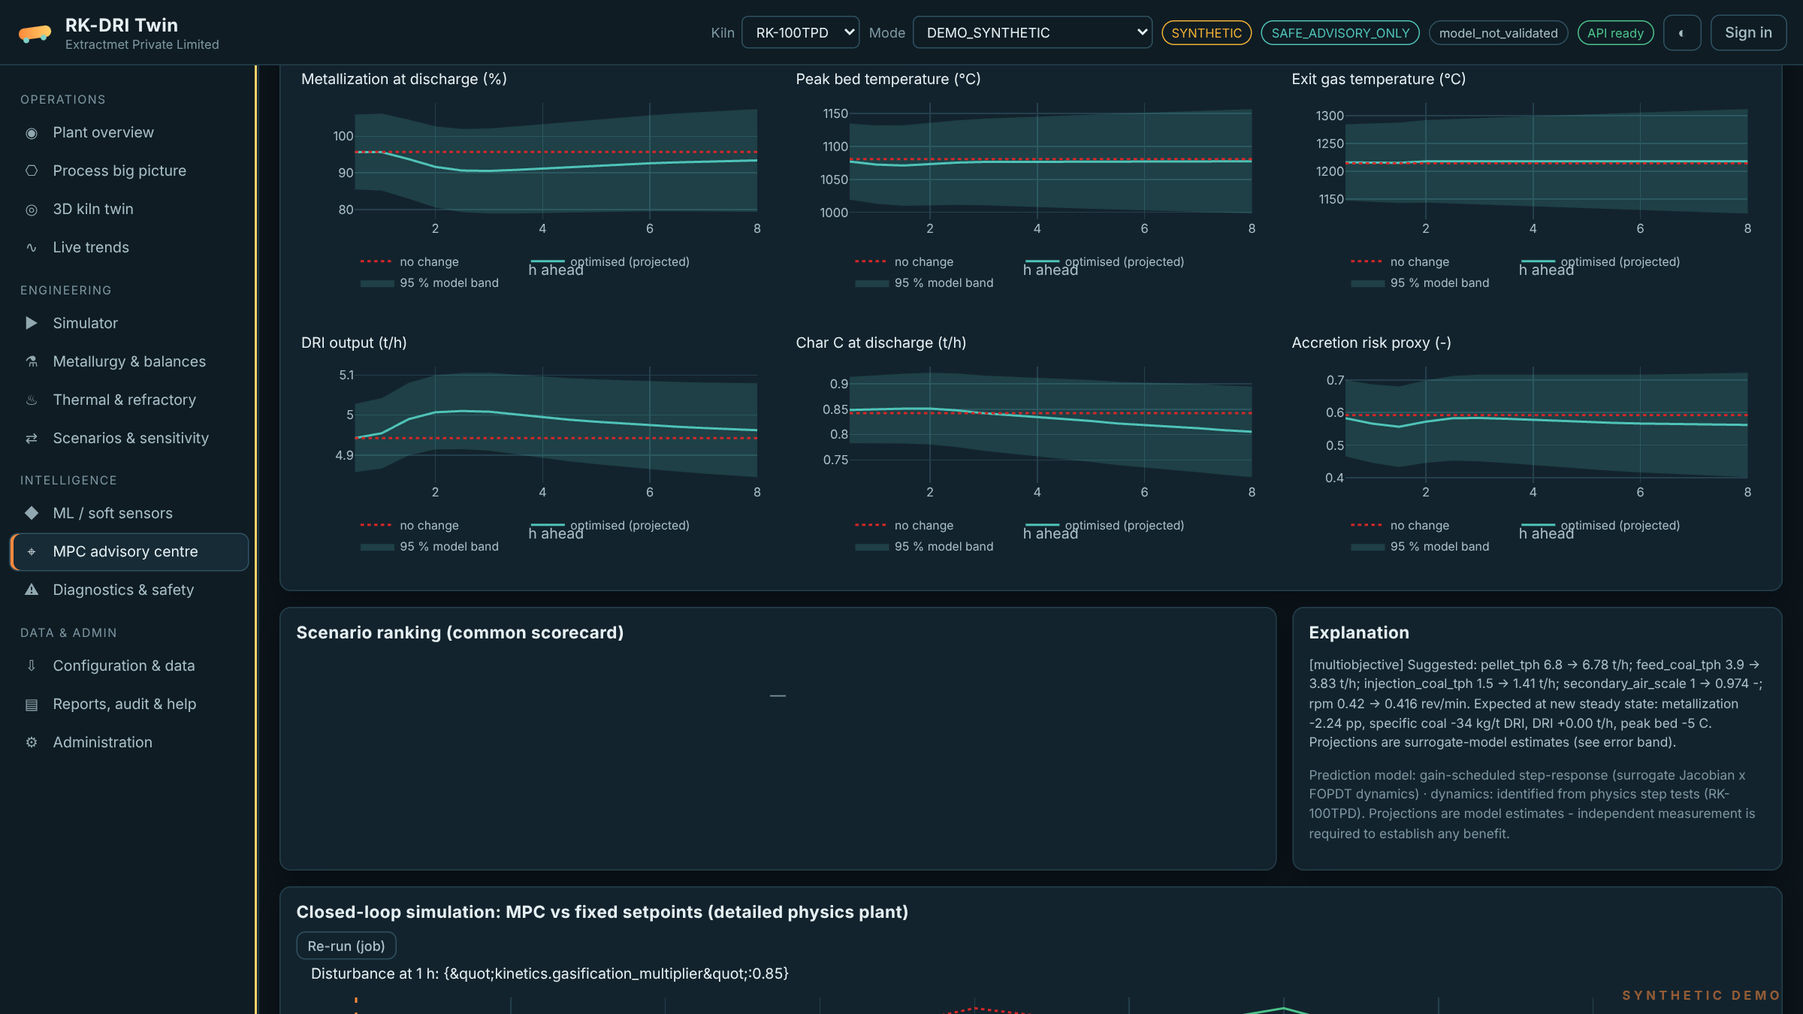
MPC advisory: recommended moves with predicted trajectories and confidence bands
- Objectives: metallization tracking, minimum specific coal, maximum throughput, minimum thermal risk, and a weighted multi-objective mode.
- Manipulated variables: pellet feed, feed coal, injection coal, secondary-air scale, kiln speed.
- Constraints: hard actuator bounds and ramp rates; bed, shell and exit-gas temperatures, metallization and accretion risk as soft constraints.
- Six safety gates must all pass before a recommendation is shown as actionable: operating mode, optimiser success, process envelope, model domain, local surrogate confidence, and data freshness.
- Operator workflow: approve, reject or defer, each with a mandatory note, stored in the audit trail.
- Boundary: advisory only. Data flow is read-only from the plant (PLC/DCS → historian → DMZ connector). Any future supervisory link requires a separate on-premises approval gateway, plant HAZOP and cybersecurity review, management of change and plant sign-off. The design follows NIST SP 800-82 Rev. 3 and OPC UA security guidance.
Current result to note: in our own closed-loop simulation, the first MPC tuning did not perform better than holding setpoints fixed. Site identification and tuning are therefore part of every engagement before any advisory trial.

7. Deployment
Item | Description
Repositories | Two GitHub repositories: rotary-kiln-dri-backend (Python, FastAPI) and rotary-kiln-dri-frontend (HTML, CSS, JavaScript, Three.js, Plotly)
Cloud demo | Render web service (backend) plus Render static site (frontend), configured by render.yaml blueprints
Plant deployment | On-premises or private cloud via Docker Compose; PostgreSQL; TLS; single sign-on
Data connectors | CSV/Excel upload, REST, historian, OPC UA (read-only); MQTT planned
Security | Role-based access (viewer, operator, process engineer, data scientist, admin), signed tokens, rate limiting, audit log; no secrets in code
Outputs | PDF, Excel and CSV reports; OpenAPI schema; WebSocket telemetry
A step-by-step deployment guide is included in both repositories (docs/DEPLOYMENT_GUIDE.md and .docx).

8. Engagement path
Step | Scope | Exit criterion
0. Demo | Hosted synthetic twin of the customer’s kiln class | Customer agrees scope
1. Configure | Drawings, lining, assays, air tubes, tag map | Configuration reviewed by plant process engineer
2. Calibrate | Historian and laboratory data; kinetic and heat-transfer fit; blind test on held-out periods | Agreed accuracy thresholds met on blind data
3. Shadow | Live read-only data; predictions, EKF and drift tracked; no advice shown | Stable predictions over agreed period
4. Advisory | Approved recommendations with measurement and verification (M&V) against a historian baseline | Benefits measured by the agreed M&V method
Benefits are measured at the customer’s plant against a baseline agreed before the trial. Extractmet does not quote generic savings.

9. Commercial packages
Package | Includes
Simulator | Configured twin of one kiln; what-if studies and operator training; reports, balances and 3D desk; cloud hosted
Shadow + Advisory | Everything in Simulator; calibration and blind test; live read-only data, EKF and ML; advisory MPC with audit trail; quarterly model review
Enterprise | Multiple kilns or sites; on-premises deployment; SSO, PostgreSQL and integrations; custom kinetics and laboratory programme; priority support
Licensing is an annual subscription per kiln plus a one-time configuration and calibration fee. Extractmet quotes prices per site scope.

10. What we need from the plant
- Kiln drawings: length, internal diameter, slope, speed range, dam height, lining layers and thicknesses, air-tube positions and fan curves.
- At least two weeks of historian data at 1–5 minute resolution, with tag descriptions.
- Laboratory results (metallization, FeO, C, total Fe) with sample and result times.
- Pellet/ore and coal assays: proximate, ultimate, NCV, ash chemistry and ash fusion temperatures; dolomite analysis.
- Shell scanner data, kiln drive current or torque, and records of accretion and shutdown events.
- A process engineer as single point of contact, and the plant’s IT/OT security requirements.

11. About Extractmet
Extractmet Private Limited is a deep-tech pyrometallurgy company incubated at IIT Madras Research Park, founded by a Full Professor of Metallurgical and Materials Engineering at IIT Madras. The team combines first-principles modelling — thermodynamics, heat and mass transfer, zone models — with data-driven machine learning on large plant datasets, and builds industry-deployable digital twins for iron, steel and mining processes.

12. Release status (honest summary)
Item | Status
Physics, balances, solver, API, desk, reports | Implemented; automated tests pass
ML layer | Implemented; on synthetic data the physics model alone currently beats the ML-corrected prediction
MPC benefit vs fixed setpoints | Not demonstrated (acceptance gate G4-03: FAIL)
Plant calibration, shadow trial, cybersecurity review | Pending site data (SITE-PENDING)
Supervisory write to DCS | Disabled by design
Sources: Mysteel, “India’s sponge iron production expected to reach around 55 Mnt in FY25” (https://www.mysteel.net/news/5077612-indias-sponge-iron-production-expected-to-reach-around-55-mnt-in-fy25); BigMint, “India sponge iron production grows 9% y-o-y in Apr–Sep’25” (https://www.bigmint.co/events/7th-india-international-dri-summit-2026/blog/india-sponge-iron-production-grows-9-y-o-y-in-apr-sep25-prices-face-pressure).

