INTEGRATED WEB AND MOBILE BUSINESS MANAGEMENT SYSTEM WITH PRODUCT RECOMMENDATION, PREDICTIVE ANALYTICS, AND INTEGRATED CHATBOT FOR BATTLEFRONT COMPUTER TRADING

A Capstone Project
presented to the Faculty of the
College of Computing and Information Sciences
State University of Northern Negros

In Partial Fulfillment
of the Requirements for the Degree
Bachelor of Science in Information Systems

By:

Daulong, Jj Niño S.
Delgado, Mark Daniel B.
Liganad, Bernie V.
Pilar, James Philip E.

2026

DISCLAIMER

This capstone project entitled “Integrated Web and Mobile Business Management System with Product Recommendation, Predictive Analytics, and Integrated Chatbot for Battlefront Computer Trading” is prepared solely for academic purposes in partial fulfillment of the requirements of the Bachelor of Science in Information Technology/Information Systems program. The content, analyses, and results presented herein are intended to demonstrate the application of theoretical and practical knowledge gained during the program and are not meant for commercial distribution or direct business implementation without further refinement and authorization. The authors declare that while the study utilized various sources of information, proper acknowledgment and citations were made to uphold academic integrity, and any similarities to existing systems or studies are purely coincidental. The institution and faculty advisers bear no responsibility for the commercial use, misinterpretation, or misuse of this study.
Declaration on the Use of AI Tools
The authors acknowledge that Artificial Intelligence (AI) tools, including large language models (LLMs), grammar checkers, and reference managers, were utilized in the preparation of this document for purposes such as improving writing clarity, grammar, formatting, and generation of initial drafts of certain sections (e.g., background of the study and literature support). However, all outputs generated through AI were critically reviewed, revised, and validated by the authors to ensure accuracy, relevance, and compliance with academic standards. The authors remain fully responsible for the integrity, originality, and authenticity of the final work.

NAME OF PROJECT MANAGER

TABLE OF CONTENTS

List of Figures

List of Tables

List of Appendices

CHAPTER I
INTRODUCTION
In today's competitive retail environment, computer hardware and peripherals trading businesses face increasing pressure to streamline operations, respond quickly to customer needs, and make data-informed decisions. The rise of e-commerce and mobile technology has reshaped how customers browse, compare, and purchase computer parts, pushing small and medium-sized trading businesses to move beyond manual, paper-based, or spreadsheet-driven processes (Chaffey & Ellis-Chadwick, 2019; Turban et al., 2018). Businesses that fail to adopt integrated digital systems risk losing customers to competitors offering faster service, personalized recommendations, and round-the-clock support (Laudon & Traver, 2021).
Battlefront Computer Trading, a computer hardware and peripherals retailer, currently relies on manual and semi-manual methods for recording sales, monitoring inventory, and assisting customers who inquire about product compatibility, availability, and pricing. Stock levels are tracked using handwritten logs and basic spreadsheets, which are prone to human error, delayed updates, and mismatched records between the physical store and online inquiries. Customer inquiries relayed through social media and phone calls are answered manually by staff, resulting in slow response times, especially during peak hours or after business hours. Moreover, the absence of a structured recommendation mechanism means that walk-in and online customers rarely receive personalized product suggestions based on their budget, intended use, preferred brand, and product preferences, which can lead to missed upselling opportunities and customer dissatisfaction.

In the Philippine setting specifically, digital adoption among small and medium enterprises remains uneven despite its growing necessity. The Philippine Statistics Authority reported that MSMEs represented 99.50% of business establishments in the country in 2022, underscoring how critical this sector is to the local economy. However, studies on Philippine MSMEs during and after the pandemic have documented persistent barriers to digitalization, including limited capital for initial technology investment, low digital literacy among owners and employees, unstable internet connectivity in outlying areas, and fear of cybersecurity risks such as data breaches or financial fraud. Research on e-commerce-adopting MSMEs in the Philippines has similarly found that while many businesses have gained access to digital sales channels, a considerable number still struggle to fully capitalize on them due to financing constraints, logistics issues, and gaps in digital skills. These local findings reinforce the relevance of a system such as the one proposed for Battlefront Computer Trading, which is designed to directly address several of these documented barriers, manual processes, delayed customer response, and the absence of data-driven decision support within the scale of a single small business rather than an enterprise-wide transformation.
An Integrated Web and Mobile Business Management System addresses these challenges by consolidating sales, inventory, and customer engagement functions into a single digital platform accessible through both a web portal and a mobile application. Beyond standard sales and inventory features, the proposed system embeds a product recommendation engine that generates personalized product suggestions based on a customer’s selections and explicit preferences, using rule-based filtering techniques informed by the broader recommendation systems literature. The recommendation process considers criteria such as budget, intended use, preferred brand, product category, and product-related tags. (Ricci, Rokach, & Shapira, 2015; Aggarwal, 2016), which encompasses content-based, collaborative, and rule-based approaches. While collaborative filtering (Sarwar et al., 2001) has demonstrated strong cross-selling results at scale, it requires substantial historical user-item interaction data that a newly deployed system for a single retail branch does not yet possess; this study therefore adopts a rule-based approach using explicit customer-defined criteria, consistent with practices for smaller-scale, newly deployed retail systems. The system further incorporates predictive analytics to forecast product demand and optimize inventory restocking, reducing instances of stockouts and overstocking (Chase, 2018). Finally, an integrated chatbot provides customers with immediate answers to common inquiries, such as product availability, specifications, and order status, reducing the workload on sales staff while improving customer response time (Adamopoulou & Moussiades, 2020).
Beyond addressing Battlefront Computer Trading's immediate operational concerns, the study contributes to the broader movement of digital transformation among small and medium computer trading enterprises in the Philippines. By demonstrating how recommendation systems, predictive analytics, and conversational interfaces can be integrated into an ordinary retail and inventory system, the study provides a practical model that similarly positioned businesses may adopt to remain competitive in an increasingly technology-driven retail landscape.
In this context, the present study proposes the design and development of an Integrated Web and Mobile Business Management System with Product Recommendation, Predictive Analytics, and Integrated Chatbot for Battlefront Computer Trading. The system is envisioned to streamline sales and inventory operations, provide customers with intelligent product recommendations, forecast demand for better inventory planning, and offer round-the-clock customer assistance through an integrated chatbot, ultimately enabling Battlefront Computer Trading to operate more efficiently across both physical and online channels.

Statement of the Problem
Battlefront Computer Trading currently relies on manual and semi-manual methods for managing sales, inventory, and customer engagement, which limits the business's ability to operate efficiently and respond to customer needs in a timely manner. This study seeks to address the following problems:
- Battlefront Computer Trading lacks a centralized system for managing product information, inventory levels, sales transactions, and customer orders, resulting in fragmented records, delayed updates, and mismatches between physical stock and online inquiries.
- Customers do not have access to a structured mechanism for receiving personalized product recommendations based on their needs, preferences, and budget, resulting in missed upselling opportunities and a shopping experience that depends heavily on staff availability and knowledge.
- The business has no data-driven method for forecasting product demand, causing recurring instances of stockouts and overstocking that manual, spreadsheet-based tracking cannot reliably prevent.
- Customer inquiries relayed through social media and phone calls are handled manually by staff, resulting in slow response times, particularly during peak hours or outside business hours.
- There is currently no established basis for evaluating the quality and usability of a proposed integrated system for Battlefront Computer Trading once developed.

Objectives of the Study
The main objective of this study is to design and develop an Integrated Web and Mobile Business Management System with Product Recommendation, Predictive Analytics, and Integrated Chatbot for Battlefront Computer Trading that unifies product management, inventory monitoring, sales processing, and customer order management into a centralized business management platform enhanced by intelligent decision-support features for business analytics and customer assistance.
Specifically, it aims to:
- Develop an integrated web and mobile business management system that streamlines product management, inventory monitoring, sales processing, customer order management, and business reporting for Battlefront Computer Trading.
- Implement product recommendation, predictive analytics, and chatbot functionalities that enhance customer experience, support sales forecasting and inventory planning, and improve business decision-making.
- Evaluate the level of the system’s quality based on McCall’s Software Quality Model, focusing on product operation, product revision, and product transition criteria.
- Determine the level of usability of the developed system as perceived by walk-in customers using the Computer System Usability Questionnaire (CSUQ), and as perceived by IT Experts and Battlefront Personnel using the usability factor of McCall's Software Quality Model.

Scope and Limitations
This study focuses on the design and development of an Integrated Web and Mobile Business Management System with Product Recommendation, Predictive Analytics, and Integrated Chatbot for Battlefront Computer Trading. The system is designed to:
The proposed system will provide a centralized web-based administrative platform and a cross-platform mobile application for Battlefront Computer Trading. The system will enable administrators to manage products and inventory, monitor stock levels and low-stock alerts, process and track customer orders, monitor sales and revenue, generate business reports, manage customer accounts, and view forecasting summaries. Customers will be able to register and authenticate their accounts, browse, search, and filter the product catalog, manage their shopping cart, place orders, select available payment methods, track order status, view order history, update their profiles, and access store information and locations through an integrated store locator. The system will also implement a product recommendation module that generates personalized product suggestions based on customer inputs such as budget, intended use, preferred brand, selected product category, and product preferences. The recommendation process will use rule-based filtering against the product catalog, product tags, and available inventory at the Sagay City branch. In addition, a predictive analytics module will use a trailing four-quarter simple moving average of Battlefront Computer Trading's covered historical unit sales to estimate product demand for quarterly inventory planning. Current inventory will be shown separately as planning context, and historical sales observations will support review of sales patterns. An integrated chatbot module will also be provided to handle product inquiries, order status inquiries, store information requests, and frequently asked questions through automated conversational interaction.
The system will be deployed for use within Battlefront Computer Trading, utilizing the business's existing operational data for inventory initialization, sales analysis, and forecasting purposes.

The proposed system is subject to the following limitations:
The product recommendation module relies on the product catalog and inventory data available within the system and does not retrieve real-time pricing or availability from external supplier databases or competitor markets. The predictive analytics and sales forecasting functions use only covered historical unit sales provided by Battlefront Computer Trading, with current inventory as separate planning context, and do not incorporate external market trends, seasonal economic factors, or supplier-side disruptions. The four-quarter moving average is a decision-support baseline; it does not estimate unrecorded demand or stockout losses. The chatbot operates within a predefined knowledge base and natural language scope limited to product inquiries, order tracking, store details, and frequently asked questions; it does not support open-domain conversations, complex complaint resolution, or product recommendations, which are handled by the Product Recommendation Module. The mobile application is primarily designed for customer-facing e-commerce functions, while administrative functions requiring complex data entry, bulk inventory uploads, and detailed report generation are optimized for the web-based platform. The study is limited to Battlefront Computer Trading, with primary requirements gathering, testing, and evaluation conducted at the Sagay City branch; branch-specific operational customization and multi-branch inventory synchronization are beyond the scope of the study. Real-time online payment gateway integration and automated payment verification, including credit card processing and third-party e-wallet services, are also beyond the scope of the study, with the system supporting payment method selection and manual payment verification procedures determined by Battlefront Computer Trading. Finally, while the system supports order placement, order monitoring, and order status tracking, logistics management, courier integration, route optimization, and real-time delivery tracking remain outside the scope of the study and will continue to depend on the business's existing delivery processes.

Significance of the Study
The development of an Integrated Web and Mobile Business Management System with Product Recommendation, Predictive Analytics, and Integrated Chatbot for Battlefront Computer Trading is significant as it contributes to improved retail operations, customer experience, and the advancement of intelligent business systems for small and medium enterprises. The following stakeholders are expected to benefit from this study:
For Battlefront Computer Trading:
The system will serve as a decision-support tool that streamlines sales recording, inventory monitoring, and customer engagement. By providing accurate demand forecasts and automated customer assistance, the business can reduce stockouts, minimize manual workload, and improve overall customer satisfaction.
For Customers:
Customers gain access to a more convenient shopping experience through personalized product recommendations, an accessible chatbot for immediate inquiries, and real-time information on product availability, whether browsing in-store or through the web and mobile platforms.
For the Academic Institution:
The project serves as a reference for integrating information systems, recommendation techniques, and conversational interfaces into a real-world retail application. It also provides future capstone project groups with a benchmark for developing similarly integrated business systems.

For Future Researchers:
This study contributes to the growing body of knowledge on integrating recommendation systems, predictive analytics, and chatbots into small business management platforms, particularly within the Philippine MSME context. Future researchers may use this as a reference for expanding such systems with additional features, such as more advanced machine learning models or omnichannel integration.
For the Researchers:
The project enables the proponents to apply theoretical knowledge in software development, data analytics, and human-computer interaction to address a real-world business challenge. It also enhances their competencies in systems design, research, and critical thinking, preparing them for professional careers in information technology.

Definition of Terms
To provide clarity and common understanding, the following key terms are defined as used in this study:
Chatbot
  - Conceptual: A category of information systems defined as software that accepts natural language as input and generates natural language as output to engage in a conversation, often acting as interactive virtual characters designed to assist people by occupying roles traditionally served by humans (Miklosik et al., 2021).
  - Operational: In this study, it refers to the integrated automated assistant that handles customer inquiries regarding store products, order status tracking, store information and branch locations, frequently asked questions through natural language interaction.
E-Commerce Platform
  - Conceptual: A digital marketplace that links businesses to a vast audience of customers by providing a complete package of integrated tools and services, including advertising campaigns, trustworthy shipping networks, and artificial intelligence-driven personalization, to democratize market access and reduce the operational costs associated with maintaining independent digital infrastructure (Turban et al., 2018; Laudon & Traver, 2021).
  - Operational: In this study, it refers to the customer-facing digital interface of the developed system where users can browse products offered by Battlefront Computer Trading, manage shopping carts, place orders, track order status, and manage their accounts through the web or mobile application.

Integrated Business Management System
  - Conceptual: An enterprise-wide information system designed to integrate, automate, and optimize core business processes and transactions, including financial management, human resources, supply chain operations, and customer relationships, into a single, unified platform to enhance organizational efficiency and facilitate data-driven decision-making (Moon, 2007; Addo-Tenkorang & Helo, 2011; Boush, 2025).
  - Operational: In this study, it refers to the centralized web and mobile system developed for Battlefront Computer Trading that unifies product catalog management, inventory monitoring, sales processing, customer order management, and business reporting into a single backend accessible via a responsive web platform and a cross-platform mobile application.
Inventory Management
  - Conceptual: A systematic process of resource optimization that utilizes real-time property monitoring and digitalized tracking to ensure the equitable distribution of materials, enhance custodianship, and provide precise, transparent accounting of organizational assets (Ahmad, 2023).
  - Operational: In this study, it refers to the administrative function of the system that tracks stock levels, inventory movements, and product availability at the primary Sagay City branch of Battlefront Computer Trading and triggers low-stock alerts when quantities fall below defined thresholds. While the system may reference branch location information for customer awareness, multi-branch inventory synchronization and branch-specific operational customization are not covered.
Predictive Analytics
  - Conceptual: A branch of advanced analytics that utilizes historical and current data combined with statistical modeling, data mining, and machine learning to identify patterns and forecast future outcomes, trends, or behaviors, thereby enabling organizations to proactively mitigate risks and optimize opportunities (IBM, n.d.-a).
  - Operational: In this study, it refers to the module that uses a trailing four-quarter simple moving average of Battlefront Computer Trading's covered historical product unit sales to estimate demand for the quarter beginning at the current calendar-quarter boundary. Current inventory is separate planning context. The module uses one deterministic, non-machine-learning forecasting method.
Product Recommendation System
  - Conceptual: A machine learning and rule-based tool that utilizes historical sales data and user behavior analysis (UBA) to predict a user’s interest in unseen products and suggest similar items, thereby enhancing the shopping experience, capturing user preferences, and improving a company’s market responsiveness (Zhao & Keikhosrokiani, 2022).
  - Operational: In this study, it refers to the intelligent module that provides personalized product recommendations based on customer preferences, budget, intended use, preferred brand, selected product categories, product tags, and available inventory within the Sagay City branch.
Sales Forecasting
  - Conceptual: A data-driven process that utilizes historical demand patterns and predictive modeling to estimate future sales volume and consumer demand, providing a critical foundation for organizational decision-making, inventory optimization, and financial planning to enhance profitability (IBM, n.d.-b).
  - Operational: In this study, it refers to the predictive function that averages product quantities sold in the four most recent completed calendar quarters to estimate demand for the full current/upcoming quarter. The incomplete target quarter is excluded from historical inputs. Estimates support inventory planning and business judgment rather than guaranteeing future demand.

Store Locator
  - Conceptual: An interactive digital tool integrated into a retailer’s website that enables visitors to search geographical databases to find physical store locations within the proximity of a specific postal code or address, providing detailed information such as postal addresses, contact details, and operating hours (Wandosell et al., 2019).
  - Operational: In this study, it refers to the integrated map feature that displays the geographical locations of Battlefront Computer Trading branches in Sagay City, Escalante City, San Carlos City, and Guihulngan City, providing customers with addresses, contact details, and operating hours. Only the Sagay City branch, the site of the study's requirements gathering, testing, and evaluation, is reflected with full operational detail (e.g., live stock and order information); the Escalante City, San Carlos City, and Guihulngan City branches are included for customer reference only, with static contact and location information supplied by the business owner.

Theoretical Framework
This study is anchored on General Systems Theory (Bertalanffy, 1968), which views an organization as a set of interrelated components, inputs, processes, outputs, and feedback. Working together toward a common objective. This theory supports the treatment of Battlefront Computer Trading's sales, inventory, and customer engagement functions as interdependent components of a single business system, justifying their consolidation into one integrated platform rather than addressing each in isolation.
The study also draws on Decision Support System (DSS) theory (Turban et al., 2018), which holds that information systems can extend human decision-making by organizing data and applying models to generate actionable recommendations rather than replacing managerial judgment outright. This principle underpins the system's predictive analytics and product recommendation modules, which are designed to support, not replace the business owner's inventory and sales decisions. Complementing this, the study applies rule-based reasoning theory (Ricci, Rokach, & Shapira, 2015), which explains how systems can generate reliable outputs by matching explicit, predefined conditions against input data. This principle grounds both the recommendation engine's criterion-matching logic and the chatbot's query-categorization mechanism, both of which rely on deterministic rules rather than inferred behavioral patterns.

Conceptual Framework

The conceptual framework of this study is anchored on the Input-Process-Output-Outcome (IPO-O) model, which illustrates the systematic approach used in developing the Integrated Web and Mobile Business Management System with Product Recommendation, Predictive Analytics, and Integrated Chatbot for Battlefront Computer Trading.
INPUT

• Client Requirements (Battlefront Computer Trading)

• Historical Business Data (sales, inventory, product records)

• User Requirements (Administrator and Customer)

• Evaluation Instruments (McCall's Software Quality Model, CSUQ)
PROCESS

1. Requirements Gathering & Analysis

2. System Design (DFD, ERD, Use Case, Architecture, UI/UX)

3. System Development (Agile Model)
- Backend Development
- Web Development
- Mobile Development
- Product Recommendation Module
- Predictive Analytics Module
- AI-Assisted Chatbot Module

4. System Testing & Evaluation
- McCall's Software Quality Model
- Computer System Usability Questionnaire (CSUQ)
OUTPUT

• Managing products, inventory, sales, and customer orders

• Enabling customer e-commerce activities through web and mobile

• Providing intelligent features: recommendations, forecasting, and chatbot assistance
OUTCOME

- Streamlined business operations for Battlefront Computer Trading

- Enhanced customer engagement and shopping experience

- Data-driven inventory and sales decision-making

- Reference model for future e-commerce system development

Fig. 1. Conceptual Framework
This conceptual framework illustrates the overall flow of the study using the Input–Process–Output–Outcome (IPOO) model. The inputs consists of the client's business requirements, historical business data, user requirements, and evaluation instruments. These inputs are processed through requirements analysis, system design, Agile-based system development, and system testing and evaluation. The resulting output is an Integrated Web and Mobile Business Management System with Product Recommendation, Predictive Analytics, and Integrated Chatbot capable of streamlining business operations and enhancing customer engagement. Ultimately, the system is expected to improve Battlefront Computer Trading's business operations, enhance customer experience, support data-driven decision-making, and serve as a reference for future retail information systems.

CHAPTER II
REVIEW OF RELATED LITERATURE AND PRIOR ARTS
International Setting
Product Recommendation Systems in E-Commerce and Retail
Recommendation systems remain a central tool for increasing sales and improving customer experience in online and retail settings. Islek and Oğuducu (2022) developed a hierarchical recommendation system that incorporates online user reviews into the recommendation process, showing that layering review-derived signals on top of purchase data produces more relevant product suggestions than purchase history alone. This provides a conceptual basis for generating relevant product suggestions based on product characteristics and customer-defined criteria. However, because the proposed system serves a smaller retail catalog with limited historical interaction data, this study applies rule-based filtering rather than review-derived or collaborative recommendation techniques.
Predictive Analytics for Inventory and Demand Forecasting
Accurate demand forecasting continues to be central to reducing stockouts and overstocking, particularly for smaller retailers with limited working capital. Franco, Guevara, Castaneda, Mansilla-Lopez, and Garcia-Nunez (2026) proposed a lightweight Random Forest-based forecasting framework built specifically for micro and small enterprises (MSEs), achieving a Mean Absolute Percentage Error of 2.41% and outperforming K-Nearest Neighbors, Decision Tree, and XGBoost models while remaining computationally inexpensive enough for resource-constrained businesses. This supports the broader feasibility of lightweight forecasting approaches for businesses at Battlefront Computer Trading's scale, though this study adopts a simpler, non-machine-learning approach — a trailing four-quarter simple moving average — given the smaller transaction volume and scope of a single-branch capstone deployment.
Complementing this, Alam, Thakur, and Islam (2024) conducted a qualitative case study of inventory management practices among small and medium enterprises in Bangladesh and found that most SME owners still rely on manual, experience-based stock decisions rather than structured forecasting tools, largely due to limited technical capacity and financing. This reinforces that the absence of predictive inventory tools in small trading businesses, such as Battlefront, reflects a broader, well-documented pattern among resource-constrained SMEs rather than an isolated local gap.
Chatbots and Conversational Interfaces in Customer Service
Chatbots have grown in popularity as a low-cost way for businesses to provide round-the-clock customer support. Marcineková, Sujová, and Ďurica (2025) conducted a mixed-method case study of an AI-powered chatbot deployed in a Slovak micro-enterprise's e-commerce operation and found that the chatbot cut average response time by nearly 46% and produced a statistically significant increase in customer satisfaction, though it still struggled with ambiguous or emotionally complex queries, underscoring that even a modest, catalog-aware chatbot can meaningfully improve customer service in a small retail business without requiring a large-scale generative AI system.
At a larger operational scale, Panigrahi, Shrivastava, Qureshi, Mewada, Alghamdi, Almakayeel, Almuflih, and Qureshi (2023) examined AI chatbot adoption among manufacturing SMEs and found that chatbot-enabled supply chain visibility positively influenced sustainable supply chain performance, mediated by the firm's innovation capability. While their focus was manufacturing supply chains rather than retail customer service, the finding that chatbot value depends on integration with a firm's existing operational data supports this study's design decision to link the chatbot directly to Battlefront's product catalog and inventory records rather than deploying it as a standalone FAQ tool.
Philippine Setting
Product Recommendation Systems in Philippine Retail
Locally, Samonte, Villaluz, Cabamongan, Gayeta, Palomo, and Samonte (2022) developed Market-e, a Philippine e-commerce platform for local wet-market vendors that embedded a recommender feature alongside an inventory management module. Their evaluation, which combined Nielsen's Heuristic Evaluation with the Questionnaire for User Interface Satisfaction across consumers, vendors, and store owners, found that the inventory feature was rated as the system's most impactful component. This finding directly supports the present study's decision to pair a recommendation engine with inventory management rather than treating them as separate systems, and demonstrates that Filipino researchers have already validated this combination as usable and beneficial for local retail operations.
Predictive Analytics for Inventory and Demand Forecasting in the Philippines
A directly comparable local study is that of Arnaiz, Cristal, Fernandez, Gubaton, Tanael, and Centeno (2023), who developed a time-series-based inventory management and demand forecasting system for a Philippine retail store. Their system addressed the same core problems this study aims to solve manual inventory tracking, inaccurate demand prediction, and excess or expired stock and demonstrated that time-series forecasting is a viable, locally proven approach for small Philippine retailers, reinforcing the feasibility of the predictive analytics module proposed for Battlefront Computer Trading.
Chatbots and Conversational Interfaces among Filipino Consumers
In the Philippine context, Pastorfide and Vasquez (2025) examined AI chatbot adoption among 392 online shoppers in Nueva Ecija using the Expectation Confirmation Theory alongside ISO/IEC 25010 quality criteria. Their findings showed that Filipino consumers place particularly high value on 24/7 availability, prompt and accurate responses, and notably multilingual support that includes Tagalog, which scored as the single highest-rated customer expectation in their study. This finding has direct implications for the present study's chatbot design: a chatbot built for Battlefront Computer Trading's customer base should account for code-switching between English and Filipino/Tagalog rather than assuming English-only interactions.
Broader Philippine MSME Digital Adoption
Beyond the studies already discussed, broader research on Philippine MSME digitalization provides useful context. Cordova, Lim, Ong, Caraan, Dela Cruz, and Jimenez (2025) found that while Philippine MSMEs are increasingly adopting basic digital tools such as social media marketing and digital payment platforms, they have largely not adopted more advanced technologies such as cloud computing or ERP-level systems, citing cultural resistance, limited technical expertise, and financial constraints as the leading barriers. This supports the present study's framing of an integrated recommendation-forecasting-chatbot system as addressing a documented, evidence-based gap in Philippine MSME technology adoption rather than an assumed one.
Prior Arts
E-Commerce Platforms with Recommendation Features
Commercial platforms continue to demonstrate the value of recommendation-driven retail. Regional marketplaces such as Shopee and Lazada apply algorithmic product recommendations during browsing and checkout, reflecting the continued commercial reliance on recommendation-driven cross-selling in Southeast Asian e-commerce. At the small-business scale, Samonte et al.'s (2022) Market-e platform, discussed above, demonstrates that Filipino-built systems have already applied comparable recommendation techniques successfully, validating that the underlying approach scales down from large marketplaces to single-vendor retail contexts such as Battlefront Computer Trading.
Inventory and Sales Management Systems
Commercial small-business tools such as Loyverse and Vend provide point-of-sale and inventory tracking but generally rely on descriptive reporting rather than predictive analytics, while larger ERP platforms such as SAP Business One incorporate demand forecasting modules that are often too costly and complex for small trading businesses to adopt. Arnaiz et al.'s (2023) locally developed forecasting system and Franco et al.'s (2026) MSE-oriented Random Forest model, both discussed earlier, represent closer-scale alternatives, though neither was built for a computer hardware catalog specifically.
AI-Powered Retail Chatbot Platforms
Commercial chatbot platforms such as Tidio and ManyChat allow retail businesses to automate responses to common inquiries across web and social channels. While useful for general customer engagement, generic chatbot platforms may provide limited responses when customers ask catalog-specific questions involving product availability, specifications, order information, and store details. This supports the development of a catalog-aware chatbot grounded in Battlefront Computer Trading’s own product, inventory, order, and store information. Pastorfide and Vasquez's (2025) Nueva Ecija study and Marcineková et al.'s (2025) Slovak micro-enterprise case study, both discussed above, indicate that customers and small business owners alike evaluate chatbots primarily on functional suitability and response accuracy rather than novelty suggesting that a catalog-aware chatbot built specifically around Battlefront's product line could outperform generic platforms on the dimensions users care about most.
Philippine-Based Prior Arts
Cordova et al.'s (2025) findings on Philippine MSME digital adoption, discussed above, further confirm that advanced, integrated digital tools remain rare among small Philippine trading businesses, reinforcing that a locally built, integrated system such as the one proposed here would fill a documented rather than assumed gap.

Limitations of Current Systems
Taken together, these prior arts show that recommendation, forecasting, and chatbot capabilities have each been demonstrated locally and internationally, but no reviewed system, commercial or academic, combines even two of the three within a single Philippine computer hardware retail context, let alone all three. Samonte et al. (2022) combined recommendation with inventory but not forecasting or a chatbot; Arnaiz et al. (2023) and Franco et al. (2026) combined inventory with forecasting but not recommendation or a chatbot; Pastorfide and Vasquez (2025), Marcineková et al. (2025), and Panigrahi et al. (2023) evaluated chatbots in isolation from inventory or forecasting concerns. This gap directly motivates the proposed Integrated Web and Mobile Business Management System with Product Recommendation, Predictive Analytics, and Integrated Chatbot for Battlefront Computer Trading.
Table 1. Gap Analysis
Prior Art | Product  Recommendation | Predictive  Analytics | Chatbot  Support | Gap Addressed by This Study
Market-e  (Samonte et al., 2022) | ✓ |  |  | No forecasting or chatbot module
Loyverse / Vend / SAP Business One |  | ✓ (SAP only) |  | No recommendation or chatbot; SAP too costly for small trading businesses
Time-Series Inventory & Forecasting System (Arnaiz et al., 2023);  MSE Stock Forecasting Model (Franco et al., 2026) |  | ✓ |  | No recommendation or chatbot module
Tidio / ManyChat;  Nueva Ecija AI Chatbot Study (Pastorfide & Vasquez, 2025);  Slovak Micro-Enterprise Chatbot (Marcineková et al., 2025) |  |  | ✓ | Not catalog-specific; no recommendation or forecasting integration
AI Chatbot Adoption in Manufacturing SMEs  (Panigrahi et al., 2023) |  |  | ✓ (supply-chain focus) | Supply-chain visibility only; no retail recommendation or forecasting

Synthesis
On product recommendation, the reviewed literature confirms that layering behavioral or review-derived signals on top of purchase data improves suggestion relevance and cross-selling potential (Islek & Oğuducu, 2022), and that Filipino-built systems have already validated pairing recommendation with inventory management at small-business scale (Samonte et al., 2022). Neither study, however, combines recommendation with forecasting or conversational support.
On predictive analytics, lightweight forecasting methods reduce stockouts and overstocking even under the resource constraints typical of small enterprises (Franco et al., 2026; Arnaiz et al., 2023), while Alam et al. (2024) confirm that the absence of such tools in businesses like Battlefront reflects a broader, well-documented pattern among SMEs rather than an isolated local gap.
On chatbots, the literature shows consistent gains in response time and customer satisfaction (Marcineková et al., 2025), with both Filipino and international customers expecting prompt, accurate, and context-appropriate service (Pastorfide & Vasquez, 2025; Panigrahi et al., 2023). This literature also surfaces a methodological constraint directly relevant to this study's scope: Marcineková et al. (2025) found that chatbots still struggle with ambiguous or emotionally complex queries, reinforcing this study's decision established in Chapter 1 to limit the chatbot to a predefined, catalog-aware knowledge base rather than open-domain conversation.
Methodologically, the reviewed literature also informs how the system should be built rather than only whether it is needed. Franco et al. (2026) demonstrate that lightweight, computationally inexpensive forecasting models can outperform more complex alternatives for resource-constrained enterprises, supporting this study's use of a similarly low-overhead approach based on a trailing four-quarter simple moving average rather than a heavier machine-learning model. Separately, Islek and Oğuducu (2022) demonstrate that layering behavioral signals onto purchase data improves recommendation relevance, but their review-inferred method requires interaction volume this study does not yet have; this reinforces, rather than supports adopting, the rule-based recommendation approach already justified in Chapter 1.
Across all three capabilities, however, both international and Philippine-based prior arts consistently address recommendation, forecasting, and chatbot support separately rather than as an integrated system and no reviewed prior art, commercial or academic, combines even two of the three within a comparable retail context. Broader research on Philippine MSME digital adoption (Cordova et al., 2025) further confirms that small trading businesses in the Philippines have not yet widely adopted advanced, integrated digital tools, largely due to cost and capability barriers rather than lack of need. This synthesis directly supports the present study's contribution: a single, locally-grounded, catalog-specific system for Battlefront Computer Trading that closes the integration gap left open by both the commercial platforms and the academic prior arts reviewed above.

CHAPTER III
METHODOLOGY
Research Design
This study will employ a descriptive-developmental research design to guide the design, development, and evaluation of an Integrated Web and Mobile Business Management System with Product Recommendation, Predictive Analytics, and Integrated Chatbot for Battlefront Computer Trading. The descriptive aspect will focus on analyzing existing sales, inventory, and customer service processes, while the developmental component will cover the actual design, implementation, and testing of the recommendation engine, predictive analytics module, chatbot, and their integration into a functional web and mobile system.
Research Locale / Site Study
This study will be conducted at Battlefront Computer Trading, specifically its Sagay City Branch, located in Sagay City, Negros Occidental. Battlefront Computer Trading is a computer hardware and peripherals retailer that sells computer parts, accessories, and related products to both walk-in and online customers, while also assisting customers with product compatibility, availability, and pricing inquiries.
Although Battlefront Computer Trading operates branches in Sagay City, Escalante City, San Carlos City, and Guihulngan City, the Sagay City Branch will be selected as the specific locale of the study for several reasons. First, it is the branch where the researchers were able to secure direct access and permission from the business owner to gather data, observe existing operations, and deploy the developed system for testing and evaluation. Second, the Sagay City Branch currently relies on manual and semi-manual methods, such as handwritten logs and basic spreadsheets, for recording sales and monitoring inventory, making it a representative and relevant setting for evaluating a system designed to address these exact operational gaps. Third, the branch maintains regular walk-in customer traffic and a small, accessible team of personnel, both of which will be necessary for the study to gather evaluation data from actual system users, in addition to the IT expert evaluators.
Given these considerations, the Sagay City Branch of Battlefront Computer Trading will serve as the primary setting for requirements gathering, system deployment, and the testing and evaluation activities described in the succeeding sections of this chapter, consistent with the scope and delimitation stated in Chapter 1.

Software Development Methodology
This study will adopt the Agile Software Development Life Cycle (SDLC) (Beck et al., 2001) as the primary methodology for designing and implementing the system. Agile will be adopted due to its iterative and incremental approach, which allows for continuous testing, stakeholder feedback, and refinement ideal for developing a system with multiple interacting components such as recommendation, forecasting, and conversational features.

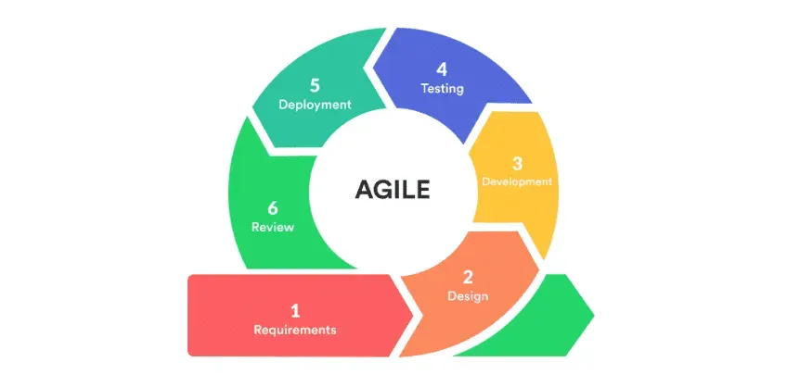
Fig. 2. Agile Software Development Life Cycle Model
The development process will follow several key phases:
Requirements Phase
Initial meetings with the owner and staff of Battlefront Computer Trading will be conducted to identify user requirements, common customer inquiries, and system expectations. Data privacy and security considerations for storing customer and transaction information will also be addressed during this phase.
Historical Sales and Inventory Data Template
A data collection template will be developed to gather and organize relevant historical sales and inventory data from Battlefront Computer Trading’s records. The template will include variables such as product name, category, price, quantity sold, stock levels, and transaction dates. This structured dataset will serve as the input for developing the recommendation and predictive analytics modules. All customer-related data will be handled in compliance with the Data Privacy Act of 2012.

Data Collection and Preprocessing
Historical sales and inventory data will be collected, cleaned, and preprocessed. For forecasting, setup/import preparation will explicitly establish complete product-level coverage for the required four completed quarters. Covered quarters without transactions count as zero sales, including a valid all-zero estimate; shorter complete history produces an insufficient-history outcome, while unknown, incomplete, stale, or gapped coverage makes forecasting unavailable. Completeness will not be inferred solely from the earliest sale, product creation date, or generated zero buckets. Categorical data such as product categories will be encoded for use in recommendation models; they are not predictors in the moving-average calculation. This structured dataset will form the basis for model development and evaluation.
Schedule Feasibility
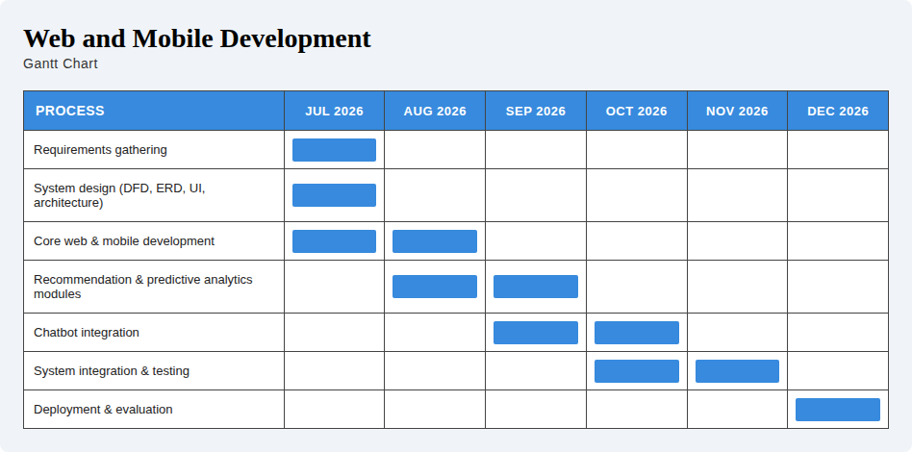
The proposed system will be assessed in terms of the time available for its development, testing, and deployment. The project will follow the adopted Software Development Life Cycle (SDLC) with Agile methodology, ensuring that tasks are divided into manageable sprints and milestones. Each phase from requirements gathering, design, development, testing, to implementation will be aligned with the academic calendar and the research timeline set by the researchers. Given the availability of resources, tools, and manpower, the researchers determined that the system can be completed within the prescribed period without compromising quality.

Fig. 3. Gantt chart
As illustrated in the Gantt chart above, the phases of the project including requirements gathering, system design, development of the recommendation and predictive analytics modules, chatbot integration, testing, and deployment are distributed across the academic semester to ensure balanced workload and timely completion, with each sprint focused on specific deliverables to allow iterative progress and early detection of issues. Therefore, the project is considered feasible in terms of schedule.
Economic Feasibility
Economic feasibility evaluates whether the proposed system can be developed and implemented at a reasonable cost while ensuring that the expected benefits outweigh the projected expenses. To support this, the researchers prepared a cost-benefit analysis (CBA) that highlights both the initial and recurring costs of the project in comparison to its anticipated operational and strategic benefits for Battlefront Computer Trading.
Table 2. Cost-Benefit Analysis
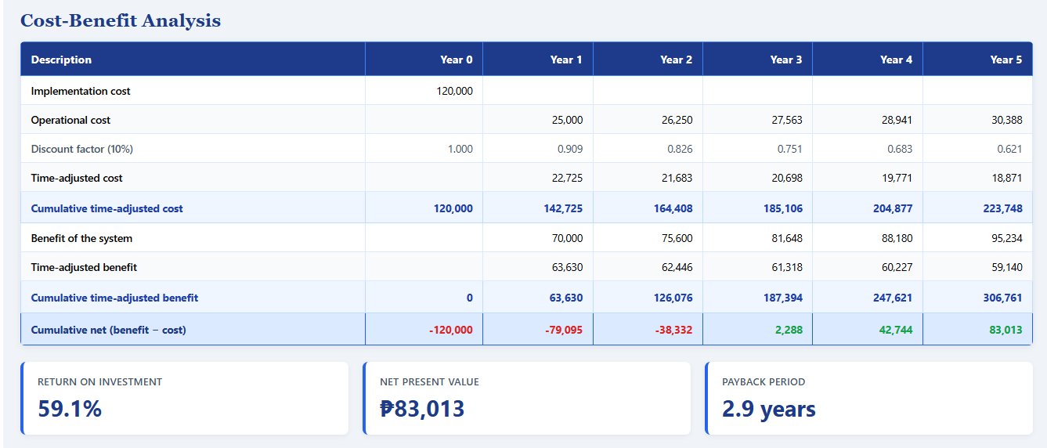

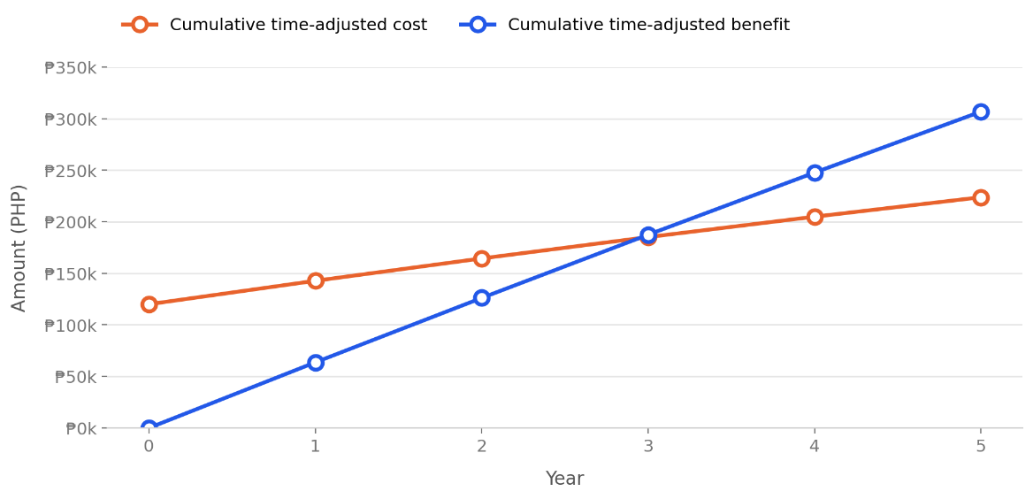

Fig. 4. Time Adjusted Payback Period
As shown in Table 2 and Fig. 4, the system requires an initial implementation cost of ₱120,000 in Year 0, with operational costs starting at ₱25,000 in Year 1 and increasing by approximately 5% annually to account for ongoing hosting, maintenance, and support, reaching ₱30,388 by Year 5. On the benefit side, the system is projected to generate ₱70,000 in Year 1, growing by roughly 8% annually as adoption increases and reaching ₱95,234 by Year 5, driven by reduced manual workload, minimized stockouts through better demand forecasting, increased cross-selling through product recommendations, and improved customer response time through the chatbot. When both cost and benefit streams are adjusted for the time value of money at a 10% discount rate, the cumulative time-adjusted benefit overtakes the cumulative time-adjusted cost between Year 2 and Year 3, resulting in a payback period of 2.9 years. Over the 5-year horizon, the project yields a Net Present Value (NPV) of ₱83,013 and, using the same time-adjusted (discounted) cost and benefit streams, a Return on Investment (ROI) of 37.1%, computed as NPV divided by the discounted total cost of ₱223,765. The 5% annual increase in operational costs, 8% annual growth in benefits, and 10% discount rate used in this analysis are researcher-formulated assumptions intended for initial project planning and feasibility estimation, rather than figures derived from Battlefront Computer Trading's actual historical financial data.
Based on these findings, the long-term benefits outweigh the development and implementation costs, making the project economically feasible.

Design Phase
Intelligent Module Design
The recommendation and predictive analytics modules will be designed using deterministic business logic to ensure consistent, maintainable, and cost-effective operation. The product recommendation module employs rule-based filtering to generate recommendations based on customer-defined criteria such as budget, intended use, preferred brand, product category, and product tags. The predictive analytics module uses one trailing four-quarter simple moving average of covered historical product unit sales to estimate quarterly demand. It automatically selects the four most recent completed calendar quarters, excludes the incomplete target quarter, and forecasts the full quarter beginning at the current quarter boundary. Administrators select a product and generate its estimate; no method choice, manual history-start selection, or repeated coverage-confirmation checkbox is required. Data readiness is established during setup/import preparation, and current inventory remains separate planning context. The chatbot module applies the same deterministic approach only to query categorization, classifying customer queries into supported inquiry types and retrieving relevant information from the system database; the response text itself is then generated by the Gemini 2.5 Flash API, a generative language model, using that retrieved context, so its final wording is not deterministic or rule-based even though the categorization and retrieval steps that ground it are.
The following logic components are employed within the intelligent modules:
- Rule-Based Filtering – Matches product attributes against customer-defined criteria to generate personalized product recommendations.
- Historical Data Aggregation – Organizes covered product unit sales into the four most recent completed calendar quarters, preserving valid zero-sales observations. Current inventory is separate operational context.
- Moving Average – Sums product units sold in the four most recent completed calendar quarters and divides by four, producing a deterministic two-decimal demand estimate for the full quarter beginning at the current quarter boundary. The incomplete target quarter is excluded.
- Forecasting Readiness – Uses explicit setup/import coverage metadata to distinguish complete four-quarter history from insufficient or unavailable history before treating empty quarters as zero. Forecast persistence remains product-focused, retaining the existing method field for compatibility and replacing results by product, method, and target quarter; new production forecasts use moving_average only.
- Query Categorization – Classifies customer inquiries into supported categories (product, order, store, and FAQ) or redirects unsupported requests through predefined fallback responses.
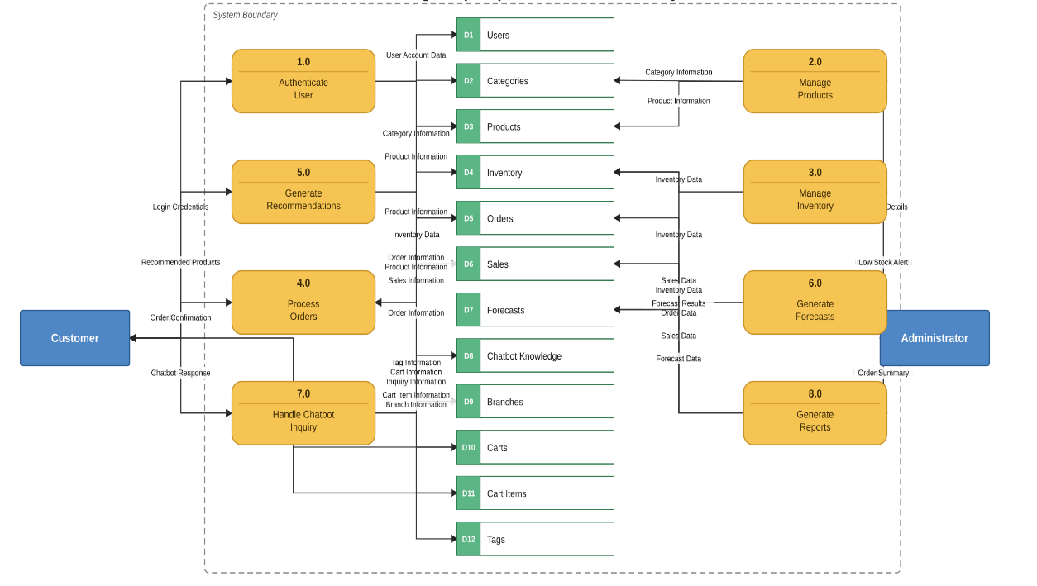
- Context-Augmented Generation – Combines retrieved database information with customer queries before sending them to the Gemini 2.5 Flash API to generate context-aware responses.
Fig. 5. Data Flow Diagram
Figure 5 presents the Data Flow Diagram (DFD) of the proposed system, illustrating how data moves between external entities, system processes, and data stores. The diagram depicts the primary business processes, including user authentication, product management, inventory management, order processing, product recommendation generation, sales forecasting, report generation, and chatbot services, together with the corresponding data exchanged throughout the system. It demonstrates how customer and administrator requests are processed, stored, and retrieved to support the system's core functionalities. Furthermore, the DFD serves as a blueprint for understanding the interaction among system components, ensuring proper data flow, consistency, and integrity during system operation. Overall, Figure 5 provides a clear representation of how the proposed system manages and processes information to achieve its intended objectives.
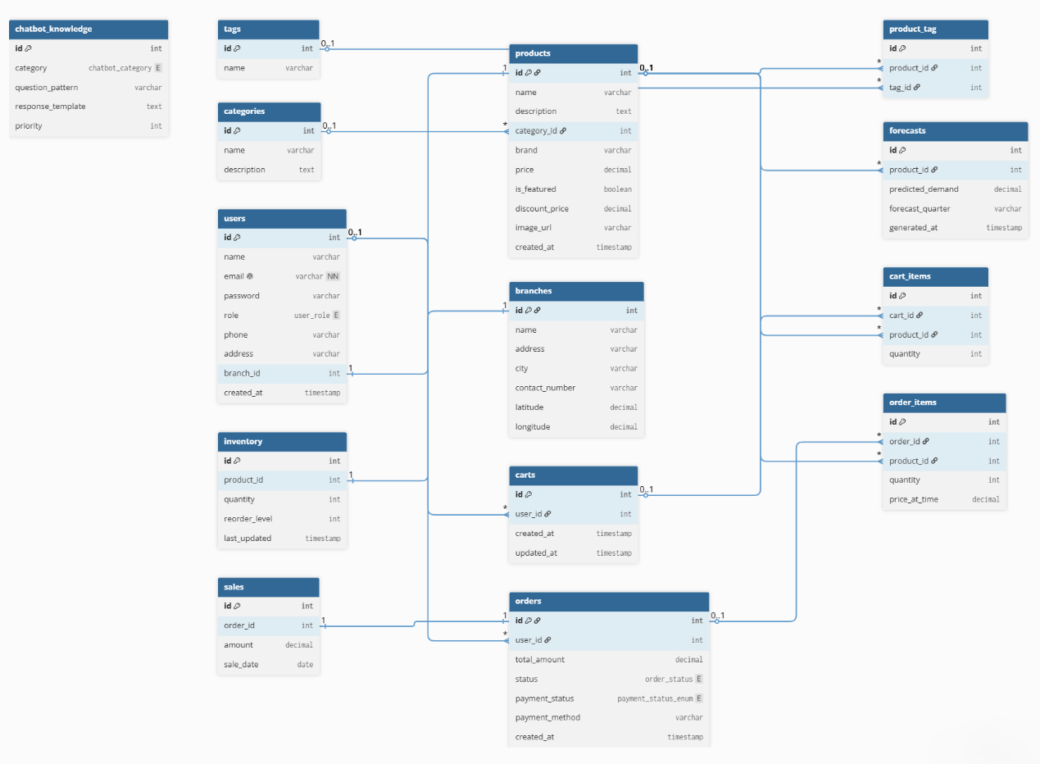Fig. 6. Entity-Relationship Diagram
Figure 6 illustrates the logical structure of the proposed system's database by presenting the entities, their attributes, and the relationships among them. It serves as the blueprint for organizing and managing data while ensuring consistency, integrity, and efficient data retrieval throughout the system. The diagram includes core entities such as Users, Branches, Categories, Products, Tags, Inventory, Carts, Cart Items, Orders, Order Items, Sales, Forecasts, and Chatbot Knowledge, which collectively support the system's business processes and information flow. The database is designed using a normalized relational structure to minimize data redundancy and maintain data integrity. Overall, the Entity-Relationship Diagram provides the foundation for implementing the proposed Integrated Web and Mobile Business Management System by supporting product and inventory management, customer ordering, sales monitoring, predictive analytics, and chatbot knowledge management.
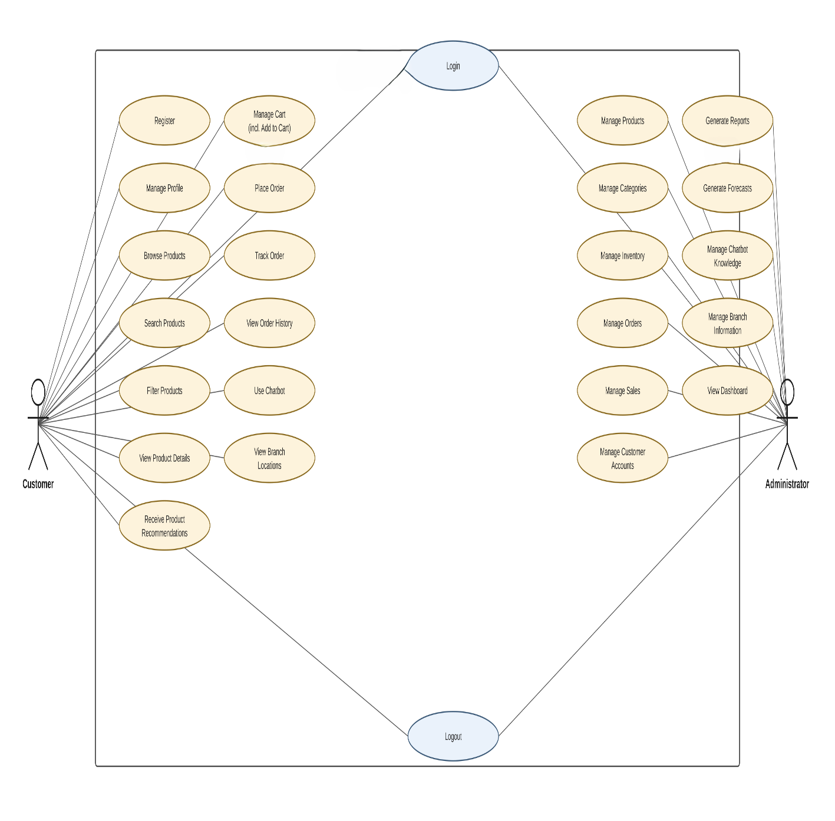
Fig. 7. Use Case Diagram
Figure 7 presents the Use Case Diagram of the proposed Battlefront Computer Trading Management System. The diagram illustrates the interactions between the two primary actors, the Customer and the Administrator, and the system's major functional requirements. Customers can register, authenticate, manage their profile, browse, search, and filter products, view product details, receive product recommendations, manage their shopping cart, place and track orders, view order history, access chatbot services, and view branch information. Administrators are responsible for managing products, categories, inventory, orders, sales, customer accounts, chatbot knowledge, and branch information, generating sales forecasts and business reports, and monitoring overall system activity through the administrative dashboard. The diagram provides a high-level representation of the system's functional scope and serves as a blueprint for defining user interactions and system behavior during development.

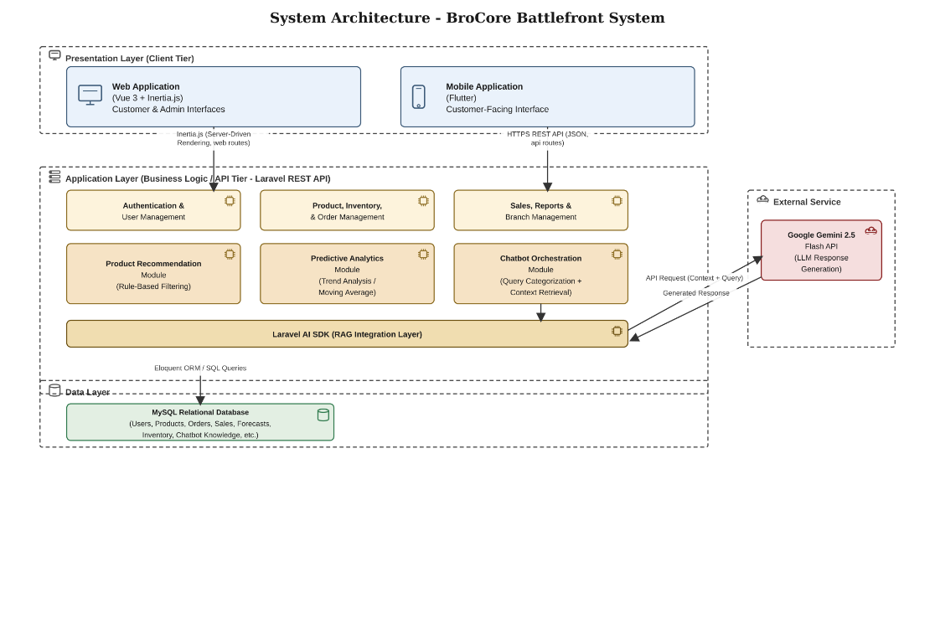
Fig. 8. System Architecture
Figure 8 presents the System Architecture of the proposed Battlefront Computer Trading Management System. The system follows a monolithic deployment model organized according to a three-tier logical architecture, consisting of the presentation layer, application layer, and data layer, supplemented by an external service integration for chatbot response generation. The presentation layer comprises a Vue 3 web application integrated with Inertia.js, which communicates with the Laravel backend through server-driven routing rather than a conventional REST API, and a cross-platform Flutter mobile application, which communicates with the backend through a dedicated RESTful JSON API. The application layer, built using the Laravel framework, handles core business logic such as authentication, product and inventory management, order processing, and business reporting, alongside three intelligent modules: a rule-based Product Recommendation module, a moving-average Predictive Analytics module, and a Chatbot Orchestration module that retrieves relevant data from the database before generating natural-language responses through the Google Gemini 2.5 Flash API via the Laravel AI SDK. The data layer consists of a MySQL relational database that stores all persistent system data. This architecture ensures a clear separation of concerns while accommodating the differing communication requirements of the web and mobile clients.

Development Phase
The user interface and backend functionalities of the system will be developed using both web-based and mobile technologies. The chatbot module will be integrated with the Google Gemini 2.5 Flash API to generate real-time, context-aware responses to customer inquiries based on data retrieved from the system's database.
The development phase of the Battlefront Computer Trading Management System involves careful planning and utilization of appropriate frameworks, hardware, and software to ensure the system is functional, secure, and scalable. On the software side, the Laravel (PHP) framework will be employed to streamline coding and speed up the implementation of business logic, handling both the web application through Inertia.js-integrated Vue 3 components and a dedicated RESTful API for the Flutter-based mobile application. MySQL serves as the relational database management system, storing product information, user accounts, order and sales records, inventory levels, and chatbot knowledge data. Laravel Herd will be used as the local development environment, providing a pre-configured PHP runtime, Nginx web server, and instant site linking without the need for manual server or virtual host configuration, allowing the development team to focus on application logic rather than environment setup. Visual Studio Code will serve as the primary integrated development environment (IDE) for coding, while Git and GitHub will provide version control and collaboration capabilities for the development team throughout the project. Postman will be used for manual API endpoint testing during development, while Laravel's built-in testing framework (Pest/PHPUnit) will be used for automated unit and feature testing of core business logic such as order processing and inventory updates.
On the hardware side, development will be carried out on a Windows-based laptop with 16GB of RAM and over 470GB of storage, which will provide sufficient memory and disk headroom to run the Laravel/Herd development environment, MySQL database, Vue/Inertia build tools, and the Flutter Android emulator simultaneously without significant performance degradation. A stable internet connection will also be essential for repository access via GitHub, package installations through Composer and npm, and communication with the Gemini API during chatbot testing. Furthermore, the development process will follow the Agile methodology, specifically a Scrum-inspired framework, which will structure the project into sprints beginning with the core system (authentication, product and inventory management), followed by the e-commerce flow (cart and checkout), then the intelligent modules (recommendation and forecasting), and finally the chatbot and mobile application integration. This iterative structure will allow adjustments to be made based on adviser feedback at each stage, reducing the risk of project delays or overlooked requirements. Altogether, the combination of reliable hardware, suitable software tools, and a structured Agile framework will provide a strong foundation for building an efficient and reliable computer trading management system.

Testing Phase
In the testing phase, the developed system will be evaluated by three respondent groups using instruments matched to their level of technical exposure to the system. IT Experts and Battlefront Personnel will assess the system using a researcher-made questionnaire anchored on McCall’s Software Quality Model, which will guide the assessment of software quality attributes such as correctness, reliability, and usability. Walk-in Customers, following a guided trial of the system’s customer-facing features, will instead complete the standardized Computer System Usability Questionnaire (CSUQ) to measure usability from an end-user perspective. All respondents will be provided access to the system, either through a live demonstration, hands-on exploration, or a guided trial as appropriate to their group, before completing their respective instrument.
McCall’s Software Quality Model
To evaluate the overall quality of the developed system as assessed by IT Experts and Battlefront Personnel, a checklist will be adapted based on McCall’s Software Quality Model, which includes metrics under three main categories:
- Product Operation (e.g., correctness, usability, reliability, efficiency)
- Product Revision (e.g., maintainability, flexibility, testability)
- Product Transition (e.g., portability, reusability, interoperability)
Evaluators will rate each criterion using a 5-point Likert scale ranging from "Strongly Disagree" to "Strongly Agree."
Computer System Usability Questionnaire (CSUQ)
To measure system usability from the walk-in customer’s perspective following their guided trial of the system, the standardized Computer System Usability Questionnaire (CSUQ) developed by IBM will be used. This tool assesses aspects such as system usefulness, information quality, and interface quality. Respondents will rate their experience using a 7-point Likert scale, allowing for quantitative analysis of perceived usability.
During the testing phase, each feature of the Battlefront Computer Trading Management System will be evaluated against the defined requirements to ensure proper functionality and alignment with the project objectives. Unit testing will be conducted to verify the accuracy and reliability of individual modules, such as order processing, inventory tracking, and user authentication, before integrating them into the whole system. This approach will allow the team to identify and resolve errors early, ensuring that every component performed as expected prior to full system integration and deployment. Afterward, quality testing will be carried out to assess overall performance and stability, followed by usability testing to evaluate ease of use, user experience, and system adaptability to real-world retail operations.

Deployment Phase
The deployment phase of the business management system is the stage where the fully tested application is installed and made available for actual use by the intended users. This process involves setting up the production server environment, configuring the database, and ensuring that all modules such as ordering, payment, and administrative functions are properly integrated and operational. Before the full rollout, a pilot deployment may be conducted with a smaller group of users to identify any remaining issues and make final adjustments.
Once the system is confirmed stable, it will be formally launched for the broader user community, with necessary documentation and user guides provided to ensure smooth adoption. Training sessions may also be conducted for administrators and staff to familiarize them with managing the system effectively. Additionally, continuous monitoring and post-deployment support will be implemented to address technical issues, apply system updates, and ensure that the business management system remains reliable and efficient in serving its users.

Review Phase
The review phase of the business management system ensures that the project outcomes are assessed against the initial objectives and requirements. This stage involves evaluating the system’s performance, usability, and overall effectiveness through feedback gathered from both users and administrators after deployment. The results are then compared to the expected deliverables, allowing the project team to identify strengths, weaknesses, and areas for improvement in the system.
Furthermore, the review phase includes analyzing usage reports, error logs, and maintenance records to determine the stability and reliability of the application. Insights from this evaluation are documented and serve as a reference for future system enhancements or similar projects. By systematically reviewing the system, stakeholders can confirm whether it meets institutional needs and makes informed decisions about potential upgrades, expansions, or long-term sustainability strategies.

Feasibility Study
The proposed Integrated Web and Mobile Business Management System will be assessed for feasibility in terms of schedule and economic viability.
Schedule Feasibility:
The project timeline will be distributed across the academic semester using the Agile SDLC with defined sprints for requirements gathering, design, development of intelligent modules, testing, and deployment. This timeline will be feasible within the prescribed academic period without compromising quality, as illustrated in the project Gantt chart to be presented in the Software Development Methodology section.
Economic Feasibility:
A cost-benefit analysis will be conducted comparing the initial implementation cost of ₱120,000 against projected operational costs and benefits over a five-year horizon. The analysis will show the payback period, Net Present Value, and Return on Investment to determine whether long-term benefits will outweigh development and implementation costs. Detailed cost-benefit projections will be presented in the Economic Feasibility subsection of the Software Development Methodology section.
Both assessments will confirm whether the proposed system is feasible for development and implementation by Battlefront Computer Trading.

Sources of Data
Data for this study will be obtained from: (a) historical sales and inventory records from Battlefront Computer Trading, which will be collected and organized as described in the Data Collection and Preprocessing subsection; (b) responses from the three respondent groups (IT Experts, Battlefront Personnel, and Walk-in Customers) which will be gathered through the questionnaire instruments outlined in the Research Instruments section; and (c) academic literature and technical documentation to be reviewed in Chapter II

Population and Sampling
Target Population
The target population of this study consists of three groups relevant to the evaluation of the developed Integrated Web and Mobile Business Management System: (a) IT experts who currently teach and/or practice software development, possessing the technical background necessary to evaluate the system's software quality; (b) personnel of Battlefront Computer Trading, specifically the business owner and rank-and-file staff involved in sales, inventory, and customer service at the Sagay City branch; and (c) walk-in customers of Battlefront Computer Trading at the Sagay City branch who interact with the system's customer-facing features.
Population Size
The IT expert group does not correspond to a fixed numerical population; rather, evaluators are drawn from the broader pool of individuals who teach and/or practice software development, from which four (4) will be selected for this study. The population of Battlefront personnel is small and fully known, consisting of the business owner and three (3) rank-and-file staff members at the Sagay City branch four (4) individuals in total. The population of walk-in customers, meanwhile, is not precisely determined, as Battlefront Computer Trading does not maintain formal records or a customer database from which an exact count could be derived.
Sample Size
A total of forty-eight (48) respondents will participate in the study, distributed as follows:
Respondent Group | Sample Size
IT Experts | 4
Battlefront Personnel (Owner + Staff) | 4
Walk-in Customers | 40
Total | 48

Sampling Technique
Three sampling approaches will be used depending on the respondent group. A purposive sampling technique will be used for the IT expert group, as evaluators will be deliberately selected based on specific relevant qualifications and experience. A total enumeration technique will be used for the Battlefront personnel group, since the entire qualified population. The business owner and all three rank-and-file staff at the Sagay City branch will be included rather than a subset drawn from a larger pool. A convenience sampling technique will be used for the walk-in customer group, as respondents will be selected based on their availability and accessibility at the time of data gathering, given the absence of a fixed customer population from which to draw a random sample.

Sample-Size Determination
Formal probability-based formulas such as Slovin's Formula are not applicable to this study, as such formulas require a known, finite population size. The IT expert and Battlefront personnel groups do not require a sample-size formula: the former will be set based on the number of qualified evaluators the study reasonably requires for a technical quality assessment, and the latter reflects the entire available personnel population (total enumeration). For the walk-in customer group, whose population size is not precisely determined, the sample size of forty (40) is informed by Roscoe's (1975) rule of thumb for sample sizes in behavioral research, which suggests that sample sizes greater than 30 and less than 500 are generally acceptable for most studies. This guideline will be used as a practical basis for setting a reasonable minimum, rather than as a statistical proof of adequacy; a sample of 40 will be adopted to exceed this suggested minimum while remaining feasible given the study's data-gathering timeline.
Inclusion and Exclusion Criteria
IT Experts:
- Inclusion: (a) currently teaches software development, information technology, or a related field in an academic setting, and/or has professional experience developing software systems; (b) familiarity with evaluating software systems using standardized quality models.
- Exclusion: Individuals without teaching or practical experience in software development, or without relevant IT/software background.
Battlefront Personnel:
- Inclusion: (a) active involvement in the business's sales, inventory, or customer service operations; (b) direct exposure to the manual processes the proposed system is intended to replace.
- Exclusion: Personnel not involved in day-to-day business operations at the Sagay City branch.
Walk-in Customers:
- Inclusion: (a) an actual walk-in customer of Battlefront Computer Trading at the Sagay City branch during the data-gathering period; (b) willingness to complete a guided trial of the system's customer-facing features before answering the evaluation questionnaire.
- Exclusion: Online-only customers, non-customers, and individuals unwilling to undergo the guided system trial.
Appropriateness of the Sampling Method
Purposive sampling is appropriate for the IT expert group because software quality evaluation requires specific technical expertise that cannot be assumed of the general population. Total enumeration is appropriate for the Battlefront personnel group because the population is small enough (n = 4) that including all members allows the study to capture the full range of operational perspectives within the business, rather than relying on a subset. Convenience sampling is appropriate for the walk-in customer group because the population is not precisely determined, making probability-based sampling impractical; it allows the researchers to efficiently gather a sufficiently large sample of actual system users within the constraints of the study's timeline and access to respondents.

Research Instrument
To gather the data needed to evaluate the developed Integrated Web and Mobile Business Management System for Battlefront Computer Trading – Sagay City Branch, the researchers will make use of two data-gathering instruments. For IT Experts and Battlefront Personnel, a researcher-made questionnaire anchored on McCall’s Software Quality Model will be used, as no existing standardized tool was found to be directly applicable to the evaluation of a system with the particular features, users, and business context of Battlefront Computer Trading at the software-quality level these two groups are qualified to assess. For Walk-in Customers, the standardized Computer System Usability Questionnaire (CSUQ) will instead be used, since usability from an end-user perspective is a dimension for which a validated, standardized instrument already exists and is appropriate to this respondent group.
Data gathering will be divided into three (3) distinct but related parts, each corresponding to one of the respondent groups identified in the Population and Sampling section of this study, namely: (1) IT Experts, (2) Battlefront Personnel, and (3) Walk-in Customers. This grouping was adopted because each type of respondent interacts with the system from a different vantage point and is therefore qualified to evaluate different aspects of its quality. IT Experts, who possess technical background in software development or information technology, will evaluate the system using the McCall's-based questionnaire based on its underlying software quality; Battlefront Personnel, who use the system directly in their daily business operations, will likewise use the McCall's-based questionnaire to evaluate it based on its functionality, usability, and usefulness in actual work; and Walk-in Customers, who will undergo a guided trial of the system's customer-facing features, will instead complete the CSUQ to evaluate their user experience during that trial.
The evaluation criteria used in the McCall's-based questionnaire, administered to IT Experts and Battlefront Personnel, will be primarily anchored on McCall's Software Quality Model, which organizes software quality into three main categories, Product Operation, Product Revision, and Product Transition, each comprising specific quality factors. From this model, the researchers will select only the quality factors that are appropriate to each respondent group's level of technical exposure to the system. For the IT Experts, the instrument will cover all three categories: Product Operation (correctness, reliability, efficiency, integrity, and usability), Product Revision (maintainability, flexibility, and testability), and Product Transition (portability, reusability, and interoperability), since this group possesses the technical competence to assess even the more code-level and architecture-level factors of the system. For the Battlefront Personnel, the instrument will cover the Product Operation factors, correctness, reliability, efficiency, integrity, and usability, reflecting their perspective as actual day-to-day users of the system. Walk-in Customers will not use the McCall's-based instrument; instead, since they are only exposed to a guided trial of specific customer-facing functions and could not reasonably be expected to evaluate technical factors such as maintainability or portability, their usability evaluation will be gathered through the standardized CSUQ, described above.
Each part of the data-gathering process begins with a brief introduction explaining the purpose of the study and an informed consent statement affirming that participation is voluntary and that all responses will be treated with confidentiality. This is followed by a short respondent profile section limited only to information relevant to establishing the respondent's qualification or exposure to the system, a set of evaluation statements (answerable through the five-point Likert scale for the McCall's-based parts, or the CSUQ's own seven-point scale for the Walk-in Customer part), and an open-ended portion for comments and recommendations.
Evaluation statements in the McCall's-based questionnaire (IT Experts and Battlefront Personnel) will be rated using a five-point Likert scale, with 5 interpreted as Strongly Agree, 4 as Agree, 3 as Neutral, 2 as Disagree, and 1 as Strongly Disagree. Computed mean scores for this instrument will be interpreted using the following scale: 4.21–5.00 (Strongly Agree), 3.41–4.20 (Agree), 2.61–3.40 (Neutral), 1.81–2.60 (Disagree), and 1.00–1.80 (Strongly Disagree). The CSUQ administered to Walk-in Customers instead uses its own standard seven-point scale, from 1 (Strongly Disagree) to 7 (Strongly Agree), consistent with the instrument's original design.
Prior to actual administration, the instrument will be submitted to a panel of qualified experts for content validation to ensure the relevance, clarity, and appropriateness of each item, as well as its alignment with the objectives of the study. Items found to be ambiguous, biased, or otherwise inappropriate will be revised accordingly based on the validators' recommendations.

Instrument Validation and Reliability
Validation:
The researcher-made questionnaire will be submitted to at least three (3) expert validators possessing expertise in software quality, information systems, or research methodology. Validators will assess each item for relevance, clarity, appropriateness, and comprehensiveness. Items receiving consensus agreement will be retained; items marked for revision will be modified accordingly. A pilot test with 2-3 representatives of the intended respondent groups will be conducted to test comprehensibility and time requirements before final administration.
The CSUQ will be administered in its original form without additional validation, as it is an established, validated instrument by IBM with demonstrated psychometric properties. It will be scored according to IBM's original procedures.

Reliability:
Internal consistency reliability of the researcher-made questionnaire will be assessed using Cronbach's Alpha (α ≥ 0.70 considered acceptable), which will be computed separately for each McCall's factor within each respondent group after data collection.

Data Gathering Procedure
To ensure the systematic and ethical gathering of data, the researchers followed a structured procedure prior to, during, and after the administration of the research instrument.
Before actual data gathering, the researchers will first seek permission from the owner of Battlefront Computer Trading – Sagay City Branch to conduct the study within the business premises and to involve its personnel and walk-in customers as respondents. A formal letter of request, together with a brief orientation on the purpose and mechanics of the study, will be presented to the business owner for approval. Once permission is granted, the researchers will coordinate with the owner to determine an appropriate schedule for data gathering that would not disrupt the normal business operations of the branch.
Prior to distribution, the finalized and validated research instrument will be reproduced in sufficient copies for each of the three respondent groups. The researchers will likewise ensure that the developed system is fully functional and ready for demonstration or trial use during the data-gathering period, since the evaluation of the system by all three respondent groups is dependent on their actual exposure to it.
For the IT Experts, the researchers will personally coordinate with individuals who meet the qualifications set for this evaluator group, such as instructors or practitioners with a background in software development or information technology. Each expert will be given access to the developed system for review and testing, either through a live demonstration or hands-on exploration of its features, before being asked to accomplish the questionnaire. The researchers will be present during this process to answer clarifying questions and to ensure that each item is understood as intended.
For the Battlefront Personnel, the researchers will coordinate directly with the business owner and the identified staff members. Prior to answering the questionnaire, the personnel will be given adequate time to use the developed system in the course of their actual work, or will be guided through its relevant features, to ensure that their responses are based on genuine experience with the system rather than assumption.

For the Walk-in Customers, the researchers will approach actual customers who visit Battlefront Computer Trading – Sagay City Branch during the data-gathering period. Before requesting their participation, the researchers will briefly explain the purpose of the study and ask for their voluntary consent. Customers who agree to participate will then be given a short, guided trial of the system's customer-facing features, facilitated by the researchers, to familiarize them with its use. Only after completing this guided trial will the customers be asked to accomplish the questionnaire, ensuring that their evaluation is grounded in actual, first-hand use of the system. Data collection from this group will continue until the target number of forty (40) respondents is reached.
Throughout the data-gathering process, the researchers will remain present to clarify instructions, address concerns, and ensure that all questionnaires are answered completely. Respondents will be reminded of the voluntary nature of their participation and will be assured that their responses will be treated with strict confidentiality and used solely for the purposes of this study.
After each respondent completes the questionnaire, the researchers will check the accomplished forms for completeness before collection. Retrieved questionnaires will then be organized, encoded, and prepared for tabulation and statistical treatment, as discussed in the following section.

Statistical Treatment / Data Analysis
To answer the objectives of this study and to make meaningful interpretation of the data gathered from the three respondent groups, the following statistical tools will be employed in the analysis of the collected data.
Frequency and Percentage Distribution. Frequency counts and percentages will be used to summarize and describe the demographic and profile characteristics of the respondents, such as sex, educational attainment, position, years of experience, area of expertise, length of service, and frequency of visiting the business, depending on the respondent group. The formula to be used is:
P = (f / N) × 100
where P is the percentage, f is the frequency of responses in a given category, and N is the total number of respondents.
Weighted Mean. For IT Experts and Battlefront Personnel, the weighted mean will be used to determine the average level of agreement of each evaluator group on the evaluation statements per McCall's Software Quality Model factor. This will be computed using the formula:
WM = Σ(fw) / N
where WM is the weighted mean, f is the frequency of evaluators who selected a particular rating, w is the corresponding weight of the rating (5, 4, 3, 2, or 1), and N is the total number of evaluators.

For the IT Experts and Battlefront Personnel, the computed weighted mean for each item, and the overall mean for each McCall's quality factor, will be interpreted using the following 5-point Likert scale and corresponding range of means:

Numerical Rating Verbal Interpretation Range of Mean
5 Strongly Agree 4.21 – 5.00
4 Agree 3.41 – 4.20
3 Neutral 2.61 – 3.40
2 Disagree 1.81 – 2.60
1 Strongly Disagree 1.00 – 1.80

For the Walk-in Customers, CSUQ responses will instead be scored following the instrument's standard convention, with mean scores computed for each of the three CSUQ subscales (System Usefulness, Information Quality, and Interface Quality) as well as an overall CSUQ score, interpreted according to the CSUQ's own established benchmarks rather than the 5-point scale above.
Composite/Overall Mean. To determine the overall assessment of each respondent group on the developed system as a whole, the mean scores of all evaluation statements within each quality factor will be further averaged to produce a composite mean per factor, and the composite means of all characteristics will be averaged to produce a single overall mean per respondent group. This will allow the researchers to determine which quality factor is rated highest or lowest by each group, and to draw an overall conclusion on the system's acceptability.
Ranking. Ranking will be used to arrange the McCall's Software Quality Model factors (for IT Experts and Battlefront Personnel) or CSUQ subscales (for Walk-in Customers) according to their computed mean scores, from highest to lowest, in order to identify the relative strengths and weaknesses of the developed system as perceived by each respondent group.
Standard Deviation. The standard deviation will be computed alongside the mean to determine the degree of variability or consistency of responses within each respondent group. A lower standard deviation will indicate a more consistent or uniform level of agreement among respondents, while a higher standard deviation will indicate a more dispersed or varied set of responses.
(If the researchers intend to statistically compare the assessments of the three respondent groups for example, to determine whether IT Experts, Battlefront Personnel, and Walk-in Customers significantly differ in their overall evaluation of the system, an appropriate inferential statistic such as One-Way Analysis of Variance (ANOVA), with a post-hoc test such as Tukey's HSD for pairwise comparison, may be included here. This should only be added if such a comparison is explicitly stated among the research objectives or hypotheses of the study.)
All quantitative data gathered from the accomplished questionnaires will be encoded and processed using [state the specific software to be used, e.g., Microsoft Excel or SPSS], and the results will be presented in tabular form with corresponding weighted means, verbal interpretations, and rankings to facilitate clear analysis and interpretation in Chapter 4 of this study.

Ethical Considerations
In the conduct of this study, the researchers adhered to accepted ethical standards in research involving human participants to protect the rights, welfare, dignity, and privacy of all respondents, as well as the interests of Battlefront Computer Trading – Sagay City Branch as the business establishment involved.
Permission and Institutional Approval. Prior to data gathering, the researchers will secure formal permission from the owner of Battlefront Computer Trading – Sagay City Branch to conduct the study within the business premises and to involve its personnel and walk-in customers as respondents. Where applicable, the study will also be submitted for review and approval by the appropriate research ethics body or the thesis adviser and panel of the researchers' institution prior to actual implementation.
Voluntary Participation. Participation in this study will be entirely voluntary for all three respondent groups. IT Experts, Battlefront Personnel, and Walk-in Customers. No respondent will be coerced, pressured, or induced through incentives to participate. Each respondent will be informed that they may decline to participate, refuse to answer any specific item, or withdraw from the study at any point without penalty or negative consequence.
Informed Consent. Before administering the questionnaire, the researchers will explain the purpose, nature, and procedures of the study to each respondent in a manner appropriate to their background. This will include a clear explanation of what the respondent will be asked to do (e.g., review the system, use it in daily operations, or undergo a guided trial) and how their responses will be used. Respondents will proceed to answer the questionnaire only after indicating their voluntary consent, either through a signed consent form or by proceeding to answer the instrument, whichever is adopted by the researchers.
Confidentiality and Data Privacy. All information gathered from the respondents, including their responses and any personal information volunteered (e.g., position, years of experience), will be treated with strict confidentiality and used solely for the purposes of this academic research. No respondent will be required to disclose their full name, and identifying information will be kept to the minimum necessary for the study. Data collected will be stored securely and will be accessible only to the researchers and their adviser. In handling personal information, the researchers will comply with the provisions of the Data Privacy Act of 2012 (Republic Act No. 10173) and its Implementing Rules and Regulations.
Anonymity. Where full anonymity is not possible, such as in cases where a respondent's position or role needs to be identified for analytical purposes the researchers will ensure that individual responses cannot be traced back to a specific respondent in the presentation, analysis, and discussion of results. Data will be reported only in aggregate or summarized form.
Minimal Risk and Non-Maleficence. The study posed no more than minimal risk to the respondents. Participation involved answering a paper- or device-based questionnaire and, for some respondents, a brief guided trial of the system, none of which exposed respondents to physical, psychological, financial, or reputational harm. The researchers ensured that the guided trial of the system's customer-facing features did not require walk-in customers to disclose sensitive personal or financial information beyond what is normally provided in an ordinary transaction.
Protection of Business Interests. Recognizing that the study involves the internal operations and proprietary information of Battlefront Computer Trading, the researchers will ensure that no confidential business data, trade secrets, or sensitive operational records are disclosed, published, or used beyond what is necessary for the academic evaluation of the developed system. Any business-related data obtained in the course of the study will be used strictly for academic purposes and with the consent of the business owner.
Non-Disruption of Business Operations. Data gathering activities, particularly those involving Battlefront Personnel and Walk-in Customers, will be scheduled and conducted in coordination with the business owner to avoid disrupting the normal flow of business operations and to minimize inconvenience to customers.
Honesty and Integrity in Reporting. The researchers commit to reporting all data and findings honestly and accurately, without fabrication, falsification, or manipulation of results. No validation results, expert ratings, or reliability coefficients will be reported unless they are actually obtained through the validation and reliability testing procedures described in this study.
Respect for Respondents' Rights. Throughout the study, the researchers will uphold the respondents' right to be treated with respect, courtesy, and fairness, regardless of their role, position, or background. Respondents will be given the opportunity to ask questions about the study at any time before, during, or after their participation.
Overall, these ethical considerations will be observed to ensure that the study is conducted in a manner that respects the rights and welfare of all individuals and parties involved, while upholding the integrity and credibility of the research process.

References
Adamopoulou, E., & Moussiades, L. (2020). Chatbots: History, technology, and applications. Machine Learning with Applications, 2, Article 100006. https://doi.org/10.1016/j.mlwa.2020.100006
Addo-Tenkorang, R., & Helo, P. (2011). Enterprise resource planning (ERP): A review literature report. In Proceedings of the World Congress on Engineering and Computer Science 2011 (Vol. II). WCECS.
Aggarwal, C. C. (2016). Recommender systems: The textbook. Springer.
Ahmad, A. (2023). e-AIMSS (Electronic Asset Inventory and Management System in School) for resource optimization and organizational productivity. International Journal of Multidisciplinary Educational Research and Innovation, 1(3), 121–139. https://doi.org/10.5281/zenodo.8326056
Alam, M. K., Thakur, O. A., & Islam, F. T. (2024). Inventory management systems of small and medium enterprises in Bangladesh. Rajagiri Management Journal, 18(1), 8–19. https://doi.org/10.1108/RAMJ-09-2022-0145
Arnaiz, A. A. P., Cristal, L. S., Fernandez, A. O., Gubaton, M. R. F., Tanael, D. V., & Centeno, C. J. (2023). Optimizing inventory management and demand forecasting system using time series algorithm. World Journal of Advanced Research and Reviews, 20(3), 021–027. https://doi.org/10.30574/wjarr.2023.20.3.2456
Beck, K., Beedle, M., van Bennekum, A., Cockburn, A., Cunningham, W., Fowler, M., Grenning, J., Highsmith, J., Hunt, A., Jeffries, R., Kern, J., Marick, B., Martin, R. C., Mellor, S., Schwaber, K., Sutherland, J., & Thomas, D. (2001). Manifesto for agile software development. Agile Alliance.
Bertalanffy, L. von. (1968). General system theory: Foundations, development, applications. George Braziller.
Boush, K. (2025, November 10). What is ERP? Benefits and solutions. Microsoft Dynamics 365. https://www.microsoft.com/en-us/dynamics-365/resources/what-is-erp
Chaffey, D., & Ellis-Chadwick, F. (2019). Digital business and e-commerce management (7th ed.). Pearson.
Chase, R. B., & Jacobs, F. R. (2018). Operations and supply chain management (15th ed.). McGraw-Hill Education.
Cordova, W., Lim, C. T. N., Ong, H. T., Caraan, H. S., Dela Cruz, G. A. R., & Jimenez, E. F. C. (2025). Digital innovation and entrepreneurial success in the Philippine MSME sector: Challenges and opportunities. ECONOMICS – Innovative and Economics Research Journal, 13(3), 69–82. https://doi.org/10.2478/eoik-2025-0056
Franco, J. K., Guevara, N. M., Castaneda, P., Mansilla-Lopez, J., & Garcia-Nunez, A. D. (2026). A machine learning-based stock forecasting method for inventory optimization in micro and small enterprises. Engineering, Technology and Applied Science Research, 16(1), 32081–32088. https://doi.org/10.48084/etasr.15535
IBM. (n.d.-a). What is predictive analytics? IBM Think. Retrieved August 16, 2026, from https://www.ibm.com/think/topics/predictive-analytics
IBM. (n.d.-b). What is sales forecasting? IBM Think. Retrieved August 16, 2026, from https://www.ibm.com/think/topics/sales-forecasting
Islek, I., & Oğuducu, Ş. G. (2022). A hierarchical recommendation system for e-commerce using online user reviews. Electronic Commerce Research and Applications, 52, Article 101131. https://doi.org/10.1016/j.elerap.2022.101131
Laudon, K. C., & Traver, C. G. (2021). E-commerce 2021: Business, technology, society (16th ed.). Pearson.
Marcineková, K., Sujová, A. J., & Ďurica, R. (2025). Implementing AI chatbots in customer service optimization—A case study in micro-enterprise. Information, 16(12), Article 1078. https://doi.org/10.3390/info16121078
Moon, Y. B. (2007). Enterprise resource planning (ERP): A review of the literature. International Journal of Management and Enterprise Development, 4(3), 235–264.
Panigrahi, R. R., Shrivastava, A. K., Qureshi, K. M., Mewada, B. G., Alghamdi, S. Y., Almakayeel, N., Almuflih, A. S., & Qureshi, M. R. N. (2023). AI chatbot adoption in SMEs for sustainable manufacturing supply chain performance: A mediational research in an emerging country. Sustainability, 15(18), Article 13743. https://doi.org/10.3390/su151813743
Pastorfide, D. M., & Vasquez, J. M. C. (2025). AI chatbots integration in online shop in Nueva Ecija, Philippines: Study utilizing the Expectation Confirmation Theory and ISO/IEC 25010 criteria. International Journal of Engineering Applied Sciences and Technology, 9(12), 27–41.
Republic Act No. 10173, Data Privacy Act of 2012 (Phil.).
Ricci, F., Rokach, L., & Shapira, B. (Eds.). (2015). Recommender systems handbook (2nd ed.). Springer. https://doi.org/10.1007/978-1-4899-7637-6
Roscoe, J. T. (1975). Fundamental research statistics for the behavioral sciences (2nd ed.). Holt, Rinehart and Winston.
Samonte, M. J. C., Villaluz, A. C., Cabamongan, E., Gayeta, J. A., Palomo, A., & Samonte, D. C. (2022, July 26–28). Market-e: An e-commerce platform for local markets [Conference presentation]. 5th European International Conference on Industrial Engineering and Operations Management, Rome, Italy. https://doi.org/10.46254/EU05.20220372
Sarwar, B., Karypis, G., Konstan, J., & Riedl, J. (2001). Item-based collaborative filtering recommendation algorithms. In Proceedings of the 10th International Conference on World Wide Web (pp. 285–295). ACM. https://doi.org/10.1145/371920.372071
Turban, E., Outland, J., King, D., Lee, J. K., Liang, T.-P., & Turban, D. C. (2018). Electronic commerce 2018: A managerial and social networks perspective (9th ed.). Springer.
Zhao, X., & Keikhosrokiani, P. (2022). Sales prediction and product recommendation model through user behavior analytics. Computers, Materials & Continua, 70(2), 3855–3874. https://doi.org/10.32604/cmc.2022.019750

