

資料結構
Data Structure

Lab #

姓名： 張智凡
學號： 113310223

Lab01-Ex1. Find Maximum
Count operations in Find Maximum code as comments.
Code
int findMax(const vector<int>& arr) {
// Count = 0 because parameter passing do not count

int max = arr[0]; // Count = 2 (Assignment and array accessing)

for (int i = 1; i < arr.size(); i++) {
// Loop initialization : Count = 1 (assignment i=0)
// Loop iteration :
// - Comparison: Count = 1 (i < arr.size())
// - Increment : Count = 1 (i++)

if (arr[i] > max) {
// Count = 1 (Array accessing)
// count = 1 (Comparison)
max = arr[i];
// Count = 2, if condition is true
// Count = 0, if condition is not true
}

}
// TODO: Add count for return
//Count = 1
return max;
}

// Total operations:

// Initialization : 2 operations
// Loop operations :
// - Initialization : 3 operations
// - iteration : 4(n-1) if condition is true, 2(n-1) it is not
// return : 1 operation

// = 2 + 3 + 4(n-1) + 1, if condition is true
// = 2 + 4n operations
// OR
// = 2 + 3 + 2(n-1) +1 , if condition is not true
// = 4 + 2n operations

Big-O complexity is O(n)

Lab01-Ex2. Print Pairs
Integrate actual count variable in PrintPairs code.
Code
void printPairs(const vector<int>& arr) {
int count = 0;

// Loop initialization
count++; // i=0

for (int i = 0; i < arr.size(); i++) {

// loop comparison
count++; // (i<arr.size())

//loop initialization
count++; // j=i+1

for (int j = i + 1; j < arr.size(); j++) {
//loop comparison
count++; // (j<arr.size())

count++; // Accessing arr[i]
count++; // Accessing arr[j]
cout << arr[i] << "," << arr[j] << endl;
}

count++; // Increment (j++)
}

count++; // Increment (i++)
}
Lab01-Ex3. Array Copying and Array element counter
Code
(a) | (b)
void copyArray(const vector<int>& source, vector<int>& dest) {  int count = 0;  // Loop initialization  count++; // i = 0  for (int i = 0; i < source.size(); i++) {  //loop comparison  count++; // (i<source.size())  //Array access  count++;  count++;  // Assignment Array elements  count++;  dest[i] = source[i];  }  // Increment i++  count++;  } | int countElement(const vector<int>& arr, int target) {  int counter =0;  int count = 0;  counter++; // For Initializing count =0  //Loop Initialization  counter++; // for i=0  for (int i = 0; i < arr.size(); i++) {  //Loop Comparison  counter++ // For i,arr.size()  // Array accessing  counter++; // for arr[i]  // comparison with target  counter++;  // Increment of count++  counter++;  if (arr[i] == target) {  count++;  }  }  // Increment i++  counter++;  // return operation  counter++;  return count;  }
Discussion Section

Lab01-Q1. (題目編號)
Briefly describe the problem. (題目簡述)

Code
class Solution {
public:
bool isMonotonic(vector<int>& nums) {
int counter = 0;

couter++;
counter++;

bool isincreasing = true;
bool isdecreasing = true;

for(int i=1; i<nums.size(); i++) // For loop initialization count = 1
{
if (nums[i] < nums[i-1])
{
isincreasing = false;
}
if ( nums[i] > nums[i-1])
{
isdecreasing = false;
}
}
return isincreasing || isdecreasing;
}
};

Result
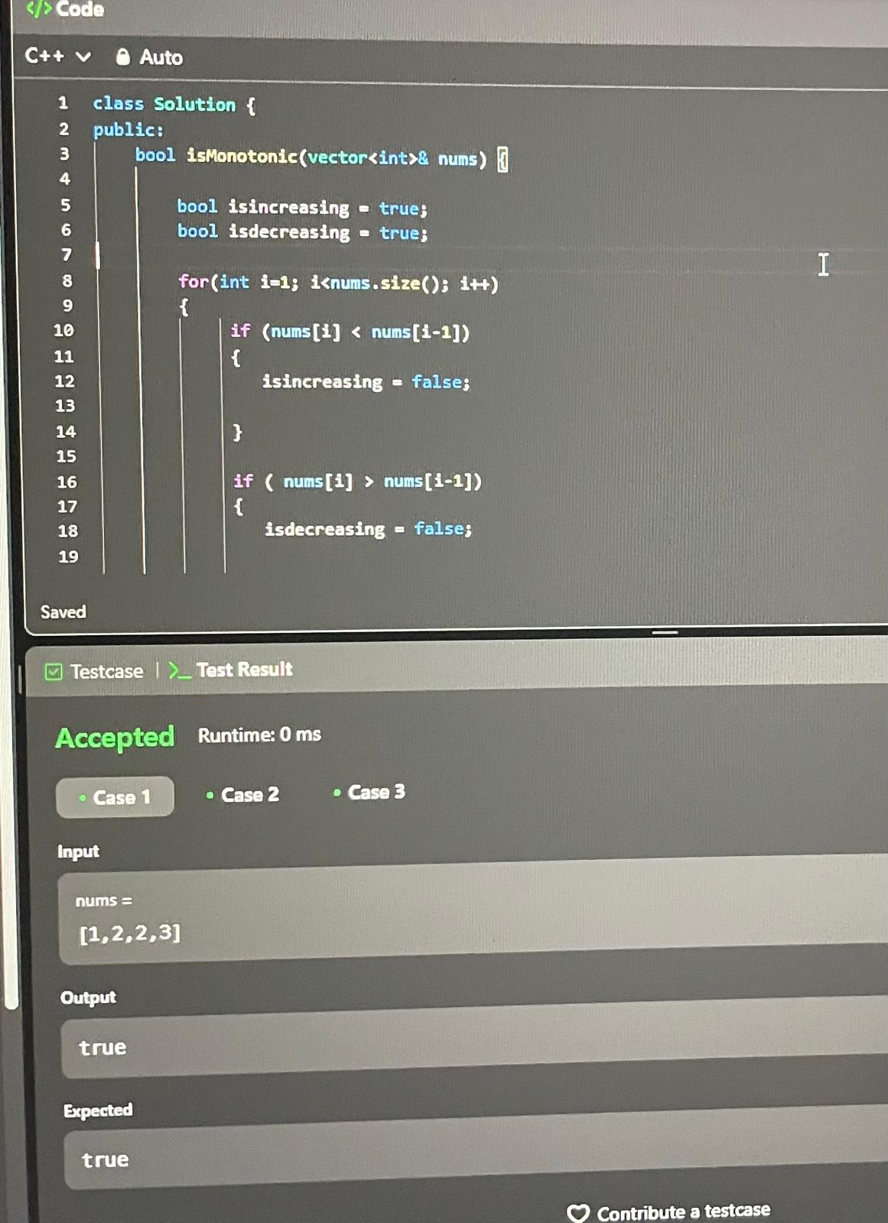

Discussion
count= 1 (isincreasing=true)
count = 1 (isdecreaasing=true)

//Loop initialization
count = 1 (i=1)
//Loop iteration
- count = 1 (I<nums.size())
- count = 1 (i++)
count =4 : double accessing array, comparison and assignment for the if satement

count = 1 for return

// Total operations
Total = 3 (initials) + 6(n-1) + 1 (return)
Total= 6n-2 operations

The Big-O complexity is O(n)

