Precisely 4750 days ago (give or take a few hours,) my First Generation iPhone was activated on an exceptionally cold Saturday – January 19th, 2008, a little over a week before my 14th birthday. In the time since, Apple has spread [over 1 Billion of these devices](https://www.theverge.com/2021/1/27/22253162/iphone-users-total-number-billion-apple-tim-cook-q1-2021) across this planet. The Internet that gave that first device the i in its name has expanded by a factor of twenty or more. Consumer technology’s future seemed more and more exiting up to a point (I have always said iOS7, but obviously, it varies) when progress suddenly made less and less sense, rending that future newly and profoundly confusing, and the bearing Western society would be taking there less and less coherent. Many of us are left now in that profound confusion, completely bewildered by anyone and everyone else’s personal utopia. Myself and my peers’ development as human beings coincided with the development of this metamorphosis in such a way that suggested humor at the spectacle of it all might be the safest way to cope. For myself, I should report, now, at 27 years old – having witnessed the most significant expansion of our species’ intellectual capabilities (and corresponding divisions) in its history just since 8th grade – that the humor has run entirely out. Determining what remains has been my own prime interpersonal struggle as of late, but I can at least tell you for certain that whatever it is exists in a more absolute state of inevitability than I could have ever imagined possible as I watched some AT&T employee crumple the clear plastic wrapping away from that most extraordinary matte black rectangular box containing my very first iPhone.[1]

It was an 8GB first-generation. I named­ it “Bob Geldoff” because I had absolutely no idea who that was[2], which I found hilarious.­ In the (admittedly unsolicited) self-psychoanalysis I’ve ended up in, these past few months, I would suggest that handset remains the single most powerful symbol of an era in my life when the future of technology felt absolutely enamoring. We were going to get to try everything just because we could, *and it was going to make everything better*. I watched and read the forming of the *Gadget Blogger* generation – Joshua Topolsky, then Joanna Stern, Paul Miller, Nilay Patel, Dieter Bohn, and others, all led by their seniors Walt Mossberg and Kara Swisher – who would eventually form the establishment technology media as it stands right now. On early tech YouTube, my friend and I worshipped SoldierKnowsBest, iJustine, and Jon4Lakers from our MacBooks – Mark Watson, Justine Ezarik, and Jon Rettinger, respectively – who managed to convey with their embedded iSight cameras the sort of Consumer Tech Hype which can become addicting, especially to those young minds searching for a simple framework from which to understand existence and time.

[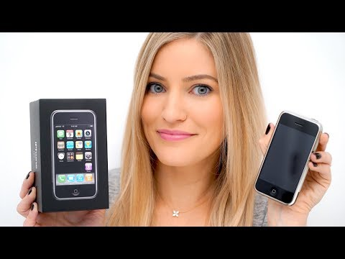](https://www.youtube.com/embed/4HX6R88QZB0?feature=oembed)

Big words for a cellular telephone review, eh?

"This *really is* my last iPhone."

This is the last sentence of [my very sentimental iPhone 8 Plus review](https://bilge.world/iphone-8-plus-review) from May, 2018, in which I bemoaned Apple's decision to finally retire the basic hardware configuration which had defined the marque's first ten years, citing my "loyalty."

In the past few weeks, I have come to realize that the device which I now hold in my hands - which I *cling to*, in fact, at all hours and completely without reason - is the absolute manifestation of everything my 14-year-old, first generation iPhone-adopting self could have possibly dreamt of in its future.

Unlike that iPhone 8 Plus review - which was a very sentimental reflection on "the last iPhone" designed in the configuration I had understood for a decade and therefore accompanied by a bunch of foolhardy lamentations *bitching* about the iPhone X - this review will be one of sincere wonderment regarding *the thing, itself.* Taken out of 2020 context and placed in my 14-year-old hand in 2009, this Pacific Blue iPhone 12 Pro Max would not have disappointed me in the slightest. By that, I mean... It is as unimaginably capable as I would have imagined.

These past months, I have indulged myself thoroughly in the company of this long-dormant *Handset Enthusiast* part of me – this dork who seems to be infinitely enchanted by conversations vaguely about innovation in a business which seemed almost inevitably alienating of anyone who didn't care enough about some unexotic discussion in the tech community to a demonstrably obsessive degree. Again, the experience has screamed over and over again that I am extremely vulnerable to high computing capability. In other words, the more a computer can do, the more I want to see what I can do *with* it[3]. For a very long time, iPhone OS' locked downness actually helped me tremendously in this regard.

1. I may actually be the most qualified person on Earth to reflect on this subject, given that I represent the very first microgeneration to have smartphones for all of our adult lives. (Just barely.)
2. I still have no idea who Bob Geldoff is.
3. I have come to refer to this as [*Just Fucking Around*](https://github.com/extratone/bilge/issues/8).