arcotpixel

Syndrome Sinistre: Left Brachiocephalic Vein Compression and its Neurolgical Manifestations.

Background:
Embryologically, the left brachiocephalic vein (LBV) originates as an anastamotic channel between the right and left anterior cardinal veins ^{1}. This positions the LBV between the manubrium sterni anteriorly and the innominate artery posteriorly ^{2}. This pattern of adjacency of the aorta to the LBV is unique to mammals and results from a quirk of evolution ^{3}. With age, the ascending aorta, unfolds, elongates and dilates ^{4}. Simultaneously, there is a change in the thoracic geometry that reduces the thoracic volume primarily from disc height loss and kyphosis ^{5}. These transitions progressively compress the LBV. Normally this compression is circumvented via collateral pathways and "Blood finds a way" ^{6}. However "What if these collaterals are insuffcient?" is a question that has not been answered. It is possible that there is no clinical detriment and this is just an innocuous finding. On the contrary, it may signal a whole class of neurological disorders and explain the pathophysiology of hitherto unexplained neurological and neurodegenrative conditions.

Embryology, Anatomy, Radiology and Clinical Features:
The anterior cardinal veins drain the cephalic portion of the embryo. During week eight of development the thyroid and thymic veins join to form a large transverse anastamosis superior to the common cardinal veins. This anastamosis allows blood from the cephalic portion of left anterior cardinal vein (future left internal jugular vein) to reach the junction of the right anterior cardinal vein (future right internal jugular vein) and right common cardinal vein (future superior venacava (SVC)). Various developmental venous malformations (left sided SVC, double SVC) may occur if the above does not proceed according to plan ^{7}. Normally however, one ends up with an efficent LBV that transports blood from the left internal jugular vein to the superior vena cava. Until, of course, it is smothered by its more sturdy neighbours.
The LBV vein is approximately 6 cm to 7 cm long. It is formed by the confluence of the left internal jugular vein and the left subclavian vein behind the left sternoclavicular joint. It then runs and obliuqe and downward course to the right to join the right brachiocephalic vein and form the superior vena cava behind the sternum and the first intercostal space. In its course, it receives the the following veins: left vertebral, left inferior thyroid, left internal thoracic, left superior intercostal, left supreme intercostal, thymic and pericardiacophrenic veins. Its relations with its less compliant neighbours forms the crux of this syndrome. It initially runs anterior to the parietal pleura of the lung and then enters a valley between the bony manubrium anteriorly and an unyielding innominate artery posteriorly ^{2}. It is in this valley that the LBV gets trapped usually for a few millimeters congruent with the portion in contact with the innominate artery.
The radiological findings are often obvious but the apparent lack of clinical relevance lends to under reporting. As an example, osteporotic vertebral fractures suffer a similar fate ^{8}. There are excellent examples of LBV compression with resultant venous reflux on CT angiography ^{9, 10}. Similar findings are noted on MR Venography ^{11}. This condition will continue to elude detection by CT angiography, if right sided injections are performed ^{10} and MR venography of the neck if coverage does not extend down to the level of the LBV.
Intravascular ultrasound (IVUS) however should be the new "gold standard" for diagnosis as it clearly identifies and demonstrates the dramatic decrease in luminal area while providing accurate vessel measurements that are necessary for treatment.
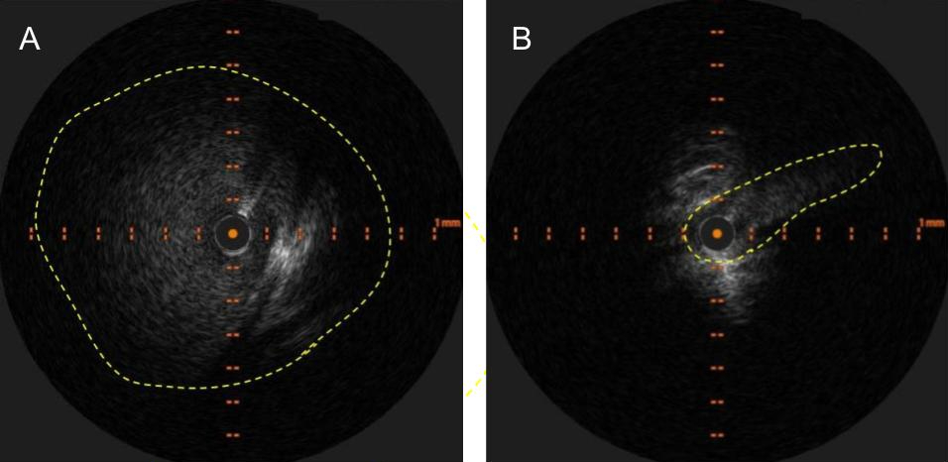 Figure 1: Appearance of LBV on intravascular ultrasound with manual demarcation of approximate border with dashed yellow lines
Clinically, in my experience, there appears to be a predeliction for headaches, vertigo, tinnitus, deafness and imbalance. Some patients report a disbaling "brain fog" in addition. Conventional catheter based angiopgraphy is useful in depicting the delay in venous emptying or stagnation or slowing of flow in the left internal jugular vein. It is also useful in depicting a radiological improvement in flow after treatement. Conventional catheter based venography is a poor modality to detect this condition, as the plane of compression is usually parallel to the antero-posterior plane and the lateral plane is obscured by the patients arms. Venous stagnation or reflux sometimes with diverticulae are noted.
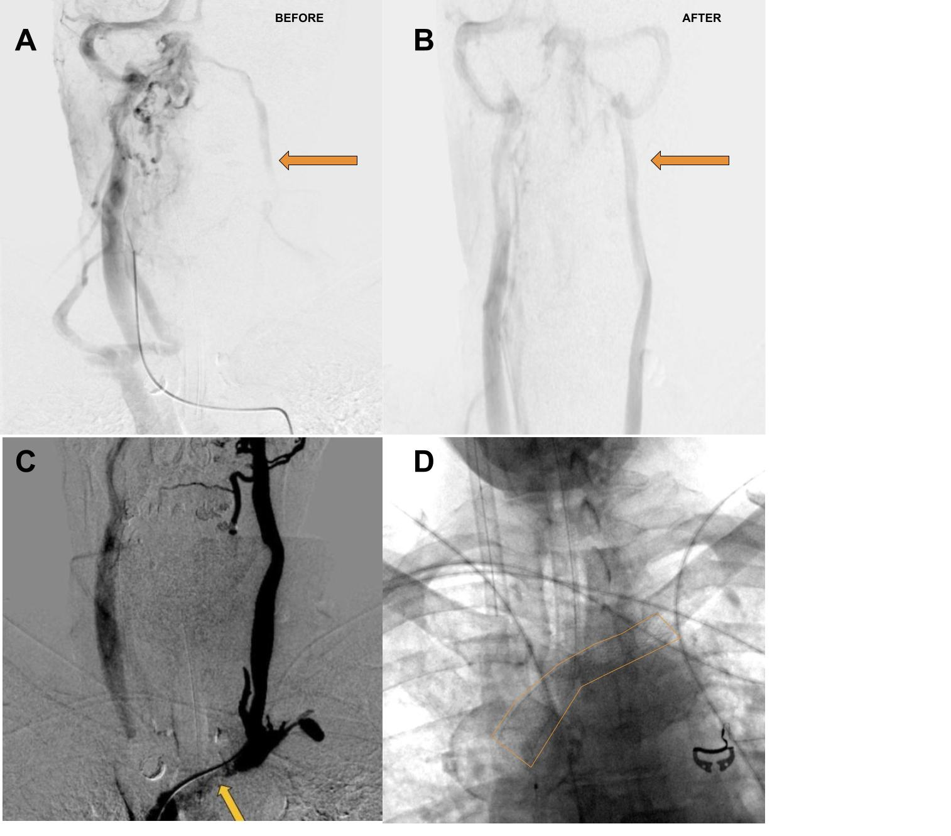 Figure 2: A. Delayed phase of arterial angiogram showing poor flow in the left internal jugular vein (orange arrow) with B. normalization after stenting of the left brachiocephalic vein C. Left Internal Jugular Vein injection with retrograde flow into the cranium and across the torcula and emptying via the right internal jugular vein due to LBV compression (orange arrow) D. Left Brachiocephalic Stent Outlined with orange line
As an intersting aside, there occurs an intersection between pacemakers / defibrillators and LBV compression. The leads are typically inserted on the side of the non dominant hand ^{12}. They can occupy some valuable space in the LBV and produce the above symptoms.
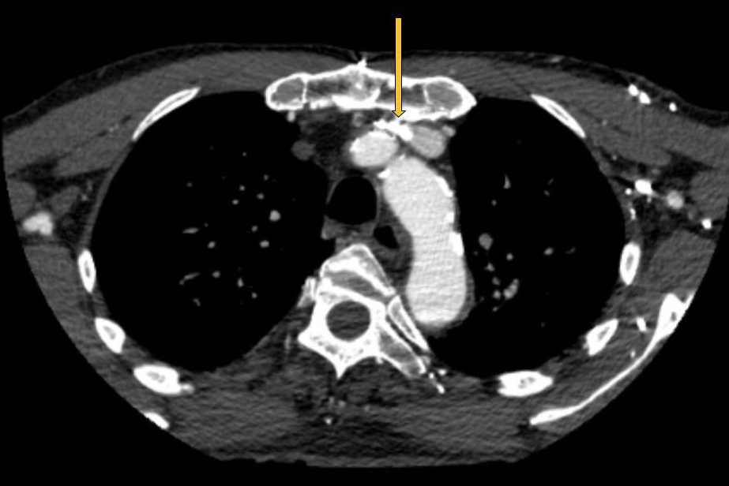 Figure 3: Pacemaker leads compounding the venous outflow obstruction in the setting of LBV compression.

Discussion:
LBV compression should be expected to occur and progress with aging due to the anatomical factors described above. It should generally be asymptomatic given the remarkable redundancy of the venous system and its collaterals. Symptoms should and do ensue when the venous collaterals are either insufficient or overwhelmed. This can be compounded by venous obstruction on the contralateral side, which is not uncommon. For example, trapping of the right internal jugular vein at the level of the C1 transverse process which is commonly noted in a similar age group. In fact it might be necesary for bilateral outflow obstruction given the robust nature of the connections between the dural sinuses. This results in the emergence of two pathophysiological states. One governed by a build up of pressure due to venous hypertension and the other governed by stagnation / venous congestion. The venous hypertensive state could potentially explain the mechanical effects such as headache and disorders that arise from obstruction of csf. Accumulation of toxic waste metabolites ^{13} due to poor venous outflow could potentially explain the chemical effects that lead to neurological dysfunction or even neurodegenration. Ageing is a risk factor for neurodegenerative disease ^{14} and ageing is a risk factor for LBV compression. Is it possible that the LBV compression is an important precursor of neurodegenrative diseases?
There have been multiple attempts to link singular neurological disorders to venous outflow obstruction. The obverse, multiple neurological manifestations from a single site of obstruction appears more likely. The prime example was chronic cerebro spinal venous insufficiency which tied itself to multiple sclerosis ^{15}. It was heralded by a flurry of research which simply imploded when the initial results were not widely repoducible ^{16}. This may have been responsible for the general perecption of dubiousness and sometimes outright opposition to venous procedures for neurological disorders. As another example, transverse sinus stenosis as a cause of intracranial hypertension, is a more recent association that appears in need of definitive evidence to become widely accepted ^{17}. The list continues on with conditions such as transient global amnesia ^{11}, deafness ^{18}, Normal Pressure Hydeocephalus ^{19} and so on.
One could argue that a more holistic approach is in order. If such an approach was applied, the entire class of disorders, neurological or otherwise would come under an umbrella term such as Venous Outflow Obstruction Disorders (Voodoo). The venous hierarchy (for the superior vena caval system) would be along anatomical lines beginning with the cortical veins, coursing through the superior sagittal, inferior sagittal and straight sinuses, moving on to the transverse and signoid sinuses, followed by the paired jugular and brachiocephalic veins with the superior venacava and the right heart, pulmonary arteries and left heart forming the inferior portions. Theoretically, any dowstream segment in this hierarchy should be able to affect any upstream segment and produce a disorder based on the affected territory. For example, one should not be surprised when superior vena caval stenosis produces papilledema in a patient and similarly not be surprised if transverse sinus stenting does not relieve the papilledema in said patient. Thus it would be important to evaluate the entire pathway and treat tandem lesions, in some cases bilaterally in order to restore good venous outflow from both the superficial and deep pathways.
LBV compression would fall into this class of disorders. The neurological symptoms would depend on the drainage pathway that was affected. On the surface, this condition appears to associated with seemingly innocuous complaints such as headache and vertigo. At a deeper level it may be a precursor of more sinister neurodegenerative disorders. Given the simplicity of its treatment with stenting, it represents a serious target for further research along with other venous outflow obstruction disorders.

Bibliography
1. Mozes G, Gloviczki P. CHAPTER 2 - Venous Embryology and Anatomy. In: Bergan JJ, ed. The Vein Book. Academic Press; 2007:15-25. doi:10.1016/B978-012369515-4/50005-3
2. Standring S. Gray’s Anatomy E-Book: The Anatomical Basis of Clinical Practice. Elsevier; 2015. http://ebookcentral.proquest.com/lib/nyulibrary-ebooks/detail.action?docID=4187461
3. Hirokawa N, Tanaka Y, Okada Y. Left–Right Determination: Involvement of Molecular Motor KIF3, Cilia, and Nodal Flow. Cold Spring Harbor Perspectives in Biology. 2009;1(1):a000802. doi:10.1101/cshperspect.a000802
4. Ohyama Y, Redheuil A, Kachenoura N, Ambale Venkatesh B, Lima JA. Imaging Insights on the Aorta in Aging. Circulation: Cardiovascular Imaging. 2018;11(4):e005617. doi:10.1161/CIRCIMAGING.117.005617
5. Holcombe SA, Wang SC, Grotberg JB. Age-related changes in thoracic skeletal geometry of elderly females. Traffic Injury Prevention. 2017;18(sup1):S122-S128. doi:10.1080/15389588.2017.1309526
6. Marini TJ, Chughtai K, Nuffer Z, Hobbs SK, Kaproth-Joslin K. Blood finds a way: pictorial review of thoracic collateral vessels. Insights into Imaging. 2019;10(1):63. doi:10.1186/s13244-019-0753-3
7. White HJ, Soos MP. Anatomy, Thorax, Superior Vena Cava. In: StatPearls. StatPearls Publishing; 2022. http://www.ncbi.nlm.nih.gov/books/NBK545255/
8. Williams AL, Al-Busaidi A, Sparrow PJ, Adams JE, Whitehouse RW. Under-reporting of osteoporotic vertebral fractures on computed tomography. European Journal of Radiology. 2009;69(1):179-183. doi:10.1016/j.ejrad.2007.08.028
9. Seth R, Bhatia V, Jain C, Kumar A. Intracranial Venous Sinus Reflux on CT Angiography: Benign or Malignant Entity? The Indian Journal of Radiology & Imaging. 2022;31(4):1075-1078. doi:10.1055/s-0041-1741097
10. Tseng YC, Hsu HL, Lee TH, Chen CJ. Venous Reflux on Carotid Computed Tomography Angiography: Relationship With Left-Arm Injection. Journal of Computer Assisted Tomography. 2007;31(3):360-364. doi:10.1097/01.rct.0000243445.95491.f2
11. Han K, Chao AC, Chang FC, et al. Obstruction of Venous Drainage Linked to Transient Global Amnesia. PloS One. 2015;10(7):e0132893. doi:10.1371/journal.pone.0132893
12. Pacemaker implantation - How it’s performed. nhsuk. Published online October 2017. https://www.nhs.uk/conditions/pacemaker-implantation/what-happens/
13. Cheng Y, Haorah J. How does the brain remove its waste metabolites from within? International Journal of Physiology, Pathophysiology and Pharmacology. 2019;11(6):238-249. https://www.ncbi.nlm.nih.gov/pmc/articles/PMC6971497/
14. Hou Y, Dan X, Babbar M, et al. Ageing as a risk factor for neurodegenerative disease. Nature Reviews Neurology. 2019;15(10):565-581. doi:10.1038/s41582-019-0244-7
15. Zamboni P, Galeotti R, Menegatti E, et al. Chronic cerebrospinal venous insufficiency in patients with multiple sclerosis. Journal of Neurology, Neurosurgery, and Psychiatry. 2009;80(4):392-399. doi:10.1136/jnnp.2008.157164
16. Baracchini C, Valdueza JM, Del Sette M, et al. CCSVI and MS: a statement from the European Society of neurosonology and cerebral hemodynamics. Journal of Neurology. 2012;259(12):2585-2589. doi:10.1007/s00415-012-6541-3
17. Gurney SP, Ramalingam S, Thomas A, Sinclair AJ, Mollan SP. Exploring The Current Management Idiopathic Intracranial Hypertension, And Understanding The Role Of Dural Venous Sinus Stenting\textless/p\textgreater. Eye and Brain. 2020;12:1-13. doi:10.2147/EB.S193027
18. Griffith AN. Venous Obstruction of the Labyrinth: Some Experimental and Anatomical Studies. Proceedings of the Royal Society of Medicine. 1961;54(10):917-922. doi:10.1177/003591576105401017
19. Satow T, Aso T, Nishida S, et al. Alteration of Venous Drainage Route in Idiopathic Normal Pressure Hydrocephalus and Normal Aging. Frontiers in Aging Neuroscience. 2017;9:387. doi:10.3389/fnagi.2017.00387

