**Overview of all our user stories – Taiga**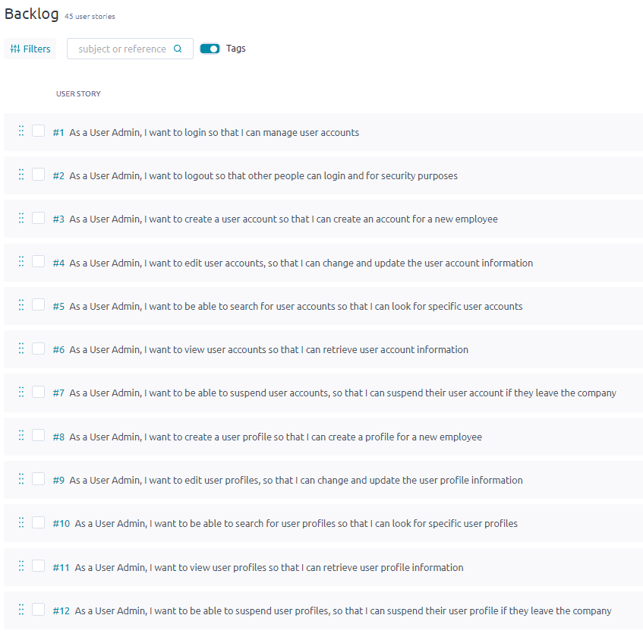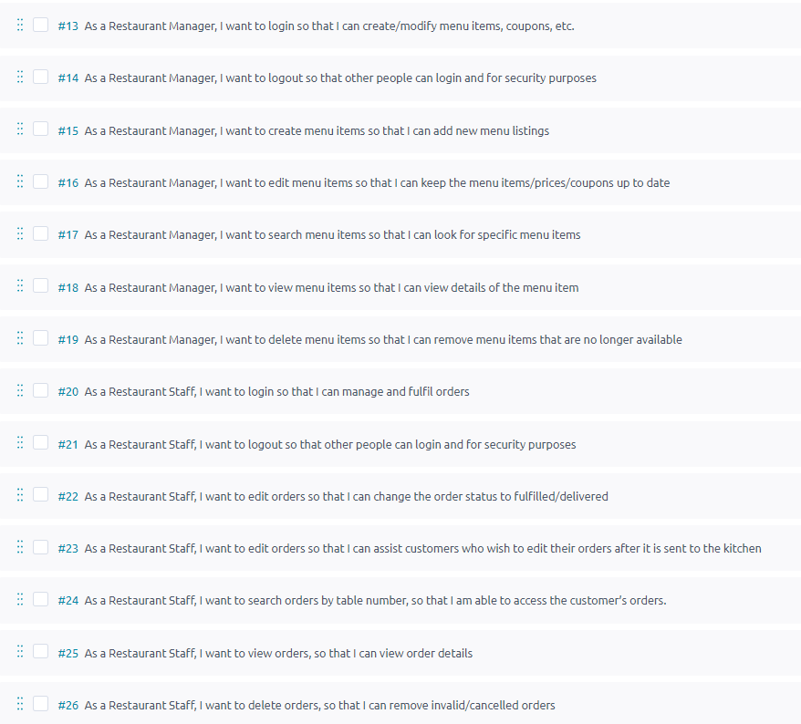 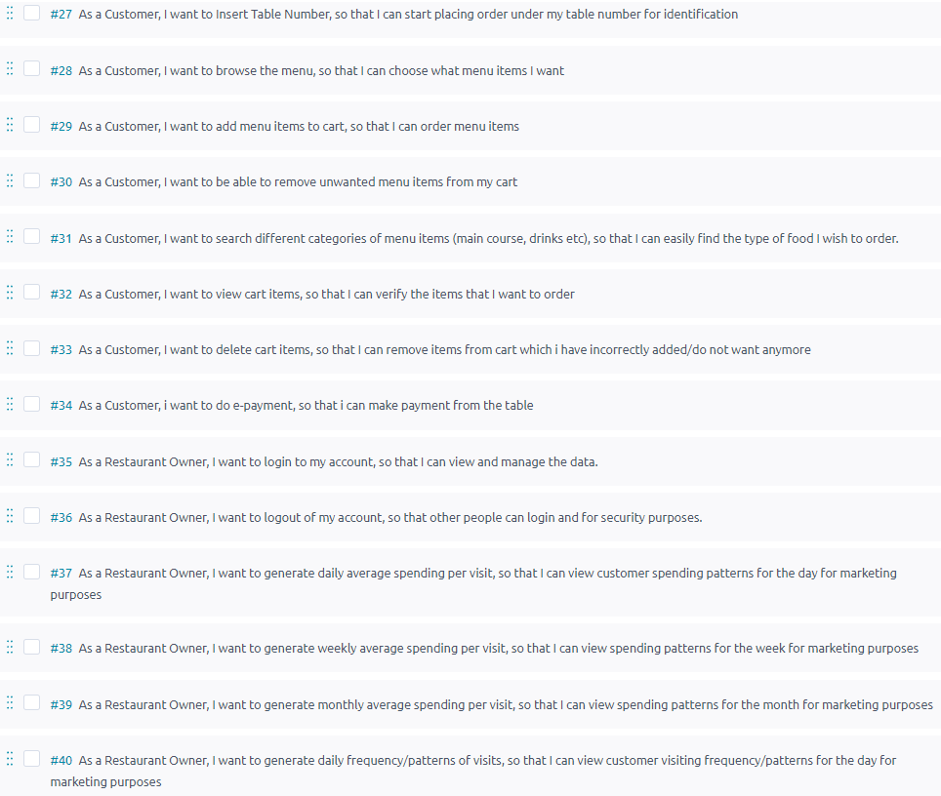 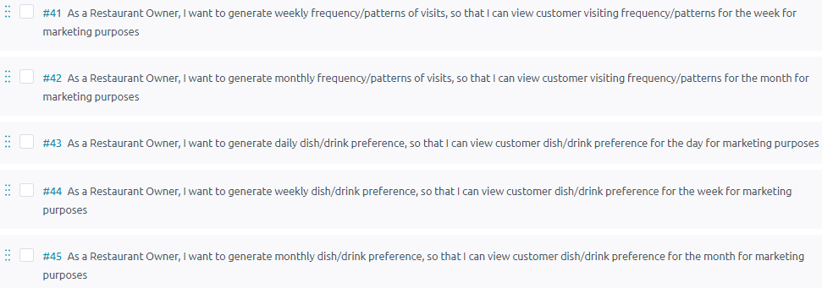

**Meeting Minutes #1**

|  |  |
| --- | --- |
| Location: | SIM Campus |
| Date: | 22/04/2022 |
| Time: | 1800hrs |
| Attendees: | All present |

# Agenda items

1. Decide on the user stories that should be added into our first sprint.
2. Delegate the tasks required of our first sprint’s user stories.
3. Draft diagrams e.g., Use Case Diagram, Sequence Diagram, Wireframe Diagram.
4. Setup Taiga and GitHub.

| Action items | Owner(s) | Deadline |
| --- | --- | --- |
| Meeting Minutes | Kwan Quan | 22/04/2022 |
| Use Case Diagram | Damian | 23/04/2022 |
| Use Case Description | Kwan Quan | 23/04/2022 |
| BCE Diagram | Sean | 23/04/2022 |
| UML Diagram | Sean | 23/04/2022 |
| Sequence Diagram | Sean | 23/04/2022 |
| Wireframe Diagram | Sean | 23/04/2022 |
| Data Persistence Diagram | Amir | 23/04/2022 |
| Front-End Programming | Tze Wei | 27/04/2022 |
| Back-End Programming | Mervyn/Tze Wei | 27/04/2022 |
| Database Programming | Joshua | 27/04/2022 |
| Testing | Damian | 28/04/2022 |
| Report | Kwan Quan | 28/04/2022 |

**Sprint #1 – 22/04/2022 – 28/04/2022**

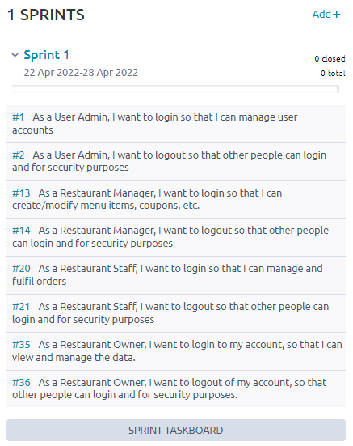

Figure : Screenshot of Sprint 1 from Taiga

**User Story**

1. #1 – As a User Admin, I want to login so that I can manage user accounts.
2. #2 – As a User Admin, I want to logout so that other people can login and for security purposes.
3. #13 – As a Restaurant Manager, I want to login so that I can create/modify menu items, coupons, etc.
4. #14 – As a Restaurant Manager, I want to logout so that other people can login and for security purposes.
5. #20 – As a Restaurant Staff, I want to login so that I can manage and fulfil orders.
6. #21 – As a Restaurant Staff, I want to logout so that other people can login and for security purposes.
7. #35 – As a Restaurant Owner, I want to login to my account, so that I can view and manage the data.
8. #36 – As a Restaurant Owner, I want to logout of my account, so that other people can login and for security purposes.

**Use Case Diagram**

1. Actors – User Admin, Restaurant Manager, Restaurant Staff, Restaurant Owner
2. User Story - #1, #2, #13, #14, #20, #21, #35, #36
3. Task - #57, #62, #74, #84, #94, #104, #114, #124

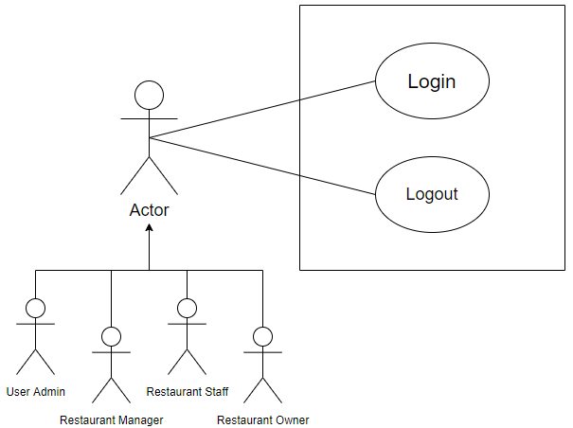

Figure : Use Case Diagram 1

**Use Case Description**

1. User Admin Login – Task #70

|  |  |
| --- | --- |
| Use Case ID | #1 |
| Use Case Name | User Admin Login |

|  |  |
| --- | --- |
| Actor | * User Admin |
| Description | * User Admin wants to login to their account |
| Pre-Condition | * User Admin must have a valid account |
| Trigger | * User Admin wants to have access to their account |
| Normal Flow | * User Admin enters username and password for their account and selects the “Administrator” user profile from the dropdown menu * User Admin then clicks on the “Login” button |
| Sub Flow | * None |
| Alt/Exceptional Flow | * Account details (username/password/user profile) are incorrect * Application informs User Admin that their credentials are invalid * Repeat normal flow |

1. User Admin Logout – Task #71

|  |  |
| --- | --- |
| Use Case ID | #2 |
| Use Case Name | User Admin Login |

|  |  |
| --- | --- |
| Actor | * User Admin |
| Description | * User Admin wants to logout of their account |
| Pre-Condition | * User Admin must be logged in |
| Trigger | * User Admin wants to exit their account |
| Normal Flow | * User Admin then clicks on the “Logout” button |
| Sub Flow | * None |
| Alt/Exceptional Flow | * None |

1. Restaurant Manager Login – Task #75

|  |  |
| --- | --- |
| Use Case ID | #13 |
| Use Case Name | Restaurant Manager Login |

|  |  |
| --- | --- |
| Actor | * Restaurant Manager |
| Description | * Restaurant Manager wants to login to their account |
| Pre-Condition | * Restaurant Manager must have a valid account |
| Trigger | * Restaurant Manager wants to have access to their account |
| Normal Flow | * Restaurant Manager enters username and password for their account and selects the “Restaurant Manager” user profile from the dropdown menu * Restaurant Manager then clicks on the “Login” button |
| Sub Flow | * None |
| Alt/Exceptional Flow | * Account details (username/password/user profile) are incorrect * Application informs Restaurant Manager that their credentials are invalid * Repeat normal flow |

1. Restaurant Manager Logout – Task #85

|  |  |
| --- | --- |
| Use Case ID | #14 |
| Use Case Name | Restaurant Manager Logout |

|  |  |
| --- | --- |
| Actor | * Restaurant Manager |
| Description | * Restaurant Manager wants to logout of their account |
| Pre-Condition | * Restaurant Manager must be logged in |
| Trigger | * Restaurant Manager wants to exit their account |
| Normal Flow | * Restaurant Manager then clicks on the “Logout” button |
| Sub Flow | * None |
| Alt/Exceptional Flow | * None |

1. Restaurant Staff Login – Task #95

|  |  |
| --- | --- |
| Use Case ID | #20 |
| Use Case Name | Restaurant Staff Login |

|  |  |
| --- | --- |
| Actor | * Restaurant Staff |
| Description | * Restaurant Staff wants to login to their account |
| Pre-Condition | * Restaurant Staff must have a valid account |
| Trigger | * Restaurant Staff wants to have access to their account |
| Normal Flow | * Restaurant Staff enters username and password for their account and selects the “Restaurant Staff” user profile from the dropdown menu * Restaurant Staff then clicks on the “Login” button |
| Sub Flow | * None |
| Alt/Exceptional Flow | * Account details (username/password/user profile) are incorrect * Application informs Restaurant Staff that their credentials are invalid * Repeat normal flow |

1. Restaurant Staff Logout – Task #105

|  |  |
| --- | --- |
| Use Case ID | #21 |
| Use Case Name | Restaurant Staff Logout |

|  |  |
| --- | --- |
| Actor | * Restaurant Staff |
| Description | * Restaurant Staff wants to logout of their account |
| Pre-Condition | * Restaurant Staff must be logged in |
| Trigger | * Restaurant Staff wants to exit their account |
| Normal Flows | * Restaurant Staff then clicks on the “Logout” button |
| Sub Flows | * None |
| Alt/Exceptional Flow | * None |

1. Restaurant Owner Login – Task #115

|  |  |
| --- | --- |
| Use Case ID | #35 |
| Use Case Name | Restaurant Owner Login |

|  |  |
| --- | --- |
| Actor | * Restaurant Owner |
| Description | * Restaurant Owner wants to login to their account |
| Pre-Condition | * Restaurant Owner must have a valid account |
| Trigger | * Restaurant Owner wants to have access to their account |
| Normal Flow | * Restaurant Owner enters username and password for their account and selects the “Restaurant Owner” user profile from the dropdown menu * Restaurant Owner then clicks on the “Login” button |
| Sub Flow | * None |
| Alt/Exceptional Flow | * Account details (username/password/user profile) are incorrect * Application informs Restaurant Owner that their credentials are invalid * Repeat normal flow |

1. Restaurant Owner Logout – Task #125

|  |  |
| --- | --- |
| Use Case ID | #36 |
| Use Case Name | Restaurant Owner Logout |

|  |  |
| --- | --- |
| Actor | * Restaurant Owner |
| Description | * Restaurant Owner wants to logout of their account |
| Pre-Condition | * Restaurant Owner must be logged in |
| Trigger | * Restaurant Owner wants to exit their account |
| Normal Flows | * Restaurant Owner then clicks on the “Logout” button |
| Sub Flows | * None |
| Alt/Exceptional Flow | * None |

**BCE / Sequence / Wireframe Diagram**

1. Actors – User Admin, Restaurant Manager, Restaurant Staff, Restaurant Owner
2. Login Function
3. User Story - #1, #13, #20, #35
4. Task - #58, #59, #60, #76, #77, #78, #96, #97, #98, #116, #117, #118

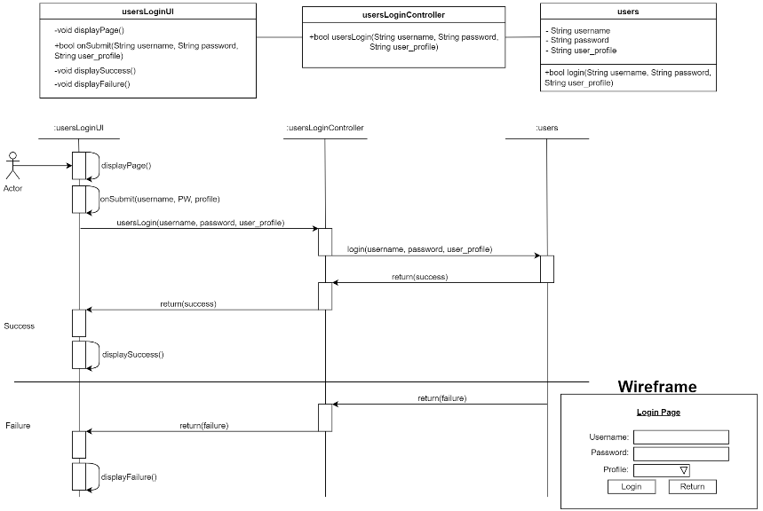

Figure : BCE / Sequence / Wireframe Diagram 1

**BCE / Sequence / Wireframe Diagram**

1. Actors – User Admin, Restaurant Manager, Restaurant Staff, Restaurant Owner
2. Logout Function
3. User Story - #2, #14, #21, #36
4. Task - #63, #64, #65, #86, #87, #88, #106, #107, #108, #126, #127, #128

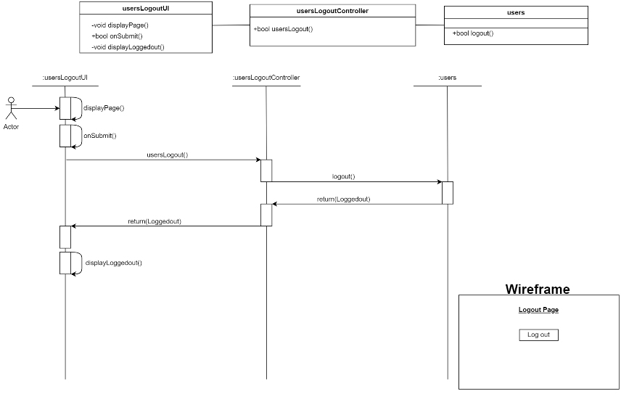

Figure : BCE / Sequence / Wireframe Diagram 2

**Data Persistence Diagram**

* Task – #61, #66, #79, #89, #99, #109, #119, #129

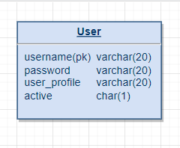

Figure : Data Persistence Diagram

**Progression – Taiga**

* User Story – #1, #2, #13, #14, #20, #21, #35, #36.

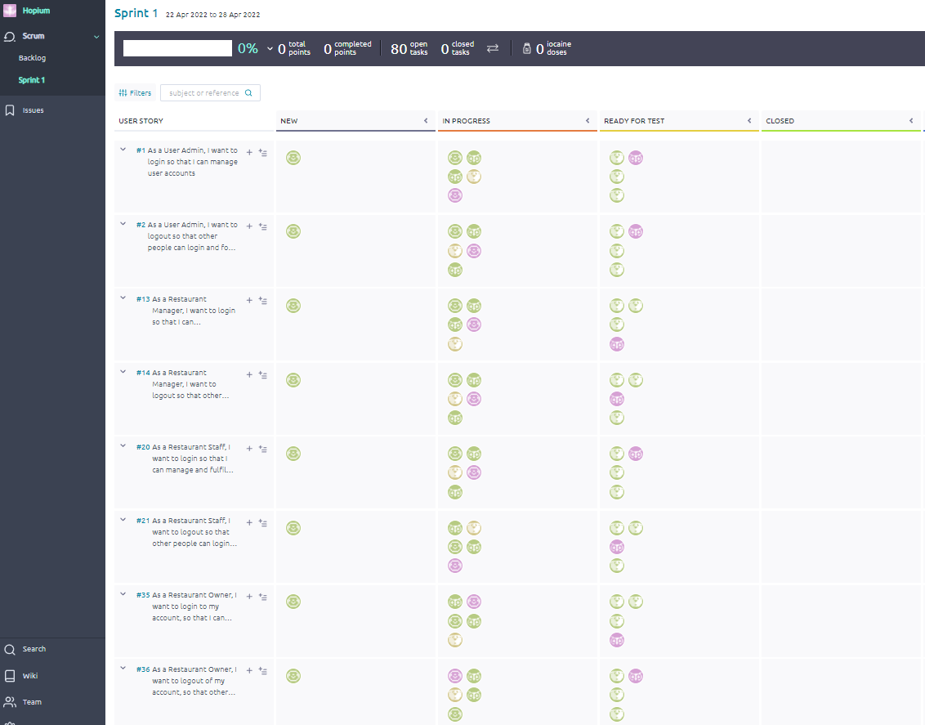

Figure : Screenshot of Progress from Taiga

**Progression – Taiga**

* User Story – #1, #2, #13, #14, #20, #21, #35, #36.

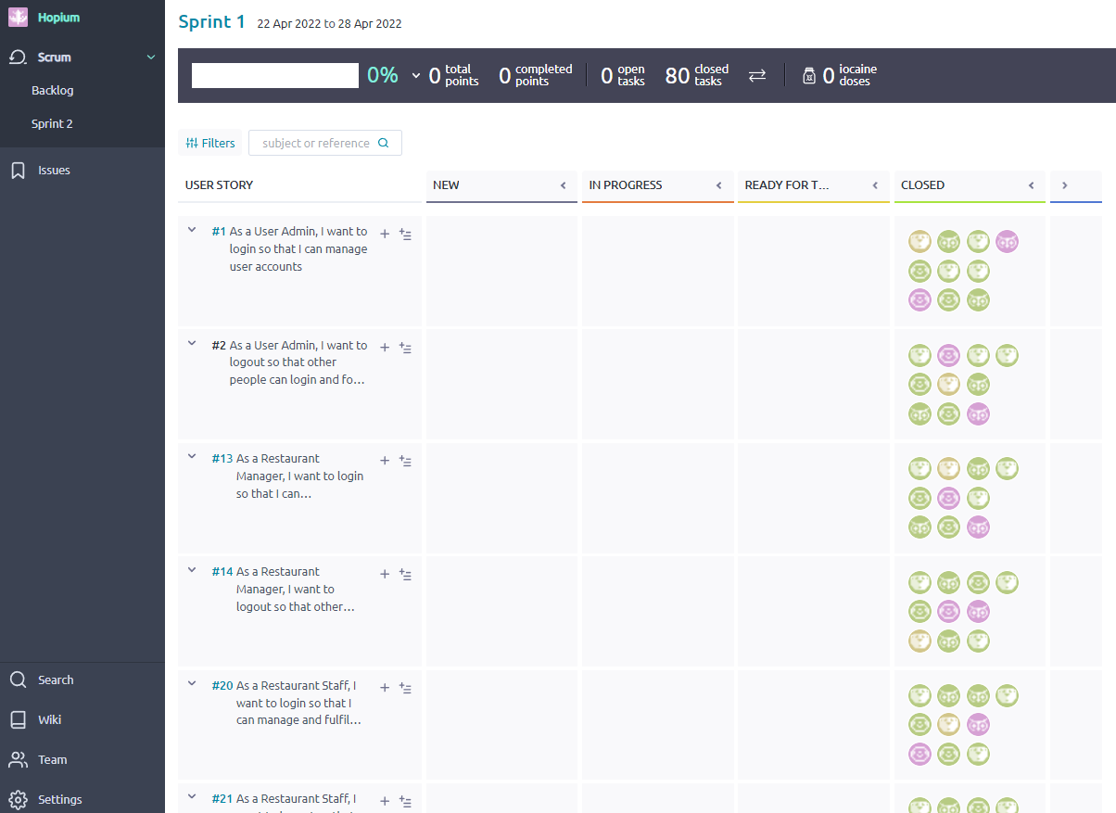

Figure : Screenshot of progression from Taiga - Closed

**Work in Progress – Software System**

* Staff Login Page

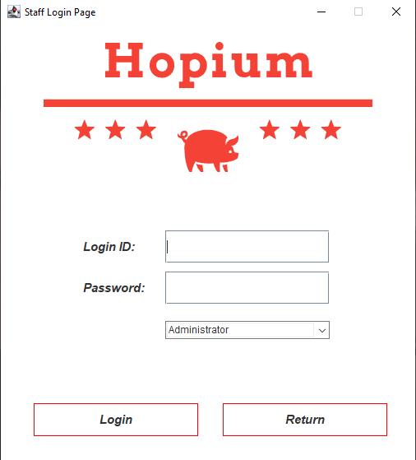

Figure : Staff Login UI

**Work in Progress – Software System**

**Test Plan**

**Meeting Minutes #2**

|  |  |
| --- | --- |
| Location: | Online - Discord |
| Date: | 28/04/2022 |
| Time: | 2100hrs |
| Attendees: | All present |

# Agenda items

1. Review what we have accomplished during our first sprint.
2. Show some demo of what we have achieved for our software system.

| Action items | Owner(s) | Deadline |
| --- | --- | --- |
| Meeting Minutes | Kwan Quan | 28/04/2022 |
| Demo of software system | Damian | 28/04/2022 |
| Report | Kwan Quan | 28/04/2022 |

**Meeting Minutes #3**

|  |  |
| --- | --- |
| Location: | SIM Campus |
| Date: | 29/04/2022 |
| Time: | 1800hrs |
| Attendees: | All present |

# Agenda items

1. Decide on the user stories that should be added into our second sprint.
2. Delegate the tasks required of our second sprint’s user stories.
3. Draft diagrams e.g., Use Case Diagram, Sequence Diagram, Wireframe Diagram.

| Action items | Owner(s) | Deadline |
| --- | --- | --- |
| Meeting Minutes | Kwan Quan | 29/04/2022 |
| Use Case Diagram | Amir | 31/04/2022 |
| Use Case Description | Amir | 31/04/2022 |
| BCE Diagram | Sean | 31/04/2022 |
| UML Diagram | Sean | 31/04/2022 |
| Sequence Diagram | Sean | 31/04/2022 |
| Wireframe Diagram | Sean | 31/04/2022 |
| Data Persistence Diagram | Amir | 31/04/2022 |
| Front-End Programming | Tze Wei | 04/05/2022 |
| Back-End Programming | Mervyn/Tze Wei/Kwan Quan | 04/05/2022 |
| Database Programming | Joshua | 04/05/2022 |
| Testing | Damian | 05/05/2022 |
| Report | Kwan Quan | 05/05/2022 |

**Sprint #2 – 29/04/2022 – 05/05/2022**

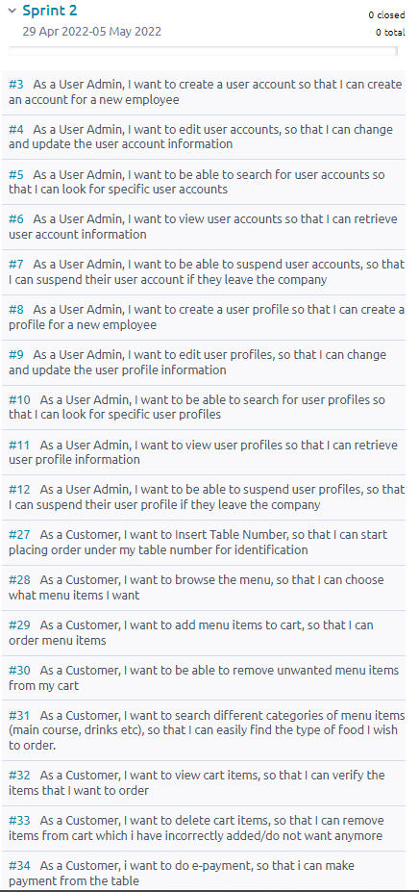

Figure : Screenshot of Sprint 2 from Taiga

**User Story**

1. #3 – As a User Admin, I want to create a user account so that I can create an account or a new employee.
2. #4 – As a User Admin, I want to edit user accounts so that I can change and update the user account information.
3. #5 – As a User Admin, I want to be able to search for user accounts so that I can look or specific user account.
4. #6 – As a User Admin, I want to view user accounts so that I can retrieve user account information.
5. #7 – As a User Admin, I want to be able to suspend user accounts so that I can suspend their account if they leave the company.
6. #8 – As a User Admin, I want to create a user profile so that I can create a profile for a new employee.
7. #9 – As a User Admin, I want to edit user profiles so that I can change and update the user profile information.
8. #10 – As a User Admin, I want to be able to search for user profiles so that I can look for specific user profiles.
9. #11 – As a User Admin, I want to be able to view user profiles so that I can retrieve user profile information.
10. #12 – As a User Admin, I want to be able to suspend user profiles so that I can suspend their user profile if they leave the company.
11. #27 – As a Customer, I want to insert table number so that I can start placing order under my table number for identification.
12. #28 – As a Customer, I want to browse the menu so that I can choose what menu items I want.
13. #29 – As a Customer, I want to add menu items to cart so that I can order menu items.
14. #30 – As a Customer, I want to be able to remove unwanted menu items from my cart.
15. #31 – As a Customer, I want to search different categories of menu items (main course, drinks, etc.) so that I can easily find the type of food I wish to order.
16. #32 – As a Customer, I want to view cart items so that I can verify the items that I want to order.
17. #33 – As a Customer, I want to delete cart items so that I can remove items from cart which I have incorrectly added/do not want anymore.
18. #34 – As a Customer, I want to do e-payment, so that I can make payment from the table.