UNIVERSITY OF GHANA — DEPARTMENT OF COMPUTER SCIENCE
DCIT 208 — SOFTWARE ENGINEERING
D2: Software Requirements Specification
Team Name | Snart
Project Title | InspectoFleet
Client Name | Phanuel K. A. Wagba
Repository URL | https://github.com/Dept-of-Comp-Sci-University-of-Ghana/dcit208-client-project-2026-team-engineering-repository-seg26-77
AI Assistance Disclosure | Claude (Anthropic) was used to structure this SRS, organize sections per the deliverable instructions, and draft use case and user story scaffolding. All client requirements, acceptance criteria, and validation decisions were supplied and reviewed by the team. See AI_USAGE.md for the full log.

A. Requirements Overview

A1. Purpose and Scope
This Software Requirements Specification (SRS) defines the functional and non-functional requirements for InspectoFleet, a digital vehicle inspection and fleet-status system being built for Kal Car Rentals this semester. The document establishes the requirements baseline from which the product backlog, architecture, and implementation will be derived.
InspectoFleet replaces Kal Car Rentals’ paper-based vehicle inspection process with a mobile-friendly digital workflow that captures time stamped photographic evidence of vehicle condition at handover and return. It also provides a fleet status dashboard giving fleet managers visibility into vehicle availability and inspection history.

A2. System Boundary
In scope for this semester: digital inspection workflow (mobile interface), time stamped photo evidence capture, inspection record storage and retrieval, fleet status dashboard, user authentication and role based access control.
Explicitly out of scope: physical GPS/telemetry hardware integration, payment processing, customer-facing portal, native mobile app (iOS/Android), and SMS/email notifications. The system will be designed so GPS/telemetry data can be integrated in a future phase without redesigning the core.

A3. Stakeholder Map and User Roles
- Counter Agent — performs vehicle handover/return inspections; primary user of the mobile inspection interface
- Fleet Manager — monitors vehicle status and inspection history; primary user of the fleet dashboard
- Management / Owner (Phanuel K. A. Wagba) — reviews summary reports and dispute evidence; secondary system user
- Customers — indirect stakeholders; not direct system users but directly affected by evidence captured at handover/return

A4. High-Level Narrative
When a customer collects a vehicle, a counter agent opens InspectoFleet on their mobile device, starts a new inspection linked to the rental contract and vehicle, and photographs the vehicle from required angles. Each photo is automatically time-stamped and attached to the inspection record. When the vehicle returns, the same process is repeated. If a damage dispute arises, staff can retrieve the before/after inspection records as evidence.
Fleet managers view a dashboard showing which vehicles are available, rented, or currently under inspection, and can browse inspection history by vehicle.

A5. Assumptions, Constraints and Dependencies
- Counter agents will use a modern smartphone browser (Chrome/Safari on Android or iOS) capable of accessing the device camera.
- Internet connectivity is available at the inspection location at least intermittently during inspection submission.
- No GPS/telemetry hardware is currently installed in Kal Car Rentals’ vehicles; fleet status shown in the dashboard is derived from inspection records and manual status updates only.
- The team will decide on the final technology stack in D4; this SRS is stack-agnostic.
- Client validation of requirements is based on conversation with Phanuel K. A. Wagba (Director) and will be confirmed further before D3.

B. Use Case Model

B1. Use Case Diagram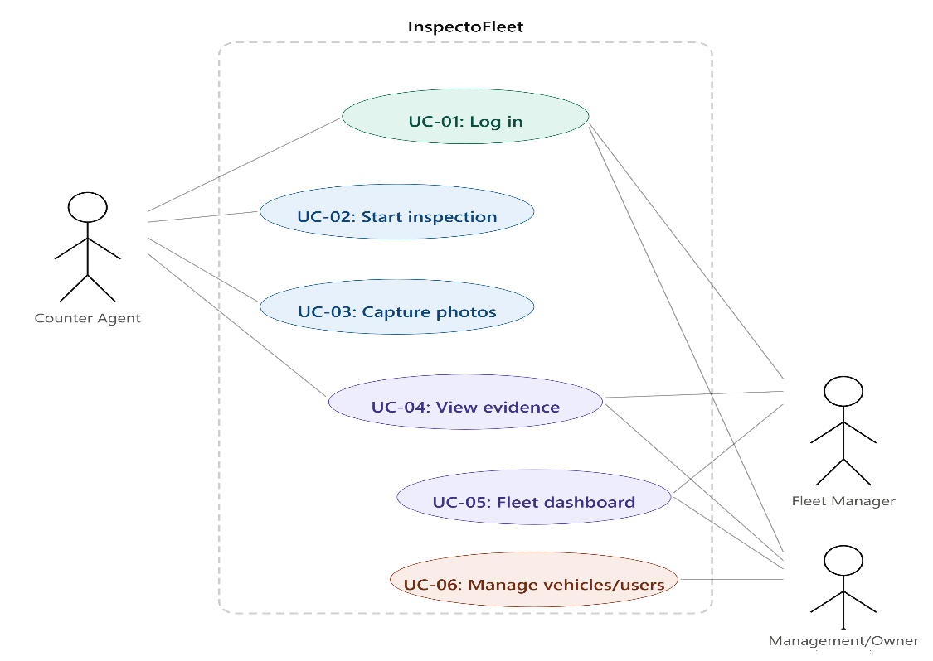

Actors: Counter Agent, Fleet Manager, Management/Owner (secondary). System boundary: InspectoFleet.

B2. Use Case Descriptions

UC-01: Log In
Field | Detail
Use Case ID | UC-01
Name | Log In
Actors | Counter Agent, Fleet Manager, Management/Owner
Preconditions | User has an active account created by an administrator
Main Success Scenario | 1. User opens InspectoFleet on their device 2. User enters email and password 3. System validates credentials 4. System redirects user to their role-appropriate home screen
Alternatives / Exceptions | 3a. Invalid credentials — system displays error, user retries 3b. Account locked after 5 failed attempts — admin must reset
Postconditions | User is authenticated and has access to features appropriate to their role

UC-02: Start Vehicle Inspection
Field | Detail
Use Case ID | UC-02
Name | Start Vehicle Inspection
Actors | Counter Agent
Preconditions | Counter Agent is logged in; vehicle exists in the system; rental contract reference is available
Main Success Scenario | 1. Counter Agent selects ‘New Inspection’ 2. Agent selects or searches for the vehicle by registration number 3. Agent selects inspection type (Handover or Return) 4. Agent optionally links a rental contract reference 5. System creates a new inspection record and presents the photo capture screen
Alternatives / Exceptions | 2a. Vehicle not found — agent can add vehicle registration manually 4a. No contract reference available — agent proceeds without it (flagged for follow-up)
Postconditions | A new inspection record exists in the system, linked to the vehicle and (optionally) the rental contract

UC-03: Capture and Attach Photo Evidence
Field | Detail
Use Case ID | UC-03
Name | Capture and Attach Photo Evidence
Actors | Counter Agent
Preconditions | An inspection record is open (UC-02 completed); device camera is accessible
Main Success Scenario | 1. System prompts agent to capture photos for each required angle (front, rear, left side, right side, interior) 2. Agent photographs each angle using the device camera 3. System automatically attaches a timestamp to each photo 4. System saves each photo against the open inspection record 5. Agent adds optional text notes per photo if damage is visible 6. Agent marks inspection as complete
Alternatives / Exceptions | 2a. Camera permission denied — system prompts agent to enable camera access in device settings 4a. Upload fails due to poor connectivity — system queues photo locally and retries upload when connection is restored
Postconditions | Inspection record contains time-stamped photos for all required angles; record is marked complete and locked from further edits

UC-04: View Inspection Record / Dispute Evidence
Field | Detail
Use Case ID | UC-04
Name | View Inspection Record / Dispute Evidence
Actors | Counter Agent, Fleet Manager, Management/Owner
Preconditions | Actor is logged in; inspection records exist for the vehicle in question
Main Success Scenario | 1. Actor searches for a vehicle by registration number or rental contract reference 2. System displays a list of past inspections for that vehicle 3. Actor selects an inspection record 4. System displays the inspection details: date/time, agent name, photos with timestamps, and any notes
Alternatives / Exceptions | 1a. No records found — system displays ‘No inspection records found’ message
Postconditions | Actor has viewed the time-stamped photographic evidence for the selected inspection

UC-05: View Fleet Status Dashboard
Field | Detail
Use Case ID | UC-05
Name | View Fleet Status Dashboard
Actors | Fleet Manager, Management/Owner
Preconditions | Actor is logged in with Fleet Manager or Management role
Main Success Scenario | 1. Actor navigates to the Fleet Dashboard 2. System displays a list of all vehicles with their current status (Available, Rented, Under Inspection) 3. Actor can filter by status or search by registration number 4. Actor can click a vehicle to view its inspection history summary
Alternatives / Exceptions | 2a. No vehicles in system — system prompts admin to add vehicles
Postconditions | Actor has a current view of fleet status based on the most recent inspection and manual status data

UC-06: Manage Vehicles and Users (Admin)
Field | Detail
Use Case ID | UC-06
Name | Manage Vehicles and Users
Actors | Management/Owner
Preconditions | Actor is logged in with Management/Admin role
Main Success Scenario | 1. Actor navigates to Administration panel 2. Actor can add, edit, or deactivate vehicles (registration number, make, model, year) 3. Actor can create, edit, or deactivate staff accounts (name, email, role)
Alternatives / Exceptions | 3a. Attempting to deactivate a vehicle currently marked as Rented — system warns and requires confirmation
Postconditions | Vehicle and user records are updated in the system

C. User Stories

C1. Epics
- EP-01: Authentication and Access Control
- EP-02: Vehicle Inspection Workflow
- EP-03: Photo Evidence Capture and Storage
- EP-04: Inspection History and Dispute Evidence Retrieval
- EP-05: Fleet Status Dashboard
- EP-06: Vehicle and User Administration

C2. User Story List
All stories follow the format: As a <role>, I want <goal>, so that <benefit>. Acceptance criteria use Given/When/Then format.

ID | Role | Goal | Benefit | Acceptance Criteria | Priority
US-01 | Counter Agent | log in with my email and password | I can access the system securely and only see features relevant to my role | Given valid credentials, when I submit, then I am taken to the inspection home screen. Given invalid credentials, when I submit, then I see a clear error and can retry. | Must
US-02 | Counter Agent | start a new inspection for a specific vehicle | I can create a record linked to the right vehicle before capturing evidence | Given I am logged in, when I select 'New Inspection' and choose a vehicle by registration, then a new inspection record is created and I am taken to the photo screen. | Must
US-03 | Counter Agent | capture photos of a vehicle at handover | there is time-stamped visual evidence of the vehicle's condition before the customer drives it | Given an open inspection, when I take a photo using the device camera, then the photo is saved with an automatic timestamp and linked to the inspection record. | Must
US-04 | Counter Agent | capture photos of a vehicle at return | I can compare the vehicle's condition before and after the rental | Given a return inspection, when I capture photos, then they are saved and linked to the same rental contract reference as the handover inspection. | Must
US-05 | Counter Agent | add a text note to a photo if I see damage | I can flag specific damage observations alongside the photographic evidence | Given a captured photo, when I type a note and save, then the note is stored alongside the photo in the inspection record. | Should
US-06 | Counter Agent | mark an inspection as complete | the record is locked and cannot be altered after submission | Given all required photos are captured, when I tap 'Complete Inspection', then the record is locked, timestamped, and no further edits are possible. | Must
US-07 | Counter Agent | search for a vehicle's inspection history by registration number | I can quickly find past records when a dispute arises at the desk | Given I search by a registration number, when the vehicle exists, then I see a list of past inspections ordered by date. | Must
US-08 | Fleet Manager | view a dashboard of all vehicles and their current status | I can see at a glance which vehicles are available, rented, or under inspection | Given I am logged in as Fleet Manager, when I open the dashboard, then I see all vehicles with their current status updated from the latest inspection data. | Must
US-09 | Fleet Manager | filter the fleet dashboard by vehicle status | I can quickly focus on vehicles that need attention | Given the dashboard is loaded, when I select a status filter (Available / Rented / Under Inspection), then only vehicles matching that status are shown. | Should
US-10 | Fleet Manager | view the inspection history for a specific vehicle from the dashboard | I can investigate a vehicle's condition trend without leaving the fleet view | Given I click a vehicle on the dashboard, when the detail panel opens, then I see a list of past inspections with dates and completion status. | Should
US-11 | Management/Owner | view time-stamped photo evidence for any inspection record | I can resolve damage disputes with factual, auditable evidence | Given I search for a vehicle, when I open an inspection record, then I see all photos with their capture timestamps and any agent notes. | Must
US-12 | Management/Owner | add a new vehicle to the system | counter agents can inspect it immediately without waiting for a separate admin process | Given I am in the administration panel, when I enter a vehicle's registration, make, model and year and save, then the vehicle appears immediately in inspection and dashboard views. | Must
US-13 | Management/Owner | create a staff account for a new counter agent or fleet manager | new staff can log in and use the system on their first day | Given I am in the administration panel, when I enter a name, email, and role and save, then the staff member receives login credentials and can access their role-appropriate features. | Must
US-14 | Counter Agent | have my photo upload queued if I lose connectivity during an inspection | I don't lose evidence just because the internet dropped briefly | Given poor or no connectivity, when I capture a photo, then it is stored locally and automatically uploaded when connectivity is restored. | Could
US-15 | Fleet Manager | manually update a vehicle's status if the system does not reflect the latest situation | the dashboard remains accurate even when an inspection wasn't completed | Given a vehicle status is incorrect, when I manually change it with a reason note, then the status updates and the change is logged with my name and timestamp. | Could

C3. Traceability — User Stories to Use Cases
Story ID | Story Summary | Linked Use Case(s)
US-01 | Log in | UC-01
US-02 | Start new inspection | UC-02
US-03 | Capture handover photos | UC-03
US-04 | Capture return photos | UC-03
US-05 | Add damage note to photo | UC-03
US-06 | Mark inspection complete | UC-03
US-07 | Search inspection history | UC-04
US-08 | View fleet dashboard | UC-05
US-09 | Filter dashboard by status | UC-05
US-10 | View vehicle inspection history from dashboard | UC-04, UC-05
US-11 | View photo evidence for dispute | UC-04
US-12 | Add new vehicle | UC-06
US-13 | Create staff account | UC-06
US-14 | Offline photo queue | UC-03
US-15 | Manual status update | UC-05, UC-06

C4. Epics to Decompose Further in D3
- EP-02 (Inspection Workflow): US-02, US-03, US-04, US-05, US-06 need story-point estimation and may require further decomposition based on chosen tech stack.
- EP-03 (Photo Evidence): US-14 (offline queuing) may need to be split into separate ‘capture locally’ and ‘sync on reconnect’ stories.
- EP-05 (Fleet Dashboard): dashboard layout and filtering complexity should be clarified with client before Sprint 1.

D. Non-Functional Requirements
ID | Category | Requirement | Measure / Target
NFR-01 | Usability | A counter agent should be able to complete a full inspection (all photos + notes + submit) with no prior training beyond a 10-minute walkthrough | Task completion in ≤ 5 minutes for a trained agent; validated via usability test in D3/D5
NFR-02 | Usability | All primary inspection actions must be accessible on a standard smartphone screen without horizontal scrolling | No horizontal scroll on 375px-wide viewport (iPhone SE baseline)
NFR-03 | Performance | Photo upload should complete within a reasonable time on typical mobile data speeds available in Accra | Upload of a 3MB photo completes within 15 seconds on a standard 4G connection
NFR-04 | Performance | The fleet dashboard should load within 3 seconds for a fleet of up to 100 vehicles | Dashboard initial load ≤ 3 seconds measured with up to 100 vehicle records
NFR-05 | Reliability | Captured inspection photos must not be permanently lost once captured by the agent | Photos are either uploaded immediately or queued locally with automatic retry; zero permanent data loss in normal operation
NFR-06 | Security | Only authenticated users may access any part of the system | All routes/endpoints return 401 Unauthorized for unauthenticated requests
NFR-07 | Security | A counter agent may not access fleet management or administration features | Role-based access control enforced server-side; UI does not expose inaccessible routes
NFR-08 | Privacy | Vehicle inspection photos and rental contract references are treated as confidential business data | No inspection data exposed to unauthenticated requests; no real data committed to public repos or pasted into public AI tools
NFR-09 | Maintainability | A developer unfamiliar with the codebase should be able to set up and run the project locally using the README and Makefile in under 30 minutes | Verified by at least one team member following setup instructions cold in D5
NFR-10 | Accessibility | Core inspection workflow must be usable with standard mobile accessibility features enabled (e.g. large text, high contrast) | No critical UI elements broken when OS text size is set to ‘Large’
NFR-11 | Portability | The system must run in a standard modern mobile browser without requiring a native app install | Functional in Chrome (Android) and Safari (iOS) current versions
NFR-12 | Data Retention | Inspection records must be retained for a minimum of 3 years to cover typical vehicle warranty and dispute periods | Records are not deleted automatically; deletion requires explicit admin action with confirmation

E. Data and External Interface Requirements

E1. Key Data Entities
Entity | Key Fields | Sensitivity
Vehicle | registration_number (PK), make, model, year, current_status (Available/Rented/Under Inspection), created_at, updated_at | Internal
User / Staff | user_id (PK), full_name, email, role (Counter Agent / Fleet Manager / Admin), is_active, created_at | Internal — email is PII, stored and accessed by admin only
RentalContract | contract_id (PK), vehicle_id (FK), customer_name, rental_start, rental_end, contract_reference | Confidential — customer name is PII
InspectionRecord | inspection_id (PK), vehicle_id (FK), contract_id (FK, optional), agent_id (FK), inspection_type (Handover/Return), status (Open/Complete), started_at, completed_at | Confidential
EvidencePhoto | photo_id (PK), inspection_id (FK), angle (Front/Rear/Left/Right/Interior), file_reference, timestamp, agent_notes | Confidential — photos may show vehicle damage and are tied to customer disputes
StatusChangeLog | log_id (PK), vehicle_id (FK), changed_by (FK), old_status, new_status, reason_note, changed_at | Internal

E2. External Systems, APIs and Services
- Device camera API — accessed via browser MediaDevices.getUserMedia() or equivalent; no external third party
- Cloud photo storage — exact provider TBD in D4 (e.g. Cloudinary free tier, AWS S3, Firebase Storage); photos stored as references in EvidencePhoto table
- Authentication provider — either custom JWT-based auth or a managed provider (e.g. Firebase Auth, Supabase Auth); decision in D4
- No payment system, SMS gateway, or email service is required this semester

E3. Data Sensitivity Classification
- Public: none (no public-facing data in this version)
- Internal: vehicle records, fleet status, inspection metadata
- Confidential: inspection photos, rental contract references, customer names
- Personal (PII): staff email addresses, customer names in rental contracts

E4. Data Retention and Deletion
- Inspection records and associated photos are retained for a minimum of 3 years (NFR-12)
- Deletion of any inspection record requires explicit admin action with a confirmation step and reason log
- Staff accounts are deactivated rather than deleted, to preserve attribution on past inspection records
- Customer PII in rental contract references is stored only as provided by the client’s existing process; no additional PII is collected by InspectoFleet beyond what is necessary for dispute evidence

F. Glossary and Validation Evidence

F1. Glossary
Term | Definition
Counter Agent | A member of Kal Car Rentals staff who performs vehicle inspections at the handover (when a customer collects) and return (when a customer brings back) desk
Fleet Manager | A member of Kal Car Rentals staff responsible for monitoring the overall vehicle fleet status, location, and operational readiness
Handover Inspection | A vehicle inspection conducted when the customer collects the vehicle; documents the vehicle’s condition before the rental begins
Return Inspection | A vehicle inspection conducted when the customer returns the vehicle; documents the vehicle’s condition after the rental ends
Inspection Record | A digital record created in InspectoFleet for a single inspection event, containing photos, timestamps, agent notes, and status
Evidence Photo | A photograph taken during an inspection, stored with an automatic timestamp indicating when it was captured
Dispute | A disagreement between Kal Car Rentals and a customer about whether vehicle damage was pre-existing or caused by the customer during the rental period
Fleet Status | A per-vehicle indicator of its current operational state: Available, Rented, or Under Inspection
Rental Contract Reference | An identifier (e.g. contract number) linking an inspection record to the customer’s rental agreement in Kal Car Rentals’ existing records
Role-Based Access Control (RBAC) | A security model where each user account is assigned a role (Counter Agent, Fleet Manager, Admin) and can only access features permitted for that role
Time-Stamped | Automatically tagged with the exact date and time of capture by the system, not editable by the user
Turnaround | The process of receiving a returned vehicle, inspecting it, and preparing it for the next rental

F2. Client Validation Notes
Requirements baseline validated with: Phanuel K. A. Wagba (Director, Kal Car Rentals) via initial client conversation (evidence on file, see docs/01_proposal/).
- Confirmed: paper inspection process, photo evidence gap, and damage dispute problem are accurately described
- Confirmed: counter agents use mobile phones during turnarounds; mobile-first design is appropriate
- Confirmed: fleet visibility is a secondary but real concern
- To be confirmed before D3: exact number of vehicles in the fleet; number of counter agents; whether customers are ever given access to their own inspection records; whether the client uses any existing software for contract management that InspectoFleet should reference

F3. Open Questions (to resolve before D3/D4)
- OQ-01: How many vehicles does Kal Car Rentals currently operate? (Affects dashboard performance targets and database sizing)
- OQ-02: How many counter agents will use the system simultaneously? (Affects concurrent user load assumptions)
- OQ-03: Does the client have an existing contract management system whose IDs should be used as rental contract references, or is this a free-text field?
- OQ-04: Should customers be able to view their own inspection records (e.g. via a link)? (Scope decision — currently scoped out but worth confirming)
- OQ-05: What cloud provider/hosting is acceptable to the client for photo storage? Are there data residency preferences?

