UNIVERSITY OF GHANA — DEPARTMENT OF COMPUTER SCIENCE
DCIT 208 — SOFTWARE ENGINEERING
D3: Product Backlog, UX Prototype and Sprint 1 Plan
Team Name | Snart
Project Title | InspectoFleet
Client Name | Phanuel K. A. Wagba
Repository URL | https://github.com/Dept-of-Comp-Sci-University-of-Ghana/dcit208-client-project-2026-team-engineering-repository-seg26-77
AI Assistance Disclosure | Claude (Anthropic) was used to structure this document, draft the backlog table, traceability matrix, sprint plan, and Definition of Done. All story point estimates, priority decisions, sprint selections, and owner assignments were made by the team. UX wireframes were created by the team in draw.io. See AI_USAGE.md for the full log.

A. Refined Product Backlog

A1. Epic Breakdown
The six epics from D2 have been decomposed into the 15 user stories below. No story exceeds 8 story points. Stories estimated at 5 points have been reviewed and confirmed to be completable within a single sprint by one owner with help from the team where needed.
- EP-01: Authentication and Access Control — US-01
- EP-02: Vehicle Inspection Workflow — US-02, US-06
- EP-03: Photo Evidence Capture and Storage — US-03, US-04, US-05, US-14
- EP-04: Inspection History and Dispute Evidence — US-07, US-10, US-11
- EP-05: Fleet Status Dashboard — US-08, US-09, US-15
- EP-06: Vehicle and User Administration — US-12, US-13

A2. Full Product Backlog
Story points use Fibonacci scale: 1, 2, 3, 5, 8. Priority: Must / Should / Could / Won’t this semester.
ID | Epic | User Story | Points | Priority | Owner | Dependencies | Risk
US-01 | EP-01 | As a Counter Agent, I want to log in so I can access my role features | 3 | Must | Freeman | None | Low
US-02 | EP-02 | As a Counter Agent, I want to start a new inspection linked to a vehicle | 3 | Must | Freeman | US-01 | Low
US-03 | EP-03 | As a Counter Agent, I want to capture handover photos with timestamps | 5 | Must | Ali | US-02 | Medium — camera API
US-04 | EP-03 | As a Counter Agent, I want to capture return photos linked to same contract | 3 | Must | Ali | US-03 | Low
US-05 | EP-03 | As a Counter Agent, I want to add damage notes to a photo | 2 | Should | Ali | US-03 | Low
US-06 | EP-02 | As a Counter Agent, I want to mark an inspection as complete and lock it | 2 | Must | Paa Kweku | US-03 | Low
US-07 | EP-04 | As a Counter Agent, I want to search inspection history by registration | 3 | Must | Paa Kweku | US-06 | Low
US-08 | EP-05 | As a Fleet Manager, I want to view a fleet status dashboard | 5 | Must | Siatey | US-06 | Medium — data model
US-09 | EP-05 | As a Fleet Manager, I want to filter dashboard by vehicle status | 2 | Should | Siatey | US-08 | Low
US-10 | EP-04 | As a Fleet Manager, I want to view inspection history from the dashboard | 2 | Should | Eugene Menye | US-07, US-08 | Low
US-11 | EP-04 | As Management, I want to view photo evidence for dispute resolution | 2 | Must | Eugene Menye | US-06 | Low
US-12 | EP-06 | As Management, I want to add a new vehicle to the system | 2 | Must | Ocloo | US-01 | Low
US-13 | EP-06 | As Management, I want to create a staff account | 2 | Must | Seity | US-01 | Low
US-14 | EP-03 | As a Counter Agent, I want photos queued offline and uploaded on reconnect | 5 | Could | Ocloo | US-03 | High — offline storage
US-15 | EP-05 | As a Fleet Manager, I want to manually update vehicle status with a reason | 2 | Could | Seity | US-08 | Low

A3. Backlog Summary
Total stories | 15
Total story points | 43
Must stories | 10
Should stories | 3
Could stories | 2
Sprint 1 capacity (planned) | 20 points across 7 stories
Remaining backlog | 23 points across 8 stories (Sprints 2–4)

B. Backlog Traceability

B1. Story to Requirement and Use Case Mapping
Story ID | SRS Req. | Use Case | Epic | Sprint | Sensitive Data?
US-01 | NFR-06, NFR-07 | UC-01 | EP-01 | 1 | No
US-02 | FR-02 | UC-02 | EP-02 | 1 | No
US-03 | FR-02, FR-03 | UC-03 | EP-03 | 1 | Yes — photos
US-04 | FR-02, FR-03 | UC-03 | EP-03 | 1 | Yes — photos
US-05 | FR-02 | UC-03 | EP-03 | 1 | No
US-06 | FR-03 | UC-03 | EP-02 | 1 | No
US-07 | FR-05 | UC-04 | EP-04 | 2 | Yes — records
US-08 | FR-04 | UC-05 | EP-05 | 2 | No
US-09 | FR-04 | UC-05 | EP-05 | 2 | No
US-10 | FR-05 | UC-04, UC-05 | EP-04 | 2 | Yes — records
US-11 | FR-03, FR-05 | UC-04 | EP-04 | 2 | Yes — photos
US-12 | FR-01 | UC-06 | EP-06 | 1 | No
US-13 | NFR-06, NFR-07 | UC-06 | EP-06 | 1 | Yes — email/PII
US-14 | NFR-05 | UC-03 | EP-03 | 3 | Yes — photos
US-15 | FR-04 | UC-05, UC-06 | EP-05 | 3 | No

B2. Stories Deferred Beyond Course Scope
- US-14 (offline photo queuing) is assigned to Sprint 3 — it is a Could priority and depends on core photo capture (US-03) being stable first. If Sprint 3 capacity is insufficient, this story will be deferred to a post-course enhancement.
- US-15 (manual status update) is assigned to Sprint 3 as a Could priority. Dashboard (US-08) must be stable before this is meaningful to implement.

B3. Stories Requiring Client Clarification Before Implementation
- US-07, US-10, US-11 — before Sprint 2, confirm with Phanuel whether inspection history search should be available to counter agents or only to management/fleet managers.
- US-13 — confirm whether the client wants email-based login credentials sent automatically or manually communicated to new staff.

B4. Stories Involving Sensitive Data or Security Decisions
- US-03, US-04 — inspection photos are confidential; cloud storage provider and access control must be confirmed in D4 architecture before Sprint 1 implementation begins.
- US-13 — staff email addresses are PII; confirm data handling and password reset flow with team security review in D4.

C. UX Sketches and Prototype Evidence

C1. Usability Assumptions
- Counter agents will use the system on a smartphone during vehicle turnarounds — all primary flows must be completable with one hand.
- Text input is kept minimal — the main interaction model is tap-to-capture, tap-to-confirm, not typing.
- The inspection flow follows a guided step-by-step pattern (one screen per angle) to reduce the chance of a missed photo.
- Fleet managers will primarily use a tablet or desktop browser for the dashboard — the dashboard is designed for wider screens but must remain usable on mobile.

C2. Accessibility Considerations
- All tap targets are minimum 44px × 44px per mobile accessibility guidelines.
- Error messages and confirmation prompts use text, not color alone, so they are readable by color-blind users.
- Photo capture prompts include text labels (e.g. Capture front of vehicle) so the flow is clear even without visual context.

C3. Core User Flows Covered by Wireframes
- Flow 1: Login → Home screen (UC-01, US-01)
- Flow 2: Start inspection → Capture photos → Complete inspection (UC-02, UC-03, US-02–06)
- Flow 3: Fleet dashboard → Vehicle detail (UC-05, US-08)

C4. Wireframe Sketches

Screen 1: Login
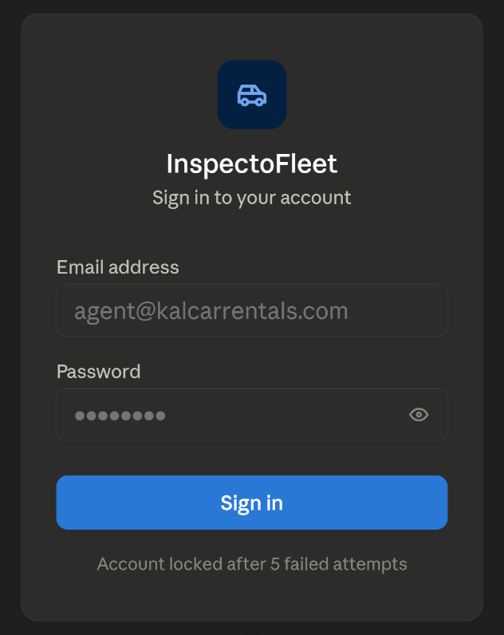

Screen 2: Counter Agent Home
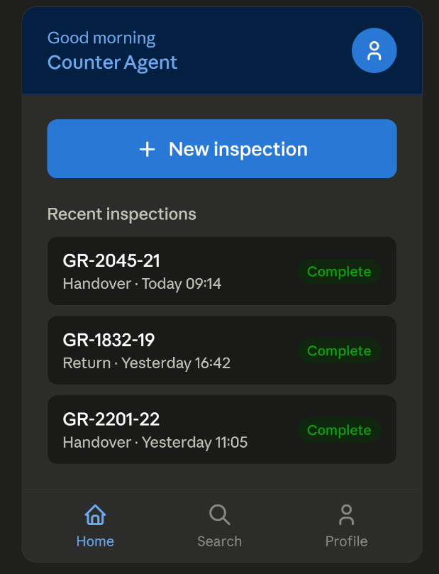

Screen 3: Start Inspection — Select Vehicle
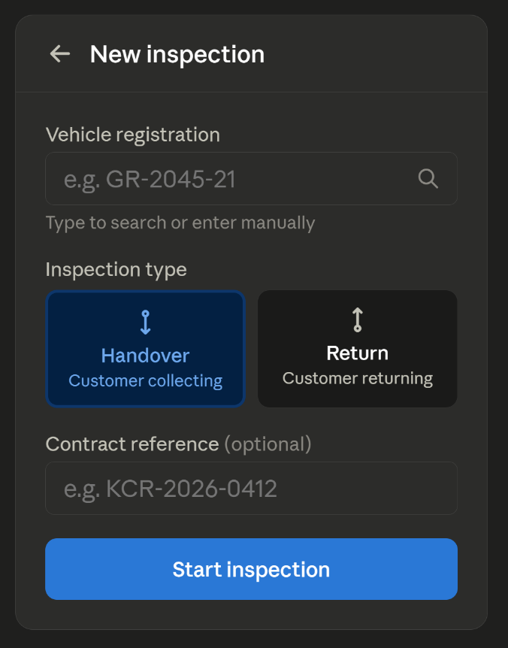

Screen 4: Photo Capture — Guided Flow
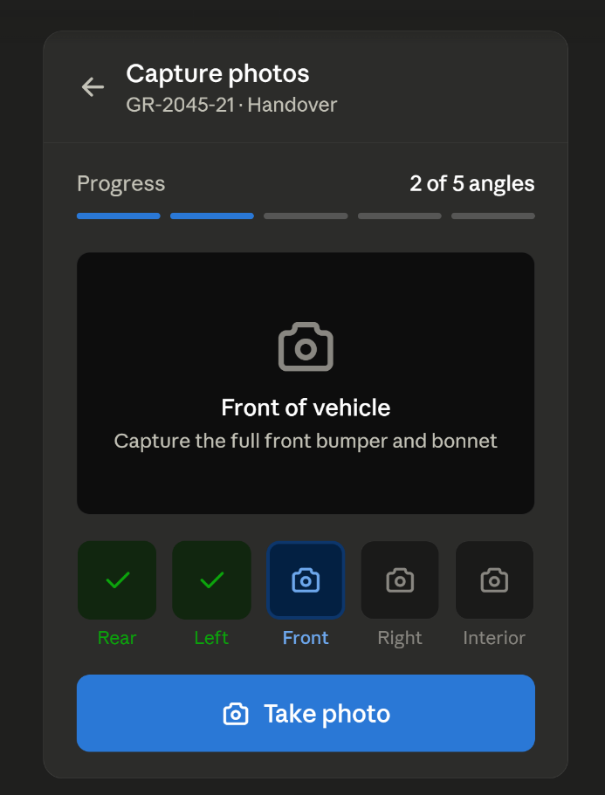

Screen 5: Photo Review and Notes
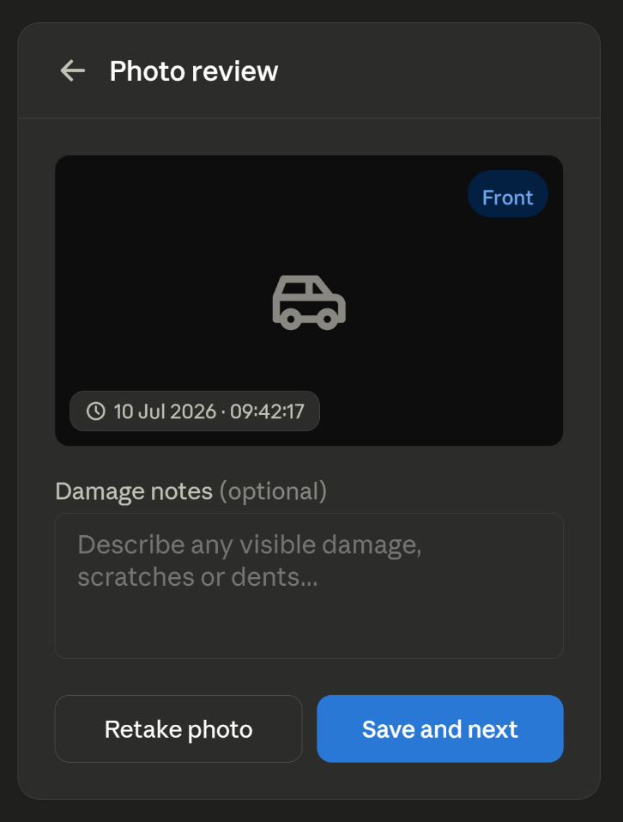

Screen 6: Complete Inspection Confirmation
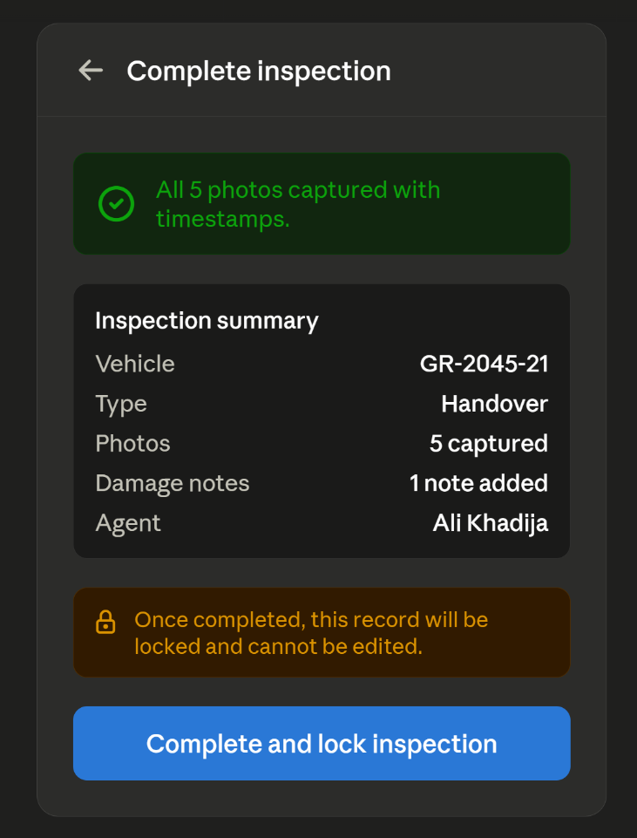

Screen 7: Fleet Dashboard
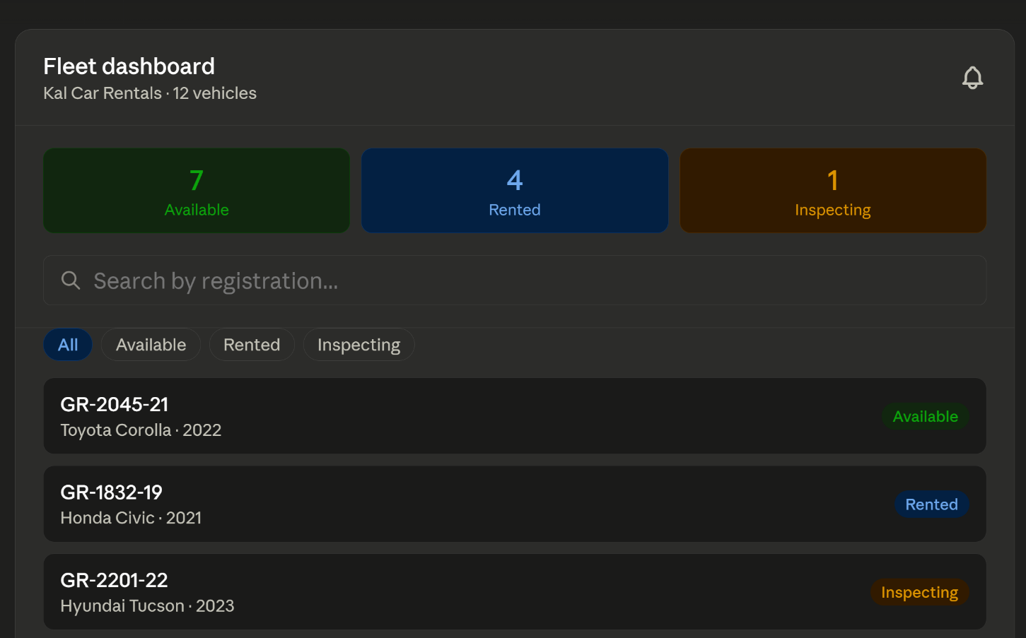

C5. Client / User Review Evidence
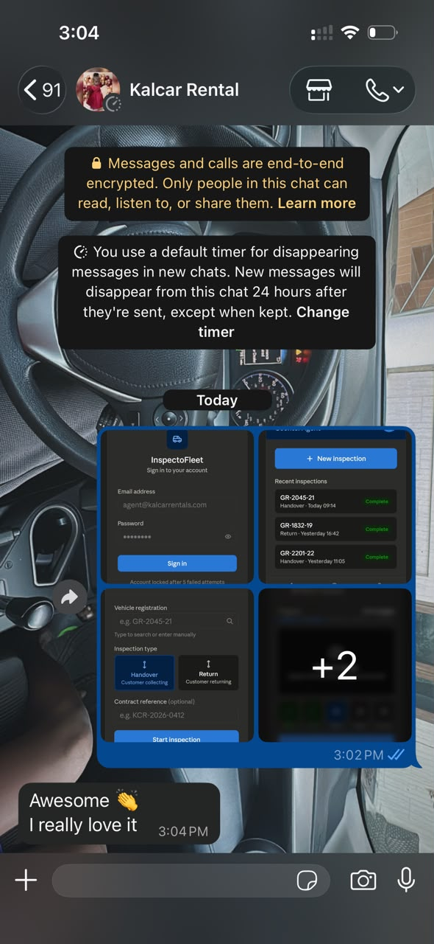

D. Sprint 1 Plan

D1. Sprint Goal
By the end of Sprint 1, a counter agent can log in, start a vehicle inspection, capture time-stamped photos for handover or return, and complete the inspection. An admin can add vehicles and create staff accounts.

D2. Sprint Dates
- Sprint 1 start: 10 July 2026 (Week 6)
- Sprint 1 end / review: 24 July 2026 (D5 deadline, Week 8)
- Sprint duration: 2 weeks

D3. Sprint 1 Selected Stories
Total planned points: 20. Team velocity baseline: unknown (first sprint). Stories selected prioritise the Must-have core inspection workflow first.
Story ID | Story Summary | Points | Owner | Planned Tests | Acceptance Criteria ref.
US-01 | Counter agent logs in | 3 | Freeman | Test valid login, invalid credentials, account lockout after 5 attempts | D2 SRS US-01 AC 1-3
US-02 | Counter agent starts new inspection | 3 | Freeman | Test inspection creation with existing vehicles, unknown vehicle, no contract ref | D2 SRS US-02 AC 1-3
US-03 | Capture handover photos with timestamps | 5 | Ali | Test photo capture with camera, verify timestamp attached, test missing angle warning | D2 SRS US-03 AC 1-3
US-04 | Capture return photos linked to contract | 3 | Ali | Test return photos link to same contract as handover | D2 SRS US-04 AC 1-3
US-06 | Mark inspection complete and lock record | 2 | Paa Kweku | Test completion locks record, test incomplete inspection blocked | D2 SRS US-06 AC 1-3
US-12 | Admin adds new vehicle | 2 | Ocloo | Test vehicle creation, duplicate registration error, missing field validation | D2 SRS US-12 AC 1-3
US-13 | Admin creates staff account | 2 | Seity | Test account creation, duplicate email error, role-based access enforced | D2 SRS US-13 AC 1-3

D4. Stories Deliberately Excluded from Sprint 1
- US-05 (damage notes) - Should priority; photo capture must be stable first. Moves to Sprint 2.
- US-07 (search history) - Depends on completed inspection records existing; Sprint 2.
- US-08, US-09 (fleet dashboard) - Must priority but depends on inspection data; Sprint 2.
- US-10, US-11 (view evidence) - Depends on US-06 and US-08; Sprint 2.
- US-14, US-15 — Could priority; Sprint 3.

D5. Definition of Ready
- The story has a clear user role, goal and benefit.
- Acceptance criteria are written in Given/When/Then format in the GitHub Issue.
- Dependencies and preconditions are confirmed as met or in progress.
- The story is estimated at 8 points or fewer.
- The team knows how it will be tested.
- The Product/Client Manager has confirmed the story’s priority.

D6. Definition of Done
- Code is committed through a branch and pull requests. Theres no direct unreviewed commits to main.
- At least one non-author reviews PR and leaves a meaningful comment on GitHub.
- CI passes or any failure is documented with an approved remediation plan.
- Tests are written or updated for the story’s acceptance criteria.
- Screenshots or demo evidence are attached for any visible UI change.
- The GitHub Issue is moved to Done only after all acceptance criteria are met.
- AI assistance is disclosed in the PR description and AI_USAGE.md if used.

D7. Test Plan for Sprint 1 Stories
- US-01: Manual login test with valid credentials, invalid credentials, and lockout after 5 failures. Automated test: POST /auth/login returns 200 on valid, 401 on invalid.
- US-02: Manual test starting inspection with known vehicle, unknown vehicle, and no contract ref. Automated test: inspection record created in DB with correct vehicle and type.
- US-03: Manual test on physical devices - capture all 5 angles and confirm timestamps. Automated test: photo record linked to inspection with timestamp not null.
- US-04: Manual test completing a return inspection and confirming it links to the same contract as the handover. Automated test: both inspection records share the same contract_id.
- US-06: Manual test completing inspection, then attempting to edit it (should be blocked). Automated test: PATCH /inspections/:id returns 403 when status is Complete.
- US-12: Manual test adding vehicle, adding duplicate (should error), saving with missing field (should error). Automated test: POST /vehicles return 201 on valid, 409 on duplicate.
- US-13: Manual test creating staff account and logging in as that user. Automated test: new user exists in DB with correct role; Counter Agent cannot access /fleet endpoint.

E. GitHub Project Board Setup

E1. Board Structure
The InspectoFleet Project Board has been created in the team’s GitHub repository with the following columns, matching the spec’s required workflow:
- Backlog — all user stories not yet started
- Ready — stories refined, estimated, and sprint-planned
- In Progress — stories actively being worked on in the current sprint
- Review — stories with a PR open awaiting review
- Done — stories merged, tested and meeting Definition of Done

E2. Issue Labels in Use
- requirement — user story linked to SRS
- frontend — UI/UX implementation work
- backend — API/database/server-side work
- testing — test writing and QA tasks
- docs — documentation tasks
- bug — defects found during testing
- security — security or privacy related work
- ai-assisted — issue or PR where AI assistance was used

E3. Sprint 1 Milestone
A GitHub Milestone titled 'Sprint 1' has been created with a due date of 24 July 2026. All Sprint 1 stories (US-01, US-02, US-03, US-04, US-06, US-12, US-13) are linked to this milestone.

E4. Board Screenshot Evidence
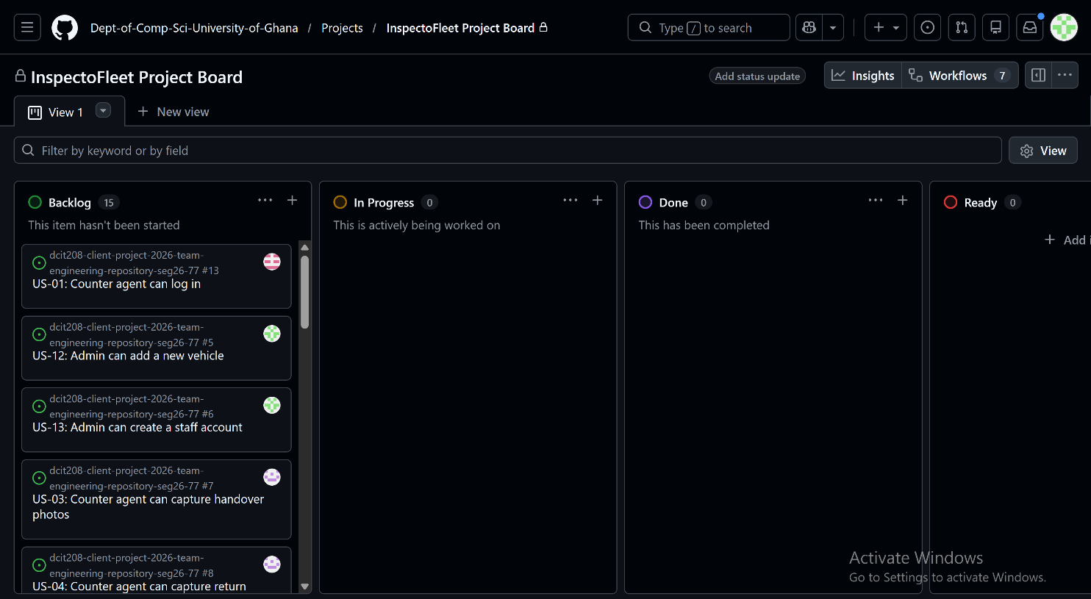

E5. Product/Client Manager Commitment
Freeman K. A. Wagba (Product/Client Manager) is responsible for keeping the project board current on a weekly basis: moving issues between columns as work progresses, ensuring every Sprint 1 issue has an owner and acceptance criteria, and updating the board before each team weekly call.

