UNIVERSITY OF GHANA — DEPARTMENT OF COMPUTER SCIENCE
DCIT 208 — SOFTWARE ENGINEERING
D7: Sprint 3 Review, Security/Privacy/AI Audit and Observability
Team Name | Snart
Project Title | InspectoFleet
Client Name | Kal Car Rentals
Sprint Number | Sprint 3
Sprint Dates | 31 July 2026 – 7 August 2026
Repository URL | https://github.com/Dept-of-Comp-Sci-University-of-Ghana/dcit208-client-project-2026-team-engineering-repository-seg26-77
Release Tag | v0.3-staging
Commit Hash | f28a724
Deployment Link | https://inspecto-fleet.vercel.app
AI Assistance Disclosure | Claude (Anthropic) was used to structure this report, draft the security/privacy/AI audit tables, and provide the US-02 code scaffold. All audit findings, sprint decisions, and reflection content were supplied by the team. US-02 code was reviewed and tested by Ocloo Eugene Selasi. See AI_USAGE.md.

A. Sprint Summary

A1. Sprint Goal
Sprint 3 goal: implement US-02 (start inspection) to give counter agents the ability to create a new inspection record linked to a vehicle, and conduct the formal security, privacy, and AI usage audit required by D7.

A2. Sprint Dates
- Start: 31 July 2026 (immediately after D6 submission)
- End / Review: 7 August 2026 (D7 deadline, Week 10)
- Duration: 1 week

A3. Sprint Outcome Summary
Sprint 3 delivered US-02 (start inspection). Counter agents can now log in, navigate to the new inspection page, enter a vehicle registration number, select the inspection type (handover or return), optionally add a contract reference and submit. The system creates a vehicle record if one does not exist, creates an inspection record in Supabase and redirects to the inspection detail page showing the unique inspection ID.
The feature is live at https://inspecto-fleet.vercel.app and has been tested end-to-end on the production deployment. This brings the cumulative implemented stories to 2 (US-01 and US-02) out of 15 total.
The security, privacy and AI audit (Sections E, F, G) was conducted this sprint as required by D7.

A4. Updated Sprint Backlog
Planned: US-02 (primary focus) + security/privacy audit. Completed: US-02. Remaining: 13 stories carried into Sprint 4.

Story ID | Summary | Points | Owner | Status | Notes
US-02 | Counter agent can start a new inspection | 3 | Freeman / Ocloo | Done | Implemented and live at /inspections/new. Vehicle created if not found. Inspection record created in Supabase. PR merged.
US-05 | Counter agent can add damage notes | 2 | Ali | Carried over | Not started. Depends on photo capture (US-03) which is Sprint 4.
US-07 | Counter agent can search inspection history | 3 | Paa Kweku | Carried over | Not started. Deferred to Sprint 4.
US-08 | Fleet manager can view fleet dashboard | 5 | Siatey | Carried over | Not started. Deferred to Sprint 4.
US-09 | Fleet manager can filter dashboard | 2 | Siatey | Carried over | Not started. Deferred to Sprint 4.
US-10 | Fleet manager can view inspection history | 2 | Eugene Menye | Carried over | Not started. Deferred to Sprint 4.
US-11 | Management can view photo evidence | 2 | Eugene Menye | Carried over | Not started. Deferred to Sprint 4.

B. Requirements and Backlog Changes

B1. Stories Changed or Added
- US-02 formally completed this sprint. Vehicle creation on-the-fly was added as an implicit sub-feature (if the vehicle registration doesn't exist in the database, it is created automatically with placeholder make/model). This is acceptable for the current prototype stage.
- No stories were split, removed or added during Sprint 3.

B2. Scope Decision — Photo Capture
US-03 (photo capture) requires browser camera API access and Supabase Storage integration. Given the team's remaining time (Sprint 4 only) and the complexity of reliable mobile photo capture with offline queuing, the team has made a scope decision: Sprint 4 will focus on US-03 and US-07 (inspection history search) as the minimum viable client-demo features. US-08 through US-11 (fleet dashboard) are acknowledged as out of scope for this semester's delivered prototype but will be documented as future work in the handoff pack (D9).

B3. Client Impact
The client (Phanuel K. A. Wagba) was updated on 22 July 2026. The next planned client touchpoint is a demo of the working inspection workflow (US-01 + US-02) before D8. The team will reach out this week to schedule.

C. Engineering Evidence

C1. Pull Requests
PR #24 — link: https://github.com/Dept-of-Comp-Sci-University-of-Ghana/dcit208-client-project-2026-team-engineering-repository-seg26-77/pull/24
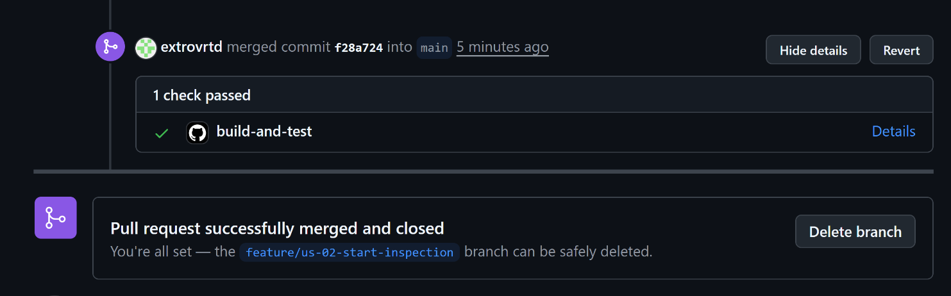

C2. New Files Added
- app/inspections/new/page.tsx — new inspection form with vehicle registration, type selector and contract reference
- app/inspections/[id]/page.tsx — inspection detail page showing inspection ID after creation
- app/dashboard/page.tsx — updated with clean UI and navigation to new inspection
- app/layout.tsx — updated app title from 'Create Next App' to 'InspectoFleet'

C3. CI Status
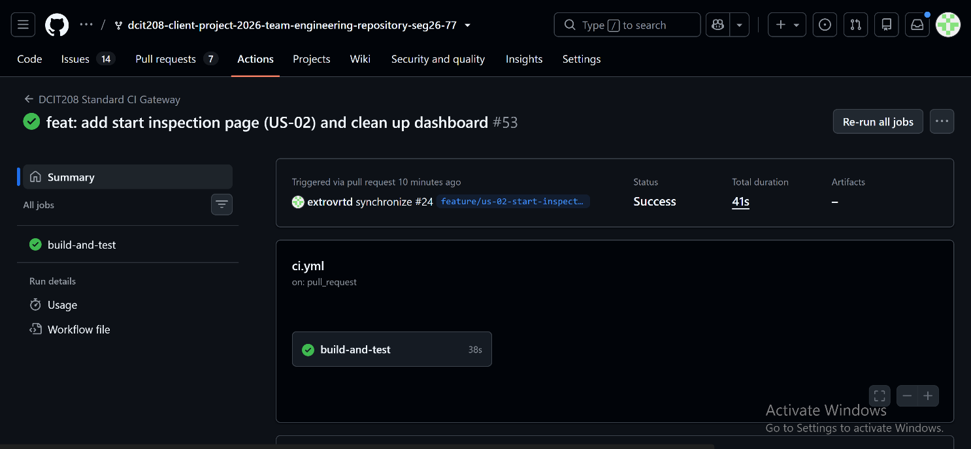
- CI workflow: npm install → npm run lint → npm run build — all passing
- Supabase environment variables configured as GitHub repository secrets

C4. Deployment Evidence
US-02 is live at https://inspecto-fleet.vercel.app/inspections/new. The full flow — login → dashboard → new inspection → inspection created — was tested on the production Vercel deployment.
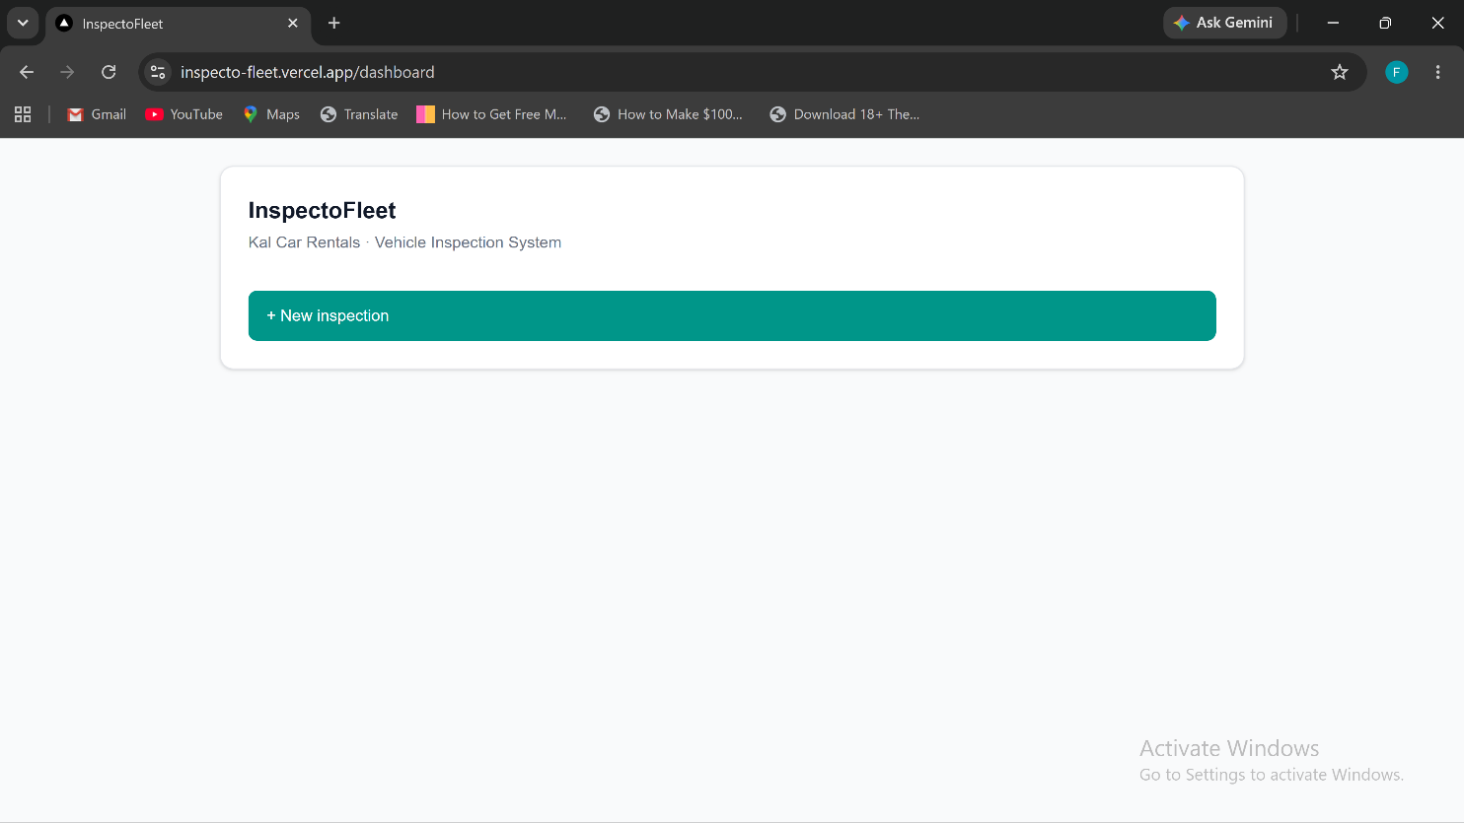
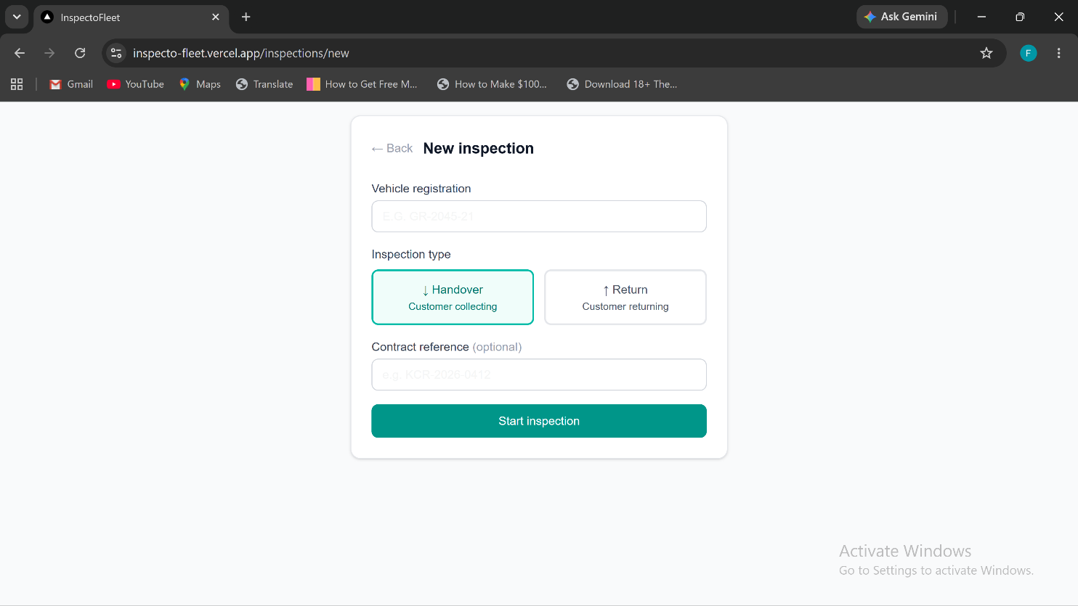

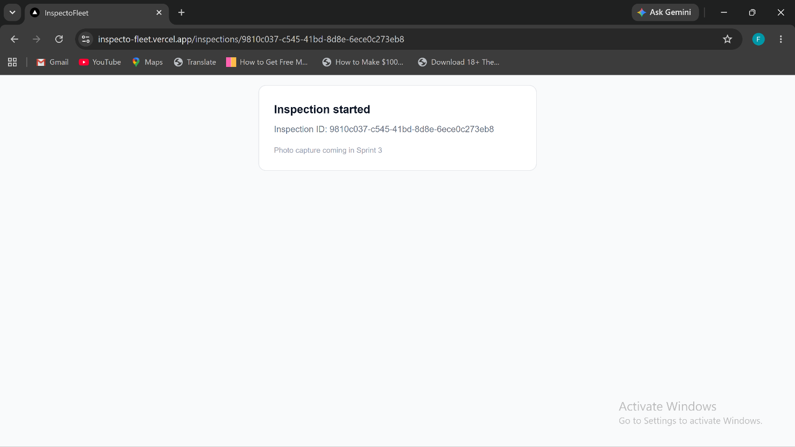

C5. Supabase Evidence
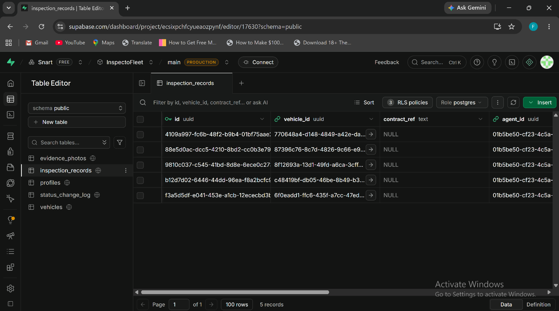

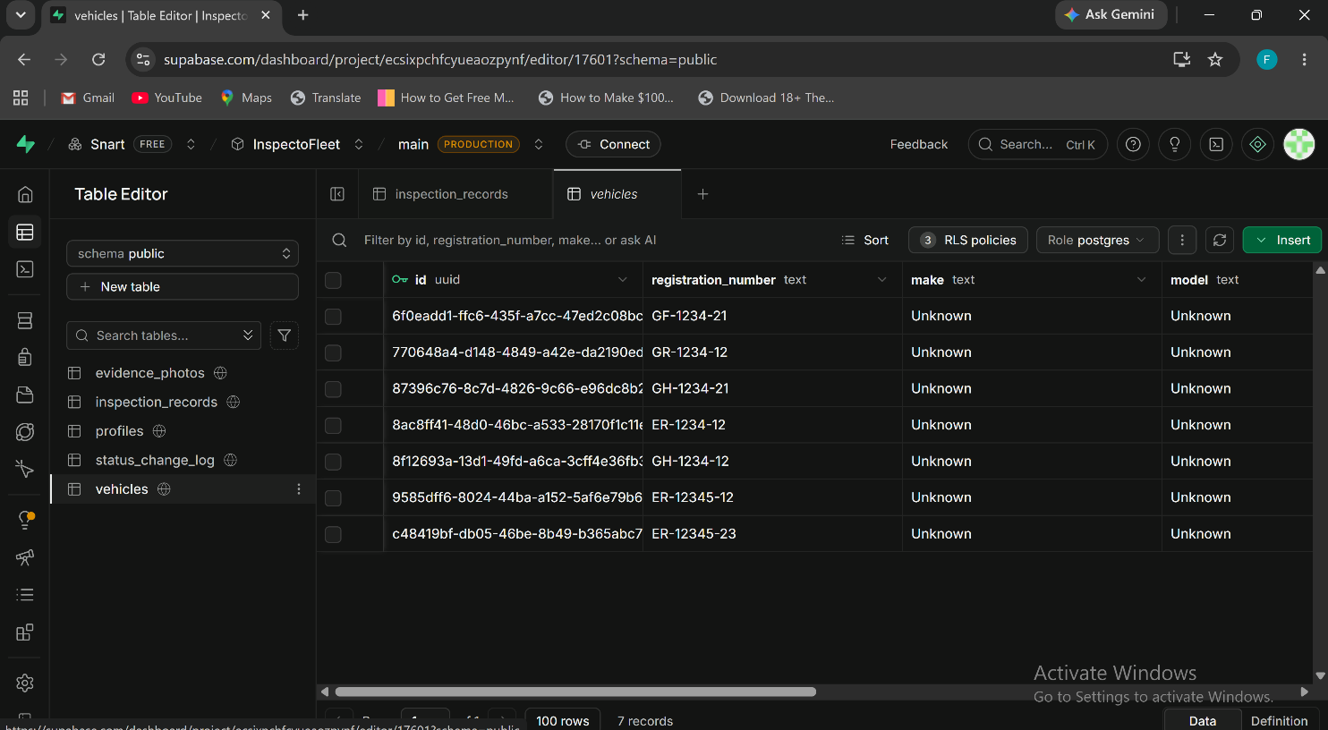

C6. Known Defects
- Vehicles created via the inspection form have make/model set to 'Unknown' and year to 2020. Acceptable for prototype, will be addressed in full admin panel.
- No session check on /dashboard or /inspections/new. Users can access these URLs directly without logging in (BUG-01, carried from Sprint 2).
- No logout button (BUG-03, carried from Sprint 2).

D. Metrics and Reflection

D1. Velocity
Metric | Value
Stories planned | 1 (US-02) + security audit
Story points planned | 3
Stories completed | 1 (US-02 ✅)
Story points completed | 3
Sprint 1 velocity | 0 points
Sprint 2 velocity | 3 points
Sprint 3 velocity | 3 points
Cumulative completed | 6 points across 3 sprints (US-01 + US-02)
Remaining backlog | 37 points across 13 stories

D2. Burndown
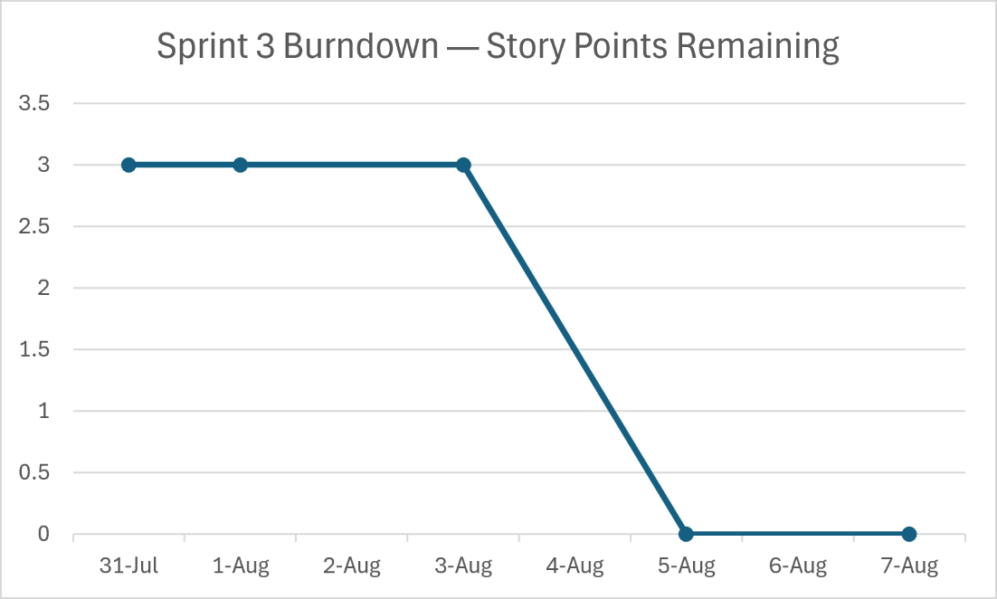

D3. Lessons Learned
- RLS policies must be tested immediately after table creation. The team discovered missing insert policies for vehicles and inspection_records during US-02 implementation, causing errors that required SQL Editor fixes.
- Profile records must exist for all auth users. Supabase Auth users are not automatically added to the profiles table; this must be handled either via a database trigger or in the application sign-up flow.
- Small focused sprints work better. Targeting one story with a clear acceptance criteria was more productive than the 7-story Sprint 1 plan.

D4. Sprint 4 Plan
- Primary focus: US-03 (photo capture with timestamps) the most technically complex remaining story and the core evidence value proposition.
- Secondary focus: US-07 (inspection history search) needed for dispute evidence retrieval.
- Fix BUG-01 (session persistence) as part of US-03 implementation.
- Add logout button (BUG-03).
- Schedule client demo with Phanuel showing US-01 + US-02 live.

E. Security Audit

E1. Security Audit Summary
A security review of InspectoFleet was conducted during Sprint 3 covering authentication, authorization, session management, data exposure, secrets handling and input validation. The system uses Supabase as its backend, which provides production-grade security infrastructure. The primary open issues are session persistence (BUG-01) and role-based access control (SEC-02), both deferred to Sprint 4.
ID | Area | Finding | Severity | Status | Mitigation
SEC-01 | Authentication | Supabase Auth handles all authentication (JWT tokens, password hashing, session management). No custom auth logic. | Low | Good | No action needed. Supabase Auth is a production-grade auth provider.
SEC-02 | Authorization | No role-based redirect after login all authenticated users land on the same dashboard regardless of role. | Medium | Open | Add role check in dashboard page to redirect counter agents, fleet managers and admins to appropriate views. Sprint 4.
SEC-03 | Session | No session persistence check on dashboard. Refreshing the page does not verify the user is still authenticated. | Medium | Open | Add Supabase session check middleware in Sprint 4. Users can currently access dashboard URL directly without a valid session.
SEC-04 | Data exposure | Supabase anon key is exposed client-side (NEXT_PUBLIC prefix). This is by design for Supabase but RLS must be enforced. | Medium | Mitigated | RLS enabled on all tables. Anon key alone cannot bypass RLS. Service role key is server-side only.
SEC-05 | Secrets | No API keys, service role keys or passwords committed to the repository. | Low | Good | .env.local is gitignored. Secrets stored in Vercel environment variables and GitHub repository secrets.
SEC-06 | Input validation | Vehicle registration number is converted to uppercase client-side but no server-side validation of format. | Low | Open | Add server-side validation in Sprint 4. Reject registrations with invalid characters or excessive length.
SEC-07 | Logout | No logout functionality. Users cannot sign out. | Low | Open | Add logout button to dashboard in Sprint 4.

E2. Dependency Vulnerability Report
Running npm audit on the current codebase reports 2 moderate severity vulnerabilities (present since initial Next.js scaffold). These are in transitive dependencies and do not affect the application's security surface directly. The team will run npm audit fix before the D8 release candidate.
- 2 moderate severity vulnerabilities in sharp and unrs-resolver (image processing transitive deps)
- 0 high or critical severity vulnerabilities
- Action: run npm audit fix before v0.9-rc (D8)

E3. Secrets and Credentials Review
- ✅ No API keys committed to repository — confirmed by scanning git log
- ✅ .env.local is in .gitignore — confirmed
- ✅ Supabase service role key is server-side only — not exposed to client
- ✅ GitHub repository secrets configured for CI
- ✅ Vercel environment variables configured for production

F. Privacy Audit

F1. Privacy Audit Summary
A privacy review was conducted covering all data types handled by InspectoFleet, their storage locations, sensitivity classification, and compliance with the team's data handling commitments from D1 and D4.
ID | Data Type | Where Stored | Sensitivity | Finding | Status
PRV-01 | Staff email addresses | Supabase Auth + profiles table | PII | Email addresses are stored as part of authentication. Only accessible to admin role via RLS. | Acceptable
PRV-02 | Vehicle registration numbers | vehicles table | Internal | Registration numbers are business data, not personal data. Accessible to all authenticated users. | Acceptable
PRV-03 | Inspection records | inspection_records table | Confidential | Records are linked to agent ID and vehicle. Accessible to authenticated users per RLS policy. | Acceptable
PRV-04 | Customer names | contract_ref field (free text) | PII | No customer names are stored in InspectoFleet at this stage. The contract_ref is a reference number only. | No PII stored
PRV-05 | Real client data in repo | GitHub repository | Confidential | No real Kal Car Rentals data (vehicles, inspections, photos) has been committed to the repository. Only placeholder/test data used. | Compliant

F2. Data Minimisation Assessment
InspectoFleet currently collects only the minimum data necessary for the inspection workflow: vehicle registration numbers (business data), staff email addresses (required for authentication), and inspection records (core business purpose). No customer personal data beyond a contract reference number is stored. This is consistent with the privacy-by-design principle stated in D2 NFR-08.

F3. Data Residency
All data is stored on Supabase's managed infrastructure. The Supabase project was created in the Europe West (London) region. This will be disclosed to the client (Phanuel K. A. Wagba) in the handoff documentation (D9) so the client can make an informed decision about data residency before production use.

G. AI Usage Audit

G1. Full AI Usage Log
The following is a complete audit of all AI tool usage across the project to date, cross-referenced with AI_USAGE_LOG.md in the repository:
Date | Tool | Task | Output used? | Verified by | Logged?
24 Jun 2026 | Claude | D0 Team Charter structure and placeholder drafting | Yes | Ocloo — team filled all real content | Yes
29 Jun 2026 | Claude | D1 Project Proposal — sections A–G, risk register, sprint plan | Yes | Ocloo — client problem statement verified with Phanuel | Yes
3 Jul 2026 | Claude | D2 SRS — 6 use cases, 15 user stories, 12 NFRs, data entities | Yes | Paa Kweku — all acceptance criteria reviewed by team | Yes
10 Jul 2026 | Claude | D3 Backlog, UX wireframes (7 screens), Sprint 1 plan | Yes | Freeman — sprint selection approved by team | Yes
17 Jul 2026 | Claude | D4 Architecture report, ADRs, API contract, slide deck, video script | Yes | Ocloo — all stack decisions reviewed and approved by team | Yes
24 Jul 2026 | Claude | D5 Sprint 1 review report + US-01 login page code scaffold | Yes | Ocloo — code reviewed, tested manually, integrated before PR | Yes
31 Jul 2026 | Claude | D6 Sprint 2 review, test plan, bug log, quality evidence | Yes | Freeman — test results verified manually against live deployment | Yes
5 Aug 2026 | Claude | D7 Sprint 3 review, security/privacy/AI audit, US-02 code scaffold | Yes | Freeman — code reviewed, tested manually, verified on Vercel | Yes

G2. AI Usage Policy Compliance
- ✅ All AI usage is logged in AI_USAGE_LOG.md with date, tool, task, output used, and verification performed.
- ✅ All AI-assisted code was reviewed and tested by a team member before being committed.
- ✅ No real client data (vehicle records, customer names, financial data) was pasted into AI tools.
- ✅ All AI-assisted PRs include AI disclosure in the PR description and checklist.
- ✅ No team member has submitted AI-generated work as their own without review and verification.

G3. AI Contribution vs Team Contribution Summary
Area | AI contributed | Team contributed
Document structure and formatting | Section headings, table scaffolding, placeholder language | All real content, decisions, evidence, client information
Requirements (D2 SRS) | Use case and user story scaffolding | All acceptance criteria verified against client conversation
Architecture decisions (D4) | ADR structure and options listing | All technology choices made by team
Code (US-01, US-02) | Initial code scaffold for login and inspection pages | Code reviewed, tested, debugged and integrated by Ocloo
Test plan (D6) | Test case table structure | All test results executed manually by Paa Kweku
Security/privacy audit (D7) | Audit table structure and finding descriptions | All findings verified by team against actual codebase

H. Observability

H1. Current Observability Setup
InspectoFleet currently has basic observability through the following built-in mechanisms:
- Vercel deployment logs — all server-side errors and API route responses are logged in the Vercel dashboard under Functions tab. Accessible at vercel.com/extrovrtd/inspectofleet/logs.
- Supabase logs — all database queries, auth events, and storage operations are logged in the Supabase dashboard under Logs. Auth logs show every login attempt, success, and failure.
- GitHub Actions logs — full CI run output for every push and PR, retained for 90 days.
- Browser console — client-side errors are visible in the browser developer tools during testing.

H2. What Is Not Yet Monitored
- No application-level error tracking (e.g. Sentry) — unhandled client-side errors are not captured or alerted on.
- No uptime monitoring — no automated check that inspecto-fleet.vercel.app is responding.
- No performance monitoring — page load times and API response times are not tracked.
- No structured logging from API routes — console.log statements only.

H3. Observability Plan for Sprint 4
- Add basic error boundary in Next.js to catch and display client-side errors gracefully rather than showing a blank page.
- Add try/catch logging in all API routes so errors are visible in Vercel function logs.
- Consider adding Sentry free tier for error tracking before the D8 release candidate decision to be made at Sprint 4 planning.

H4. Client Evidence
Client update planned before D8. The demo of US-01 and US-02 to be scheduled this week

