UNIVERSITY OF GHANA — DEPARTMENT OF COMPUTER SCIENCE
DCIT 208 — SOFTWARE ENGINEERING
D5: Sprint 1 Review Report and Working Prototype v0.1
Team Name | Snart
Project Title | InspectoFleet
Client Name | Kal Car Rentals
Sprint Number | Sprint 1
Sprint Dates | 10 July 2026 – 24 July 2026
Repository URL | https://github.com/Dept-of-Comp-Sci-University-of-Ghana/dcit208-client-project-2026-team-engineering-repository-seg26-77
Release Tag | v0.1-prototype
Commit Hash | 6a983df
Deployment Link | https://inspecto-fleet.vercel.app/login
AI Assistance Disclosure | Claude (Anthropic) was used to structure this sprint review report, draft section content, and provide the login page code scaffold for US-01. All sprint decisions, velocity data, reflection content, and engineering evidence were supplied by the team. Login page code was reviewed and integrated by Ocloo Eugene Selasi. See AI_USAGE.md.

A. Sprint Summary

A1. Sprint Goal
By the end of Sprint 1, a counter agent should be able to log in, start a vehicle inspection, capture time-stamped photos for handover or return, and complete and lock the inspection. An admin should be able to add vehicles and create staff accounts.

A2. Sprint Dates
- Start: 10 July 2026 (Week 6, immediately after D3 submission)
- End / Review: 24 July 2026 (D5 deadline, Week 8)
- Duration: 2 weeks

A3. Sprint Outcome Summary
Sprint 1 was the team's first implementation sprint and the first time most members attempted to write and deploy production code. The sprint was significantly impacted by the team's learning curve with the Next.js and Supabase technology stack, combined with the time spent completing D4 (Architecture Defense) and its associated setup work. Initializing Next.js, connecting Supabase, and deploying to Vercel which consumed the first several days of the sprint window.
By the end of Sprint 1, the login page (US-01) has been partially implemented: the UI is built, Supabase Auth is connected, and authentication calls are functional. The remaining 6 Sprint 1 stories were not completed and are carried over to Sprint 2. This is an honest assessment, the team acknowledges the gap between planned and completed work and has identified clear root causes and corrective actions below.

A4. Updated Sprint Backlog
Planned: 7 stories / 20 points. Completed: 0 stories fully done / 0 points. Partially implemented: US-01 (login — functional but not PR-reviewed and merged). Carried over: 7 stories / 20 points.

Story ID | Story Summary | Points | Owner | Status | Notes / PR Link
US-01 | Counter agent can log in | 3 | Freeman | Carried over | Login page implemented by Ocloo (see Section C). Partially working auth connected to Supabase, redirect to dashboard. PR pending review.
US-02 | Counter agent can start a new inspection | 3 | Freeman | Carried over | Not started. Depends on US-01 being stable first.
US-03 | Counter agent can capture handover photos | 5 | Ali | Carried over | Not started. Depends on US-02.
US-04 | Counter agent can capture return photos | 3 | Ali | Carried over | Not started. Depends on US-03.
US-06 | Counter agent can mark inspection as complete | 2 | Paa Kweku | Carried over | Not started. Depends on US-03.
US-12 | Admin can add a new vehicle | 2 | Ocloo | Carried over | Not started. Deferred to Sprint 2 given login priority.
US-13 | Admin can create a staff account | 2 | Seity | Carried over | Not started. Deferred to Sprint 2.

B. Requirements and Backlog Changes

B1. Stories Changed, Split, Added or Removed
- No stories were changed, split, added or removed during Sprint 1. All 7 Sprint 1 stories remain in their original form from the D3 backlog.
- US-12 and US-13 (admin features) were effectively deferred within the sprint in favour of prioritising the authentication foundation (US-01) first, since all other stories depend on a working login.

B2. Reason for Incomplete Stories
- Technology learning curve: most team members had no prior experience with Next.js, React, TypeScript, or Supabase. The first week of the sprint was largely spent learning the framework basics before writing any feature code.
- D4 setup overlap: the D4 deliverable required initializing the Next.js project, connecting Supabase, and deploying to Vercel. All of which happened in the first days of the sprint window, reducing effective implementation time.
- PR review bottleneck: the team's branch protection setup and PR review process was new to all members, slowing the merge cycle for the first real feature branch.
- No prior velocity baseline: this being Sprint 1, the team had no data on how long individual stories would take, leading to an overambitious sprint plan.

B3. Updated Traceability Impact
No requirement changes. All US-01 through US-13 SRS requirements remain valid and unchanged. The sprint delivery shortfall affects timeline only, not requirements scope or priority.

B4. New Stories Added to Backlog
No new stories were added. One implicit sub-task was identified during Sprint 1: creating a test user account in Supabase Auth for development and QA purposes. This is an internal task, not a user-facing story, and does not require a new GitHub Issue.

C. Engineering Evidence

C1. Pull Requests
- PR #23 — feat: implement login page and dashboard (US-01) with Supabase Auth
- Author: extrovrtd (Ocloo Eugene Selasi)
- Reviewer: Eugene Menye Shiangah Senam
- Status: Merged
- Link: https://github.com/Dept-of-Comp-Sci-University-of-Ghana/dcit208-client-project-2026-team-engineering-repository-seg26-77/pull/23
- AI assistance: Yes — Claude provided the initial code scaffold for app/login/page.tsx and app/dashboard/page.tsx. Code was reviewed, tested manually, and integrated by Ocloo Eugene Selasi before the PR was opened.

C2. Tests Added or Updated
No automated tests were written during Sprint 1. The team acknowledges this as a gap relative to the Definition of Done (which requires tests alongside implementation). Sprint 2 will prioritise adding at minimum a test for the authentication flow (US-01) before starting new stories.
Manual testing performed during Sprint 1:
- Login page renders correctly at /login on localhost:3000 and on the Vercel deployment
- Valid Supabase Auth credentials redirect to /dashboard
- Invalid credentials display an error message without crashing the page
- Empty form submission is blocked by HTML5 required validation

C3. CI Status
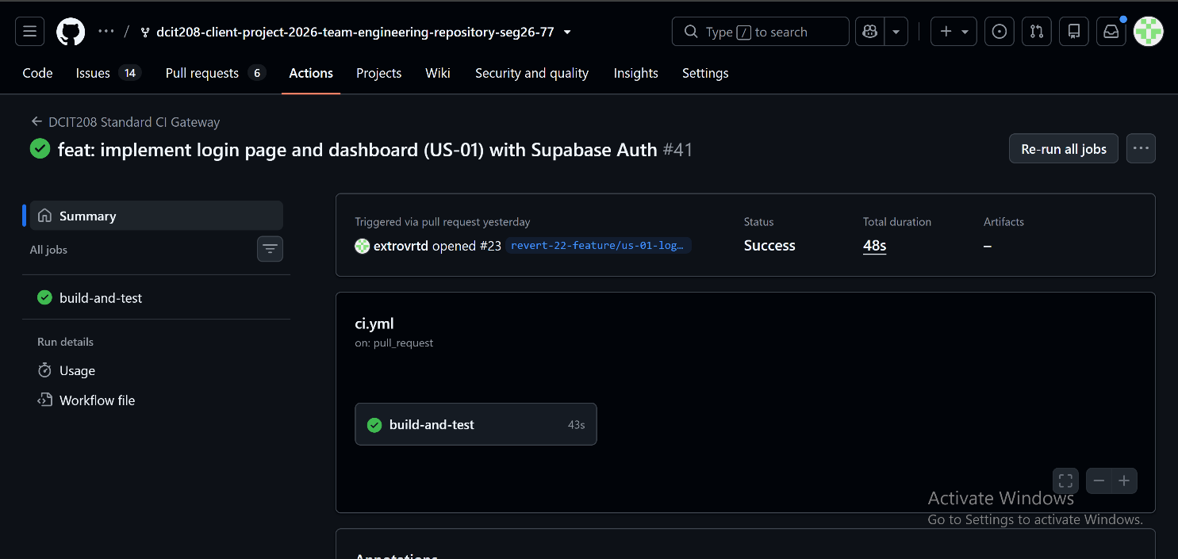
CI workflow: .github/workflows/ci.yml running npm install → npm run lint → npm run build on every push to main and every PR.

C4. Deployment Evidence
The login page is accessible at https://inspecto-fleet.vercel.app/login. Vercel auto-deployed the login page commit from the main branch.
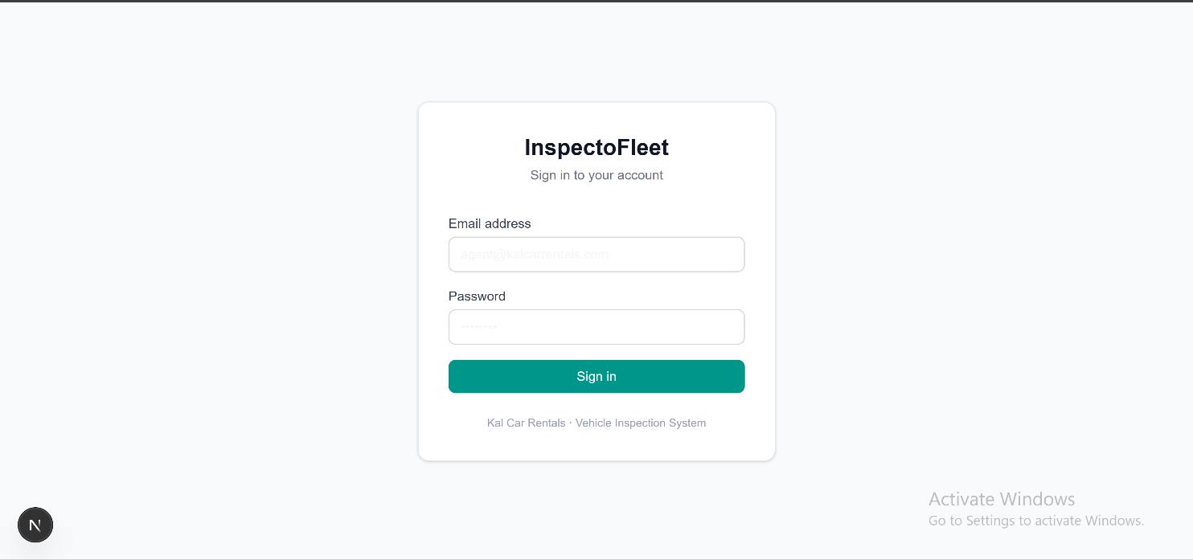

C5. Known Defects and Technical Debt
- US-01 login: after successful login the dashboard page is a placeholder with no real content known, acceptable for v0.1-prototype.
- No role-based redirect yet. All users land on the same dashboard page regardless of role (counter agent, fleet manager, admin). This will be addressed in Sprint 2 alongside US-02.
- No session persistence check, refreshing the dashboard page does not verify the user is still authenticated. Supabase session middleware will be added in Sprint 2.
- No logout functionality. Deferred to Sprint 2.
- No tests. Highest priority technical debt for Sprint 2.

D. Metrics and Reflection

D1. Velocity
Metric | Value
Stories planned | 7
Story points planned | 20
Stories completed (Definition of Done met) | 0
Story points completed | 0
Stories partially implemented | 1 (US-01 — login page functional, PR pending)
Stories carried over to Sprint 2 | 7
Points carried over | 20

D2. Burndown
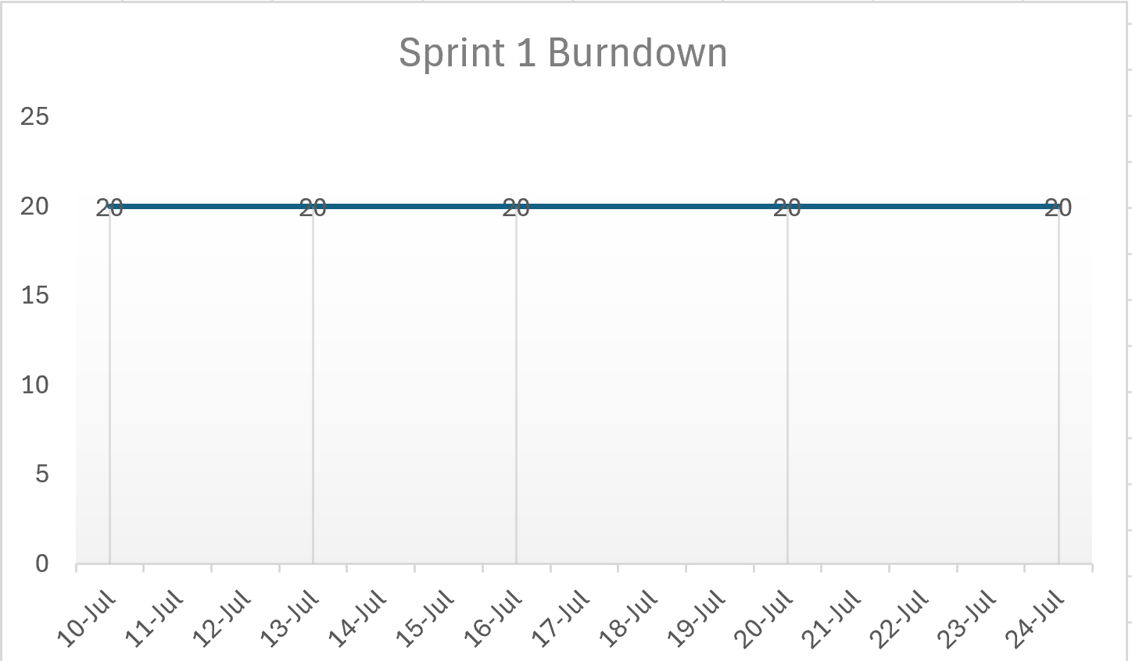

D3. Lessons Learned
- Sprint planning must account for learning time: the team's first sprint with a new stack needs a lower story point target. Recommended Sprint 2 target: 10–12 points rather than 20.
- D4 setup work should not overlap with Sprint 1: in future semesters, the architecture setup (initializing framework, connecting services, deploying) should be completed before the sprint clock starts.
- PRs need faster review cycles: the team will establish a rule that any open PR must be reviewed within 24 hours of being opened, to prevent merge bottlenecks.
- US-01 (login) is the correct first story: the decision to start with authentication was right — it is a dependency for every other story and needed to be stable first.
- Manual testing caught real issues: even without automated tests, the manual testing of the login page found the missing session persistence issue early.

D4. What the Team Will Change in Sprint 2
- Reduce sprint commitment to 10–12 points to match actual team capacity.
- Merge US-01 properly via a reviewed PR before starting US-02.
- Write at least one automated test per story before marking it as done.
- Each member will time-box their story to 3 days maximum before escalating for help.
- Weekly mid-sprint check-in on Wednesdays to catch blockers before the Friday deadline.

D5. Contribution Summary by Member
Member | Sprint 1 Contribution
Freeman K. A. Wagba | Product/Client Manager: maintained project board, coordinated team communication, liaised with client (Phanuel). Owner of US-01 and US-02 (carried over).
Ali Khadija | UX/Research Lead: D3 wireframes finalized. Owner of US-03, US-04 (carried over). Reviewed D4 architecture diagrams.
Paa Kweku Tawiah Oppong-Ntori | QA/Validation Lead: drafted manual test cases for US-01. Owner of US-06 (carried over).
Siatey Desmond | UX/Research Lead: contributed to D4 slide deck. Owner of US-08, US-09 (Sprint 2). Assisted with D5 documentation.
Ocloo Eugene Selasi | Implementation Lead: implemented login page (US-01). Created app/login/page.tsx and app/dashboard/page.tsx, connected Supabase Auth. PR opened for review.
Eugene Menye Shiangah Senam | Implementation Lead: supported D4 ADR documentation. Owner of US-10, US-11 (Sprint 2). [fill in any additional Sprint 1 contributions]
Seity Matin | Documentation/Evidence Lead: maintained AI_USAGE_LOG.md, compiled D5 evidence. Owner of US-13 (carried over).

E. Client Feedback

E1. Sprint 1 Client Review
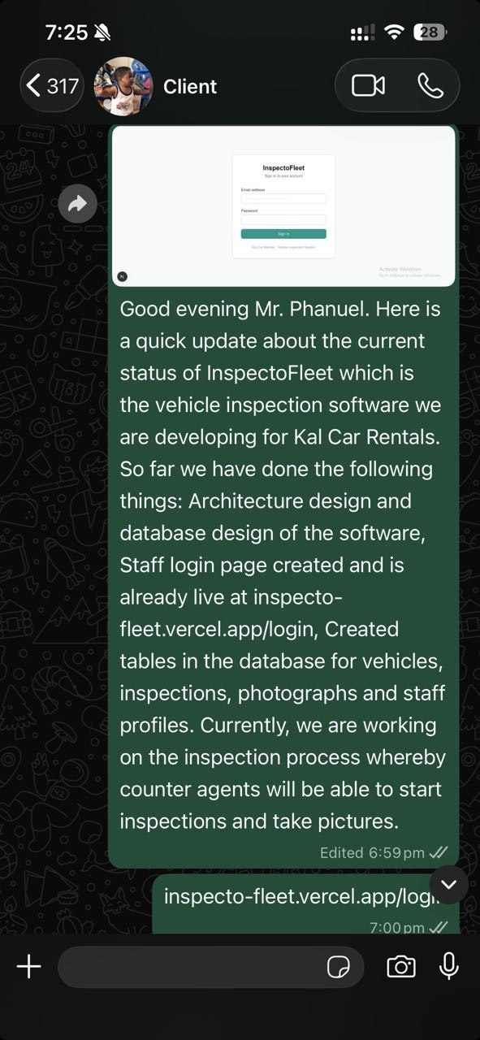

E2. What the Client Accepted, Rejected or Changed
The client responded positively on 22 July 2026:
"Good evening. Thank you for the update. I'm pleased with the progress you've made so far. It's good to hear that the architecture, database design, and login page have been completed, and that work on the inspection process is underway. Please continue to keep me updated on your progress, especially once the inspection feature is ready for testing. Keep up the good work."
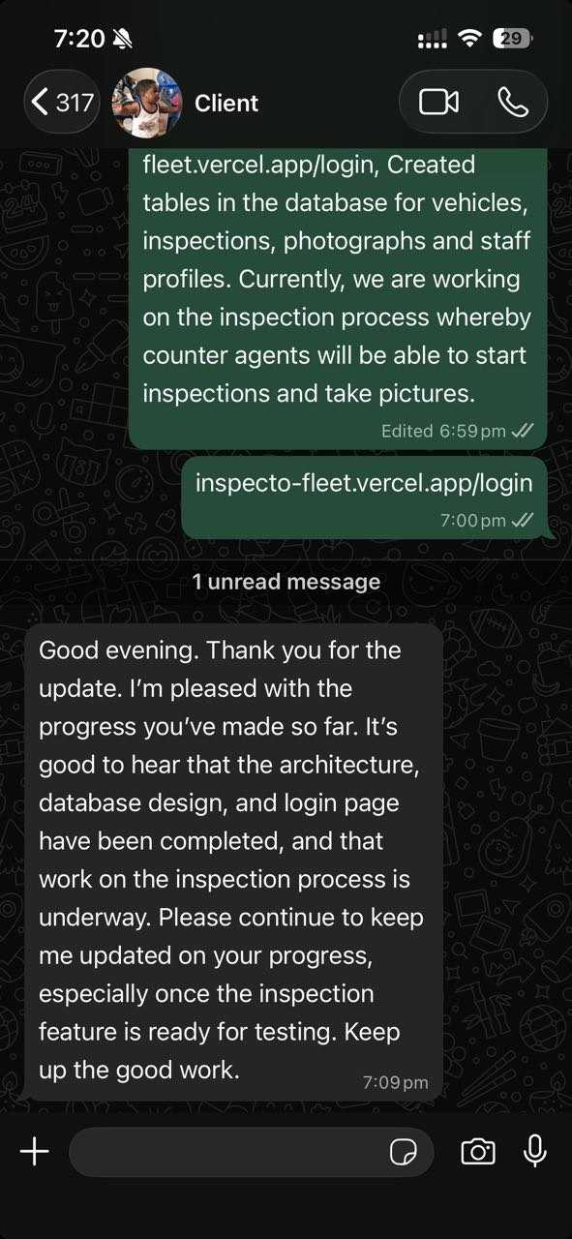

E3. New Questions for the Next Client Meeting
- How many counter agents will use the system simultaneously?
- Should staff be able to reset their own password, or does admin always handle resets?
- Is there an existing vehicle registration format we should follow?

F. Minimum Prototype Expectations

F1. End-to-End Flow Implemented
US-01 (login) is partially functional end-to-end: a user can navigate to /login, enter their email and password, submit the form, and be redirected to /dashboard on successful authentication. The Supabase Auth integration is working. The dashboard is a placeholder page showing the Sprint 1 status of each story.
This is the only end-to-end flow available at v0.1-prototype. The team acknowledges this is below the intended sprint scope and has identified the root causes in Section D.

F2. CI Status
GitHub Actions CI passes on all commits to main: npm install, npm run lint, and npm run build all succeed. The login page and dashboard page introduced no linting or build errors.

F3. User-Visible Changes Documented
- Login page showing the InspectoFleet login form with email and password fields
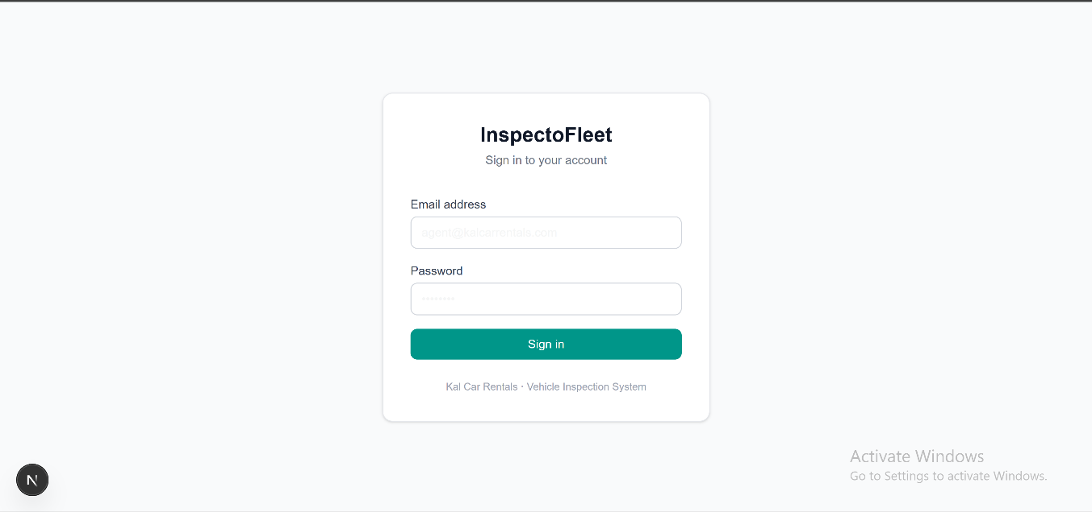
- Dashboard page showing the authenticated state with Sprint 1 story status cards
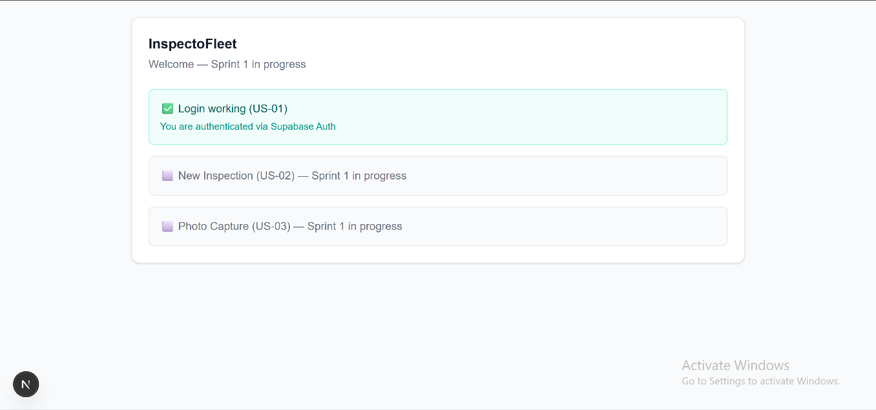

- Login page showing the error state with invalid credentials
