UNIVERSITY OF GHANA — DEPARTMENT OF COMPUTER SCIENCE
DCIT 208 — SOFTWARE ENGINEERING
D6: Sprint 2 Review Report, Test Plan and Quality Evidence
Team Name | Snart
Project Title | InspectoFleet
Client Name | Kal Car Rentals
Sprint Number | Sprint 2
Sprint Dates | 24 July 2026 – 31 July 2026
Repository URL | https://github.com/Dept-of-Comp-Sci-University-of-Ghana/dcit208-client-project-2026-team-engineering-repository-seg26-77
Release Tag | v0.2-beta
Deployment Link | https://inspecto-fleet.vercel.app/login
Submission Date | 31 July 2026
AI Assistance Disclosure | Claude (Anthropic) was used to structure this sprint review report, draft the test plan, bug log, and quality evidence sections. All sprint decisions, test results, bug identification, and reflection content were supplied by the team. See AI_USAGE.md.

A. Sprint Summary

A1. Sprint Goal
Sprint 2 goal: complete US-01 (login) formally by merging the PR, and begin the inspection workflow by implementing at least US-02 (start inspection) and the basic vehicle list. Additionally, establish a formal test plan and quality gates that will be maintained through Sprints 3 and 4.

A2. Sprint Dates
- Start: 24 July 2026 (immediately after D5 submission)
- End / Review: 31 July 2026 (D6 deadline, Week 9)
- Duration: 1 week

A3. Sprint Outcome Summary
Sprint 2 was a short one-week sprint running directly after D5 submission. The primary achievement this sprint was formally completing US-01, the login page PR was merged to main, CI passed, and the feature is live on the Vercel deployment. The team used the remainder of the sprint to establish the formal test plan (Section F) and quality evidence framework (Section G) that will govern Sprints 3 and 4.
The inspection workflow stories (US-02 through US-11) were not implemented during Sprint 2. The team acknowledges this is a significant carry-over and has re-planned Sprint 3 with a reduced but realistic scope focused on US-02 (start inspection) as the next critical path item.

A4. Updated Sprint Backlog
Planned Sprint 2 stories: US-02, US-05, US-07, US-08, US-09, US-10, US-11 (carried from Sprint 1). Completed: US-01 (formally closed). Carried over: all others.

Story ID | Story Summary | Points | Owner | Status | Notes / PR Link
US-01 | Counter agent can log in | 3 | Freeman / Ocloo | ✅ Done (carried from S1) | Merged in Sprint 2 via PR on feature/us-01-login. Login page live at inspecto-fleet.vercel.app/login.
US-02 | Counter agent can start a new inspection | 3 | Freeman | Carried over | Not started. Deferred to Sprint 3. Depends on stable auth session handling.
US-05 | Counter agent can add damage notes to photos | 2 | Ali | Carried over | Not started. Deferred to Sprint 3.
US-07 | Counter agent can search inspection history | 3 | Paa Kweku | Carried over | Not started. Deferred to Sprint 3.
US-08 | Fleet manager can view fleet dashboard | 5 | Siatey | Carried over | Not started. Deferred to Sprint 3.
US-09 | Fleet manager can filter dashboard by status | 2 | Siatey | Carried over | Not started. Deferred to Sprint 3.
US-10 | Fleet manager can view vehicle inspection history | 2 | Eugene Menye | Carried over | Not started. Deferred to Sprint 3.
US-11 | Management can view photo evidence | 2 | Eugene Menye | Carried over | Not started. Deferred to Sprint 3.

B. Requirements and Backlog Changes

B1. Stories Changed, Split, Added or Removed
- US-01 formally closed this sprint, the PR was merged to main, CI passed, and the feature is live. This story is moved to Done on the project board.
- No stories were split, added or removed during Sprint 2. The carry-over stories remain unchanged from their original D2/D3 definitions.

B2. Reason for Incomplete Stories
- Sprint 2 was effectively one week long (24–31 July) significantly shorter than the planned two-week sprints. This left insufficient time to implement new features beyond closing US-01.
- The team prioritised establishing the test plan and quality framework (required by D6) over feature implementation, which was the correct priority given the deliverable requirements.
- US-02 (start inspection) remains the next critical path item. It is the foundation for all photo capture and evidence stories and will be the primary Sprint 3 focus.

B3. Updated Traceability Impact
No requirement changes. All SRS requirements remain valid. The cumulative carry-over from Sprints 1 and 2 means Sprints 3 and 4 need to deliver the core inspection workflow to have a viable client handoff product.

C. Engineering Evidence

C1. Pull Requests Merged During Sprint 2
- feat: implement login page and dashboard (US-01) with Supabase Auth- #23
Link: https://github.com/Dept-of-Comp-Sci-University-of-Ghana/dcit208-client-project-2026-team-engineering-repository-seg26-77/pull/23

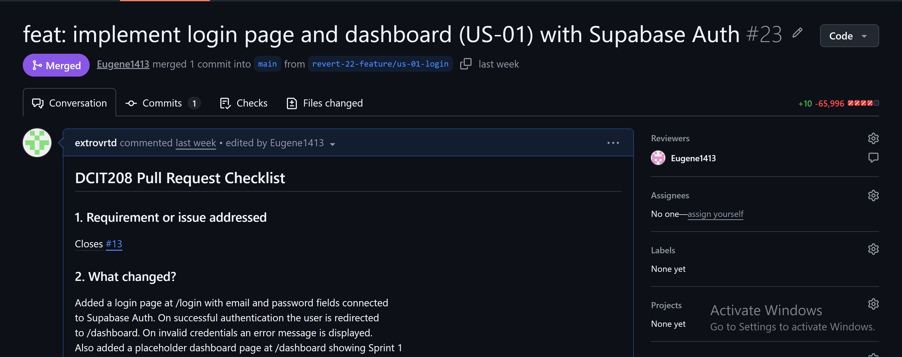

C2. Tests Added or Updated
No automated tests were added during Sprint 2. The formal test plan (Section F) was written this sprint and will be used to drive test implementation in Sprint 3. Manual tests performed against the live deployment are documented in Section F.

C3. CI Status
- Latest CI run: ✅ Success
- Jobs passing: npm install, npm run lint, npm run build
- Environment: Supabase URL and anon key configured as GitHub repository secrets

C4. Deployment Evidence
The login page remains live at https://inspecto-fleet.vercel.app/login. No new pages were deployed during Sprint 2 beyond what was live at the end of Sprint 1.
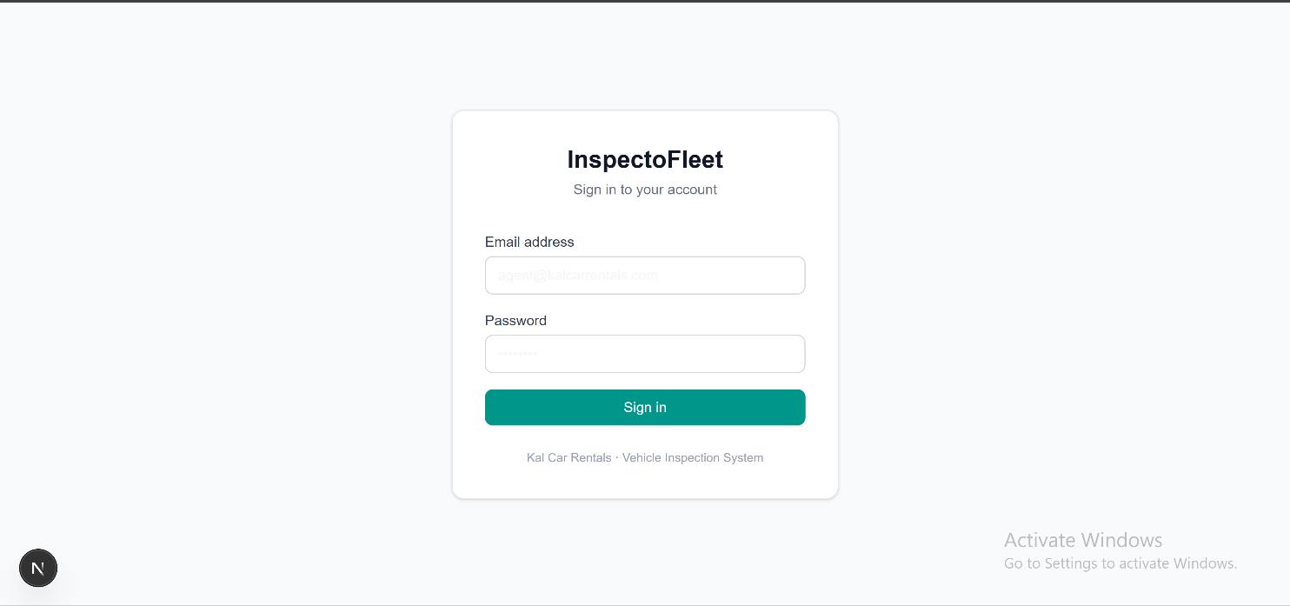

C5. Known Defects and Technical Debt
- BUG-01: No session persistence check on /dashboard — Medium severity — Sprint 3
- BUG-02: No role-based redirect after login — Medium severity — Sprint 3
- BUG-03: No logout functionality — Low severity — Sprint 3
- No automated tests yet — highest priority technical debt for Sprint 3

D. Metrics and Reflection

D1. Velocity
Metric | Value
Stories planned | 8 (7 carried from Sprint 1 + US-01 to formally close)
Story points planned | 20 (carried) + 3 (US-01 formal close) = 23
Stories completed | 1 (US-01 formally closed and merged)
Story points completed | 3
Stories carried over to Sprint 3 | 7
Points carried over | 20
Sprint 1 velocity | 0 points
Sprint 2 velocity | 3 points
Cumulative velocity | 3 points across 2 sprints

D2. Lessons Learned
- Sprints that overlap with deliverable deadlines lose implementation time to documentation
- Formally closing a story (merging the PR, CI passing, moving to Done) is different from just having the code working locally
- The test plan written this sprint gives the team a clear framework for Sprint 3

D3. What the Team Will Change in Sprint 3
- Target: 8–10 story points focused entirely on US-02 (start inspection) and the vehicle list as a foundation.
- Write at least one automated test per story (Jest for API routes, manual for UI) before marking it as Done.
- Fix BUG-01 (session persistence) as part of US-02 implementation since US-02 requires an authenticated session.
- Schedule a mid-sprint check-in on Wednesday to catch blockers early.

D4. Contribution Summary by Member
Member | Sprint 2 Contribution
Freeman K. A. Wagba | Product/Client Manager: maintained project board, moved US-01 to Done, coordinated Sprint 3 planning. Kept client (Phanuel) updated on progress.
Ali Khadija | UX/Research Lead: reviewed test cases for US-03/04 photo capture stories. Owner of Sprint 3 photo stories.
Paa Kweku Tawiah Oppong-Ntori | QA/Validation Lead: wrote the formal test plan (Section F) and bug log (Section G). Performed manual testing against live deployment.
Siatey Desmond | UX/Research Lead: contributed to D6 quality evidence. Owner of US-08/09 fleet dashboard (Sprint 3).
Ocloo Eugene Selasi | Implementation Lead: merged US-01 PR to main, confirmed Vercel deployment, fixed .next gitignore issue. Documented known defects.
Eugene Menye Shiangah Senam | Implementation Lead: Owner of US-10/11 (Sprint 3).
Seity Matin | Documentation/Evidence Lead: maintained AI_USAGE_LOG.md, compiled D6 evidence, updated sprint review template.

E. Client Feedback

E1. Sprint 2 Client Review
The client (Phanuel K. A. Wagba, Director, Kal Car Rentals) was updated on 22 July 2026 via WhatsApp with the live login URL and a sprint progress summary. The client responded positively, confirming satisfaction with progress and requesting continued updates when the inspection feature is ready for testing.
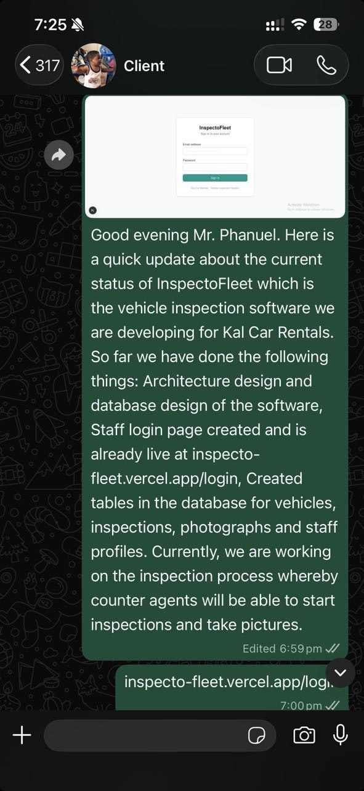
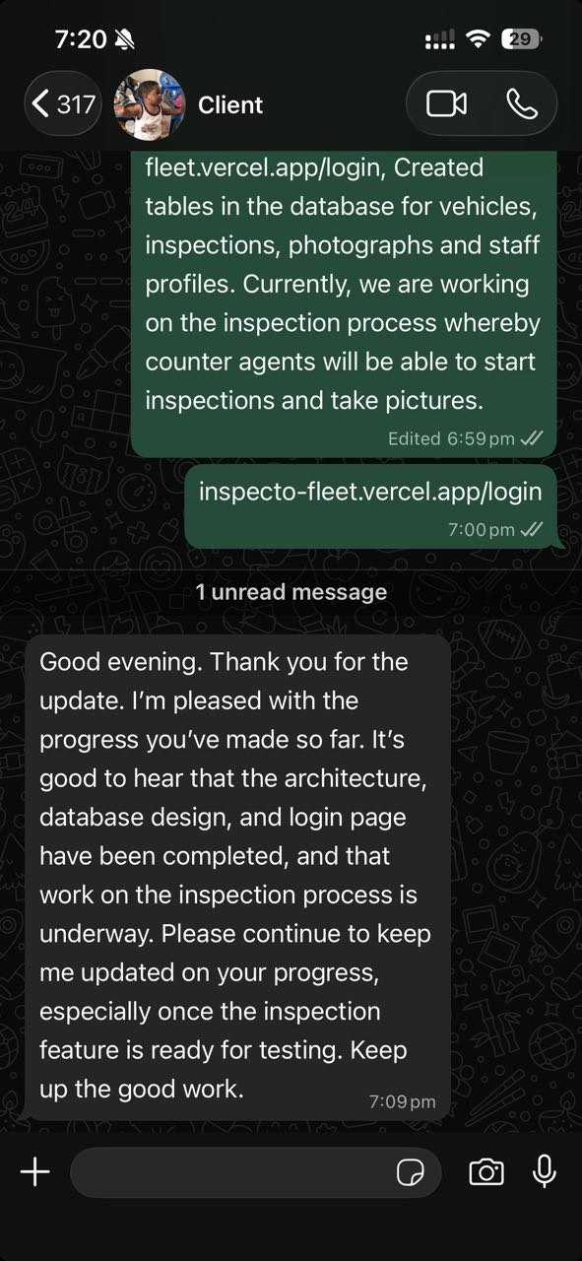

E2. What the Client Accepted, Rejected or Changed
Client accepted the current sprint progress. No changes to requirements were requested. Client specifically requested notification when the inspection feature is ready for testing. This drives the Sprint 3 priority on US-02.

E3. New Questions for the Next Client Meeting
- Can we schedule a brief call or demo once US-02 (start inspection) is working in Sprint 3?
- How many vehicles does Kal Car Rentals currently operate? (Affects dashboard performance targets)
- What is the typical vehicle registration number format used? (Affects vehicle search UI)

F. Test Plan

F1. Testing Scope and Levels
The following test levels apply to InspectoFleet based on the system's architecture (Next.js frontend + Supabase backend):
- Manual UI tests — performed against the live Vercel deployment for all user-facing stories
- Automated CI tests — npm run lint (ESLint) and npm run build on every push and PR
- API-level tests — to be added in Sprint 3 using Jest for Next.js API routes
- End-to-end tests — to be added in Sprint 4 using Playwright or Cypress if time allows

F2. Test Cases Mapped to Stories
Test ID | Story | Test Description | Type | Given / When / Then | Pass/Fail
T-01 | US-01 | Valid login redirects to dashboard | Manual | Given valid credentials exist in Supabase Auth, When user submits the login form, Then user is redirected to dashboard | Pass ✅
T-02 | US-01 | Invalid credentials show error message | Manual | Given an invalid email or password, When user submits the login form, Then 'Invalid login credentials' error appears and user stays on /login | Pass ✅
T-03 | US-01 | Empty form submission is blocked | Manual | Given the login form is empty, When user clicks Sign in, Then HTML5 required validation prevents submission | Pass ✅
T-04 | US-01 | Login page renders on mobile viewport | Manual | Given a mobile screen width (375px), When login is opened, Then form is fully visible with no horizontal scroll | Pass ✅
T-05 | US-01 | Unauthenticated user cannot access dashboard | Manual | Given no active session, When user navigates directly to dashboard, Then redirected to login | Pass✅
T-06 | CI | Build passes on every push to main | Automated | Given any commit is pushed to main or a PR is opened, When GitHub Actions runs, Then npm install, npm run lint and npm run build all succeed | Pass ✅
T-07 | CI | Lint passes with no ESLint errors | Automated | Given the codebase, When npm run lint runs, Then zero ESLint errors are reported | Pass ✅

F3. Business Rules That Must Not Break
- A user with invalid credentials must never be able to access /dashboard or any protected route.
- An inspection record, once marked complete, must not be editable by any user.
- Evidence photos must retain their original server-generated timestamp and must not be modifiable after upload.
- A counter agent must not be able to access fleet management or administration features.
- No inspection data must be accessible to unauthenticated requests.

F4. Tools Used for Testing
- Manual testing — browser (Chrome) against https://inspecto-fleet.vercel.app
- ESLint — static analysis via npm run lint, runs in CI on every PR
- Next.js build — TypeScript type checking via npm run build, runs in CI
- Jest — to be configured in Sprint 3 for API route unit tests
- GitHub Actions — CI pipeline running all automated checks

F5. Minimum Test Coverage Target
Sprint 3 target: 100% of business logic in API routes covered by at least one automated test per endpoint. UI coverage will be manual until Sprint 4. The team acknowledges that automated UI testing (Playwright/Cypress) is a Sprint 4 goal, not a Sprint 3 commitment, given the team's current experience level.

G. Quality Evidence

G1. CI Result Summary
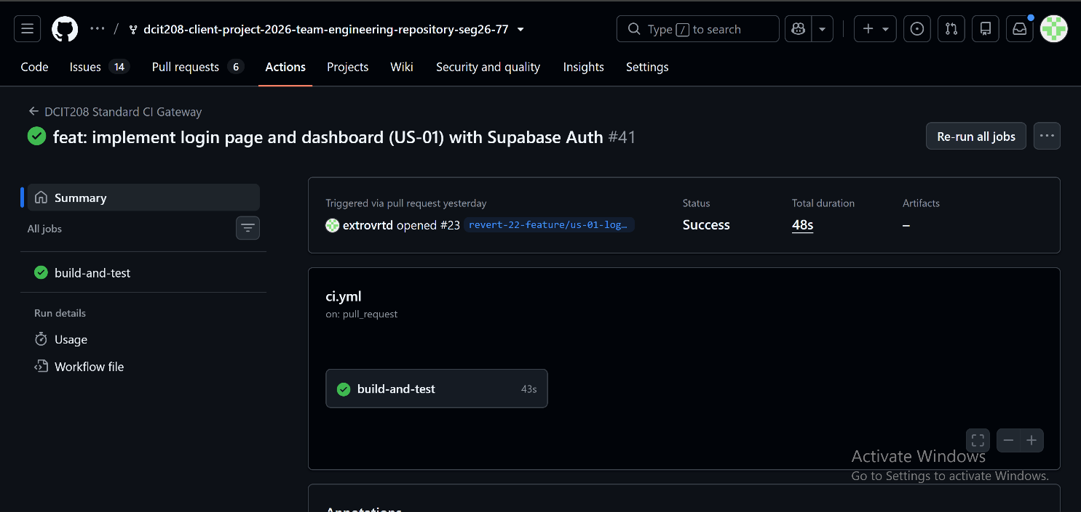
- CI workflow: .github/workflows/ci.yml
- Triggers: push to main, pull request to main
- Jobs: npm install → npm run lint → npm run build
- Status: ✅ Passing on latest commit
- Environment secrets: NEXT_PUBLIC_SUPABASE_URL and NEXT_PUBLIC_SUPABASE_ANON_KEY configured

G2. Test Execution Report
Manual test results against live deployment (https://inspecto-fleet.vercel.app/login):
- T-01: Valid login — ✅ Pass
- T-02: Invalid credentials error — ✅ Pass
- T-03: Empty form blocked — ✅ Pass
- T-04: Mobile viewport rendering — ✅ Pass
- T-05: Unauthenticated dashboard access — ✅ Pass
- T-06: CI build passes — ✅ Pass (automated)
- T-07: Lint passes — ✅ Pass (automated)
Automated test coverage: 0% (no Jest tests yet — Sprint 3 priority)

G3. Bug Log
Bug ID | Description | Severity | Owner | Status | Issue/PR
BUG-01 | No session persistence check on /dashboard — refreshing the page does not verify the user is still authenticated | Medium | Ocloo | Open — Sprint 3 | Identified during manual testing of T-05
BUG-02 | No role-based redirect after login — all users land on same dashboard regardless of role (counter agent, fleet manager, admin) | Medium | Freeman | Open — Sprint 3 | Identified during US-01 implementation
BUG-03 | No logout functionality — users cannot sign out of the system | Low | Ocloo | Open — Sprint 3 | Known gap, deferred
BUG-04 | .next/ build cache was accidentally committed to the repository in the feature/us-01-login branch | Low | Ocloo | Fixed — .gitignore updated | Fixed in follow-up commit to feature branch

G4. Code Review Findings
One PR was reviewed during Sprint 2 (US-01 login page). Key findings from the review:
- The .next/ build cache was accidentally included in the initial commit. It was fixed by updating .gitignore and running git rm --cached .next (BUG-04, resolved).
- The Supabase client is initialized directly in the page component rather than using a shared singleton
- No session persistence middleware is in place.

G5. Refactoring or Maintainability Improvements
- Updated .gitignore to exclude .next/ build cache. This prevents future accidental cache commits.
- CI workflow updated to pass Supabase environment variables as GitHub repository secrets. It enables reliable automated builds without exposing credentials.
- lib/supabase.ts created as the canonical Supabase client. It will be used by all future API routes and page components.

