Date: _______________

Michał Nawrot
Student number: 408811
Field of study: Informatyka Spec. Computer Science
Table of Contents
1 Code documentation 3
1.1 Audio Input and Enabling Effects (PluginProcessor.h / PluginProcessor.cpp) 3
1.2 Next part of code 5

Code documentation

Audio Input and Enabling Effects (PluginProcessor.h
/ PluginProcessor.cpp)

To start explaining the logic of certain parts of the Program, the overview of all Plug-In functions is needed, as well as as a brief description of the process occurring with audio, but most importantly the definition of the
plug-in itself, as it is a crucial piece of information in furthering the explanation of ways the Program works.
Quoting the “Encyclopedia Britannica”, a plug-in is a “computer software that adds new functions to a host program without altering the host program itself. Widely used in digital audio, video, and Web browsing, plug-ins enable programmers to update a host program while keeping the user within the program’s environment.”
Knowing this, the user might expect the program to be not “runnable” outside of a specific environment – in that case a Digital Audio Workstation – however the project covers for that, by having a standalone version of the Plug-In. While it might not be the most conventional use of an audio plug-in among professionals, for the didactic purposes of the thesis and showcasing the possibilities of the Plug-In, it is the most helpful version of the Program.
Simple explanation of the audio processes included in this Project - mentioned in chronological order – are:
- Audio entering the plugin – input.
- Processing of the delay effect (if enabled).
- Processing of the reverb effect (if enabled).
- Plugin releasing the processed audio – output.
In next parts of the thesis the parts shall be explained in that order, and referred to as input, delay, reverb and output respectively.

After opening a plug-in in the Digital Audio Workstation – being the type of software used for audio editing, DAW for short – the host connects to it via VST3 protocol. After that the Workstation sends the audio to the Plug-In to start processing, by calling the processBlock method.
The DAW provides audio data in form of an object called AudioBuffer<float>. It contains the incoming audio samples.
This buffer is passed as a parameter to the processBlock method.

As the audio needs to be processed, prior to that the preapraeToPlay method (shown below) is called. Its purpose is to inform the plugin about the sample rate and block size.

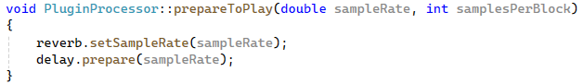
The information being passed on to the plugin is needed for configuring internal components:
- The reverb needs to know the sample rate to calculate sound decay times correctly
- The delay effect initializes its functions based on the sample rate

Additionally the plugin needs defining input and output channels configuration, in that case setting it to stereo in both cases:

Using buffer’s functions, the code accesses the audio data in inside processBlock. The getWritePointer method returns a pointer to the raw audio sample data for a specific channel:
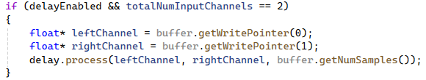
The plugin processes audio data in-place, meaning the buffer that comes in is the same buffer that goes out – code modifies the samples directly.

The effects are enabled since the moment user turns the program on, as it is a common practice among the plug-in manufacturers. It is possible because of the parameter values in PluginProcessor.h shown below:
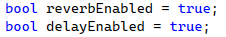
Then the parameters are called

Chronological Code Overview - Audio Processing

The overview of the whole code used for audio processing, should be started from the Plugin Processor Header File. This file is responsible for setting up the classes to use by other files - in that case PluginProcessor.cpp.
The file starts with #include <JuceHeader.h>. It is inclusion of the JUCE framework header file, which provides access to all core JUCE classes (such as Reverb or Delay mentioned previously) and functionality needed for audio plug-in development. Additionally it gives access to usable GUI components and cross-platform compatibility layer.
Next part that is seen, is the Constructor. It initializes the audio processor with stereo Input/Output buses (mentioned previously in 1.1) and sets up all parameters with default values. Additionally it registers parameter listeners and initializes the Reverb parameters.
Regarding that it is required to explain how the parameter listeners work in JUCE framework. They allow the processor to automatically react when parameters change based on user interaction with GUI, automation in the host DAW or preset loading.

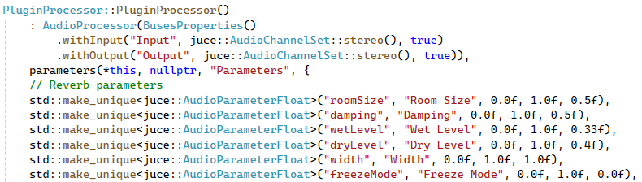
After that the Destructor can be seen, which removes all parameter listeners.
Next parts that are visible are audio processing methods

