有时我们可能需要一块物理网卡绑定多个 IP 以及多个 MAC 地址，虽然绑定多个 IP 很容易，但是这些 IP 会共享物理网卡的 MAC 地址，可能无法满足我们的设计需求，所以有了 MACVLAN 设备，其工作方式如下：
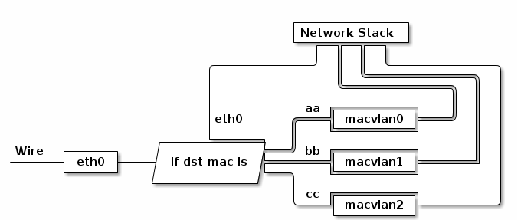
MACVLAN 会根据收到包的目的 MAC 地址判断这个包需要交给哪个虚拟网卡。在macvlan设备上可以绑定一个新IP, 而这个ip有自己的mac地址。
# echo 1 > /proc/sys/net/ipv4/conf/eth0/arp_ignore
# echo 1 > /proc/sys/net/ipv4/conf/macvlan-xxx/arp_ignore
另外配合之前介绍的 network namespace 使用，我们可以构建这样的网络：
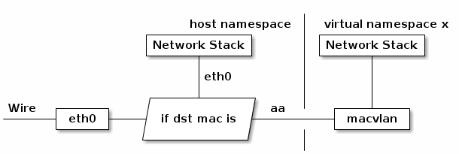
由于 macvlan 与 eth0 处于不同的 namespace，拥有不同的 network stack，这样使用可以不需要建立 bridge 在 virtual namespace 里面使用网络。不过在这种环境下host不能与namespace进行通信。

# ip link add link eth0 name macvlan0 type macvlan mode bridge
Macvlan有3种模式
enum macvlan_mode {
MACVLAN_MODE_PRIVATE = 1, /* don't talk to other macvlans */
MACVLAN_MODE_VEPA = 2, /* talk to other ports through ext bridge */
MACVLAN_MODE_BRIDGE = 4, /* talk to bridge ports directly */
}

static struct rtnl_link_ops macvlan_link_ops = {
.kind = "macvlan",
.setup = macvlan_setup,
.newlink = macvlan_newlink,
.dellink = macvlan_dellink,
};

- 创建
static const struct net_device_ops macvlan_netdev_ops = {
.ndo_start_xmit = macvlan_start_xmit
}；
static void macvlan_setup(struct net_device *dev)
{
ether_setup(dev);
dev->priv_flags &= ~(IFF_XMIT_DST_RELEASE | IFF_TX_SKB_SHARING);
dev->priv_flags |= IFF_UNICAST_FLT;
dev->netdev_ops = &macvlan_netdev_ops;
dev->tx_queue_len = 0;
}

static int macvlan_newlink(struct net *src_net, struct net_device *dev,
struct nlattr *tb[], struct nlattr *data[])
{
struct macvlan_dev *vlan = netdev_priv(dev);

lowerdev = __dev_get_by_index(src_net, nla_get_u32(tb[IFLA_LINK]));
if (!macvlan_port_exists(lowerdev)) {
/*在lower设备上没有创建过macvlan的时候就会创建vlan port*/
err = macvlan_port_create(lowerdev);
// port = kzalloc(sizeof(*port), GFP_KERNEL);
// INIT_HLIST_HEAD(&port->vlan_hash[i]);
/*设置lower设备的receive handler*/
// netdev_rx_handler_register(dev, macvlan_handle_frame, port);
}
port = macvlan_port_get_rtnl(lowerdev);

vlan->lowerdev = lowerdev;
vlan->dev = dev;
vlan->port = port;

/*默认模式*/
vlan->mode = MACVLAN_MODE_VEPA;
if (data && data[IFLA_MACVLAN_MODE])
vlan->mode = nla_get_u32(data[IFLA_MACVLAN_MODE]);

err = register_netdevice(dev);
list_add_tail_rcu(&vlan->list, &port->vlans);
}

B. 接收
static rx_handler_result_t macvlan_handle_frame(struct sk_buff **pskb)
{
port = macvlan_port_get_rcu(skb->dev);
if (is_multicast_ether_addr(eth->h_dest)) {
/*如果是广播或者多播地址 是private模式，src mac是一个macvlan就发送给它(将skb->dev改为该macvlan dev，放进协议栈)*/
src = macvlan_hash_lookup(port, eth->h_source);
if (src && src->mode != MACVLAN_MODE_VEPA &&
rc->mode != MACVLAN_MODE_BRIDGE) {
/* forward to original port. */
vlan = src;
ret = macvlan_broadcast_one(skb, vlan, eth, 0) ?:
netif_rx(skb);
goto out;
}
else
{
/*广播给所有macvlan*/
macvlan_broadcast(skb, port, NULL)
}
}
//根据报文目的mac查找所属macvlan
vlan = macvlan_hash_lookup(port, eth->h_dest);
if (vlan == NULL)
return RX_HANDLER_PASS;

dev = vlan->dev;
/*目标macvlan设备没有up就扔掉*/
if (unlikely(!(dev->flags & IFF_UP))) {
kfree_skb(skb);
return RX_HANDLER_CONSUMED;
}

/*接收设备改为目标macvlan， 放进协议栈*/
skb->dev = dev;
skb->pkt_type = PACKET_HOST;

ret = netif_rx(skb);
}

C. 发送

static int macvlan_queue_xmit(struct sk_buff *skb, struct net_device *dev)
{
const struct macvlan_dev *vlan = netdev_priv(dev);
const struct macvlan_port *port = vlan->port;

/*如果是bridge模式， 目的mac为其他macvlan，
就发送给其他macvlan*/
if (vlan->mode == MACVLAN_MODE_BRIDGE) {
const struct ethhdr *eth = (void *)skb->data;

dest = macvlan_hash_lookup(port, eth->h_dest);
if (dest && dest->mode == MACVLAN_MODE_BRIDGE) {
/* send to lowerdev first for its network taps */
dev_forward_skb(vlan->lowerdev, skb);

return NET_XMIT_SUCCESS;
}
}
/*如果没找到就通过lowerdev 发送*/
xmit_world:
skb->dev = vlan->lowerdev;
return dev_queue_xmit(skb);

static netdev_tx_t macvlan_start_xmit(struct sk_buff *skb,
struct net_device *dev)
{
struct macvlan_dev *vlan = netdev_priv(dev);

ret = macvlan_queue_xmit(skb, dev);
}

