CPU using the page tables to translate the virtual memroy address to the phisycal address. virtual memory implementations take advantage of the principal of locality by storing recent translations in a cache called the Translation Lookaside Buffer (TLB). The amount of memory that can be translated by this cache is referred to as the "TLB reach" and depends on the size of the page and the number of TLB entries. Inevitably, a percentage of a program's execution time is spent accessing the TLB and servicing TLB misses. With the amount of memory increased there are more and more page tables in the kernel with 4kb PAGESIZE. it will lead so many TLB misses. The needs for hugepage come out.
1. HugePage in hardware:
X86_32:
PAE disable，OFFSET is 22bit，TABLE is 0bit，PMD is 0bit, PUD is 0bit, PGD is10bit
PAGE_SHIFT = 22; PMD_SHIFT = 22; PUD_SHIFT = 22; PGD_SHIFT = 22;
Page Size = 4M
Page descriptor:
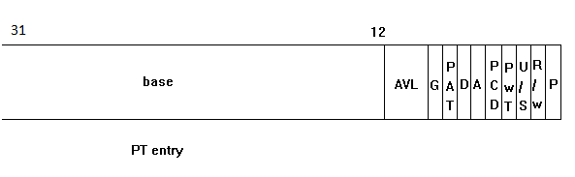
typedef unsigned long pteval_t;
typedef union {
pteval_t pte;
pteval_t pte_low;
} pte_t

PAE enable，OFFSET is 21bit, TABLE is 0bit，PMD is 9bit，PUD is 0bit，PGD is 2bit.
PAGE_SHIFT = 21; PMD_SHIFT = 21; PUD_SHIFT = 30; PGD_SHIFT = 30;
Page Size = 2M
Page descriptor: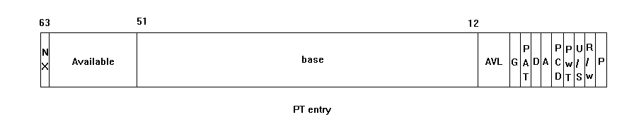

typedef u64 pteval_t;
typedef union {
struct {
unsigned long pte_low, pte_high;
};
pteval_t pte;
} pte_t;

X86_64:
OFFSET is 21bit，TABLE is 0bit，PMD is 9bit, PUD is 9bit, PGD is 9bit
PAGE_SHIFT = 21; PMD_SHIFT = 21 PUD_SHIFT = 30 PGD_SHIFT = 39;
Page Size = 2M
Page descriptor:
typedef struct { pteval_t pte; } pte_t;
typedef unsigned long pteval_t;

2. Hugetlbfs
Userspace can allcate hugepage page according through the hugetlbfs, It depends on the /proc/sys/vm/nr_hugepages and /proc/sys/vm/nr_overcommit_hugepages. It likes the mempool mechanism. Kernel pre-allocate
nr_hugepages pages in a pool when set the nr_hugepage value. When mmap with MAP_HUGETLB, kernel will allocate the hugepage from the pool. If There is no enough pages and the extra number is not exceed the nr_overcommit_hugepages, the kernel will dynamic allocate hugepage from the system memory or it will fail. After unmmap the kernel will put the hugepages to the pool and put the extra hugepage back to system memory.

a. Map with MAP_HUGETLB and fd associate with files in hugetlbfs
vaddr = mmap(0, 1024*1024, PROT_READ | PROT_WRITE, MAP_HUGETLB | MAP_PRIVATE, fd, 0);
/*when access the vaddr it arise a page fault---> hugetlb_fault*/
*vaddr = 'a';

b. Map with MAP_HUGETLB and MAP_ANONYMOUS, no fd.
vaddr = mmap(0, 1024*1024, PROT_READ | PROT_WRITE, MAP_HUGETLB | MAP_PRIVATE | MAP_ANONYMOUS, 0, 0);
/*when access the vaddr it arise a page fault---> hugetlb_fault*/
*vaddr = 'a';

int handle_mm_fault->handle_pte_fault
{
if (unlikely(is_vm_hugetlb_page(vma))) // for case a, b
/*check the flags VM_HUGETLB*/
return hugetlb_fault(mm, vma, address, flags);
}

Linux provide a hugetlbfs feature to support allocateing hugepages for userspace. But it is a urgly interface to user access this feature
Hugepages can be used with hugetlbfs
a. They can't be swapped out
b. They better be reserved at boot
c. Hugepages and regular pages can't be mixed
d. If reservation is not used and dynamic
e. Requires admin privilege and libhugetlbfs
f. Hugetlbfs is growing like a second but inferior Linux VM with its own paths, as people add more features to hugetlbfs

3. Transparent HugePage
Now linux kernel provide a Transparent Hugepage feature that userspace can easily allocate a hugepages.
a. Any Linux process will receive 2M pages, if the mmap region is 2M naturally aligned
b. Hugepages are only mapped by huge pmd
c. When VM pressure triggers the hugepage are split, Then they can be swapped out as 4k pages
d. Tries to modify as little code as possible
e. Entirely transparent to userland
f. Boost for page faults too.

It should eanble the THP in the system /sys/kernel/mm/transparent_hugepage/enabled
# cat /sys/kernel/mm/transparent_hugepage/enabled
always [madvise] never

THere are two ways to get the THP

a. set /sys/kernel/mm/transparent_hugepage/enabled is always

#define SIZE (4*1024*1024)
#define HUGESIZE 2*1024*1024
void *vadr;
posix_memalign(&vadr, HUGESIZE, SIZE);
/*when access the vaddr it arise a handle_mm_fault---> do_huge_pmd_anonymous_page*/
*(char*)vadr = 'a';

b. set /sys/kernel/mm/transparent_hugepage/enabled is madvise
mmap with MAP_PRIVATE and MAP_ANONYMOUS and the vaddr align with HugePageSize, The total len is one more times than the HugePageSize

#define SIZE (4*1024*1024)
#define HUGESIZE 2*1024*1024
vadr = mmap(0, SIZE, PROT_READ | PROT_WRITE, MAP_PRIVATE | MAP_ANONYMOUS, -1, 0);// only private
/*algin the vaddr with HugePageSize*/
if (!(SIZE & (HUGESIZE -1)) && (size_t)vadr & (HUGESIZE - 1))
{
char *old;
munmap(vadr, SIZE);

vadr = mmap(0, SIZE + HUGESIZE - 1, PROT_READ | PROT_WRITE, MAP_PRIVATE | MAP_ANONYMOUS, -1, 0);
old = vadr;
vadr = (char*)(((size_t)vadr + HUGESIZE - 1) & ~(HUGESIZE - 1));
if (old != vadr)
munmap(old, (size_t)vadr - (size_t)old);
if (vadr != old + HUGESIZE -1)
munmap(vadr + SIZE, (size_t)old + HUGESIZE - 1 - (size_t)vadr);
}

/*set the MADV_HUGEPAGE to the vm*/
ret = madvise(vadr, SIZE, MADV_HUGEPAGE);
/*when access it it will arise a handle_mm_fault---> do_huge_pmd_anonymous_page*/
*(char*)vadr = 'a';

page fault:
handle_mm_fault()
{
if (pmd_none(*pmd) && transparent_hugepage_enabled(vma)) {
int ret = VM_FAULT_FALLBACK;
if (!vma->vm_ops)
ret = do_huge_pmd_anonymous_page(mm, vma, address,
pmd, flags);
if (!(ret & VM_FAULT_FALLBACK))
return ret;
}
}

