1. queues: 128 queues
a. Rx Queuing Schemes Supported (No Virtualization)
RSS RSS Queues
No 1 queue Rx queue 0
Yes 16 RSS queues

Ixgbe default runs in rss mode with queues the same as cores. if the queues are more than 16. only The first 16 ones can work in rss.

b. Rx Queuing Schemes Supported with Virtualization
The 128 Rx queues are allocated to a pre-configured number of queue sets, called pools.
In non-IOV mode, system software allocates the pools to the VMM, an IOVM, or to VMs.
In IOV mode, each pool is associated with a VF.

RSS RSS Queues
No 16/32/64 pools x 1 queue

Yes 32 pools x 4 RSS/64 pools x 2 RSS

IOV mode
— Determine the number of pools: the number must support the value configured
by the operating system in the PCIe NumVFs field
Therefore, the number of pools is min of {16, 32, 64} that is still >= NumVFs.
— Note that RSS is not supported in IOV mode since there is only a single RSS hash
function in the hardware

- Filters
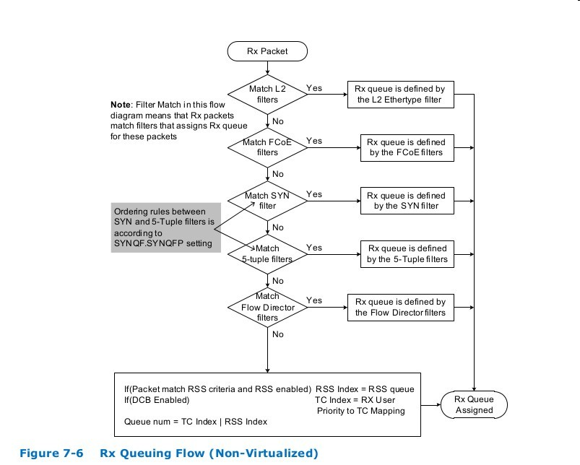
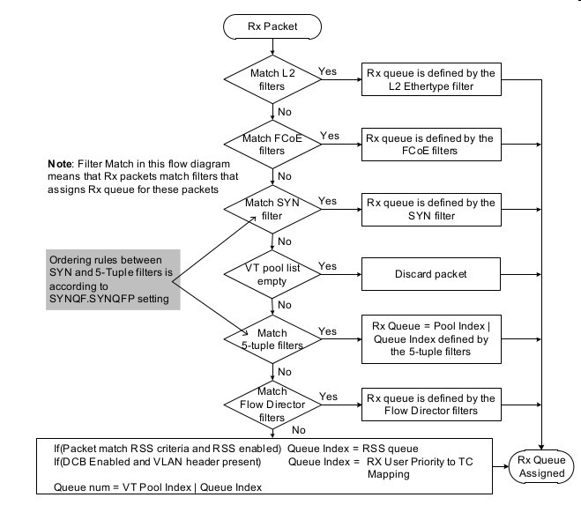
1). L2 filter
a. mac filter: can be used for pool selection in vmdq
b. vlan filter: can be used for pool selection in vmdq
c. L2 type filter
2). syn filter
3). tuple5 filter
4). flow dirctor
5). rss
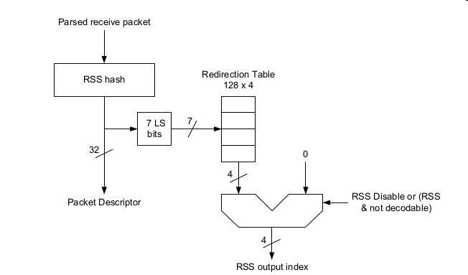

3. config
a. rss hash function
# ethtool -n eth2 rx-flow-hash tcp4
UDP over IPV4 flows use these fields for computing Hash flow key:
IP SA
IP DA
L4 bytes 0 & 1 [TCP/UDP src port]
L4 bytes 2 & 3 [TCP/UDP dst port]

f Hash on bytes 0 and 1 of the Layer 4 header of the rx packet.
n Hash on bytes 2 and 3 of the Layer 4 header of the rx packet.

# ethtool -N eth2 rx-flow-hash udp4 s|d|f|n

b. rss hash key
ethtool -x/X
unsupported now

Next release will be support as flowed
https://patchwork.ozlabs.org/patch/460409/
http://lists.openwall.net/netdev/2015/09/02/17

c. flow direcoir
ethtool -n/N
# ethtool -N eth2 flow-type ip4 action 0
# ethtool -n eth2 flow-type ip4 action 0
24 RX rings available
Total 1 rules

Filter: 2045
Rule Type: Raw IPv4
Src IP addr: 0.0.0.0 mask: 255.255.255.255
Dest IP addr: 0.0.0.0 mask: 255.255.255.255
TOS: 0x0 mask: 0xff
Protocol: 0 mask: 0xff
L4 bytes: 0x0 mask: 0xffffffff
VLAN EtherType: 0x0 mask: 0xffff
VLAN: 0x0 mask: 0xffff
User-defined: 0x0 mask: 0xffffffffffffffff
Action: Direct to queue 0

d. indirect table
unsupported
ethtool -x/X

Next release will be support as flowed
https://patchwork.ozlabs.org/patch/460409/
http://lists.openwall.net/netdev/2015/09/02/17

example for igb
ethtool -x enp7s0f0
RX flow hash indirection table for enp7s0f0 with 8 RX ring(s):
0: 0 0 0 0 0 0 0 0
8: 0 0 0 0 0 0 0 0
16: 1 1 1 1 1 1 1 1
24: 1 1 1 1 1 1 1 1
32: 2 2 2 2 2 2 2 2
40: 2 2 2 2 2 2 2 2
48: 3 3 3 3 3 3 3 3
56: 3 3 3 3 3 3 3 3
64: 4 4 4 4 4 4 4 4
72: 4 4 4 4 4 4 4 4
80: 5 5 5 5 5 5 5 5
88: 5 5 5 5 5 5 5 5
96: 6 6 6 6 6 6 6 6
104: 6 6 6 6 6 6 6 6
112: 7 7 7 7 7 7 7 7
120: 7 7 7 7 7 7 7 7

e. full command
ethtool -n|-u|--show-nfc|--show-ntuple DEVNAME Show Rx network flow classification options or rules
[ rx-flow-hash tcp4|udp4|ah4|esp4|sctp4|tcp6|udp6|ah6|esp6|sctp6 |
rule %d ]
ethtool -N|-U|--config-nfc|--config-ntuple DEVNAME Configure Rx network flow classification options or rules
rx-flow-hash tcp4|udp4|ah4|esp4|sctp4|tcp6|udp6|ah6|esp6|sctp6 m|v|t|s|d|f|n|r... |
flow-type ether|ip4|tcp4|udp4|sctp4|ah4|esp4
[ src %x:%x:%x:%x:%x:%x [m %x:%x:%x:%x:%x:%x] ]
[ dst %x:%x:%x:%x:%x:%x [m %x:%x:%x:%x:%x:%x] ]
[ proto %d [m %x] ]
[ src-ip %d.%d.%d.%d [m %d.%d.%d.%d] ]
[ dst-ip %d.%d.%d.%d [m %d.%d.%d.%d] ]
[ tos %d [m %x] ]
[ l4proto %d [m %x] ]
[ src-port %d [m %x] ]
[ dst-port %d [m %x] ]
[ spi %d [m %x] ]
[ vlan-etype %x [m %x] ]
[ vlan %x [m %x] ]
[ user-def %x [m %x] ]
[ dst-mac %x:%x:%x:%x:%x:%x [m %x:%x:%x:%x:%x:%x] ]
[ action %d ]
[ loc %d]] |
delete %d
ethtool -x|--show-rxfh-indir|--show-rxfh DEVNAME Show Rx flow hash indirection and/or hash key
ethtool -X|--set-rxfh-indir|--rxfh DEVNAME Set Rx flow hash indirection and/or hash key
[ equal N | weight W0 W1 ... ]
[ hkey %x:%x:%x:%x:%x:.... ]

