1. What is BPF
The Berkeley Packet Filter or BPF provides, on some Unix-like systems, a raw interface to data link layers, permitting raw link-layer packets to be sent and received. In addition, if the driver for the network interface supports promiscuous mode, it allows the interface to be put into that mode, so that all packets on the network, even those destined for other hosts, can be received.
In addition, it supports "filtering" packets, so that only "interesting" packets can be supplied to the software using BPF; this can avoid copying "uninteresting" packets from the operating system kernel to software running in user mode, reducing the CPU requirement to capture packets and the buffer space required to avoid dropping packets.

2. How BPF JIT filter work
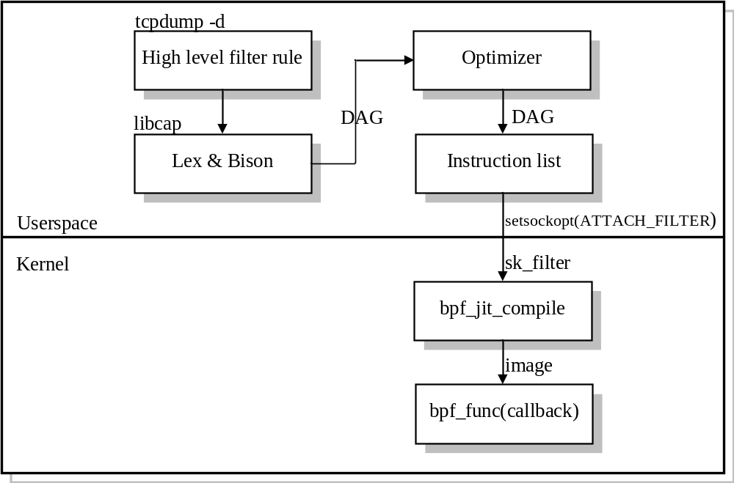

Filter rules
High level filter rule can be any kind of programming language, which suits for packet filter. Tcpdump provides syntax through command line.
For example, if want ip packet, udp destination port is 2152, the high level rules are such like this.
# tcpdump –d ip and udp dst port 2152

Flex and Bison
Tcpdump actually called the libcap library, which integrated the Flex and Bison. Flex is a lexical analyzer; Bison is the most famous Yacc grammar analyzer. The output of Flex and Bison is DAG structure. DAG is Directed Acyclic Graph, which is a basic structure to be further optimized by lots of mature standard optimize algorithm.
The high level filter rules will generate a DAG graph.
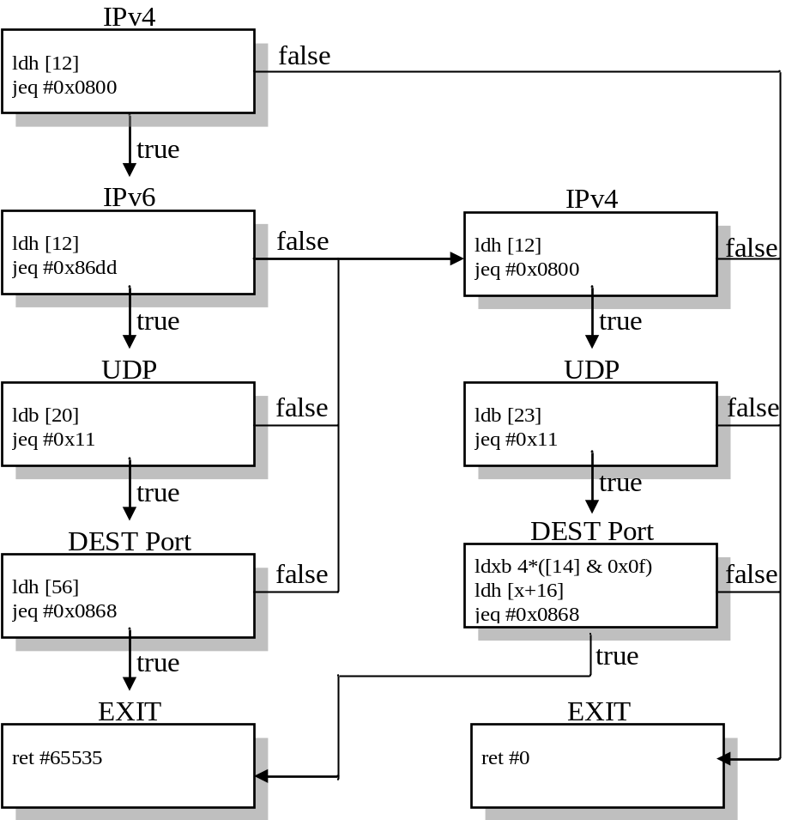
The first box IPv4 is the tcpdump –d ip counterpart instructions. The following are the UDP and destination port check. Since UDP can be over IPv4 and IPv6, so there are two main branches. This part is actually tcpdump –d udp dst port 2152. This is the original instructions flow after Lex and Bison without optimization.
(000) ldh [12]
(001) jeq #0x800 jt 2 jf 18
(002) ldh [12]
(003) jeq #0x86dd jt 4 jf 8
(004) ldb [20]
(005) jeq #0x11 jt 6 jf 8
(006) ldh [56]
(007) jeq #0x868 jt 17 jf 8
(008) ldh [12]
(009) jeq #0x800 jt 10 jf 18
(010) ldb [23]
(011) jeq #0x11 jt 12 jf 18
(012) ldh [20]
(013) jset #0x1fff jt 18 jf 14
(014) ldxb 4*([14]&0xf)
(015) ldh [x + 16]
(016) jeq #0x868 jt 17 jf 18
(017) ret #65535
(018) ret #0

Optimization
BPF uses the following optimize algorithm:
Const folding and copy propagation
Partial redundancy elimination
Peephole optimization
Generally there are two kinds of optimization: local optimization and global optimization.
After optimizer, the DAG graph is such like the following.
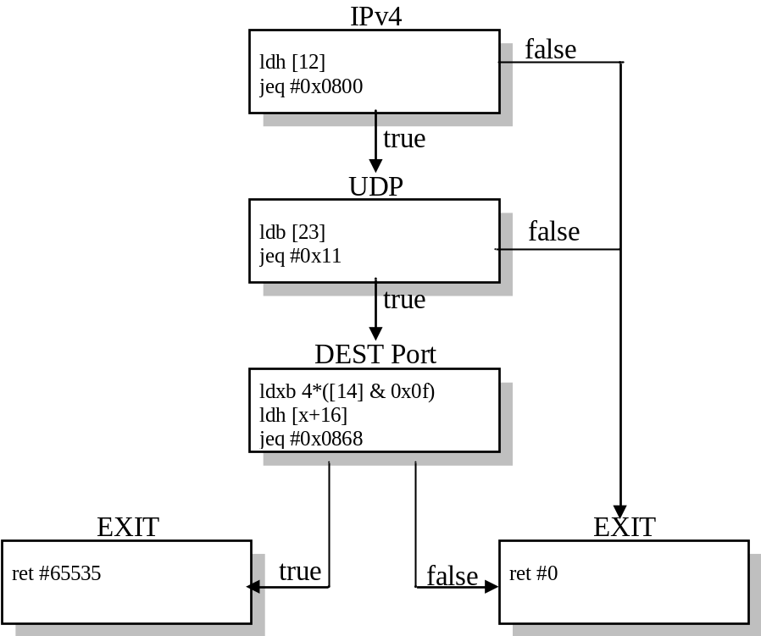

Virtual machine instructions
The output of optimizer is still DAG graph structure. The output will be changed to virtual machine instruction array list through an instruction generator.
Instruction list will be attached to the PF_PACKET socket or raw socket by setsockopt system call.
The final code instructions are:
(000) ldh [12]
(001) jeq #0x800 jt 2 jf 10
(002) ldb [23]
(003) jeq #0x11 jt 4 jf 10
(004) ldh [20]
(005) jset #0x1fff jt 10 jf 6
(006) ldxb 4*([14]&0xf)
(007) ldh [x + 16]
(008) jeq #0x868 jt 9 jf 10
(009) ret #65535
(010) ret #0

Programs in this virtual machine language can fetch data from the packet, perform arithmetic operations on data from the packet, and compare the results against constants or against data in the packet or test bits in the results, accepting or rejecting the packet based on the results of those tests.

JIT compile
In the kernel, the attach filter operation will dynamically call the bpf_jit_compiler function to compile the instruction list into machine code basing on the hardware instruction set used. So far, only x86_64 and PPC are supported.

How BPF JIT filter is used
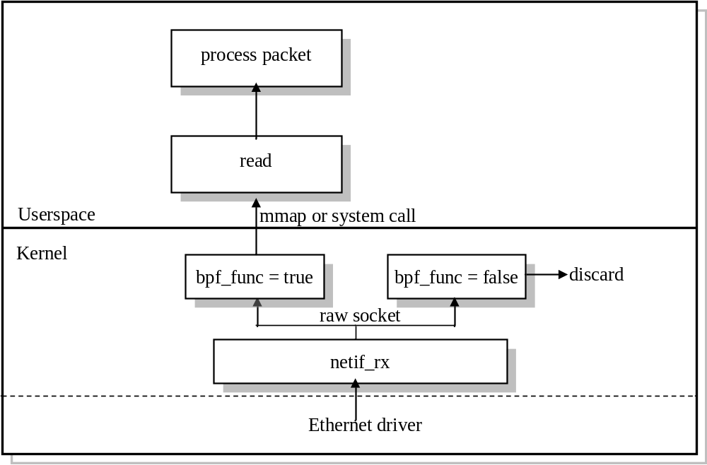
When the filter is attached and dynamically compiled into an image. It is registered as a callback on the PF_PACKET socket or raw socket. When a packet arrives at Ethernet driver, it will be passed to network layer interface via NAPI or softirq interrupt. The packet will be inspected via the compiled callback function, bpf_func on the socket, to see if the packet is interested packet or not. If not, it will be discarded or do other handling. If yes, it will be passed to user-space application via system call.

3. Performance testing and comparing
Except the BPF JIT filter there are another two packet filtering method. One is BPF interpreter method and the other is programming the filter in kernel. Let’s introduce the two methods first and then compare the performance of each method.

3.1 BPF work in interpreter method
This BPF filtering capabilities are implemented as an interpreter for the virtual machine language. When each link-layer packet is received, the socket in the kernel will run the sk_run_filter function to filter the packets. sk_run_filter is a interpreter which translate each virtual machine instruction to a C programming language syntax. The instruction list is not changed to local machine code. For each packet, it will be interpret once.

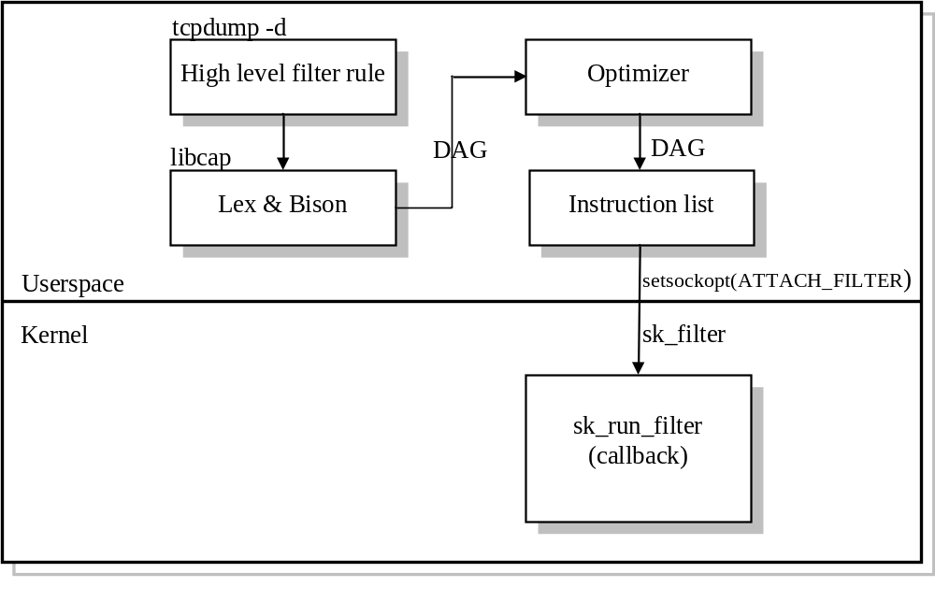3.2 Programming the filter in the kernel
This method we filter the packets in the kernel through that getting the packet header information and programming the filter in the kernel protocol stack to accept or reject the packets. We add the following function to the protocol stack and the user can only receive packets which base on ip and udp protocol and destination port 2152.

static int my_filter(const struct sk_buff *skb)
{

unsigned char *ethhead = skb->data;
unsigned char *iphead = skb->data + 14;

uint16_t type = ntohs(ethhead[12] | ethhead[13] << 8);
if(type != ETH_P_IP)
return 65535;
unsigned char tp = iphead[9];
if( tp != IPPROTO_UDP)
return 65535;
uint16_t frag = (ethhead[20] << 8 | ethhead[21]);
if(frag&0x1fff)
return 65535;
uint16_t port = (iphead[22] << 8 | iphead[23]);
if( port!= 2152 )
return 65535;
return 0;
}

3.3 testing and comparing
We test the performance of each method through a simple example which only permits the ip packet whose udp destination port is 2152 to be accepted by the user-space. The performance is described by the filter function’s running time in jiffies. We afford each filter function (BPF JIT image, BPF interpreter sk_run_filter, my_filter function) three different testings which include 10000000 times, 50000000 times and 100000000 times to run the relative filter function. The result is shown below:

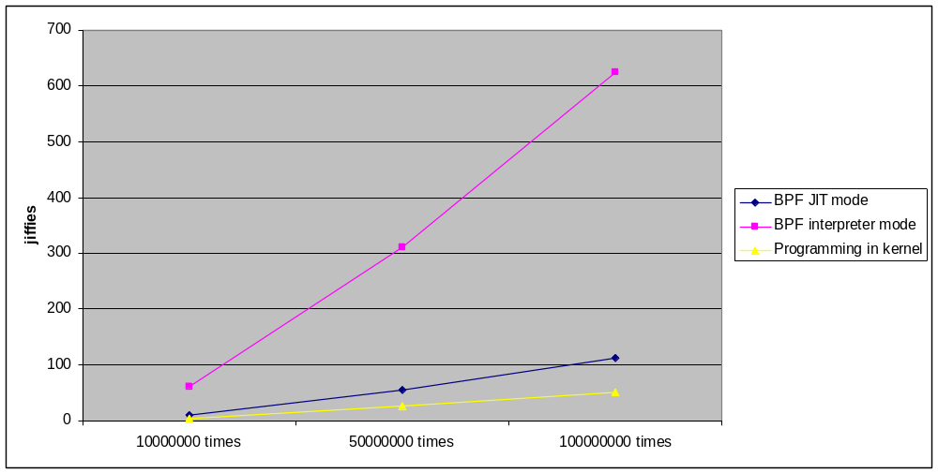

1. BPF interpret method

Virtual machine instruction

({0x28, 0, 0, 0x0000000c},
{0x15, 0, 8, 0x00000800},
{0x30, 0, 0, 0x00000017},
{0x15, 0, 6, 0x00000011},
{0x28, 0, 0, 0x00000014},
{0x45, 4, 0, 0x00001fff},
{0xb1, 0, 0, 0x0000000e},
{0x48, 0, 0, 0x00000010},
{0x15, 0, 1, 0x0000020b},
{0x6, 0, 0, 0x00000060},
{0x6, 0, 0, 0x00000000},

 | BPF interpret
10000000 times | 62(jiffies)
50000000 times | 312(jiffies)
100000000 times | 624(jiffies)

As we known that the interpreter is a so less effective. The more numbers of the virtual machine the more times to scan the interpreter. So it is not an effective method for filtering the uninteresting packets. The performance is not good due to the instruction list is not changed to local machine code. For each packet, it will be interpret once.

2. BPF JIT method

Virtual machine instruction

{0x28, 0, 0, 0x0000000c},
{0x15, 0, 8, 0x00000800},
{0x30, 0, 0, 0x00000017},
{0x15, 0, 6, 0x00000011},
{0x28, 0, 0, 0x00000014},
{0x45, 4, 0, 0x00001fff},
{0xb1, 0, 0, 0x0000000e},
{0x48, 0, 0, 0x00000010},
{0x15, 0, 1, 0x0000020b},
{0x6, 0, 0, 0x00000060},
{0x6, 0, 0, 0x00000000},

Machine instruction
0: 55 push %rbp
1: 48 89 e5 mov %rsp,%rbp
4: 48 83 ec 60 sub $0x60,%rsp
8: 48 89 5d f8 mov %rbx,-0x8(%rbp)
c: 31 db xor %ebx,%ebx
e: 44 8b 4f 68 mov 0x68(%rdi),%r9d
12: 44 2b 4f 6c sub 0x6c(%rdi),%r9d
16: 4c 8b 87 e0 00 00 00 mov 0xe0(%rdi),%r8
1d: be 0c 00 00 00 mov $0xc,%esi
22: e8 c2 0a 04 e1 callq 0xffffffffe1040ae9
27: 3d 00 08 00 00 cmp $0x800,%eax
2c: 75 41 jne 0x6f
2e: be 17 00 00 00 mov $0x17,%esi
33: e8 c9 0a 04 e1 callq 0xffffffffe1040b01
38: 83 f8 11 cmp $0x11,%eax
3b: 75 32 jne 0x6f
3d: be 14 00 00 00 mov $0x14,%esi
42: e8 a2 0a 04 e1 callq 0xffffffffe1040ae9
47: 66 a9 ff 1f test $0x1fff,%ax
4b: 75 22 jne 0x6f
4d: be 0e 00 00 00 mov $0xe,%esi
52: e8 b9 0a 04 e1 callq 0xffffffffe1040b10
57: be 10 00 00 00 mov $0x10,%esi
5c: e8 84 0a 04 e1 callq 0xffffffffe1040ae5
61: 3d 0b 02 00 00 cmp $0x20b,%eax
66: 75 07 jne 0x6f
68: b8 60 00 00 00 mov $0x60,%eax
6d: eb 02 jmp 0x71
6f: 31 c0 xor %eax,%eax
71: 48 8b 5d f8 mov -0x8(%rbp),%rbx
75: c9 leaveq
76: c3 retq
0xffffffffe1040ae9:
mov %r9d,%eax
sub %esi,%eax # hlen - offset
cmp $1,%eax
jle bpf_slow_path_half
movzwl (SKBDATA,%rsi),%eax
rol $8,%ax # ntohs()
ret
callq 0xffffffffe1040b10:
mov %r9d,%eax # hlen
sub %esi,%eax # hlen - offset
cmp $3,%eax
jle bpf_slow_path_word
mov (SKBDATA,%rsi),%eax
bswap %eax /* ntohl() */
ret
callq 0xffffffffe1040b01:
add %ebx,%esi /* offset += X */
js bpf_error
callq 0xffffffffe1040ae5
cmp %esi,%r9d /* if (offset >= hlen) goto bpf_slow_path_byte */
jle bpf_slow_path_byte
movzbl (SKBDATA,%rsi),%eax
ret
 | BPF JIT
10000000 times | 11(jiffies)
50000000 times | 56(jiffies)
100000000 times | 112(jiffies)

In the kernel the virtual machine instruction is compiled to a machine instruction image through bpf_jit_compile function. So the performance is improved almost twice than interpreter way. The improvement is due to the virtual instruction list is directly translate to local machine code. So we do not need to interpret the virtual instruction once for each packet.

3. Programming in the kernel

C type function
static int my_filter(const struct sk_buff *skb)
{

unsigned char *ethhead = skb->data;
unsigned char *iphead = skb->data + 14;

uint16_t type = ntohs(ethhead[12] | ethhead[13] << 8);
if(type != ETH_P_IP)
return 65535;

unsigned char tp = iphead[9];
if( tp != IPPROTO_UDP)
return 65535;
uint16_t frag = (ethhead[20] << 8 | ethhead[21]);
if(frag&0x1fff)
return 65535;
uint16_t port = (iphead[22] << 8 | iphead[23]);
if( port!= 523 )
return 65535;

return 0;
}
Machine instruction
e60: 55 push %rbp
e61: 48 89 e5 mov %rsp,%rbp
e64: e8 00 00 00 00 callq e69 <my_filter.clone.25+0x9>
e69: 0f b6 47 0d movzbl 0xd(%rdi),%eax
e6d: 0f b6 57 0c movzbl 0xc(%rdi),%edx
e71: c1 e0 08 shl $0x8,%eax
e74: 09 c2 or %eax,%edx
e76: b8 ff ff 00 00 mov $0xffff,%eax
e7b: 66 83 fa 08 cmp $0x8,%dx
e7f: 74 07 je e88 <my_filter.clone.25+0x28>
e81: c9 leaveq
e82: c3 retq
e83: 0f 1f 44 00 00 nopl 0x0(%rax,%rax,1)
e88: 80 7f 17 11 cmpb $0x11,0x17(%rdi)
e8c: 75 f3 jne e81 <my_filter.clone.25+0x21>
e8e: 0f b6 4f 14 movzbl 0x14(%rdi),%ecx
e92: 0f b6 77 15 movzbl 0x15(%rdi),%esi
e96: c1 e1 08 shl $0x8,%ecx
e99: 09 f1 or %esi,%ecx
e9b: 81 e1 ff 1f 00 00 and $0x1fff,%ecx
ea1: 75 de jne e81 <my_filter.clone.25+0x21>
ea3: 0f b6 77 24 movzbl 0x24(%rdi),%esi
ea7: 0f b6 57 25 movzbl 0x25(%rdi),%edx
eab: c9 leaveq
eac: c1 e6 08 shl $0x8,%esi
eaf: 09 f2 or %esi,%edx
eb1: 66 81 fa 0b 02 cmp $0x20b,%dx
eb6: 0f 44 c1 cmove %ecx,%eax
eb9: c3 retq
eba: 66 0f 1f 44 00 00 nopw 0x0(%rax,%rax,1)

 | Programming in kernel
10000000 times | 5(jiffies)
50000000 times | 26(jiffies)
100000000 times | 52(jiffies)

The progarm is in the kernel-spaces, our filter function will be compiled to a machine instruction and build in the kernel. as we see, the machine code is shorter almost twice than BPF JIT mothod’s image and the expense of the machine code is less than BFP JIT for the calling expense in the BFP JIT method. So the performance is almost twice than BFP JIT method.

4. Conclusion
 | BPF JIT mode | BPF interpreter mode | Programming in kernel
GPL | OK | OK | NO
Flexible | OK | OK | NO
Effective | OK | NO | OK

1. Programming in kernel method
This method has a good performance, but less flexible. It can be hardly reused. Each application will have its specific kind of filter. The GPL license will also make all the code public without enterprise propriety. This method can be used for both the incoming and the outgoing packet

2. BPF in interpreter method
It interprets each virtual machine instruction into c programming language. This method is the original BPF filter used. It has well flexible to change the filter rules in the application. However the performance is not good due to the instruction list is not changed to local machine code. For each packet, it will be interpret once. raw socket before Linux 3.0 all uses this kind of way to filter packet. This method is only used for the incoming packet. For the outgoing packets, there is no impact.

3. BPF in JIT method
BPF JIT filter has both the advantages of flexible and performance. It is can flexible to change the filter rules in the application like BPF in interpreter method. This method’s performance is better than BPF in interpreter method, but less than programming in kernel method due to the cost for changing the filter rules flexible in user-space. This method is also only used for the incoming packet. For the outgoing packets, there is no impact.

